Encountering the Spectral: The Haunted Photograph

Maria Cristina Castro Rodriguez
2223477
Ryan Moule
Independent Project (ADAA6000)
Word Count: 6552

Submitted in partial fulfillment of the requirements for the degree of BA (Hons) University of Wales Trinity Saint David, Swansea, and the date of presentation (13th December 2024).

Contents

List of Illustrations 3
Introduction. 4
Chapter 1: Understanding Ontology. 6
Chapter 2: Hauntology and the Ontology. 14
Chapter 3. Artists’ Practice. 21
Conclusion. 31
Bibliography 33

List of Illustrations

Fig. 1: Muñoz, O. (2004) Re/trato. Available at: https://artblart.com/tag/oscar-munoz-retrato/ (Accessed: 10 December 2024).
Fig. 2: Muñoz, O. (1995) Aliento. Available at: https://artblart.com/tag/oscar-munoz-retrato/ (Accessed: 10 December 2024).
Fig. 3: Price, E. (20212) Woolworths Choir of 1979. Available at: https://elizabethprice.site/the-woolworths-choir-of-1979/ (Accessed: 10 December 2024).
Fig. 4: Price, E. (2009) User Group Disco. Available at: https://elizabethprice.site/user-group-disco (Accessed: 10 December 2024).
Fig. 5: Seers, L. (2017) Nowhere Less Now. Available at: https://www.glynnvivian.co.uk/whats-on/lindsay-seers-nowhere-less-now%E2%81%B7/ (Accessed: 10 December 2024).
Fig. 6: Seers, L. (2016) Nowhere Less Now. Available at: https://www.artangel.org.uk/artwork/nowhere-less-now/ (Accessed: 10 December 2024).
Fig. 7: Seers and Sargent. (2022) Cold Light. Available at: https://www.mattsgallery.org/news/lindsay-seers-and-keith-sargent-turner (Accessed: 10 December 2024)
Fig. 8: Seers and Sargent. (2022) Cold Light. Available at: https://lindsayseers.info/exhibition/turner-contemporary-cold-light/ (Accessed: 10 December 2024)

Introduction.
Photography is my way of holding on—a bridge between who I am now and who I once was. My work often revolves around family photographs, not as mere objects of nostalgia, but as portals to moments I am both connected to and distant from. These images are witnesses to faces and places slipping further from memory. I’ve experienced the fear of forgetting—a face once vivid begins to blur, a detail fades. Yet photographs bring them back, imperfectly and incompletely, offering something new with every encounter.
Photographs shape as much as they preserve. When I look at an old image of myself, I see a version I can no longer access. It’s a ghost—not just of who I was, but of the person I thought I’d always remember. These ghosts haunt me, influencing my present in ways I don’t fully understand. They remind me that we are all haunted—by memories, by invisible forces of the past. These echoes of history live within us, shaping who we are while keeping us connected to what we’ve lost.
This realization has transformed how I understand identity, time, and connection. We are not isolated; we are constellations of memories and histories. Family photographs, in particular, serve as vessels for the past, actively shaping how we engage with time and loss. My practice becomes a way to grasp this unity and acknowledge the beauty in impermanence. Each photograph connects me to something universal—a reminder that, in our brief existence, we are inseparably linked to everything around us.
Through this research, I aim to navigate the haunting nature of images, not to escape it, but to live with it. Photography teaches me that to see the ghost is to see myself and, in doing so, confront the complexities of identity and time. By studying how images preserve, distort, and reimagine memory, I hope to deepen my understanding of personal and collective histories. This work is not just a way to hold on, but also a way to let go—a bridge between what was, what is, and what could be.
The first chapter establishes foundational concepts for understanding the intersection of ontology and hauntology in photography. It begins by exploring ontology—the study of being and existence—and its relevance to how photography both represents and participates in processes of memory, absence, and presence. Drawing on the ideas of thinkers like Roland Barthes and Susan Sontag, the chapter discusses how photography mediates our experience of time and existence, highlighting the transient nature of time. This philosophical framework prepares the reader for a deeper exploration of hauntology, focusing on the spectral presences and echoes of the past that haunt the photographic image. The chapter ultimately sets the stage for understanding how hauntology shapes our perception of memory, identity, and the ongoing influence of the past on the present.
Chapter 2 explores the connection between photography and the philosophical concept of hauntology, which challenges traditional ideas of being and existence. Coined by Jacques Derrida, hauntology examines the presence of the past in the present, with photography serving as a spectral medium that captures moments now gone. The chapter draws on Derrida’s concept of the "spectre" and the works of thinkers like Eduardo Cadava and Mark Fisher to discuss how photography bridges the past, present, and future, transforming moments into lingering traces that continue to shape our perception of time and memory. By examining the paradox of presence and absence in photography, the chapter argues that the photograph does not just document but resuscitates the past, creating an ongoing dialogue with the ghosts of time.
The third chapter examines how photography and multimedia practices by artists like Oscar Muñoz, Elizabeth Price, and Lindsay Seers challenge the boundaries between past, present, and future, reshaping our understanding of time, memory, and identity. Drawing on Simon O'Sullivan’s concept of "the encounter," we explore how these artists provoke reflection and disrupt habitual ways of seeing, creating moments of rupture where the spectral presence of the photographic image allows new possibilities for thought and transformation. Through a hauntological lens, we see how these practices reshape our engagement with time, memory, and identity.

Chapter 1: Understanding Ontology.
To grasp the concept of hauntology, it is essential to first understand ontology. Ontology, derived from the Greek words ontos (being) and logia (study), explores the nature of existence, being, and reality. Martin Heidegger offers a profound perspective in Being and Time, describing ontology as "the science of the Being of entities," with the task "to explain Being itself and to make the Being of entities stand out in full relief" (Heidegger, 2001, p. 49). This exploration of Being is not just an abstract inquiry but a fundamental step in understanding how the past, the spectral, and the absent interweave with our present—a core theme of hauntology.
Heidegger emphasizes that ontology is not merely about cataloguing entities but investigating the fundamental question of what it means for something to exist. By focusing on (Dasein)—the human experience of being—Heidegger reframes ontology as an inquiry into the temporal and contextual nature of existence (Heidegger, 1962, p. 27), paving the way for deeper explorations of how being and time intersect.
Ontology explores the nature of existence, encompassing both tangible objects, like trees and buildings, and abstract concepts, such as justice and love. It addresses fundamental questions about what exists, investigating both physical and intangible entities. A key focus is the categorization of existence, distinguishing between living and non-living things, as well as material and immaterial forms. Ontology also examines relationships between entities, including the connection between physical objects and the abstract concepts they represent, as well as interactions between individuals and society.. Additionally, it considers whether abstract entities—like numbers, memories, or possibilities—can be valid forms of existence (Lofgren, 2013).
Ontological debates centre on how to categorize and relate existence, with different philosophical traditions offering varying interpretations. Ontological Materialism argues that physical matter is the foundation of reality, existing independently of human observation. In contrast, Ontological Idealism suggests that consciousness and immaterial phenomena are the true basis of reality, with the world ultimately constructed in the mind of the observer. Both perspectives offer contrasting views on understanding existence (Lofgren, 2013).
Heidegger, in Being and Time (1962), critiques traditional materialism by proposing a more complex understanding of being rooted in human experience. He introduces the concept of Being-in-the-world, suggesting that existence is interpreted through human engagement with the world. He asserts, "Dasein is an entity which, in its very Being, comports itself understandingly towards that Being" (Heidegger, 1962, p. 53), highlighting human existence as an active relationship to Being.
Roland Barthes, in Mythologies (1991), explores how signs and images shape our understanding of reality, arguing that meaning is mediated through cultural symbols. He states, "Myth is a type of speech" (Barthes, 1991, p. 107), emphasizing that reality is constructed through language and the system of signs that communicate meaning.
Therefore, ontology is not just an abstract issue but impacts how we understand the world materially and conceptually. In fields like social science, information systems, and artificial intelligence, ontology provides tools to define what is "real" within a domain, helping structure knowledge and frameworks for engagement with systems around us.
Ontology is often paired with epistemology, the study of knowledge—what we know and how we can know it. While ontology addresses what things are, epistemology focuses on how we know them (Knowledge Quest, 2021).
A useful analogy for understanding ontology is to think of the world as a library containing books on every subject, from tangible facts to abstract ideas. Ontology is like studying how this library is organized, what kinds of books are inside, and how they are related. This metaphor highlights the challenges in categorizing existence and shows how ontologies structure knowledge across fields. As noted by the National Academies of Sciences, ontologies are crucial in advancing research by categorizing and relating concepts in the behavioral sciences (National Academies of Sciences et al., 2022).
Barthes, in Mythologies (1991), explores how representation shapes knowledge. He argues that myth is defined not by its content but by its form: “Myth is not defined by the object of its message, but by the way in which it utters this message” (Barthes, 1991, p. 107). This shows that reality is shaped by representation. Ontology and epistemology are inseparable: our understanding of what things are is mediated by how we come to know and represent them.
The ontological exploration of photography asks: What is a photograph? It is both a representation of reality and an independent entity—a new reality in itself. Barthes, in Camera Lucida (1982), observes that photographs are both present and absent:
What I see has been here, in this place which extends between infinity and the subject (operator or spectator); it has been here, and yet immediately separated; has been absolutely, present, and yet already deferred” (Barthes, 1982, p. 77).
For Barthes, the photograph functions not as the moment itself but as a trace of it, pointing out the interplay between presence and absence. This paradox underpins photography’s ontological significance, illustrating the dual ontic states of existence: asserting being while highlighting its transience.
Susan Sontag, in On Photography (1977), deepens this ontological exploration by reflecting on the evocative and temporal power of photographs. She writes,
A photograph is both a pseudo-presence and a token of absence. Like a wood fire in a room, photographs—especially those of people, of distant landscapes and faraway cities, of the vanished past—are incitements to reverie. (Sontag, 1977, p. 12).
This expresses photography’s duality: it conjures the presence of what is depicted while reinforcing its irrevocable absence.
Through this duality, photographs transcend their static nature, serving as catalysts for reflection and nostalgia. They invite viewers to engage with the ephemeral quality of time, echoing Barthes’ notion of the photograph as a trace—tangible yet unattainable.
Sontag’s metaphor of a "wood fire" illustrates how photography stimulates the imagination while highlighting its inability to restore what has been lost. It is within the tension between presence and absence, memory and reality, that photography occupies a unique ontological status, compelling us to reconsider how we perceive and interact with the world.
A key ontological characteristic of photography is its indexicality—the intrinsic link between a photograph and the reality it depicts. Unlike paintings or drawings, which are mediated by the artist’s interpretation, photography directly captures light reflected from the subject. Sontag emphasizes this, noting, observing:
A photograph is not only an image (as a painting is an image), an interpretation of the real; it is also a trace, something directly stencilled off the real, like a footprint or a death mask” (Sontag, 1977, p. 120).
This positions the photograph not just as a representation, but as an imprint of reality, indelibly tied to its subject. Similarly, Barthes, in Camera Lucida (1982), underscores the mechanical nature of photography, which preserves moments that can never be relived: “The photograph mechanically repeats what could never be repeated existentially” (Barthes, 1982, p. 4). Both Sontag and Barthes emphasize the photograph's ontological significance as a "trace," reinforcing its role as a medium that bridges the tangible and the representational.
This concept is particularly vivid in analogue photography, where the chemical interaction of light with film underscores its material link to reality. In digital photography, while the indexical relationship between the photograph and its subject becomes mediated by algorithms and technology, the photograph’s role as a tangible trace persists in the way it continues to evoke a direct relationship with the subject it depicts. In the context of non-representational theory, photographs are seen not just as representations of reality, but as experiences that engage with time, memory, and effect on a subjective level.
Photography, as a medium, has profoundly influenced how we understand existence, memory, and reality. These transformations have been critically examined by thinkers such as John Berger, Susan Sontag, and Roland Barthes, who each highlight the unique ways photography mediates and reshapes our perception of the world. Their contributions align with broader discussions about photography's ontological status, particularly its ability to document fleeting moments, evoke memory, and blur the line between representation and reality
John Berger, in Ways of Seeing (1972), explores how photographs frame our understanding of history and memory by isolating and recontextualizing fragments of reality. This framing influences our perception of existence and alters our engagement with both the past and present.
Similarly, Susan Sontag, in On Photography (1977), examines how photography commodifies moments, transforming them into objects that can be preserved, shared, and mediated. In doing so, photography extends our ability to document history while shaping how we interpret and prioritize experiences. For Sontag, photography is not just a tool for memory but a cultural practice that alters our perception of the world.
For Roland Barthes, photography's power lies in its indexicality, or its direct connection to what it depicts. In Camera Lucida (1982), Barthes emphasizes the "that-has-been" quality of photographs, which links the viewer to a specific moment in the past. This characteristic underscores photography’s role as a tangible trace of reality: “I can never deny that the thing has been there” (Barthes, 1982, p. 76). This indexical nature positions photography as both evidence of existence and a reminder of its transience.
Together, Berger, Sontag, and Barthes underscore the profound shifts brought about by photography in how we perceive and interact with memory and reality. Their insights highlight how photography not only expands our sense of history and memory but also shapes our understanding of the past while influencing our perception of the present and future
A photograph is a record of the past—it captures a fleeting moment that is already gone. This positions photography in an intrinsic relationship with time, serving as both a document of what once was and a reminder of what can no longer be. In this duality, a photograph becomes a meditation on impermanence, freezing time while underscoring its brevity.
Photography also intersects with memory, acting as a tangible extension of personal recollection. While it can evoke vivid memories, a photograph is inherently limited—it captures only a trace of an experience, never fully encapsulating its depth. As a proxy for memory, it preserves fragments of the past yet falls short of embodying the entirety of a lived moment.
Roland Barthes’ theory of the punctum evolves as he reflects on photography's temporal nature. Beyond the initial punctum—a striking detail within the frame—Barthes introduces a second dimension, rooted in Time. This punctum is not bound to form but emerges as an "intensity," tied to the noeme of photography: "that-has-been." Barthes states, "This new punctum, which is no longer of form but of intensity, is Time, the lacerating emphasis of the noeme ('that-has-been'), its pure representation" (Barthes, 1982, p. 86). This temporal aspect reveals photography's intrinsic connection to impermanence, where every photograph carries the weight of what was and, implicitly, the inevitability of what will be. The image confronts us with the duality of presence and absence, making the passage of time both vivid and haunting.
Barthes identifies Time in photography as a "lacerating emphasis," which he interprets through the lens of death. For instance, Barth uses a photograph of Alexander Gardner’s photograph of Lewis Payne encapsulates both past and future—the historical fact of Payne’s execution and the impending inevitability of his death. This dual temporal awareness creates an unsettling tension, as the photograph becomes a site where life and death coexist, intensifying its emotional resonance. Even images without explicit ties to death carry this haunting quality, as they testify to a moment’s irretrievability.
This interplay of Time aligns photography with hauntology, which explores how traces of the past linger, disrupting linear time. Each photograph is a spectral artifact, preserving and displacing its subject. Historical photographs amplify this effect, making the past feel both close and distant. Photography, in this sense, bridges eras, where the ephemeral becomes enduring and what has passed continues to resonate.
By foregrounding Time as the second punctum, Barthes highlights photography's ontological complexity. It is more than a medium of representation; it is a meditation on existence and mortality. Each image embodies a paradox: presence and absence, the enduring trace of a fleeting moment. Photography does not simply document reality but challenges us to confront the temporal dimensions of being, memory, and loss.

Chapter 2: Hauntology and the Ontology.
Photography is inherently a spectral medium. It captures a moment that no longer exists, preserving it in a form that evokes both presence and absence, memory and loss. This phenomenon can be explored through the concept of Hauntology, first introduced by Jacques Derrida in Specters of Marx (1993), which examines the intricate relationship between photography, time, and being.
Hauntology challenges traditional ontological notions of being and existence. Derrida uses the spectre as a figure that deconstructs the living present, positioning it on the threshold between life and death, presence and absence. As Derrida states, the spectre "opens up the virtual space of spectrality,” defying "the sharp distinction between the real and the unreal, the actual and the inactual, the living and the non-living, being and non-being" (quoted in Sugiyama, 2023, p. 212). This formulation rejects clear separation and highlights the complex, often contradictory nature of existence. The spectre, therefore, is not an isolated entity but one that continually haunts the present through its relationship to both the past and the future.
Hauntology challenges the traditional concept of 'ontology,' which defines being through self-identical presence. As Sugiyama (2023) explains, drawing on Martin Hägglund’s Radical Atheism, the spectre "cannot be fully present: it has no being in itself but marks a relation to what is no longer or not yet" (Sugiyama, 2023, p. 212). This emphasizes the spectral nature of entities that do not exist as complete, self-contained beings, but rather as traces of absence, constantly straddling the line between presence and non-presence. The spectre inhabits a temporal space between what has passed and what is yet to come, constantly lingering on the margins of time, resisting full presence, and disrupting our teleological understanding of time and existence.
Building on the spectre’s existence within the temporal margins of past and future, Derrida’s concept of survivre expands this notion by redefining life as a continuous process of "living on." Rather than adhering to the binaries of life and death, survivre positions survival as an iterative movement that transcends biological limits (Sugiyama, 2023, p. 217). This idea resonates with Eduardo Cadava’s exploration of cyclical temporality in Words of Light (1997), where photography similarly dissolves the distinctions between past, present, and future. Together, these concepts frame both life and photography as spectral processes, perpetually reshaping identity through their interplay with time.
Photography, as Roland Barthes observes, "is literally an emanation of the referent. From a real body, which was there, proceed radiations which ultimately touch me, who am here" (Barthes, 1981, p. 80). This captures photography’s ability to transmit traces of the past into the present, aligning closely with Derrida’s concept of spectrality—where the spectre exists as a trace of "what is no longer or not yet." The photograph, much like the spectre, exists in the "living on" of the referent—the object or moment captured within the image—continuing to be across time and memory, allowing its essence to return and haunt the viewer across time.
Eduardo Cadava’s reflection on photography as "a writing of light, a script of light" (Cadava, 1997, p. xv) invokes Walter Benjamin’s metaphor of lightning, which illuminates the fleeting nature of memory and history. Lightning, like a photograph, captures a moment in sudden brightness before vanishing into darkness, embodying the transience of eternal return. This interplay between light and darkness resonates with Derrida’s understanding of survival as a process that defies closure, oscillating between presence and absence. The photograph, like the specter, lingers at the edge of perception, refusing resolution while evoking the persistent tension of being and non-being.
Cadava emphasizes that photography is a medium that embodies temporal complexity, collapsing the distinctions between past, present, and future. This aligns with his exploration of eternal return, a concept he connects to Walter Benjamin’s theories on photography and memory. Eternal return, as Cadava articulates, is not merely a repetition of the past but a recurring interplay of traces, where past, present, and future fold into one another. This cyclical temporality challenges linear notions of time and reconsiders how to engage with the past.
To illustrate this, Cadava incorporates Benjamin's notion of memory and photography as a form of inscription:
Like photography, lightning in Benjamin names the movement of writing and inscription. Linked to the flashes of memory, the suddenness of the perception of similarity, the irruption of events or images, and even the passage into night, Benjamin's vocabulary of lightning helps register what comes to pass in the opening and closing of vision. It tells us what brings sight to writing. (Cadava, 1997, p. 21).
This comparison emphasizes the ephemeral nature of both photography and lightning. Just as lightning momentarily illuminates the sky, photography captures the fleeting awareness of a particular moment in history. The flash of lightning—like a photograph—creates a connection between the past, present, and future, bringing traces of what has been into dialogue with the present. This supports the idea of eternal return, where the past reemerges not as a static repetition but as a sudden, illuminating flash that redefines our understanding of temporality and memory.
Photography’s inherent spectrality, as explored through hauntology, emphasizes its connection to time and memory. Mark Fisher, in Ghosts of My Life (2014), describes haunting as "a failed mourning," where the past refuses to release its grip on the present. This notion resonates with Eduardo Cadava’s description of the photograph as a "cemetery," a space where the act of photography transforms the living into the "living dead" (Cadava,1997, p. 10). Similarly, Roland Barthes, in Camera Lucida, describes the photograph as something that "certifies that the corpse is alive, as a corpse: it is the living image of a dead thing" (Barthes, 1982, p. 79). These reflections reveal photography’s eerie ability to collapse the distinctions between life and death, past and present, creating a haunting interplay between what has been and what lingers on.
This spectral quality of photography aligns with Jacques Derrida’s concept of "photographic performativity," discussed in Copy, Archive, Signature (2010). Derrida suggests that photographs—particularly in the digital age—do not merely document what has occurred but actively shape our understanding of what is possible. Photography, in this sense, engages with what is "not yet" or "no longer," drawing attention to the gap between the present and unrealized futures. This gap becomes the space where "lost futures" reside—moments, ideas, or possibilities that were never fully realized. Derrida reframes photography as an active participant in shaping temporality, where images are no longer static records of the past but dynamic entities that can simultaneously preserve and erase, challenging linear notions of time (Derrida, 2010, p. 5).
As Barthes observes in Camera Lucida (1982), photographs are "a new form of hallucination: false on the level of perception, true on the level of time... a mad image, chafed by reality" (Barthes, 1982, p. 115). This paradox underscores photography’s spectral essence—its ability to evoke what is lost and what might have been, blurring the boundaries between past, present, and future. The photograph presents an illusion of presence, while simultaneously revealing the absence of the moment captured. Barthes further explores this notion, stating that photography "transformed subject into object, and even, one might say, into a museum object" (Barthes, 1982, p. 13). This transformation, in which living individuals become ghosts of their past selves, highlights the photograph’s dual nature as both annihilation and survival. Cadava, in Words of Light (1997), explains that the photograph, by capturing a fleeting moment, creates a rupture in the continuous flow of time—a break that signifies both loss (annihilation) and preservation (survival).
Derrida reflects on this unsettling transformation in Copy, Archive, Signature (2010), observing:
that the catastrophe has always already taken place when one sees oneself as having become an object, as having become one’s own loss. One is photographable, “photogenic,” and this is perhaps the catastrophe, that one
can be photographable, that one can be captured and
caught in time. (Derrida, 2010, p.36)
This emphasizes the disconcerting nature of being rendered into an object, permanently fixed in time.
Barthes' meditation on the photograph’s ability to connect the viewer to the past evokes a sense of both loss and presence. He writes:
The photograph of the missing being, as Sontag says, will touch me like the delayed rays of a star. A sort of umbilical cord links the body of the photographed thing to my gaze: light, though impalpable, is here a carnal medium, a skin I share with anyone who has been photographed. (Camera Lucida,1982, p. 80).
This passage underscores the unique intimacy created by photography between the subject, the photographer, and the viewer. Barthes describes the photograph as a connection to the past, where the “delayed rays” of light from the subject’s body now reach the viewer in the present (Camera Lucida,1982, p. 80). This underscores not only the temporality of the medium but also its physicality—the light that once touched the subject’s body creates an intimate connection, a shared "skin" between the photographed and the viewer, lingering long after the moment has passed.
For Barthes, the photograph is not merely a representation but an emotional experience, an encounter with the past that leaves an indelible mark on the viewer. The photograph’s haunting quality emerges from this tension between presence and absence, the fleeting moment captured, and the loss it simultaneously represented.
In conclusion, photography is inherently tied to the spectre, acting as a medium that collapses the distinctions between past, present, and future. While a photograph serves as a record of what is no longer physically present, its spectral quality maintains an intimate connection to the past, lingering in the present. This complex relationship challenges conventional understandings of time and existence, as each photograph carries traces of a past that refuses to disappear. Photography does not merely capture a moment; it brings it into the present, where it continues to haunt, survive, and reemerge, inviting reflection on the intricacies of memory, loss, and the passage of time. In this way, photography uniquely exemplifies hauntology by preserving the spectral presence of what once was, forever binding the past to the present. Furthermore, through its connection to the past, photography has the potential to anticipate the future, as the images we create today will inevitably become the ghosts of tomorrow, shaping how understand both ourselves and the world.
Why do we often overlook the spectral essence embedded within photography? In an age dominated by the instantaneity of contemporary photography, we tend to focus on presence, neglecting the "ghost in the machine." What draws you to surface this spectral aspect? The re-emergence of the ghost can serve as an existential rupture in the overwhelming flow of imagery that surrounds us

Chapter 3. Artists’ Practice.
If photography collapses the boundaries between past, present, and future, the artists in this chapter navigate these temporal complexities through their practices, transforming photographs into spaces of encounter and reflection. Rooted in the framework of hauntology, this chapter explores how their works evoke the spectral presence of memory, identity, and the past as unresolved and perpetually returning.
Using Simon O’Sullivan’s concept of “the encounter”, this chapter deepens the exploration of these practices. O’Sullivan distinguishes the encounter from recognition by emphasizing that while recognition reaffirms what we already know, the encounter disrupts our habitual ways of being and thinking. As O'Sullivan writes: “Something in the world forces us to think. This something is an object not of recognition but of a fundamental encounter” (O'Sullivan, 2023). An object of recognition simply reaffirms what is already understood, confirming our existing knowledge and beliefs, and reinforcing a stable sense of self and world. In contrast, an encounter challenges these assumptions, forcing us to think otherwise and opening us up to new possibilities. It produces a rupture in our usual ways of being, and thus, a "crack" through which new ideas can emerge. This encounter, according to O’Sullivan, is not just a disruption but also contains a moment of affirmation—a new world, a new way of seeing and thinking.
For the artists discussed in this chapter, their works do not merely represent the past, memory, or identity but provoke encounters with these spectres. They create moments of disruption where recognition is replaced with a rupture, forcing viewers to reconsider how they engage with the temporalities and identities embodied in the photographs. The encounter, in this sense, becomes a site where photography operates beyond representation, embracing the potential for transformation and creative thought. Through their work, these artists invite the viewer into an encounter that destabilizes linear narratives and invites new relational understandings of memory and identity.
By situating these encounters within a hauntological framework, we can further understand how photography becomes a medium that is inherently haunted—by what it captures, by what it misses, and by the temporal ruptures it embodies. The works of these artists make visible the "cracks" where the spectres of memory and identity are continuously negotiated. These ruptures disrupt linear narratives, adopting a relational approach to understanding the self, suggesting that memory and identity are never fully stable but are constantly reshaped through ongoing encounters. Through these moments of encounter, the artists demonstrate how the past and present intertwine, showing the power of photography to reshape our understanding of who we are and how we relate to the world.
Oscar Muñoz’s exploration of memory and identity as spectral, fleeting, and perpetually in fluctuation. Born in Colombia in 1951, Muñoz’s work addresses personal and collective themes, often reflecting on the fragility of existence within a socio-political context marked by erasure and violence. Through photography, video, and installation, he engages with a hauntological sensibility—evoking the past’s lingering presence and the instability of memory. Muñoz's use of the photographic medium challenges its traditional role of preserving moments, instead emphasizing its ability to disappear and transform. His work becomes a meditation on memory’s impermanence and identity’s elusive nature, capturing the processes of creation and erasure.

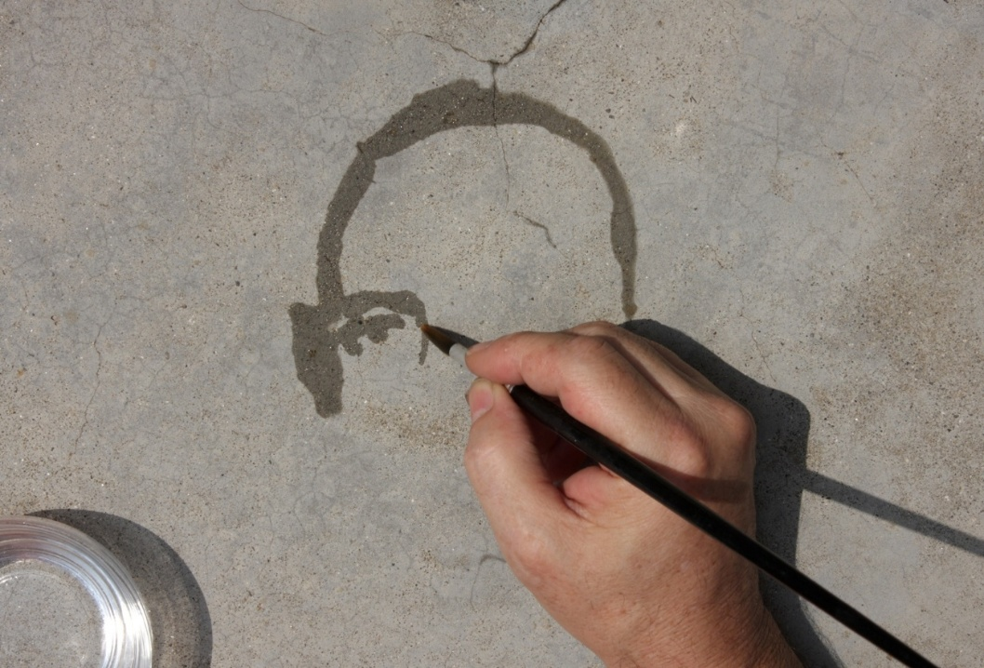
Fig. 1: Re-trato

In Re-trato (2004), Muñoz presents an evocative meditation on memory's impermanence and identity's elusive nature. Using water to paint portraits that evaporate over time, the work is a reminder of the inevitable dissolution of the self. The title—a play on the Spanish words for "portrait" (retrato) and "retreat" (re-trato)—signals the cyclical process of creation and erasure. Through evaporation, the image becomes spectral, never fully present yet never entirely absent, embodying the hauntological interplay of presence and loss. This briefness transforms Re-trato into a metaphor of how memory and identity continually slip through the cracks of time.

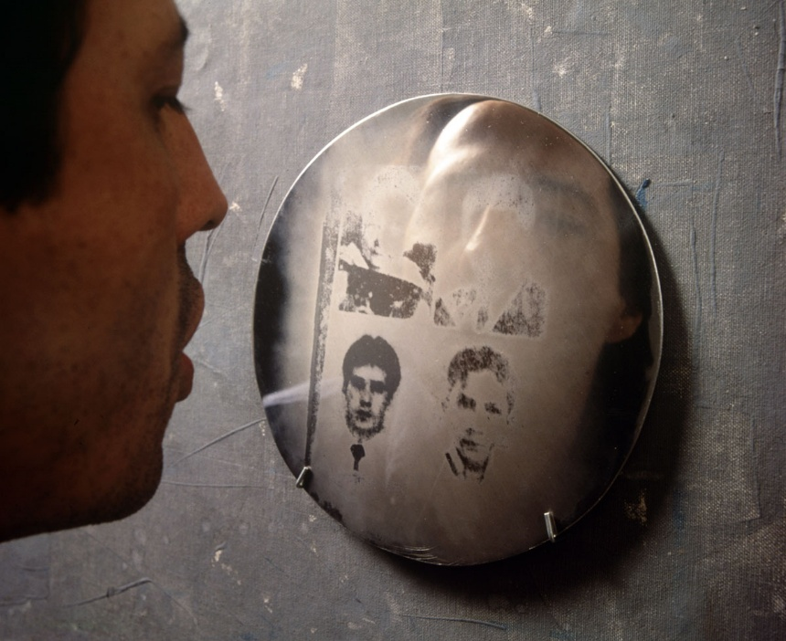
Fig. 2: Aliento

Similarly, in Aliento (1995), Muñoz's deepens his exploration of identity as relational and ephemeral. In this work, the viewer’s breath reveals hidden portraits on polished metal surfaces, only for the images to vanish as the metal cools. This haunting interplay of visibility and erasure highlights the performative nature of identity—it exists only in fleeting encounters and interactions. The spectral presence of the portraits, which emerge and dissipate with the viewer’s exhalation, underscores the hauntological idea that memory and identity are never fully fixed, but perpetually haunted by absence and impermanence.

In parallel, Elizabeth Price’s practice also interrogates the relationship between memory, identity, and cultural objects, often highlighting how memory is fragmented and erased, Price’s work explores the intersections of memory and material culture, focusing on how objects mediate our understanding of the past and identity. Through video, sound, and installation, she examines the decay of memories and the destabilizing effect of absence.

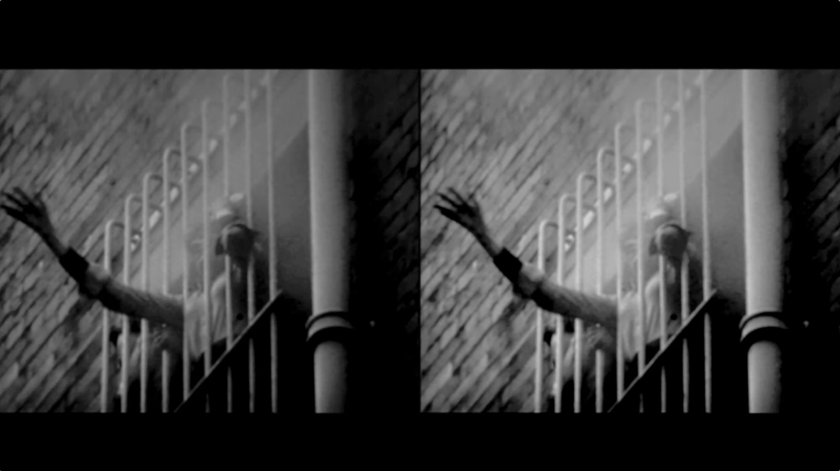
Fig. 3: Woolworths Choir of 1979

In Woolworths Choir of 1979 (2012), Price reflects on the legacy of a traumatic fire at a Woolworths store, using archival imagery, choral music, and sound to reconstruct a moment of collective memory and loss. The work’s combination of haunting preserved trauma, and ephemeral memory—mirrors the dissertation’s focus on photographic rupture. Price’s exploration of absence and presence calls attention to how memories are preserved in fragments, never fully intact, but always haunted by their loss.


Fig. 4: User Group Disco

In User Group Disco (2009), Price further investigates the relational nature of memory, using objects as containers of fragmented histories. Through a layered audio-visual installation, she interrogates how objects carry cultural weight, even as they become released from their original contexts. These objects—present, yet ghostly—exist in a liminal state, embodying the hauntological tension between presence and absence.
Price’s work suggests that objects, much like memories, gain meaning through human interaction, but this relational process is loaded with instability. The absence of their original function or context makes them spectral, emphasizing how identity, too, is fragmented and constructed in dialogue with the past. In User Group Disco, the encounter becomes a site where these tensions are negotiated, further underscoring the relational and spectral nature of memory.

The changing nature of identity is also a central concern for Lindsay Seers, whose multidisciplinary practice spans video, installation, and sculpture. Seers examines how memory and perception interact to shape an ever-changing understanding of the self. Through the use of technology, including video, robotics, and virtual reality, Seers’ work explores how the past continues to haunt the present and mediate our perception of identity. Her works align with a hauntological framework by revealing how fragmented narratives and technological forces reshape the self.

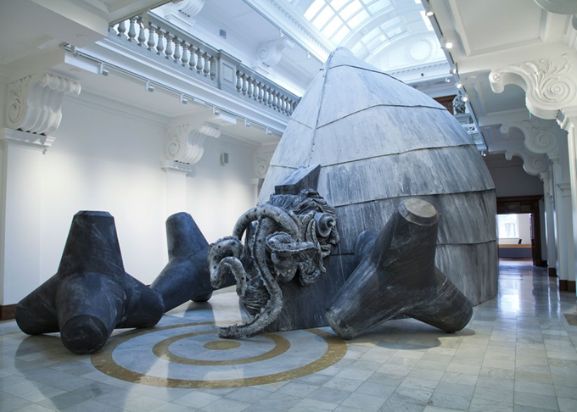
Fig. 5: Nowhere Less Now
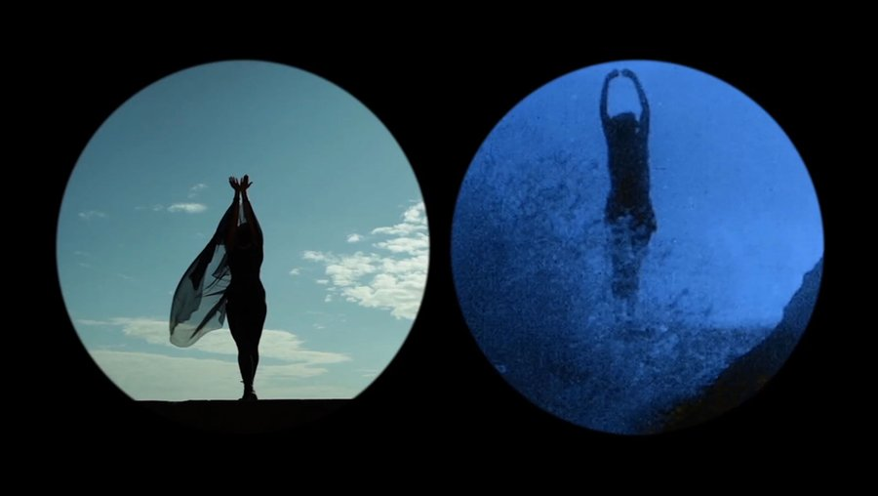
Fig. 6: Nowhere Less Now
In Nowhere Less Now (2012), Seers creates a fragmented narrative that immerses the viewer in shifting perspectives and temporal dislocations. The two-channel video installation, accompanied by a sculptural structure, challenges the viewer’s perception of time and space, destabilizing the notion of a fixed identity. The immersive experience reflects how memory fragments our understanding of the present and the self.

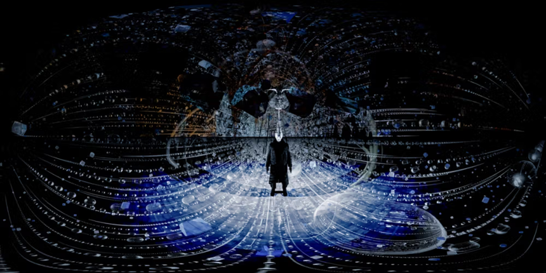
Fig. 7: Cold Light
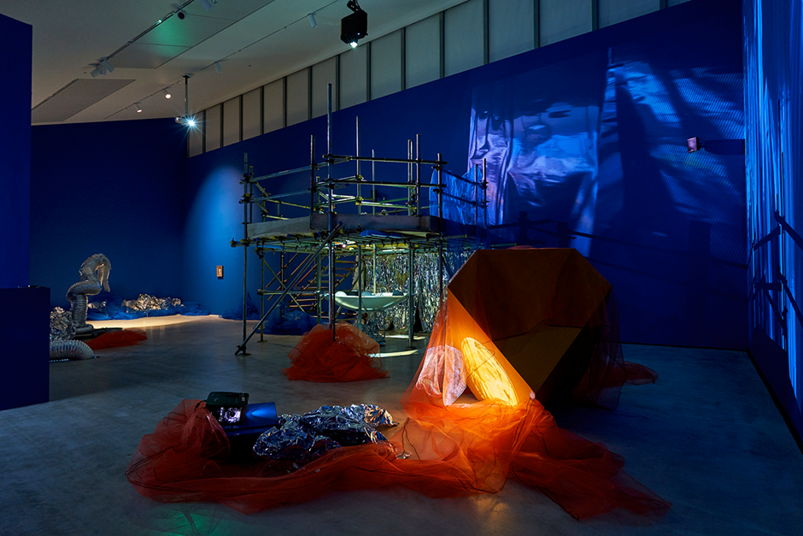
Fig. 8: Cold Light
Seers’ Cold Light (2022) also addresses the transitory nature of identity, highlighting its collaborative formation. In this work, Seers collaborates with Keith Sargent to integrate robotics, video, and virtual reality, suggesting that identity and memory are shaped not only by personal experience but also by external technological forces.
The blending of the physical and virtual in Cold Light exemplifies the constantly shifting nature of the self, where external and internal forces converge to reshape identity. Both Nowhere Less Now and Cold Light demonstrate the relational and unstable nature of memory, identity, and perception.

Through the works of Oscar Muñoz, Elizabeth Price, and Lindsay Seers, this chapter explores the photograph as a site of encounter—a dynamic space where identity, memory, and time are perpetually in flux. The notion of the encounter, as explored here, is rooted in its ability to create moments of interaction between the viewer, the medium, and the subject, opening up spaces where meaning is negotiated and contested. The encounter destabilizes fixed interpretations, instead fostering a relational process where identity and memory are experienced as fluid and multifaceted.
These artists challenge the traditional notion of the photograph as a static representation, instead transforming it into a medium that exposes the fragility, impermanence, and spectral nature of the self. Muñoz’s ephemeral portraiture, Price’s interrogation of absence and material culture, and Seers’ immersive explorations of memory and identity demonstrate the photograph’s capacity to rupture linear narratives and reveal the complexities of existence. Together, their practices navigate the cracks, gaps, and spectres within the image, reminding us that identity is never fixed, that memory is always subject to loss and decay, and that the act of looking itself becomes an encounter with absence.
In these moments of rupture and transformation, the photograph transcends its role as a mere mirror of reality. It becomes a lens through which presence and absence coexist, memory is continuously rewritten, and identity is glimpsed as a fragmentary and evolving process. These artists compel to see the photograph not as a means of capturing the past, but as a space of haunting and possibility—where what is lost and what remains converge to shape how we understand the self in relation to time and memory.

Conclusion.
This dissertation has traced a layered journey through the interconnections of ontology, hauntology, and photography, exploring how the medium navigates the complexities of identity and memory. Beginning with the ontological foundations of being, it continued into hauntology as a lens through which the persistence of the past shapes our present realities. Through the works of artists and theorists, the spectral nature of photography emerged as central to its power: it simultaneously reveals and conceals, bringing us into an encounter with the traces of life that linger in every form of representation.
As a medium, photography thrives in the in-betweens, embodying dualities that reflect the complexities of the human condition. It navigates presence and absence, memory and forgetting, life and death. In doing so, it creates moments of rupture—haunting breaks in our perceptions of reality that compel us to confront our ontological foundations. It is often in these ruptures, in the spectral aspects of photography, where we experience discomfort, vulnerability, and a departure from our usual ways of understanding. In an era where instantaneity rules, it is easier to overlook the spectral essence of photography, as it requires us to pause, reflect, and move beyond our established patterns of recognition. Confronting the ghostly aspects of the image challenges our fixed beliefs and invites a confrontation with the unknown and the ambiguous. This encounter can feel unsettling, making us more vulnerable in the face of uncertainty.
Through hauntology, the photograph reveals its existential potential, exposing not only the spectres of the past but also the ambiguities of the present. Here, the ideas of Existentialist philosophers like Jean-Paul Sartre, while not central to this dissertation, offer a complementary perspective. Much like Sartre's exploration of the disquieting nature of existence, hauntology reminds us that the world, stripped of its reassuring narratives, is both haunting and beautiful. The photograph, in its spectrality, invites us to inhabit these ambiguities, to see the world not as fixed and known, but as layered, fragmented, at times uncertain, and full of potential.
This dissertation suggests that the act of photographing and interpreting plays a significant role in the processes of identity formation. Photography becomes a site of encounter, where the visible and the invisible, the familiar and the unknown, intersect. The works of the artists discussed complicate how the photographic image challenges preconceptions, not to resolve them but to make their complexities visible. In reflecting on these ideas, we are reminded of the importance of imagination and openness. To encounter life through photography is not merely to document it but to engage with its haunting echoes and elusive possibilities. While we may never fully escape the preconceptions that shape our understanding, recognizing and questioning them allows us to envision different futures and alternative ways of being.
Ultimately, the layered nature of photography—its ability to deconstruct and reconstruct meaning—offers a powerful framework for understanding identity and existence. It is a medium uniquely suited to revealing the traces that haunt us, inviting us not only to look but to imagine, to encounter, and to dream.

Bibliography
Barthes, R. (1982) Camera Lucida. New York: Hill & Wang.

Barthes, R. and Lavers, A. (1991) Mythologies. New York: The Noonday Press.

Batchen, G. (2009) Photography degree zero: reflections on Roland Barthes’s Camera Lucida. Cambridge, Mass.; MIT Press.

Berger, J. and Berger, J. (2008) Ways of seeing. London: Penguin.

Cadava, E. (1997) Words of light: theses on the photography of history. Princeton, N.J: Princeton University Press.

Castroverde, A. (2023) ‘Philosophical Fiction as World Literature: Jean-Paul Sartre’s Nausea’, Sartre Studies International, 29(2), pp. 59–78. Available at: https://doi.org/10.3167/ssi.2023.290205

Derrida, J. et al. (2010) Copy, archive, signature: a conversation on photography. Stanford, Calif: Stanford University Press. Available at: https://doi.org/10.1515/9780804775014.

Derrida, J., Kamuf, P. and Carver, T. (1997) ‘Specters of Marx’, History of political thought, pp. 345–348. Available at: https://www-jstor-org.ezproxy.uwtsd.ac.uk/stable/26217295?seq=1

Eisenbeis, W. (1983) The key ideas of Martin Heidegger’s treatise Being and Time. Washington, D.C.: University Press of America

Fisher, M. (2012) ‘What Is Hauntology?’, Film quarterly, 66(1), pp. 16–24. Available at: https://doi.org/10.1525/fq.2012.66.1.16.

Fisher, M. (2014) Ghosts of my life : writings on depression, hauntology and lost futures. Winchester: Zero Books.

Heidegger, M., MacQuarrie, J. and Robinson, E. (1962) Being and time. London: SCM Press.

Knowledge Quest (2021) What are Ontology & Epistemology? Available at: https://www.youtube.com/watch?v=UHl0ThG2kNU&list=PLphlicjeAaE1ybI7A0Kw4Un92LsmqON-H&index=1 (Accessed: 20 November 2024).

Lofgren, K. (2013) What is ontology? Introduction to the word and the concept. Available at: https://www.youtube.com/watch?v=XTsaZWzVJ4c&list=PLphlicjeAaE1ybI7A0Kw4Un92LsmqON-H&index=3 (Accessed: 20 November 2024)

National Academies of Sciences, Engineering, and Medicine (2022) Ontologies in the Behavioural Sciences: Accelerating Research and the Spread of Knowledge. Available at: https://www.ncbi.nlm.nih.gov/books/NBK584339/ (Accessed: 20 November 2024)

O’Sullivan, S. (2006) Art encounters Deleuze and Guattari: thought beyond representation. Basingstoke: Palgrave Macmillan.

Palmer, K. (2023) Elizabeth Price: Unsettled Histories. Available at: https://various-artists.com/elizabeth-price/ (Accessed: 10 December 2024)

Sontag, S. (1977) On Photography. New York: RosettaBooks LLC.

Sugiyama, K. (2023) ‘The Survival of Specters: Hauntology and Richard Powers’s The Overstory’, Studies in the novel, 55(2), pp. 210–232. Available at: https://doi.org/10.1353/sdn.2023.a899473.

Theschooloflife (2014) Philosophy – Sartre. Available at: https://www.youtube.com/watch?v=3bQsZxDQgzU (Accessed: 10 December 2024)

TurnerContemporary (2022) Lindsay Seers & Keith Sargent: Cold Light Exhibition Film | Turner Contemporary. Available at: https://www.youtube.com/watch?v=_fbS4-2P8ic&t=291s (Accessed: 10 December 2024).

Vergara, I. (2021) ‘Flows of Breath: Oscar Muñoz’s Unfolding Images’, Discourse (Berkeley, Calif.), 43(2), pp. 286–310. Available at: https://doi.org/10.13110/discourse.43.2.0286

