

Can schools utilise the use of music to foster learning?

Ross McDonnell 1600632

BA (Hons) in Primary Education with QTS

University of Wales Trinity Saint David

April 2019

Frontispiece_ _ _ _ _ _ _ _ _ _ _ _ _ _ _ _ _ _ _ _ _ _ _ _ _ _ _ _ _ _ _ _ _ _ _ _ _ _ _ _ _

I can confirm that, with exception to where there is specific reference made, the work discussed in the research project is the result of a research investigation carried out by the student. This research project nor any part of it has or will be presented or submitted towards any academic award other than in part for the degree of BA (Hons) in Primary Education with QTS with The University of Wales Trinity Saint David. I understand that if I use any work without appropriate referencing constitutes as plagiarism, which will lead to the failure of this module.

Acknowledgements_ _ _ _ _ _ _ _ _ _ _ _ _ _ _ _ _ _ _ _ _ _ _ _ _ _ _ _ _ _

The author would like to take this opportunity to kindly thank the school involved within the research project. The valued assistance and ever so important contribution from the staff and students is greatly appreciated and has a fundamental importance to the research project as a whole. Thank you to the head teacher and assistant head teachers for allowing access to the school and the opportunity to get to know the staff, students and school alike.

The author would also like to that Iwan Ellis-Williams and Dr Sioned Hughes of the University of Wales Trinity Saint David for their continuous support and assistance throughout the progression and development of this research project.

A big thank you and great appreciation goes out to the staff and students that have completed an electronic questionnaire distributed by the writer; their responses have made good contribution towards the writer’s research and analysis.

The author cannot thank everybody enough for their help and support throughout the research project. The help is highly appreciated. Thank you all.

Contents _ _ _ _ _ _ _ _ _ _ _ _ _ _ _ _ _ _ _ _ _ _ _ _ _ _ _ _ _ _ _ _ _ _ _ _ _ _ _ _ _ _ _ _ _ _ _ _ _ _ _ _ _ _ _ _ _ _ _ _ _ __ _ _ _ _ _ _ _ _ _ _ _ _ _ _ _ _ _ _ _ _ _ _ _ _ _ _ _ _ _ _ __ _ _ _ _ _ _ _ _ _ _ _ _ _ _ __ _ _ _ _ _ _ _ _ _ _ _ _ _ _ __ _ _ _ _ _ _ _ _ _ _ _ _ _ _ _ _ _ _ _ _ _ _ _ _ _ _ _ _ _ _ __ _ _ _ _ _ _ _ _ _ _ _ _ _ _ __ _ _ _ _ _ _ _ _ _ _ _ _ _ _ __ _ _ _ _ _ _ _ _ _ _ _ _ _ _ _ _ _ _ _ _ _ _ _ _ _ _ _ _ _ _ __ _ _ _ _ _ _ _ _ _ _ _ _ _ _ _ _ _ _ _ _ _ __ _ _ _ _ _ _ _ _ _ _ _ _ _ _ _ _ _ _ _ _ _ _ _ _ _ _ _ _ _ _ __ _ _ _ _ _ _ _ _ _ _ _ _ _ _ __ _ _ _ _ _ _ _ _ _ _ _ _ _ _ __ _ _ _ _ _ _ _ _ _ _

Chapter 1- Introduction
  - Scope of research
  - Aims of the project
  - Research sources
  - Limitations
  - Hypothesis

Chapter 2- Literature review
2.1 Scope of the chapter
2.2 Theories of learning
2.3 What about Donaldson?
2.4 Can music foster or hinder learning
2.5 Conclusion of the chapter

Chapter 3- Methodology
3.1 Code of conduct
3.2 Ethics
3.3 Type of research

Chapter 4- Results and discussion
4.1 Scope of chapter
4.1 Observations
4.3 Student questionnaire
4.4 Staff questionnaire

Chapter 5- Conclusion

Appendices
_ _ _ _ _ _ _ _ _ _ _ _ _ _ _ __ _ _ _ _ _ _ _ _ _ _ _ _ _ _ _ _ _ _ _ _ _ _ _ _ _ _ _ _ _ _ __ _ _ _ _ _ _ _ _ _ _ _ _ _ _ __ _ _ _ _ _ _ _ _ _ _ _ _ _ _ __ _ _ _ _ _ _ _ _ _ _ _ _ _ _ _ _ _ _ _ _ _ _ _ _ _ _ _ _ _ _ __ _ _ _ _ _ _ _ _ _ _ _ _ _ _ __ _ _ _ _ _ _ _ _ _ _ _ _ _ _ __ _ _ _ _ _ _ _ _ _ _ _ _ _ _ _ _ _ _ _ _ _ _ _ _ _ _ _ _ _ _ __ _ _ _ _ _ _ _ _ _ _ _ _ _ _ _ _ _ _ _ _ _ __ _ _ _ _ _ _ _ _ _ _ _ _ _ _ _ _ _ _ _ _ _ _ _ _ _ _ _ _ _ _ __ _ _ _ _ _ _ _ _ _ _ _ _ _ _ __ _ _ _ _ _ _ _ _ _ _ _ _ _ _ __ _ _ _ _ _ _ _ _ _ _

Appendix one - Ethics form

Appendix two – Pupil Questionnaire

Appendix four – Staff Questionnaire

Appendix five – electives report

Chapter 1: Introduction _ _ _ _ _ _ _ _ _ _ _ _ _ _ _ _ _ _ _ _ _ _ _ _ _ _ _

1.1 Scope of the research
The motivation behind choosing the research project was derived from prior experiences with the upcoming Times Table Rockstars (TT Rockstars) initiative. Within a typical session of TT Rockstars session, the children will be given sixty multiplication/ division either online or the printable paper versions that are available. The children then have three minutes to complete the times tables questions with ‘rock’ music playing in the background as a motivator for the children.
Copley Junior School (2019) describes TT Rockstars as, ‘a fun and challenging programme designed to help pupils master the times tables.’ The TT Rockstars program focuses more so on teaching creatively as opposed to focusing on teaching the children how to be creative.
Sir Ken Robinson’s (2006) TED talk Seminar, ‘Do schools kill creativity’, in which Robinson discussed the hierarchy of the importance of different subjects in schools. Robinson identified that the arts are commonly placed at the bottom of the hierarchy. In his report, Successful Futures, Donaldson (2015) recommends that the national curriculum is adapted to foster the creativity of the children, putting emphasis on the arts to create ‘enterprising, creative contributors’ that can think creatively. Although it is seen as important to foster the creativity of the children and teach for creativity, the writer asks; should we also consider teaching creatively as well as teaching for creativity?

1.2 Aims of the project
Within this research project, the writer will intend to develop an acute and critical understanding of how the use of music can take effect on the classroom environment and behaviour of the children within education in Wales.
The overarching aim of the project is to is to identify if the use of music within the classroom can alter the behaviour and engagement of children within the primary school setting.
Another aim of this research project is to gain further insight to how practitioners can incorporate the use of music to further develop the learning and foster the ethos of the classroom.
The main aim can be achieved by the researcher conducting varies forms of primary and secondary research to gain observations from the perspectives of; teachers, non-teaching staff and also the pupils. The research data can then be analysed and interrogated in order to identify any ways in which, if any, different genres of music can alter the behaviour and engagement of children.
The writer intends to utilise the results of the research project in order to enhance their personal teaching practice alongside the teaching practice of schools and/ or classes that the writer can influence through their teaching career.

1.3 Research sources
The research carried out during this research project includes

- Structured and unstructured observations – primary observations of various classrooms through different activities with and without the use of music. The writer believes the observations can be used to utilise visual representations of the change in the behaviour of the children.

- Literature review – Secondary research that will allow the writer to critically respond to the use of music being used to influence the behaviour and engagement of the children. The writer will be using research from various different books, journals, websites and reports from different organisations.

- Electronic questionnaires to teaching and non-teaching staff - primary research to gain qualitative and quantitative data from the perspective of school staff.

- Electronic questionnaires to pupils – primary research to gain the personal perspective of the children within the same school environment as the teacher’s questionnaires.

1.4 Limitations

There are various different limitations to the research project carried out by the writer but there were two main limitations that the writer would have benefitted greatly without.
One of the main limitations was the time constraint to which the writer could have carried out the primary research. The writer believes if there was more time to conduct the research, there could be data collected from many different schools giving a larger scale research. Thus, giving a more reliable outcome than the research through the smaller demographic.
The final major limitation was due to the lack in responses from the teaching staff of the school. The writer had distributed to all staff of the school where the research was placed. Out of over forty members of staff that received the questionnaire, there were only a handful of respondents to the questionnaires. The writer determined that the lack in responses would not give a fair representation of the perspective of teachers in Wales.

1.5 Hypothesis

Within witnessing the TT Rockstars program and the benefits it has brought to the children that the writer has had experience in teaching, the writer believes that music can influence the work ethic of the children but to what extent can music be an influence? Can music influence all areas of learning?
The writer is also curious to distinguish if the different genres of music can take influence on the behaviour and engagement of the children?

Chapter 2: Literature review_ _ _ _ _ _ _ _ _ _ _ _ _ _ _ _ _ _ _ _

2.1 Scope of the chapter

This chapter will consist of a literature review of the use of background music in education. For this study, the term ‘background music’ will be defined as music that is played in the background when studying or participating in activities.
The literature review will consist of secondary research that was used to inform the writer of background research for the use of music within education.

2.2 Theories of learning

Ertmer and Newby (2013) suggests that, ‘Learning has been defined in numerous ways by many different theorists’. Kelly (2012) identified the three key learning theories as;
- Behaviourism
- Cognitivism
- Constructivism

Behaviourism

As the name suggests, behaviourism is a study of the behaviour and how it may change through different influences or actions. Kelly (2012) suggested ‘behaviourists believe that learning actually occurs when new behaviours or changes in behaviours are acquired through associations between stimuli and responses.’
Taggart (Date unknown) identified that, ‘there are three individual scientists and psychologists that are extremely important to the history of behaviourism because of their theories and research:
- Ivan Pavlov - Developed the concept of Classical Conditioning
- John Watson - Founder of Behaviourism, 1878-1958
- B. F. Skinner - Founder of Operant Conditioning’

Skinner developed operant conditioning chamber (skinners box) in which was an isolated chamber were animals were given positive or negative reinforcements to their reactions to different stimuli to distinguish if rewards help the animals learn what stimuli give rewards. Lumen (date unknown)

Cognitivism (Cognitive information processing)

Cognitivism, sometimes knowns and cognitive information processing, focuses more on ways in which the learning can be processed by learners. Ertmer and Newby (2013) stated, ‘in the late 1950’s, learning theory began to make a shift away from the use of behavioural models to an approach that relied on learning theories and models from the cognitive sciences.’
Complimenting Ertmer and Newby, Kelly (2012) indicated that,

‘Cognitive information processing is used when the learner plays an active role in seeking ways to understand and process information that he or she receives and relates it to what is already known and stored within memory.’

LearningTheories (2015) identified five key contributors to cognitivism as:
- Marriner David Merill
- Charles Reigeluth
- Robert Mills Gagné
- Jerome Bruner
- Roger Schank

Constructivism

Constructivism, as a learning theory, is built upon how learners construct their own learning and build upon prior knowledge and experience of meaning. Kelly (2012) suggests that ‘constructivist theorists believe that learning is a process where individuals construct new ideas or concepts based on prior knowledge and/ or experience.’

(Bednar et al., 1991, as cited in Ertmer and Newby, 2013) ‘Constructivism is a theory that equates learning with creating meaning from experience.’

In regards to relating the learning theories to the use of music in the learning environment;
- The music could be seen as an extrinsic motivator, tying in with Watson’s behaviourist learning theory as the children may see the music as a reward.
- If there is new learning with background music playing, the children may link a particular song / rhythm with the area of learning. Thus, displaying an element of the constructivist approach.

2.3 What about Donaldson?

Donaldson (2015) has recommended that the ‘Expressive arts’ should be made one of the six areas of learning for the new curriculum for Wales. Donaldson (2015. P43) suggested that, ‘the expressive arts provide opportunities to explore thinking, refine, and communicate ideas, engaging thinking, imagination and senses creatively.’ With this in mind, the writer poses the question of: Can we help children to foster their creativity by applying creative teaching and learning method in the classroom? i.e. background music to be used to set a relaxing ethos calming the children.

2.4 Can music foster or hinder learning?

It was ‘Rauscher et al (1993) who reported that brief exposure (10 min) to a Mozart sonata generates short term increases in spatial-reasoning abilities (the Mozart effect).’ Schellenrg (as cited in, Peretz and Zattore (2003. P432)
The Mozart effect was encountered after Rauscher et al (1993) when participants were split in to three separate groups. One of the groups listened to Mozart’s sonata for two pianos (K448) for 10 minutes; another group listened to relaxing music designed to lower blood pressure; and the final group sat in silence for 10 minutes. After the 10 minutes, all of the participants were to complete a series of activities. Surprisingly, the results showed evidence of listening to Mozart’s sonata having short term effects on spatial reasoning. Jenkins (2001) identified that ‘the mean spatial IQ scores were 8 and 9 points higher after listening to the music than in the other two conditions.’

However, Perham and Currie (2014), researcher of the psychology department at Cardiff University, were intrigued by ‘the Mozart effect’ and decided to apply their knowledge into their own study to find out if listening to preferred music can improve reading comprehension. Busch (2018) reported that Perham and Currie;

‘assigned students into one of four groups: the first revised in silence, the second revised while listening to music with lyrics they liked, the third group revised to music with lyrics they did not like and the fourth group revised listening to music without lyrics.’

Interestingly, Perham and Currie (2014) identified that the group that revised in silence scored more than sixty percent higher than peers who revised with music with lyrics. On the contrary, students that revised listening to music without lyrics, scored higher than the group who listened to music with lyrics.
Perham and Currie’s study revealed that, in regards to revision, it is more beneficial for student to revise in silence than listening to any music at all. With this study, in particular, showing that music can actually hinder revision, the writer is left but to question the validity of ‘the Mozart effect’. On the contrary, Lehmann and Seufert (2017.P2) using the work of Floss (1982) give a brief response to the Mozart effect and identify,

’even though in the experiment the exposition to music took place in advance of the task, the results are transferrable to listening to music while learning. Priming effects should be even stronger during the exposition to the stimulus and decay over time’

Thompson et al. (2011) gives an insight to why different studies give mixed results during researching the effects on music. Thompson et al (2011) decided to dive deeper into the studies and varied the pitch, tone and duration of the music. Thompson et al (2011) identified that, ‘these findings reveal that listening to background instrumental music is most likely to disrupt reading comprehension when the music is fast and loud.’
Lehmann and Seufert (2017. P2) counteract Thompson et al (2011) and suggests that the work of Wallace (1999) shows that ‘it is not the characteristics of a song per se, but their effects on the learner which influence learning outcomes.’

2.5 Conclusion of the chapter

To conclude the literature review, there has been many different theories and studies that investigate different areas of music and learning apprehended.
To summarise, yes music can alter the learning outcomes when the optimum music is utilised. Studies showed that music without lyrics had a greater impact than music with lyrics. This may be due to the brain trying to process audible words alongside visual words or thought processes. As opposed to no lyrical music that can have a calming meditational effect on learners.

Chapter 3: Methodology _ _ _ _ _ _ _ _ _ _ _ _ _ _ _ _ _ _ _ _ _ _ _ _ _ _ _ _

3.1 Code of conduct
During the primary research aspect of the project, it was made clear that all data will be stored in adherence to the recently revised data protection act 2018. The data protection act 2018 is a legislation providing ‘a code of conduct’ for any consumer of personal data for any purpose. Van der Sloot (2014) simplistically describes and refers to the data protection principles as, ‘specific obligations and rights in order to protect the interests of citizens and consumers’. Cohen, Manion and Morrison (2007. P60) suggests that, ‘One can treat people with respect but still the research may make no material difference to their lives.’ The data protection act allows all data collected to be relevant and meaningful to any of the research undertaken. The writer has made it crucial to adhere to all of the principles in order to ensure that no part of the data collected can come of any harm to the participants of the research.
The writer will follow the British Educational Research Association (BERA, 2018) beliefs in that; researchers within education should have the upmost of respect for any persons involved within the research project. All individuals, involved in or in contact with the research, have and will be treated fairly, sensitively and with the upmost of respect throughout the project.
Similarly, The University of Wales Trinity Saint David (UWTSD, 2017) recognised one of the core aspects of research integrity, found in the Research Ethics & Code of Conduct, as;

‘Care and respect for all participants in and subjects of research, including humans, animals, the environment and cultural objects. Those engaged with research must also show care and respect for the stewardship of research and scholarship for future generations.’

3.2 Ethics

Cohen, Manion and Morrison (2007. P69) suggested that ‘the researcher will frequently find that methodological and ethical issues are inextricably interwoven in much of the research’. To overcome any foreseeable ethical implications, the writer was to submit an ethics form (see appendix one) to be reviewed and approved by the university’s ethics committee. Following the granted approval of the ethics form, a figure of authority from School A will need to complete and sign a consent form before research can be started within the establishment. Throughout the research project, all participants will be reminded of their right to withdraw from the research at any point without giving any reason to why they want to withdraw. The reminders of the right to withdraw from the research at any given time, directly implements the UN Conventional Rights of the Child (UNCRC, 2016. P6) Article 16 by protecting the privacy of the children, their honour and reputation. BERA (2011. P6) acknowledges that ‘Researchers must recognize the right of any participant to withdraw from the research for any or no reason, and at any time, and they must inform them of this right.’ Corresponding to BERA’s acknowledgments, Edwards (2005) suggested that, ‘Most ethics committees… insist that potential research participants reserve unconditional or absolute 'right' of withdrawal at any time and without giving any reason.’

3.3 Type of research

Throughout the project, the writer will be using a combination of primary and secondary research to gather evidence and data to analyse and draw conclusions.
Kowalczyk (date unknown) refers to;
- Primary research as first hand research that is usually factual and direct to what the researcher is looking for.
- Secondary research as an interpretation of other people’s primary research.

Observations:

As the name of the research method implies, the researcher is to observe specific fields or areas of interests Bryant (date unknown). When observing people or the behaviour of people, in this instance, the researcher deemed it more suitable to carry out unstructured observations of the children in their more natural setting and classroom environment. Forman and Hall (2005. P189) recommends observing children in their play as, ‘observing is relevant if we desire to learn about children and thus improve the quality of our teaching.’ Bryant (date unknown) complements Forman and Hall (2005) and suggested that observations give ‘first-hand experience with a setting allows researchers to open to discovery and inductive, rather than guessing what the context is like.’
The upfront analytics team (2015) identified one drawback to observational research that stood out to the writer as they can sympathise with the drawback of ‘Observation only tells one part of the story. Attitudes and opinions cannot be clearly expressed only through actions, so it may not be the clearest picture possible.’ Any teacher can agree that the foundation phase classroom can be unpredictable at times. Therefore, observations can be seen as unreliable when observing such a small scaled demographic.

Upon reflection, the observations did provide good visual evidence on how the behaviour of the children altered when prompted with different genres of music through different activities. On the contrary, when the researcher was observing the children, there may have been alternatives reasoning to why the behaviour changed at those particular moments.

Questionnaires:

As part of the research project, the writer had decided to use electronic questionnaires as another method of primary research. One of the main reasons for the use of electronic questionnaires are as McLeod (2018) suggested ‘Questionnaires provide a relatively cheap, quick and efficient way of obtaining large amounts of information from a large sample of people’. Another reason for using questionnaires was because the use of a questionnaire using closed and open ended questions can be an effective way of recording qualitative and quantitative data.
Within using a personally written research questionnaire, the writer is able to design the questions to best suit the project in hand, only collected data that is necessary and relevant to the research. Mathers, Fox and Hunn (2009. P19) propose that, ‘Questionnaires can only produce valid and meaningful results if the questions are clear and precise and if they are asked consistently across all respondents.’
The writer distributed the electronic questionnaires via and online survey forum. In which, compiles the data together to be interrogated and analysed when all of the research is gathered. The writer decided to distribute two different questionnaires, one for the teachers and one for the pupils within the same school setting.

Chapter 4: Results and discussions_ _ _ _ _ _ _ _ _ _

4.1 Scope of the chapter

Within this chapter, the writer will be discussing the data received and what was observed during the observations conducted by the researcher. The writer will also be discussing and analysing the responses received by both the staff and student questionnaires.
When the data is analysed and presented, the writer can refer back to the secondary research to try to identify any correlation between primary and secondary research obtained.

4.2 Observations

During an electives experience, the writer was fortunate enough to carry out the observational research in a school that has music at the heart of the school. There was music playing in the background from the first step into the main entrance, instantly setting a calming and relaxed ethos from the start of the visit.
The writer was able to shadow one particular class through various different subject lessons over a number of days. During these sessions, some of the teaching practitioners were asked to try to use background music through the lesson. Unfortunately, there were only a few teachers whom felt comfortable playing background music as they were unsure if the music would disrupt the lesson. The writer can sympathise with the teachers as the initial introduction of background music can be seen as daunting and could possible disrupt the lesson. All of the teachers that did choose to play background music used different radio stations as they were songs that were popular and well known by the children.
The writer found it interesting being able to observe the same class of children through different subjects and teachers as the behaviour of the children would alter between each lesson before the music being implemented. When the music was implemented, the behaviour of the children changed for another time and also altered between genres of music that were playing. The writer was surprised that the genre of background music that the children were more engaged with was fast pace pop songs that the children knew and could sing along with.
Upon reflection, this observation can be seen as the opposite to what Thompson et al (2011) had previously identified in chapter 2.4
The writer also observed that the school played classical music throughout the day as the children came to read or to work in. When asked why there is classical music playing in the library, the practitioner replied with “the school had done some research and it was drawn to their attention that classical music can foster creative writing.” The writer inferred that the practitioner may have discovered ‘the Mozart effect’ and applied the effect to their provisions available.

4.3 Pupil questionnaires

The writer had created pupil questionnaires (See appendix two) in which the questions were designed with a variety of closed and open ended questions to generate data that is meaningful and relevant to the research in hand.
To begin the questionnaire, the writer decided to start the questions off with closed questions to engage the children with the questionnaire.

Question one
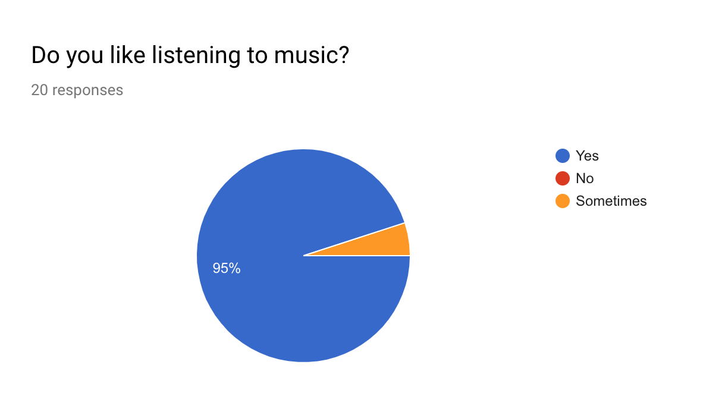

As the graph above shows, not one student responded that they did not like listening to music. With this in mind, the writer set the question to find out what is the most popular genre of music that children listen to. As the graph below shows, there are over eight genres that are favorited by the children from such a small group of children. The writer identifies that the majority of the genres of music are faster paced but others are deemed as slower paced and able to reduce blood pressure.
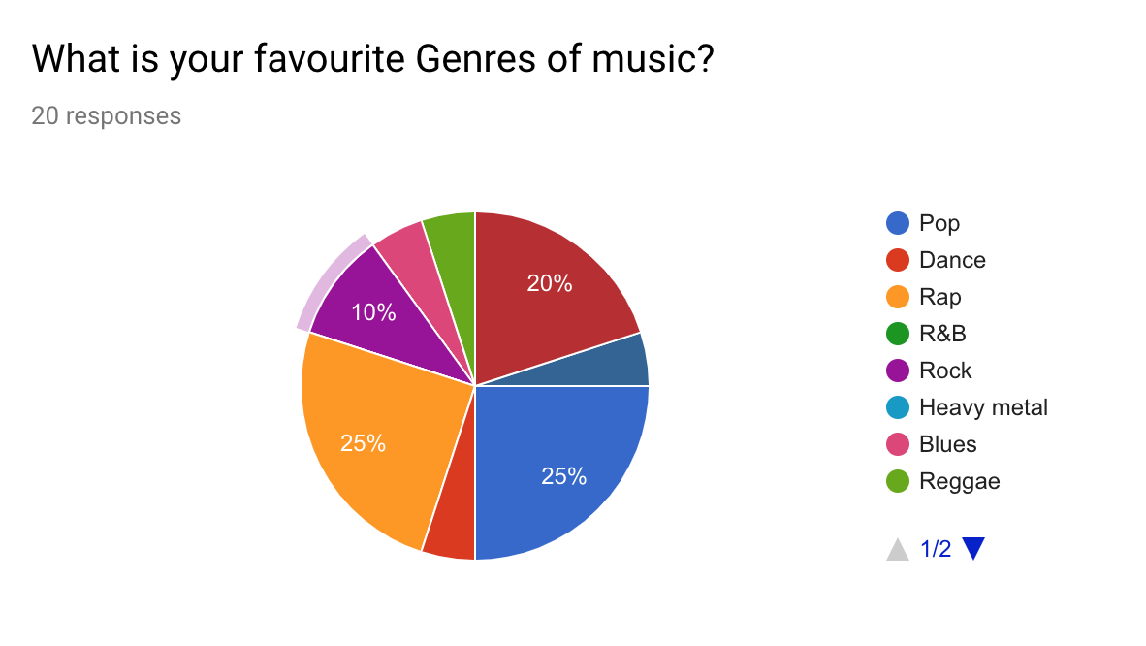
The writer then shifted the closed questions to opened ended question asking the child how music makes them feel emotionally.
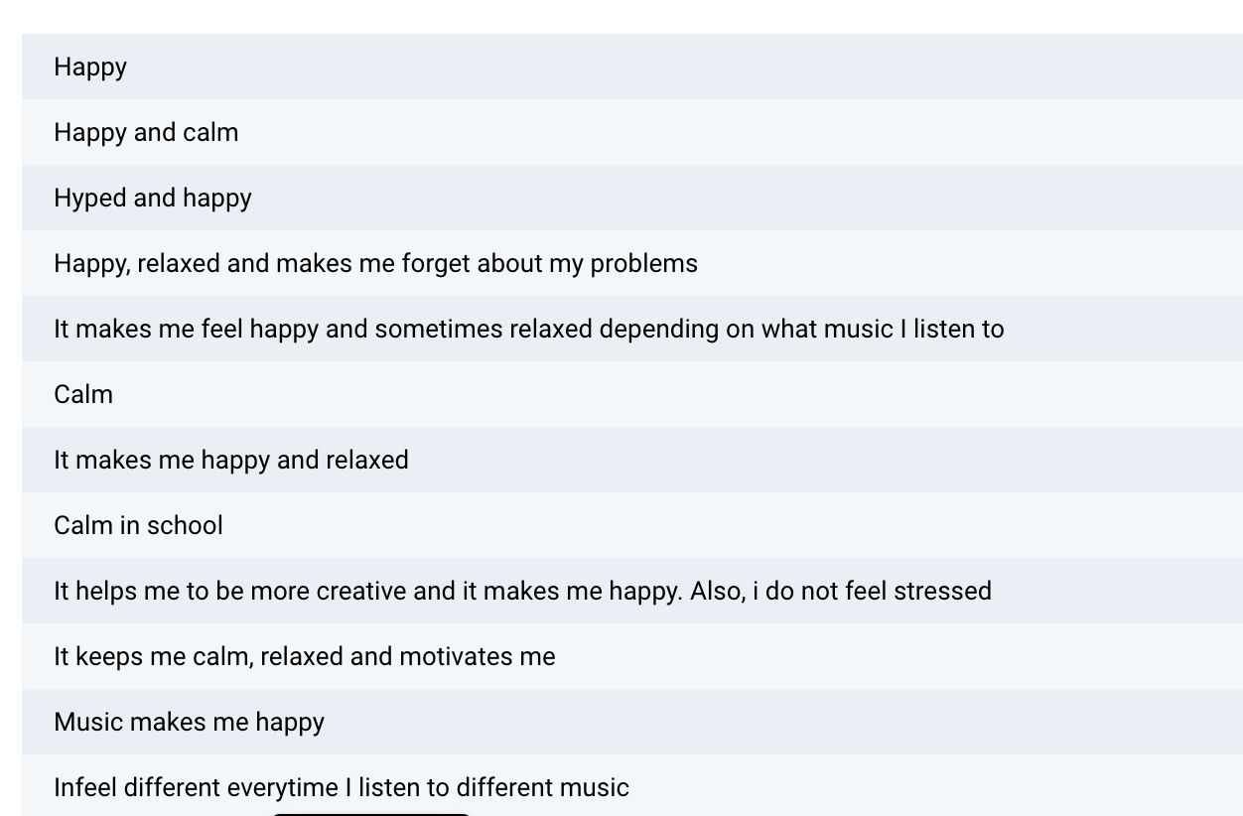
The grid above shows some of the responses that the children had given. As shown above, none of the children responded with music making them feel any negative emotions when stimulated with music. Thus, showing that music gives the children positive feelings and may be used as a reward more than a learning aid if necessary.
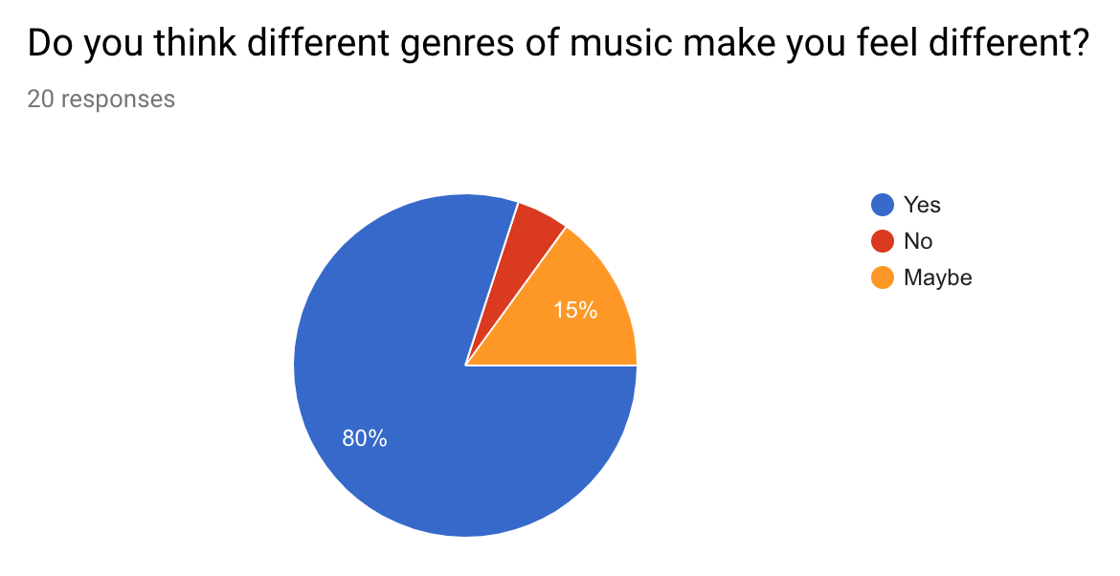
The children have displayed that they understand that different genres of music can change the way that the children feel. This may allow the school to utilise the children’s knowledge and prompt the children to share how different genres make them feel. This will then allow the school and teachers to incorporate personal and emotional skills.

In consideration to the use of music when learning, the writer posed the question of;
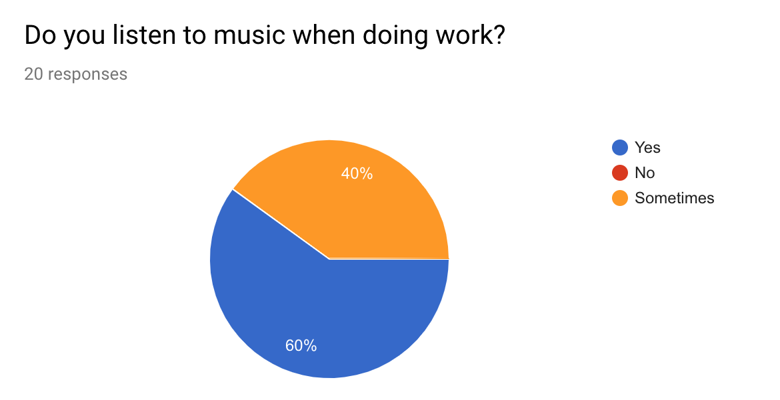
Out of the twenty respondents, not one of the students said that they do not listen to music when learning. If music is a big influence on the children when they are doing work, can the children be taught to use music as an educational advantage for their studies.

As the writer observed the classical music being played in the library, the writer posed the question of; 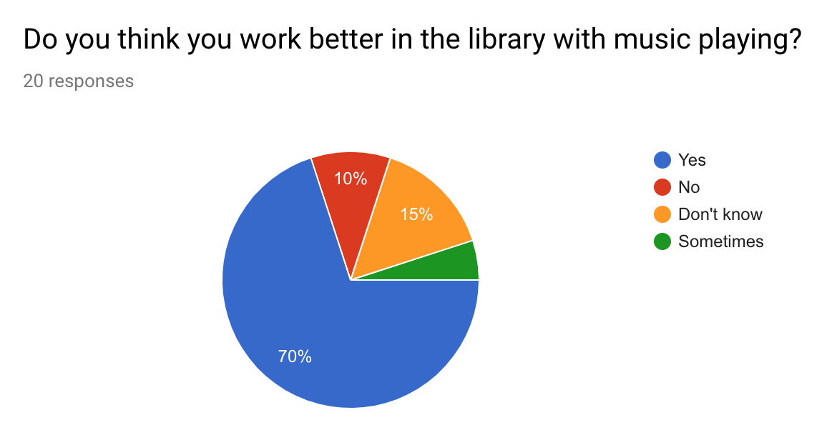
Although the children do not like or listen to clssical music, the majority of children are aware that the classical music helps them concentrate and work better with the music present. Althought the children have identified that they do work better when listening toclassicl musc in the library, eighty percent of the student would like to change the genre of musicaway from the classical genre.
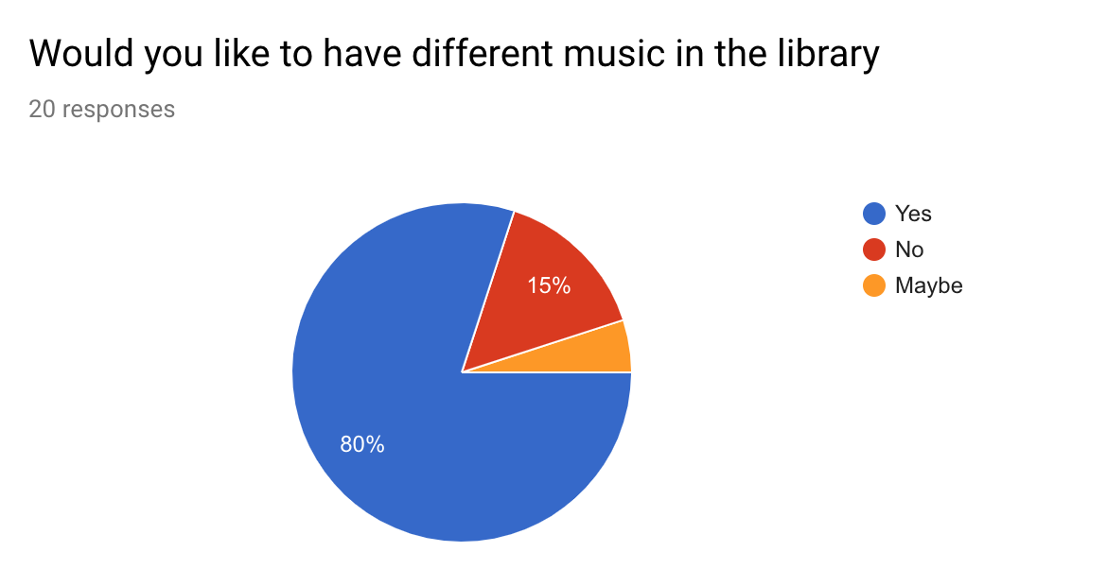

The writer then asked the children what genre they would like to listen to in the library. Some of the responses to what genre the children want in the library are seen below.

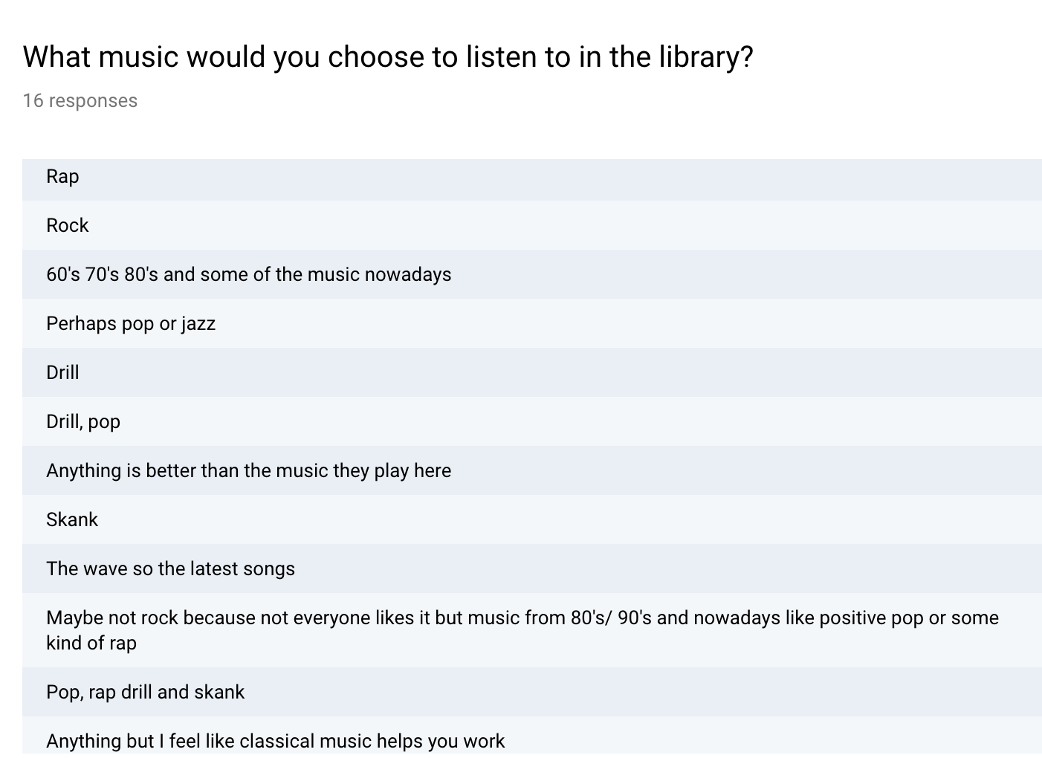

The majority of the genres above are fast paced and as Thompson et al (2011) suggested, fast and loud music can disrupt and hinder learning. Therefore, the genres above are more than likely to hider the learning and disrupt the children from their studies.

4.4 Staff Questionnaires

Unfortunately, there were only four members of staff that responded to the electronic questionnaire. With this in mind, the writer concluded that there was not enough data to analyse and be critical with. Fincham (2015) identified that, ‘Lack of response to the questionnaire by potential respondents in a sample or population is referred to as nonresponse bias.’

Chapter 5: Conclusion_ _ _ _ _ _ _ _ _ _ _ _ _ _ _ _ _ _ _ _ _ _ _ _ _ _ _ _

To summarise, the research undertaken shows that music can in fact enhance the learning and learning environment for the children. Although, some of the research showed that pupils achieved higher grades from studying in silence. The majority of research shows that the right kind of music can further enhance learning and productivity of the children.

To conclude, the combination of primary and secondary research shows that particular types of music can take influence on the learning environment. Although music can alter the learning, this may not be for all learners involved. Different music may affect each and every child in different ways.

In regards to the writer’s hypothesis, yes can alter the work ethic of the children. The ways in which music can influence the work ethic will very between learners and vary between the characteristics of the music.

The Mozart effect and the work of Perham and Currie (2014) both identify that the genre and characteristics of the music greatly influence the effect of music upon the learning of the children.

Reference list _ _ _ _ _ _ _ _ _ _ _ _ _ _ _ _ _ _ _ _ _ _ _ _ _ _ _ _ _ _ _ _ _ _ _ _ _ _ _ _ _ _ _ _

Bednar, A. K., Cunningham, D., Duffy, T. M., & Perry, J. D. (1991). Theory into practice: How do we link? In G. J. Anglin (Ed.), Instructional technology: Past, present, and future. Englewood, CO: Libraries Unlimited.

BERA (2011) Ethical guidance for educational research. London: British Educational Research Association.

BERA (2018) Ethical Guidelines for Educational Research. 4th ed. London: British Educational Research Association.

Bryant. M, (date unknown) Conducting observational research. Available at: https://www.deakin.edu.au/__data/assets/pdf_file/0004/681025/Participant-observation.pdf [Accessed: 26/04/19]

Busch. B, (2018) Drowned in sound: how listening to music hinders learning. Available at: https://www.theguardian.com/teacher-network/2018/mar/14/sound-how-listening-music-hinders-learning-lessons-research[Accessed: 20/04/19]

Cohen. L, Manion. L, Morrison. K, (2007) Research methods in Education. 6th Ed. Routledge: Oxon.

Copley Junior School (2019) Times Table Rock Stars. Available at: http://www.copley.doncaster.sch.uk/learning/curriculum/maths-curriculum/times-tables-rockstars [Accessed: 23/09/19]

Donaldson, G (2015) Successful Futures. Cardiff. WAG.

Edwards. S, (2005) Research participation and rights to withdraw. Available at: https://www.ncbi.nlm.nih.gov/pubmed/15943021 [Accessed: 24/04/19]

Ertmer, P. A., & Newby, T. J. (2013). Behaviourism, cognitivism, constructivism: Comparing critical features from an instructional design perspective. Performance Improvement Quarterly, 26(2), 43-71.

Fincham. J, (2015) Response Rates and Responsiveness for Surveys, Standards, and the Journal. Available at: https://www.ncbi.nlm.nih.gov/pmc/articles/PMC2384218/ [Accessed: 23/04/19]

Forman. G, Hall. E (2005) Wondering with Children: The Importance of Observation in Early Education. Massachusetts: Videatives, Inc.

Jenkins J. S. (2001). The Mozart effect. Journal of the Royal Society of Medicine, 94(4), 170–172.

Kelly, J. (2012) Theories. Available at: http://thepeakperformancecenter.com/educational-learning/learning/theories/ [Accessed: 19/04/19]

Kowalczyk, D. (Date unknown) Primary & Secondary Research: Definition, Differences & Methods. Available at: https://study.com/academy/lesson/primary-secondary-research-definition-differences-methods.html [Accessed: 19/04/19]

LearningTheories (2015) Cognitivism. Available at: https://www.learning-theories.com/cognitivism.html [Accessed: 23/04/19]

Legislatoins.gov.uk (2018) Available at: http://www.legislation.gov.uk/ukpga/2018/12/contents/enacted [Accessed: 21/04/19]

Lehmann. J, Seufert. T, (2011) The Influence of Background Music on Learning in the Light of Different Theoretical Perspectives and the Role of Working Memory Capacity

Lumen (Date unknown) The History of psychology- behaviourism and humanism. Available at: https://courses.lumenlearning.com/waymaker-psychology/chapter/reading-behaviorism/ [Accessed: 24/04/19]

Mathers. N, Fox. N, Hunn, A. (2009) Surveys and questionnaires. Available at: https://www.rds-yh.nihr.ac.uk/wp-content/uploads/2013/05/12_Surveys_and_Questionnaires_Revision_2009.pdf [Accessed: 19/04/19]

McLeod. S, (2018) Questionnaires. Available at: https://www.simplypsychology.org/questionnaires.html [Accessed: 25/04/19]

Peretz. I, Zattore. R.J, (2003) The cognitive neuroscience of music. Oxford: Oxford University Press

Perham. N, Currie. H, (2014) Does listening to preferred music improve reading comprehension and performance? Cardiff: Cardiff Metropolitan University.

Rauscher, F. H., G. L. Shaw, and K. N. Ky (1993) Music and spatial task performance. Nature 365, 611.

Robinson, K. (2006) Do schools kill creativity. Available at: https://www.ted.com/talks/ken_robinson_says_schools_kill_creativity?language=en [Accessed: 19/04/19]

Taggart, E. (Date unknown) History of Behaviourism. Available at: https://www.sophia.org/tutorials/history-of-behaviorism [Accessed: 15/04/19]

The Upfront Analytics Team (2015) The pros and cons of observational research. Available at: http://upfrontanalytics.com/the-pros-and-cons-of-observational-research/ [Accessed: 20/04/19]

Thompson, W. F., Schellenberg, E. G., and Letnic, A. K. (2011). Fast and loud background music disrupts reading comprehension. Psychol. Music 40, 700– 708. doi: 10.1177/0305735611400173

UNICEF (2016) ‘United Nations Convention on the Rights of the Child’ Available at: http://unicef.org.uk/UNICEFs-Work/UN-Convention/ [Accessed: 21/04/19].

UWTSD (2017) Research Ethics & integrity code of conduct. Available at: https://www.uwtsd.ac.uk/media/uwtsd-website/content-assets/documents/research/research-ethics-integrity-code-practice.pdf [Accessed: 20/04/2019]

Van der Sloot. B (2014) Do data protection rules protect the individual and should they? An assessment of the proposed General Data Protection Regulation, International Data Privacy Law, Volume 4, Issue 4, November 2014, Pages 307–325, https://doi.org/10.1093/idpl/ipu014

Bibliography _ _ _ _ _ _ _ _ _ _ _ _ _ _ _ _ _ _ _ _ _ _ _ _ _ _ _ _ _ _ _ _ _ _ _ _ _ _ _ _ _ _ _ _ _ _

Arthur, J. and Cremin, T. (2010) Learning to teach in the primary school. 2nd Ed. New York: Routledge.

Cowley, S. (2009) How to survive your first year in teaching. 2nd Ed. New York: Continuum International Publishing Group.

Grigg, R, (2014). Becoming an Outstanding Primary School Teacher. 2nd. New York: Routledge.

Nottingham, J. (2013) Encouraging learning. 2nd Ed. New York: Routledge.

Petty, J. (2009) Teaching today: a practical guide. 4th Ed. Cheltenham: Nelson Thorne.

Pollard, A. and Bourne, J. (1997) Teaching and learning in the primary school. 3rd Ed. England: Open University Press.

WAG (2016) Well-being of Future Generations Act. Cardiff: WAG

Appendices_ _ _ _ _ _ _ _ _ _ _ _ _ _ _ _ _ _ _ _ _ _ _ _ _ _ _ _ _ _ _ _ _ _ _ _ _ _ _ _ _ _ _ _ _ _ _ _ _
_ _ _ _ _ _ _ _ _ _ _ _ _ _ _ __ _ _ _ _ _ _ _ _ _ _ _ _ _ _ _ _ _ _ _ _ _ _ _ _ _ _ _ _ _ _ __ _ _ _ _ _ _ _ _ _ _ _ _ _ _ __ _ _ _ _ _ _ _ _ _ _ _ _ _ _ __ _ _ _ _ _ _ _ _ _ _ _ _ _ _ _ _ _ _ _ _ _ _ _ _ _ _ _ _ _ _ __ _ _ _ _ _ _ _ _ _ _ _ _ _ _ __ _ _ _ _ _ _ _ _ _ _ _ _ _ _ __ _ _ _ _ _ _ _ _ _ _ _ _ _ _ _ _ _ _ _ _ _ _ _ _ _ _ _ _ _ _ __ _ _ _ _ _ _ _ _ _ _ _ _ _ _ _ _ _ _ _ _ _ __ _ _ _ _ _ _ _ _ _ _ _ _ _ _ _ _ _ _ _ _ _ _ _ _ _ _ _ _ _ _ __ _ _ _ _ _ _ _ _ _ _ _ _ _ _ __ _ _ _ _ _ _ _ _ _ _ _ _ _ _ __ _ _ _ _ _ _ _ _ _ _
Appendix one - Ethics form

Appendix two – Pupil Questionnaire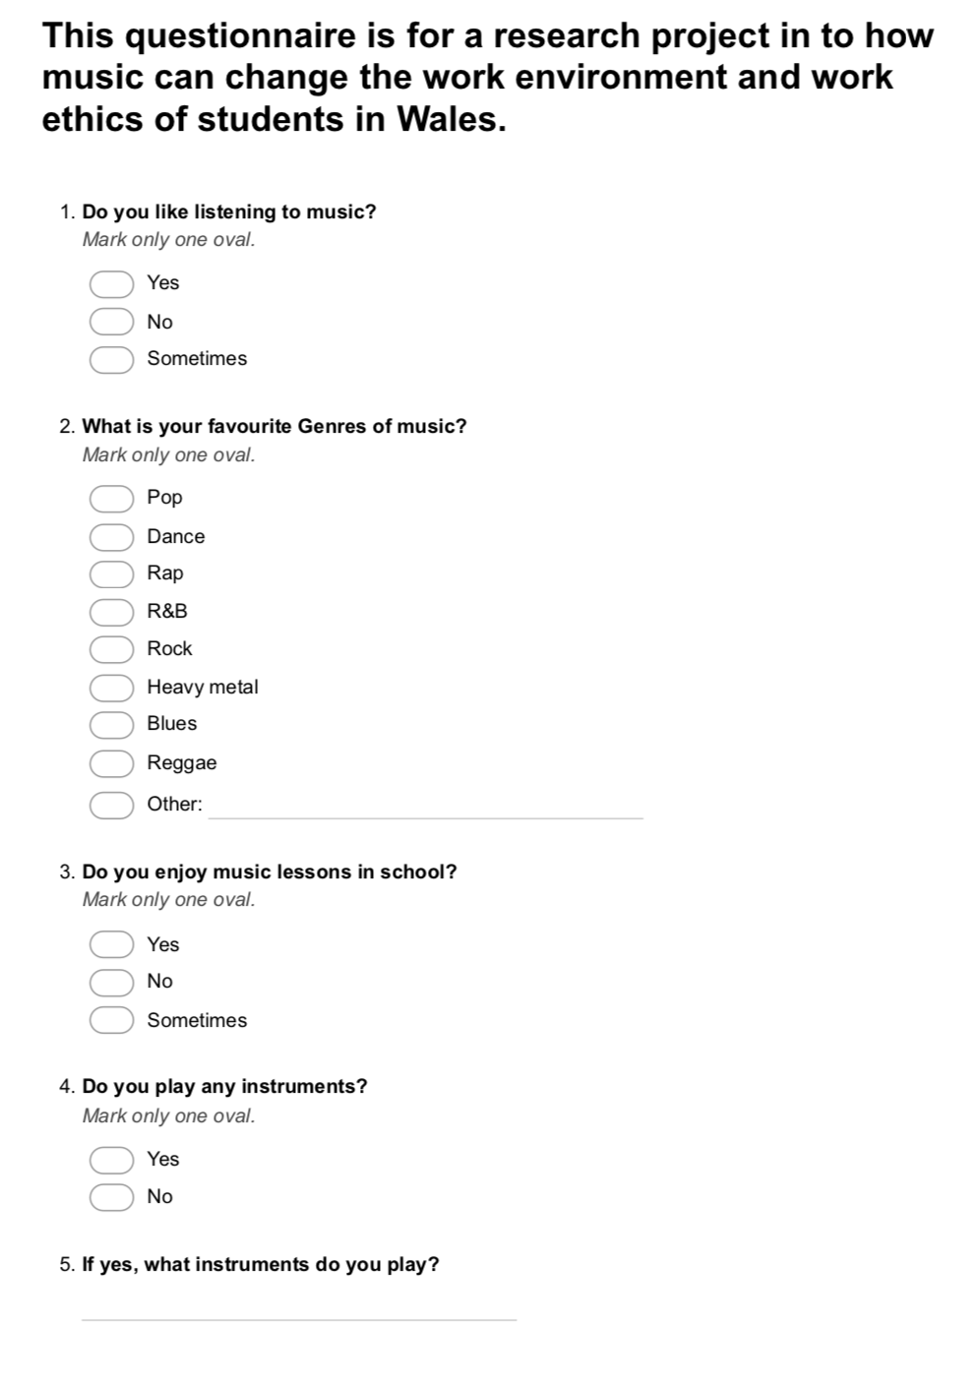
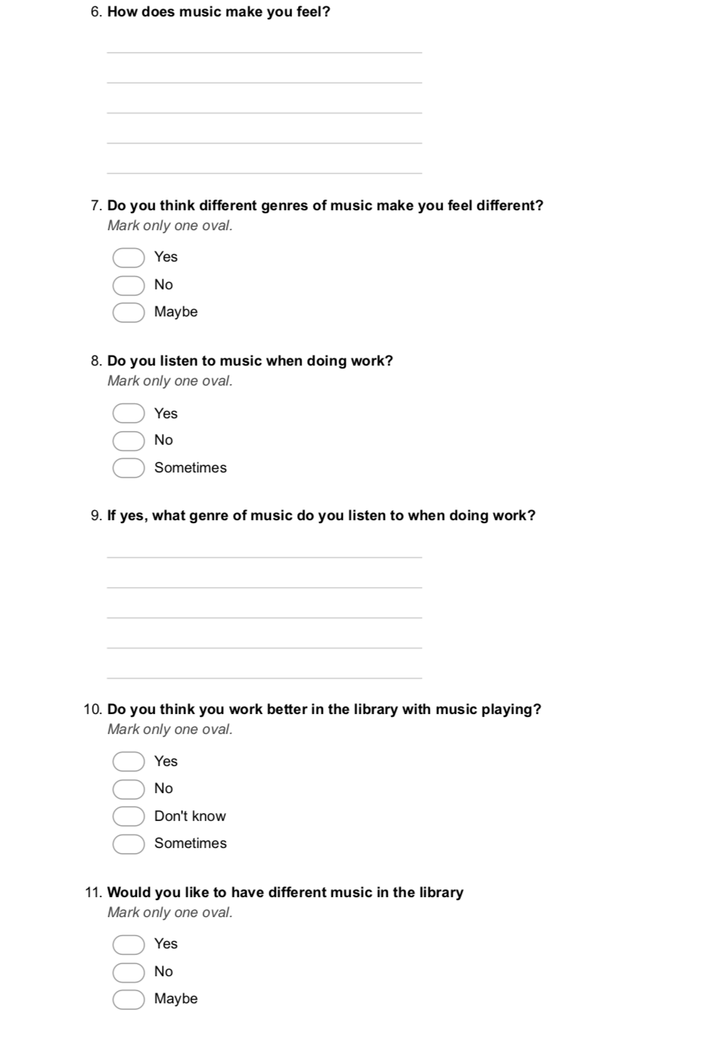


Appendix three – Staff questionnaire
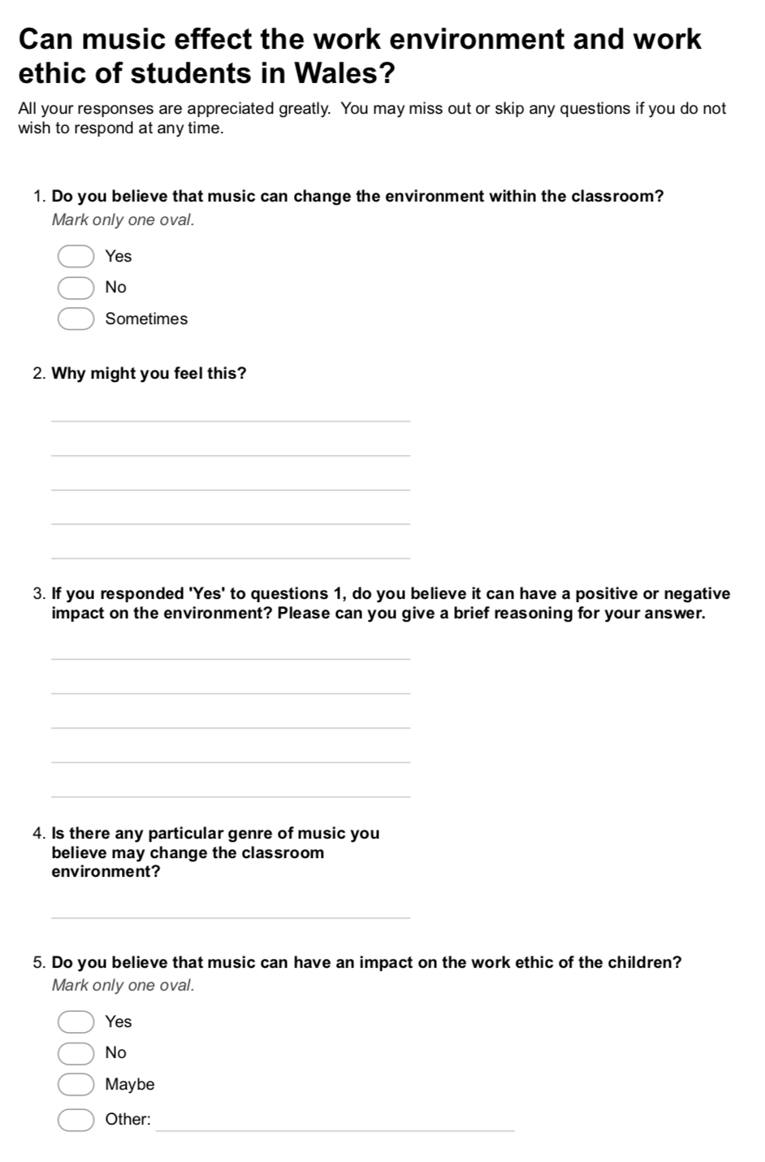
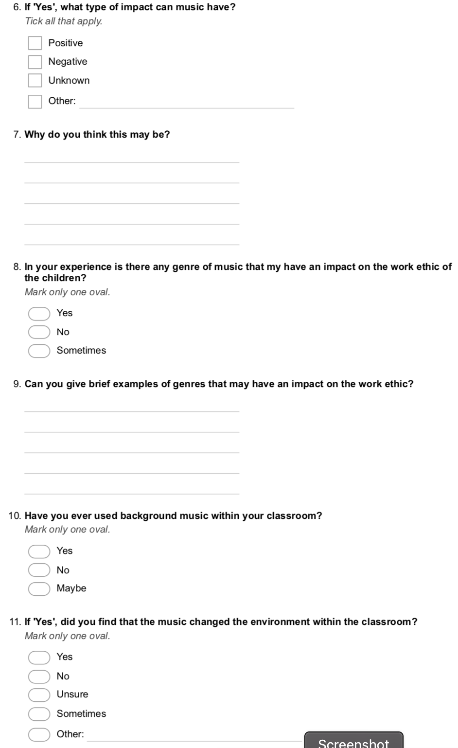

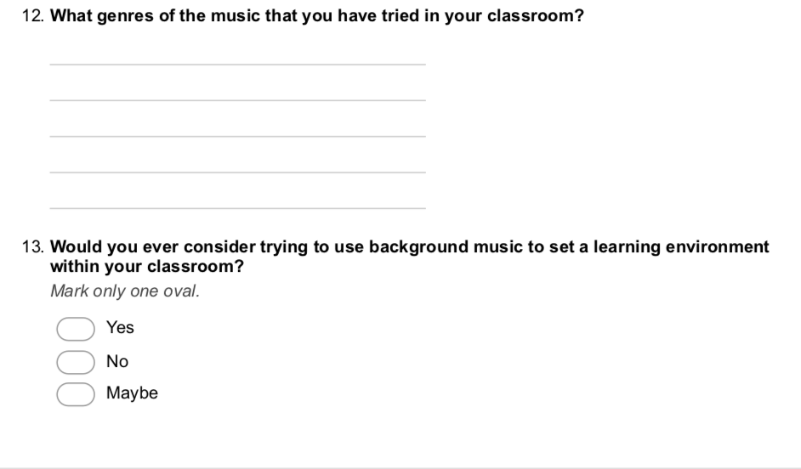

Appendix five – Electives report


