CASE STUDY: Structural framing properties of two High Rise Building.
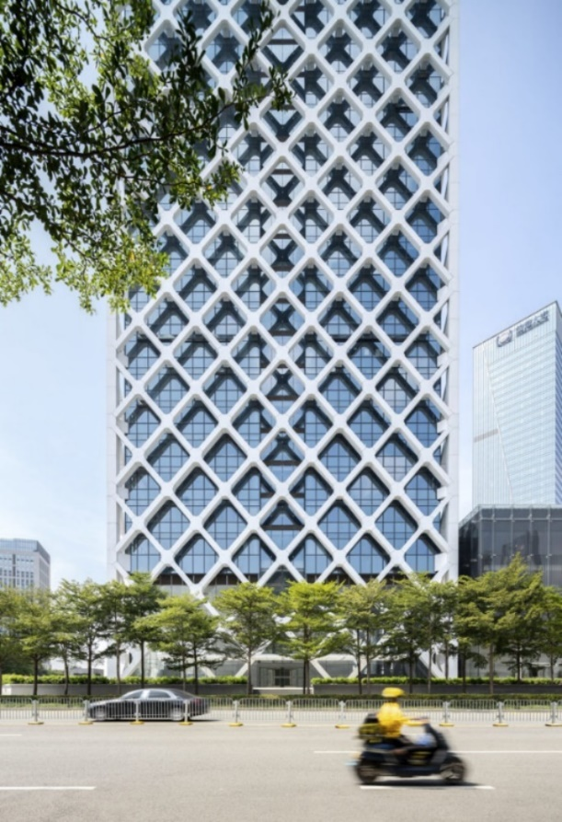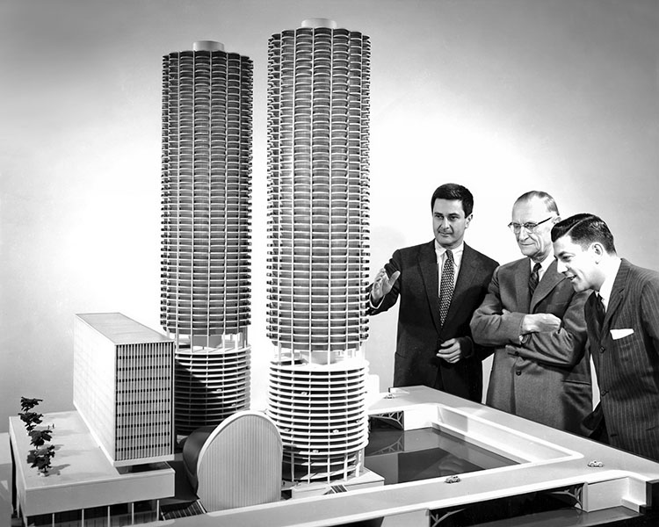

Table of Contents
CASE STUDY: Structural framing properties of two High Rise Building. 1
Introduction 3
Case Study 1 Marina Towers Chicago 3
The framing material choice. 3
Strength, durability and climatic resistance 4
Environmental conditions at the site. 5
Impact to production process, community and to the environment. 6
Ease of assembly and the potential ease of its adaptation. 7
Shape and use, within the life cycle of the building. 7
Case Study 2 Shenzhen Rural Commercial Bank Headquarters 8
The framing material choice 9
Ease of assembly and the potential ease of its adaptation. 11
Shape and use, within the life cycle of the building. 12
A comparison of the advantages and disadvantages of the framing materials 12
Reference List 17
Image reference list 20

Introduction
The focus of this case study will be on two habitable high-rise buildings, one constructed of Concrete the Marina Towers in Chicago and one Constructed of Steel the Shenzhen Rural Commercial Bank headquarters in China. Exploring their design, construction methods and the impact the different materials will bring in performance of strength, durability climatic resistance, environment impact and adaptability. The different climates in which these two building are constructed will also need to be considered.

Case Study 1 Marina Towers Chicago
The Marina towers were the brainchild of architect Bertrand Goldberg, the complex consists of 5 buildings, an office building, theatre a shopping complex and the two residential towers. The Ideas was for it to be designed as an experimental mixed-use development that integrated residential, commercial, and recreational spaces within a single complex (Marina City Online, 1960). The Complex was built between 1960 and 1967 when it was completed. At the time the towers were the tallest concrete structures and the tallest residential towers in the world.

The framing material choice.
The Marina towers are constructed entirely of reinforced concrete as a primary structural component and its external face. It was poured in situ using fibre glass moulds to create a smooth finish. This choice was influenced by serval factors, Goldbergs Architectural design using curves and complex shapes meant that concrete was the best option to allow for their creation, aligning with Goldberg's vision of organic architecture (City of Chicago, 2015). Marina City was constructed using mostly insitu poured reinforced concrete, however some parts were made using precast concrete, which was attached to a central core. While both steel and concrete were considered, concrete proved to be the cheaper option. The towers were originally planned to be rectangular but were changed to a round shape to save costs and ease of design. This design helped spread weight more efficiently, reducing the need for extra materials reinforcement using steel (The Art Institute of Chicago, 2011). Reinforced concrete provided the necessary strength to support the towers' mixed-use, including residential units, parking, and commercial spaces, meaning the load put on the building would be very high. Goldberg also wanted to use a ‘aggressive’ schedule of works, a continuous 48-hour cycle alternating between the towers would mean a quicker completion rate, he argued that this allowed residence to move in and pay rent faster and start paying back the cost of the construction.

Strength, durability and climatic resistance
Adesina and Zhang (2024) discuss that Concrete’s compressive strength allows it to withstand heavy loads and compressive stresses, making it ideal for infrastructure. Its strength naturally means it requires fewer repairs over time, this can reduce the environmental and its financial costs that are associated with the maintenance compared to steel. A denser stronger concrete has lower permeability which leads to longer lasting structures and allows for the concrete to be left exposed with no form of weather cladding. This over time can promote better sustainability. The process of how the towers were made can be seen at (MarinaCityOnline, 2010) and was filmed by the Portland Cement Association.
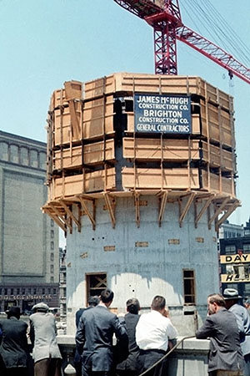
Image 1 The construction of on the marina towers cores using the moulds Dahlman, S. (1961).

Abed and Balázs (2021) discuss the durability of concrete. It is one of its key features, concrete has a high resistant to chemical attacks due it being inert which intern stops any reaction, Concrete has good durability under freeze-thaw cycles and has low physical wear under these conditions. This durability of the material minimises the need for frequent repairs or maintenance, further enhancing the sustainability through diminishing the need for energy intensive processes. Concrete adapts well to changes in climatic conditions. Its ability to withstand extreme temperatures both high and low as well as environmental stresses such as moisture and humidity and wind make it suitable for regions with harsh climates like Chicago. To make sure the concrete can withstand these conditions it may need to have the addition of admixtures like air-entraining agents from the hydrophobic group to give the air voids protection, giving the concrete resistance to freeze-thaw cycles and thermal expansion can be enhanced through this note Adesina and Zhang (2024)

Environmental conditions at the site.
Given the environment in Chicago, concrete is indeed a good choice. Chicago experiences extremes of environmental challenges that would be thrown at a building, it has very harsh winters, and warm humid summers, there is also a high exposure to moisture from Lake Michigan, this means any materials used in the construction should be a durable or sufficiently protected. As mentioned above concrete's properties therefore make it a good choice to withstand these conditions.
However, due to issues in the construction, there has been ongoing maintenance to the building As stated in Marina City Online, (1960)
The cost was $2 million in 2008 when the condo association needed to repair problem areas identified in 2006 and 2007 by the structural engineering firm Wiss, Janney, Elstner Associates, Inc.
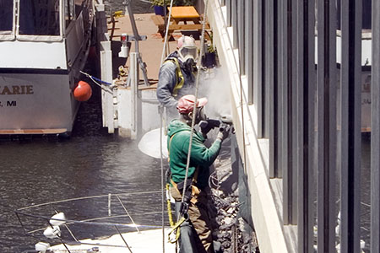
Image 2 Repair works to the concrete that had blown. Dahlman, S. (2015.)

Impact to production process, community and to the environment.
Concrete’s production, which in this case is in America, particularly cement manufacturing has significant environmental and social impacts through its production. Cement production alone is responsible for around 8% of global CO₂ emissions, this is due to the process needed to produce cement one of the main ingredients in concrete. This is an energy-intensive process through the heating limestone (NRDC, 2023). This intern contributes to air pollution and can have a impact to health and the environment (EPA, 2023). The communities nearest to the production sites may face respiratory issues as well as habitat destruction from raw material extraction (EPA, 2023). However, it can be argued that concrete's durability offers long-term benefits, and its low maintenance will mean it has a lower disturbance to the communities it is used to build in (Science Museum, 2023). Although this was not seen as a major issue when building the Marina towers in the 1960 in the modern era, sustainable practices such as low-carbon cements and improved energy efficiency, are essential for mitigating these impacts and have helped to bring down the environmental impact.

Ease of assembly and the potential ease of its adaptation.
Marina City’s structural design naturally allowed for adaptability. The modular construction method of the residential apartments made it easier to modify or replace individual components when necessary. The open floor plans provided flexibility for reconfiguring interior spaces without the need for major structural changes. The main contributor to the building’s adaptability has come from its mixed-use design. This has enabled the building to evolve according to changing residential and commercial demands over time. (Marina City Online, 1960). However, concrete has its limits in terms of adaptability, a modular design could be altered to some extent however a reinforced concrete collum cannot be altered in shape of design. It’s the smart design and use of the material that have given the Marina towers its adaptably. 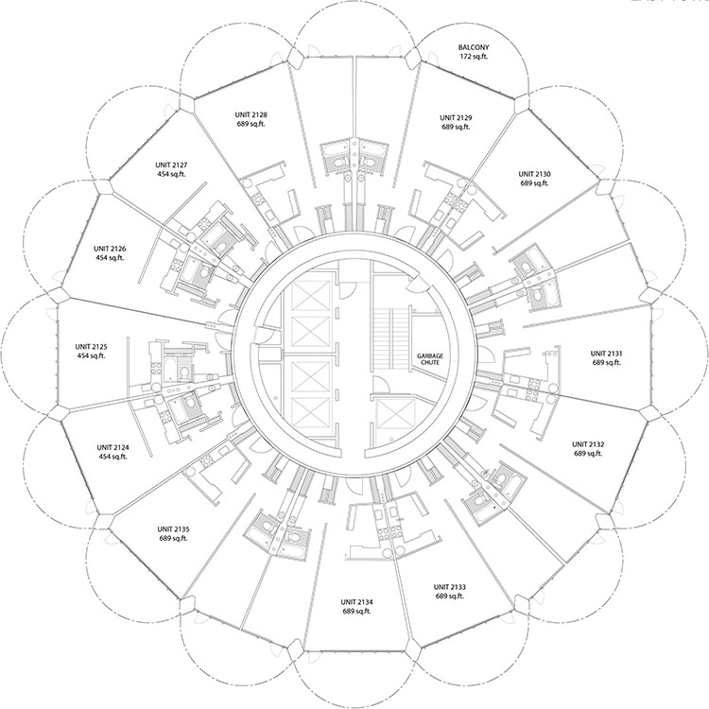
Image 3 Sketch showing the circular open plan design of the tower’s residential flats Dahlman, S. (1960).

Shape and use, within the life cycle of the building.
Marina City’s design has allowed for long-term adaptability due to its at the time innovative use of reinforced concrete, its flexible use of the structure, and a mixed-use functionality of the buildings. Although the other buildings the Ice rink Dahlman (1998) and the office building Dahlman (2006) were both redeveloped and repurposed, the marina towers are still used for their official purpose as residential building showing the longevity of their use.

Case Study 2 Shenzhen Rural Commercial Bank Headquarters
The Shenzhen Rual Commercial Bank Headquarters (SRCBH) was designed and created by Skidmore, Owings & Merrill (SOM) and completed in 2020. It was designed with the environment in mind, using sustainable techniques to use as little energy as possible. The external steel frame not only allowed the engineers to make the internal floors collum-less spaces to maximise office space, it also helps to reduce solar gain by 34% shading the building. The building incorporates as many natural resources as possible into keeping the building a comfortable place to be as possible, including automated natural ventilation systems to a multi-storey waterfall. 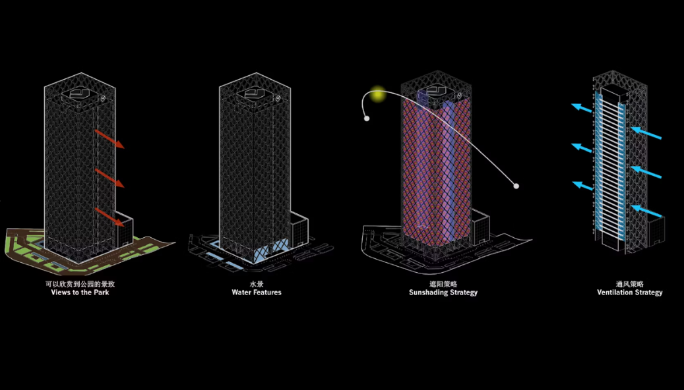
Image 4 3d model showing the SRCBH sustainable element and links with green spaces Architizer (no date).

The framing material choice
The SRCBH has a high-performance steel Exoskeleton frame, this would have be chosen due to steels properties as a strong, flexible and time efficient material to use in a high-rise construction. Steel is known for its quick assembly, this is largely due to offsite prefabrication of the product allowing for accurate and fast assembly. Steel being a lighter weight material to concrete makes it desirable for high rise buildings. (Liew et al., 2017). Although Shenzhen has a low earthquake risk the strongest in the last 10 years being a magnitude 4.2 as noted in (Earthquake List, n.d.) it is still good to note that steel frames have a good seismic resilience, making it suitable to use and withstand the small earthquakes the building would need resist. The SRCBH has a reinforced concrete elevator shaft to give the building the rigidity and structural performance needed and allows for the column-less spaces. (Ali & Moon, 2007).
Strength, durability and climatic resistance
Steel has a high Tensile strength which allows it to with stand high wind loads. The diagrid structure gives it the ability to carry high structural loads while being lighter and allows for ease of assembly. Steel can have a good resistant to the high rain fall and humidity of the subtropical climate in Shenzhen if a weatherproof coating is applied as in the case for the SRCBH and can be clearly seen in the picture of the building (Khan & Moon, 2012). Steel has a good resilience to heat and temperature fluctuations and if weather proofed has a good resilience to moisture degradation, this would help to ensure the life span of the building in the harsh conditions seen in subtropical climates. (Fosas et al., 2023). While specific details about the weather protection treatments applied to the steel diagrid are not mentioned in the available sources, or by SOM themselves, after emailing then would not reveal any information about the building. It is standard practice in such projects to apply protective coatings to steel structures to prevent corrosion and give them fire resistance. These coatings include primers for the paint to get a good bond to the steel and paint systems designed to withstand environmental stressors and fire resistance. (Steel Construction, 2023).
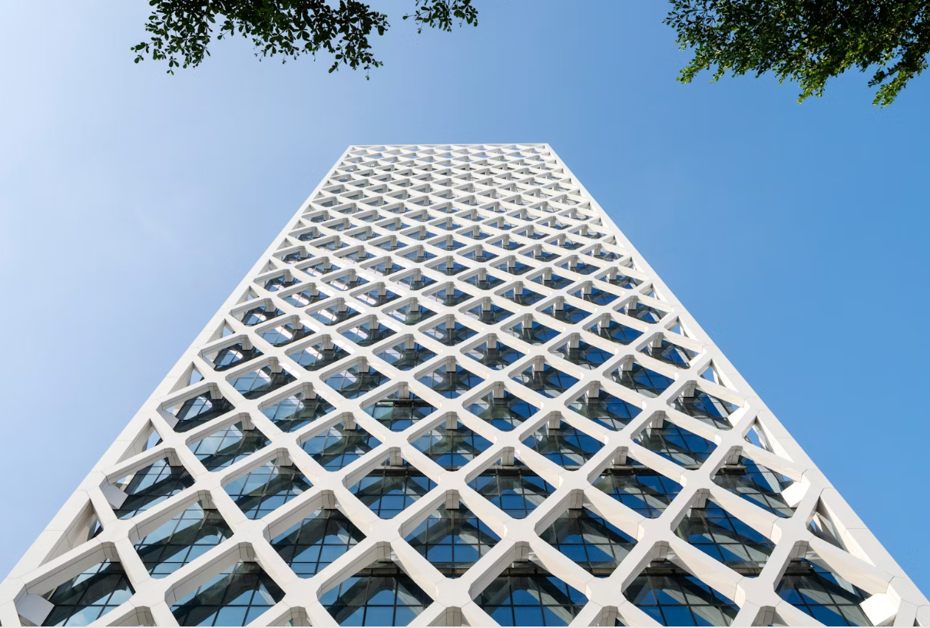
Image 5 the Diagrid exoskeleton linking to the each floors supporting beams Architizer (no date).
Environmental conditions at the site.
SRCBH will be exposed to high humidity, heavy rainfall as well as potential typhoons. As steel in its natural form will rust over time degrading its structural integrity does not necessarily make it the best material to use as a exoskeleton. Civil's Guide (n.d). However, when coated or treated with corrosion resistance paint or ducting, it will still perform well in such conditions.
Impact to production process, community and to the environment.
The production of steel is a high energy-intensive process and has a substantial bearing on the environment. It produces high carbon emissions during the smelting and refining processes when being manufactured. However, steel used in the Shenzhen Rural Commercial Bank Headquarters includes a considerable amount of recycled materials as part of the buildings claim to having good environmental credentials, this has helped to reduces its overall carbon footprint (Kanyilmaz et al. 2023). One way to help reduce the carbon footprint of steel is in the production method, for example the use of electric arc furnaces. Another major benefit of using recycled steel it the reduction in the use of the raw material that needs to be Dug up and extracted cutting out a large part of the processing. (Kanyilmaz et al. 2023). One of the major benefits of using steel is the reduced construction time, this would have both benefits for the community and the client due to less construction related disruption, noise and traffic congestion. By opting for prefabricated steel components, this helped to minimise waste dust and pollution on site, this helps with the green and conscious building practices adopted when building the Shenzhen Rural Commercial Bank Headquarters (Li et al., 2021).

Ease of assembly and the potential ease of its adaptation.
The Diagrid construction used for the building is structurally strong and visually striking to see. It is also very easy and efficient to assembly. As it is essentially put together in sections and allows for future adaptability. (Liew et al., 2017). The diagrid system has allowed each floor to be a fully open space with no need for vertical supporting pillars, this has maximised the office space available and in turn has also allows for the redesign of the space repeatedly through the ability to add partition walls anywhere in the space and to allow for the reuse of the steel frame. (Build-Construct, 2025).
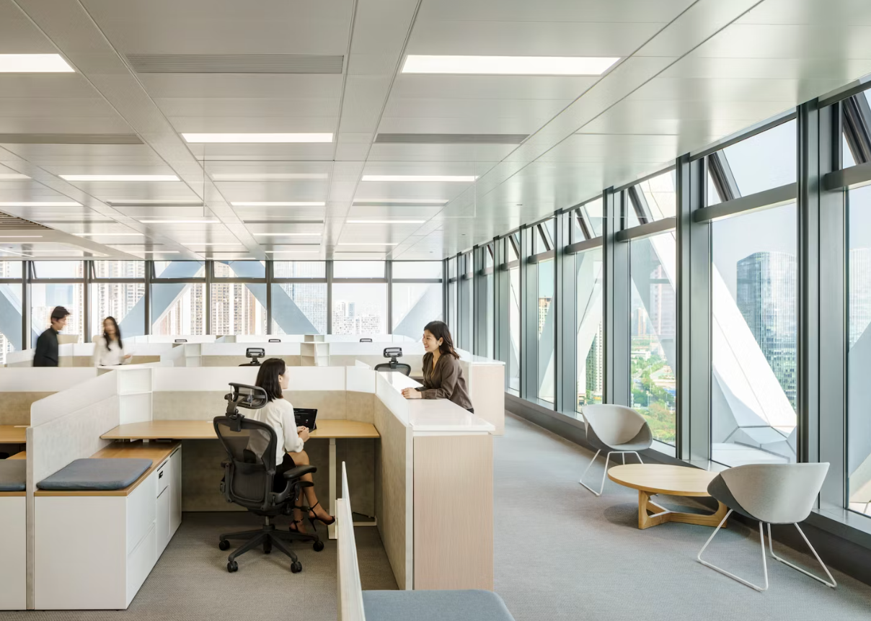
Image 6 shows the open spaces created using a steel frame structure Architizer (no date)

Shape and use, within the life cycle of the building.
As mentioned above the adaptableness of the steel frame and open plan spaces created by its design have allowed for the repurposing of this building in the future. This absence of internal load-bearing walls enables reconfigurations, for example new tenants, business needs, or even different functions, such as converting the office spaces into residential or mixed-use developments (Kanyilmaz et al., 2023). Being able to adapt the building with minimal cost ensures the building remains functional and relevant.

A comparison of the advantages and disadvantages of the framing materials
Below is a tabular looking at the different criteria of the materials, their advantages and disadvantages and the best options for their use. As you will see rarely does one come out hugely better then the other. As we can see in the case studies neither of these building are made fully of one of the two materials they both have favourable properties depending on the criteria specified. This shows that neither of these materials are the perfect framing material and cannot be used to their full potential without the other especially when used in a high rise buildings.
Criteria | Concrete Framing | Steel Framing | Best Choice Material
Structural Strength & Load-Bearing Capacity | Greater compressive strength which is ideal for loadbearing components i.e. columns and foundations. Overall, the compressive and axial loads perform well. | Has a high tensile strength, this allows for long spans of beams without failure. Steel also has a high resistance to tension forces. | Concrete as the better load-bearing capacity for walls and columns, while Steel is the better choice for spanning large expanses.
Durability & Longevity | Concrete is extremely durable to weathering, fire, and pests when the correct cement, aggregate chemical mixes are used. Reinforced concrete as the same characteristics but with the added caveat that the reinforcement must be in good condition and at least 50mm from the edges. | Is durable however it is susceptible to corrosion especially in humid or marine environments. It must be weatherproof and rust treated and requires regular maintenance for long life span. | Concrete is the natural choice to use for its longevity and low maintenance cost. However, Steel is the preferred choice due to its ease of assembly and recyclability as a framing choice.
Fire Resistance | Concrete has a natural fire-resistant due to it inherit non-combustible nature. It keeps is strength and structural integrity even in high temperatures. | High heat and fire exposure Quickly weakens it structural integrity warping it. Steel requires fireproofing treatment through a expanding coating or encasement of the steel. | Concrete is a better choice when looking at its fire resistance due to its natural inherit properties Steel with the right treatments has the same ability but at a higher cost.
Construction Speed & Efficiency | The curing time of 7–28 days to reach full strength means longer construction times. formwork and reinforcement must be used in the installation. Prefabricated concrete can be a solution to speed up construction. Human error can also be costly in the forming of the concrete. | Much faster construction with the use of prefabrication and modular systems. Can be built in days or weeks compared to potentially months for concrete. Must lower chance of human error. | Steel is by far the better choice; it is more likely to stop delays, and its efficiency is far greater. Concrete can be used if a modular or prefab system is used
Weight & Foundation Requirements | Heavy material then steel it requires a stronger foundation but can take high compressive loads. This in turn means high cost for the foundations. | It is lighter than concrete, this reduces the foundation loads and potential number of piles to be used reducing the costs | Steel is a perfect material when the load on the foundations needs to be minimised and there is a smaller compressive stress is possible. Concrete is the better choice when there are high compressive loads on the building.
Environmental Impact & Sustainability | Concrete is known for its high carbon footprint. The CO₂ emissions should be taken into consideration in comparison to its life span. Recycled materials i.e fly ash, slag cement can be incorporated to improve sustainability. | Steels production process is not far off the same in CO₂ emissions to concrete, it is however far easier to recycle and reuse, up to 90% of structural steel can be recycled. | Concrete as a great thermal mass which also needs to be taken into consideration. Steel although having a similar CO₂ emissions in production has a better end of life reuse capability.
Flexibility & Modifications | Very rigid and difficult to modify when set and hardened. Structural elements cannot be changed easily and are costly to do. | Much easier to modify or extend. Especially if the structure is bolted on the connection. This gives the building functionality | Steel is mostly certainly the better option if a building is going to be modified in the future. However, Concrete is a great material and a longer life span. If a building is well designed, it can be a good option.
Cost (Initial & Lifecycle) | The initial cost of the project is higher due to labour, formwork, curing time and higher human error. In general, the maintenance costs over time are lower. | The initial cost of the project will be lower due to faster construction times. This can be outweighed with higher maintenance costs for corrosion protection and fireproofing. | Concrete may be the better option for a long-term investment. Steel on the other hand is better for cost and environmentally sensitive projects, that are likely to be adapted or reused in the future.
Seismic & Wind Performance | Performs well under lateral load with the correct reinforcement in place, however its heavier weight and rigidity increases the likely hood of buckling under seismic forces. | Excellent ductility allows steel to absorb seismic energy with the right bracing. its flexible makes it less stable under wind loads, however, it also reduces stress on connections. | Steel has better performance in seismic active areas i.e. earthquake prone areas. Concrete can be used with the right reinforcement, but if the right ratios of cement aggerates and rebar are not used it is likely to fail catastrophically
Thermal & Acoustic Performance | Concrete has a higher thermal mass and can be adjusted to help improve these qualities; it also has excellent soundproofing properties. This will help to minimise the cost of extra thermal and soundproofing layers needed to be added to a building. | Steel is a good conductor of heat, meaning it will need additional insulation for energy efficiency. It also as a very low acoustic performance meaning further treatment with sound-absorbing materials are needed. | Concrete is superior in its thermal and acoustic performance allowing for a simpler design. Steel requires both thermal and acoustic layers.
Corrosion & Chemical Resistance | Concrete has brilliant resistant to corrosion due to it inherit nature. steel reinforcement inside concrete can corrode if exposed to moisture and chlorides weakening the structural integrity of the building. It therefore requires the mixture ratio to be in impermeable enough to stop water ingress. | Prone to rust and corrosion, this is especially evident in coastal, humid, or industrial areas due to chemicals. Rust and chemical protection or incasement must be used to treat steel on a regular basis and needs to be monitored to be sure it will keep its structural strength | Concrete is a good choice in marine and chemical-exposed environments. Steel requires protective treatments and more frequent periodic inspection.
Aesthetic & Architectural Flexibility | Is brilliant when the design requires complex shapes and textures. This gives for greater architectural creativity. Exposed concrete finishes or brutalist architecture is an example of this. | Allows for less complex designs. It will however allow for lightweight designs across large open spaces ideal for office spaces. Can be easily incorporated with glass, composite panels, and facades for greater choice of materials. | Steel is better for modern and open-plan buildings like offices and industrial building. Concrete is ideal for sculptural, natural shapes or monolithic aesthetics.

Reference List
Adesina, A. and Zhang, J. (2024) ‘Impact of concrete structures durability on its sustainability and climate resiliency’, ScienceDirect. Available at: https://www.sciencedirect.com/science/article/pii/S2949823624000023 [Accessed 18 March 2025].
Abed, M.A. and Balázs, G.L. (2021) ‘Concrete performance in cold regions: Understanding concrete’s resistance to freezing/thawing cycles’, Sustainability of Concrete With Synthetic and Recycled Aggregates, 15 October. Available at: https://www.intechopen.com/chapters/78598 [Accessed 18 March 2025].
Ali, M.M. and Moon, K.S. (2007) ‘Structural developments in tall buildings: Current trends and future prospects’, Architectural Science Review, 50(3), pp. 205-223. Available at: https://www.academia.edu/88443435 [Accessed 21 March 2025].
ArchDaily (2010) ‘AD Classics: Marina City / Bertrand Goldberg’. Available at: https://www.archdaily.com/87408/ad-classics-marina-city-bertrand-goldberg [Accessed 17 March 2025].
ArchEyes (2024) ‘Marina City: Bertrand Goldberg's Vertical Vision for Urban Living’. Available at: https://archeyes.com/marina-city-bertrand-goldbergs-vertical-vision-for-urban-living [Accessed 17 March 2025].
Bertrand Goldberg Archive (n.d.) ‘Marina City’. Available at: https://bertrandgoldberg.org/projects/marina-city [Accessed 17 March 2025].
Build-Construct (2025) ‘Diagrid structural system’, Build & Construct. Available at: https://build-construct.com/structural-engineering/diagrid-structural-system [Accessed 25 March 2025].
City of Chicago (2015) Marina City: Preliminary Summary of Information. Available at: https://www.chicago.gov/content/dam/city/depts/zlup/Landmarks/Marina_City_Prelim_Report.pdf [Accessed 17 March 2025].
Civil's Guide (n.d.) ‘Steel durability and exposure conditions’. Available at: https://civilsguide.com/resources/steel-durability-and-exposure-conditions [Accessed 25 March 2025].
Dahlman, S. (1998) ‘New use for the skating rink’, City Within a City: The Biography of Chicago’s Marina City, 15 April. Available at: https://www.marinacity.org/history/story/new_rink.htm [Accessed 21 March 2025].
Dahlman, S. (2006) ‘House of Blues hotel relaunches’, City Within a City: The Biography of Chicago’s Marina City, 22 February. Available at: https://www.marinacity.org/history/story/hotel_relaunches.htm [Accessed 21 March 2025].
Earthquake List (n.d.) ‘Recent earthquakes near Shenzhen, Guangdong, China’. Available at: https://earthquakelist.org/china/guangdong/shenzhen [Accessed 24 March 2025].
EPA (2023) ‘Cement Manufacturing Enforcement Initiative’. Available at: https://www.epa.gov [Accessed 18 March 2025].
Fosas, D., Coley, D., Natarajan, S., Herrera, M., Kershaw, T., Eames, M., Fiala, D. and Lomas, K. (2023) ‘Ten questions concerning thermal resilience of buildings and their occupants’, Building and Environment, 240, p.110902. Available at: https://www.sciencedirect.com/science/article/pii/S0360132323008338 [Accessed 21 March 2025].
Kanyilmaz, A., Birhane, M., Fishwick, R. and del Castillo, C. (2023) ‘Reuse of steel in the construction industry: Challenges and opportunities’, International Journal of Steel Structures, 23, pp.1399–1416. Available at: https://link.springer.com/article/10.1007/s13296-023-00778-4 [Accessed 25 March 2025].
Khan, S. and Moon, K.S. (2012) ‘Analysis and design of diagrid structural system for high-rise steel buildings’. Available at: https://www.researchgate.net/publication/257726272_Analysis_and_Design_of_Diagrid_Structural_System_for_High_Rise_Steel_Buildings [Accessed 21 March 2025].
Li, H., Zhang, H., Skitmore, M. and Heng, L. (2021) ‘Prefabrication construction and environmental sustainability’, Journal of Cleaner Production, 280, p.124806. Available at: https://www.sciencedirect.com/science/article/pii/S0959652620309255 [Accessed 25 March 2025].
Liew, J.Y.R., Sojobi, A.O. and Zhang, M.H. (2017) ‘Sustainable design of steel-concrete composite structures’, Journal of Building Engineering, 9, pp.84-98. Available at: https://www.researchgate.net/publication/303391919_Sustainable_Design_of_Deconstructable_Steel-Concrete_Composite_Structures [Accessed 21 March 2025].
Marina City Online (1960) ‘A mixed-use laboratory’. Available at: https://www.marinacity.org/history/story/mixed_use_laboratory.htm [Accessed 17 March 2025].
NRDC (2023) ‘Cut carbon and toxic pollution: Make cement clean and green’. Available at: https://www.nrdc.org/bio/veena-singla/cut-carbon-and-toxic-pollution-make-cement-clean-and-green [Accessed 18 March 2025].
Skidmore, Owings & Merrill LLP (SOM) (2020) ‘Shenzhen Rural Commercial Bank Headquarters’. Available at: https://www.som.com/projects/shenzhen-rural-commercial-bank-headquarters/ [Accessed 17 March 2025].
Steel Construction (2023) ‘Fire Protection for Steel Structures’. Available at: https://www.steelconstruction.info/images/8/87/Steel_construction_-_Fire_Protection.pdf [Accessed 21 March 2025].

Image reference list
Architizer (no date) Shenzhen Rural Commercial Bank Headquarters by Skidmore, Owings & Merrill (SOM), Shenzhen, China [Image]. Available at: https://architizer.com/idea/3534942/ (Accessed: 27 March 2025).
Architizer (no date) Shenzhen Rural Commercial Bank Headquarters by Skidmore, Owings & Merrill (SOM), Shenzhen, China [Image]. Available at: https://architizer.com/idea/3534948/ (Accessed: 27 March 2025).
Architizer (no date) Shenzhen Rural Commercial Bank Headquarters by Skidmore, Owings & Merrill (SOM), Shenzhen, China [Image]. Available at: https://architizer.com/idea/3534957/ (Accessed: 27 March 2025).
Dahlman, S. (1960) Line drawing by Richard Binfield, an architect with Bertrand Goldberg Associates, issued April 5, 1960 [Image]. Available at: https://www.marinacity.org/history/story/mixed_use_laboratory.htm (Accessed: 27 March 2025).
Dahlman, S. (1961) Men watching from State Street the construction of Marina City’s east tower [Image]. Available at: https://www.marinacity.org/history/story/starts_rise.htm (Accessed: 27 March 2025).
Dahlman, S. (2015) Workers on a scaffold saw away loose concrete above the marina outside Smith & Wollensky on April 28, 2015 [Image]. Available at: https://www.marinacity.org/history/story/concrete_repair.htm (Accessed: 27 March 2025).

