Assignment feedback

Student Name: Broyan Dymond
Student University Email:
Module code: HPAR6007  Module title: Nautical Archaeology | Student ID number:  1303350 |  | Educational support needs:  Yes
Assignment title: portfolio

Assignment due date:21/12/2018
Assignment Number: 1
(i.e. 1,2,3)
Marker’s signature: |  | Date:
Provisional.
NB. All marks are provisional until confirmed by the final examination board.

Report on the excavation of the HMS Colossus

Introduction
This essay is concentrating on the HMS Colossus (1798) which is protected and listed by English Heritage (Historic England). This project will be starting by exploring the background of HMS Colossus and this involves the description of the ship and when it sank. This will proceed in sections: detection/discovery, assessment, excavation, post-excavation documentation and analysis, conservation, publication and dissemination and conclusion.
Main Body
The HMS Colossus was built as a warship for the British Navy from plans acquired from the French battleship Courageux. The Colossus was British built out of oak by Cleverly, at Gravesend based on a French design (Stevens, 2002). HMS Colossus was designed and engineered for sail propulsion and was launched in 1787 from Gravesend, Kent.
Due to the design of the Colossus as a Battleship and a French design, constructed by the British, this ship was slightly different as it was fitted with an upper gun deck, quarter deck and forecastle and cargo area (Lavery, 1993, p. 180), with the sail plan of a full Rigger Ship. The ship was constructed from English Oak (Steffy, 1994, p. 258). She had a complete refit which took six months in 1796 (Historic England, 2019).
HMS Colossus was in service for 11 years. She carried 74 guns, 18 x 9 pound guns, 28 x 18 pound guns and 28 x 32 pound guns spread over four decks. She was approximately 51m (170 feet) long and had a cargo capacity of 1703 tons, with a crew of around 350- 600 people (Kevin Camidge, Janet Witheridge, Robin Witheridge, 2005).
On the 10th December 1798, HMS Colossus ran aground on Southward Well Rocks, Samson in the Isles of Scilly. Due to local support, all the crew were saved, except for one (Historic England, 2019).
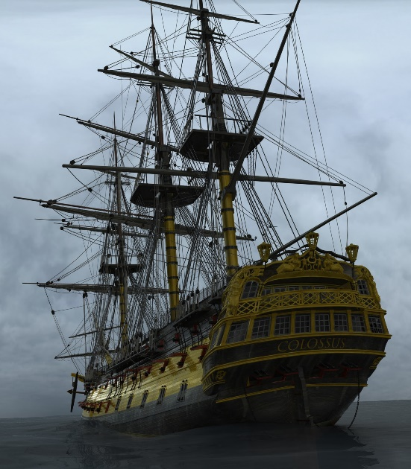
Image 1 HMS colossus
Methods employed in detection/discovery
The wreck was forgotten until the late 1960s when a team of divers led by Roland Morris found it whilst pleasure diving. It was not recognised as a valuable discovery until 1974 when parts of Greek vases were discovered on the seabed (Wessex Archaeology, 2017). The wreck consists of scattered remains 300m apart (Historic England, 2019). The stern section lies at a depth of 15m in a sheltered bay, however the sands are mobile and shift with the current (Cismas, 2019). Unfortunately Morris did not record the position of his finds (Cismas, 2019). Morris continued his investigation until 1984 when another local diver Todd Stevens discovered a new section of the wreckage (Stevens, 2002).
Assessment and survey
An Archaeological Diving Unit carried out a partial magnetometer survey of the debris site in 2002. The Cornwall and Isles of Scilly Maritime Archaeology Survey group (CISMAS) undertook a geophysical survey of the rest the area in 2005 (Cismas, 2019). A review of the site did not take place until 2004 when a survey was completed. This is surprising since the wreck was protected under the Protection of Wrecks Act (1973) and Morris was working with the British Museum (Cismas, 2019).
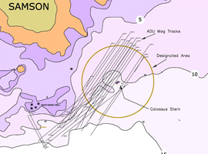 | 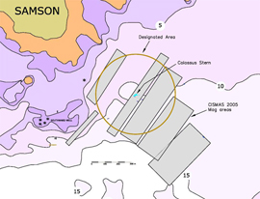

Image 2
The area covered by the ADU (left) and CISMAS (right) magnetometer surveys (Cismas, 2019).

At this time, GPS and bathymetric data was collected by CISMAS using a marine magnetometer and a dual frequency echo sounder and side scan sonar (Cismas, 2019).
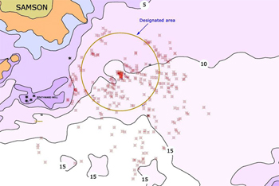 | Image 3  The distribution of magnetic anomalies recorded during the 2005 geophysical survey (Cismas, 2019)

From the image above it can be seen that there were numerous magnetic anomalies in the survey, some of which were identifiable, for example, iron wreckage from the stern section.
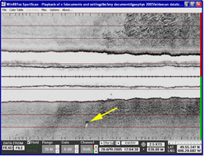 | 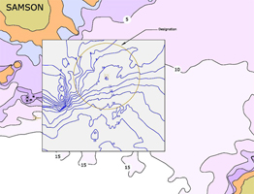
Image 4  A side scan sonar image and  target (Cismas, 2019) | Image 5  The results of the bathymetric  survey (Cismas, 2019)

The bathymetric survey along with the side scan sonar were used to develop a contour map of the seabed. This helped in the consideration of the original position of the wreck (Cismas, 2019).
Excavation, dig 1 – Survey Report 2001
There are a number of survey reports from the initial discovery in 1974 and from 2001 to 2015 carried out by CISMAS on behalf of Historic England and another survey report carried out by Wessex Archaeology for the British Museum.
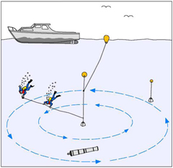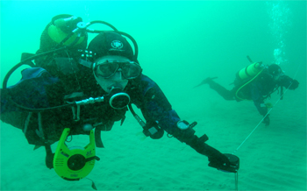
Image 6
Divers conducting a circular search (Cismas, 2019)
With the benefit of modern technology, CISMAS’s survey reports from 2001 up to the present day enabled the divers to gain understanding of where the ship laid before going into the water. They developed a grid system similar to that used on land archaeology (Cismas, 2019). The camera was carefully positioned to ensure consistency in the horizontal plane (Cismas, 2019). This was a challenging project, due to the environmental conditions. Video recordings were also made of the dives and slides and monochrome pictures of some of the most interesting visible features (Cismas, 2019).
Site Plan
After using all the information they had gathered, GPS and echo sounding, photographic evidence and establishing a grid system, the archaeologists had a clear idea where the Colossus laid and where the scattered debris was positioned. This then enabled a 1:50 scale drawing to be made and a dive plan to be developed (Cismas, 2019).
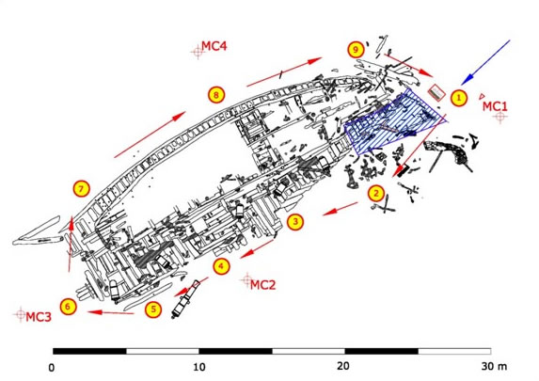
Image 7
Dive Trail HMS Colossus

Post-excavation – dig 2
When they came to start the excavation in 2001, many artefacts had been removed by the initial salvage in December 1798 carried out by HMS Fearless and the local islanders. That recovery had removed many items such as copper and iron, an anchor, masts and spars and one of the cases of Greek vases belonging to Lord Hamilton (Wessex Archaeology, 2017).
From 1975 until the 1980s, whilst HMS Colossus was protected under the Protected Wrecks Act (1973), Morris and his team excavated and recovered about 35,000 shards of Hamilton’s collection of Greek pottery, which allowed the reconstruction of several original pieces. Unfortunately, accurate records of the position of the finds were not kept at this time (Cismas, 2019). After this the protection of the site was removed until a new section of wreckage, a large wooden statue, was discovered by Todd Stevens in 1999 (Wessex Archaeology, 2017), the wreck was designated as protected again from then (Wessex Archaeology, 2017).
The large wooden statue discovered by Stevens turned out to be a neo-classical carving from the stern of the ship. The wood was elm unlike the oak used for the main construction (Cismas, 2019).
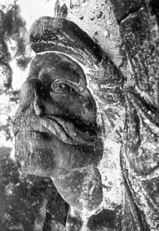 | 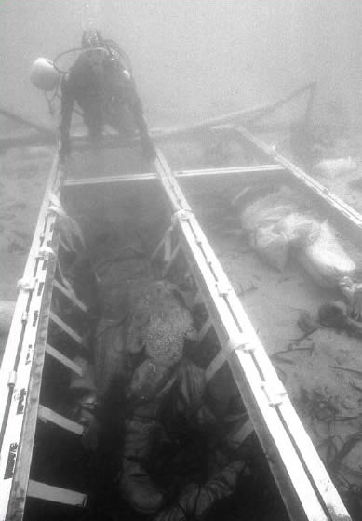

Image 8: The stern carving on the seabed, being prepared for recovery to the surface (Cismas, 2019)
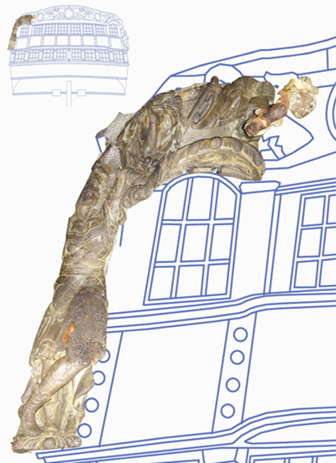
Image 9
The stern carving shown superimposed onto the stern of a 74-gun ship. (Cismas, 2019)
The conserved carving has been returned to Abbey Gardens, Trescoe on the Isles of Scilly where it is displayed (Cismas, 2019).
After discovering this they started dredging in a small trench around the site, using a water driven reaction dredge. This exposed the hull of the ship. Many discoveries were made including cannon balls, personal effects, such as leather shoes and fragments of clothing and smaller items such as lead shot, glassware and rope. These were packed in labelled bags and reburied to study the effects of reburial at a later time (Cismas, 2019). After all the excavation and reporting the site was made safe for public use.
CISMAS was involved in this project from 2001 and documents were published as recently as 2017, as the site has been developed by Historic England as a tourist destination, including a guided dive trail (Cismas, 2019).
Documentation and analysis,
All the parties involved in the discovery have published their findings from the shipwreck, apart from Morris who was the initial investigator. Numerous documents are available on the CISMAS and Historic England website, individual reports on the surveys, dives and the making of the dive trail.
Conservation
There are several reasons why the HMS Colossus was designated as protected under the 1973 act. Notably the Colossus is the only example of a Third rate 74 gun ship and is an example of 18th century construction techniques. Importantly, as it is at such a shallow depth, it is still vulnerable to souvenir hunters (Historic England, 2019).
Due to the way the Colossus was shipwrecked and because it was discovered in two parts, Historical England decided to conserve this as a designated heritage site and preserve this wreck in-situ, rather than try to salvage and reconstruct. Therefore efforts were focused on stabilisation trials and the reburial of original artefacts to discover the effects of this (Historic England, 2019). This ship has been used for trials and experimentation as it has been left in-situ.
Whilst they were exploring the site from 1975 to 1980, these shards and potteries went to the British Museum (Wessex Archaeology, 2017). For a while after 1980 the wreck was not protected and open to salvagers. After Todd Stevens discovered it in 1999 this wreck was protected again in-situ (Wessex Archaeology, 2017).
The reason Historic England decided to keep the ship as a designated in-situ wreck comes in under a number of factors. Firstly, it was discovered in two different parts and there are environmental risks to the site. Secondly, requirements of conservation and the Marine Environmental assessments examined chemical, physical and biological factors to the marine wildlife. This shipwreck was subject to a stabilisation trial, undertaken between 2003 and 2005, to discover efficient cost effective methods to slow down the erosion of the site. (Peters, 2013, pp. 343 - 344).The problem with preserving wood in-situ is that it can come under attack by crustaceans and molluscs (Pournou, 2017, p. 3).
Pournou states most shipwrecks which stay in-situ for a while can actually gain 0.5 to 8 cm of sediment from the sea bed which actually protects the wood from open water (Pournou, 2017, p. 9). However, according to the 2015 report from Historic England in the case of the HMS Colossus, sediment levels were monitored between 2002- 2012 and were discovered to be falling (Historic England, 2019).
The collection of artefacts including some of the cargo (Greek vases belonging to Lord Hamilton, personal effects of the crew etc.), which is now on display in the Isles of Scilly Museum, was raised by and belongs to Todd Stevens (Stevens, 2002).
CISMAS are still undertaking conservation and have made plans for future research and assessment of the wreck site according to their 2015 report (Historic England, 2019).
Historic England have developed new ideas and procedures to record artefacts based on their work on the HMS Colossus, instead of concentrating on the two main parts of the wreck they decided to dig trenches in between to look for artefacts buried under the sand (Historic England, 2019).
The trenches and the surveys and the position of the finds enabled those who were involved to develop a new theory of the way the ship was wrecked and how it came to be in the location it was discovered in. This led to the proposals for the future protection of the ship and other investigations and research. To test the new hypothesis, several searches need to be carried out to the south of the current remains and sediment monitoring points will be installed (Historic England, 2019). The idea that the ship bounced along the sea bed before settling can explain the wide distribution of debris, possibly now being exposed due to the change in sediment levels. The two missing anchors and the rudder have not been discovered, therefore this is another feature in the protection of the wreck for future exploration (Historic England, 2019).
Publication & dissemination
Reports from Historic England and the CISMAS website as well as Wessex Archaeology, give those interested a full history of the stages of the discovery of the ship and the stabilisation trials, along with photographic evidence and site plans.
Now it is possible to take part in virtual dives and dive tours. The list of sites in the appendix are available to visit to learn more about the Colossus.

Conclusion
The wreck was re-discovered by Morris in the late 1960s when scuba diving was becoming popular. There were still safety issues with the equipment and procedures compared to those found in modern diving. The condition of the wreck when he found it, is not known due to illegal salvaging from the time of the wreck until rediscovery. Morris did not record any information, for example, the position and depth of the artefacts and the recovery procedures undertaken before protection under the 1973 act in 1974 when shards from some of Hamilton’s Greek vases were found. This work continued until 1984.
A new section of the wreck was discovered in 1984 by local diver Todd Stevens. This discovery of a large statue prompted re-protection of the site and improved funding from the British Museum, CISMAS and Historic England and Wessex Archaeology Society. Developments in technology and diving procedures meant it was possible to carry out a partial magnetometer survey in 2002 and a geophysical survey of the rest the area in 2005 (Cismas, 2019). These procedures took place without ever going into the water. The next stages were underwater archaeology in which the processes are similar to land archaeology but using scuba equipment.
All the finds had their location recorded and were documented, photographed and some were drawn before recovery. Some were recovered and cleaned and documented before repatriation. This is one of the trials which make this an important wreck as the results will help towards the conservation of other sites.
Another key factor of the preservation of a ship kept in-situ at its wreck location is the movement of the sea bed. HMS Colossus was used to investigate procedures needed to stabilise the wreck on the sea bed. Due to its location in the Isles of Scilly off the coast of Cornwall, the sea can be rough and unstable through the winter period, which in turn affects the sea bed at shallow depths. Historical England have developed new ideas and procedures to record artefacts based on their work on the HMS Colossus. Instead of concentrating on the two main parts of the wreck they decided to dig trenches in between to look for artefacts buried under the sand. They discovered ropes and pulleys as well as personal effects such as buttons, shoes and leather artefacts.
The trenches and the surveys and the position of the finds enabled those who were involved to develop a new theory of the way the ship was wrecked and how it came to be in the location it was discovered in. This led to the proposals for the future protection of the ship and other investigations and research. To test the new hypothesis, several searches need to be carried out to the south of the current remains. The trenches and the surveys and the position of the finds enabled those who were involved to develop a new theory of the way the ship was wrecked and how it came to be in the location it was discovered in. This led to the proposals for the future protection of the ship and other investigations and research, including searching for the missing anchors and the rudder and installing monitors to map the change in sediment levels.
HMS Colossus was initially considered to be a valuable wreck due to the design and build of the ship and its cargo of Greek pottery. However, now it is a useful learning tool which is providing valuable knowledge of the ways to protect a wreck in-situ.

References
Images
- http://scillydivers.blogspot.com/p/wreck-of-hms-colossus.html
- The area covered by the ADU (left) and CISMAS (right) magnetometer surveys (Cismas, 2019)
- The distribution of magnetic anomalies recorded during the 2005 geophysical survey (Cismas, 2019)
- A sidescan sonar image and target (Cismas, 2019)
- The results of the bathymetric survey (Cismas, 2019)
- Divers conducting a circular search (Cismas, 2019)
- Dive Trail HMS Colossus (Cismas, 2019)
- The stern carving on the seabed, being prepared for recovery to the surface (Cismas, 2019)
- The stern carving (Cismas, 2019)
Appendix 1
https://www.wessexarch.co.uk/our-work/hms-colossus
https://historicengland.org.uk/images-books/publications/hms-colossus-investigation-2015/hms-colossus-investigation/
http://www.cismas.org.uk/
http://scillydivers.blogspot.com/p/wreck-of-hms-colossus.html
http://scillypedia.co.uk/WreckColossusHMS.htm
http://www.colossus-scilly.co.uk/wreckofcolossus/historyatsea.htm
https://www.youtube.com/results?search_query=hms+colossus1798
Isles of Scilly Museum
https://collections.rmg.co.uk/collections/objects/18740.html
Books
HMS Colossus: The Salvage of the Hamilton Treasures Roland Morris
Historic Shipwrecks Valerie Fenwick & Alison Gale (a chapter in this book)

References
Bowens, A., ed., 2009. Underwater Archaeology. In: The NAS Guide to Principles and Pracatice. Portsmouth: Blackwell, pp. 2-10.
Bowens, A., 2009. Underwater Archaeology the NAS guide to Principles and Practice. second ed. Portdsmouth: Blackwell.
Cismas, 2019. The Cornwall and Isles of Scilly Maritime Archaeology. [Online]
Available at: http://www.cismas.org.uk/colossus.php
[Accessed 12 02 2019].
Gale, V. F. &. A., 1998. Historic Shipwrecks. Stroud: Tempus Publishing Ltd.
Historic England, 2019. Historic England. [Online]
Available at: https://historicengland.org.uk/listing/the-list/list-entry/1000078
[Accessed 12 2 2019].
Kevin Camidge, Janet Witheridge, Robin Witheridge, 2005. HMS Colossus Debris Field Survey , s.l.: CISMAS.
Lavery, B., 1993. The Ship of the Line - Volume 1 - The Development of the Battlefleet - 1650 - 1850. Stanfords: Conway Maritime Press Ltd.
Peters, C., 2013. Developing Marine Historic Environment Management Policy: THe English Heritage Experience. Marine Policy, Volume 45, pp. 342 - 348.
Pournou, A., 2017. Assessing the Long-Term Efficacy of Geotextiles in Preserving Archaeological Wooden Shipwrecks in the Marine Environment. J Mari Arch, Volume 13, pp. 1 - 14.
Steffy, J. R., 1994. Wooden Shipbuilding and the Interpretation of Shipwrecks. London: Texas AM University Press.
Stevens, T., 2002. Wreck of the HMS Colossus Scilly, 1798 -. [Online]
Available at: http://scillypedia.co.uk/WreckColossusHMS.htm
[Accessed 16 02 2019].
Wessex Archaeology, 2017. Wessex Archaeology. [Online]
Available at: https://www.wessexarch.co.uk/our-work/hms-colossu
[Accessed 16 2 2019].
Wilkes, B. S., 1971. Nautical Archaeology. Bristol: David &Charles limited.

