Awareness of Climate Change to Human Kind

By Natalie Harris
One of the main topics in the world today is climate change and how it affects our lives. If we don’t change the ways we treat our planet it is going to have a detrimental impact on humankind.
What are the problems causing this to happen?

Outdoor Air Pollution

Air pollution has been linked to a rise in the cases of heart disease, stroke, cancer, and asthma. Emissions from vehicles are a main concern. The introduction of all electric cars and vans is a step in the right direction to lessen the pollution by cutting back on the fuel usage.
Acidification
Marine life is in danger and continuing to die off due to the acidification causing the water to heat up. Atmospheric carbon is important for the ocean to absorb, but the effects from acidification are jeopardising this. Ocean acidification also affects coral, weakening its skeleton and causing breakage according to Robinson D, (August 18, 2021) Earth.Org.
Extinction of Species
Wildlife on Earth is becoming extinct at an extremely fast pace. More than 500 species of land animals are on the brink of extinction and are likely to be lost within 20 years; the same number were lost over the whole of the last century. Scientists say that without the human destruction of nature, this rate of loss would have taken thousands of years.
Agriculture
Crops are getting affected by the climate crisis, having a detrimental impact on agriculture due to the temperature changes.
Deforestation
The loss of our forests is having a devastating impact on our lives. Carbon is emitted when the trees are cut down or burned.
Deforestation is suffering as a result of food production. For example, beef, palm oil and soy are some of the products that are contributing to this problem. Agriculture is a big culprit causing deforestation.
Plastic waste
This affects human health. The toxic chemicals that are produced from plastic are found in the body and blood of nearly all of us. Illnesses such as cancer can occur due to this.

Ocean Acidification
Human activities such as burning fossil fuels are the main cause of ocean acidification. There is an ongoing decrease in the pH value of the Earth’s oceans. The carbon dioxide in the atmosphere is at fault for this.
WE ALL NEED TO TACKLE THESE ISSUES FOR A BETTER FUTURE

Unit 2
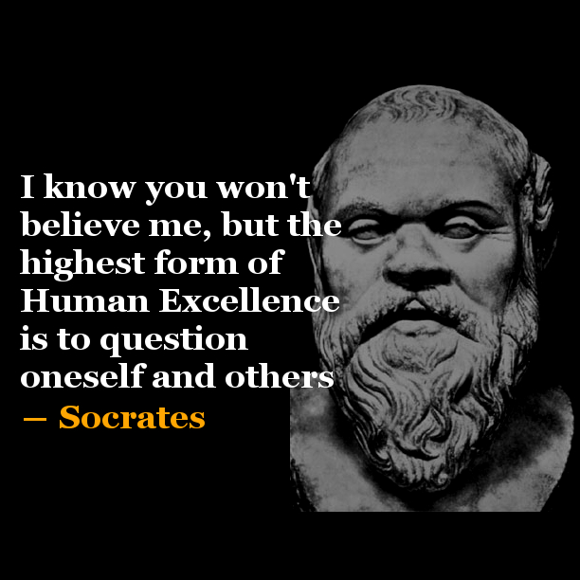
By Natalie Harris
SKILLS IN THE WORKPLACE
Becoming a good employee for a business involves problem solving skills. Critical thinking will help you to solve problems and build strategies to make you better at your job. It is all about having the knowledge on how to evaluate new information, consider the source, ask lots of questions, follow up with research and to form an opinion. Critical thinking in the workplace will enable you to problem solve when issues arise, locate the errors, evaluate arguments and associate ideas.
According to Doyle, A (June 8th, 2020) Critical Thinking, Definitions, Skills, and Examples, states that “Critical thinking refers to the ability to analyse information objectively and make a reasoned judgment. It involves the evaluation of sources, such as data, facts, observable phenomena, and research findings.”
Problems arise in businesses, and this is when a manager can analyse an issue and know how to overcome any obstacles with the above skills. Manager’s roles are extremely important due to having the task to oversee other individual’s job roles that could affect them. Critical thinking is also required when hiring new personnel, to ensure the right candidate gets the job role.
Critical thinking is used to problem solve when there are issues and ensuring there is evidence-based knowledge. The four steps to this are as follows.
Evaluation
Using logic to understand a problem in detail before coming up with a solution for the same.
Assessment
Considering the possible outcomes before making any decision.
Categorisation
Putting different solutions together based on their similarity before selecting any one of them.
Reasoning
Using logic to make decisions rather than being creative.
“Learn to use your brain power.
Critical thinking is the key to creative
Problem solving in business.”

Unit 3
What is design thinking and why does it matter?
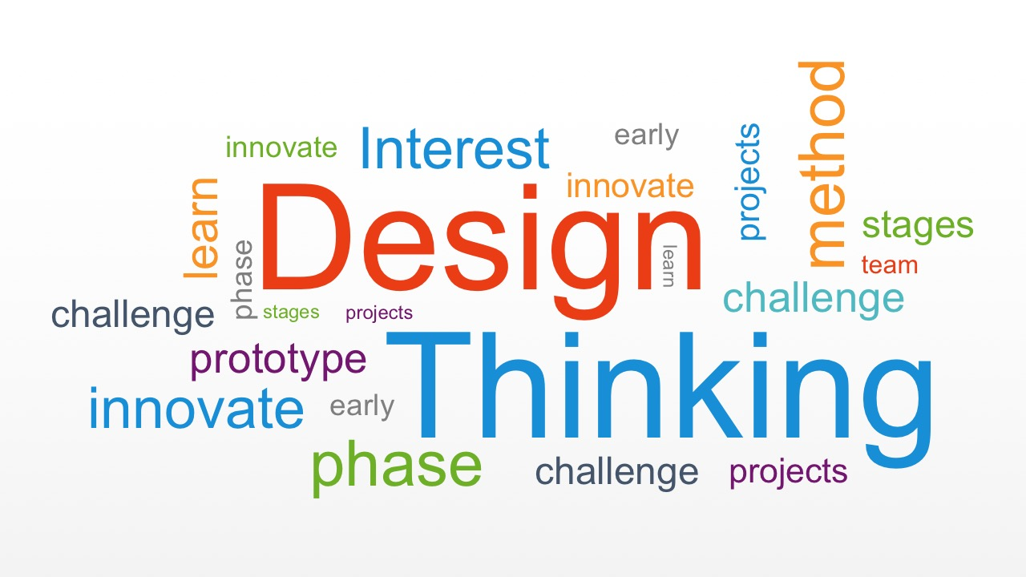
By Natalie Harris
Design thinking is “a revolution that allows your business to thrive amidst a constant flood of product releases and ever-evolving technology.”

Solving Business Challenges
Design thinking can be used to incorporate new ideas to enhance market sales, employee turnover or making a governmental agency more efficient. Innovation evangelist, Dr Panan Soni quoted “Deep down, design thinking is nothing but a systematic approach to problem solving.

Thinking Differently
Empathy towards what the end result will be, how the person will feel when using a product, software or service.
Design thinking focuses on making things appeal to people in order to achieve better outcomes, liasing with individuals from businesses to find out what is wanted, ensuring good results at the end.

Design Thinking is a process for creative problem-solving which uses group thinking and a human-centred approach to understanding problems.

.

References
Unit 1
Image/Pemberton, C (October 26, 2020)
Unit 2
Image/quotesgram.com
Doyle, A, (June 8th, 2020) Critical Thinking, Thoughtco.com
Unit 3
Image/Slide,model
Storey, M, (April 29, 2020) The basics and benefits of design thinking

