An investigation into early onset Dementia in the UK

Rebecca Williams

Dissertation submitted as part of the requirements for the award BSc (hons) Health and Social Care

Acknowledgements
Firstly I would like to say a massive thank you to my research supervisor Tania Davies, for providing excellent communication throughout this challenging time. I would also like to thank her for the confident boost she has given me to enable me to complete the final thesis regarding facing a number of challenges every step of the way at the same time. I would also like to thank her for her time and effort in supporting me throughout the last 3 years. Thank you Tania.
I would also like to thank my fellow class mates, for encouraging me to provide the best of my ability and for motivating me to do well in my final year. However I would like to say a massive thank you to Rachel Sosu for her time and effort in guiding me and supporting me throughout challenging and difficult times this year.
Finally I would like to say a massive thank you to my boyfriend & family for all their help and support, and for believing in me. I wouldn’t be where I am today if it was not for them.

Abstract
The aim of this research project is to investigate the causes of early onset dementia, and to identify and compare the differences between early onset dementia and dementia in later life. Early onset dementia is based on people ages 65 years old and under whereas dementia in later life is based on people over the age of 65.
The methods chosen throughout this research article was a critically appraisal skills programme (CASP) to ensure the correct and relevant information was obtained throughout each article chosen. Due to the findings of literature, dementia in younger people is less common than those who have general dementia (also known as dementia in later life) however there are a number of causes of dementia in early years, with the main cause of dementia being a damage brain cell.
Age has a major role in dementia in younger life, due to dementia being known as an illness in the elder generation. By researching it is said that a lot of care workers and health professionals do not have a great understanding on how to treat a patient with dementia. More training is needed to give carers a better knowledge and understanding on dementia and give them the confidence to enable them to treat a person with dementia in younger life.
The themes chosen throughout this article were related to the most important factors and the factors that came up most in each article related to the chosen topic. Age, Causes and diagnosis are the most important factors of dementia in early life, due to many misdiagnoses.

Contents Page
Title Page 1
Acknowledgment Page 2
Abstract Page 3
Contents Page Page 4

Chapter 1 – introduction & Background
Introduction Page 5
Background Page 5 & 6
Justification Page 7
Aims & Objectives Page 7

Chapter 2 – Methodology, Methods & Search Strategy
Systematic Review Page 8
Methods & Methodology Page 9 & 10
Search Strategy Page 10
Ethical considerations Page 11
Creations of themes Page 12

Chapter 3 – Thematic analysis of literature
Theme 1 – Age factors Page 13 & 14
Theme 2 -Causes & Mitigating factors Page 14 - 16
Theme 3 - importance of diagnosis Page 16 & 17
Theme 4 – Religion & Culture Page 17

Chapter 4 – results, conclusion and recommendations
Findings & Gaps in Literature Page 18
Methodological weaknesses identified Page 18
Over all Conclusion Page 19
Recommendations Page 19
Reference List Page 20 – 22

Appendices
Appendix 1 - Page 23 & 24
Appendix 2 - Page 25
Appendix 3 - Page 26 - 28
Appendix 4 - Page 29

Chapter 1
Introduction
This research project will investigate the early onset dementia (EOD) in people living in the UK. Dementia is usually associated with the elder generation, however this research will discuss dementia at younger ages, and the differences between early onset dementia and dementia in later life. There will also be a historical and political background information on early onset dementia. Often (EOD) early onset dementia, is ignored while focusing on (LOD) late onset dementia. It will also include statistics on the number of people in the UK that suffer with dementia, and also briefly touch up on the difference between early onset dementia and dementia in later life.
Background
According to (WHO) dementia is syndrome in which diseases effects the brain. Due to this the thinking, behaviour and the ability to perform in everyday activities are also affected. Dementia usually occurs in the elderly, however it is not a normal part of aging. (WHO, 2017) Young onset dementia (YOD) can also be known as early onset dementia (EOD) (chemali et al., 2012) early onset dementia is usually diagnosed in patients under the age of 65 years. It was estimated that 42,325 people had young onset dementia in 2013, which accounts for 5% of the total amount of people living in the UK that live with the condition. (Prince et al., 2013) caring for someone with dementia can be extremely challenging, not only mentally but also physically, however there are specific difficulties in caring with someone who has young onset dementia. (Schulz and Sherwood, 2009)
Early onset dementia is important and poorly understood. Early onset dementia is usually ignored while the concentration is on dementia in later life, as dementia in later life or in elderly people is more common than early dementia. There are two types of early onset dementia, first one being presenile dementia and the second being senile dementia. (Miyoshi,K.,2009) presenile dementia, is a name used for the Alzheimer type of dementia when it occurs in people under the age of 65 years old. (Medical dictionary, 2018)
Dementia is a very common disease and effects 50 million people worldwide (WHO, 2017) Dementia is one of the major causes of disability and dependency amongst the older generation worldwide. (WHO,2017) however there is a number of cases and reports on dementia in the older generation, and not as many reports on dementia in the early years as it is ‘less common’ than dementia In older people. According to the Alzheimer’s disease International (2017) every 3 seconds someone in the world develops dementia. With near enough 50 million people worldwide suffering with dementia, It is said that in 20 years’ time it is estimated to double in figures, and to reach 75 million by 2030 (Alzheimer’s Disease International,2017)
These pie charts were taken from the dementia statistics (2017) they explain the diagnosis rate in England in 2017. This charts show the percentage of people diagnosed with dementia over 65 years old and those who are under 65. Relating to the charts it shows that people suffering with early onset dementia is just over half of the percentage of those over the age of 65. This goes to show that the amount of people being diagnosed with dementia in early years is becoming more prominent and more alarming than expected. (Dementia statistics hub, 2017)

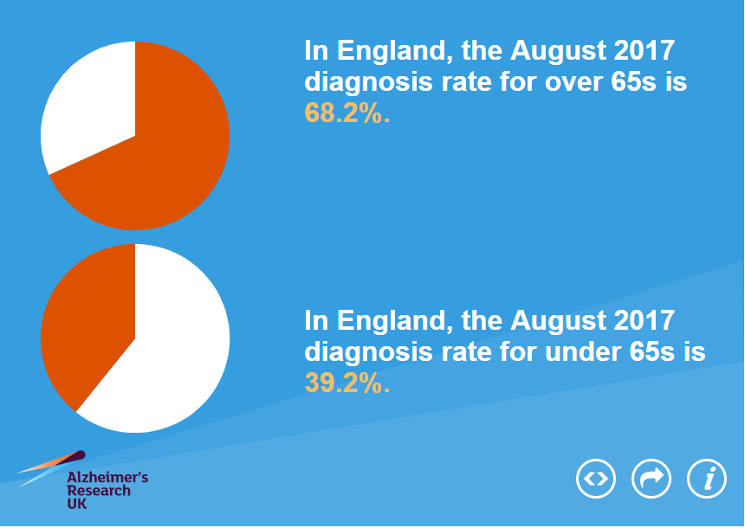
. https://www.dementiastatistics.org/

Justification
The topic selected was chosen as there is so much information on dementia, and it is a disease that is rising and many more people are being diagnosed daily with the disease, however the chosen topic discussed is a topic of a personal high level of interest and has been for a long time. As dementia across the world is so common the feeling of researching topics around dementia was very interesting. The topic that appeared most interesting was dementia in younger people and early onset, as it is less likely to occur than dementia in older people, and to explore and get more understanding rather than choosing dementia overall.
The difference between dementia in early life and later life is that dementia in early life is less common than dementia in later life. (Jefferies & Agrawal, 2009) the diagnosis is broader and people with younger dementia are more than likely to have a rarer form of dementia, other than someone who has dementia 65 years and older. Ethical considerations have been taken into consideration in order to define the boundaries and limitations of the workforce, however ethical consideration and guidelines were not needed to undergo the research article.

Aims & Objectives
Aim
The aim of this research article is to investigate the causes of early onset dementia and the difference between early onset dementia and dementia in later life.
Objectives
- Give a background into definitions of early onset dementia
- Examine current academic journal articles related to early onset dementia
- Identify gaps in research & provision
- Provide recommendations for future research & improvements.

Chapter 2
This chapter will include a description of a systematic review and the used throughout this thesis. It will also include a search strategy in order to provide evidence and information on the process of systematically selecting secondary and empirical data. This chapter will also include ethical considerations and justification and also the creation of themes chosen throughout the research papers chosen.
Systematic Review
A systematic review attempts to identify, synthesize and appraise empirical evidence that meets the criteria in which connects to the given research question. It is used to minimize and produce the most reliable findings on a specific topic, and to conduct a systematic review using explicit methods. (Cochrane Library 2017) Along with this, research found on the CASP website, stated that there will typically be more than one research study addressing a particular health question. In such circumstances it is logical to collect all these studies together in order to base the conclusion on the cumulated results. The most obvious sign that a review is systematic will be the presence of a methods section. Meta-analysis is the statistical process of combining the results from several studies that is often part of the systematic review. (CASP,2017) Literature Reviews are important as new insights can be found when all the research is put together (Aveyard, 2014)
A Systematic review has both advantages and disadvantages, advantages of this would be, that the review would be able to indicate how well findings in research were, and how they can be applied in everyday practice. Another advantage of this would be to figure out and identify its knowledge and gaps in research to enable further research, as well as these advantages reviews are considered more reliable than taking part in an individual study. (Medical News, 2016) by having advantages to something, there will be disadvantages to follow, using unpublished studies are fairly hard to find, however using published literature can also lead to misinterpretation. By the researcher only using published literature the conclusions may become unreliable as well as misinterpreted (Medical News, 2016)

Methods
The process ‘used’ to collect information and data for the purpose of making a decision. The methodology could include publication research, interviews, surveys and other research techniques, and also can include both present and historical information. (Business dictionary, 2018) The methods used throughout this thesis are, questionnaires, highlighted documents, research papers and also key words. By providing these methods, it will give a better understanding and a clear breakdown for each article and their purpose.
The methods that have been chosen is CASP. Critical Appraisal Skills Programme allows people to assess the trustworthiness, relevance and results of published papers so that you can decide if they are believable and useful. (CASP, 2017) This method is used in order to track what questions are approved in the chosen articles and what information is not covered. The critical appraisal skills and tools (CASP) method is a basic toolkit which is made up of a 10 question checklist, to provide the correct research evidence to reach their own judgments. (CASP, 2017)
There are pros and cons for using this toolkit, and will be discussed briefly here, pros for using the CASP method is that the results will be accurate, it is quick and easy and also clear understanding of the results, and also it will identify the outcomes of the results in order to understand and collect the correct information required. (I think well, 2017) However the cons to doing this method is that there is not a significant amount of information as it is only a question that will give you an idea on the results, as well as there is only 10 questions in the CASP toolkit and your results will be based on the 10 questions that are suggested in order to gather the best information needed, another point is that by using the CASP toolkit a checklist is not always accurate and can sometimes be incorrect. (CASP, 2017)
The evidence found from this method will summarize and conclude the information required in order to get a result in relation to the aim of this thesis, by using the evidence from the selected articles and including a checklist on each, it will hopefully give the outcome on what the causes of early onset dementia, and also the difference between early onset dementia and dementia later on in life
24.11.17 | Google | CASP tool for systematic review | 45,500 | Downloaded systematic review CASP checklist to include in research proposal
15.1.18 | Google Scholar | Early onset dementia in the UK | 168,000 | Printed early onset dementia article
15.1.18 | UWTSD online library | Dementia in early years | 71,896 | Saved & Printed a number of journal articles in order to use in final thesis
15.1.18 | UWTSD online library | Dementia in the UK | 21,000 | Found a number of articles one in particular I found interesting. The others were no use to my needs.
16.1.18 | UWTSD online library | Early onset dementia | 78,896 | Printed journal of dementia scanned through to ensure it was an article that was relevant.
Please see appendix 1 for an attachment of the CASP questionnaires. For a brief paragraph on the findings and results of these articles that have been critically appraised please see appendix

Search Strategy
This section will include an overview of the research that has under gone throughout this thesis, it will include where all information has been received and what documents have been found, it will also include comments on what was included in the thesis and what information found was irrelevant for what was needed. The majority of my search strategy was found in google, (google 2018), I also used google books, (google books 2018) as well as the university online library. (UWTSD 2017) This is where the majority of my work has been researched. Below will include a number of searches in which were under taken in order to complete the thesis, however please see appendix 3 for a full breakdown of the search strategy performed throughout this whole thesis.

Ethical Considerations
Ethical considerations are extremely important in research. Ethics are the norms or standards for conduct that distinguish between the rights and wrongs, they also help find a balance between acceptable and unacceptable behaviours. Ethical consideration in research is vital and is that important to research, a number of professional associations and agencies have adopted codes and policies that outline ethical behaviour, and provides a guide to researchers. (CIRT, 2017) According to (Foster et al 2003) the ethical issues in dementia care require an understanding of demographic changes and the social and transnational context of care work, according a central role to social scientists. Ethical guidelines are basically there to make sure. According to (Hammersley, 1999)
‘ a tendency to see research almost entirely in ethical terms, as if its aim were to achieve ethical goals or to exemplify ethical ideas… whereas previously ethical considerations were believed to set boundaries to what research could do in pursuit of knowledge, now ethical considerations are treated by some as constituting the very rationale of research. For example, its task becomes the promotion of social justice. Miller et al (2012)
Ethical guidelines are used in order to set the correct rules of conducts when necessary whilst carrying out research, and have moral responsibilities in order to protect researchers from harm. (Simply Psychology 2015) For this thesis ethical approval was not needed but all research collected was conducted within ethical guidelines.

Creation of themes
This section of the thesis will discuss how the themes were chosen, and also discuss what the themes are and how they were decided, it will include a brief overview of the techniques available in order to create themes during the thesis.
There are several techniques available to come to a conclusion on the themes chosen. According to Bernard (2000) Theme identification is one of the most fundamental tasks in qualitative research. The most common technique used is the word repetitions, are the words that occur the most often, D’Andrade noted that, maybe it is the simplest and most direct indication of schematic organization in naturalistic disclosure’. (D'Andrade, 1995) The second most common theme is the Key words in context (KWIC) KWIC is based on a simple observation: if people wish to understand a concept, then look at how it is used. (Bernard, 2000) researches usually find a key word in which is interesting and topic related, they will then identify the key words and systematically search for the corpus of full text in order to find the whole instances of the word or phrase chosen. Gery,(1999) Themes get identified by physically sorting the examples into piles of similar meaning.
However the technique that was chosen for this thesis was the pawing technique, the technique involves finding relevant information which is highlighting certain texts with different coloured highlighting pens. Bernard (2000) refers to this as the ocular scan method, otherwise known as eyeballing. In this method, it is stated that ‘you get a feel for the text by handling your data multiple times. Bogdan and Biklen (1982) suggest reading over the text at least twice. The technique chosen may not seem the best or scientific way to discover the themes, however it is one of the best ways known to begin searching for the correct information and patterns in qualitative data. Bernard (2000)
Please see appendix 4 for an example of evidence on how the themes were created.

Chapter 3
This chapter will include the themes chosen throughout the articles to include in the thesis, in literature, themes refer to the main idea or moral of the story. (Soft Schools, 2017) this section of the thesis, will examine the existing literature thematically and will also compare each theme within the articles chosen.
Theme 1 – Age factor
The theme was chosen due to the majority of the articles chosen for this thesis all mention in them that ‘YOD young set dementia, is diagnosed in people 65 years old or younger’. (Rosser et al 2011) Mendez, (2006) defines early onset dementia as a traditional and cut off of dementia with the age onset less than 65 years. (Jefferies & Agrawal 2009) state that,
‘Early onset dementias are a fascinating group of disorders that present challenges in a diagnosis, management and service provision. It has become accepted practice that ‘early onset’ refers to dementias that occur before the age of 65 years.’
Dementia is a very common illness in this century however, there is a current lack of awareness for those who have early onset dementia, even by the health professionals. (Jefferies & Agrawal 2009) In 1998, there was an estimated 18,500 people who were suffering with early onset dementia in the UK (Harvey 1998) the usual age to have onset dementia is around 45- 65 years old, however the average age of illness at such a young age is only 8 years. (Jefferies & Agrawal 2009) The (WHO,2018) indicate that age is probably one of the strongest known risk factor for dementia, however dementia does not only affect older people, early onset dementia account for up to 9% of cases in the UK. In many cases, young onset dementia is more likely to be hereditary other than late onset dementia, 10% of all the people living with early onset dementia the conditions seem to be inherited form a parent. (Alzheimer’s society, 2018)
Therefore goes to show that dementia can occur at any point in people’s lives and needs to be more recognised in younger people and supported.
Following a recent study that had been completed regarding identifying the causes of dementia in a person under the age of 65. A study was conducted in order to get a range of ages that causes of dementia was most common. A prevalence of dementia between the age of 30 and 64 years old was 54 per 100,000 with the prevalence approximately doubling with every 5 year age band. Figures show that an estimated 19,319 people are derived from dementia under the age of 65 in the UK. The study was conducted with the variety of dementia disease such as, young onset Alzheimer’s and Vascular dementia. The figures for Alzheimer’s in younger people were that 35% of people between 45 and 64 suffer with that type of dementia, whereas frontotemporal dementia only accounted for 12% and vascular dementia covered 15% of the population. To conclude these results, dementia in young people is more common than people expect, however there are many misdiagnoses and cause patients to be unknown of their condition. As well as this, people with young onset dementia, are less likely to receive the support and the help they should be required to have in the UK. (Harvey et al, 2003)

Theme 2 – Causes & Mitigating factors
The theme chosen was a theme that occurred a number of times in every article available, however every article states different opinions on similar causes. The main cause of dementia is damage to the brain cells, by the brain cells being damage it interferes with the communication of the cells. (Alzheimer’s.org, 2018) The usual age at onset is between 40 and 65 years old, and there is a possibility that males can be more affected than females. However family history plays a big part in the causes of dementia, as up to 50% of patients and a number of genetic causes have been identified as inherited. (Rosser et al 2004)
Alzheimer’s disease accounts for almost a third of early onset dementia diagnosis cases. This type of disease affects a person’s memory loss, and a number of other factors, however has well-preserved language and social functioning, and this type of dementia is most common in younger people. (Rosser et al 2004)
Another cause of early onset dementia can be Vascular dementia, this type of dementia is the second most common cause in YOD, patients developing this type of dementia can often lack conventional vascular risk factors. (Rosser et al 2004) the cause of Vascular dementia is a lack of blood flowing to the brain which can be caused by a number of different things, e.g. smoking, diabetes, stroke, blood clots, and that is only a few examples. (NHS, 2018) dementia and Alzheimer’s are extremely big topics to cover and have a wide research range. Diagnosis for vascular dementia is based on the clinical picture and identifying if any risk factors occur in the brain. (Jefferies & Agrawal 2009)
There is currently no treatment available to cure dementia or to even slow down its progression, however there are a number of new treatments being investigated in order to provide the best treatment to support those people who are currently living with early onset dementia. (WHO, 2018)
A number of articles have repeatedly referred to a cause of early onset dementia can be in relation to a major trauma to the brain (brain injury). The ICD’s definition of dementia is a syndrome which has occurred due to a disease of the brain, which is usually a chronic or progressive nature in which there is a disturbance. (WHO, 1992)
McMurtray et al (2005) conducted a study in relation to the causes of early onset dementia. All patients that were included in the study had been presented with memory or other related cognitive complaints. A total of 1,683 were seen and evaluated for memory loss and related cognitive complaints from 2001 and 2004. The outcome of the study was that the large number of patients under the age of 65 had the consequences deficit of head trauma, alcohol abuse, and HIV, these were the 3 main causes for early onset dementia throughout this study.
Having dementia can be significantly challenging, however it is said that dementia after a traumatic brain injury will present itself in the same ways as other causes, there will be the same problems and issues with a traumatic brain injury as any single person, however the consequence to this would be same with a chronic determination of mental functions, this can include personality, behaviour, memory, attention, thoughts, and language, all of these consequences can occur due to a traumatic brain injury. (Caruso, 2010) as well as this, it is said that an age of a person or how rapid symptoms worsen can be in conjunction with a number of traumatic head injuries a single person has received. (Caruso, 2010)
The world health organisation quotes a statements in which deprives people with dementia their human rights
‘People with dementia are frequently denied the basic rights and freedoms available to others. In many countries, physical and chemical restraints are used extensively in care homes for older people and in acute-care settings, even when regulations are in place to up hold the rights of people to freedom and choice.’ (WHO,2018)
A number of articles have repeatedly referred to a cause of early onset dementia can be related to a major trauma to the brain (brain injury). The ICD’s definition of dementia is a syndrome which has occurred due to a disease of the brain, which is usually a chronic or progressive nature in which there is a disturbance. (WHO,1992)
Therefore there is no definite cause of dementia, however there are causes of different kinds of dementia, and how they can affect a person, or what types of dementia is usually caused when a young person under the age of 65 discovers that they have early onset dementia. However shows that brain injuries can affect people in different ways, and can sometimes cause dementia if a single person has had multiple head injuries.

Theme 3– importance of diagnosis
There are several types of dementia, and each type has different causes and symptoms, and this is the cause of so many misdiagnosis in the UK. Dementia is diagnosed based on the clinical pictures found out by health professionals and brain imaging. It is also based on the findings and identification of predisposing factors. (Rosser et al 2004)
(smith et al, 2016) carried out a study to provide training to care workers to improve the care given to people suffering with dementia, and to enable them to gain a better knowledge and understanding of the illness in order to give a correct and appropriate diagnosis.
In the study that was conducted there was only 29% of carers that felt that they had enough confidence to deal with a person with young dementia, however 24 participants took part in the training and 22 in total completed their full training on the course. Once the training was complete caregivers had more confidence and a better understanding on what care to provide to those suffering with YOD. (Smith et al, 2016)
Another reason that early onset dementia in can be misdiagnosed is, that early onset Alzheimer’s disease can happen to have predominant cognitive deficits, and not only have the memory loss and a potential familial inheritance with spastic Para paresis, seizures, or myoclonus.(Mendez,2006) Another major reason in why misdiagnosing early onset dementia is that, as early onset dementia is much less common than general late onset dementia, EOD is usually ignored while all the focus tends to go on (LOD) late onset dementia. However in recent surveys undergone EOD is currently more of a problem and a lot more common than what health professionals realized. (Mendez, 2006). There are a number of ways misdiagnosing EOD is possible, however EOD s may require different type of medical attention leading to a diagnosis. (Mendez, 2006)
To conclude the theme of diagnosing and misdiagnosing dementia, it goes to show that there are so many different types of dementia, and Alzheimer’s, that diagnosing dementia is significantly challenging and hard, this goes to show how misdiagnosing a patient with dementia is easily done.

Theme 4 – Culture & Religion
Throughout some studies culture and religion has been a key word. In s certain study called Understanding and awareness of dementia in the Sikh community , a study was conducted in relation to view the % of people in the UK that suffer with early onset dementia from different cultures and religions. Approximately 0.8% of the population in the UK are Sikh. During the study, participants from the Sikh culture had a lack of awareness and understanding of dementia. (Braun et al, 1996) suggested that symptoms of dementia in various cultures were aggravated due to migration and exposure to different cultures although this was suggested after symptoms had developed. The study was conducted in order to prove how many different cultures and religions know any information regarding early onset dementia, and also to enable them to gain a better knowledge and understanding on the symptoms, treatments and the support and help that is available. (Kuar et al 2013)

Chapter 4
This chapter will include gaps in research and literature, recommendations, and a conclusion in order to understand the process of the methodological weaknesses identified and to conclude the overall thesis.
Findings and gaps in literature
A certain article in which was studied throughout this thesis, had undergone a training course in order to see the extent of how health care workers have a better understanding on dementia from all aspects, if the correct training is provided. They had an increase knowledge of how to support people with dementia, by this happening it has provided them with confidence to enable them to work with patients and also families of those suffering with dementia. (Smith et al 2017) future evaluations on the findings of the research proves that training courses specifically for dementia and the care and support would be beneficial to enable care workers, by providing these training courses, will determine whether those receiving the care approve of the level of care they are receiving after a training course has been completed. (Smith et al 2017)
Methodological weaknesses identified
Throughout this research there has been 6 main articles used in order to get the results. During this article a Critical appraisals skills programme was taken in order to identify the most relevant articles to include in the thesis. By looking at the results found, it will give an idea on what weaknesses were identified, and also give an understanding on what articles were most useful.
The evidence shows that there are a weakness in most areas of the causes of dementia. Firstly there are many things that can be defined as the cause of dementia, however the main cause of dementia is a damage to brain cells. This damage interferes with the activity in the brain allowing cells to communicate with each other (Azlehiemrs.org, 2018). Please see appendix 1 for a copy of the CASP questionnaires in order to discover the weaknesses throughout this research.

Overall Conclusion
Throughout this research many points have arisen due to the lack of understanding and concentration set on people with early onset dementia. The aim of this research article was to identify and investigate the causes of early onset dementia and the difference between early onset dementia and dementia in later life. The objectives of this article were to include a background into the definitions of early onset dementia and to examine current academic journal articles in relation to early onset dementia. As well as this, providing recommendations for future research and improvements and also identify gaps in research.
All aims and objectives have been met throughout this research, the causes of dementia and the difference between early onsets and late have been discovered, the causes of dementia have been identified as a number of causes, however the main cause to this is a damaged brain cell. A background of definitions to early onset dementia have been defined and journal articles have been included. Gaps in research have been identified and raised in chapter 4 and also recommendations and improvements have also been made aware of in chapter 4.

Recommendations for the future
The royal college of psychiatrists & Alzheimer’s society report (2006) advices that there should be a specific person named responsible for planning services for people with young onset dementia. They also said that there should be a named consultant in order to provide information and clinical input. With a population of nearly half a million or more there should be a specialised multidisciplinary team is to be justified. More research is needed in order to clarify the diagnosis as there are a number of different types of Alzheimer’s and dementias, patients do not have an accurate diagnosis and is often misdiagnosed. There are different managements and increasingly likely to target treatments in the future. (Mendez, 2006)
(Jefferies & Agrawal 2016) state that is is often unclear on how services can be accessed, with subsequent delay in diagnosis, and sometimes miss diagnosis on patients, and for patients to receive the correct treatments and the appropriate support for their diagnosis.
Reference List
Alzheimer’s disease international (2017) dementia statistics [online] available at https://www.alz.co.uk/research/statistics

Alzheimer’s Society (2018) young onset dementia [online] available at https://www.alzheimers.org.uk/info/20007/types_of_dementia/17/young-onset_dementia

Alzheimers.org (2018) causes of dementia [online] available at https://www.alz.org/what-is-dementia.asp

Aveyard,.H (2014) Doing a literature review in health and social care. A practical guide. 3rd edition. Open University press McGraw education house. England
Bernard, H. Russell 2000 Social Research Methods: Qualitative and Quantitative Approaches. Thousand Oaks, CA: Sage Publications
Bogdan, Robert, and Sari Knopp Biklen (1992) Qualitative Research for Education: An Introduction to Theory and Methods, 2d ed. Boston: Allyn and Bacon
Braun,K., Takamura,J., & Mougeot, T., (1996). Precautions of dementia, caregiving and help-seeking among recent Vietnamese immigrants. Journal of cross culture.
Business dictionary (2018) methods/methodology in research [online] available at http://www.businessdictionary.com/definition/research-methodology.html

Chemali,Z., Schamber,S., Tarbi,E., Acar,D., Avila-Urizar,M., (2012) Diagnosing early onset dementia and then what? A frustrating system of aftercare resources .int.J.Gerenral med.

CASP (2017) making sense of evidence [online] available at http://www.casp-uk.net/appraising-the-evidence
CASP (2017) Systematic Review [online] available at http://www.casp-uk.net/casp-tools-checklists
CIRT (2017) ethical considerations [online] available at https://cirt.gcu.edu/research/developmentresources/tutorials/ethics
Cochrane library (2017) Systematic Reviews [online] available at http://www.cochranelibrary.com/about/about-cochrane-systematic-reviews.html
Critical Appraisal Skills Programme (2017). CASP Systematic Review Checklist. [Online] available at http://docs.wixstatic.com/ugd/dded87_7e983a320087439e94533f4697aa109c.pdf
Critical Appraisal Skills Programme (2017) CASP diagnostic test [online] available at http://docs.wixstatic.com/ugd/dded87_5f100f2d207a462a8dd552bfb6090d60.pdf
Cifu,D.X. & Caruso,D (2010) Traumatic brain injury. Demos medical publishing: New York
D'Andrade,R (1995) The development of cognitive anthropology. Cambridge: Cambridge University Press
Dementia Statistics (2017) dementia stats [online] available at https://www.dementiastatistics.org/wp-content/uploads/2017/06/statistic-widget-2551-2.png
Dementia statistics (2017) dementia diagnosis rate [online] available at https://www.dementiastatistics.org/statistics/diagnoses-in-the-uk/
Foster.,C Herring,. Doron,I., (2003) the law and ethics of Dementia. H.A.R.T publishing.
Gery,R (1999) Measuring the typicality of text: Using multiple coders for more than just reliability and validity checks
Google (2018) google search [online] available at https://www.google.co.uk/?gfe_rd=cr&dcr=0&ei=aSqwWv2MLsHO8geupomQCA&gws_rd=ssl
Google books (2018) books [online] available at https://books.google.com/
I think well (2017) CASP [online] available at http://www.ithinkwell.org/casp-critical-appraisal-skills-programme-for-all/
Kapp,M,. Prince,M,. (2007) Dementia UK: the full report. Alzheimer’s society
Kumar,R,.(2008) Research methodology. APH Publishing Corporation. New Delhi
McMutreay,A,. Christine,D,. Clark,D,. Farag,E,. Mendez,M. (2006) onset dementia:Frequency and causes in comparison to late onset dementia. Dementia Geriatric Cognizant Disease.
Medical news today (2016) advantages and disadvantages of a systematic review [online] available at https://www.medicalnewstoday.com/articles/281283.php
Miller,T,.Birch,M,.Mauthner,M,.Jessop,J,. (2012) Ethics in qualitative research. London: Sage pulblishing
Miyoshi,K (2009) what is early onset dementia. Institute for mental health, japan.
Medical Dictionary (2018) presenile dementia [online] available at https://medical-dictionary.thefreedictionary.com/presenile+dementia
NHS (2018) Dementia causes and symptoms [online] available at https://www.nhs.uk/conditions/dementia/causes/

Prince,M., Bryce,R., Albanese,E., Wilmo,A., Riberio,W., Ferri,C,P., (2013) the global prevalence of dementia; a systematic review and meta-analysis. Alzheimers dement

Rosser,M.N,.Fox,N.C,.Mummery,C,J,.Schott,J.M,.Warren,J.D,. (2011) the diagnosis of young onset dementia. Lancet Neurol.

Royal college of Psychiatrists, Alzheimer’s society (2006) service for younger peopelw ith Alzheimer’s disease and other dementias. (Council report (CR135). Royal college of Psychiatrists.

Schulz,R Sherwood, P.R., (2009) Physical and mental health effects of family caregiving.

Simply Psychology (2015) ethics [online] available at https://www.simplypsychology.org/Ethics.html

Soft schools (2017) themes [online] available at http://softschools.com/examples/literary_terms/theme_examples/238/

World Health Organisation (2017) Dementia [online] available at http://www.who.int/mediacentre/factsheets/fs362/en/
Word Health Organisation (1992) The ICD-10 classification of mental and behaviour disorders: clinical descriptions and guidelines. (WHO)
USC Library (2018) Writing guides- methodology [online] available at http://libguides.usc.edu/writingguide/methodology
Uwtsd library (2017) online library [online] available at http://www.uwtsd.ac.uk/library/online-library/

Appendix 1
Key codes
Y – Yes
CT – Can’t Tell
N – No

Article Number | Q1 | Q2 | Q3 | Q4 | Q5 | Q6 | Q7 | Q8 | Q9 | Q10
1 | Y | Y | Y | CT | Y | Patience with EOD are not rare. More research required to clarify diagnosis. | CT | Fairly Precise | Y | CT
6 | Y | Y | Y | N | CT | There is no accurate understanding of the cause of EOD | Y | Not very clear and precise | N | CT
4 | Y | Y | Y | CT | Y | Age of people diagnosed with EOD and also causes | CT | Clear results and precise | Y | Y
5 | Y | CT | Y | CT | N | Not stated clearly | CT | Not precise and no clear outcome | N | CT

Critical appraisal skill programme (CASP) checklist – systematic review
Critical Appraisal Skills Programme (2017).

Article Number | Q1 | Q2 | Q3 | Q4 | Q5 | Q6 | Q7 | Q8 | Q9 | Q10 | Q11 | Q12
2 | N | Y | Y | CT | Y | N | Results were clearly presented | CT | Y | CT | Y | Good understanding on different types of dementia including early onset dementia

Critical Appraisal Skill programme (CASP) – diagnostic checklist
Critical Appraisal Skills Programme (2017).

Article number | Q1 | Q2 | Q3 | Q4 | Q5 | Q6 | Q7 | Q8 | Q9 | Q10 | Q11
3 | Y | CT | Y | N | Y | Y | Each patient treated to their needs as there are different types of dementia | CT | Y | Y | Y
Critical Appraisal Skill programme (CASP) – Controlled trial checklist
Critical Appraisal Skills Programme (2017).

Appendix 2
Here I will include a paragraph in order to understand and find out the best articles for the thesis and also to identify strengths and weaknesses throughout each article. As a result, the systematic review checklist was the most useful out of the other questionnaires included. I found that this questionnaire was the one that most of my chosen articles fitted in mostly. The Authors used the relevant papers to their studies and also included good evidence, and also addressed the question clearly. 4 out of 6 of my articles fitted into the systematic review slot, with the majority of each question being a yes. This goes to show that the article chosen fits into that category. However I found that another good checklist to use was the diagnostic checklist and also the controlled trial checklist they were the other two checklist that matched my articles best.

Appendix 3
Thesis Search Sheet
My research question / aim / objective : |  | An investigation into early onset dementia in the UK  - Provide a background into the early onset of Dementia and compare the difference between early onset dementia and dementia in later life. As well as identifying the gaps in research related to early dementia.
Places to search for information: |  | Google search, google scholar, university of wales trinity saint David library.
Date | Database Name |  | Search Terms | No of Results | Comments
24.11.17 | Google |  | CASP tool for systematic review | 45,500 | Downloaded systematic review CASP checklist to include in research proposal
15.1.18 | Google Scholar |  | Early onset dementia in the UK | 168,000 | Printed early onset dementia article
15.1.18 | UWTSD online library |  | Dementia in early years | 71,896 | Saved & Printed a number of journal articles in order to use in final thesis
15.1.18 | UWTSD online library |  | Dementia in the UK | 21,000 | Found a number of articles one in particular I found interesting. The others were no use to my needs.
16.1.18 | UWTSD online library |  | Early onset dementia | 78,896 | Printed journal of dementia scanned through to ensure it was an article that was relevant.
16.1.18 | UWTSD online library |  | Historical background on early onset dementia | 11 | Printed and highlighted key points on the article relating to the history of early onset dementia
16.1.18 | UWTSD online library |  | Dementia in young people | 60,046 | Journal printed
29.1.18 | Google |  | WHO (world health organisation) | 11,900,000 | Printed information on dementia and early onset. (statistics/key facts)
08.2.18 | Google |  | Dementia in later life Vs early onset dementia | 8,020,000 | Took information from Alzheimer’s society and intend to use a graph chart in my work to provide evidence
25.2.18 | Google books |  | Methodology definition | 1,180,000 | Looked through a number of different books that came up in order to find the correct information that I needed to include in my thesis
29.2.18 | Google |  | Methodology in a dissertation | 52,000 | Detailed information however excluded from thesis.
29.2.18 | Google books |  | Methodology research | 747,000 | Read a couple of books to find the relevant information and included them into my thesis.
29.2.18 | Google books |  | Systematic Review | 1,020,000 | Chose a few books and compared their definitions and included what was relevant in my thesis
3.3.18 | Google books |  | Literature review in health and social care | 683,000 | Used a book in order to help with some information for the thesis
4.3.18 | Google |  | CASP ( Critical appraisal skills programme) | 3,710,000 | Followed different types of CASP questionnaires and used them as a guide in my final thesis in order to get information on the articles used and to find out what article is most useful.
10.3.18 | Google |  | Examples of methods and methodology used in a research project | 102,000,000 | Clicked through a number of different sites in order to get a good understanding on what to include and what is important to provide the best information in to my thesis.
10.3.18 | Google |  | Methods used in dissertation | 145,000,000 | Did not find any link useful enough or give me a clear understanding on what to include and what information is relevant. I also could not find a good structure layout in order to follow.
12.3.18 | Google |  | Research methods | 830,000,000 | Used an idea off the business dictionary to include in my thesis for a better understanding on what is expected.
13.3.18 | Google books |  | Ethical considerations in research | 1,140,000 | Scanned through a number of different books to get a clear picture on what the majority of authors stated, used some text in my thesis.
13.4.18 | Google books |  | Ethics considered in dementia | 3.110 | Took relevant information out of the book to include in my thesis.
13.3.18 | Google |  | Ethics in research | 120,000,000 | Used useful information off CIRT site in my thesis.
15.3.18 | Google |  | Ethical consideration | 2,650,000 | Followed link to simply psychology and used ideas out of their definition of ethics
16.3.18 | Google books |  | Creation of themes definition | 403,000 | Searched for the correct and relevant information to include in my opening paragraph
18.3.18 | Google |  | Themes | 57,900,000 | Had a look for ideas to enable me to write my introduction to the chapter.
18.3.18 | Google |  | How age affects dementia | 1,600,000 | Viewed information on the Alzheimer’s society page and included a small sentence into my work
18.3.18 | Google |  | Early onset dementia | 2,110,000 | Found useful information  (WHO)
19.3.18 | Google books |  | Brain injury & early onset dementia | 32,432,000 | Found useful information and included it into my work
19.3.18 | Google |  | NHS website, causes and symptoms of dementia | 17,600,000 | Found some relevant information to include in my theme section of my thesis
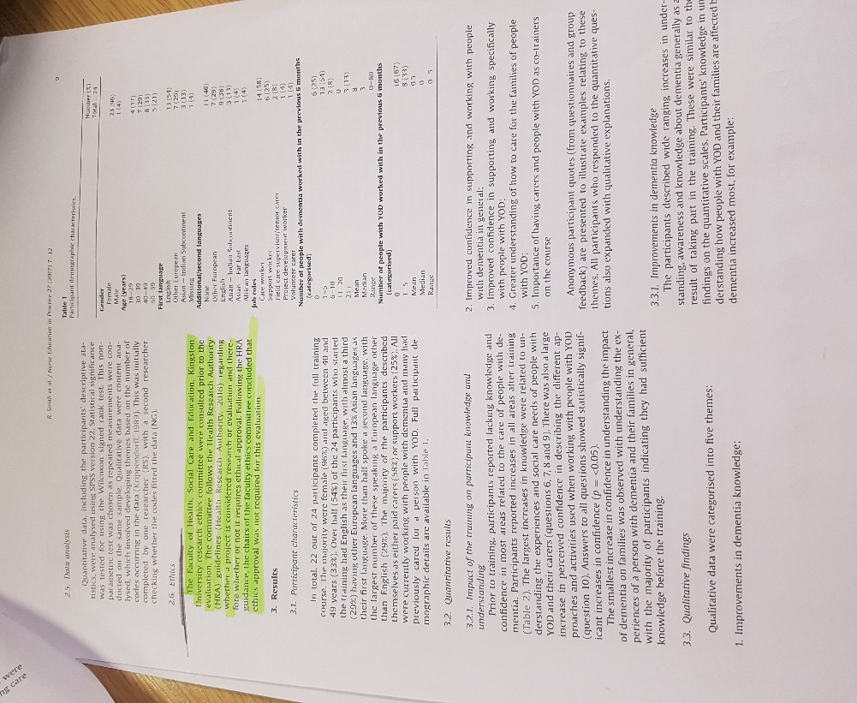
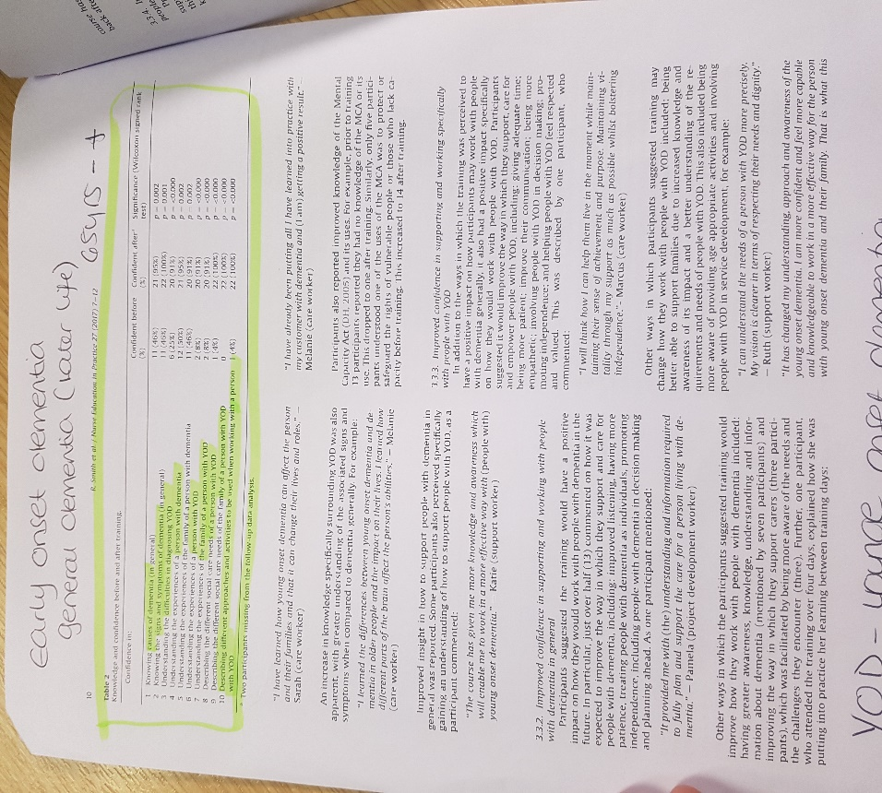
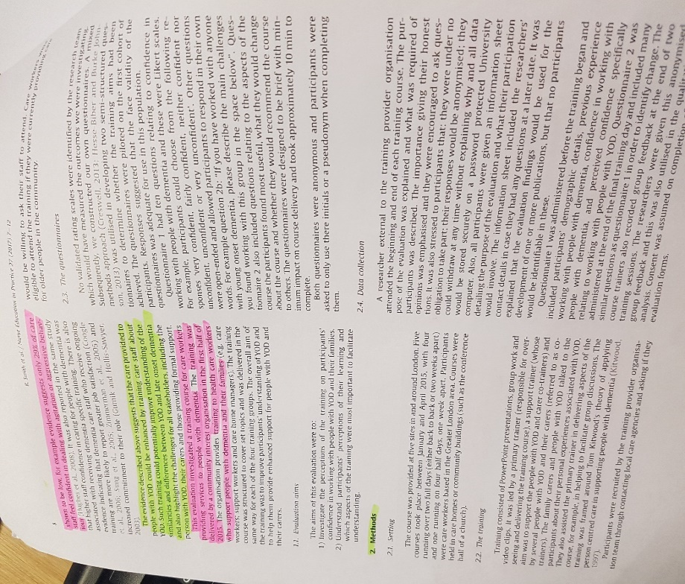
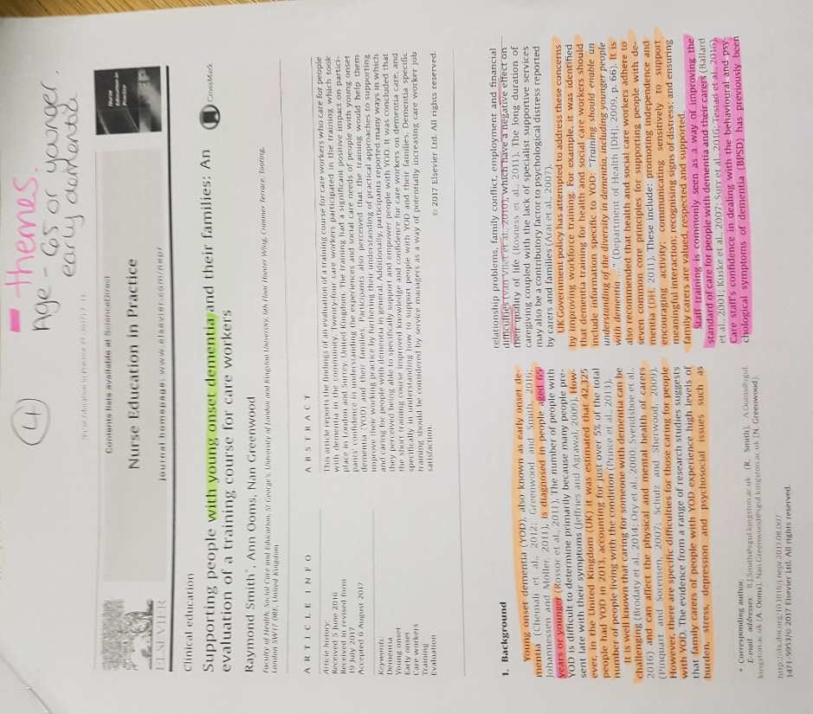
Appendix 4
Here is the evidence of a journal article conducted in this research thesis and evidence of the creation of themes.

