Katie Lewis ECAD5008

A written assignment critically evaluating how Assessment for Learning can be utilized in a series of learning opportunities to aid progression across chosen areas of learning and experience.
Introduction
In this assignment I will be critically evaluating how assessment for learning can be utilized in the classroom and learning environment to aid progression in my 3 chosen areas of learning and experience. I will be discussing assessment for learning (AfL) strategies that I have used in my own teaching experience as well as discussing views from theorists and researchers. AfL is vital for learners progression as it allows teachers to view pupils abilities and what they may struggle with, or alternatively succeed in. It is important to see how pupils are progressing, and how their progression can be improved. During the Welsh curriculum reform in 2021, Donaldson introduced the curriculum and assessment act (Wales) 2021, where the key principles of assessment in Wales are presented ( (Welsh Government, 2022). There are 6 elements which fit in with the ideology of ‘The four purposes’ and pupil led learning (Welsh Government, 2022). One of the elements of assessment states that ‘assessment is an ongoing process which is indistinguishable from learning and teaching’ (Welsh Government, 2022). After my own teaching experiences, I have realized how important ongoing assessment is; assessment for learning should be utilised in every lesson not only once a week or once a term. This can be done by using one of the following elements in each lesson – sharing criteria with learners, quality of question and talk, peer or self assessment, and use and quality of feedback. These elements are founded and researched by Dylan William (Dylan William, 1998). These elements are part of formative assessment, concerning ‘moments of contingency’ (Paul Black, 2009), which links in with one of the six elements in the Curriculum for Wales. Theorist Jerome Bruner introduced ‘the spiral curriculum theory’. He presented the idea of returning to previous learning and deepening levels of difficulty and knowledge in that area over a longer period of time. Bruner believes that this way knew skills related to previous learning are developed (Jo Ireland, 2020). I noticed this method used in my placement school, especially during mathematics and numeracy lessons. I observed that pupils were becoming more and more knowledgeable every day when they completed ‘morning mental math’s’. There was one pupil who did not know his 5 times tables when I began, but after practicing his 5 times tables every morning he then knew them within 3 weeks. This allowed him more confidence then with division and long multiplication.
Moreover, during this assignment I will be discussing my own lesson and how I utilized assessment for learning. My lesson follows the spiral curriculum (Jo Ireland, 2020) with contingency and revisiting prior learning. This is a series of three lessons which I actually taught on placement so I will be discussing them in past tense. The theme of these lessons was ‘Dementia’ as the pupils were performing a concert with a Dementia choir and I felt that they should gain some knowledge on the subject and create a leaflet to hand out at the concert. This gave the concert a purpose. The pupils I taught my lesson to was a Year 5 class at progression step 3, although there was a few lower ability pupils at progression step 2, and more able and talented pupils at progression step four. (Welsh Government, 2021). I ensure that my lessons were differentiated appropriately for each step, which can be seen in my lesson plans (in the appendices). My lesson was separated into 3 days. Day 1 the pupils used Padlet – a collaborative digital platform - where they collaborated to discuss and write down the features of a leaflet. (Edwards, 2022). The main area of learning experience was languages, literacy and communication, but also incorporated the digital competency framework. On day 2 they planned out their leaflet on paper by drawing, and not actually writing anything. They peer assessed these leaflets before they created their final draft. This was part of the Expressive arts area of learning. On day 3 they crated a digital leaflet following their plans and research that had already been done in previous learning. This was part of the Science and technology area of learning experience. These 3 lessons show the progression between finding out the features of a leaflet and then actually creating one. I believe that the second digital draft was important to improve digital skills, and also allowed for pupils to assess their own learning and improve.
Literature review
Assessment for learning plays a huge role in pupil progression. I believe that AfL is the most important part of pupil progression as different AfL methods allow for teachers to see who is progressing well and who is not. It allows teachers to clearly see who the lower ability children may be, and who the MAT children are. However, I believe that some AfL methods work more than others. For example, I believe that live marking is more efficient and shows a better quality of feedback in comparison to taking books home and marking them. It is important that pupils see their mistakes and efforts at present, rather than the next day where they are less likely to make any improvements. This comes under the element of use and quality of feedback ‘In the Black Box’ (Dylan William, 1998) . Dylan believes that feedback should cause thinking, be focuses, relate to learning goals and be more work for the recipient than the donor’. In addition to this, Educator Kim Marshall wrote that Dylan believes students must do something with the feedback they receive, otherwise it is pointless. (Marshall, 2016). Live marking is excellent for pupil engagement with the feedback, as they respond to it then and there, while they are still completing the work, allowing pupils to realize their mistakes earlier on and improve them. According to Ross Morrison McGill, the founder of the teacher tool kit, there are benefits of live marking with verbal feedback and ‘speaking with students’ adds value to the feedback (McGill, 2023). This was very apparent on my placement experience, as sometime the pupils wouldn’t understand what your feedback meant and needed further explanation. This is also a great time to give praise and highlight what they have done well.
One of the other AfL elements Dylan researches is quality of question and talk (Dylan William, 1998). It is important that the quality of questioning is at a high standard to get the most progress and understanding from pupils. He believes that there are two reasons you should ask pupils questions which are to cause thinking, and to collect evidence which will inform your teaching (Dylan William, 1998). These reasons are important for progression in learning, however I believe that there are other reasons that are just as vital, such as to check knowledge and understanding, and to address any misconceptions which may come up. Alternatively, Rosenshines theory is that there are 17 principles with instruction, and his principle on questioning states that a large number of questions should be asked and understanding checked ’ (Barak Rosenshine 1978). I feel that this principle is too broad, and can be supported with questioning techniques such as Blooms Taxonomy. Blooms taxonomy is a pyramid method of higher and lower order questioning (Benjamin Bloom,1994). The top of the pyramid is ‘creating’ and the bottom of the pyramid is ‘remembering’. The elements in between (such as applying and analyzing) help the pupils progress within the pyramid. However, it is important to note that the aim is not to get from the bottom to the top of the pyramid- progress can be made within each element with good quality questioning. Within my placement experience, I used the question matrix to improve my quality of questions, and therefore receive more detailed and thought about answers. This ideology was created by Chuck Weiderhold in 1998. He designed a set of questions to aid higher order thinking. The question matrix allows for metacognition (thinking about your thinking). It allows pupils to delve deeper into their knowledge and understanding through using open ended questions. (Gardener's multiple intelligences, 2023). This can link in with the four purpose element of being an ‘ambitious, capable learner’ that ‘are building up a body of knowledge and have the skills to connect and apply that knowledge in different contexts’ (Welsh Government, 2022). This also links in with the LLC what matter statement ‘Expressing ourselves through languages is key to communication’ allowing pupils to express their opinion and explore ideas with high order questioning (Welsh Government, 2021). The question matrix can be used in planning to help progression within the progression steps, especially for the lower ability children who may need additional prompting with questions and who haven’t reached the target of progression step 3 for year 5 (Welsh Government, 2021).
Discussion of lesson planning decisions
During my placement, I taught a series of lessons to my year 5 class on the creation of a leaflet. In this section I will be discussing 3 of those lessons in contingency, and why I chose those specific lessons and areas of learning experiences to provide progression within the class. I will be references my lesson plans that are showed in the appendices. I will additionally be discussing what AfL strategies I used during these lessons and whether they were effective or not. Before these three lessons, the pupils already completed research on the topic which is Dementia. I choose this topic as it was on theme for their learning at the time as they were performing with a dementia choir. It is important to teach current issues with real life context as they will develop into ethically informed citizens (Welsh Government, 2022). This allows allows for discussions to open up at home which may lead to more learning (Rink, 2016). The leaflets were given out at the performance so parents and guardians could view all the learning that has taken place in school.
My first lesson I taught and planned was an LLC Lesson, incorporating the DCF also. This lesson was specifically focusing on the skill of collaborating (Welsh Government, 2022) and understanding views and ideas of a text (Welsh Government, 2019) . I planned to use Padlet to incorporate the DCF, but my main focus was on LLC. I looked at the collaboration strand in the DCF and choose 2 progression steps, one from progression step 2- ‘ I can use collaborative platforms to create and edit a file’ and one from progression step 3- ‘I can work with others to create an online, collaborative project for a specific purpose, sharing and appropriately setting permission for other group members’ (Welsh Government, 2022). The reason I choose 2 progression steps was that a lot of the pupils in my class struggled using technology, especially when it was newly introduced. However, I did notice that the lower ability pupils appeared to be more confident using the iPad and laptops as they did not have to handwrite anything or worry about spelling errors. According to Kristin Stanberry, pupils with learning disabilities have more success when using technology within reading, writing and math’s (Stanberry, 2024). My LLC progression step 3 was from the cross-curricular framework. ‘ I can use my understanding of different kinds of texts to consider whether a text is effective in conveying information, views and ideas’. I focused on this as they needed to look at the features of a leaflet before they made their own. This way they had some prior knowledge and understanding ready for their leaflet draft. The what matter statement I choose for this lesson was ‘ Understanding languages is the key to understanding the world around us.’ I felt that this was fitting to the lesson as the pupils will need to understand the language and features used before they create their own leaflet.
During my lesson introduction I used the basket/ping pong ball questioning strategy for AfL. This is where you ask a question to the class and use a soft ball and randomly throw it to pupils to answer. If they struggle to answer the question they can then throw the ball to someone else for help. This method was beneficial as it is useful to see what pupils know, and what they don’t as they are randomly chosen, not based on hands up. This method was created by Dylan William called ‘pause-pose-pounce and bounce’ (Chartered college of teaching, 2023). However, one implications you must be aware of is ensuring that there is enough wait time between the pause and pose to allow pupils to think critically. Researcher Mary Budd Rowe came up with the concept of wait time. She found that a longer wait time caused longer, logical answers from pupils. She found that teachers waited on average 0.9 seconds for answers, whereas they should wait at least 2.7 seconds for a more informed answer. (Mary Budd Rowe,2003). Moreover, another limitation to this method is that some pupils misbehaved with ball. They would just throw it to their friends or at their friends. However, this was limited and could be less of an issue if you set out behavior expectations before hand. It is important t be explicit when telling pupils what you want from them to give pupils a ‘sense of confidence safety and security’ – they consistently know how they should behaving if this is clearly shared with them (Sword, 2021). In comparison to this, this strategy worked well because it was more fun than pupils just putting their hands up to answer a question. I found a lot more pupils were willing to try and answer my questions than usual. According to an article published by Growth Engineering, Pupils are more motivated to complete work if it is fun and are more likely to achieve better outcomes (Growth Engineering, 2023). Altogether, I conclude that this AfL strategy was effective for opening my lesson. It enabled prior thinking and whole class discussion ready for when they create their Padlet. It also allowed me to address any misconceptions beforehand.
My second I planned in this series of lessons was an Expressive arts lesson, also linked in with LLC. I choose an Expressive Arts what matters statement that suits my lesson intention. This was ‘creating combines skills and knowledge, drawing on the senses, inspiration and imagination’ (Welsh Government, 2021). I choose this statement as my lesson uses designing and creativity to combine skills and knowledge that were previously learnt. It also enabled pupils to express themselves creatively, becoming creative enterprising contributors who can ‘connect and apply their knowledge and skills to create ideas and products’ (Welsh Government, 2022). Within this lesson, pupils were planning their leaflets on paper. I did a quick introduction to activate prior knowledge (APK) and to explicitly share the learning intention. I gave them WAGOLLS so they had an idea of what to do. They discussed what is good about the leaflet then we created a success criteria as a class. This fits in with ‘sharing criteria with students’ from Dylan Williams AFL theory (Dylan William, 1998). This lesson plan can link in with the 12 pedagogical principles, specifically ‘sets tasks and selects resources that build on previous knowledge and experience and engage interest’ (Welsh Government, 2023). It is significant that pupils are building on knowledge and constantly progressing. This links in with Bruners Spiral curriculum theory of revisiting what they have learned before and building upon it Brian Gibbs.2014) . In this case they have completed research on their topic Dementia to gain knowledge, they have read articles and also collaborated to look at the features of a leaflet. All this has knowledge has been activated when they create their leaflet plan (APK). I linked this lesson to an LLC progression step 3 from the cross-curricular framework ‘ I can plan writing, making choses to about the best ways to present content for effect’ (Welsh Government, 2019). Even thought the main area of learning for my lesson was expressive arts, these two can link together which meets the pedagogical principle of ‘ranging with in and across areas’ which creates authentic and more meaningful learning experiences. (Welsh Government, 2023). I taught this lesson full class but made sure that I walked around and checked on pupils throughout, also addressing any misconceptions.
One of my AfL strategies I used in this lesson that worked well was explicitly sharing my learning intention and success criteria with the class. The class helped me make the Success criteria. I found that if I didn’t do this, sometimes the pupils would not even look at the learning intention. This fits in with the AfL element of sharing criteria with learners (Dylan William, 1998). One of the benefits of this strategy was that it gave me an opportunity to address misconceptions then and there, before they even started working; any questions they had about the lesson they could ask then. I encouraged them to do this so they feel more positive going into the lesson. This strategy is backed up by John Hattie’s research explaining the importance of sharing the learning intention and success criteria. He believes that you should try different ways to maximize the effect of impact of a success criteria, one of these being ‘doing it wrong or not completing it so students correct you’ (hattie, 2019). This is essentially what I planned for. Another strategy he researched is revisiting a success criteria after doing the work and seeing if you can make a better one. This is a method I would love to try in the future. Learning intentions are part of ‘active learning through formative assessment’ (Clarke, 2008) . Formative assessment is when teachers are monitoring progress of pupils regularly, and assessed informally (Twinkl, 2023). This method is used within the Welsh Curriculum. Furthermore, success criteria’s are useful for showing differentiation in learning. I would set separate learning intentions for each ability, which each had slightly different success criteria’s. In my class there was four level of abilities they could choose from which gave them independence and confidence. They then did their work in mixed ability groups so they could help each other- they allows opportunities to discuss work and perspectives (Mohammed, 2022).
My third and final lesson plan in this learning series was a science and technology session where the pupils made a final draft of their leaflet on a laptop using publisher, incorporating creating elements of the DCF (Welsh Government, 2022). I chose the what matter statement ‘computation is the foundation of our digital world’. I chose this because computers have changed the way we complete work, such as these leaflets. This area of learning allows pupils to be ambitious capable learners who ‘use digital technologies creatively to communicate, find and analyse information’ (Welsh Government, 2022). In this lesson they worked independently, but I kept watch of what they were doing and addressed any misconceptions throughout. In this lesson I chose the LLC cross curricular framework progression step 3 which was ‘You can adapt structures in writing for different contexts’. This fit in with them doing a second draft and improving their work, and also them taking their research and putting it into their own words. One of the AfL strategies I used in this lesson was the use of mini-plenaries to address any misconceptions. This enabled me to help the class as a whole when the majority of them were stuck, rather than having to keep addressing issues. This method was a simple way of measuring progress and where improvements need to be made. It also allowed me to see where I haven’t explain something well enough or what needs revisiting. Successful plenaries enable the pupils to process and see what they have learned (Main, 2021). I did these mini-plenaries whenever an issue arise, or alternatively when I saw the work being done very well. However, I did find that this strategy had some drawbacks, one of which is that they were disruptive to the flow of work. The plenaries would enable discussion, which then sometimes didn’t end when going back to doing the work. One of the strategies used to combat this would be to set clear behaviour intentions. This fits in with Dylan Williams AfL element ‘quality of question and talk’ (Dylan William, 1998).
Another AfL strategy I used in this section was live marking. A benefit of live marking is that it ‘promotes rich dialogue’ (Wells, 2023). It encourages discussion with the pupils where you can find out their strengths and weaknesses, and what they need some guidance on. I agree with this. I believe it is more beneficial than usual marking as problems are addressed at present and the pupils actually get to hear the praise and encouragement, which will boost their confidence; according to research, highly confident learners are more willing to challenge them self’s and progress (Gill, 2023). Alternatively, a drawback to live marking is that it is very time consuming (Wells, 2023). Sometimes it is difficult for teachers to live mark during lesson time. To conclude, I think both AfL strategies in this lesson worked well and I will use them again in the future.
Conclusion
In conclusion, during my research I have found and used many different AfL strategies, all of which have their own benefits and limitations. I have also seen a lot of AfL strategies being used in school that I would love to try in the future such as exit and admission tickets. These are tickets where pupils write what they have learned and questions they may have at the end of the lesson (Saxton, 2023). This allows for further learning and progress as teachers can clearly see what pupils need extra help with. This is a method I saw other classes using while on placement and I will use in the future. I believe that assessment for learning is extremely important when it comes to progress in learning, but I think its even more important to use effective strategies like the ones I have discussed above. In addition, I think that more AfL strategies could be tried and tested in the school, especially targeting those of a lower ability- such as the traffic light method, (Twinkl, 2023) but overall the ones used work really well and the pupils are progressing appropriately.
Appendices

References
Anderson, L. W., Sosniak, L. A., & Bloom, B. S. (Benjamin S. (1994). Bloom’s Taxonomy : a forty-year retrospective : ninety-third yearbook of the National Society for the Study of Education. University of Chicago Press for National Society for the Study of Education.

Chartered college of teaching, 2023. Pause-pose-pounce-bounce. [Online]
Available at: https://my.chartered.college/wp-content/uploads/2018/10/7.-Pose-Pause-Pounce-Bounce-1.pdf
[Accessed 3 January 2024].
Clarke, S., 2008. Active learning through formative assessment. s.l.:Hodder Murray.
Dylan William, P. B., 1998. Inside the Black box:raising standards through classroom assessment. 1 ed. London: GL Assessment.
Edwards, L., 2022. What is padlet?. [Online]
Available at: https://www.techlearning.com/how-to/what-is-padlet-and-how-does-it-work-for-teachers-and-students#:~:text=Padlet%20is%20a%20platform%20in%20which%20you%20can,students%2C%20other%20teachers%2C%20and%20even%20parents%20and%20guardians.
[Accessed 28 December 2023].
Gardener's multiple intelligences, 2023. The Question Matrix. [Online]
Available at: https://edcr3332015gardnersmultipleintelligences.weebly.com/the-question-matrix.html
[Accessed 29 December 2023].
Gibbs, B. C. (2014). Reconfiguring Bruner: Compressing the spiral curriculum. Phi Delta Kappan, 95(7), 41–44. https://doi.org/10.1177/003172171409500710

Gill, R., 2023. Why building confidence can benefit learners and help them to achieve. [Online]
Available at: https://www.ncfe.org.uk/all-articles/confidence-benefits-learners/
[Accessed 7 January 2024].
Growth Engineering, 2023. Why fun in learning works better than dull learning. [Online]
Available at: https://www.growthengineering.co.uk/why-fun-in-learning-is-important/
[Accessed 4 January 2024].
hattie, J., 2019. John Hattie:Learning intentions and Success Criteria. [Online]
Available at: https://www.stem.org.uk/rxacud
[Accessed 5 January 2024].
Jo Ireland, M. M., 2020. Perspectives on curriculum design: comparing the spiral. [Online]
Available at: https://www.cambridgeassessment.org.uk/Images/598388-perspectives-on-curriculum-design-comparing-the-spiral-and-the-network-models.pdf
[Accessed 28 December 2023].
Main, P., 2021. A teachers guide to lesson plenaries. [Online]
Available at: https://www.structural-learning.com/post/a-teachers-guide-to-lesson-plenaries
[Accessed 7 January 2024].
Marshall, K., 2016. Dylan William on feedback that makes a difference to students. [Online]
Available at: https://www.tieonline.com/article/1836/dylan-wiliam-on-feedback-that-makes-a-difference-to-students
[Accessed 29 December 2023].
McGill, R., 2023. Teacher tool kit: taking live marking two steps forward. [Online]
Available at: https://www.teachertoolkit.co.uk/2022/11/01/taking-live-marking-two-steps-forward/
[Accessed 29 December 2023].
Mohammed, S., 2022. Mix It Up! The Benefits of Mixed-Ability Groups: IgnitED Research Insigh. [Online]
Available at: https://practices.learningaccelerator.org/
[Accessed 6 January 2024].
Paul Black, D. W., 2009. Developing the theory of formative assessment. [Online]
Available at: https://link.springer.com/article/10.1007/s11092-008-9068-5#citeas
[Accessed 28 December 2023].
Rink, T., 2016. Current events and why we need to teach them. [Online]
Available at: https://blog.mimio.com/current-events-and-why-we-need-to-teach-them
[Accessed 3 January 2024].
Rosenshine, B., & Meyers, L. (1978). Staff development for teaching basic skills. Theory into Practice, 17(3), 267–271. https://doi.org/10.1080/00405847809542776

Rowe, M. B. (2003). Wait-time and rewards as instructional variables, their influence on language, logic, and fate control: Part one-Wait-time. Journal of Research in Science Teaching, 40, S19–S32. https://doi.org/10.1002/tea.10090

Saxton, S., 2023. 15 Assessment for learning strategies. [Online]
Available at: https://www.twinkl.co.uk/blog/assessment-for-learning-strategies-and-ideas-you-can-try-this-term
[Accessed 8 January 2024].
Stanberry, K., 2024. Assistive technology. [Online]
Available at: https://www.readingrockets.org/topics/learning-disabilities/articles/assistive-technology-kids-learning-disabilities-overview
[Accessed 2 January 2024].
Sword, R., 2021. How to set behaviour expectations in the classroom. [Online]
Available at: https://www.highspeedtraining.co.uk/hub/how-to-set-behaviour-expectations-in-the-classroom/
[Accessed 3 January 2024].
Twinkl, 2023. Formative Assessment. [Online]
Available at: https://www.twinkl.co.uk/teaching-wiki/formative-assessment
[Accessed 5 January 2024].
Wells, A., 2023. The pros and cons of live marking. [Online]
Available at: https://www.teachertoolkit.co.uk/2018/03/04/live-marking-2/
[Accessed 7 January 2024].
Welsh Government, 2019. Cross curricular framework. [Online]
Available at: https://hwb.gov.wales/curriculum-for-wales/cross-curricular-skills-frameworks/
[Accessed 2 January 2024].
Welsh Government, 2021. Progression code. [Online]
Available at: https://www.gov.wales/sites/default/files/publications/2021-11/curriculum-for-wales-progression-code.pdf
[Accessed 28 December 2023].
Welsh Government, 2021. Statements of what matters. [Online]
Available at: https://www.gov.wales/sites/default/files/publications/2023-06/curriculum-for-wales-statements-of-what-matters-code.pdf
[Accessed 29 December 2023].
Welsh Government, 2022. Curriculm for Wales- Assessment arrangements. [Online]
Available at: https://hwb.gov.wales/curriculum-for-wales/assessment-arrangements/supporting-learner-progression-assessment-guidance/
[Accessed 28 December 2023].
Welsh Government, 2022. DCF. [Online]
Available at: https://hwb.gov.wales/curriculum-for-wales/cross-curricular-skills-frameworks/digital-competence-framework/
[Accessed 2 January 2024].
Welsh Government, 2022. The four purposes. [Online]
Available at: https://hwb.gov.wales/curriculum-for-wales/designing-your-curriculum/developing-a-vision-for-curriculum-design/
[Accessed 28 December 2023].
Welsh Government, 2023. Pedagogy. [Online]
Available at: https://hwb.gov.wales/curriculum-for-wales/designing-your-curriculum/pedagogy/
[Accessed 4 January 2024].

Lesson plans referenced in assignment below.
Lesson plan 1- Language, literacy and communication
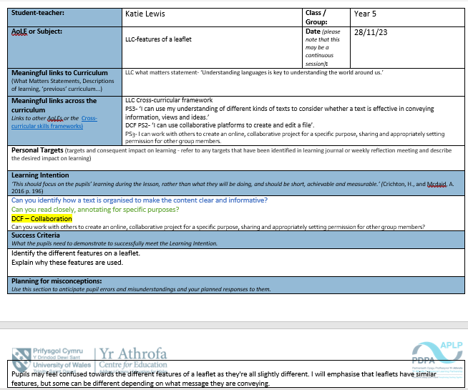
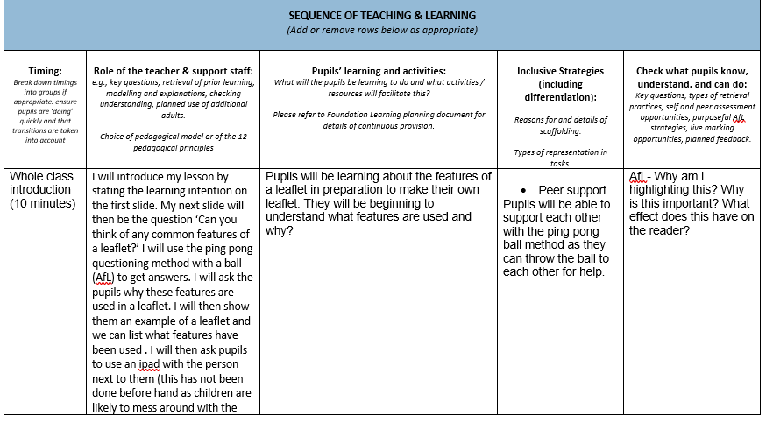
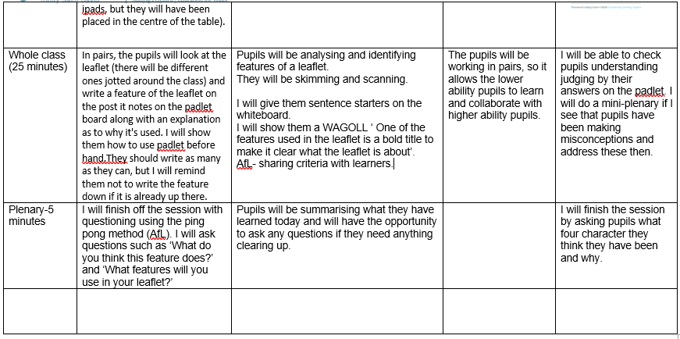

Lesson Plan 2- Expressive Arts

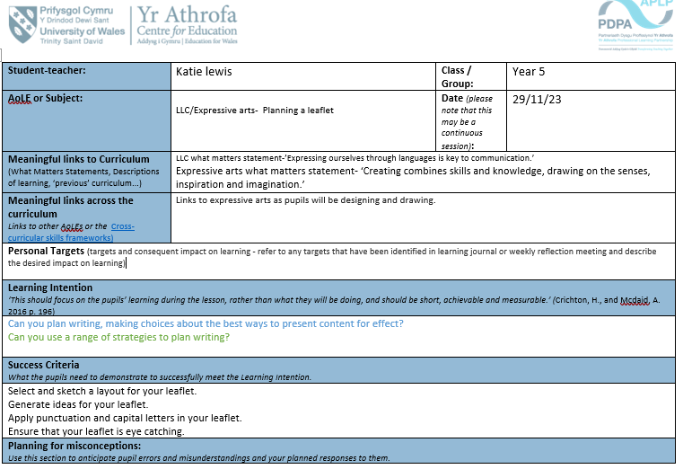

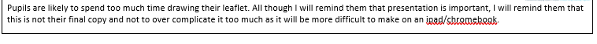

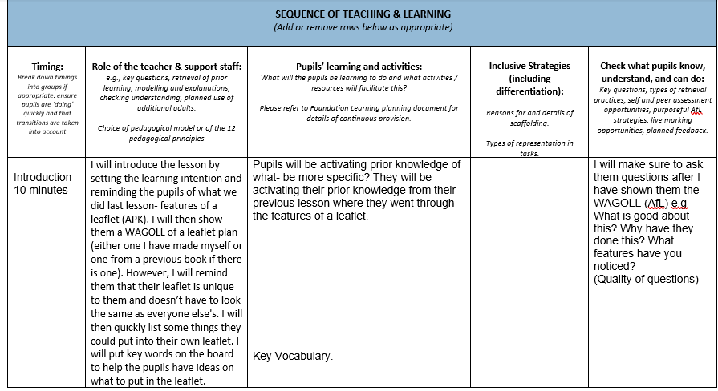
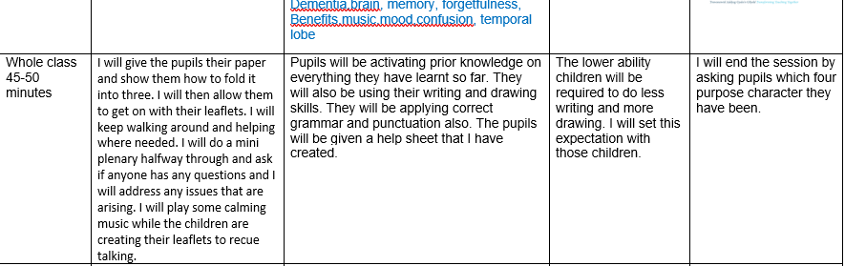

Lesson Plan 3- Science and technology



