A critical evaluation and the identification of next teaching and learning steps focusing on a case study of an individual learner or a group of learners based on an observed critical incident.

Introduction

The purpose of this assignment is to evaluate critically and to identify the steps that will be taken within my teaching career using an observed critical incident within a school setting, intending to improve teaching practice for my future teaching career.
A Critical Incident (Tripp, 2011) is a significant incident or a life-changing event of a person or a political institution. However, within a teacher’s lifetime, it is a rarity that such an event would occur as not being ‘dramatic’ or ‘obvious’ but, in fact, a typical or a common event that would occur in a routine professional practice that sets standards and structures.
Critical incidents are vital as they are used to link teaching methodologies to practice (Tripp,2011). It allows teachers to analyse their teaching practices and continuously evolve as an educator. Critical incidents identify the underlying context of a particular teaching situation, which leads the teacher to reflect upon the event and consider possibilities for future actions. This assignment will reflect on an observed critical incident within a pedagogical context using Tripp’s (2011) method of reflective teaching practice. Differing methods of reflection and underlying education theories will also be explored to gain a more profound meaning into why the observed critical incident has occurred and what this means for the broader professional teaching context.
In this assignment, I will be researching theories of Constructivism, Scaffolding and constructionism as a theory of the critical incident observed.
The role of critical reflection
Critical reflection is an integral part of a teacher’s practice as it allows individuals to evaluate their skills within their retrospective profession. Critical reflection identifies a framework of various obstacles and challenges that an educator will face in the present and future. Therefore, helping to create better learners through the changes to their practice is integral to developing and maintaining competency throughout an educator’s profession.
Dewey (1910), who is usually described to be a founder of reflection, compared reflection to a physician identifying symptoms, meaning that the ‘symptoms’ need to be examined in various methods to improve reflective practice (Brandenburg et al., 2017). This would mean that reflective practice must provide an emphasis on looking at their work with hindsight to provide resolutions to problems that teachers may face when teaching.
Various scholars have contributed to the research of reflective practice of teaching. For instance, Kolb (1975) introduced the Learning cycle, which focuses on reflective observation to analyse and provide explanations from an experience. The methods learned from that experience then is taken to new settings to improve existing skills.
Ghaye (2011) has devised his method of critical reflection, which comprises four characteristics; Cyclical, Flexible, Focused, and Holistic. Cyclical refers to reflection, and action should progress you onto better cycles. Flexible suggest that for the model to be effective, improving learning and teaching does not happen in sequential events. Somewhat simultaneously, a teacher may improve their practice during the current event. In contrast, another teacher may reflect on their teaching practice at the end of the event. Focused refers to reflection needing to have a purpose; a direction must be established for meaningful learning to occur. Holistic refers to the model enabling the teacher to link professional practice and development to the student’s wellbeing.
Alternatively, Brookfield (1998) has stated that critical reflection can be engaged through four lenses, the self, the students, the peers and theoretical literature. Brookfield (1998) believed that cogitating upon these lenses allowed for a well-rounded teacher to become an effective educator. Through reflecting from four lenses, teachers can highlight hidden practices within their teaching to improve professional practice.
The importance of reflective practice within education can be seen within the reform of education in Wales today. Furlong (2020) has worked closely with the Welsh government to overhaul the Initial Teaching Education (ITE) to reflect society today within Wales. Furthermore, the new Welsh curriculum will prepare young people to be digitally competent, creative and adaptive to the fast-paced changes of society alongside knowledge (Education is changing | GOV.WALES. 2021). Furlong (2020) has proposed the need for education reform in Wales as the education system has largely mirrored the education system in England. The Curriculum 2022 comprises university-based education and “lead schools”, allowing for collaborative and reflective teaching methods when training student teachers and experienced teachers.

Observation School & Class context

In line with BERA Guidelines, “the confidential and anonymous treatment of participants data is considered the norm for the conduct of research”. Thus, the observation of the staff, school and students will be anonymised throughout this literature.
The observation took place in an English medium comprehensive school based in the Northwest of Cardiff. The school is a mixed gender Christian faith-based school that welcomes students of all faiths and backgrounds, including those with no faith (Estyn, 2018). There are 1263 pupils on the roll; this includes 295 in the Sixth form. Furthermore, under 16% of pupils have additional learning needs, below the national average. (Estyn, 2018) There is also 5% of pupils with special education needs statements, higher than the national average (Estyn, 2018). Almost all pupils speak English as their first language and under 9% of pupils are eligible for free school meals, making the students below the national average of 17%. Around 18% of pupils come from Black and ethnic minority backgrounds (Estyn, 2018). The school provides multiple facilities, such as an additional teaching facility for pupils with autism (Estyn, 2018).In the 2018 Estyn report, the school was awarded ‘Excellent’ in every category and were commissioned to exemplify their standards to other secondary schools. The school ensures that positive relationships are maintained with the pupil’s families, this is demonstrated through the fundraisers to improve ICT equipment and outdoor furniture within the school (Estyn, 2018).
Critical incident linked to Donaldson’s Four Purposes
The Critical incident was observed in a year 7 classroom setting where students learned about the 7 life processes of all living things. The teacher recapped the keywords of the 7 processes and definitions and to further enhance knowledge. The teacher reminded the students of the acronyms that were covered in the previous lesson. The context of the lesson would tie in with the purpose of students becoming ambitious capable learners.
Once students recapped the keywords with the teacher, the students were tasked with ‘designing an alien’ using the keywords and the acronym as a guideline; students were allowed to speak to each other to exchange ideas. The task would, in turn, help students to ‘think creatively to reframe and solve problems as students had to reflect on all 7 life processes to design their alien. The students were informed that they must use all 7 life processes as a guideline of the characteristics of the alien; otherwise, the ‘alien’ will not live. This will, in turn, allows the children to ‘set themselves high standards and seek and enjoy a challenge’ as they must use the guideline to keep the alien alive. Once students had completed designing the alien, the students had to engage in a ‘show and tell’ presenting their designs to their cohort, describing the 7 characteristics of the alien. Presentation of their designs prepares the students to ‘explain ideas and concepts that they are learning about (Apperson,2006).
Pupils then asked the presenter further questions about the alien, which in turn allowed the presenter to critically think about their design, further enhancing subject knowledge. The critical incident observed was when a student who did not understand the concept of the 7 life processes began to think about how to incorporate the characteristics into his alien; he had shouted to the teacher ‘Oh! Sir, I finally understand this now. The knowledge and understanding of the information recapped at the beginning of the lesson was applied in a different context of the task, allowing the students to have the ‘skills to connect and apply that knowledge in different contexts’ (Donaldson,2015). Furthermore, the critical incident has shown that the lesson has contributed to pupils developing their knowledge to becoming enterprising, creative contributors(Donaldson,2015). This is as students had to connect and apply their knowledge and skills to create ideas and products (Donaldson,2015), if the students did not recap the lesson and were provided with acronyms to help meet their success criteria, there could have been challenging to meet them.
Based on the critical incident explained above, I will be looking into theories of Constructivism, Scaffolding and Social Constructionism to explore the basis of the critical incident further.
Literature Review
Constructivism is not a single learning theory but rather a multi-layer concept. Constructivism is a learning theory that equates learning with creating meaningful experiences, learning is ensured when students are able to interact with a new problem or concept by integrating the information with previously learned knowledge (Alesandrini and Larson, 2002).
There are two main components of Constructivism, Cognitive Constructivism and Socio-Constructivism. Piaget pioneered the individualistic lens of Constructivism namely, cognitive constructivism(Ackerman, 2001). Cognitive Constructivism is the idea that learning occurs through “adaptation” and “organisation”, therefore learning occurs on the basis of pre existing knowledge of the self.
Socio-constructivism emerged as Vygotskys an opposing argument to Jean Piaget’s contributions to Constructivism. Socio-constructivism emphasises the significance of both culture and environment as an learning agent (Aubrey and Riley 2019). Vygotsky believed that collaborative action is integral to childhood, utilising speech and activities and the use of social speech. Vygotsky’s theories of Constructivism arises from his ideas on the relationship between speech, language and their relevance to society. Vygotsky emphasises that the process of learning is affected by society, community, and culture (Amineh and Asl 2015).
Constructivism emphasises that the learner must have prior knowledge and experience based on their cultural and socioeconomic environment. Therefore, knowledge is acquired by ‘constructing from their own experiences (Aubrey and Riley 2019).
Although Piaget (year) and Vygotsky’s work both contribute to the learning theory of Constructivism, they appear to hold different stances. Vygotsky’s work is mainly critical of Piaget’s theory of learning; Vygotsky (year) believes that learning precedes development, whereas Piaget deems the opposite. For instance, Piaget believes that children’s style of communication fades as children mature and transform into social speech (Lourenço 2012)
. However, Vygotsky theorised that the child’s communicative mind is innate; therefore, the speech will transform from communicative to inner egocentric (Lourenço,2012). Therefore, Vygotsky has theorised that the individuals’ social values derive from society to the self and not the latter.
Due to the nature of this literature, I will be focusing on Vygotsky’s theory of Social Constructivism.
Social Constructivism emphasises that exchanging individualistic opinions is known as ‘collaborative elaboration’.Van Meter and Stevens (2000) tested this and found that construction of learning cannot happen within the self; collaboration between peers is pertinent to gaining optimum knowledge. On the contrary, Van Boxtel et al. (2000 et al.|) examined this and found opposing results; participants were tasked to create a map and results had yielded that individual preparation had created better results and the asking of more questions, whereas the collaborative approach showed more of discussion but not a higher learning outcome.
To support this theory, Gijbels et al. (2006) investigated the impact of learning through learning environments within university students and found that university students who worked in a constructivist, collaborative setting of groups could help understanding further than a lecture setting. Sawyer (2013) further researched this and supports the idea that peer collaboration improves learning. However, due to the study of Gibbs et al.(2016) taking place through the second half of the semester, previous knowledge could have been built within the first half of the semester, allowing participants to find learning within a constructivist setting to become more beneficial (Segers and Dochy, 2001).
The constructivist approach is seen as a more favoured method of learning due to the idea of communication being intergral to learning. Schools are increasingly emphasising the idea of speech as an essential strategy to children’s learning as it assists children to express their ideas and thoughts (Bartlett et al.,2000). For Instance, Vygotsky highlighted that learning by play is an integral part of a child’s development (Aubrey and Riley, 2019). This is as play therapy can prepare a child for the challenges of the real world and for children to familiarise themselves with the roles of adults (Hedges, 2000).
Moreover, learning through play allows children to develop a Zone of Proximal Development (ZPD). Zone of Proximal Development, a term coined by Vygotsky, is the intellectual potential of an individual when assisted by a peer with further knowledge or an adult familiar with the objective (Aubrey and Riley, 2019).
Vygotsky stressed the importance of the zone of proximal development as it allows for the measurement of the intellectual potential of an individual rather than on what the individual has achieved (Kuusisaari, 2014)
Working with experts allows the student develop an understanding for processes and can integrate the knowledge with their pre-existing notions(Fawcett and Garton, 2005). However, ZPD has been met with criticism, Beaver (1984) stated that in that the theory is too reliant on previous experiences, it assumes that prior learning must have taken place, which is not always the case (Roth and Radford, 2010). Furthermore, ZPD is met with apprehension by teachers as it does not take into account the restrictions of the National Curriculum and leaves little room for the student to take a more independent approach to learning (Bartlett, 2001).
Zone of proximal development does not address the process of Scaffolding which takes place, a theory further developed by Jerome Bruner. Expanding on Vygotsky’s theory, Scaffolding is the type of assistance that a child receives from an adult who is familiar with the task or a more capable peer through methods of ‘show and tell’ or modelling((Aubrey and Riley, 2019). Once the learning has been met, support levels are drastically reduced, and children are given a new challenge to utilise their new knowledge, further developing their understanding(Aubrey and Riley, 2019).
For successful Scaffolding to occur, adults must be aware of the level of knowledge that the student already acquires for the student to be responsive (Turner et al., 2003). This is as Scaffolding requires the student to move from a teacher-led form of learning to a more self-regulated method of learning (Aubrey and Riley, 2019).. Perry, Hutchinson and Thauberger (2008) found that the more comprehensive the range of scaffolding techniques that occurred within the classroom, the more knowledge that the students retained; however, this study could not quantify the number of scaffolding techniques used within the classroom.
Scaffolding places too much emphasis on the teacher as being the expert, Scaffolding could then become a more dictated form of learning by the teacher. Jarowski (2015) has further critiqued Scaffolding, stating that teachers may guide students to realise their own limitations, therefore labelling it ‘intellectual dishonesty’.
To further improve scaffolding techniques, technological advancements must be emphasised within the classroom. Suryani, Hidayah and Dewi (2021) Investigated the use of Google classroom to promote scaffolding tecniques and self-efficacy and found that students understood knowledge better through the use of technology as a scaffolding technique.
Although Constructivism has a significant impact on how teachers apply their practice, the theory has been met with criticism. Firstly, Constructivism theory is not standardised with multiple explanations and significant differences (McPhail, 2015). Social constructionism and collaboration with peers allow room for students to just be in excessive agreeance with their peers; therefore learning cannot take place (Tillemma and van der Westhuizen,2006).
Constructivism also does not take into account that teacher’s freedom of creativity is hindered due to other factors for instance, educational and social policies. Therefore, limiting ZPD for students. (Shabani et al., 2010)
Vygotsky fails to specify the role of the learner during Scaffolding. Rogoff (2008) has further expanded on the theory of Scaffolding by including terms such as ‘guided participation and ‘apprenticeship’, highlighting that the learner takes agency within their own learning, both the expert and learner collaborate to find resolutions to problems.
Students do not always replace existing knowledge with new information; it can be sometimes retained simultaneously with pre-existing concepts. Strike and Posner (1992) suggested that new learning Is kept as a broader knowledge rather than wholly forgotten about.
Vogel-Walcutt et al. (2010) investigated the efficacy Constructivism in comparison to Cognitive Load Theory (CLT), and the results yielded that integrated knowledge was better acknowledged by the group that were taught with CLT based instruction.
Socially interactive Constructivism is aligned with Dewey’s work who opposed the idea of learning being sequential or based on a curriculum (Scott, 2008). Bruner had further developed the idea of Scaffolding by using Vygotsky’s theory of ZPD and emphasised that the communication methods of a teacher are an integral part of learning (Aubrey and Riley,2019).
Through the critical incident, creating materials using keywords allowed for an understanding of the lesson objective, this may be deemed as constructing knowledge through a social constructionist lens. Social constructionism is the idea that knowledge is constructed and not created (Burr, 2015). Constructionism is the view that learning is created and not discovered (Schwandt,2003)

REFLECTION / EVALUATION & NEXT STEPS
Reflection requires teachers to constantly revaluate their teaching practices, although we may not be aware that reflection is used daily in our personal lives to think about what could be done differently (Newton, 2005). As reflection is difficult to encapsulate in one sentence, the definition within my research that has resonated with me is of Lucas (1991), who argued that reflection involves a ‘systematic enquiry to improve and deepen our understanding of the practice. This definition summarises that we need to challenge our own assumptions of everyday meaning consistently. In my observed critical incident, students had to reflect on their own defintions of the 7 life processes to design their alien and presently reflect with their peers on their creation. Although the definition I have used demonstrates the notion of reflection, it does not profoundly emphasise that learning arises as a result.
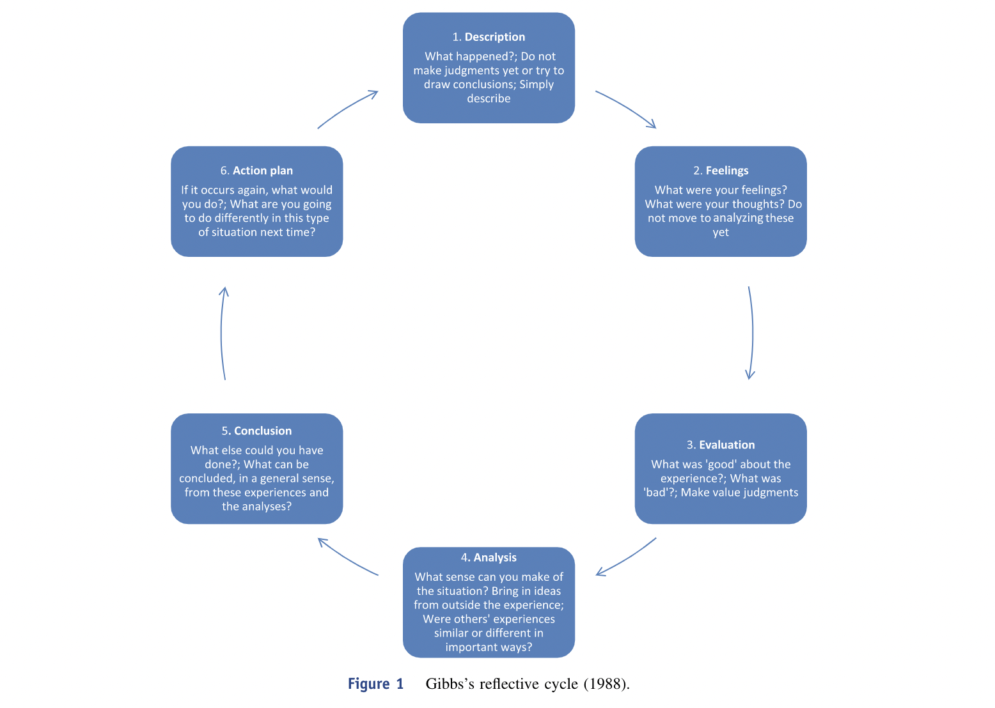
There are multiple models of reflection used by researches however, I will focus on Gibb’s reflective cycle to discuss my own reflections.
Gibb’s reflective cycle (Gibbs,1998) suggests that reflection can only take place after the event has completed. In this sense, the reflective individual can go through a series of sequences post event to gain a true sense of what has happened and any future improvements to make. Gibbs reflective cycle consists of 6 processes with each step informing the next, The cycle allows for feelings, thoughts and recommendations to occur and for any future improvements (Alesandrini and Larson, 2002).
1. Description
Students had to design an ‘alien’ which included the 7 life characteristics to show and tell to their peers; they were given an acronym that consisted of the 7 life characteristics previously learned and were allowed to discuss with their peers and exchange ideas while designing their alien, in preparation for their show and tell.
2. Feelings
I was very excited to see the results produced from the materials given to continue building their knowledge. Knowing that the students had the prompt of the acronyms left me curious as to the results presented, as most students grasped the idea of the definitions of the characteristics.
3. Evaluation
The lesson was very insightful as I was able to see the use of Scaffolding and Constructivism as an integral part of the lesson. Students collaborated on the design of their individual aliens, borrowing ideas from eachother and correcting each others mistakes, allowing for learning to be derived from peers. Also, students questioning each other during the show and tell aspect allowed for students to challenge their own thoughts to deepen their understanding and allow any definitions of keywords to be corrected. Although the lesson was very informative and insightful, allowing the students to discuss their ‘alien’ characteristics allowed for correction prior to the assessment from the teacher; therefore, true knowledge intake could have not been measured.
4.Analysis
The observation allowed me to witness that research on social Constructivism remains consistent with results in the classroom. Witnessing collaborative learning occur within the classroom, as discussed by Van Meter and Stevens (2000), was insightful as the student within my critical incident only understood the true nature of the task and learning objective of the life processes; the lesson had also demonstrated the Refining pedagogy within the Professional standards of teaching as it involved partners in learning. Furthermore, students using the acronym covered in the previous lesson as a primary focus within this lesson demonstrated that Scaffolding is an integral part of learning for students( Turner et al. 2003).
5. Conclusion
Within the lesson, students gained a deep understanding of their lesson objective as they were able to present their work to their cohorts confidently. To conclude, reminding the students of the previous work covered and providing prompts throughout the lesson allowed the students to gain sufficient knowledge. Learning through collaboration and using different mediums of learning within the lesson keeps students engaged throughout the session.
6. Action plan
Although I feel as though I had observed a model lesson that I would take on for my own personal practice, the following steps that I would suggest for the teacher is to include more technological advancements within the lesson as research shows that student learning is more effective (Suryani, et al., 2021).
Conclusion
To conclude, an overwhelming number of research heavily supports the educational theory of Constructivism and its subcomponents of Scaffolding and ZPD. Observing the classroom teaching practice has allowed me to see elements of Pedagogy, such as a blended learning experience, where students used multiple tasks to progress in learning. Constructivist theory firmly ties in with the refining pedagogy as it involves partners in learning through collaborative approaches (Gijbels et al.,2006). Scaffolding is complementary to the standard of innovation. The teacher must offer expertise to allow the student to conceptualise learning and become an effective teacher. Scaffolding allows teachers to develop new techniques to administer learning. Constructivism allows for pedagogy to spread as learners take agency of their own learning, therefore producing ambitious capable learners ready to tackle new learning. Furthermore, the approach allows for leadership pedagogy to grow within students as students become independent learners. Therefore, students can begin to work in different settings in pair work, group work and teamwork, ready to contribute The researchers suggest that with the importance given to collaboration, knowledge, and creativity through both social Constructivism and Constructivism, the learners can start learning in pair work, group work, and teamwork, and later make their contributions to the world of knowledge. Constructivism is an approach that I will be further researching and taking within my professional practice as a teacher, as I see elements of the approach throughout the teaching standards, four purposes and the national curriculum.

Appendecies

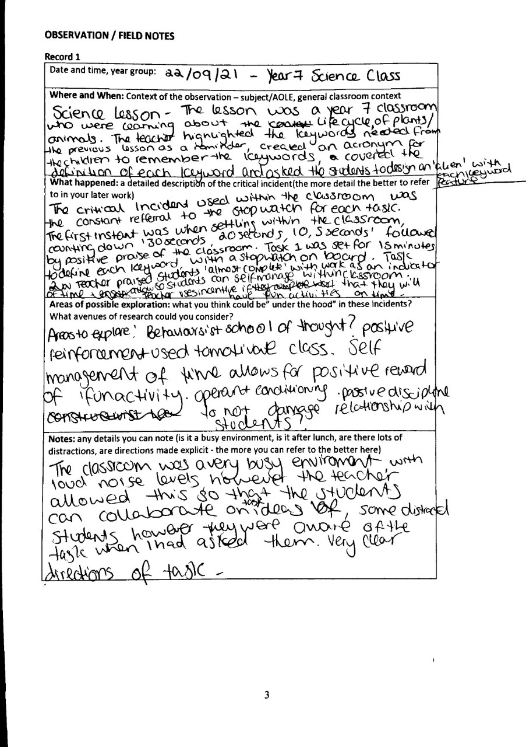
Figure 1.

Figure 2.
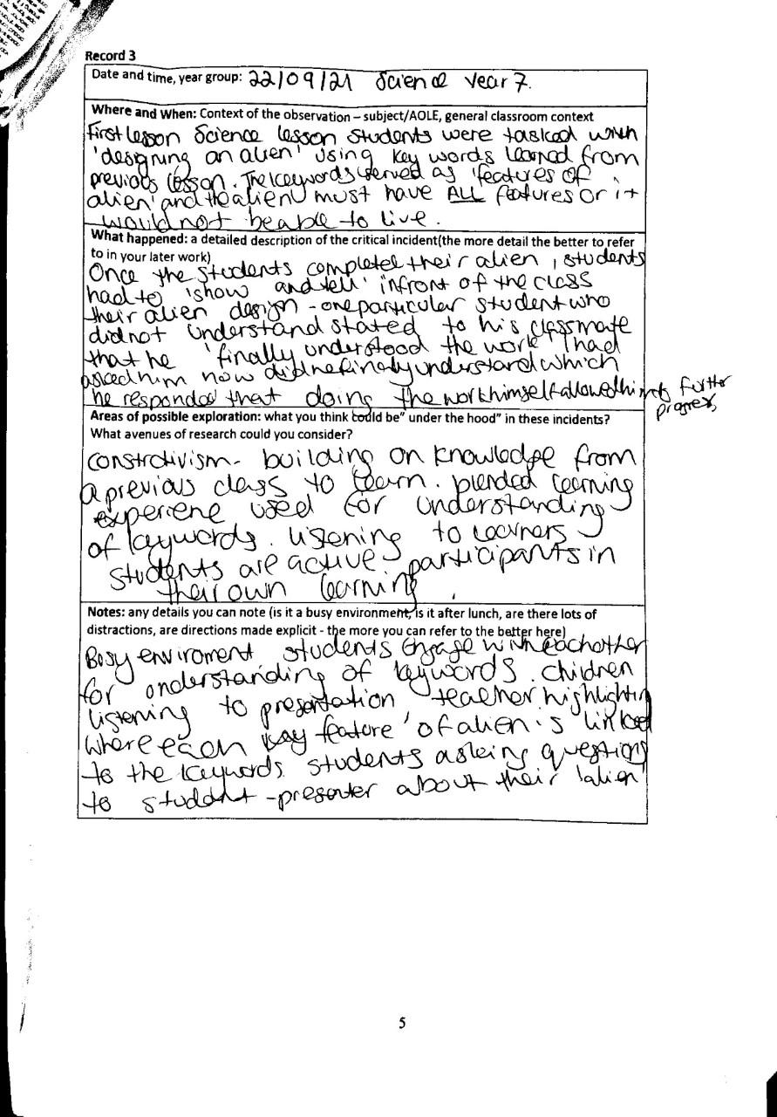

Figure 3.

References
Alesandrini, K. and Larson, L., 2002. Teachers Bridge to Constructivism. The Clearing House: A Journal of Educational Strategies, Issues and Ideas, 75(3), pp.118-121.
Amineh, R. and Asl, H., 2015. Review of Constructivism and Social Constructivism. Journal of Social Sciences, Literature and Languages, [online] 1(1), pp.9-16.
- Andrews, Tom. “What is Social Constructionism?” Grounded Theory Review: An International Journal, vol. 11, no. 1, 2012. http://groundedtheoryreview.com/
2012/06/01/what-is-social-constructionism/
- Apperson, J.M., Laws, E.L. and Scepansky, J.A., 2006. The impact of presentation graphics on students’ experience in the classroom. Computers & Education, 47(1), pp.116-126.
Ackermann, E., 2001. Piaget’s constructivism, Papert’s constructionism: What’s the difference. Future of learning group publication, 5(3), p.438.
Aubrey, K. and Riley, A., 2019. Understanding & Using Educational Theories. 2nd ed. London: SAGE Publications, pp.55-117.
Bartlett, S., 2001. Introduction to Education Studies. London: SAGE PUBLICATIONS.
Brandenburg, R., Glasswell, K., Jones, M. and Ryan, J., 2017. Reflective Theory and Practice in Teacher Education. 17th ed. Springer Nature.
Brookfield, S., 1998. Critically reflective practice. Journal of Continuing Education in the Health Professions, 18(4), pp.197-205.
Burr, V., 2015. Social Constructionism.
Donaldson, G. (2015) Successful futures: Independent review of curriculum and assessment arrangements in Wales (Cardiff, Welsh Government).
ESTYN, 2018. The Bishop Of Llandaff C.I.W. High School. [online] Cardiff: ESTYN, p.3. Available at: <https://4905753ff3cea231a868-376d75cd2890937de6f542499f88a819.ssl.cf3.rackcdn.com/llandaff/uploads/document/The-Bishop-of-Llandaff-CIW-High-School-May-2018.pdf?ts=1526294263> [Accessed 11 October 2021].
Fawcett, L. and Garton, A., 2005. The effect of peer collaboration on children's problem-solving ability. British Journal of Educational Psychology, 75(2), pp.157-169.
Furlong, J., 2020. Re-forming Initial Teacher Education in Wales: A Personal Review of the Literature. Cylchgrawn Addysg Cymru / Wales Journal of Education, 22(1).
Ghaye, T., 2011. Teaching and Learning through Reflective Practice : A practical guide for positive action. 2nd ed. New York: Routledge.
Gijbels, D., van de Watering, G., Dochy, F. and van den Bossche, P., 2006. New Learning Environments and Constructivism: The Students’ Perspective. Instructional Science, 34(3), pp.213-226.
GOV.WALES. 2021. Education is changing | GOV.WALES. [online] Available at: <https://gov.wales/education-changing> [Accessed 9 October 2021].
Hedges, H., 2000. Teaching in Early Childhood: Time to Merge Constructivist Views so Learning through Play Equals Teaching through Play. Australasian Journal of Early Childhood, 25(4), pp.16-21.
Husebø, S., O'Regan, S. and Nestel, D., 2015. Reflective Practice and Its Role in Simulation. Clinical Simulation in Nursing, 11(8), pp.368-375.
Kuusisaari, H., 2014. Teachers at the zone of proximal development – Collaboration promoting or hindering the development process. Teaching and Teacher Education, 43, pp.46-57.
Lourenço, O., 2012. Piaget and Vygotsky: Many resemblances, and a crucial difference. New Ideas in Psychology, 30(3), pp.281-295.
McPhail, G., 2015. The fault lines of recontextualisation: the limits of constructivism in education. British Educational Research Journal, 42(2), pp.294-313.
‘Newton, L. (2005). ‘The Reflective Practitioner’ in English, E. and Newton, L (Eds.) Professional Studies in the Primary School: Thinking Beyond the Standards. London: David Fulton.
Perry, N., Hutchinson, L. and Thauberger, C., 2008. Talking about teaching self-regulated learning: Scaffolding student teachers’ development and use of practices that promote self-regulated learning. International Journal of Educational Research, 47(2), pp.97-108.
Roth, W. and Radford, L., 2010. Re/thinking the Zone of Proximal Development (Symmetrically). Mind, Culture, and Activity, 17(4), pp.299-307.
Rogoff, B., 2008. Observing sociocultural activity on three planes: Participatory appropriation, guided participation, and apprenticeship. Pedagogy and practice: Culture and identities, pp.58-74.
Scott, D., 2008. Critical Essays on Major Curriculum Theorists. 1st ed. New York: Routele
dge.
Segers, M. and Dochy, F., 2001. New Assessment Forms in Problem-based Learning: The value-added of the students' perspective. Studies in Higher Education, 26(3), pp.327-343.
Shabani, K., Khatib, M. and Ebadi, S., 2010. Vygotsky's Zone of Proximal Development: Instructional Implications and Teachers' Professional Development. English Language Teaching, 3(4).
Suryani, Y., Hidayah, A. and Dewi, N., 2021. The effectiveness of blended learning- baed scaffolding strategy assisted by google classroom towards the learning outcomes and students self-efficscy. Journal of Physics: Conference Series, [online] 176(1). Available at: <https://www.proquest.com/docview/2512295293?accountid=130472&pq-origsite=primo> [Accessed 21 October 2021].
Tillema, H. and van der Westhuizen, G., 2006. Knowledge construction in collaborative enquiry among teachers. Teachers and Teaching, 12(1), pp.51-67.
Tripp, D., 2011. Critical Incidents in Teaching (Classic Edition). Hoboken: Taylor & amp.
Sawyer, R.K., 2013. Qualitative methodologies for studying small groups. In The international handbook of collaborative learning (pp. 138-160). Routledge.
Turner, J.C., Meyer, D.K., Midgley, C. and Patrick, H., 2003. Teacher discourse and students’ affect and achievement-related behaviors in two high mastery/high performance classrooms. Elementary School Journal, 103, pp.357-382.
van Boxtel, C., van der Linden, J. and Kanselaar, G., 2000. Collaborative learning tasks and the elaboration of conceptual knowledge. Learning and Instruction, 10(4), pp.311-330.
Van Meter, P. and Stevens, R., 2000. The Role of Theory in the Study of Peer Collaboration. The Journal of Experimental Education, 69(1), pp.113-127.
Vogel-Walcutt, J., Gebrim, J., Bowers, C., Carper, T. and Nicholson, D., 2010. Cognitive load theory vs. constructivist approaches: which best leads to efficient, deep learning?. Journal of Computer Assisted Learning, 27(2), pp.133-145.

