Name – Moshiur Rahman

Student ID- 1814025

Programme- BA (Hons) Leadership and Management Skills for the Workplace

Internal Verifier: Dr. Eric Osei

Assignment title: Coursework (Innovative service plan )

Module: Developing Innovation and Creativity for Business Advantages

Module code – BMSW6102

Lecturer- Dr. Charles Vincent

Submission Date- 06/04/2022

Developing Innovation and Creativity for Business Advantages

Table of Contents
Introduction 3
Innovation services concept 3
Selling innovative services 3
Emerging customers need and want 4
Customers of my innovative services 4
Venture 4
Where and how to sell my Innovative Services 4
Customers, selling place and venture of my innovation 5
Competitors plan, competition advantage and others of my innovation 5
E-commerce or Brick and Mortar store 6
Figure: Rising E-commerce innovation 6
E-commerce 6
Brick and Mortar store 8
Marketing Strategies 9
Promoting my innovative services 9
Target customers and reach point to them 10
Using the social media 10
Using of Paid Search Engine 10
Understanding the role of Customers journey 11
Using physical and online marketing techniques 11
Pre-launch Promotion 12
Conclusion 12
References 12

Introduction
Creativity and Innovation are two diverse terms and they have diverse implications. Creativity implies inventiveness, creative ability, and inventiveness that are brought out through genius. Innovation, on the other hand, alludes to modernization and enhancement over an existing thought. Another critical thing required is that there's an administrative move and a cognitive move. This makes a difference the firm creates conjointly be open to new concepts. As there's increasingly learning within the company, naturally there would be a chance for breakthrough innovation. This expanded likelihood of modern item improvement leads to higher success rates of the company and at the same time leads to improvement of competencies, provides the next competitive advantage conjointly makes a difference handle competition in distant better (Asbari et al, 2021).

Innovation services concept

Selling innovative services
There are different kinds of innovation service businesses and these are individual innovations including residence-discipline, bookkeeping, trading-project, carpet dyeing, porcelain ware repair, individual analysis, licensed organizer, extreme service, cafeteria delivery, and so on. Sales and marketing innovation including copywriting and proofreading service, mailing services, popular-relations department, sales-egad generating, and so on. Home innovation services including lawn stress, regional shifting service, miniblind washing, contract service, packing and unpacking service etc. Technology innovation services will be done such as computer improvement, computer consulting, internet inquiry, website planner and so on. also children’s innovative services, and affair services. I’m going have a car breakers license which can be obtained from the local authority in my case it will be Birmingham City Council, I will be buying insurance right off vehicles from a company call COPART and take off all the parts and sell it back on the market using online platform like Ebay and other source, What is COPART? It’s an industry leader in the resale and remarketing of used, wholesale and salvage vehicles through exclusive online auction platform. With over 10 years of experience in the UK automotive industry, it specialise in selling vehicles on behalf of the insurance sector, fleet, lease and hire companies, trade sellers, financial institutions, and the general public. Whether you are a dismantler, dealer, body shop, salvage buyer or individual, Copart UK makes it easy for Members to find, bid and win vehicles through their innovative online auctions. As a global company, they also give you the power to link up with buyers and sellers all over the world from your fingertips. .

Emerging customers need and want
In emerging customer needs and wants there will service attend to product and services need and these are 1. Functionality: Clients require my item or benefit to operate the way they require in arranging to illuminate our issue or want. 2. Cost: Clients have one kind of money with that they can buy an item or benefit. 3. Plan: Along the lines of involvement, the item or benefit requires a smooth plan to create it generally simple and intuitive to utilize. 4. Unwavering quality: The item or benefit should dependably work as publicized every time the client needs to utilize. 5. Execution: The item or benefit must be task accurately so the client can accomplish my objectives. 6. Sympathy: When my clients take in touch with client benefit, consumers need compassion and understanding from the individuals helping them. 7. Decency: From estimating to terms of benefit to contract length, clients anticipate decency from an organization.

Customers of my innovative services
Usually every business has different types of customers. Just as there are customers for physical services, there are also customers for using or enjoying innovative services. Those who have a good idea about innovative services and those who want to use innovative services are the customers of innovative services. People who generally rely on creativity, who themselves are very interested in innovation, are the main customers of my innovation service.

Venture
Every business has its own venture name and my venture name is ‘Creatinovative Idea'. 24/7 Car parts LTD The name of my venture has been taken in such a way that customers can easily find and know about my innovative service.

Where and how to sell my Innovative Services
A company or business organization can sell their products in different ways if they want. Goods or services can be sold directly to customers from the point of production or services can be sold through an organization. I sell my innovative services through organizations, various online sites, agencies, and my own organization. There are several strategies that can be used to sell innovative services and these are innovative services need to build good relationships with users or consumers, innovate services need to be designed in a way that makes them more attractive to customers, provide easy access to information for everyone to know about the services, customers need to respond in a timely manner, deal with buyers in a timely manner, review customer issues and needs, provide free services if possible, and return opportunities. Through social media such as Facebook, Instagram, Twitter, LinkedIn is one of the levels of selling my innovative services (Tang et al, 2021).

Customers, selling place and venture of my innovation
Actually, those people are customers who want to consume my innovation products and services. I will sell my products and services in online media such as e-commerce and offline media such as my own shop and branches. There is my own venture in my business. Some additional and important products and services are my unique selling points. No matter what you’re offering, making a clear and compelling esteem suggestion could be a key part of understanding the client's encounter. (Benzaghta et al, 2021).

Competitors plan, competition advantage and others of my innovation
There are different types of competitors in the innovation services area and they produce a lot of products and services like our products. They also sell their products and services online and offline. The main competition advantages are increasing production, gaining customers satisfaction, more profit gain, increasing quality of products etc. My value proposition is different from theirs and these happen for supplying quality products, engaging customers and customer’s priority. The finest esteem recommendations will offer assistance to your commerce within the taking after ways. It makes separation, adjusts companies’ items with their target market’s needs and pulls in their perfect client.

E-commerce or Brick and Mortar store
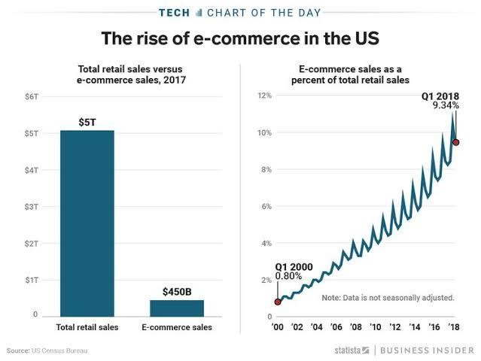

Figure: Rising E-commerce innovation

E-commerce
Amazon Marketplace is an e-commerce stage possessed and worked by Amazon that empowers third-party vendors to offer modern or utilized items on a fixed-price online commercial center nearby Amazon's normal offerings. Utilizing Amazon Commercial center, third-party dealers pick up to get to Amazon's client base, and Amazon grows the offerings on its location without having to contribute in extra stock. Amazon funding includes a run of attention items as well as assistance offerings by Amazon.com to assist shoppers and small commerce clients to reward for buying up season (Prysiazhnyk, 2021). terminology and conditions differ depending on commercial soundness and the construction of advances includes both portions in addition to wide-completed attention arrangements. Amazon’s raid into monetary administrations has continuously been around building openings for investing inside the Amazon biological system. The company has generally been dynamic in a few finch regions, especially online installments. At that point in 2011, it propelled little trade loaning, and from there began to roll out diverse credit card items for both its small commerce and customer clients. Amazon offers clients a few spinning credit options.
Amazon’s most well-known card is credit cards and most important for financing. Workforce Staffing (WFS), a division of Around the world Operations, makes a difference by bringing together the workforce controlling Amazon’s capacity to charm clients: the Amazon Relate. With over 100,000 worldwide enlists a year, WFS underpins our retail and Prime brands by sourcing, enlisting, and creating the leading ability to work in our fulfillment centers, sortation centers, conveyance stations, shopping destinations, Prime Discuss areas, and more. WFS is made up of experts in corporate, field-based, and inaccessible parts, traversing different disciplines, counting Operations, IT, Showcasing, Human Assets, Trade Insights, and more. Amazon Pay accepts credit, charge cards and PayPal payment system. Credit cards right now acknowledged include Visa, MasterCard, Discover, American Express, Coffee shops Club, and JCB etc. The Amazon.com store card is accessible for utilizing with chosen shippers (Morello, 2021). There are a few key focuses famous within the direction including in PCI-DSS compliance issues: The have to be amass a security mindfulness group, which is mindful of the improvement, conveyance and support of the security mindfulness program, why creating security mindfulness substance for the trade plays a basic part in creating suitable substance and preparing data and how commerce can utilize security-awareness checklists to screen and security mindfulness preparing programs.

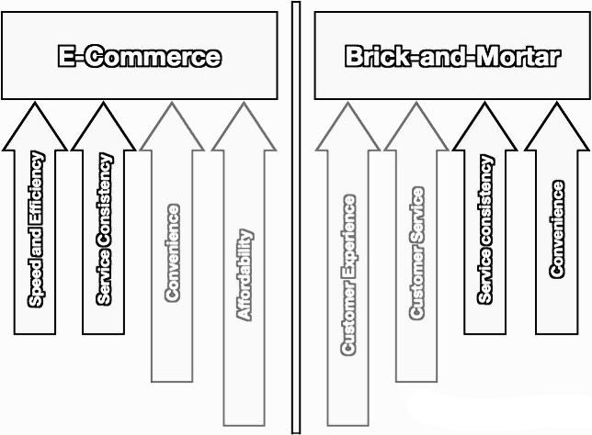
Figure: E-commerce and Brick-and-Mortar’s activities

Brick and Mortar store
The word "brick-and-mortar" alludes to a conventional street-side commerce that gives items and services to its clients face-to-face in an office or store that the commerce claims or rents. The nearby basic need store and the corner bank are illustrations of brick-and-mortar companies. Brickand-mortar businesses have found it troublesome to compete with, for the most part, web-based businesses like Amazon.com since the last mentioned as a rule have lower working costs and more prominent adaptability (Zeng et al, 2021). Amazon gifts you a restricted, shifting, non-complete, percentage-free, non-transferable, non-sub licensable grant to get to, utilize and replicate the Program Materials exclusively for the reason of sending and accepting data in association with Amazon Publicizing by or on sake of the specific Amazon Promoting Member that has explicitly authorized you to do so. In arranging to get to or utilize the Program Materials, you must total the enrollment prepare and give certain enlistment data to us. When utilizing the Program Materials, you may not make any diverts or third-party calls unless you begin with getting Amazon’s express, earlier composed endorsement. There is some space a company will need for setting up their visual merchandising and for selling their services. These visuals engage customers from external of the market, body products closely, optimize display to commodity, stimulate displays and layouts, online visible producing for e-commerce like short videos about products and advertisements, create a seamless shopping experience, present company's products in the best light, personalize the shopping experience and optimize the company's store for mobile. On a per-market premise, openly-traded merchants regularly announce same-store deals, or equivalent-market deals, in their quarterly and annual SEC-monitored revenue reports. These budgetary measurements give an decapitation observation for the set up stores of a retail chain over an indicated period of time. Brick-and-mortar businesses that integrate eateries, key demand stores, and standard stock stores utilize these figures to determine their monetary hanging to direct collaborative decision-making with respect to their stores. On a macroeconomic level, the U.S. Census Bureau discharges retail deals figures on a month to month premise and e-trade retail deals figures on a quarterly premise. The brick-and-mortar store likely encompasses a steadfast client base, all experienced staff of any brick-and-mortar, and an acknowledged approach to forms. These, however, depend for the most part on printed material or spreadsheets to induce things done. Presently, as you step into a more ambitious situation with the latest openings at each surprise, we offer supreme arrangements to assist maximize your potential (Boysen et al, 2021).

Marketing Strategies

Promoting my innovative services
There are different stages online where you'll be able to advance your items and can reach a tremendous number of gatherings of people. There's barely any individual who isn't utilizing either Facebook or Instagram. By using this stage, you'll make individuals mindful of your product. You'll conversation approximately its employments and how it is basic for them. In expansion to this, you'll appear, individuals, how your item is superior to other comparable products. Unlike other special techniques which are indiscriminately pushing their item on everybody. You'll make beyond any doubt that your item has reachability to your potential clients who have tall chances to urge change over. On the off chance that you’re trying to find cost-friendly alternatives for advancing your advancement administrations.

Target customers and reach point to them
There are some elements of reaching target customers and these are- Characterize Your Target Audience: To reach your target group of people, you must begin with characterizing your target group of onlookers. And, for this, you wish to get it from your clients. Deliver Valuable and Important items and services: The best way to reach your target group of onlookers is by giving them valuable and important substances. Composing almost all points that are of interest to your aiming group of onlookers may be a beyond any doubt shot way of snatching their attention. Leverage Influencers: Influencer promoting has rapidly gotten to be the go-to promoting fashion for computerized marketers. Utilize Focused on Advertising: You can reach your target group of onlookers more viably by using focused on promoting. Whether it is Google advertisements or social media advertisements, they all give progress focusing on choices to assist you reach your target gathering of people. Reach Your Target Group of onlookers on Social Media through Hashtags (Kross et al, 2021).

Using the social media
Social media is now a very popular and effective medium for marketing. Companies promote their products by marketing through social media. Almost all the domestic and foreign companies have taken social media marketing as an important aspect. I do marketing using some of the famous social media like Facebook, Instagram, Twitter, etc. Sales advancement: In-shop show materials reflecting the same messages and project as the advertisements, emphasizing objective-of-sale affect. Computerized promoting: restricted time data on the organization’s network position that reflects the equivalent messages, structure, and offers reflected enclosed by the advertisements; advertisements themselves may be posted on sites, YouTube, Facebook, and mutual on other social media. Public relations: A push discharge broadcasting object meaningful in company with the shocking situation, destinations, and objective fraction. Nowadays more or less people of all ages are involved with social media. In today's market you must use social media if you want to increase the customer base of your business or product. You can promote your business through social media by uploading various posts on Instagram, Facebook or Twitter.

Using of Paid Search Engine
Paid search engine may be a shape of advanced showcasing where search engines such as Google and Bing permit sponsors to appear advertisements on their search engine results pages (SERPs).
Paid search works on a pay-per-click demonstrate, significance anyone is accomplishment precisely that – until somebody clicks on their publicity, they do not pay. It's totally depend on digitalize methods. There are five ways to advance your advancement administrations and items on Google. These ways are- type in valuable, high-quality substance, incorporate keywords on your pages, gain backlinks, utilize Google Commerce Profile (GBP), and list your commerce in online registries etc. In an effectively worked campaign, all exercises will be well-coordinated to construct on one another to extend the by and large affect.

Understanding the role of Customers journey
Understanding the organization from the customer’s point of view brings unused thoughts and suppositions to the table. Customer journey analysis does accurately that – it analyzes client perspectives approximately items so simply can make fitting changes to keep clients steadfast to your brand. Utilize information from clients to actualize progressed promoting methodologies. To create an appropriate client journey, a company should take after a few things and these things are;
Understand the target buyer’s persona, recognize the target audience’s expectations, note the touch points, inquire pivotal questions, make a list of needs and put all thoughts to paper.

Using physical and online marketing techniques
There are different types of physical and online marketing techniques utilized in my innovation services marketing. The physical marketing strategies are show stands, posters, sponsorship and physical branding. The main types of online marketing techniques, counting SEO, PPC, social media promoting, e-mail showcasing, blogs, videos, recordings, podcasts, infograms, social media posts, and more. There are some physical or online showcasing and these are advertising: An adjustment of cognate, well-timed, precisely insert TV advertisements coupled with newspaper elevation in chosen magazines and newspapers. private offering: arrangement and preparing for client deals agents roughly the offensive to plan them to analyze and emphasize the piece benefits focused on marketing. Digital marketing is a great way to market your product. At present companies can only reach their target customers in a very short time with the contribution of digital marketing. If we talk about the last few years, we can see that the style of advertising has changed a lot. If you want your ad to reach millions of people at once, you need to move away from the old traditional marketing fund and move on to digital marketing.

Pre-launch Promotion
A company may use different types of pre-launch promotion methods and strategy. Pre-launch promotion creates good minded about any products and services. Some pre-launch promotion that I use in my innovative services that is plans for pre-launch products; Organize a pre-launch giveaway, increment the items natural personality, make shareable substance, take a chance with remarketing, make a referral program, optimize the company's site Speed, set up connections with influencers, lookout of the client benefit, get ready company’s FAQs some time recently propelling their Item, and don’t disregard almost mail promoting etc.

Conclusion
Innovation, creativity and expository abilities are profoundly basic in overseeing and succeeding in a trade. Most of the effective companies like Amazon, Hewlett Packard and numerous more have continuously been the result of a fruitful association between an imaginative and an expository leader. This makes a difference-making commercially practical advancement, which is the key to victory. Analysis of an idea is exceedingly basic in any trade and typically enormously impacted by social impacts. In addition, innovations within the field of technology and amusement are greatly influencing cultures and masses. It is additionally essential that improvement may be a fragment of all organizations that should or must be energetic.

References
- Asbari, M., Prasetya, A.B., Santoso, P.B. and Purwanto, A., 2021. From Creativity to
Innovation: The Role of Female Employees’ Psychological Capital. International Journal of Social and Management Studies, 2(2), pp.66-77.
- Benzaghta, M.A., Elwalda, A., Mousa, M.M., Erkan, I. and Rahman, M., 2021. SWOT analysis applications: An integrative literature review. Journal of Global Business Insights, 6(1), pp.55-73.
- Boysen, N., de Koster, R. and Füßler, D., 2021. The forgotten sons: Warehousing systems for brick-and-mortar retail chains. European Journal of Operational Research, 288(2), pp.361-381.
- Johnston, A., 2021. Open innovation in science: assessing the formation and function of SME-university collaborations through the proximity matrix. Industry and Innovation, pp.1-23.
- Kross, E., Verduyn, P., Sheppes, G., Costello, C.K., Jonides, J. and Ybarra, O., 2021. Social media and well-being: Pitfalls, progress, and next steps. Trends in Cognitive Sciences, 25(1), pp.55-66.
- Morello, T.F., 2021. COVID-19 and agricultural fire pollution in the Amazon: Puzzles and solutions. World Development, 138, p.105276.
- Prysiazhnyk, A., 2021. Dynamic Pricing using Reinforcement Learning for the Amazon marketplace.
- Tang, T.Y., Zhang, S.K. and Peng, J., 2021. The value of marketing innovation: Marketdriven versus market-driving. Journal of Business Research, 126, pp.88-98.
- Zeng, D., Liu, Y., Yan, P. and Yang, Y., 2021. Location-Aware Real-Time Recommender Systems for Brick-and-Mortar Retailers. INFORMS Journal on Computing, 33(4), pp.1608-1623.
- Zhang, M., Fan, B., Zhang, N., Wang, W. and Fan, W., 2021. Mining product innovation ideas from online reviews. Information Processing & Management, 58(1), p.102389.

