Marketing plan



By Lucy Bianca Harratt
Tutor: Jessica Shore
Unit: Digital and Social Marketing

Content page

- Title page
- Executive summary
- Brief of the marketing plan for Ultimate Dance Academy
- Background research
- Overview on digital and social marketing
- The 7Ps
- Identifying the marketing approach for this business
- Stages of advertisement
- Stage one: Creating a brand
- Stage two: Social media
- Stage three: Out-of-home advertisement
- Stage four: spreading the word
- Target audience
- Who to target
- Where are we targeting (Location)
- Why to target them
- How to target the audience
- Our brand
- How the brand will become recognisable
- Success rate
- The plan to measure success rate
- References

Executive summary
This report will examine the marketing process behind the ‘Ultimate Dance academy’. The aim is to demonstrate how the company will be targeting people that might be interested in the services of which they offer. The report will show research done in order to find the most successful marketing scheme and how it will be constructed and used. It will show the development behind creating the brand and how it will advertised throughout the company’s progress. Along with this, it will include a ‘stage’ system demonstrating how the company will create and image and share it through social media and other forms of advertisement.

Background research
This research will demonstrate the studies that have been done in order to find the correct and beneficial way to market this company. This has been done by studying methods,techniques and tricks used by other companies that have proved successful. A popular tool for executing marketing is the ‘7Ps’. This originated from the original 4Ps, a concept created by Edmund Jerome McCarthy in 1960. The economy we know now has changed a lot since 1960, since then this method has been developed into the ‘7Ps’ by Booms and Bitner in 1981, since then other theorists have added and changed this framework as they had different opinions. A study of this method was done byMohammed Rafiq, Pervaiz K. Ahmed, (1995) which gives a detailed analsis on the development of this marketing methood and wwhy it has changed. This showed that the groth was made to make the process of marketing more detailed This marketing mix is still popular and used regular in today’s marketers all around the world. The aim is to find the correct way to adapt this market mix to fit Ultimate Dance Academy (UDA)
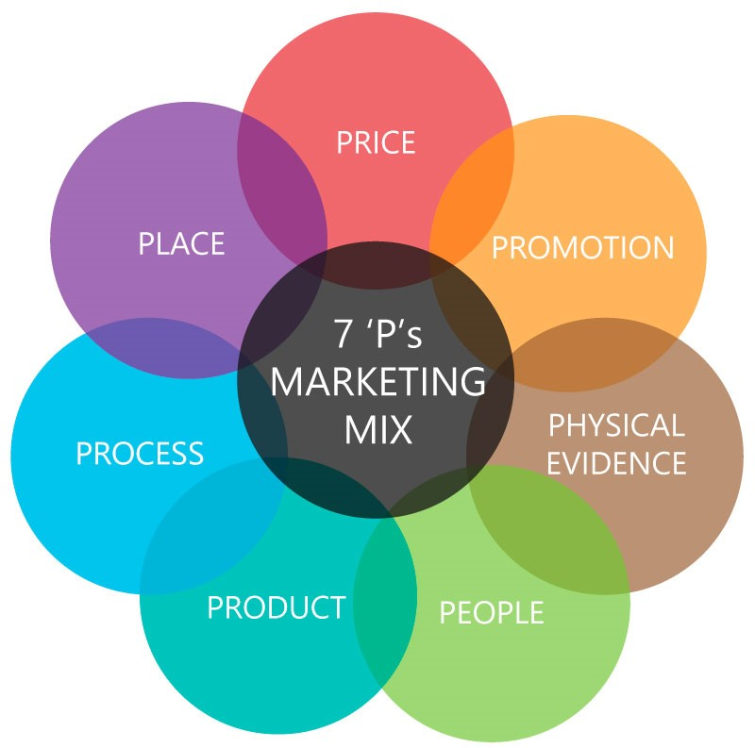

Abover is a diagram of the 7Ps demonstrating the 7 different elements used to make the marketing mix. This was used to build a plan or marketing for the business Ultimate Dance Academy. This business will need to advertise the ‘product’ which is the services they offer which is a number of dance classes that include baton twirling and pom dance. These classes will include building strength, endurance and flexibility throughout. It will also need to advertise the prices of the classes and how they need to be paid. The ‘Place’ will be the location of which the dance classes are held. Promotion will be a number of different advertisement techniques such as social media and Out-of-home promotions. The company will also have a target audience which will cover the ‘people’ they want the advertisement to reach and how they are going to reach them.

Stages to advertisement
Stage one : Creating a brand
After deciding the concept of the business, the net step was to name the business. The idea is to create a name that is ‘catchy’ and memorable. You want the name to draw people in and be more interested in what you have to offer. ‘Ultimate’ is a descriptive that is means ‘best’ or ‘powerful’ this intrigues customers as they see the company is confident, and when looking for services, people want the best for the best price. Dance academy is to show people what the company is and what they do, this is a clear and bold indication that is simple yet effective. The idea of a colour scheme is to represent your company. You want people to see the colour and automatically think of the logo or the company itself like a reminder. The colour scheme for UDA is a mixture of Black, Pink, grey and white. Colour palette below:

These colours were decided as they are easy to repeat and create whilst making different forms of advertisement. And the overall look is sophisticated and elegant and gives a processional outlook.
The next step was to create a logo, after looking at examples it was decided that the logo would again be simple and effective, inspired by the phrase ‘simple is more’. This is an important step as the logo is the first thing a customer sees and you want it to attract them. As UDA is a dance company, an image of a dancer was used followed by the company name using the company colours. This logo will be placed on uniforms, social media profiles, posters, leaflets and business cards. The Logo following is the current logo chosen for the business.

After the logo and name is decided, the next stage would be to look into different methods of advertisement.

Stage two: Social media
The next step was to create a Facebook business page. This including setting a profile picture, and a cover image. The aim was to show people the services we were offering, so the images used included a list of the dance we teach and evidence of previous classes. On this page, there is a ‘contact us’ button where the email for the company has been placed if there are any enquiries, there is also an ‘inbox’ method through the facebook application itself.
- Facebook page: Ultimate Dance Wales
- Email address: Ultimatedancewales@gmail.com

The following image is the cover photo used for the facebook page, advertising the styles of dance classes we offer, this was created using our company logo font, and colour scheme.

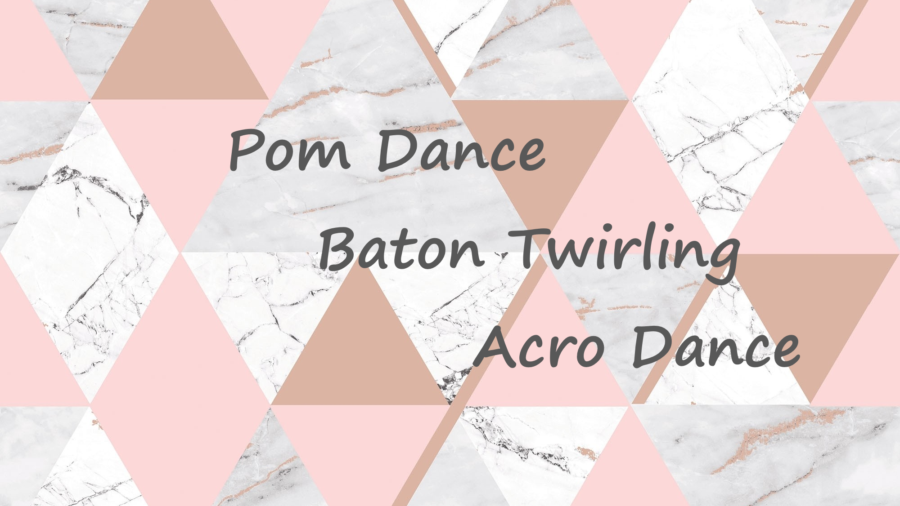

The facebook page means it is possible to post updates, upcoming classes, available time slots for private classes and more. This page can be shared between anyone and can be passed around and reach hundreds of people. The benefit of this being that it is completely free and extremely effective. Facebook has now advanced so much that they have a success rate score out of 5, a speed of reply score and even an area where people can post pictures of their experience with you for others to see. This can also be a threat as you could get someone who is bias or worse, could be pretending they attended a class when they did not, possibly a co existing company trying to lower the score of success. Facebook share their love for small businesses, they even made it easier for people to start a business page by creating a “a tool that makes it easy to create a video that shows what your business brings to the world. Because we believe the best way to tell the story of three million businesses is to empower each one to share their own.” This tool is called “your business story” and is available for anyone who is starting or has a business. This will make it easier to see how many people your page has reached.

Stage three: Out-of-home Advertisement
The next stage is to advertise the class, this can be done on the page or on paper. The easier and more effective way is to advertise on the page as it reaches more people. The creation of a poster/leaflet will need to include
- What type of dance class it is
- The location of the class
- The price of the class
- The age of the children allowed to attend
- What they should expect
- contact details
- images and evidence
This poster would need to be bold and clear in order for it to be easy to read and understandable. These posters can be advertised on the page and shared through friends and family. There is also an option to pay to boost your page to people in your area for a low price. This is a great way to get your company known in the area. Promotion videos are a brilliant way to showcase your classes, this will need to be done after you have gathered enough physical evidence to create a clip.
Here is an example of Celtique’s promotion video they posted in 2019. This is a dance team located in Carmarthenshire.
Link below for video.
https://www.facebook.com/Carmarthentowntwirlers/videos/2403629519965293/
Posters and leaflets are needed as they can be handed out at performances where people get to see first hand what they do. This is a good way to reach people instantly and hook them into joining or even telling other people of our services.

Stage four: Spreading the word
The next step would be to just spread the information, reaching as many people as possible through all forms of advertisement.

Target audience
The idea of target audience is to guess the type of audience that would want to use your services. As this is a dance company for children between the ages of 6 and 15+. We are more likely to need to reach parents or guardians or anyone who knows children that would be interested. Parents are looking for more creative ways to keep their children active, dance is a brilliant way to keep them stimulated. This is an important element to share and demonstrate through advertisement. This dance school may appeal to adults, so the idea is to reach as many people as possible. To Target these people, there are many settings on facebook where you can select the page to be advertised to people who are interested in things in common to dance. At performances, leaflets can be handed out to people who show interest. A great way to reach a target audience is to go into school or facilities where children can be shown the art of baton twirling and pom. They may then chose to join as they’ve had the chance to experience a class. Offers such as a ‘free taster’ class is a great way to invite people in as they know they can try something without sending all their money which may make them hesitant. This is similar to the ‘money back’ technique that many companies offer when selling a product. To reach a young audience, social media is not the best option as most children are too young for the page, but parents and guardians will be able to locate the page easily.

Our brand
Our logo and name will be located on the training uniforms and team tracksuits in order to look smart and professional during training classes and also be recognisable in public. When performing in local parade and event, it is important for the uniform to be visible so if possible customer are interest in joining the classes, they can search or ask for the contact details. These uniforms will also bee worn at important competitions where it is important to look clean and tidy. It is vital to look sorted when it comes to uniform, the issue here is that this can be expensive. This is where sponsorship may be needed, where the logo of a company would be placed on the kit that they have paid or donated money towards. The aim is to get the name and logo well recognised in order to reach more people when we perform or compete.

Success rate
The plan to measure the success rate of the marketing of the company is by looking for feedback. Asking where people heard about the classes. This way we can determined which technique is more effective and whether they were intrigued by the live performance, or images and videos on facebook. Through facebook it is possible now to see how many people your page has reached, this is similar to business accounts on other forms of social media such as Instagram which allows you to see how many views your videos get and how many people have viewed your business page.

Conclusion
To conclude this report, a marketing plan was needed to determine how the company as going to select and target an audience. To do so, its evident that there is a need for a well though out brand image. In order to appeal possible customers, a logo and stand out name will be needed. Post research, social media has become a very successful and easy way to promote a business. Research showed that over 3 million companies advertise using facebook, 70% being outside the US. Facebook prides themselves on being the location where small businesses can share their stories. Although there are many threats to advertisement through social media such as false claims or bad ratings which could harm the businesses reputation, the benefits of it are the fact It is free and more easy and accessible than ever. The selected target audience could easily be gained through both digital and face to face interaction, but digital advertisement appears to have a higher success rate.

References

- Celtique, promotion video, (2019), https://www.facebook.com/Carmarthentowntwirlers/videos/2403629519965293/
- Facebook, business news, (2016), https://www.facebook.com/business/news/3-million-advertisers
- Image of the ‘7Ps’, (2018), https://www.edumapia.in/the-marketing-mix-from-4-ps-to-7-ps/
- Images from Celtique, (Retrieved 2020), https://www.facebook.com/Carmarthentowntwirlers/
- Mohammed Rafiq, Pervaiz K. Ahmed, (1995) "Using the 7Ps as a generic marketing mix: an exploratory survey of UK and European marketing academics", Marketing Intelligence & Planning, Vol. 13 Issue: 9, pp.4-15, https:// doi.org/10.1108/02634509510097793
- Ultimate Dance Wales, Logo and cover photo, 2020, https://www.facebook.com/photo?fbid=120458832954737&set=a.110902127243741

