Structure and properties of materials
Glass reinforced plastic
Kurtis Russ
2116773

Contents
Introduction 3
Task 1 4
Application Description 4
Task 2 5
Importance of the Application 5
Material Options 5
Justification for Material Choice 6
Task 3 7
Available Manufacturing Processes 7
Selected Process (VARTM) 7
Task 4 8
Structures of GRP 8
Task 5 9
Properties of GRP 9

Introduction
Glass Reinforced Plastic (GRP) is a versatile material that combines the protective properties of a polymer with the strength of glass fibres. GRP is robust, lightweight, and resilient to environmental stresses produced in different environments, which makes it a great option for the marine industry, especially for boat hulls. Compared to other materials like steel and wood, GRP's durability and resistance to corrosion helps boats to handle these difficulties. GRP's lightweight and design flexibility further increase its appeal for marine applications. The advantages and characteristics of GRP in maritime environments are examined in this research, along with an assessment of substitute materials and a reason for using GRP for boat hulls. It also evaluates other manufacturing techniques, The paper concludes by going over important testing techniques that validate GRP's performance in operational circumstances.

Task 1

Application Description
Glass Reinforced Plastic (GRP) is a composite material that consists of glass fibres that are placed within a polymer matrix. The matrix usually consists of polyester, vinyl ester, or epoxy resins, this then bonds the fibres together to create a solid structure. This can be backed by Naveen as he explains “Composite materials produce a combination properties of two or more materials that cannot be achieved by either fibre or matrix when they are acting alone” (Naveen et al., 2014). The combination of these components makes the material strong, lightweight, and resistant to environmental factors, making it an ideal choice for marine applications. Increased tensile strength and stiffness are the main functions of the fibres in glass reinforced polymer (GRP), and the resin matrix protects the fibres from the elements and loads applied to them. Naveen says that “Glass fibres are having excellent properties like high strength, flexibility, stiffness and resistance to chemical harm” (Naveen et al., 2014).

Task 2

Importance of the Application
Boats are subjected to a variety of harsh environments all the time, such as UV radiation, impact forces, seawater corrosion, and water pressure. Due to its material qualities, GRP is the perfect material for it because it can withstand these challenging conditions with little maintenance needed. “The resins used in GRP offer corrosion resistance over a wide pH range” (Gripclad, 2019). Unlike more conventional materials like steel and wood, this corrosion resistance allows boats to retain their structural integrity over time, lowering the need for regular repairs and replacements.
Performance is greatly enhanced by GRP's lightweight nature. For boats used for both commercial and recreational purposes, a lighter hull improves speed and fuel efficiency. As states, “The main reason why GRP boats are popular is because they’re so lightweight.” (Philip Nieman, 2023) These qualities are especially useful for performance-driven boats such as yachts and speedboats, where agility and quickness are essential.
GRP also provides a great deal of design versatility; this allows boat manufacturers to produce complex hull shapes that maximise performance. This is because of its moulding capability’s. As stated, “GRP can be moulded into virtually any shape or form, allowing for the creation of complex geometries and intricate designs”. (Green Credentials, 2024)
Another benefit is GRP's financial advantages. GRP needs less maintenance than other materials since it rusts, rots, and breaks down slower in a marine environment. As stated by Du Plessis “It virtually lasts forever. On the face of it, an ideal material for marine use” (Du Plessis, H, 2013). This allows companies, manufacturers and end users to save money long term due to not needing to pay for repairs or replacements of broken materials. Although it will save money long-term it can be costly to manufacture, so this needs to be weighed up before use.

Material Options
Glass Reinforced Plastic as discussed throughout this essay, is frequently used in small to medium-sized boats.
Aluminium, this is another good material to use because it has a good resistance to corrosion “Aluminium is light weight. It has high corrosion resistance in marine environments” (AZoM.com, 2008). Although this is true it still can corrode.
Large ships and commercial vessels are usually made of steel, which is incredibly robust and resilient “Steel has been in use for over 150 years in the shipbuilding industry, thanks to its excellent mechanical properties and low cost” (Sargun Sethi, 2019). Although these are great properties, due to its weight and rustiness, corrosion must be avoided by routine maintenance.
Wood was used to build boats because of its aesthetic appeal and buoyancy, but it is more prone to decay, requires more maintenance, and is not as durable. “It is a relatively weak material and is subject to rapid deterioration.” (Gibbs et al., 2019). This used to be the material used but as better ones were discovered, wood became a material that wasn’t desired.

Justification for Material Choice
There is a lot of interest about GRP for other applications and plenty of information on it, this makes it a great material to discuss in this assignment. GRP is one of the best materials for boat hulls because it balances performance, durability, and affordability. Other materials can deteriorate quickly in marine situations due to exposure to seawater, its resistance to corrosion is especially significant.

Task 3

Available Manufacturing Processes
GRP components are made using a variety of production processes, each with unique advantages and disadvantages:
Hand Lay-Up: This is where you layer glass fibres into a mould and manually apply resin. Due to manual handling, it can result in unpredictable quality even if it is straightforward and economical for small production runs.
Spray-Up: This technique involves simultaneously spraying resin and chopped glass fibres onto a mould. Although it is quicker than hand lay-up, it gives you less control over where the fibres are placed, which can change the final part's consistency and strength.
Resin Transfer Moulding (RTM): RTM produces products of superior quality with uniform mechanical qualities by injecting resin into a closed mould.
Vacuum-Assisted Resin Transfer Moulding (VARTM): This is RTM but better as it minimises voids and improves the structural integrity of the finished product by drawing resin into the mould using vacuum pressure. According to Hsiao “VARTM process is a closed-mold process that is capable of manufacturing high performance and large-scale FRP”. (Hsiao and Heider, 2012)

Selected Process (VARTM)
Due to its ability to produce parts with superior mechanical qualities and few flaws, VARTM is the recommended process for producing GRP boat hulls. The vacuum procedure makes sure that the resin completely fills in the gaps in the glass fibres, increasing the hull's overall strength and longevity.
In addition to producing high-quality parts, VARTM is also a cost-effective process for large-scale manufacturing. The process is highly automated, reducing labour costs and material waste, which contributes to the overall affordability of producing the hulls. According to Dhimole, Serrao and Cho “VARTM is highly productive and cheap” (Dhimole, Serrao and Cho, 2021). Overall VARTM is an ideal choice for the marine industry, where both performance and cost are critical factors.

Task 4

Structures of GRP
GRP is not like the typical materials with grains due to it being a composite material with a matrix consisting of layers. it does not create a grain structure in the way that crystalline structures do in metals. To have the best production of GRP’S mechanical qualities requires a strong contact between the fibres and the matrix.
GRP does have a lower melting temperature than other materials used, this is because GRP is mostly made from a polymer, like polyester or epoxy resin but the introduction of the glass fibres does increase the melting point, this is still not as high as metals. Polymers have lower melting points because they are primarily made of long-chain polymers and have weak covalent bonding “Substances melt or boil, it is these weak intermolecular forces that are overcome” (BBC Bitesize, 2019). This needs to be considered before producing the hulls. To keep the vessel strong and functional in a marine environment, the hull must be able to withstand temperature changes. This is important in environments where exposure to the sun and sea leads to significant temperature changes for example hot countries.

Task 5

Properties of GRP
GRPs properties are assessed using several procedures to make sure the material is suitable for its intended use. These methods offer crucial information about the dependability, performance, and quality of the GRP material used:
Fibre distribution, bonding quality, and void content inside the composite are examined using microscopy techniques. Also scanning electron microscopy (SEM) enables a more thorough examination of the microstructure, revealing any flaws that might compromise the properties.
TGA (Thermogravimetric Analysis) evaluates how the material reacts with temperature. This method provides information on the thermal breakdown of a material by measuring variations in its weight while it is heated. Shokry states that "Thermogravimetric analysis (TGA) is used to measure sample mass losses and decomposition temperatures under heating or isothermal conditions” (Shokry, 2014). Manufacturers can enhance the hull's performance in extremely hot or cold climates by using this to understand the properties of that material.
Ultrasound Testing can be used, this non-destructive testing technique finds internal defects in the GRP structure, including cracks, voids, and delamination’s. Defects are found by transmitting high-frequency sound waves through the material and analysing the reflected signals. This can be done without damaging the GRP as stated in the following “Ultrasound can measure for; impact damage, delamination, voids, fibre and resin volume, mechanical strength and condition of the fibre/matrix interface. Ultrasonic testing is non-destructive, it is a most useful test and will reveal the internal structure” (Butterfield, 2021). This is a big help when trying to find out any defects to the material.
X-ray Diffraction (XRD) and Fourier Transform Infrared Spectroscopy (FTIR) determines the chemical makeup of the polymer matrix and analyses the crystalline structure of the glass fibres. "X-ray diffraction (XRD) and Fourier-transform infrared (FTIR) spectroscopy are both analytical techniques that can be used to identify and characterize the chemical composition of materials” (Mineral, 2023). These methods help in confirming that the material's characteristics meet those needed for the required environments.

To determine GRP's strength, stiffness, and impact resistance, mechanical testing is done. Flexural tests evaluate the material's resistance to bending. Tensile and compression testing gauges its capacity to tolerate pulling and pushing pressures. Impact tests show real-world scenarios in which collisions could exert forces on the hull. According to Bhat "Evaluating the mechanical property of materials is of the utmost importance in any application. Various researchers have dedicated their time in investigating the mechanical property of fibre reinforced polymer matrix composites in aged as well as unaged conditions concerning the marine applications” (Bhat et al., 2019)
Below are tests, test results and graphs produced for Glass reinforced plastic testing. These were all taken from R-Tech materials who are a company that test materials to meet a required standard. All the examples below are tested for a company who use GRP to produce the hull of a boat. When it comes to testing composites the temperature and humidity needs to be controlled as this influences the results of the test. The standard states that “The preferred atmosphere is (23 ± 2) °C and (50 ± 10) % RH, except when the properties of the material are known to be insensitive to moisture, in which case humidity control is unnecessary.” (EN ISO 527-1. 2019) This is because of plastics melting and freezing points. If the temperature is too high for composites it would elongate more, making it more ductile, whereas if it was too cold it would make the sample more brittle. This wouldn’t give a true test result as the properties of the material would change. If it was a steel test this wouldn’t be considered because it wouldn’t affect the results as steels melting and freezing points are much higher. It is stated that “The results of the investigations show that the tensile strength, compressive strength and hardness for GPR composite decrease proportionally to temperature increase.” (Khaled M. Shokry 2014)

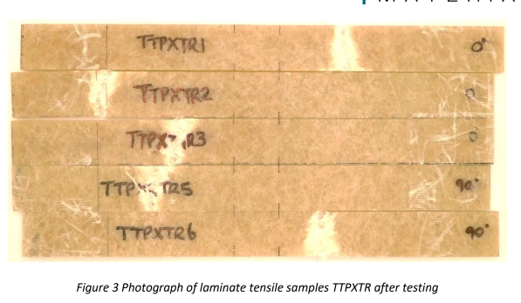
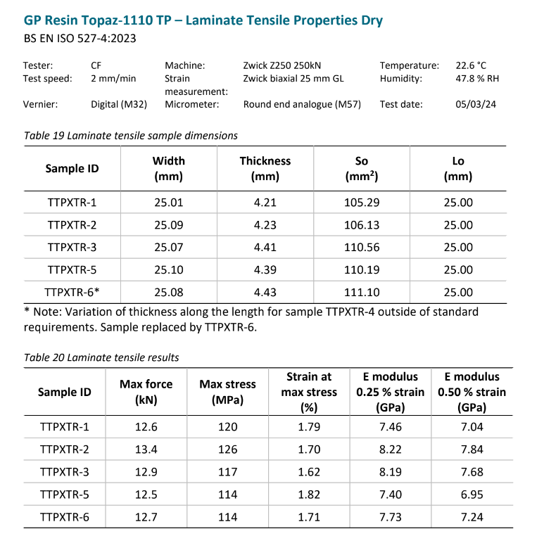

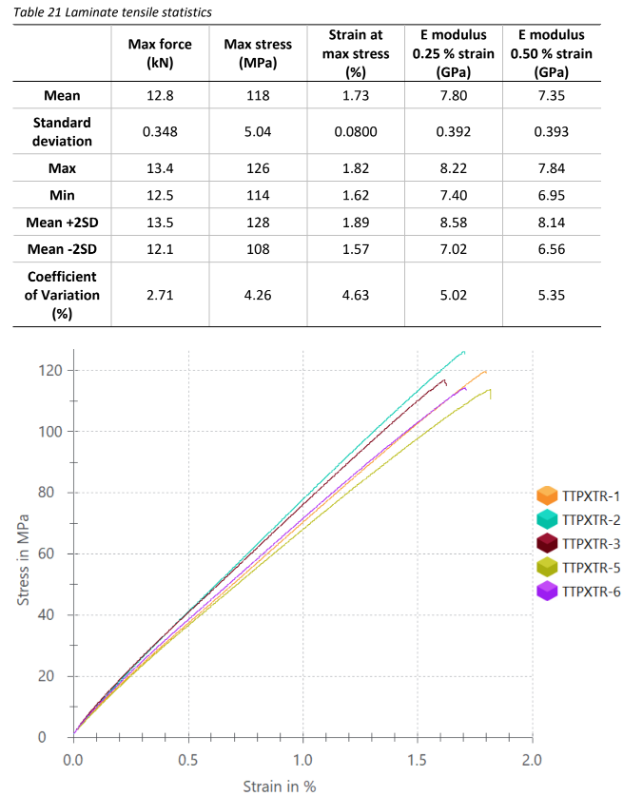
From doing a tensile test several properties can be determined, these being: Tensile strength, yield strength, elongation, modulus, ductility, poisons ratio and toughness.

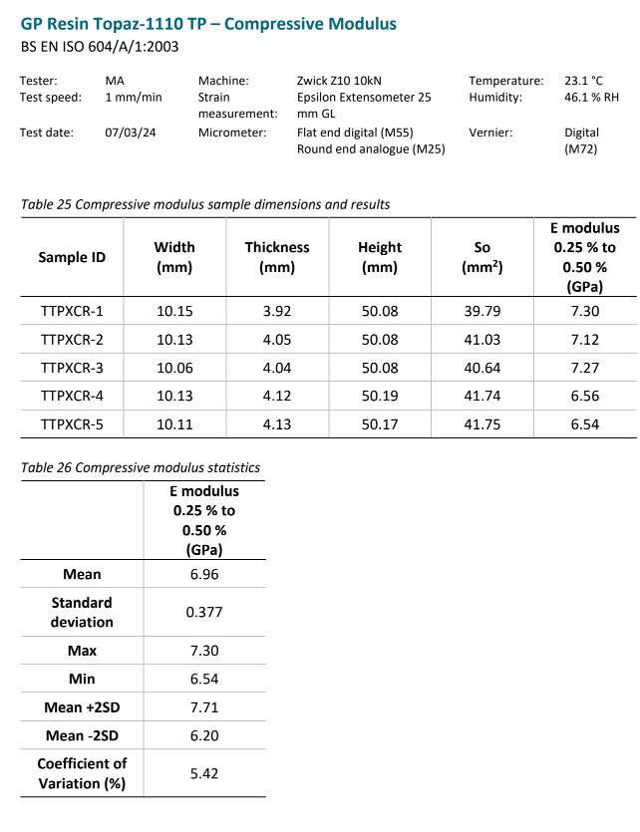

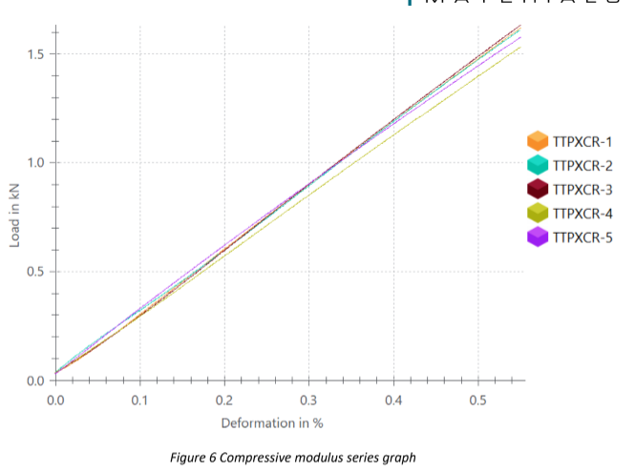

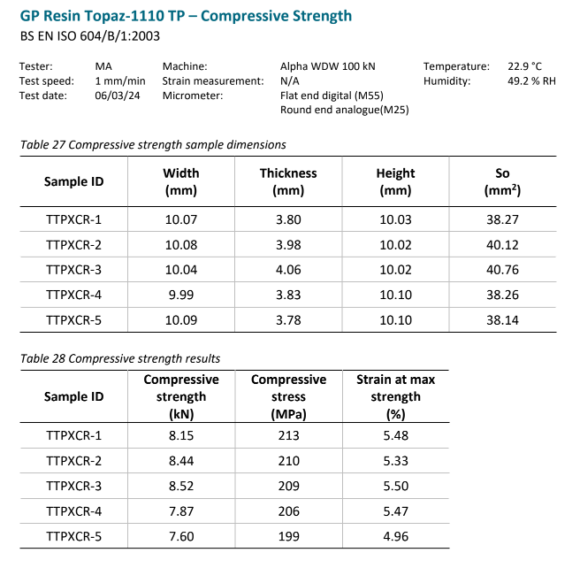

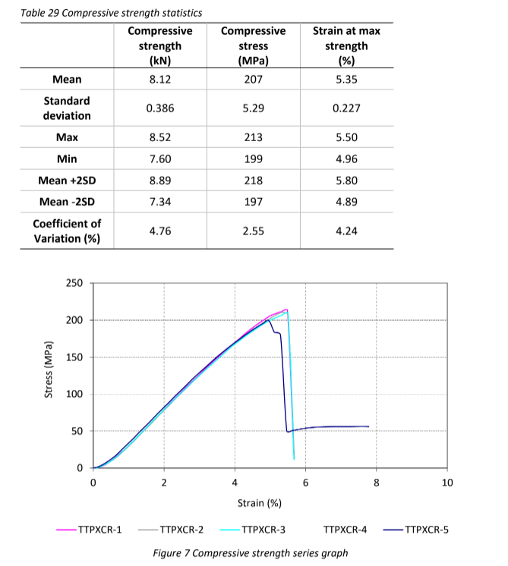
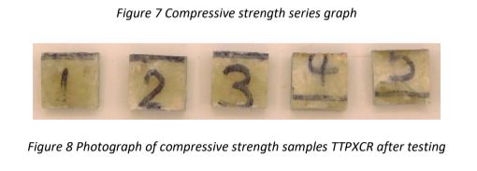

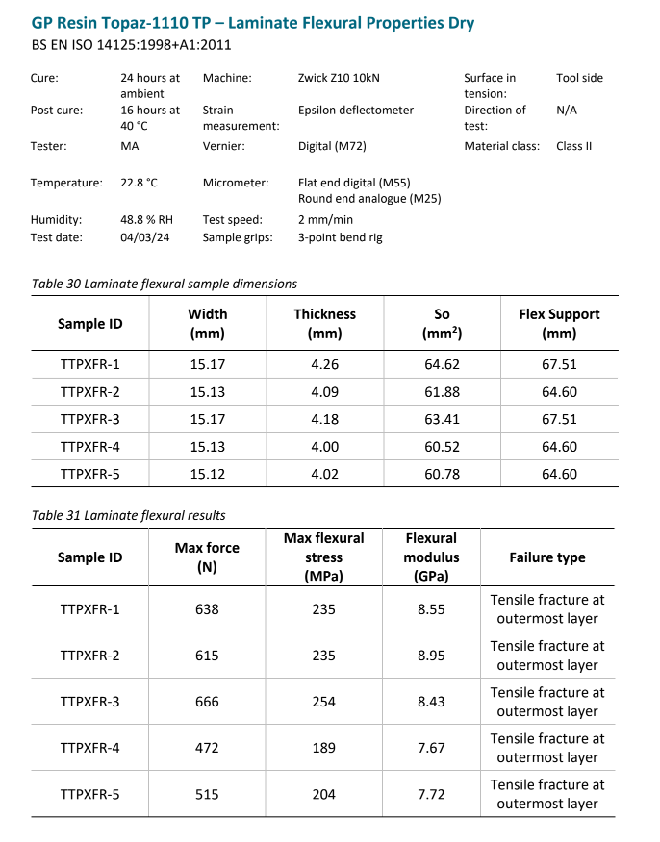

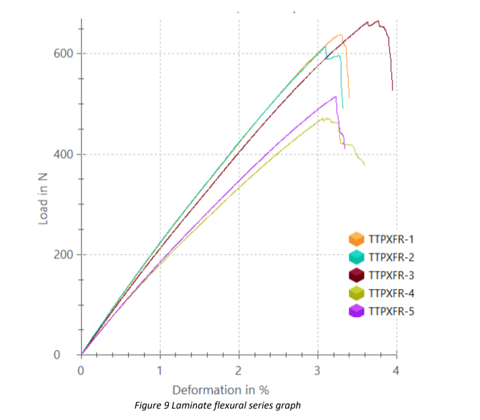
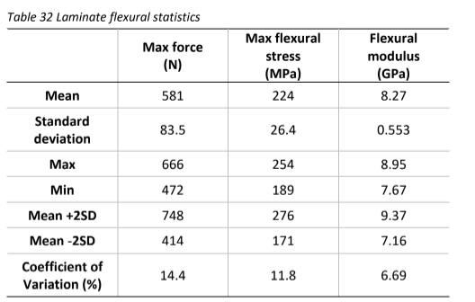

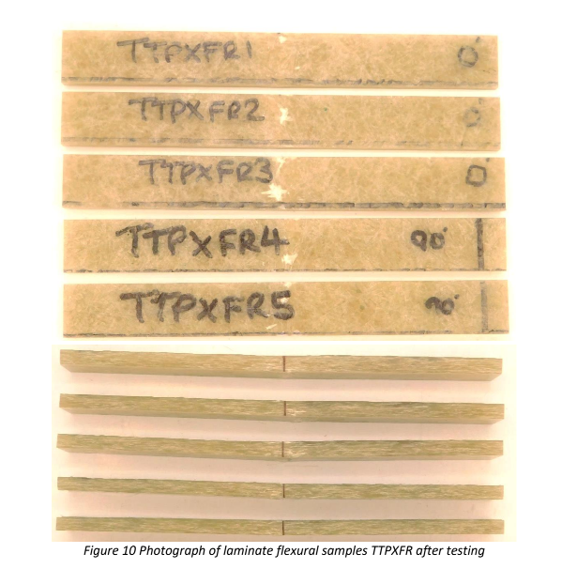

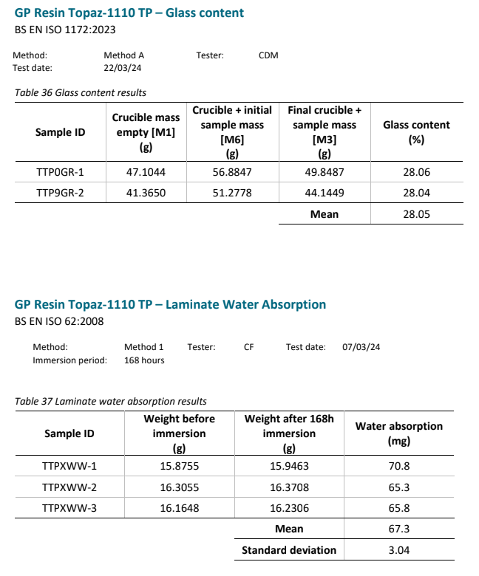

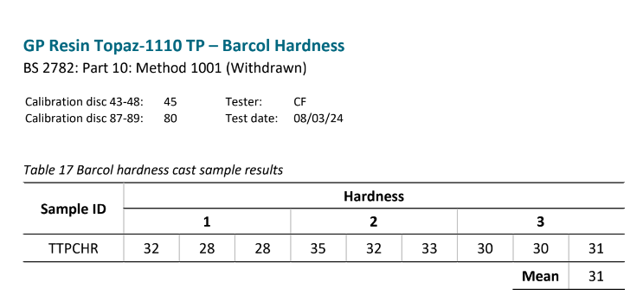
(R-Tech, 2024)

This is a Barcol hardness test to find the hardness of a material, an indenter would be used to put a dent in the material. The tool would give the figures shown in the table above and the average would be taken.
All the tests above can be used to understand a materials behaviour under different circumstances. By employing these characterization techniques, manufacturers can ensure that GRP hulls meet the required standards for safety, performance, and longevity. Rigorous testing and analysis help identify potential weaknesses in the material, allowing for adjustments in the manufacturing process to improve quality and reliability.

Conclusion
The use of Glass Reinforced Plastic in boat hull construction offers many advantages, including increased strength, corrosion resistance, and design flexibility. The material’s unique properties are because of its composite structure, which combines the high tensile strength of glass fibres with the protective qualities of a polymer matrix. Careful selection of manufacturing processes ensures that GRP hulls are produced with minimal defects and mechanical properties required.
The structure-property relationships in GRP are critical to its performance, with fibre orientation, bonding quality, and thermal stability playing key roles in the material’s effectiveness in marine applications. Testing techniques such as microscopy, mechanical testing, etc are essential for verifying that GRP hulls meet required quality and safety standards.
As technology advances, further innovations in GRP and manufacturing processes will continue to enhance the performance and sustainability of marine vessels. The continued development of GRP materials will deliver even more efficient, durable, and environmentally friendly solutions for the maritime industry.

References
AZoM.com. (2008). Aluminium in Marine Applications – Aluminium Alloys Used in Boat Building.
BBC Bitesize. (2019). Covalent bonding - AQA Synergy - Revision 4 - GCSE Combined Science - BBC Bitesize.
Bhat, R., Mohan, N., Sharma, S., Pratap, A., Keni, A.P. and Sodani, D. (2019). Mechanical testing and microstructure characterization of glass fiber reinforced isophthalic polyester composites. Journal of Materials Research and Technology, 8(4), pp.3653–3661.
Butterfield, K. (2021). Ultra-Sound Testing GRP/FRP. Keith Butterfield, Marine Surveyor situated on the Costa del Sol.
Dhimole, V.K., Serrao, P. and Cho, C. (2021). Review and Suggestion of Failure Theories in Voids Scenario for VARTM Processed Composite Materials. Polymers, 13(6), p.969.
Du Plessis, H. (2013). Fibreglass Boats: Construction, Gel Coat, Stressing, Blistering, Repair, Maintenance. Bloomsbury Publishing.
EN ISO 527-1. (2019). Plastics - Determination of tensile properties. Part 1: General principles (ISO 527-1:2019). BSI Standards Publication.
Gibbs, W. Ericsson, J., Taylor, D. and Stevens , R., (2019). naval architecture | Development & Principles. In: Encyclopædia Britannica.
Green Credentials. (2024). Green Credentials: The (Glass Reinforced Plastic) GRP Manufacturing Sustainability Advantage - Engineered Composites.
Gripclad. (2019). Gripclad.
Hsiao, K.-T. and Heider, D. (2012). Vacuum assisted resin transfer molding (VARTM) in polymer matrix composites.
Khaled M. Shokry. (2014). Effect of Temperature on Mechanical Properties of Glass Reinforced Plastic GRP. World Applied Sciences Journal 31(7).
Mineral, C. (2023). Scope Geo.
Nieman, P. (2023). Why Is Grp Used for Boats? - PJNC Ltd UK. PJNC Ltd UK.
R-TECH Materials. (2024). R-TECH Materials | World Class Expertise in Engineering Materials.
Sargun Sethi. (2019). What Materials Are Used For Building Ships? Marine Insight.

Sathishkumar, T.P. Satheeshkumar, S. and Naveen, J., (2014). Glass fiber-reinforced polymer composites–a review. Journal of reinforced plastics and composites, 33(13), pp.1258-1275.
Shokry, K. (2014). Effect of Temperature on Mechanical Properties of Glass Reinforced Plastic GRP. World Applied Sciences Journal, 31(7), pp.1341–1344.

