

31/03/2022
Adam Cross (2106959)

DSP & Communications
Assignment 1

Contents
Abstract 2
Introduction 2
Amplitude Shift Keying (ASK) 2
Phase Shift Keying (PSK) 3
Quadrature Phase Shift Keying (QPSK) 3
Quadrature Amplitude Modulation (QAM) 4
Background Information 5
Constellation Diagrams 5
Bit Error Rate (BER) 5
Filter Order 5
Simulation Models 6
ASK 7
PSK 8
QPSK 8
QAM 9
Results 12
ASK 12
PSK 12
QPSK 13
QAM 13
Discussion 14
Conclusion 14
References 15

Abstract
This report contains a critical analysis of digital signal processing systems. These systems include amplitude shift keying (ASK), phase shift keying (PSK), quadrature phase shift keying (QPSK) and quadrature amplitude modulation (QAM). Each model’s performance was tested by subjecting them to varying levels of additive white gaussian noise (AWGN) to compare the overall performance of each system. Modelling software Simulink was utilised to create, simulate, and test each model with the aim of the experiment being to find the point at which system failure occurs, whereby the bit error rate (BER) of the output compared to the input source signal reaches a reading of 0.5 or more.
To summarise, this experiment shows that QAM is affected most by noise as it has the highest failure point of all four systems. While ASK is the worst performing system in the presence of noise in terms of reliability, as it has a very random relationship between BER and SNR and fails at a similar point to QAM.
The two best performing systems in the presence of noise are PSK and QPSK, with the latter being the least affected and as it provides more efficient use of bandwidth, is therefore the most efficient system.

Introduction
Digital signal processing (DSP) involves the conversion of analog signals if the signal is not already in digital form, into a digital format of 1’s and 0’s that can be mathematically manipulated and transmitted along a carrier wave, the carrier wave is generally an FM carrier wave of tens or hundreds of megahertz (MHz), the reason for this is to reduce the wavelength for efficient transmission and reception of the data. Encoding information on to this carrier wave signal is known as modulation. The aim is to keep as much of the original data as possible while compressing it into the smallest amount of spectrum possible. The signal must then be demodulated which involves extracting the original data from the modulated carrier wave. [1], [2]

Amplitude Shift Keying (ASK)
ASK shown in figure 1 below, manipulates the amplitude of the carrier wave signal between two discrete levels to match the change in the digital source data. A basic ASK modulator can be created using a simple switch, whereby the carrier wave, binary data and a constant are connected as inputs to the switch. A switching point is set, 0.5 for example, when the binary data is above this, the carrier wave is passed through the switch but if the set point is not met, when the binary data input is 0, a constant of 0 is passed through the switch instead of the carrier wave, this provides the change in amplitude that is needed to illustrate the change in digital data. This waveform of this is show in figure 1 below.
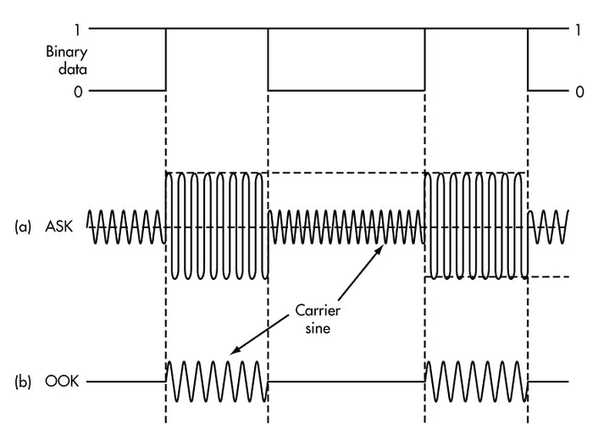

[2]
Figure 1 [2]
To demodulate the information on the receiving end of the carrier wave, the signal must be multiplied by the original carrier wave, converting the negative portion of the carrier wave to positive, as multiplying a sine wave by a negative sinusoid is equivalent to inverting it. Finally, the resultant is passed through a low pass filter, the aim of the low pass filter is to filter out the carrier frequency from the resultant waveform to produce the demodulated waveform.
ASK is very susceptible to noise interference, as noise can easily affect the amplitude of the wave, therefore it is typically only used in low frequency RF applications such as voice grade lines, although the ASK modulation technique is also used in fibre optic transmission, whereby a high light intensity represents a binary value of 1 and low intensity represents a binary value of 0.

Phase Shift Keying (PSK)
PSK is a form of digital modulation whereby the phase of the carrier wave frequency is changed based on the digital input, also known as binary shift keying (BPSK). Shown in figure 2 below, a binary change of state is represented by a phase shift of 180 degrees, this occurs at the zero-crossing point. To create this phase shift, two carrier waves 180 degrees out of phase are fed into a switch with a set point of 0.5, thus when the binary input is more than 0.5 (i.e. 1), the in phase carrier wave passes through the switch, when the binary input changes to a 0 state, the switch changes to port 3, allowing the 180 degree out of phase carrier wave to pass through. Finally, when the binary state changes back to a state of 1, the switch changes back to the in-phase carrier wave.
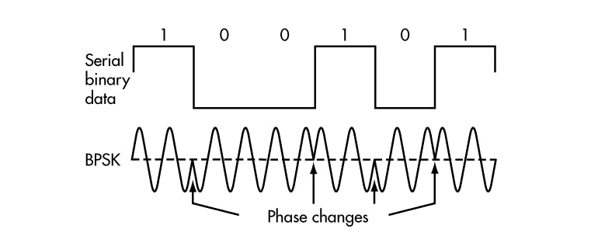
To demodulate the carrier signal, the transmitted signal is multiplied by the original in phase carrier wave. As a result, when the carrier wave is in phase (representing a binary value of 1), multiplying by the same phase carrier wave removes the negative part of the carrier wave and when the carrier wave is 180 degrees out of phase (binary value of 0), multiplying by the in-phase carrier wave gives a resultant negative carrier wave, removing the positive portion. Similar to ASK, the resultant waveform is passed through a low pass filter to filter out the original carrier frequency from the transmitted signal. Finally, this filtered signal is passed through a switch, with a constant of 1 and 0 on each input port. The switch point is set to 0.2, as the resultant waveform after filtering peaks at an amplitude of approximately 0.5, thus providing an output of 1 when the waveform is above the setpoint, the signal has now been demodulated and the original data recovered.

Figure 2[2]
Due to the 180-degree phase change, the constellation points are therefore 180 degrees apart, thus this modulation technique is more robust than ASK and is much less susceptible to noise interference. Consequently, PSK can travel longer distances, used by many cellular towers for satellite communication, as well as wireless communications like Bluetooth and RFID.

Quadrature Phase Shift Keying (QPSK)
QPSK is a four level PSK modulation technique that carries two bits of data per symbol period, equivalent to 2bits/Hz making it a more bandwidth efficient modulation technique. [2] QPSK has four symbols represented as the coordinates of a location in the in-phase and quadrature (IQ) plane, each being 90 degrees apart, as shown in figure 3 constellation diagram under ‘background information’ heading below. Between each symbol there is 1 bit change, with each bit change being represented by a 45-degree shift in phase in the carrier wave, this ensures that only 1 symbol and therefore 1 bit is in error thus reducing bit error rate of the model.
The system first takes the serial binary bit stream, passes it through a serial to parallel converter in order to produce the two bit I and Q data bit stream, each two-bit section will dictate the phase of the waveform that gets transmitted for that specific symbol period. To do this, the two-bit data section passes through a demultiplexer, this takes the 2-digit number and splits it so that one bit goes to one output and the other to the second output of the demultiplexer. The two data bits are subtracted by 0.5 to take the data from the range of 0 and 1 to -0.5 and 0.5. This data is fed through a sign block, which will produce an output of +1 for a positive input and -1 for a negative input. The output is multiplied by two carrier waves, one in phase and one 90 degrees out of phase, with the result of the two sine waves being 45 degrees out of phase.
To demodulate the signal, the received signal is split and multiplied by the original carrier waves in turn to provide two outputs that will have a frequency twice that of the original carrier wave frequency. These are passed through separate low pass filters to filter out the unwanted carrier frequency. Each filtered signal enters a switch, that will output 0 or 1 depending on the transmitted signal. Finally, the two data streams are fed through a multiplexer which will take the two inputs and provide a singular output that is passed through a serializer to convert the parallel data back to a serial data bit stream.
Like PSK, QPSK is used in many wireless communications, such as GSM, LTE, 802.11 WLAN and satellite and cable television applications. [3]

Quadrature Amplitude Modulation (QAM)
QAM combines the two techniques of amplitude and phase modulation to transmit more data symbols at different amplitudes and phases. There are various forms of QAM, this report will be covering 16QAM. The 16 symbols are arranged as shown in figure 4 below, with each symbol carrying 4 bits making the data rate 4 times greater than ASK and PSK and 2 times greater than QPSK. Although with this system, higher data rates are achieved at the cost of a noise margin, due to a smaller constellation point spacing increasing potential crossover interference between symbols.
QAM modulation works by transmitting two signal frequencies along the same carrier wave, with the one being phase shifted by 90 degrees, producing an in phase and quadrature signal path. [4] To add to the QPSK simulation model and vary the amplitude of each of the phase shifted channels, the signals are passed through switches to select a constant to multiply the I and Q channels by respectively.
To decode the amplitude of the signal as well as the phase, 4 switches are used, 2 for phase detection as in the QPSK model and the other 2 combined with an ‘abs’ functional block to negate the sign (+/-) of the 2 bits of data to allow the amplitude to be distinguished. Using a scope in the model, a setpoint of 0.3 is set, as the signal is between 0 and 0.5, with an average amplitude of approximately 0.25 and peaks at 0.5. See figure in the results section for parameters.
16QAM digital signal processing technique is used extensively throughout the UK for digital terrestrial television as its data rate increases the useable bandwidth for data to be transferred while not suffering from as much noise interference as 64QAM for example.

Background Information

Constellation Diagrams
Shown in figures 3 and 4 below, constellation diagram are useful illustrations to show the effect noise can have on the transmitted signal. As you can see, in ASK and BPSK, each symbol carries 1 bit of data. ASK has two symbols in phase while in BPSK modulation, the coordinates of the symbols are moved 180 degrees apart and are therefore less susceptible to noise interference. QPSK has twice the number of symbols and transfers two data bits per symbol period. 16QAM has 16 symbols, with each carrying 4 bits of data, making this form of signal processing more bandwidth efficient.
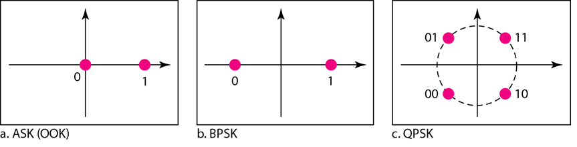
Figure 3 [5]

[5]
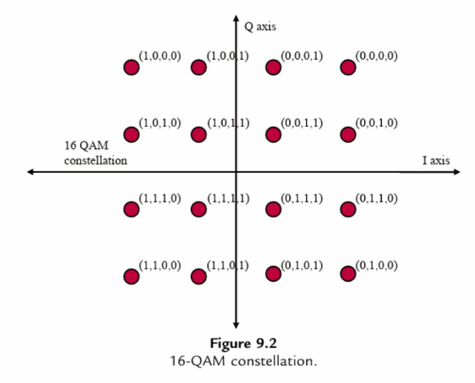
Figure 4 [1]

[1]

Bit Error Rate (BER)
In digital signal transmission, the BER is the number of bits of data, 1 or 0 that have errors, divided by the total number of bits that have been transmitted. A bit in error means that the data received was not in the same form that it was sent, i.e., was 1 instead of 0. A bit error rate of more than 0.1 is poor, although this experiment is looking for complete system failure at 0.5 as this is the same as simply guessing if the data bit is 1 or 0, as there is a 50% chance of getting it right. [6]

Filter Order
Filter order represents the number of delay elements used in the filter design. A higher order filter will have a faster roll off rate [7], which is the steepness of the slope corresponding to the filter’s response in the shift between the frequency passband and the stopband. A high order filter will roll off quicker and decrease ripple in filtering but will be more complex compared to a low order filter.

Simulation Models
To make the experiment a fair and valid test, several variables were kept the same throughout all models.
The Bernoulli binary generator was set to output at probability of 0.5 (random) with a sample time and samples per frame of 1, meaning the signal is on for 1 second and off for 1 second. The parameters of this are shown in figure 5 below.
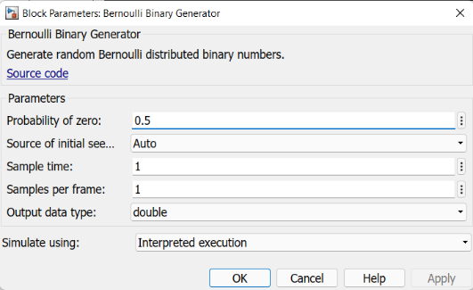

Figure 5
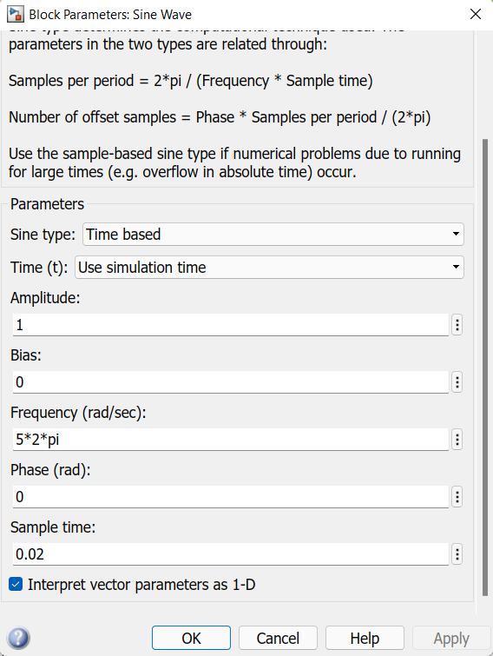
The carrier wave in each model has an amplitude of 1 and a frequency of 5Hz as the carrier frequency should be at least five times the source data rate of 1. Sample rate is the number of data points acquired per second, this should be at least two times the highest frequency of the input signal to satisfy the Nyquist theory, otherwise not all of the information will be captured from the continuous time signal which would lead to aliasing. All models have a sample rate of 10 samples per period/second, with 5Hz frequency being equivalent to 0.2 seconds per period, the sample time is therefore set to a 1/10th of this, 0.02. 10 samples per period produces a 50Hz sample frequency output.

Figure 6

ASK
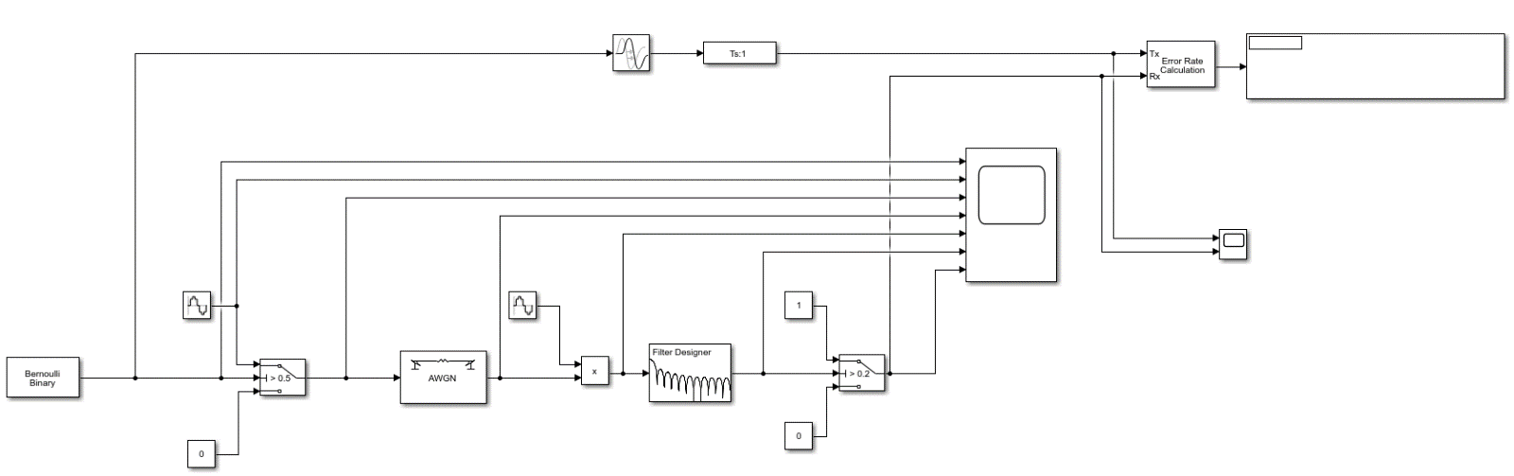
Below, shown in figure 7, is the ASK simulation model created in Simulink. The explanation of what is being simulated and the operation of the system can be found in the introduction section under ‘ASK.’
Figure 7
Figure 8 below contains the low pass filter parameters. The sampling frequency (Fs) of the filter must be the same as the carrier wave sampled frequency of 50Hz. Frequency cut-off (Fc) is set to 5Hz to remove the carrier wave from signal.
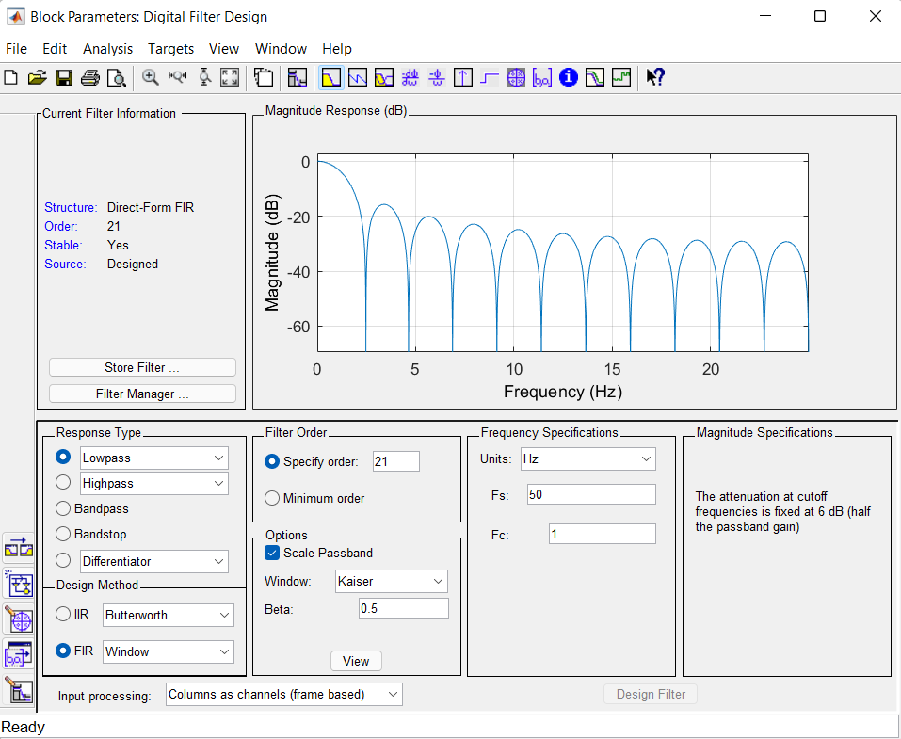

Figure 8

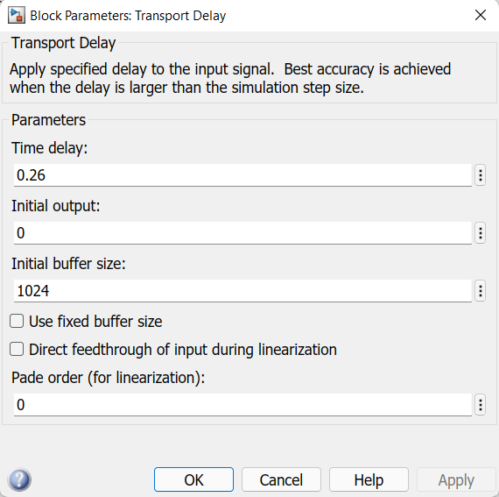
Using a scope on the transmitted and original data signals, it was necessary to add a transport delay of 0.26 seconds at 0dB to match up the original data stream and transmitted data before the error rate calculation was performed. Parameters shown in figure 9 below.

Figure 9

PSK
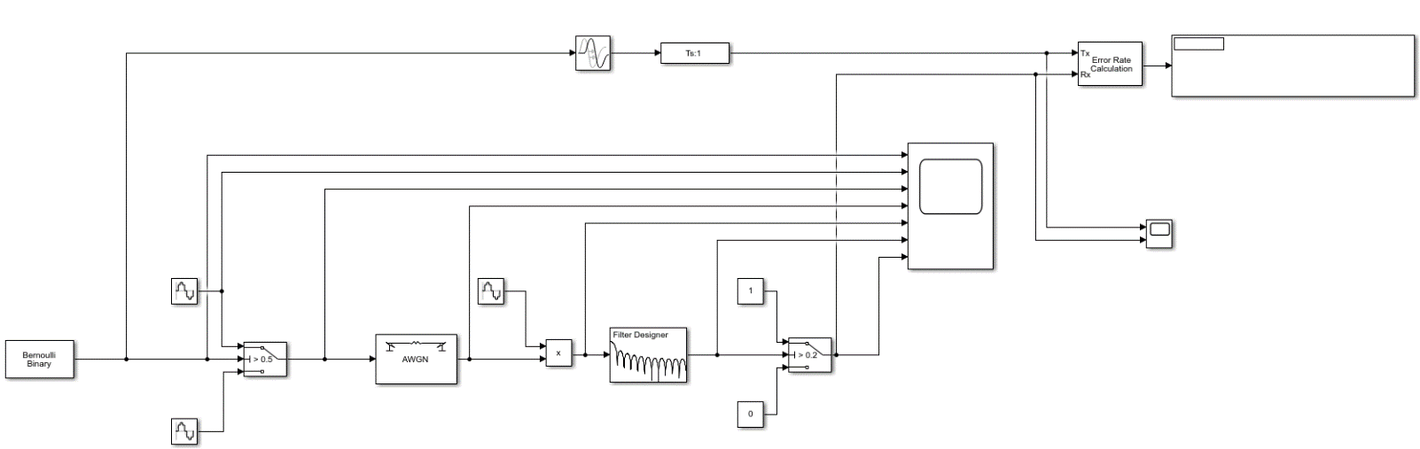
Below, shown in figure 10, is the PSK simulation model created in Simulink. The explanation of what is being simulated and the operation of the system can be found in the introduction section under ‘PSK.’
Figure 10
The only parameter that is different in this model compared to ASK is the second sine wave at 180 degrees out of phase, added to the switch to create a phase shift.

QPSK
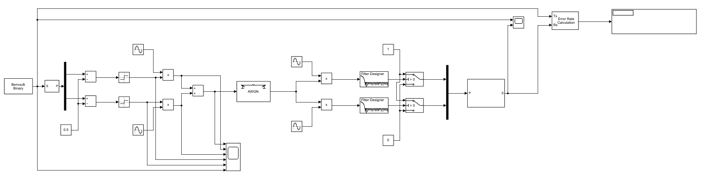
Shown in figure 11 below is the QPSK simulation model created in Simulink. The explanation of what is being simulated and the operation of the system can be found in the introduction section under ‘QPSK.’
Figure 11

The ratio of the de-serializer is set to 2, this sets the input vector size to 1 and the output to 2 to convert the serial bit stream into a parallel data bit stream. Likewise, the serializer used in demodulating the signal is also set to 2 to convert the 2-bit data stream back to serial.
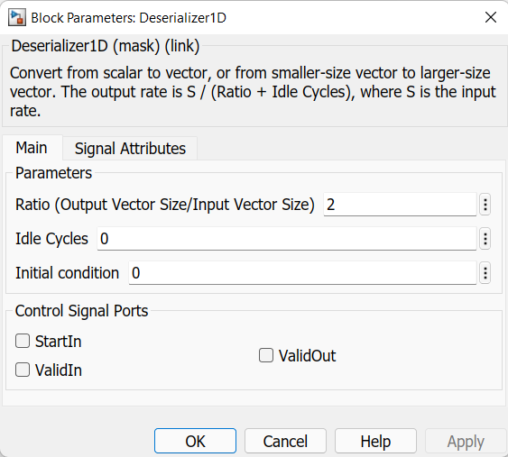
Figure 12

Filter parameters are shown in figure 13 below. The sample frequency is set to equal the original sample rate of the signal at the modulation stage, 50Hz. Low pass filter (Fpass) is set to 0.5Hz as the original data rate from the Bernoulli generator is 0.5Hz, as its on for 1 second and off for 1 second and after modulation, the signal is then on for 2 seconds and off for 2 seconds as it is combined into two-bit sections, which when added together is 0.25Hz. The original carrier wave frequency is 5Hz, therefore Fstop is set to 4Hz. The reason for this is to filter out the carrier wave to retrieve the original data.
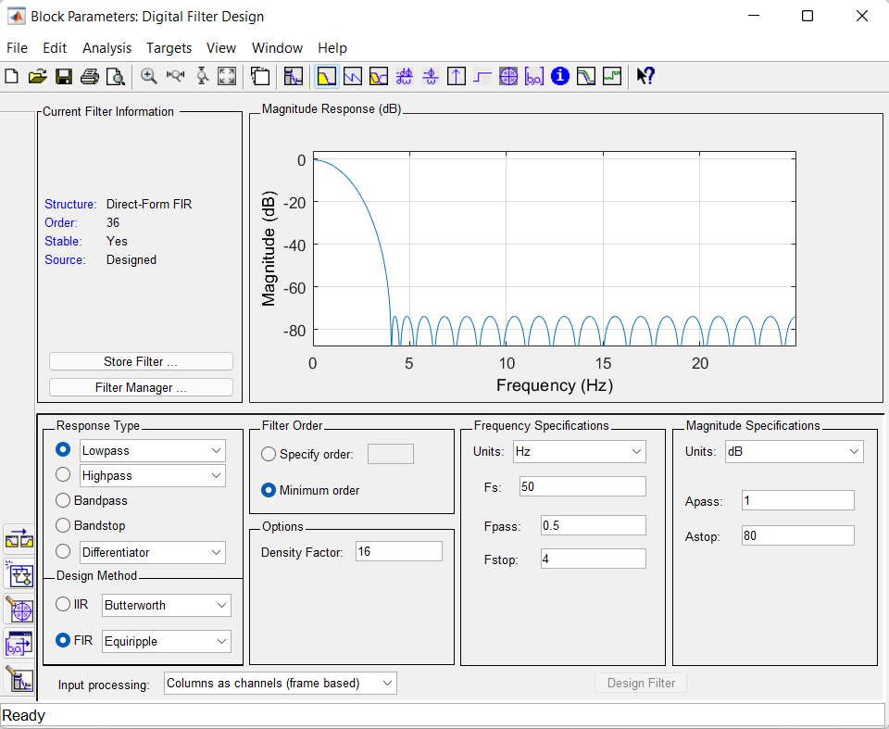
Figure 13

QAM
Shown in figure 14 below is the QAM simulation model created in Simulink. The explanation of what is being simulated and the operation of the system can be found in the introduction section under QAM.’ Parameters are the same as the QPSK model, only now there are extra parameters in place to modulate the amplitude as well as the phase of the signal.
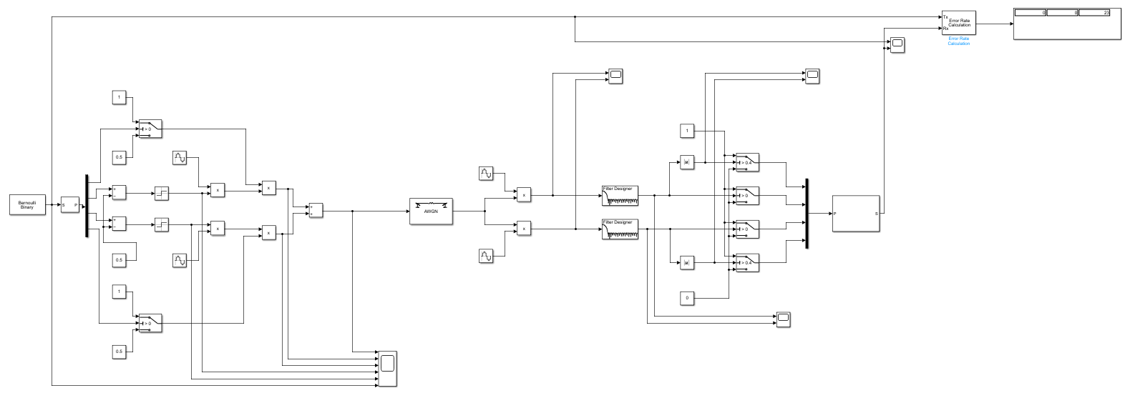
Figure 14

The ratio of the de-serializer is set to 4, as QAM has a 4-bit data stream per symbol. Likewise, the serializer used in demodulating the signal is also set to 4 to convert the 4-bit data stream back to serial.
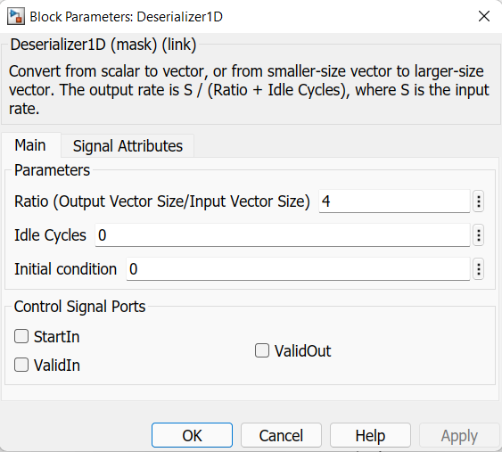
Figure 15

Shown in figure 16, the blue highlighted section, as well as the identical section on the second carrier wave provides a constant to multiply the I and Q channels by respectively. Constant parameters are 0.5 and 1 to control the amplitude of the signal, as multiplying by 0 would switch off the carrier wave.
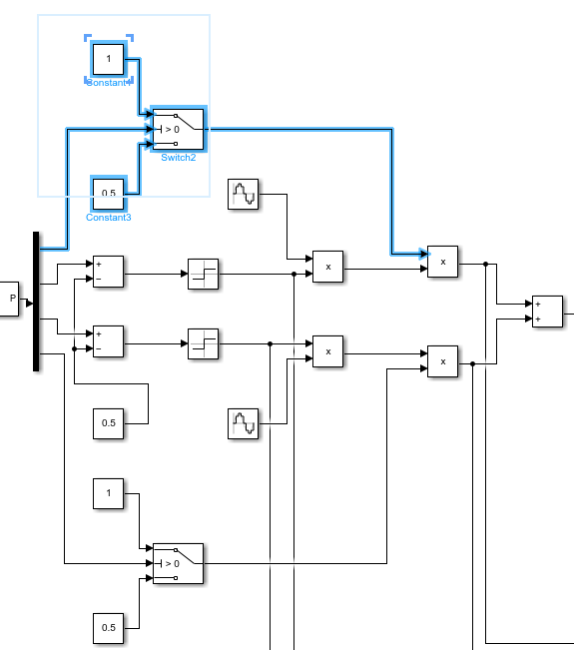

Figure 16

The operation of the amplitude switches is explained in the introduction section for this model. Using a scope, shown in figure 18, a setpoint of 0.3 is set within the switches as the signal is between 0 and 0.5, with an average amplitude of approximately 0.25 and peaks at 0.5.
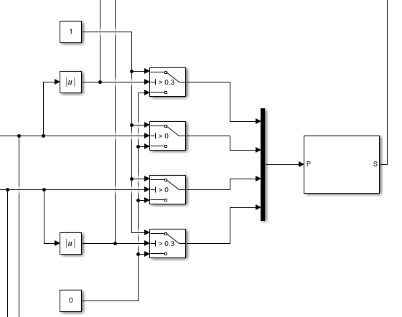

Figure 17
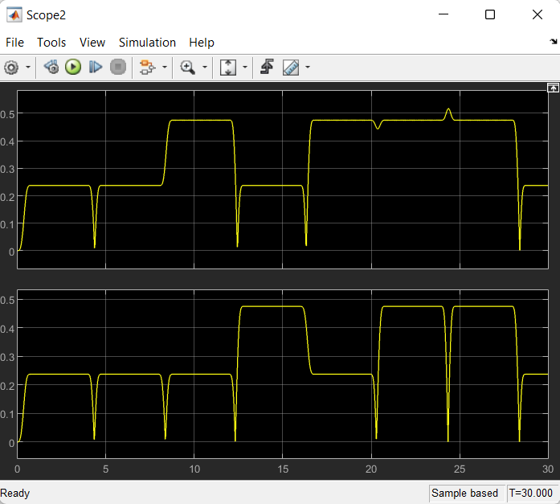
Figure 18

Using a scope on the original signal and transmitted signal, a receive delay of 8 was set to account for the delay of the system.
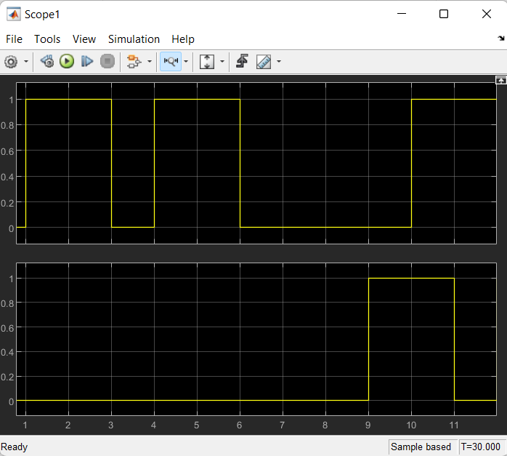
Figure 19

Results
To carry out a true comparison of the models, the signal to noise ratio (SNR) test of each started at 10dB and decreased in increments of 1dB until system failure occurred. At each AWGN level, 5 readings were taken from the bit error rate calculator in Simulink and an average of the readings were taken and plotted on a graph comparing the BER to signal to noise SNR ratio.

ASK
Figure 20

PSK
Figure 21

QPSK
Figure 22

QAM
Figure 23

Discussion
Collated results are shown in figure 24 below, it is clear to see that the QAM system is most effected by noise, with errors occurring at 5dB and system failure at -21dB, this is expected as the 16 symbols are within close proximity to one another on the I and Q planes, making the system more susceptible to noise. Although overall the ASK system is the worst performing data transmission system, as its data rate is ¼ of QAM and system failure occurs at a similar SNR ratio of -26dB. These two systems are easily affected by noise as amplitude shifting and noise on the modulated signal can’t be distinguished by the demodulator. QAM and ASK also start to experience errors at much higher signal to noise ratios of 5dB.
Reviewing the results, it is clear to see that PSK is a better digital data transmission system for noise immunity, reaching system failure at -43dB, with no errors present until -5dB. This is due to the transmitted symbols being 180 degrees apart on the in-phase plane which leads to less crossover between the points.
Furthermore, PSK and QPSK have very similar system failure and bit error rate points, with the latter failing at -47dB in testing, although it seems that PSK withstood slightly more noise throughout the test without as much disruption to the transmitted signal. As QPSK transmits two bits per symbol period and only has one bit change per symbol this combats noise interference and makes QPSK twice as bandwidth efficient, requiring only half of its available bandwidth to transmit the same amount of data as PSK.

Figure 24

Conclusion
Referring to figure 24 above. This experiment has showed that QPSK and PSK systems provide the lowest probability of error out of the four systems, reaching system failure of 0.5 BER at AWGN levels of -47dB and -43dB respectively. In comparison, ASK and QAM, which both incorporate amplitude shifting and are more susceptible to noise interference, reach a 0.5 BER at -26dB and -21dB.
The two systems that started to experience errors first due to AWGN noise were QAM and ASK, at 5dB and 2dB. The worst performing system was ASK due to the relationship between BER and SNR being very random, whereas QAM had a more gradual increase without the random spikes of the ASK system, making it a more predictable system.
As QPSK provides more efficient use of bandwidth compared to PSK and is the least affected by noise, this experiment has concluded that a QPSK modem is the most efficient of the systems tested.

References
[1] M. Parker, Digital signal processing 101 : everything you need to know to get started, Second edition. Oxford, United Kingdom ; Newnes, 2017.
[2] “Understanding Modern Digital Modulation Techniques | Electronic Design.” https://www.electronicdesign.com/technologies/communications/article/21798737/understanding-modern-digital-modulation-techniques (accessed Mar. 21, 2022).
[3] “QPSK Modulation-Quadrature Phase Shift Keying modulation.” https://www.rfwireless-world.com/Terminology/QPSK.html (accessed Mar. 28, 2022).
[4] “What is QAM: Quadrature Amplitude Modulation » Electronics Notes.” https://www.electronics-notes.com/articles/radio/modulation/quadrature-amplitude-modulation-what-is-qam-basics.php (accessed Mar. 29, 2022).
[5] “Constellation Diagrams - Digital To Analog Conversion and Transmission Tutorials Part V | IngenuityDias.” http://ingenuitydias.blogspot.com/2014/04/constellation-diagrams-digital-to.html (accessed Mar. 28, 2022).
[6] M. G. Sadeque, “Bit Error Rate (BER) Comparison of AWGN Channels for Different Type’s Digital Modulation Using MATLAB Simulink”, Accessed: Mar. 28, 2022. [Online]. Available: http://asrjetsjournal.org/
[7] “11.4: Filter Order and Poles - Engineering LibreTexts.” https://eng.libretexts.org/Bookshelves/Electrical_Engineering/Electronics/Operational_Amplifiers_and_Linear_Integrated_Circuits_-_Theory_and_Application_(Fiore)/11%3A_Active_Filters/11.04%3A_Section_4- (accessed Mar. 28, 2022).

