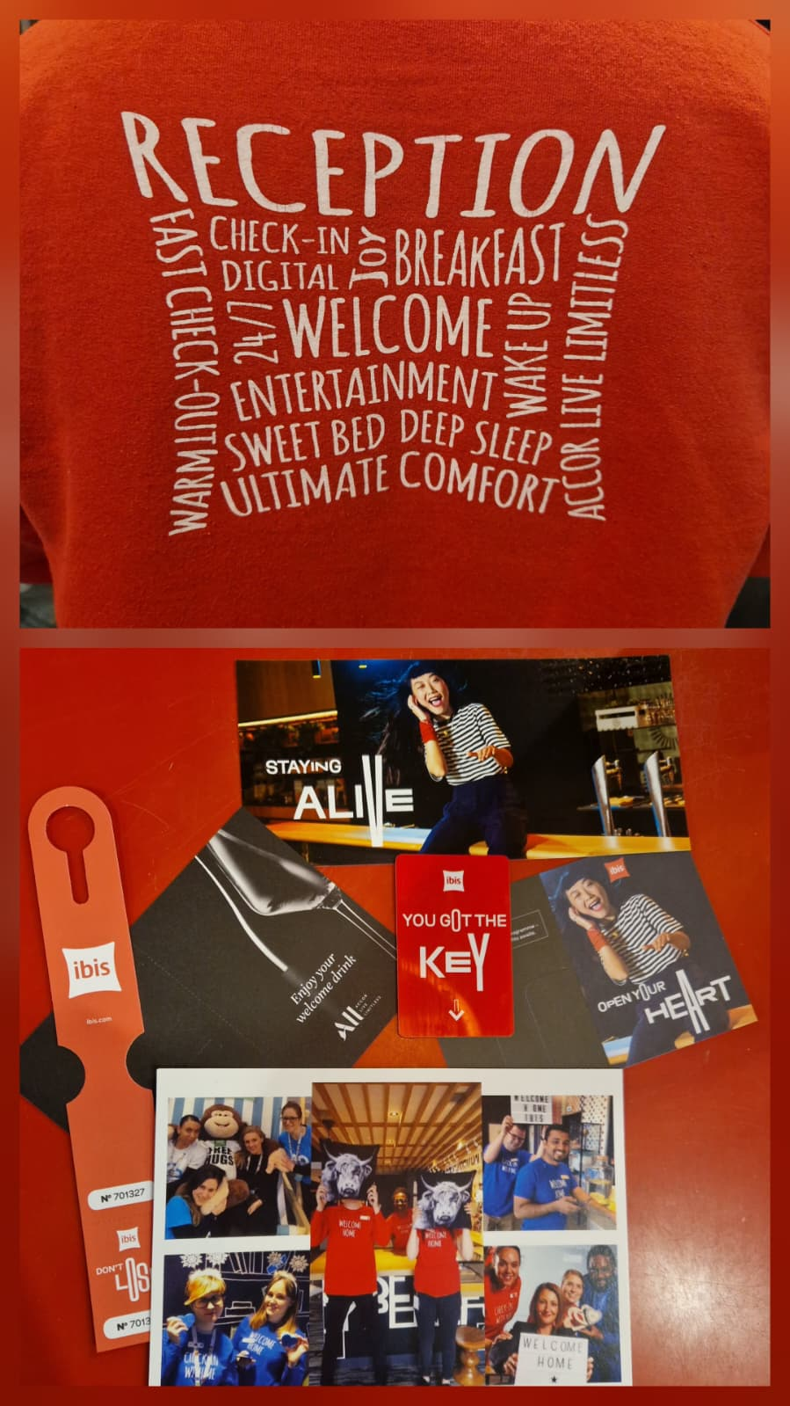  REFLECTIVE LEARNING LOG | Module title: Managing Hotel Administration  Module code: BMIH6004  Lecturer name: Jessica Newport  Student name: Anamaria Alma Vida  Student ID: 2244885  Placement Hotel: Ibis Nottingham Centre

I acknowledge the use of Copilot (https://copilot.microsoft.com/) on 26th of September to create a draft of my reflective journal using the prompt:
- Can you please help me create a draft of a reflective journal to focus on my student placement in a hotel?
I acknowledge the use of Grammarly (https://www.grammarly.com/) on 14th of November to check my work using the prompt:
- Please check the following text for readability, grammar, and syntax.
I confirm that I have not presented any AI generated text as my own work. I confirm I have copies of my drafts, notes, and other resources I used before, and after the use of AI tools which I may be asked to provide in evidence.

Introduction
My placement at the Ibis Nottingham Hotel provided an invaluable opportunity to enhance my understanding of hotel operations and guest service within a fast-paced and professional environment. I was assigned to the Front Office department, where my responsibilities included handling check-ins and check-outs, managing reservations, responding to guest queries, and supporting coordination with other departments to ensure smooth guest experiences. I worked closely with my Front Office colleague Arash Haidiri, who supported me in developing practical front-of-house skills, and with Kapish Kapoor from the Kitchen team, whose collaboration highlighted the importance of clear communication between departments, especially during breakfast service.
For this reflection, I will use Gibbs’ Reflective Cycle (1988), which encourages critical thinking and continuous professional improvement through six stages: description, feelings, evaluation, analysis, conclusion, and action plan. The purpose of this reflection is to evaluate my professional growth and demonstrate how my Level 4 placements and modules—including Hospitality and Guest Services, Food and Beverage Operations, Operating Hotel Facilities, and Hotel Administration and Front Office Operation—have shaped my development. By linking practical experiences to theoretical frameworks such as Front Office Management (Bardi, 2010) and Service Operations Management (Johnston et al., 2012), I aim to demonstrate how academic learning has informed my workplace performance.

Scenario 1: Managing Guest Complaints During a Busy Check-in Period
Description:
During a particularly busy check-in period, a guest became frustrated after discovering a double-booked room. Several guests were waiting in line, and the situation was tense. I remained calm, apologised sincerely, and liaised with housekeeping and reservations to allocate an alternative room quickly.
Feelings:
At first, I felt anxious because of the pressure and the visibility of the situation. However, my previous Level 4 placement in Front Office Operations at Premier Inn had helped me build confidence in handling difficult guest interactions. Remembering the importance of calm and empathy, I communicated clearly with the guest to reassure them that the issue was being prioritised.
Evaluation:
Although challenging, the experience was highly educational. It tested my ability to manage stress, multitask, and maintain professionalism. The positive resolution showed that empathy and timely communication can prevent guest dissatisfaction and restore confidence.
Analysis:
This situation reflects Johnston, Clark, and Shulver’s (2012) concept of service recovery, which states that resolving service failures effectively can turn negative experiences into opportunities for loyalty. Similarly, Bardi (2010) highlights that front office staff represent the hotel’s image, and their behaviour shapes guest perception. Through this reflection, I realised that my actions directly influenced the guest’s trust and satisfaction. My earlier placement gave me procedural knowledge, but this Level 6 experience demanded higher-level emotional intelligence and judgment, demonstrating professional progression.
Conclusion:
The incident reinforced the significance of empathy and emotional composure in guest-facing roles. Recognising guests’ feelings and taking ownership of mistakes builds stronger service recovery outcomes.
Action Plan:
To improve further, I plan to attend workshops on conflict resolution and time management, as well as continue observing how experienced front office colleagues manage guest complaints calmly under pressure.

Scenario 2: Anticipating Guest Needs for a Guest with Multiple Allergies
Description:
During breakfast service, a guest informed me that she had several severe food allergies, including gluten, nuts, shellfish, dairy, and eggs. It was crucial to ensure her meals were safe and that she felt comfortable dining with us. I immediately consulted Kapish from the kitchen staff to review ingredients and preparation methods. Together, we arranged for her breakfast to be prepared separately to avoid cross-contamination, and I personally checked the utensils and surfaces. On the second morning, her meal was ready upon arrival without her needing to repeat her request.
Feelings:
I initially felt nervous due to the responsibility of managing food allergies, but my Level 4 Food and Beverage Operations module had taught me the importance of food safety and allergen awareness. Drawing on that knowledge, I handled the situation carefully and confidently. When the guest thanked me for my attention to detail, I felt proud that my actions had ensured her comfort and safety.
Evaluation:
This experience deepened my understanding of how proactive communication and anticipation of guest needs enhance service quality. It also reinforced the importance of interdepartmental collaboration between Front Office and Kitchen teams.
Analysis:
This scenario aligns with Johnston, Clark and Shulver’s (2012) focus on reliability and consistency as key factors in service excellence. It also supports Vallen and Vallen’s (2014) principle that integration between departments strengthens operational effectiveness. Furthermore, my approach reflects Wood’s (2013) assertion that proactive service behaviour is central to guest satisfaction. Compared to my Level 4 placement in Operating Hotel Facilities, where I followed instructions, this situation required initiative and accountability—showing my development toward independent problem-solving and leadership readiness.
Conclusion:
I learnt that guest confidence depends on both competence and care. Anticipating needs and ensuring accurate information sharing across departments are essential to a safe and positive guest experience.
Action Plan:
To enhance my professional skills, I plan to complete Allergen Awareness and Food Safety certification and propose creating an Allergen Communication Log accessible to both Front Office and Kitchen staff to ensure consistent guest care.

Overall Conclusion and Development Plan
Using Gibbs’ Reflective Cycle (1988) has allowed me to examine each stage of my experiences systematically, linking emotions and outcomes to learning. My placement at Ibis Nottingham strengthened my understanding of guest service operations and highlighted how theory informs practice. In both scenarios, I demonstrated progression from my Level 4 placements—where I learnt core operational procedures—to my Level 6 placement, where I applied that foundation with confidence, empathy, and independent decision-making.
This reflection also illustrates how key modules such as Hospitality and Guest Services and Food and Beverage Operations shaped my ability to prioritise guest safety and satisfaction. Meanwhile, insights from Operating Hotel Facilities and Hotel Administration and Front Office Operation informed my understanding of interdepartmental communication and operational standards.
Critically, I have learnt that exceptional guest service relies not only on technical efficiency but on emotional intelligence, anticipation, and collaboration. My future goal is to advance into a supervisory role where I can apply these principles to lead by example and foster teamwork. Continuing to use Gibbs’ model will help me maintain reflective practice, ensuring my professional growth remains ongoing and purposeful.
Future Goals:
- Leadership Development: I aim to gain supervisory experience within Front Office operations to build confidence in decision-making, staff coordination, and guest service leadership. This will prepare me for future managerial roles in hospitality.
- Professional Communication: I plan to enhance my guest interaction and service recovery techniques by attending workshops focused on conflict resolution, emotional intelligence, and proactive communication strategies.
- Continuous Reflection: I will continue applying Gibbs’ Reflective Cycle to regularly evaluate my performance, identify areas for improvement, and ensure ongoing personal and professional growth throughout my career.

Reference List
Bardi, J. (2010) Hotel Front Office Management. London: Wiley.
Fallon, M. and Rutherford, D. (2010) Hotel Management and Operations. London: Wiley.
Gibbs, G. (1988) Learning by Doing: A Guide to Teaching and Learning Methods. Oxford: Oxford Polytechnic.
Johnston, R., Clark, G. and Shulver, M. (2012) Service Operations Management: Improving Service Delivery. 5th ed. London: Pearson.
Vallen, G.K. and Vallen, J.J. (2014) Check-In Check-Out: Managing Hotel Operations. 9th ed. Harlow: Pearson Education Limited.
Wood, R.C. (2013) Key Concepts in Hospitality Management. London: Sage.

