E-Portfolio
Emilie Brown Student ID number- 2405925
Module: Study Skills for Psychology

Contents Page
300 word written summary……………………………………………………………………………… 3
Infographic…………………………………………………………………………………………………… 4
Essay outline………………………………………………………………………………………………… 5
References…………………………………………………………………………………………………… 9
Library search………………………………………………………………………………………………. 10
300 word written summary of a single article that has been provided
How to succeed in your degree, with psychology
This article offers valuable advice for students pursuing a degree in psychology. It emphasizes the importance of developing a deep understanding of the subject, not just for academic success, but for personal growth and future career opportunities.
The article starts by highlighting procrastination and the importance of effective time management. Creating a structured schedule is crucial for psychology students due to the workload of various assignments, reading and exams. Research by Oettingen, Honig and Gollwitzer suggests that procrastination can be addressed using ‘implementation intentions’. These statements make a clear connection between the actions required to achieve the desired objective and goal-relevant situational indicators. “When creating an implementation intention, the words ‘if’ and ‘then’ come before the situational cue and the response to it. Prioritising tasks, breaking them down into manageable parts and avoiding procrastination are essential strategies for keeping up with their workload”.
Note taking is important with course material and joining in on discussions, providing questions to ask and making similarities between theories and the real world are extremely helpful for success in your degree, more so with psychology. Being present at lectures and accessing knowledge from reading matter advised by a lecturer isn’t enough. Reviewing and writing notes can help accelerate learning.
The article also addresses the importance of students to seek opportunities and connect with experts in the field of psychology, other students and tutors through social media, conferences and university. Another way for psychology students to prepare for their professional roles in the field, the article suggests that there is a need for critical thinking and independent learning. It is important for psychology students to be encouraged in engaging in research outside of set reading and to also challenge existing ideas.
To conclude, the article offers a suitable guide for psychology students to succeed academically while also preparing for their career in the field of psychology.
How to succeed in your degree, with psychology… | BPS

Infographic to explain a study skill of your choice to educate other learners about this skill (time management)
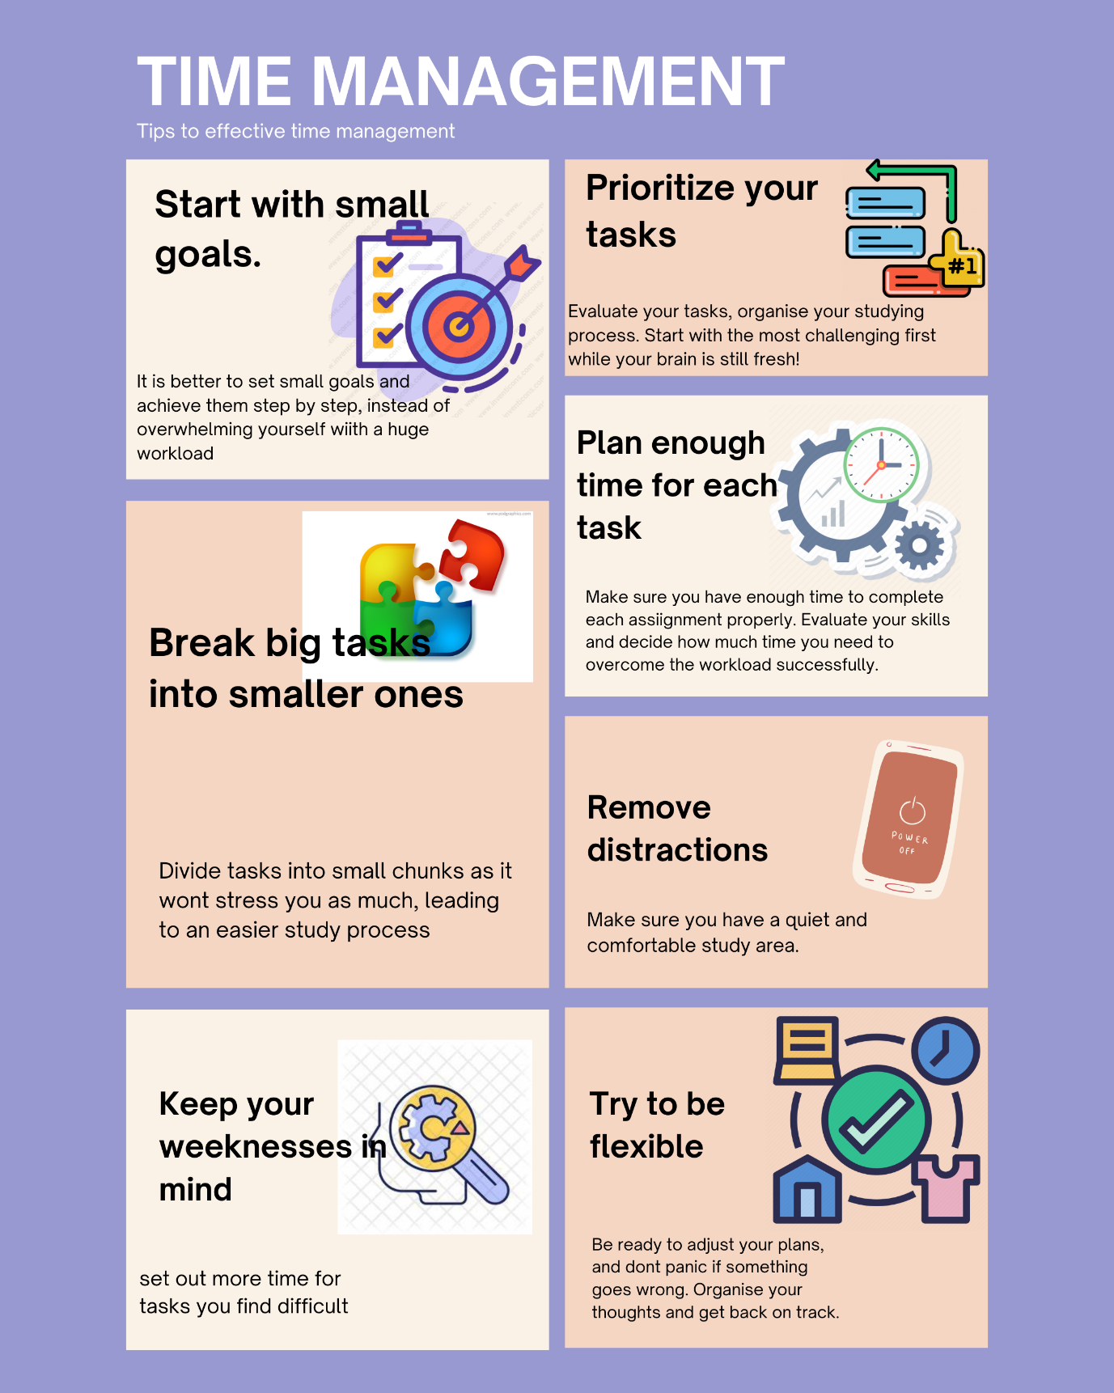

Describe and discuss the psychological, social and physical benefits of owning a pet.
Introduction
Being the owner of a pet can significantly amplify our lives in innumerable ways, providing not just fellowship but also a range of psychological, social and physical benefits. Psychologically, pets offer emotional support and can alleviate feelings of loneliness and anxiety, developing a feeling of direction and purpose. Socially, they act as a bridge to connect with others by being a conversation starter in public spaces. Physically, pets encourage a more active lifestyle, as they require regular exercise and playtime, which in turn promotes better health for their owners. This essay will explore these multiple benefits, illustrating how the bond between humans and their pets improves our overall wellbeing.
Thesis Statement;
- Assess the benefits and risks of owning a pet- reference: Cherniack, E. P., & Cherniack, A. R. (2015). Assessing the benefits and risks of owning a pet. Cmaj, 187(10), 715-716.
- Psychological benefits of owning a pet
- Social benefits of owning a pet
- Physical benefits of owning a pet
Body: 1st point, Topic Sentence. (examples, facts, theories etc) Supporting evidence. C. Conclusion
Psychological benefits of owning a pet
Evidence- “While researchers have examined the relationship between pet ownership and psychological health… possible health benefits of pet ownership for individuals living alone”

Antonacopoulos, N. M. D., & Pychyl, T. A. (2010). An Examination of the Potential Role of Pet Ownership, Human Social Support and Pet Attachment in the Psychological Health of Individuals Living Alone. Anthrozoös, 23(1), 37–54. https://doi.org/10.2752/175303710X12627079939143

- “Pets provide better coping strategies for stress, can promote greater empathy and compassion, protect people from loneliness.”
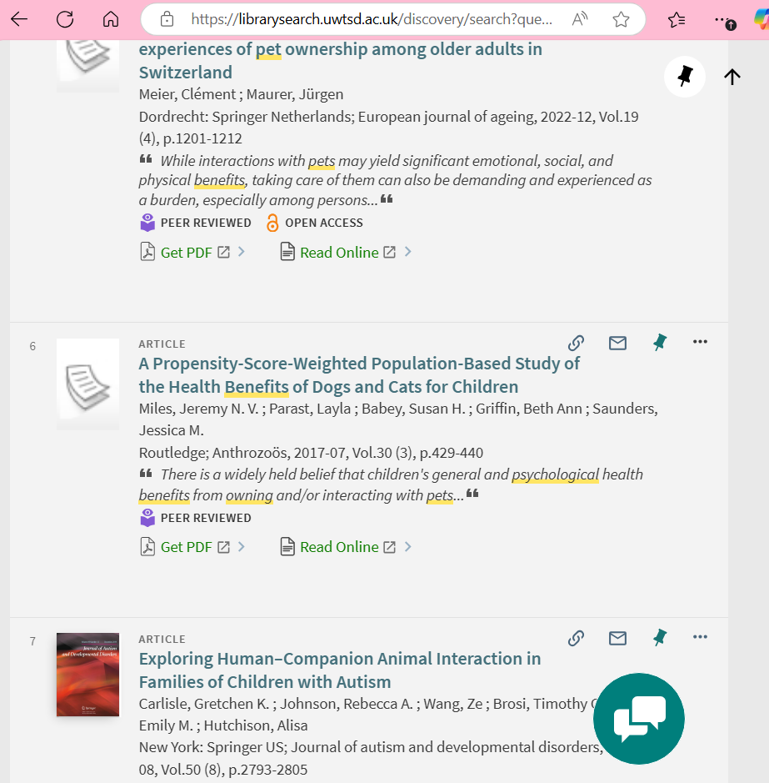 https://librarysearch.uwtsd.ac.uk/permalink/44WHELF_UWTSD/igoone/cdi_informaworld_taylorfrancis_310_1080_08927936_2017_1335103
Summary- credible source, relevant and valid
2nd Point, Evidence, Support, Optional
Social benefits of owning a pet
Evidence- Improve social interaction with other humans, reduce loneliness and social isolation and indirectly improving wellbeing.
- Provides emotional support
- Creates structure, stability and routine
- Regular exercise, boosts mood and emotional wellbeing
Supporting evidence: McConnell, A. R., Brown, C. M., Shoda, T. M., Stayton, L. E., & Martin, C. E. (2011). Friends with benefits: on the positive consequences of pet ownership. Journal of personality and social psychology, 101(6), 1239.
Supporting evidence: Obradović, N., Lagueux, É., Latulippe, K., & Provencher, V. (2021). Understanding the benefits, challenges, and the role of Pet Ownership in the Daily lives of Community-Dwelling older adults: a Case Study. Animals, 11(9), 2628.
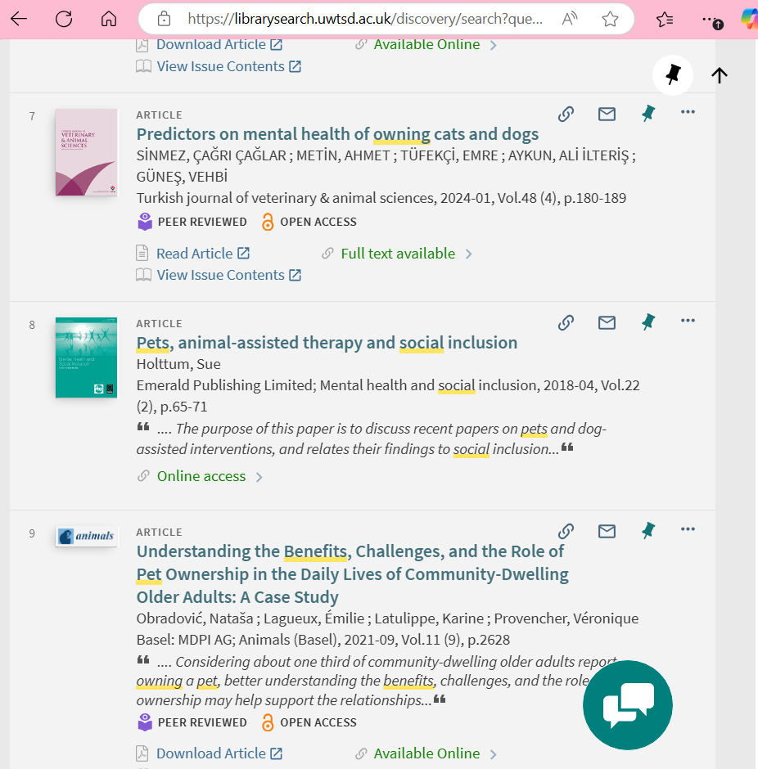
Holttum, S. (2018). Pets, animal-assisted therapy and social inclusion. Mental Health and Social Inclusion, 22(2), 65–71. https://doi.org/10.1108/MHSI-02-2018-0004
Summary- credible source, relevant and valid

3rd Point, Evidence, Support, Optional
Physical benefits of owning a pet
Evidence- Enhanced fitness levels
- Lower blood pressure and cholesterol levels
- Stress relief
- Improved heart health
- Boosted immunity
Supporting evidence: Utz, R. L. (2014). Walking the dog: The effect of pet ownership on human health and health behaviours. Social Indicators Research, 116, 327-339.
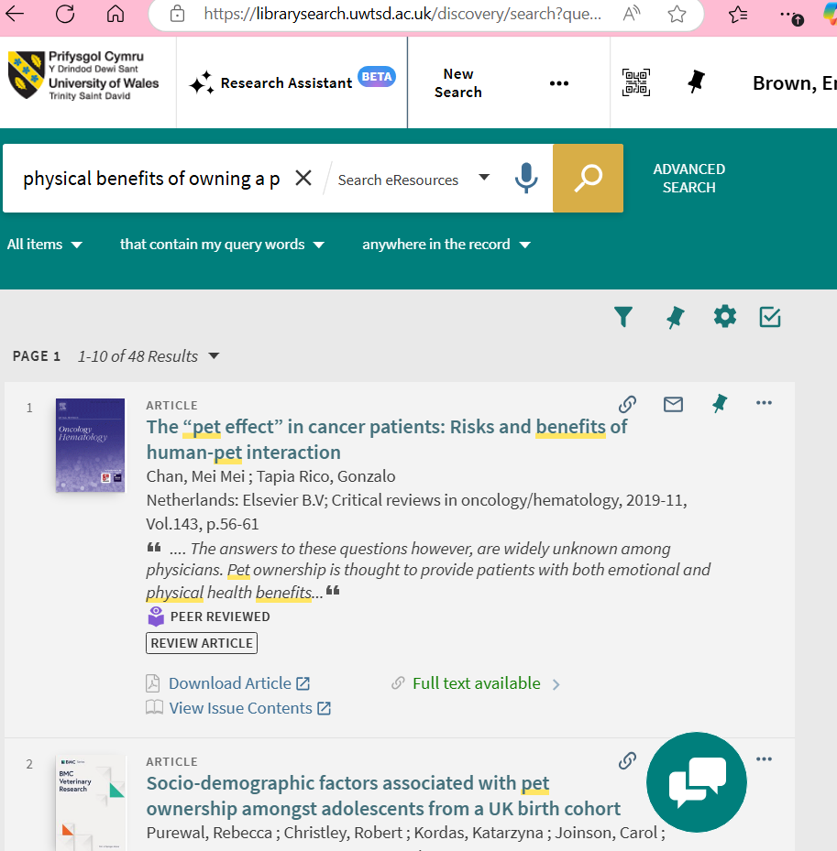
Chan, M. M., & Tapia Rico, G. (2019). The “pet effect” in cancer patients: Risks and benefits of human-pet interaction. Critical Reviews in Oncology/Hematology, 143, 56–61. https://doi.org/10.1016/j.critrevonc.2019.08.004
Summary- credible source, relevant and valid

Conclusion: Key information and an ending point.

Reference List
How to succeed in your degree, with psychology… | BPS

Antonacopoulos, N. M. D., & Pychyl, T. A. (2010). An Examination of the Potential Role of Pet Ownership, Human Social Support and Pet Attachment in the Psychological Health of Individuals Living Alone. Anthrozoös, 23(1), 37–54. https://doi.org/10.2752/175303710X12627079939143

Supporting evidence: McConnell, A. R., Brown, C. M., Shoda, T. M., Stayton, L. E., & Martin, C. E. (2011). Friends with benefits: on the positive consequences of pet ownership. Journal of personality and social psychology, 101(6), 1239.

Supporting evidence: Obradović, N., Lagueux, É., Latulippe, K., & Provencher, V. (2021). Understanding the benefits, challenges, and the role of Pet Ownership in the Daily lives of Community-Dwelling older adults: a Case Study. Animals, 11(9), 2628.

Holttum, S. (2018). Pets, animal-assisted therapy and social inclusion. Mental Health and Social Inclusion, 22(2), 65–71. https://doi.org/10.1108/MHSI-02-2018-0004

Utz, R. L. (2014). Walking the dog: The effect of pet ownership on human health and health behaviours. Social Indicators Research, 116, 327-339.

Chan, M. M., & Tapia Rico, G. (2019). The “pet effect” in cancer patients: Risks and benefits of human-pet interaction. Critical Reviews in Oncology/Hematology, 143, 56–61. https://doi.org/10.1016/j.critrevonc.2019.08.004

Library search screenshots

