Student Name: Jordan Danielle Davies
Student Number: 1701078
Course Title: BA 3D Computer Animation

Module:
Research Practises

Assignment Brief:
Write a proposal of 2,500 words which explores the surrounding research context for your emergent area or field of interest.
Tutors:
Scott Smith

Word Count: 2509

In this essay I will be using three keywords; Narrative, Empathy and Success and artists Walt Disney, Brad Bird and Glen Keane to then achieve the question for my dissertation. In the animating world, Disney and Pixar go hand in hand. However, if investigated in more detail the major differences between the two companies can be spotted and set aside from each other. This essay will target the subject of the two companies and how they are far from the same. The narratives of their feature movies as well as how they present their characters and how they go through the story in which has been created for them. The success between the companies and how they differ between the popularities of their makings.

Disney Animation Studios had set their foot into the world back in the 1920s, with Walt Disney creating hand drawn 2D animations telling the stories of famous fairy tales known by many and adapting them into their magical pieces of storytelling. Drawing in a huge audience with each movie, targeting children but creating for all. Cavalier (2011/119) takes the reader back to the time that Snow White was created y saying, “The film’s colour palette was muted due to concerns that audiences would not be able to sit through the usual bright colours of a cartoon for an extended length of time.” How the studio created their movies back before the cartoon wasn’t seen at such a length was with the audience in mind and how they would react, only using certain colours to suit the audiences view.
Pixar was a struggling company that wanted to make their name in the media world in the 1980s. Wanting to distribute their films but not having the money to do so. Working alongside Disney up until the making of Toy Story 2 they remained separate companies, however Disney wanted to buy out Pixar. Causing argument as it is said that Disney wanted to eat all that was Pixar. Eventually Disney bought Pixar but with the promise of Pixar having full creative control of their creations as well as having their names on their work. Not just Disney but Disney Pixar. Catmull (2014/xi) explains that “We’d resisted the advice of Disney executives who believed that since they’d had such success with musicals, we too should fill our movie with songs.” Showing how much of an influence Disney tried to be on the then new company, how much they wished them to have the same success as they had, however Pixar chose their own path and created the stories that they want to create. Not following that had already been created or certain techniques deemed popular, even if it was suggested by such a big influencer in the industry.

Narrative
Disney create their movies using fairy tales or existing stories adapted to a style of their own. Using magic and different forms of storytelling to break through to their audience of all ages. Even though some of their adapted stories are centuries old, Disney’s versions are what most people think of when they hear the many titles. From Snow White (1937) to Cinderella (1950), most don’t know the origin of the stories but just the movie that Disney had created. Catmull (2014/287) talks on how “the rise of computer animation -and 3D in particular- had convinced Disney’s previous leaders that the era of hand-drawn animation was over.” How 2D animation, the start in this media was being overtaken by the all new and perhaps more popular 3D was an influence on both Disney and Pixar. Pixar using it from the start to build their bases which ultimately led them to their success and then Disney then having to evolve the way that they create their movies to this new way of technology. How their stories would develop and change with this new technology. Crossing bridges that they may not have been able to use before. Abbott (2002/109) explains that “We draw upon pre-existing types that we have absorbed from our culture.” This can relate to Disney using the stories that most would have read or heard of when younger. Developing them into full feature films that can home in memories and create the empathy between the audience and character. As their childhood may come out through a film. When the customer sees what Disney is creating, the story may already be familiar, and they would then want to watch the movie to see how it has been created in todays world.
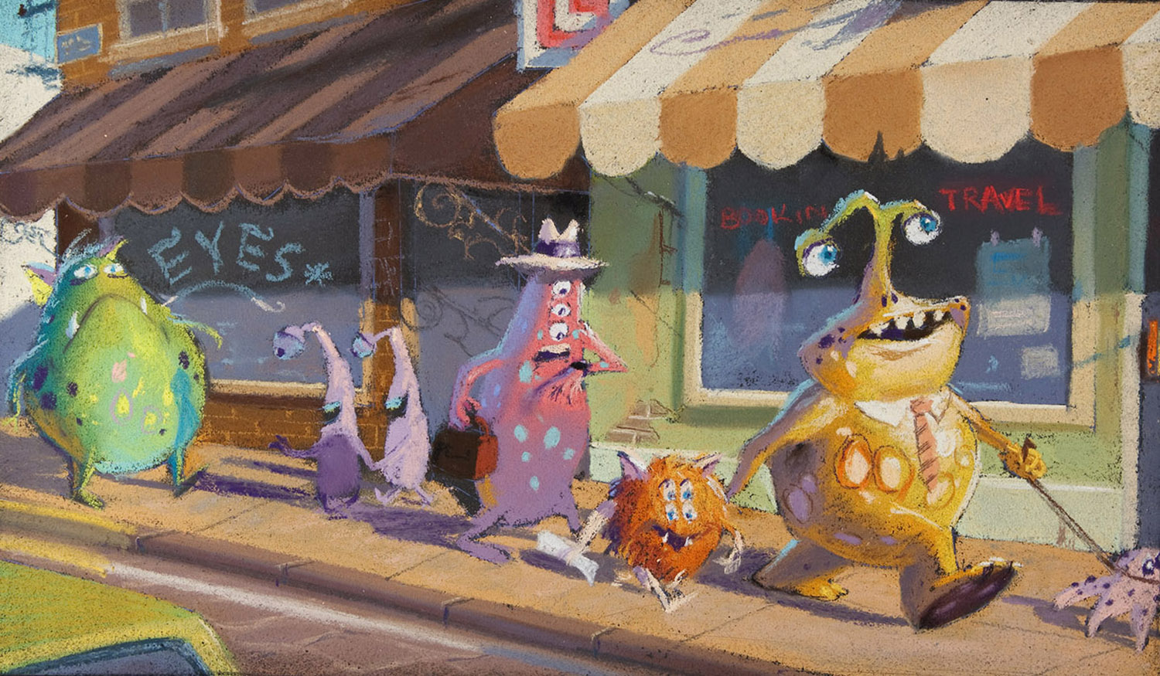
Monstropolis Concept Art, Dominique Louis (2002)
Pixar on the other hand create a new world with their movies. Creating a sense of wonder to what could be. Taking thoughts that children have and thinking what it would be like if it were true. What would the story be? From monsters living in the closet to a rat wanting to become a chef. The stories are those that haven’t existed, but most are something that we have thought of before. What if we all had super powers? What kind of world would that be and what problems would be faced? Catmull (2014/210) explains “we have learned that shorts are a relatively inexpensive way to screw up.” Showing that Pixar uses their famous short movies to try different ways of creating films and seeing how they will react with the audience and what can be then done to improve even more when they get to creating the full-length feature film. Seeing how far they can push the narrative of the story as Palik (2007/80) says “What hand-drawn animation could not do.” In the days when the only form of creating an animation was a pen and paper the limitations were great but with todays technology and knowledge of people from all over the world. The pieces created can break out and be something completely new. Using this technology to push even further than what been done before and seeing what else can be created, the next step in the world of animation.

Empathy
In the creation of their movies, Disney follows a linear approach with their storytelling. Villains are the characters that usually put the plot into motion in which the hero must then overcome. Conquering and becoming the winner. In the Lion King (1994), if Scar did not kill Mufasa during the wilder beast chase he would still be king, and Simba wouldn’t have gone on the journey of self-discovery. He would not then have to fight his uncle and win over him to then become king himself. Being more classic in using the villain to push the hero out of their comfort zone. As Hooks (2000/60) explains “In order to have a strong hero, you have to have an even stronger villain.” To carry the story the villain must create the break up in the story and take the hero elsewhere in their path. Creating a villain that carries the story as it is them that gives the hero their purpose of saving those who are in terror. It may also be them that are telling the story therefore gaging the audience from a different point of view, as Warner (1995/215) says “Fairy tales are not told in the first person of the protagonist, and though Cinderella or Snow White engages our first attention as well as the narrator’s, the voice of the storyteller may be issuing elsewhere.” A classic example of a story being told not from the protagonist but from the villain is Maleficent (2014). From the fairy tale of Sleeping Beauty where she is seen as the bad guy who simply wants to cause havoc to those around this new view of telling the story shows why she does these actions and changes the way that audience views them. Instead of just someone with a dark heart and no sympathy for others, the audience can delve deeper into their story and learn about why they are who they are and what happens after the famous animated movie. The live action movie made in the present uses technology that is vastly different to what is created for the animation made almost 50 years apart the advances in technology is great. Being able to create the ambience for the character which may not have been possible at the time of Disney’s classic.
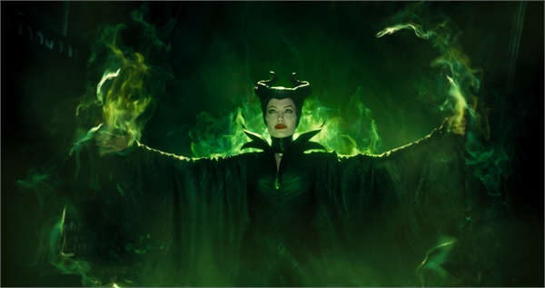
Maleficent (2014)

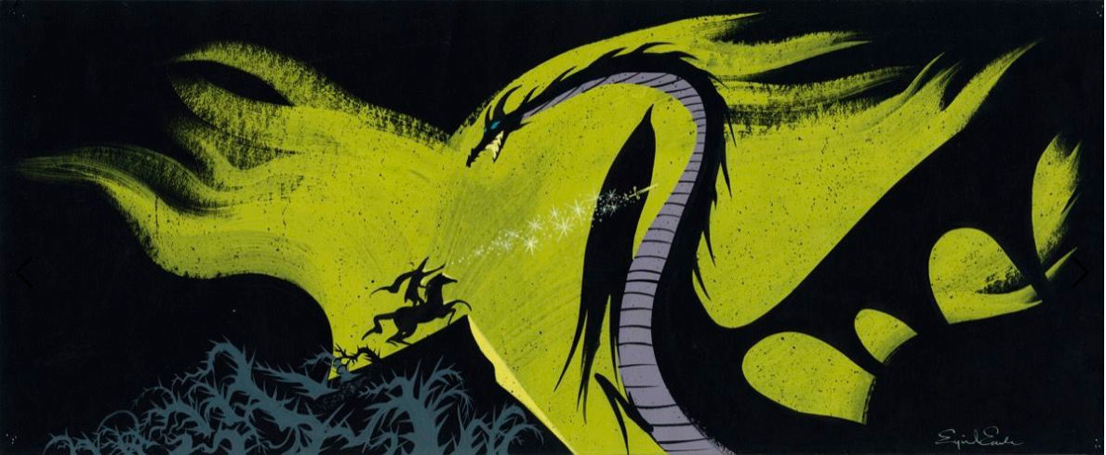
Sleeping Beauty Concept Painting, Eyvind Earle 1959
Pixar on the other hand creates a story that the protagonist would have to confront themselves with the complications of an antagonist. For example, Toy Story (1995), Sid is seen as a villain as he mutilates the toys and changes them while having hold of Buzz and Woody as they are then in danger of becoming one of Sid’s’ projects and getting destroyed. However, it is Woody himself that becomes the villain and must discover this problem and grow from it. Learning from what he has done and making better of it. Pixar push on how you can view a character and how a character can change in themselves throughout the story, becoming a villain but then learning from their mistakes.
Disney has the distinction between good and evil in most of their movies. Clearly put in place even in their appearance, the story shows who is the good and who is the evil. The evil doing wrong and the good putting it right and fixing the problem achieving the inevitable happily ever after. Pixar on the other hand can do this with just one character. Telling from a certain point of view, not seeing clearly who is the good and evil because the character themselves may not know who they are themselves. In The Incredibles (2004), most would say that Syndrome is the villain of the movie. Which can be true to an extent however Brad Bird created a story from a different point of view, Bob is the character that carries the story for good and evil. Learning about himself, overcoming his issues to save not just the others around him; his family but also himself. Seeing the wrong within him and using that to then save those around him. Jones (2008/121) explains that “Empathy is one of the strongest elements to breathing life into your characters and the scene.” Proving that without empathy the character cannot live and breath in the movie and have the audience perceive them as a human being who is telling their own story. Showing how they overcome their bumps in life and giving those who watch the movie the feeling that they can accomplish just as much as the character in the movie. Going back to the example of Bob from The Incredibles, the hardships that he goes through when trying to choose which path to take from his dream of becoming a hero or staying loyal with his family but then discovering he cannot do one without the other can create the empathy connection with the audience as it may be something that they themselves are going through.

Success
Pixar have grown in success with each movie, gaining a bigger box office success bringing in more money with each release. As of now the most successful film from the studios is The Incredibles 2 which came out in 2018. The most recent film that has been released from the studios, the sequel of an already successful franchise that had ended off a cliff-hanger back in 2002 and then released the sequel so many years later continuing the story. People of all ages wanted to watch the movie, those who grew up watching the first and those who went to see the first in its release, creating major success. With each new movie there is a step up in technology. Whether that being in the characters themselves or with how the entire movie is created. Using the newer technologies to advance the movies and push the boundaries even more. Showing more and more with each movie bringing in a wider audience and bettering their success as they would want to see what will be in the next movie. Such as with their sequels, the audience would want to know what would have changed, especially if the movies were created years apart.
Disney, a forever successful film hasn’t had a 3D animated film no more successful than Frozen which was released in 2013. Other films have been released since then but have not met the amount that Frozen had made. This is not a major blow for the company but in the industry, it is strived for each release to make more than the last and Disney have not been able to do that with their animated releases. Pixar has. Cavalier (2011/384) says that “the Disney executives’ decision in 2004 to abandon 2D drawn animation in favour of the currently more profitable 3D CGI.” This could be perceived in many ways. Simply as the company seeing the success of Pixar’s CG movies and wanting to receive the same. However, it could be that the company wanted to branch out from what they had always done for their movies, the 2D cartoon movies that were still bringing success to them but wanting to try the new and adventurous technologies of 3D. Breaking out of their comfort to see how much more successful they can get with this new technology after seeing the way that other had profited from it.
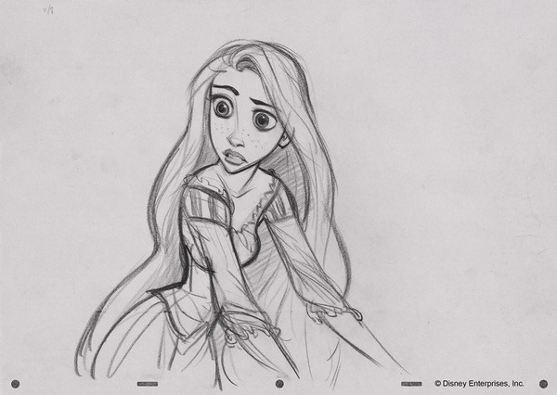
Glen Keane Original Sketch (Raul:2011)
To then be able to create their own new style such as that of Glen Keane who created famous characters such as Rapunzel in Tangled (2010) from this and creating all new elements in their movies that haven’t been seen before or perhaps couldn’t be created in 2D, being able to expand their narrative and media world. Such as with the success of Frozen, all new character and being able to bring in more elements of nature such as the snow to create a new world yet to be seen and using that to interact wit the story throughout and not just having it as a background element.
From seeing the differences between the two studios, Disney Animation and Pixar. The differences between the two in terms of style and narrative is great whether that is from how they created their movies from the set off or how they evolved into using newer technology and using them to creating a greater success. My question is how different would the first movies made by Disney Animation and Pixar be if they were made today? How todays technology and how narrative is perceived today could affect the movies and if they would become a different piece of animation or if the changes in technology wouldn’t make an effect on the narrative. Going into what makes the story and how that has changed in the history of the studios as well as the audience as these companies have evolved. Seeing how the movies would turn out today could then prove how much the companies themselves have changed as well as the world in which they are being released to.

Bibliography
Books
Catmull, E., 2014. Creativity inc.. 1st ed. London: Bantam Press.
Cavalier, S., 2011. The World History of Animation. 1st ed. California: University of California Press.
Hooks, E., 2000. Acting for Animators. 1st ed. Portsmouth: Heinemann.
Jones, A., 2008. Thinking Animation, Bridging the gap between 2D and CG. 1st ed. Boston: Thomson Course Technology.
Palik, K., 2007. To Infinity and Beyond. 1st ed. London: Virgin Books.
Warner, M., 1995. From the Beast to the Blonde. 1st ed. London: Vintage Books.

Movies
Cinderella. (1950). [film] Directed by C. Geroimi. California: Walt Disney Studios.
Frozen. (2013). [film] Directed by J. Lee. California: Walt Disney Studios.
Incredibles. (2004). [film] Directed by B. Bird. California: Pixar.
Incredibles 2. (2018). [film] Directed by B. Bird. California: Pixar.
Lion King. (1994). [film] Directed by R. Minkoff. California: Walt Disney.
Monsters Inc.. (2001). [film] Directed by P. Docter. California: Pixar.
Snow White and the Seven Dwarfs. (1937). [film] Directed by D. Hand. California: Walt Disney Studios.
Tangled. (2010). [film] Directed by B. Howard. California: Walt Disney Studios.
Toy Story. (1995). [film] Directed by J. Lasseter. California: Pixar.
Toy Story 2. (1999). [film] Directed by J. Lasseter. California: Pixar.

Image Sources
Dominique Louis, (2002), Monstropolis Concept Art [ONLINE]. Available at:
https://www.pixar.com/feature-films/monsters-inc [Accessed 10 April 2019].

Earle, E. (1959). Sleeping Beauty Concept Painting. [image] Available at: https://www.artsy.net/article/artsy-editorial-artist-made-disneys-sleeping-beauty-enchanting-impossible-animate [Accessed 10 Apr. 2019].

Raul. (2011) “The Art of Glen Keane” Blogger 20 July Available at:
http://theartofglenkeane.blogspot.com/

