Essential Concepts and Principles of Modelling and Analysing data

Assignment one

Lois Elizabeth Rossiter

1909920

Table of Contents
Spreadsheet models 3
Figure 1.0 5
Data analytics 5
Figure 2.0 6
Figure 2.1 7
Figure 2.2 7
Stages of modelling 7
Sum +-/* 8
Figure 3.0 8
Average 8
Figure 3.1 8
IF 8
Figure 3.2 9
Figure 3.21 9
Figure 3.3 10
Figure 3.31 10
PIVOT TABLES 11
Figure 3.4 11
GRAPHS 11
Figure 3.5 12
Categories of data in the files 13
Data Visualisation 13
Value of a spreadsheet for organisations 14
Reference List 14

The following report will outline the effectiveness within using spreadsheets within business practices, specifically in the businesses Dragon Trading and Fferm Fach-o-Bopeth. It will also an analysis of the spreadsheet model and its functions. Prior to writing this report, two spreadsheets were created, firstly Dragon Trading which was an established spreadsheet model to which need data, formula and charts added. Secondly, Fferm Fach-o-Bopeth which required a spreadsheet model to be created. The requirement for the creation allowed for development in my personal understanding of how spreadsheets and formula are undertaken.

Spreadsheet models
When developing a spreadsheet model it is important that the spreadsheet which is created is correct in regards to the information to which needs to present that particular data. Planning is an essential part of this process because any issues that are found can be altered to prevent any problems at a later date when data is transferred into the spreadsheet, “This is the most fundamental level of your work, and the most creative moment in the entire existence of your spreadsheet. An error here can be hard to fix, requiring massive rearrangements of the spreadsheet structure or new inputs from new sources.” (Bewig, 2015, p. 1). Spreadsheet modelling is where the creation of cells ,whether it has literacy or numeracy content, tables are created and calculations are incorporated with the use of formula. Sheets can also be added to data to be presented individually, but can also be connected to formula and data on other sheets within the document, but they can make formula more complex, therefore if it is not essential to include multiple sheets into the spreadsheet, unless they are needed, due to that that it can complicate matters, “Multiple sheets make formulas longer and harder to read because the sheet name must be included.” (Bewig, 2015, p. 2).
Fferm Fach-o-Bopeth required its data model to be created from the beginning. The business required the creation of a spreadsheet model to display its data. One model that needed to be created was one in which could display an estimation forecast illustrating the income from animals sold during each season of the year. The creation of a simple table that outlined columns for each season. The data was transferred into the table from documentation to which provided the relevant figures. This model can be seen in Figure 1.1.

The creation of Fferm Fach-o-Bopeth’s spreadsheet model allowed for the development of the creation process before applying data to eliminate any errors found and as Bewig states “this is the most fundamental level of your work” (Bewig, 2015).
“That way you can always see the assumptions neatly in a single place, formulas are less likely to be overwritten, you know where to go to make changes, and output can be formatted for the reader while logic can be laid out for the developer.” (Bewig, 2015, p. 2).

Figure 1.0
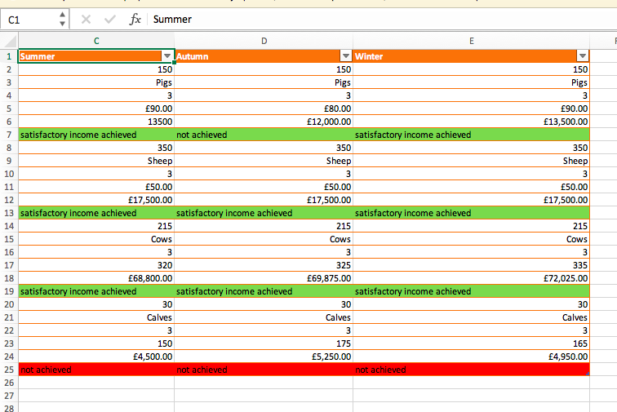

Data analytics

“Data Analytics is a process of inspecting, cleansing, transforming and modelling data with the goal of discovering useful information, suggesting conclusions, and supporting decision-making. If focuses on knowledge discovery for predictive and descriptive purposes to discover new ideas or to confirm existing ideas” (Sedkaoui, 2018, p. 46). Therefore data analytics is essential to business planning and it allows for a business performance to be analysed and forecast.

The “application of descriptive, predictive and prescriptive major analytic components, the outcome of which supports and demonstrates business decision-making and organizational performance” (Sedkaoui, 2018, p. 46). As stated within the previous quote, there are three main context surrounding analytics, firstly, descriptive analytics, which condense the figures into charts and these then allow business managers to use them with reports. Secondly, predictive analytics whom incorporate former data results of attainments to predict future data. Lastly there is prescriptive analytics, to which makes effective methods to establish the best results, using software, that displays variant results (Evans, 2012).

Data analytics is important for businesses due to the fact that its main aim is to provide the data. It is also widely concluded that it helps in assisting business decisions, displays previous and current data in addition to future predictions. “Various research studies have discovered strong relationships between a company's performance in terms of profitability, revenue, and shareholder return, and its use of analytics” (Evans, 2012). Business analytics supports management choices, however if as previously noted, the spreadsheet modelling, data or formula is incorrect it could negatively affect the business’ performance.

The data model allowed Dragons Trading to create a data table which displayed the results of a VLOOKUP formula and as a result supplied them with their quality control statistics needed. Figure 2.0 and figure 2.1.

Fferm Fach-o-Bopeth spreadsheet data required the creation of an income and expenditure table. This data allows for Fferm Fach-o-Bopeth to gain an over view into the business’ finances based on each month of the specific year. The data in which required to be incorporated included animal costs, vaccination and veterinary fees. The results shows the business its expenditure each month and its income. This data will allow for future planning and also review of costings. Figure 2.2.

Figure 2.0

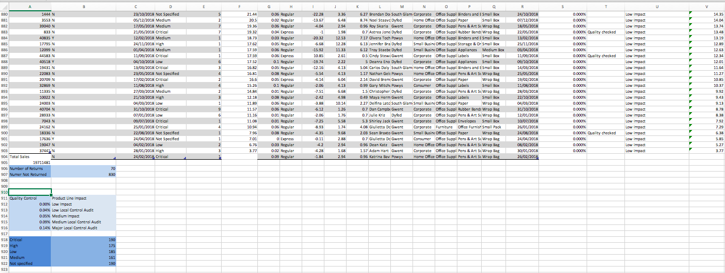

Figure 2.1

Figure 2.2

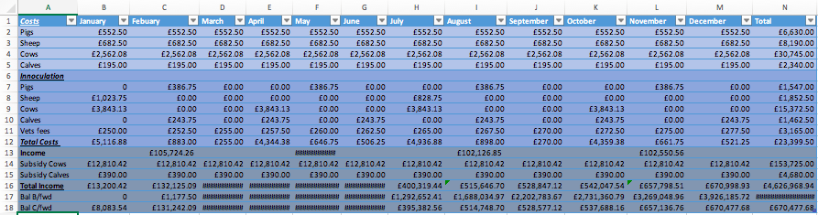

Stages of modelling

D Mather looked at a framework for spreadsheet building, this included the framework, where firstly the identification of outputs and inputs are used to calculate the variables. How pages should be divided into the managers page the constants page, the calculations page and the graphs page. They also spoke about the constant inputs, therefore mostly fixed costs, the variable inputs, so changes in demand and orders and lastly the outputs. (Mather, 1999).

The simplicity of a spreadsheet model is important because the information needs to be easy to interoperate, “Most spreadsheets work well enough with a few SUMS and IFS” (Bewig, 2015, p. 1). Formal and test are required within a spreadsheet, some of these used are listed below:

The goal of this spreadsheet was to show if each animal during each season provided an outcome of more than £12,000. This therefore needed a space where an IF function could be incorporated. The IF function was then formulated into the spreadsheet and provided one of two outcomes, firstly “satisfactory income achieved” if more than £12,000 and secondly “not achieved” if less an £12,000. To finish this spreadsheet model colour was introduced to make the spreadsheet simpler to interoperate. An example of this formula used is =IF(C6>12000,"satisfactory income achieved","not achieved")

Sum +-/*

The Sum or AutoSum is a formula used within excel, click on the cells or add figures, also the cells chosen will automatically formulate. This formula was used multiple times throughout both spreadsheets, for example, in the Farm the sum formula was used =SUM(150*0.85*13/3). Plus is the sign + , minus is - , divide is / and times is *. Figure 3.0.

Figure 3.0
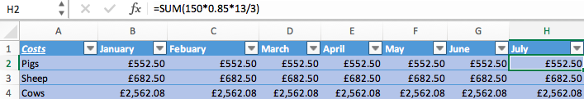

Average

Average is an excel function used when the spreadsheet requires and average, for example, this was used in the Dragon Trading spreadsheet, =AVERAGE(F3:F903). The cells references was highlighted regarding the cells figures that were required within the sum and the average function finds this automatically. Figure 3.1.

Figure 3.1

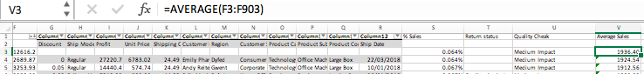

IF

One goal of farm spreadsheet was to show if each animal during each season provided an outcome of more than £12,000. This therefore needed a space where an IF function could be incorporated. The IF function was then formulated into the spreadsheet and provided one of two outcomes, firstly “satisfactory income achieved” if more than £12,000 and secondly “not achieved” if less an £12,000. To finish this spreadsheet model colour was introduced to make the spreadsheet simpler to interoperate. Figure 3.2.

Figure 3.2

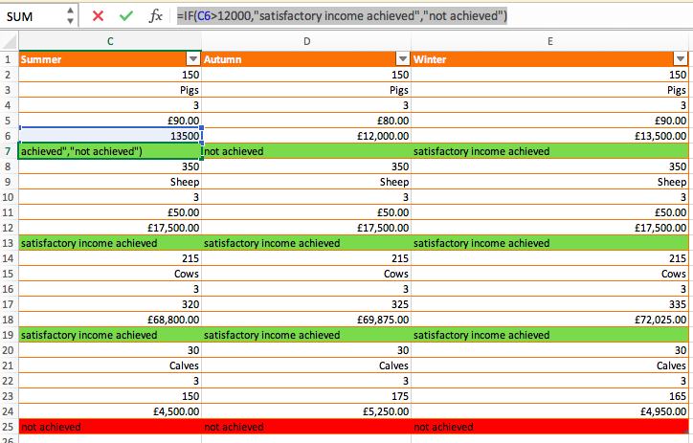

Dragon Training’s spreadsheet required the use of an IF function to see if returned items needed to be quality checked. This was done by creating an If function test, the formula was created in regards for this, =IF(B8="Y","Quality checked","").
Figure 3.21.

Figure 3.21

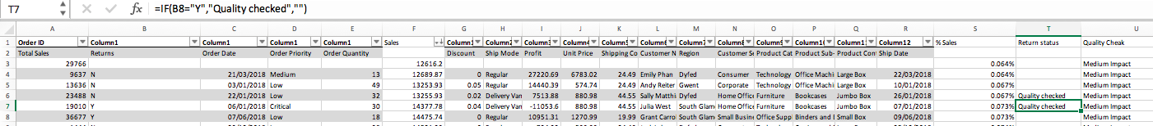

LOOK UP

The vlookup function is used to find data, in Dragon Trading’s spreadsheet the vlookup function was used to find the product line impact in regards the sales percentages. The formula used was, =VLOOKUP(S3,$A$909:$B$914,2). The $ signs is use to create an absolute cell reference, meaning this cell will not change, during working on this spreadsheet the work alternated between a windows computer and an Apple MacBook, Apple did not have an F4 key, so some formulas within the spreadsheet do not have this, although not having an effect for the majority, sometimes it had to be entered manually. This data was then transferred into a table. Figure 3.3. Figure 3.31

Figure 3.3

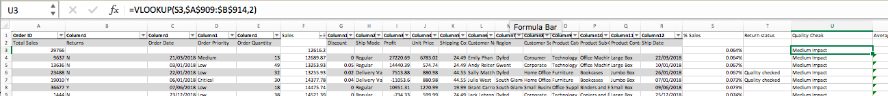

Figure 3.31

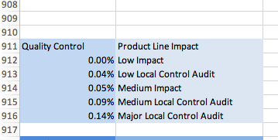

PIVOT TABLES

Pivot tables are a feature on excel and used to summarise the most important data into a table. PIVOT TABLES are created using the PIVOT TABLE option on the insert bar, to create this following table the main spreadsheet was highlighted and inserted into the function. Figure 3.4.

Figure 3.4

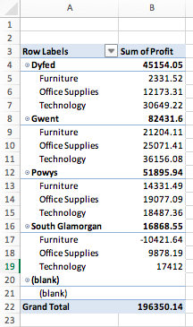

GRAPHS

Graphs are incorporated into a spreadsheet for visual effect and were inserted into the Farm spreadsheet, again the relevant data was highlighted and inserted into the chart feature on the excel software. Figure 3.5

Figure 3.5

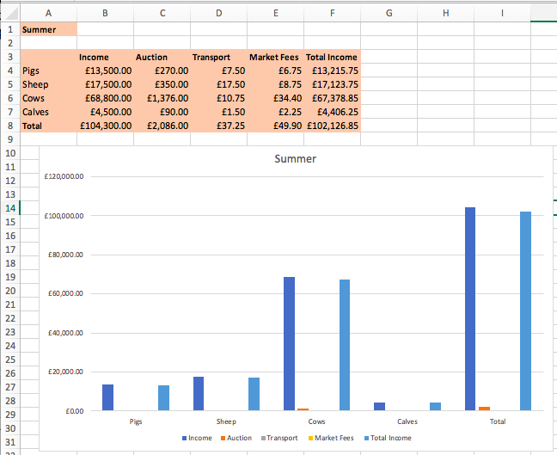

Categories of data in the files

There are four types of categories of data, nominal, ordinal, interval and ratio.
Nominal also referred to as labels of variables, therefore the names of data, for example with the Farm spreadsheet the names of the animals for inserted into the relevant cells, figure 4.0. Next there is ordinal, which refers to the data being set in order, order of cell values are be change in regards to the date needed to be shown, for example in Dragon Trading’s spreadsheet the value needed to be changed to the highest figure set first and not in order of dates. Interval are the scales that show values in numerical differences. Lastly there is ratio, which refers to the ratio scales that can be created, for example, measuring the mean and mode. (methods, 2019).

Figure 4.0

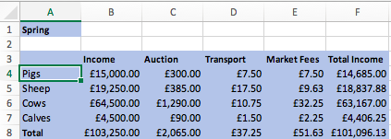

Data Visualisation

As there is conflict in regards to whether data visualisation has an effect on the success of the spreadsheet. It therefore is individual decision as to whether the data within the spreadsheet would benefit from the use of data visualisation. The importance is seen as an individual decision. “The visualization immediately provides “gestalt” information about the dataset that is useful for quickly understanding the dataset.” (National Center for Data Mining , p. 3). According to Grossman “We are not aware of any research efforts to apply information visualisation techniques specifically towards data quality” (O'Berine, 2018, p. 178).
It is a decision that’s taken by the developer as to whether data visualisation will add to the spreadsheet. In regards to the National Centre for Data Mining, it was thought that the Farm and Dragon Trading will benefit from the used of visualisation throughout their spreadsheets due to the fact that it will be simpler for the data to be presented to individuals or a group of people. Visualisation charts allows for the required data to be compressed. There are many different graphs that can be used to display data, these include line, bar, pie. Throughout both Farm and Dragon trading the use of two charts were used, the bar and the pie chart. The Bar chart made the data compressed into a visual presentation that allowed for data to be simple to understand. Figure 5.0 and Figure 5.1.

Figure 5.0
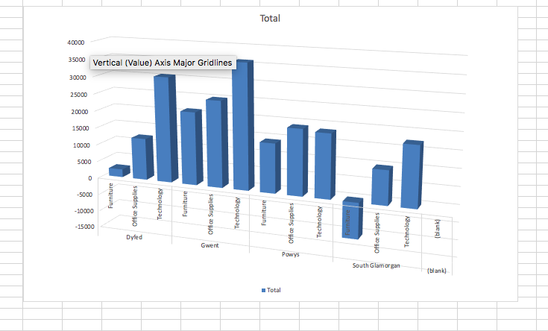

Figure 5.1
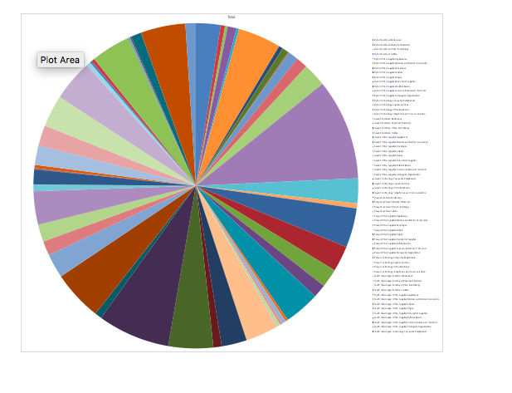

Value of a spreadsheet for organisations

Spreadsheets are extremely valuable to organizations because they show data and analysis of their figures that allow them to plan and strategies. “Despite the low level of research in the domain, spreadsheet technology is as fundamental to the smooth running of every financial department as the dedicated financial accounting system that may be in place.” (Dr. Kevin McDaid, 2011). Spreadsheet software allows all business data to be stored in one place with the use of added formula, which will give the specific information based on the data needed. The business is then able to analyse this data, to allow it to make informed business decisions from both a data standpoint and a visual one, if graphs are included. It is important therefore that the data, information and formulas are correct, otherwise business decisions and plans could be made using false data and could have major implications on an organisation, mainly financially. Errors in spreadsheet reports can happen and as previously noted in this report, planning is the best way to help prevent errors happening. It is also important to use the correct formula and cell references. If the organisation consistently creates and updates their spreadsheets then it will give them the background information to compare and contrast to from modern date information. Business need to make informed decisions that allow them to invest and grow within their industry.
In conclusion, Fferm Fach-o-Bopeth and Dragons Trading spreadsheet allowed the business to create data information based on the information that was needed Fferm Fach-o-Bopeth needed costs and income regarding their sales figures so an income and expenditure sheet was created. A costing table was also created to outline the costs of the animals. This information will help Fferm Fach-o-Bopeth with their costings, they are now able to see where their income and expenditure figure are based on each month of the year and by each animal they have on their farm. Dragon Trading required sales information, such as, their total and average sales, this data was found by using the correct formulas. They also needed a range of figures including the highest and lowest discounts that they were offering. Pivot and lookup tabled were included to find specific data figures and make the information more compacted in the way in which it was displayed. Dragon trading and Fferm Fach-o-Bopeth spreadsheets were both formatted using shading and colour so that it help the way in which the data was presented. The both businesses can now use there spreadsheets to expand and review their businesses figures and finances so that they are able to make informed decisions and stratergies.

Reference List
(n.d.).
Bewig, P. L. (2015). How do you know your spreadsheet is right? Principles, Techniques and Practice of Spreadsheet Style. Saint Louis, Missouri: Philip L. Bewig.
Dr. Kevin McDaid, D. R. (2011). Spreadsheets in Financial Departments: An Automated Analysis of 65,000 Spreadsheets using the Luminous Technology . Technology.
Evans, J. R. (2012). Business Analytics: The Next Frontier for Decision Sciences. Carl H. Lindner College of Business, University of Cincinnati.
Mather, D. (1999). A framework for building spreadsheet based decision models. Journal of the Operational Research Society , 70-74.
methods, m. m. (2019, September 3). Types of Data & Measurement Scales: Nominal, Ordinal, Interval and Ratio. Retrieved from my market research methods: https://www.mymarketresearchmethods.com/types-of-data-nominal-ordinal-interval-ratio/
National Center for Data Mining . (n.d.). DaVis: A tool for Visualizing Data Quality: Rajmonda Sulo* Stephen Eick † Robert Grossman‡. Chicago: National Center for Data Mining.
O'Berine, P. (2018). Information and Data Quality in Spreadsheets . Wexford : Systems Modelling Ltd .
Sedkaoui, S. (2018). Data Analytics and Big Data . London and Hoboken: John Wiley &Sons, Inc. .

