Title Page
Qualification: CIPD Diploma in Applied Human Resources

Module Name: Developing Professional Practice in HR

Activity 2 – The CIPD HR Profession Map

Word Count: 1026

Student Name: Mrs Angela May Procter
Student Number: 2015609
CIPD Membership Number: 54466106

By signing below, I confirm that the work/evidence presented is my own, unaided work. I understand the regulations pertaining to candidate malpractice and the action that may be taken as a result.

Signed: A M Procter
Date: 03/01/2021

Activity 2 - CIPD HR Profession Map

The CIPD has a vision to be ‘the people profession for now and for the future’ (CIPD) and have therefore created a tool in order to achieve that vision by setting standards for HR professionals. This tool is the HR Profession Map (HRPM) originally created in 2009 by CIPD and updated in 2013 which is the basis for study, however, it has since been remodelled and it is this new CIPD HR Profession Map that is now used by professionals in the workplace to guide their work, develop their skills and plan their careers.

The HR Profession Map (2013)
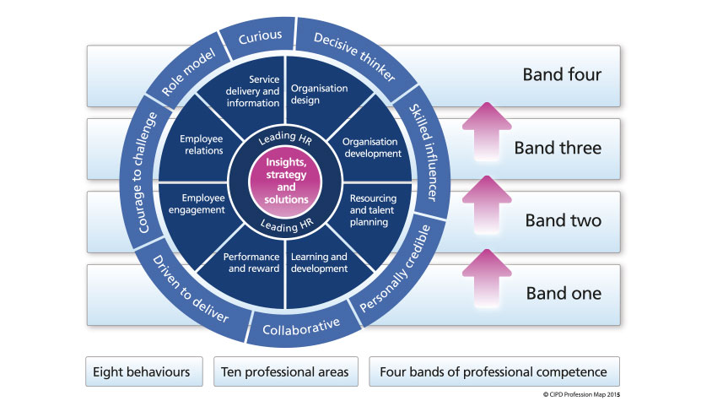
Source: CIPD (2013)
As can be seen from the map above, it comprises ten professional areas, two of which are core areas that underpin the whole HR profession – ‘Insights, strategy and solutions and Leading HR’. These areas stipulate what HR professionals need to know and what to do. The eight behaviours stipulate how this should be done which ultimately gives credibility to the HR profession.
Also included in the map are four bands of professional competence which determines what activities and behaviours need to be displayed when working at the various levels within the profession, with the lowest level being one and the highest, four. Each part of the map will apply equally to all of those within the profession to a greater or lesser extent, however, the level of responsibility and influence will vary accordingly with those working within Band four having the greatest level of responsibility as they will be working at a strategic level.
The map is used for individuals to plan their own continuous professional development (CPD) which is based on reflection, to prepare for performance reviews, interviews, CIPD membership and new career opportunities. However, it is also a useful tool for businesses and organisations as it is able to help identify the skills needed for change and team capability, to develop career pathways, competency frameworks and role profiles which focus on the behaviours needed to deliver success in the workplace.
The Core Professional Areas
As mentioned above, the two ‘Core’ professional areas: ‘Insights, strategy and solutions’ and ‘Leading HR’ provide a firm foundation on which to base the remaining eight professional areas. In fact, when evaluating these areas, it is clear that there is a direct link between the ‘Core’ areas and the supporting professional areas as each professional area fits perfectly within one of the ‘Core’ areas to help deliver the objectives as can be seen below
- Insights, strategy and solutions
  - Objective: To develop an understanding of the organisation and its context and use these insights to tailor strategy and solutions to meet organisational needs now and in the future
    - Organisational design
    - Organisational development
    - Resource and talent planning
    - Learning and development
- Leading HR
  - Objective: To act as a role model, maximising the contribution that HR, or a specialist function, makes throughout the organisation both through their own efforts and through supporting, developing and measuring others across the organisation
    - Performance and reward
    - Employee engagement
    - Employee relations
    - Service delivery and information

The HRPM Behaviours
For years, many organisations have included competencies only when managing the performance and development of their staff which has often resulted in the wrong behaviours being adopted. It has been recognised that behaviours are just as important, if not more important, than the competencies themselves as it is ‘how’ an activity is performed that delivers professionalism and not just the ‘what’ is done. Certainly the College of Policing ( has adopted a framework similar to that of the CIPD profession map (2013) to manage the performance of its officers and staff across all police forces within England and Wales which can be seen below:

The College of Policing’s Competency and Values Framework (CVF)
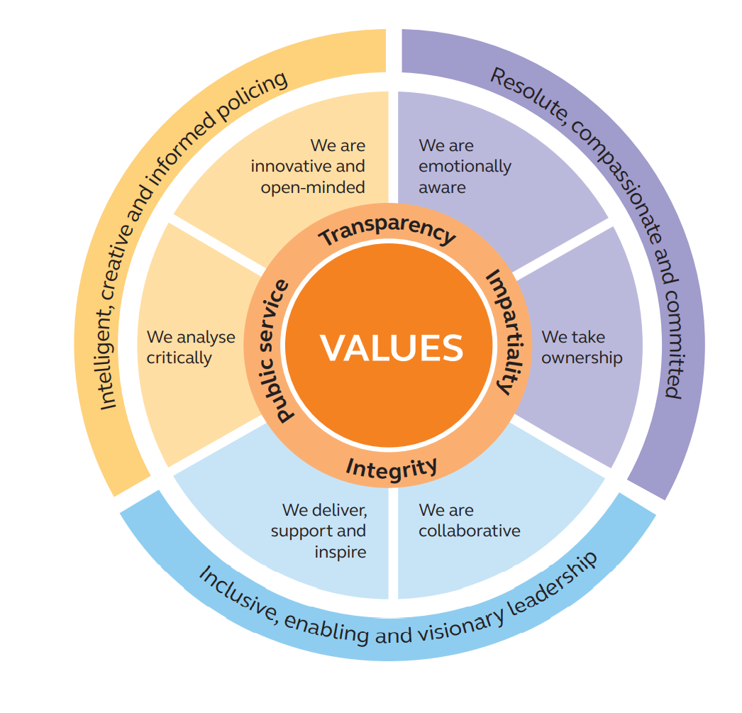
Other public sector bodies including the NHS and government departments have similar models.
Traditionally, HR professionals have focused on compliance, however, as reported by Rachel Sharp (2019), David D’Souza, CIPD Membership Director has pointed out, the CIPD has made it clear that ‘in every interaction and decision, we’re expecting people to reflect on what’s the right thing to do’. Certainly ethics and integrity are key behaviours that are needed to demonstrate professionalism and this has been included within both the framework and the qualifications for CIPD accreditation. The new CIPD HRPM now not only includes this within its behaviours under ‘ethical practice’ but it is also included within one of the three main values as ‘Principles-led’.
Any breaches to the code of conduct by an HR Professional will be investigated by CIDP which may then be referred to a Code of Professional Conduct Hearing should this be proven.
The way in which individuals and companies behave has come to the forefront in recent years with scandals such as the VW emissions scandal and the Carillion’s collapse , although perfectly legal, the damaging behaviours caused significant harm to individuals, other companies and the environment.
HR professionals have a responsibility to try to influence and challenge the behaviours of individuals and cultures within companies with performance and development systems being the perfect tool to influence this, thereby allowing the CIPD HRPM to be adapted for this purpose. Difficult decisions would need to be made where there is a mismatch in values between the HR professional and the organisation in which they work if they were unable to influence the changes required. As Claire Fox, Chief People Officer for Unicef has said ‘The human race needs to change the way it lives, and the way it does business is an important part of that’ Sharp (2019). In answer to Rachel Sharp’s question ‘how can HR develop it’s capability in regards to ethics?’ Richard DeGeorge, co-director of the International Center for Ethics, responded ‘simply treating people with respect and considering everybody who might be affected by one’s own actions’ which is sound advice when considering behaviours.
Certainly the behaviours within the HRPM revolve around adding value to the organisation, stakeholders and peers, working effectively and inclusively to deliver the best results for the organisation and its people, acting with integrity, impartiality and independence.

Reference List
CIPD HR Profession Map (2013) can be found at https://www.cipd.co.uk/learn/profession-map/2012-profession-map (accessed 12/11/2020)
CIPD ‘CIPD Vision can be found at https://www.cipd.co.uk/news-views/guture-profession (accessed 12/11/2020)
College of Policing CVF Framework can be found at http://beta.college.police.uk/career-learning/career-development/competency-and-values-framework-cvf (accessed 30/12/2020)
Sharp, R. (2019) Ethics & HR, HR Magazine April 2019

