Commemorating the Welsh Landscape
Emma Lyles – 1804295
BA of Fine Art
1,045 words
Professor Sarah Tombs

Emma Lyles
Professors Sarah Tombs and Louise Burston
Creative Research
13 December 2018
When we hear the word ‘commemorate’, we usually think that a person who has passed or an event that took place is being remembered. Commemorating is a way to show respect for something or to celebrate it. In art, there have been creators who look to nature to be inspired. In the case of Wales, the beauty of the countryside has been celebrated for many years by being recreated in fine art, poetry, or even music. In a way this is commemoration of a place; serene mountains, calming beaches, or quiet waters. Artists in Wales from David Jones to Dylan Thomas revelled in the unmistakable beauty and uniqueness of the country in a way to commemorate the feelings of home.
Wales Art Review argues that Wales plays an important role in romantic landscape painting. Artists like Thomas Jones looked to painting the Welsh landscape as a meditative practice. Walesartreview.org talks about his paintings; “In their gentle, meditative depictions of nature and the presence of a still, solitary figure, these drawings seem like love-letters to a landscape with which the artist is completely intimate”. Jones studied the rolling hills just next to his home and hung many of these paintings in his house for his own viewing pleasure (Peter Wakelin, Romanticism in the Welsh Landscape). The article goes on to explain how visitors of Wales came to experience what Edmund Burke said was “the ‘sublime’, a response of fear and awe brought on by the vastness of mountains or the grandeur of ruinous destruction. The sublime mountains, waterfalls, mines and ruined castles of Wales became subjects through which to consider themes such as the individualism of Britain, the power of nature, the immensity of Creation and the devastation wrought by time” (Peter Wakelin). The serene beauty in many Welsh landscape paintings convey not only the sense of home and nature, but often the deeper underlying historical passing of time in the country. The picturesque mountain images depict natural grandeur but also fear and power from such immense formations. Artists like William Turner or John Sell Cotman began their landscape paintings in Wales, which helped to bring out their artistic visions (Peter Wakelin). Turner is now the most well-known British Romanticism artist of this time. Graham Sutherland wrote of his landscape paintings of Pembrokeshire that they “expressed the intellectual and emotional essence of a place” (Tate.org). With the dark colors and calm aura of his paintings, he depicts an eerie perspective of Wales. Sutherland’s paintings were transformed after seeing the strangeness of Pembrokeshire's skylines, evident in his work.

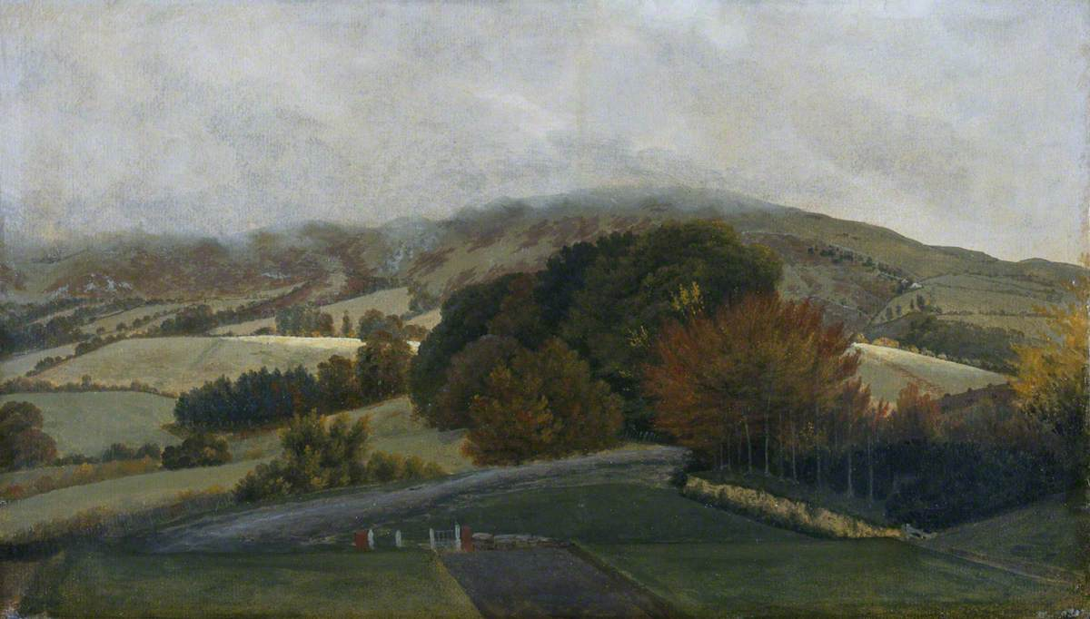
Jones, Thomas. Carneddau Mountains from Pencerrig (1742-1803)
For another neo-romanticist painter, John Piper, Wales was a place of discovery that led him to express the power of the mountains in an abstract way. ‘I felt then that I was seeing the mountains for the first time and seeing them as nobody had seen them before’ Piper said of Snowdonia (Jim Morphy). According to the Wales Art Review, the series in which Piper is referring rank as the most memorable recordings of the Welsh Lanscape for their century. Piper was stationed near Snowdonia during the war by the War Artists Advisory Committee as a way to document important areas and boost national morale (Jim Morphy). Like anyone would, the artist grew attached to the landscape and found himself in North Wales time and time again in the following years. Another quote by Piper talks about how the artist used color to convey different moods in his paintings: ‘the rocks can only look grey in a leaden light, and then do not, commonly. Against mountain grass or scree, against peaty patches near tarns, on convex slopes, in dark cwms, the same kind of rock can look utterly different, and changes equally violently in colour according to the light and time of year. The rocks are often mirrors for the sky, sometimes antagonistic to the sky’s colour’ (walesartreview.org). His abstracted paintings give off a specific feel that conveys the mood of North Wales. Although most of the works are free from bright color, there is a wild element to the loose brushstroke and freedom of his pen and charcoal drawing overtop the paint.
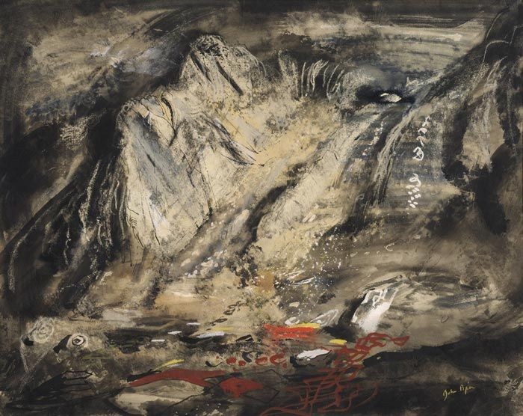
Piper, John. Jagged Rocks Under Tryfan. 1948
Wales might have been a place that some artists feared, with its mountains covered in ominous overcast light, but for some like David Jones, Wales was a place of safety and its beauty permeated with spiritual divinity. While also a poet, Jones exhibited his emotional moods and underlying meaning in his visual art. According to The Metamorphosis of David Jones about Wales, its “otherness,” he said, left “an indelible mark on the soul” (Ian Tuttle). This seems to be a persistent feel among all the previous painters mentioned. He cared deeply of the history and folklore of the country, and this shows in his work. After being in the first world war that devastated him, Jones looked to the Welsh landscape as a safe place of peace. In his visual artworks he was commemorating the war but also the rich history of Wales by depicting the moods of the era. Jones was not himself Welsh but came from a Welsh father and connected with the land in ways he could not connect to his home country of England. Even apart from Wales, Jones would paint and draw images of the Welsh landscape from memory. His catholic influences show through his paintings in a spiritual way.
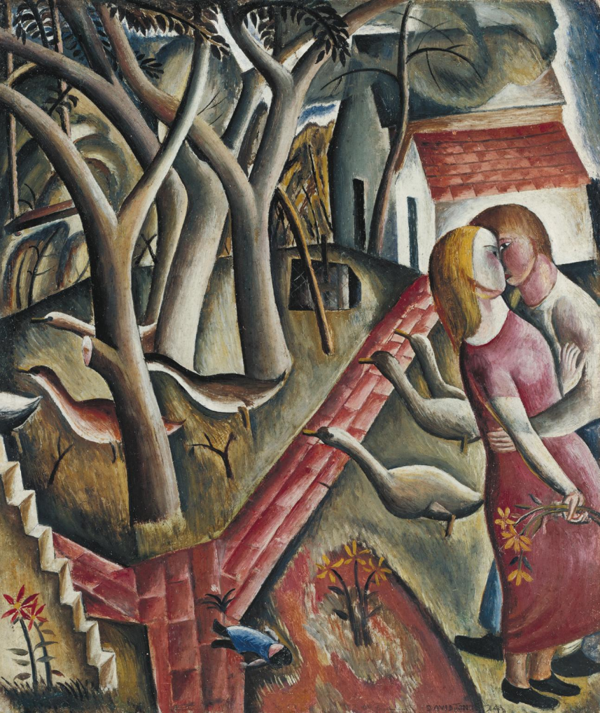
Jones, David. The Garden Enclosed. 1924
There are many Welsh landscape painters because the land is something to be commemorated. With its beauty, powerful essence, and uniqueness of the land, Wales lets off a feel like nowhere else. I’ve felt it, and many artists have felt it for the longest time. Looking through Welsh landscape art, a history can be explained through eras of unrest and peacefulness. Wales presents itself as a place of inspiration and meditation, as seen in artwork.

Works Cited
Morphy, Jim. “John Piper: The Mountains of Wales.” Wales Art Review, 19 March 2013, https://www.walesartsreview.org/john-piper-the-mountains-of-wales/. Accessed 10 December 2018.
Wakelin, Peter. “Romanticism in the Welsh Landscape.” Wales Art Review. 4 March 2016, https://www.walesartsreview.org/romanticism-in-the-welsh-landscape/. Accessed 10 December 2018.
“Welsh Landscape with Roads.” August 2004. https://www.tate.org.uk/art/artworks/sutherland-welsh-landscape-with-roads-n05666. Accessed 10 December 2018.
Tuttle, Ian. “The Metamorphosis of David Jones.” New Criterion, vol. 36, no. 9, May 2018, pp. 28–31. EBSCOhost, ezproxy.uwtsd.ac.uk/login
url=https://search.ebscohost.com/login.aspx?direct=true&db=aph&AN=129328893&site=ehost-live.

