Student code: 1605158

Module: Professional and Pedagogic Studies Learning: Leading the Learning: what, how and why am I teaching?

Module code: ECAD6008

Assignment title: Critically reflect on your progress in planning, preparing, and teaching lessons that incorporate specific pedagogical principles. Identify one of these pedagogical principles as an area for development and justify the next steps in your development.

Pedagogic principal focus: Using assessment for learning to accelerate progress.

QTS Standard focus: Assessment
Table of Contents
Part One: Professional Experience Templates………….……….…..……… | Page 3
Part Two: Critical Reflection Plan…..………………………………….….…… | Page 11
Reference List……………………………………………………………….…..… | Page 20
Appendices……………………………………………..…………………………… | Page 24

Part One: Professional Experience Templates

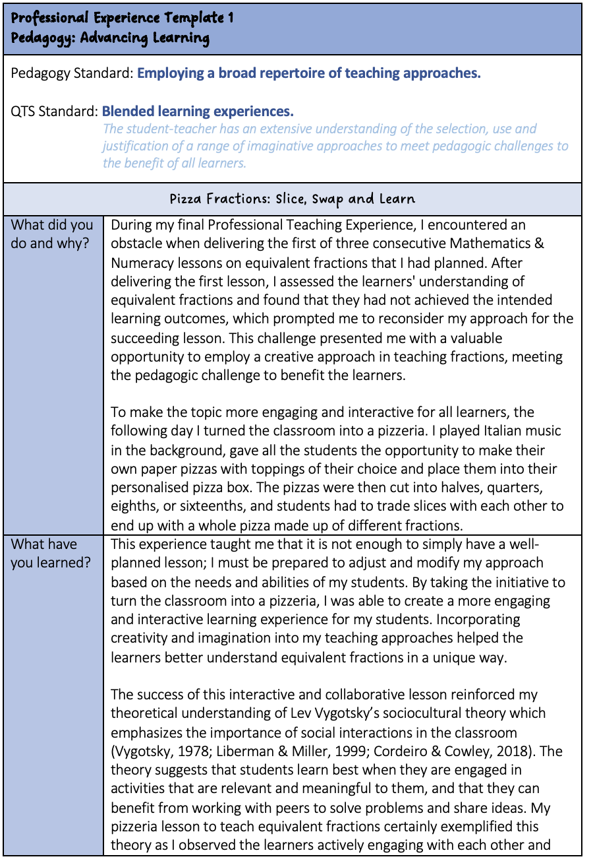

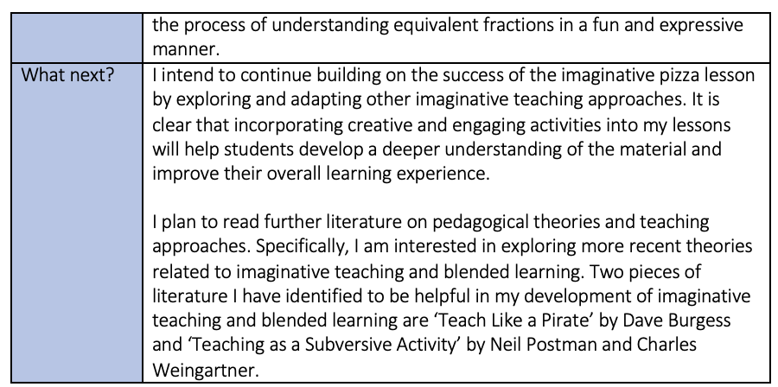

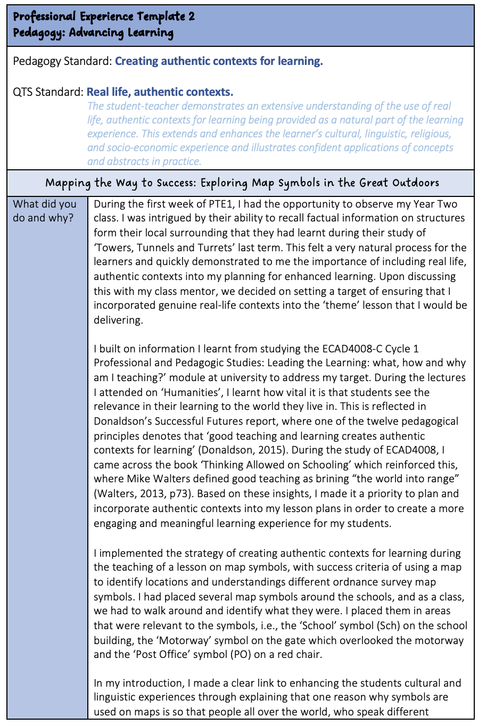

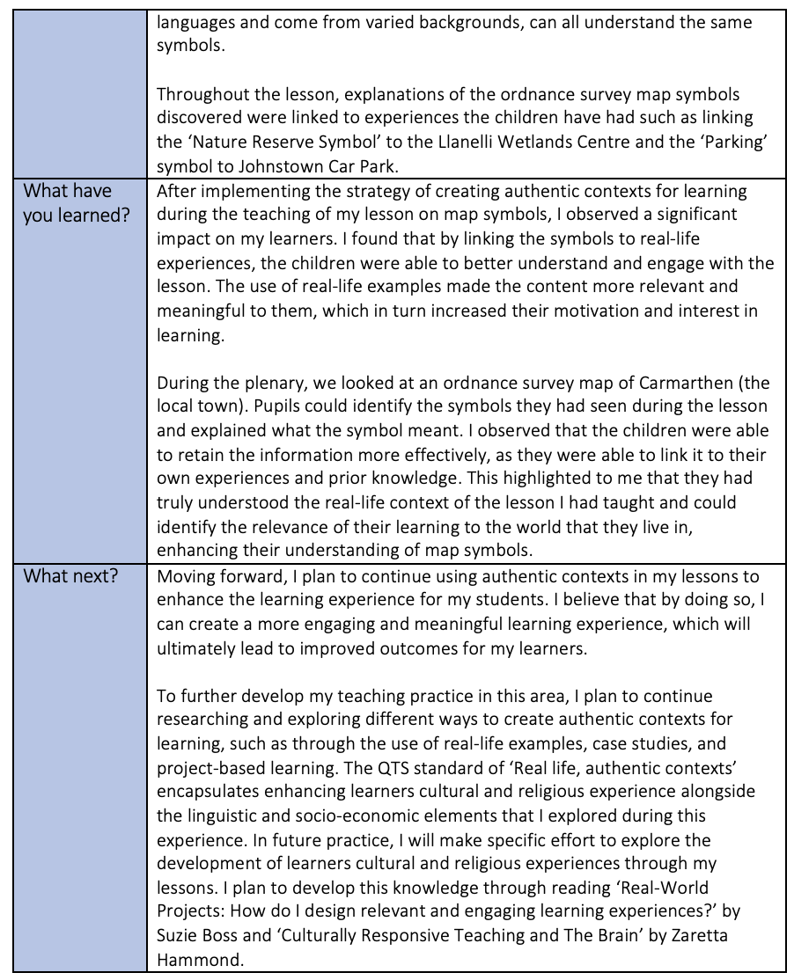
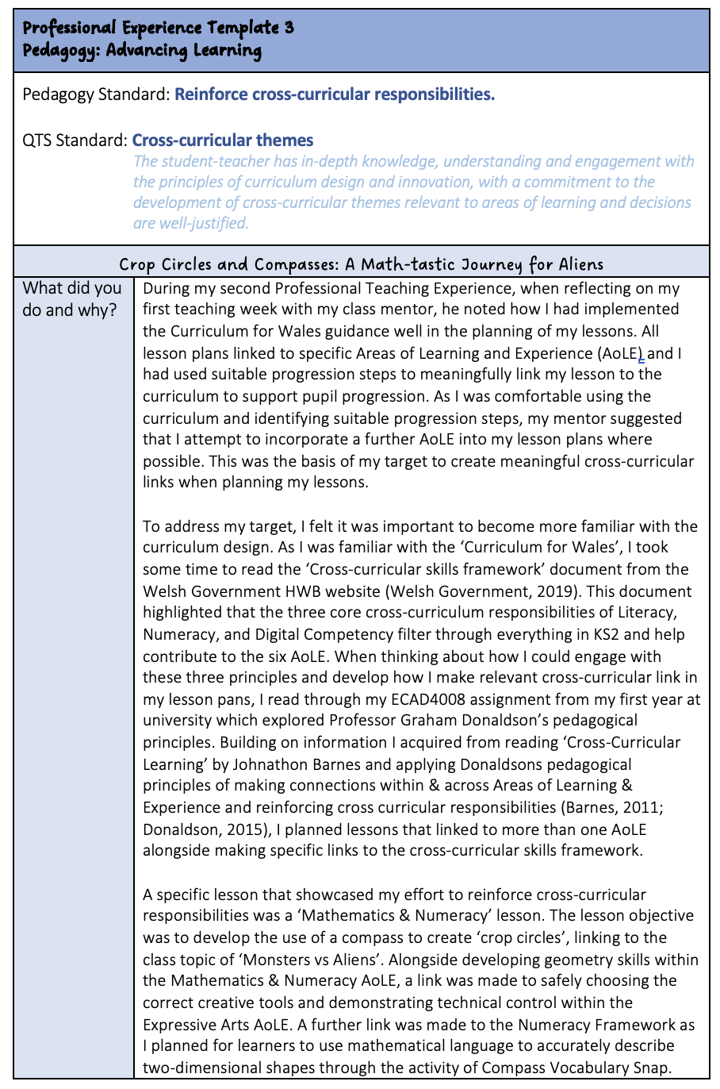

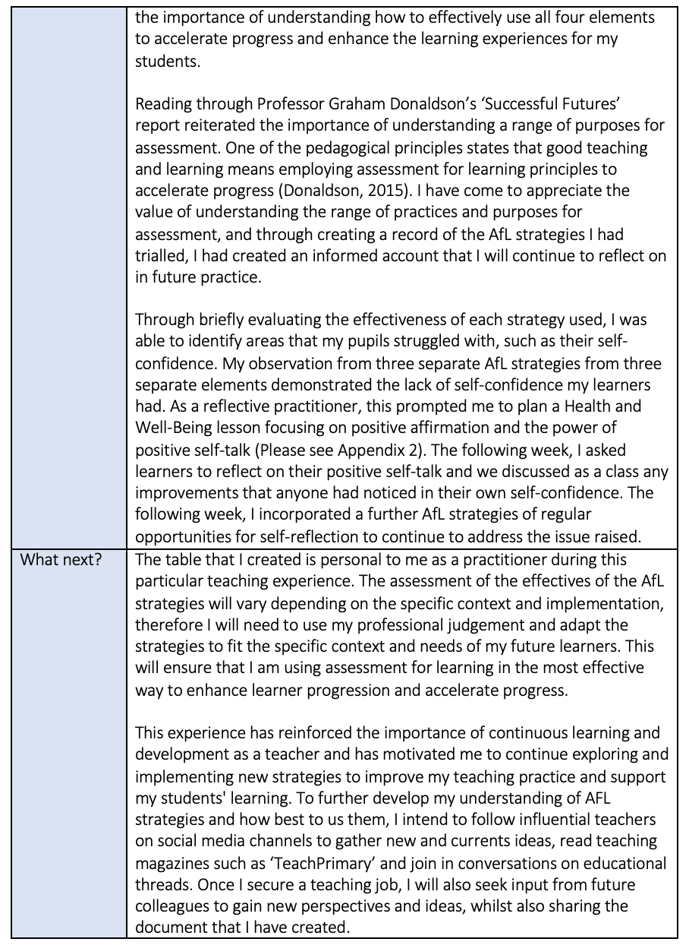

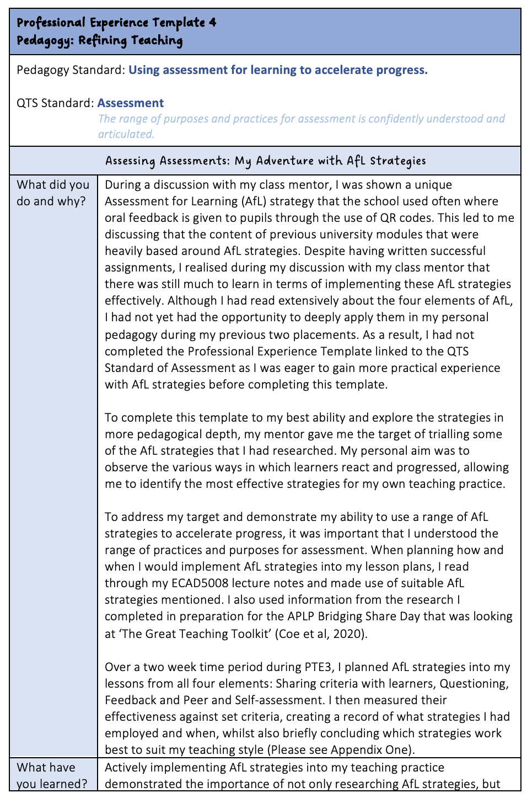

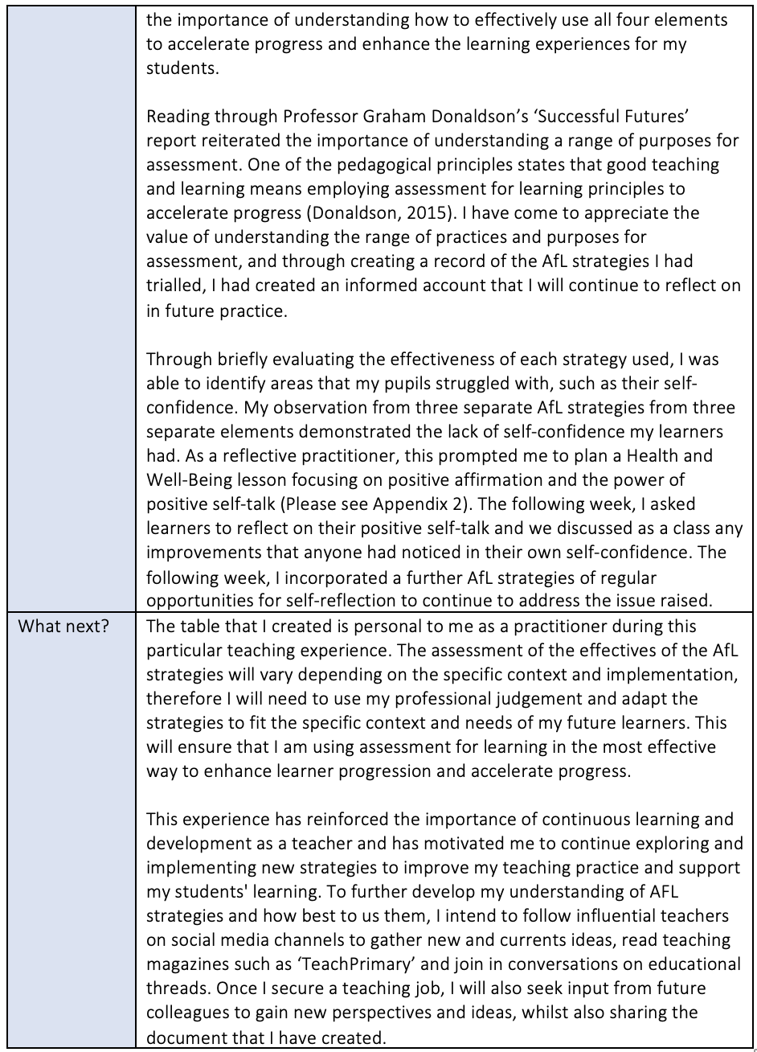
Part Two: Critical Reflection Plan

An increasing focus is placed on progressivism in teaching, a philosophy of education that encapsulates the need for learning to be relevant and meaningful to students’ lives and experiences (Dewey, 1938; Robertson, 2010; Kamenetz, 2021). John Dewey, a pioneer of education and advocator of progressivism, particularly emphasised the importance of learning through action and reflection (Dewey, 1938). While there is argument that Dewey’s work is outdated as it does not sufficiently account for the role of technology in modern education (Beneitone, 2018), his work is widely considered influential and continues to shape the principles and practices of progressive education today (Siraj-Blatchford, et al., 2013; Wright & Stutter, 2020; Lebow & Zisser, 2021).

As a student-teacher, it is crucial I understand the principles of progressivism as it promotes the philosophy of pragmatism in education. Similar to progressivism, pragmatism advocates the testing of ideas through practical application to assess their merit (Wringe, 2019). Aligned with John Dewey’s philosophy of learning through action and reflection, pragmatism highlights the role of experience in shaping knowledge and places great emphasis on inquiry and experimentation as a means of developing effective pedagogical practice (Alexander, 2004; Sorwar, et al., 2022).

To achieve professional recognition as a qualified teacher, practitioners must meet several professional standards which identify the skills, conduct and understanding that define exceptional pedagogical performance and promote professional development (Welsh Government, 2020). A pragmatic approach was taken in evidencing the professional teaching standard of ‘Assessment’ through the completion of a Professional Experience Template (Please see Part 1). The decision to take a pragmatic approach to reach the standard was made following a discussion with my class mentor during my final Professional Teaching Experience (PTE) where I was shown a unique Assessment for Learning (AfL) strategy of using QR codes. Despite having studied AfL in university and written successful assignments, it was clear that I still had much to learn about implementing these strategies effectively. As educators, it is important to remain open to constructive criticism and continuously improve pedagogy through evidence informed practice (Ko & Sammons, 2013; Siraj-Blatchford, et al., 2013; Coe, et al., 2020).

Adopting a pragmatic approach to developing my pedagogical practice was an effective way to demonstrate this. The target was set of exploring AfL strategies through trialling them in my lessons over a two week period. Applying the philosophy of pragmatism, I meticulously planned and tested multiple AfL strategies in my lessons, measuring their effectiveness against specific criteria (Please see Appendix One). Understanding the role of a reflective practitioner to analyse and adjust teaching methods (Zeichermen & Liston, 2015), I kept a detailed record of when the strategies were employed, concluding which strategies worked best to suit my teaching style and the needs of the learners.

While actively implementing AfL strategies was successful in enhancing learner progression and informing my practice, it also highlighted areas of development that learners were struggling with. On three separate occasions, the use of AfL strategies highlighted a lack of self-confidence in learners. After reflecting on this and striving to be an innovative and reflective teacher (Coe, et al., 2020), a Health and Well-Being lesson was planned to focus on the power of positive self-talk (Please see Appendix Two). This was followed with regular opportunities for self-reflection and discussion to address any concerns through implementation of further AfL strategies.

Creating a record of AfL strategies emphasised the importance of learning through action and reflection, demonstrating a successful pragmatic approach in reaching the standard of assessment as a range of purposes for assessment were trialled, understood, and evaluated (Dewey, 1938; Welsh Government, 2020; Sorwar, et al., 2022). However, it is important to acknowledge that the table created is personal to my specific PTE journey, and the effectiveness of the AfL strategies used may vary depending on the specific context and implementation in which they are used in the future (Wiliam & Black, 2006; Wylie & Heritage, 2020). Whilst the record created is an informed account I can reflect on in future practice (Bolton, 2016), professional judgement will be needed to adapt the strategies to fit the specific needs of my future learners, ensuring that assessment for learning is used in the most effective way to enhance learner progression and accelerate progress (Stiggins, 2002; Pang, 2022).

As highlighted in Professor Graham Donaldson’s comprehensive review of the Welsh curriculum, Successful Futures, the pedagogical standard of understanding a range of purposes for assessment is paramount in becoming an effective practitioner and accelerating learner progress (Donaldson, 2015). As I continue to explore, implement, and reflect on new AfL strategies, a particular aspect of my practice that I wish to develop further is to develop an improved approach in assessing learners’ progress following the implementation of AfL strategies. Through refining my approach to assessment and implementing a more structured system, I hope to provide my future students with effective instruction and feedback that will expedite progress, whilst ensuring that my AfL practices are aligned with instructional standards (Estyn, 2022).

To address the relationship between progression in the classroom and the role of AfL in facilitating it, it is necessary to first understand the concept of AfL. According to Leung and Rea-Dickings (2007), AfL is a relatively new concept in education. It is distinct from summative assessment, also known as assessment of learning, which provides teachers with a systematic way to measure overall learner achievement (Orlich, et al., 2017). AfL is a formative method of assessment, one that allows teachers to gather information about their students’ abilities and adjust their teaching methods accordingly (Ninomiya, 2016). While this approach to assessment has gained popularity in recent years, its impact on raising classroom standards varies depending on several factors.

Professor Dylan Wiliam, a British educationalist and advocate of AfL, believes that formative assessment is only effective once teachers use the evidence gathered to adapt their teaching to meet the individual needs of their learners (Wiliam & Black, 2006). Therefore, teachers need to make informed pedagogical choices and collect evidence to make accurate judgments about learners when implementing AfL strategies (Siraj-Blatchford, et al., 2013). This will ensure that the evidence is structured and utilised effectively to positively enhance learner progression.

To effectively utilise AfL strategies to enhance learner progression, it is crucial for practitioners to ensure continuity in the curriculum and integrate assessment purposefully into lesson planning (Welsh Government, 2020). The Curriculum for Wales emphasise the importance of assessment in enabling individual learners to make progress (Welsh Government, 2021). Practitioners must have a strong understanding of learners' prior knowledge and experiences and use this information to appropriately challenge, establishing new learning through the implementation of specific AfL strategies (Wylie & Heritage, 2020). The incorporation of AfL strategies into lesson planning should not only be limited to individual lessons but should be a continuous process throughout the academic year to support ongoing learner progression.

Viewing AfL as an ongoing process that is used to continually evaluate the effect of intended assessments reinforces the idea that learning is developed incrementally, and practitioners must build on prior knowledge (Wiliam & Black, 2006; Welsh Government, 2020). No single AfL strategy can effectively accommodate the needs and abilities of all learners, and strategies must be tailored to effectively support learners as individuals (Blakemore & Firth, 2015; Shepard, 2019). To achieve this, strategies must be used and understood from all elements of AfL. While some sources identified five elements of AfL (Lysaght & O'Leary, 2017), in line with current theoretical understanding and for the purposes of this assignment, AfL is considered as having four elements: Sharing Criteria with Learners, Questioning, Feedback and Peer and self-assessment (Flórez & Sammons, 2013).

Conversely, although seen as transformative practice that can anticipate the next steps in learning (Wylie & Heritage, 2020), AfL becomes problematic when considering how it is used to directly progress learners from where they are in their learning to where they aim to be (Hunt & Pellegrino, 2012). Addressing this discrepancy in knowledge is key for any AfL strategy to be successful in motivating and inspiring learners to progress, establishing a relevant use of the four elements of AfL to correspond to the needs of the learner.

D Royce Sadler (1989), an Australian educator involved in formative assessment for decades, established a strong connection between ‘closing the gap’ and accelerating student performance. Sadler emphasised the importance of practitioners identifying the disparity between learners' current knowledge and their desired learning goals, reinforcing how this gap can affect learning (Sadler, 1989). While Sadler’s work is relevant in highlighting the utilisation of all four element of AfL to progress learning, it is important to note that the research was conducted in a time that may not reflect the current educational landscape (Tempelaar, 2019). Additionally, some critics argue that the focus on ‘closing the gap’ between current knowledge and desired learning goals overlooks the importance of building upon students' prior knowledge and experiences, leading to a less equitable learning environment (Koretz, 2017) However, Sadler’s work remains a valuable contribution to the field of formative assessment and reinforces the ample evidence that supports the notion that AfL, when implemented correctly, can facilitate progression (Sadler, 1989; Wiliam & Black, 2006; Hattie, 2012).

This is further supported by William and Thompson (2007). Drawing inspiration from Sadler’s work, they identified three essential steps for using AfL to accelerate learner progression. By identifying learners' current position in their learning, establishing their learning goals, and determining the best way to reach those goals, they argue that the disparity in achievement among students can be decreased. Lev Vygotsky (1978), an educational psychologist, conceptualised the difference in knowledge as the zone of proximal development (ZPD). His concept of the ZPD refers to the area where learning is too challenging to accomplish independently but can be achieved with guidance and support. This guidance may come from a more knowledgeable adult or a peer who possesses more advanced skills (Vygotsky, 1978; Daniels, 2017). AfL can be an effective classroom to facilitate this process by involving learners in the assessment process, supporting them to recognise where they are in their learning journey, reducing the cognitive distance within their ZPD and enabling cognitive development to arise (Hattie & Timperley, 2007). Empowering learners to take ownership of their learning and bridging the gap between their current knowledge and desired learning goals can facilitate progression in learning (Nicol & Macfarlane‐Dick, 2006). Ultimately, practitioners must carefully plan and implement a variety of AfL strategies that align with learners' needs and abilities for those AfL strategies to be effective.

While Professor Dylan Wiliam has had a significant impact on the way we understand AfL, even proposing that the use of formative assessment in classrooms can result in up to eight months of additional learning (Wiliam, 2009), he acknowledges that there are potential drawbacks to the approach. A potential issue with implementing AfL strategies that involve comparing learners with each other is the focus being on competition between learners rather than on individual progress (Wiliam & Black, 2006). As a consequence, an unhealthy learning environment may be created where learners become demotivated and experience a decrease in self-esteem due to rivalry undermining the development of a positive learning community (Perrenoud, 1991; Ko & Sammons, 2013).

It is interesting to note that during my experience trialling AfL strategies, I observed a decrease in learners' confidence in their learning due to their own lack of personal self-esteem, and not due to being exposed to comparison based AfL strategies. Having said that, this may have been a result of seeing their peers perform better, which can be demotivating in itself (Urdan & Pajares, 2018). Both observations highlight the importance of practitioners being cautious in how they communicate and implement AfL strategies. To ensure a positive and inclusive learning environment is created, strategies must be adapted to meet the needs of the individual learner alongside communicating specifically what is expected of each learner (Nicol & Macfarlane-Dick, 2006; Daniels, 2017).

It is commonly accepted in education that students who are actively engaged in their learning, through methods such as receiving constructive feedback or having clear expectations, are more likely to develop confidence and make academic progress (Hattie & Timperley, 2007; Siraj et al., 2019; Coe, et al., 2020). However, with the continuous evolution of educational theories, the idea that students should have autonomy and be actively involved in their learning may not always align with the principles of AfL unless AfL strategies are adapted to meet the current demands of the curriculum (Newton & English, 2005; Shepard, 2015). Whilst AfL is an approach to education that fosters the empowerment of students taking an active role in their learning (Wiliam & Black, 2006), the demands of the curriculum to achieve certain learning outcomes may require more structure and guidance than what is typically associated with student-led learning (Hattie, et al., 2012; Delpit, 2015). Thus, while AfL can be a powerful tool for fostering pupil empowerment, strategies used must align with learning outcomes to demonstrate a balance between student-led learning and the need to meet the requirements of the government curriculum.

Assessment is a key component to the reformed Curriculum for Wales, intended to support learner progression (Welsh Government, 2020; Estyn,2022). Nevertheless, the Welsh Government has acknowledged past challenges in implementing AfL approaches to do so. In a previous report, it was noted that AfL practices were not successfully integrated into the curriculum, indicating a need for further improvement (Welsh Governemnt, 2014). This view was shared by The Organisation for Economic Co-operation and Development (OECD) who raised concerns on the implementation of AfL strategies, emphasising the importance of ensuring such strategies are aligned with curriculum objective to effectively support learners (Schleicher, 2014).

Although Professor Gordon Stobart, a member of the OECD and honorary researcher at the 'Oxford University Centre for Educational Assessment', concurs that AfL methods should prioritise the curriculum and the learner, he proposes that AfL should not solely be viewed as an assessment tool linked to the curriculum, but rather as a pedagogical approach to the curriculum (Stobart, 2011). To effectively implement AfL in the classroom to meet the needs of the learner and the curriculum, the prevailing view in the field is that educators must assess learners’ progress following the implementation of AfL through ongoing formative assessment (Shepard, 2015).This assessment of learner progression should not be viewed as a stand-alone process but rather as one that is integrated into teaching practice and the curriculum (Wiliam, 2011). Ongoing formative assessment requires careful planning and ongoing evaluation of teaching practices, ensuring that students are meeting curriculum objectives (Marzano, 2010). Taking a pragmatic approach in trailing and adapting AfL strategies continuously provides learners with feedback, guidance and support that will enable them to reach their full academic and holistic potential.

To demonstrate a well-informed and research-led approach to teaching (Orchard & Winch, 2015), I plan to utilise my findings from the literature review and incorporate research and evidence of effective practice into my teaching strategies to address my target of assessing learners’ progress following the implementation of AfL strategies. When planning for ongoing formative assessment, I want to ensure that my practice supports the right of the child to be supported in education (UNICEF, 2019). The Great Teaching Toolkit, a widely recognised resource providing practical strategies for practitioners to improve their practice, suggests that establishing a climate of high expectations and challenge can cultivate a supportive environment for learners (Coe, et al., 2020, p. 24). Due to experience of observing learners from my PTE lacking self-confidence, I have some concerns that demanding high continuous high standard from my future students may negatively hinder their progression as they may disengage from the lesson due to a fear of failure (Wiliam, 2011; Hattie,2012). Alternatively, lowering expectations is not a viable solution, as it may result in learners not being sufficiently challenged and may limit their potential for growth and development (Hall & Simeral, 2015). To enhance my future teaching practice, I plan to incorporate Carol Dweck’s ‘Growth Mindset’ into my pedagogical practice. This theory is based on the belief that a student’s abilities and intelligence can be developed through praise and perseverance, and through promoting a positive mindset in the classroom, learners begin to view challenges as opportunities for progression (Dweck, 2010). Rather than lowering expectations, I will motivate learners to complete their work by praising their efforts and not their intelligence, in line with Dweck's recommendations (Dweck & Mueller, 1998). By portraying challenges as fun and exciting, I hope to encourage learners to achieve high standards through positive reinforcement and a supportive learning environment.

To further promote a growth mindset and ensure work is appropriately challenged to promote a positive learning environment, I aim to do further research into the differentiation of AfL strategies. Providing each learner with an appropriate level of challenge and support during the implementation of formative assessment will help accelerate progress and ensure that I am meeting the professional teaching standard for good assessment practices (Ko & Sammons, 2013; Siraj-Blatchford, et al., 2013; Welsh Government, 2020). For example, when using questioning as an AfL strategy, I can implement differentiated questioning strategies to involve open ended questions, using different levels of questioning and providing prompts to support learners (Gregory & Chapman, 2013). Whilst balancing the needs of all learners can be difficult due to the time-consuming aspect of creating different resources (Tomlinson, 2018), it is essential in promoting equity and in ensuring all learners have opportunity to succeed (Embur & Sánchez, 2016). I have a duty of care as a future teacher to ensure that my students have the opportunity to succeed (BERA, 2018), and making time for creating different resources where possible to meet their diverse needs sits within my philosophy of education of having an inclusive classroom, promoting a growth mindset.

As I work towards developing an improved approach in assessing learners’ progress following the effective implementation of AfL strategies, I am reminded that teaching and the use of AfL is a constantly evolving field (OECD, 2019). While acknowledging the considerable workload that teacher face (Alzahrani & Huang, 2020), it is essential that I strive to stay up to date with good practice and current research findings (Gardner, et al., 2017). In the context of my career development, I am committed to continually improving my knowledge in the area of AfL and pupil progression. To facilitate this, I have compiled a list of resources that I will consult and reference in my ongoing professional development (Please see Appendix 3). These resources will serve as essential references in my pursuit of refining my approach to assessing learners' progress and providing the best possible learning experiences for my future students (Coe, et al., 2020).

In conclusion, this critical reflection plan has enabled me to recognise that ongoing formative assessment is the most effective way to track progress and accelerate learner progression. While there is more to learn about the individual elements of AfL individually (Wiliam & Black, 2006; Hattie 2012; Flórez & Sammons, 2013), I am confident in my ability to immediately improve my practice having explored the complexities of implementing AfL to successfully assess learners’ progress. Ongoing formative assessment not only supports teachers to understand the learning needs of their students, but also supports learners in taking ownership of their progress and developing their metacognitive skills (Shepard, 2015). Additionally, I recognise the value of sharing my personal experiences of both success and challenges surrounding the implementation of AfL, and I aim to share this professional development with my future colleague in hope of facilitating growth and progress (Nijj, 2018; Estyn, 2019). Overall, ongoing formative assessment is a fundamental aspect of effective teaching and learning, supporting both student progress and teacher development.
Reference List

Alexander, R., (2004). Still no pedagogy? Principle, pragmatism and compliance in primary education. Cambridge Journal of Education, 34(1), pp. 11-13.

Alzahrani, F. & Huang, J., (2020) Teacher Time Crunch: Exploring the Factors Contributing to Teachers Feeling of Being Overworked. Journal of Educational Research and Practice, 10(2), pp. 147-148.

Beneitone, P. &. G. M. B., (2018). John Dewey and educational technology: The challenge of intertwining. Education and Information Technologies, 23(1), pp. 2-14.

BERA, (2018). Ethical Guidelines for Educational Research. fourth edition ed. London: British Educational Research Association.

Bolton, G., (2016). Reflective Practice: Writing and Professional Development, London: SAFE Publications.

Coe, R., Rauch, C., Kime, S. & Singleton, D., (2020). Great Teaching Toolkit Evidence Review, Cambridge: Evidence Based Education.

Daniels, H., (2017). Introduction to Vygotsky. London: Taylor & Francis.

Delpit, L., (2015). "Other people's children": Whose students are they? Educational Researcher, 44(6), pp. 334-339.

Dewey, J., (1938.) Experience and Education. New York: Macmillan Publishers.

Donaldson, G (2015) Successful Futures: Independent Review of Curriculum and Assessment Arrangements in Wales: Welsh Government

Dweck, C., (2010). Mindset: The New Psychology of Success. New York: Random House.

Embur, S. & Sánchez, R., (2016). Inclusive education: A necessary approach for equity in education. Journal of Education and Human Developmen, 5(2), pp. 113-121.

Estyn, (2019). Improving professional development, Cardiff: Estyn.

Estyn, (2022). Effective approaches to assessment that improve teaching and learning, Cardiff: Estyn Publications Secion.

Flórez, M. T. & Sammons, P., (2013). Assessment for learning: effects and impact, Oxford: Oxford University Department of Education.

Gardner, M., Darling-Hammond, L. & Hyler, M., (2017). Efective Teacher Professional Development, London: Learning Policy Institute.

Gregory, G. & Chapman, C., (2013). Differentiated instructional strategies: One size doesn't fit all. London: Corwin Press.

Hall, P. & Simeral, A., (2015). Creating a Culture of Reflective Practice: Capacity-Building for Schoolwide Success. New York: ASCD.

Hattie, J., Fisher, D. & Frey, N., (2012). Visible learning for teachers: Maximizing impact on learning. London: Routledge.

Hattie, J. & Timperley, H., (2007). The power of feedback. Review of Educational Research, 77(1), pp. 83-111.

Hunt, E. & Pellegrino, J., (2012). Issues, Examples, and Challenges in Formative Assessment. New Directions for Teaching and Learning, 2002(89), pp. 73-85.

Kamenetz, A., (2021). Progressive Education: Why It’s Hard to Beat, But Also Hard to Find. EdSurge, 3(2), pp. 103-107.

Koretz, D., (2017). The risks of using assessments as instruments of education policy.. Educational Researcher, 46(4), pp. 204-213.

Lebow, Z. & Zisser, R., (2021). Democracy, Education, and Equality: John Dewey on Education for Democratic Citizenship. Educational Theory, 71(2), pp. 145-158.

Leung, C. & Rea-Dickings, P., (2007). Teacher assessment as policy instrument: contradictions and capacities. Language Assessment Quarterly, 4(1), pp. 6-36.

Lysaght, Z. & O'Leary, M., (2017). Scaling Up Assessment for Learning. Assessment in Education: Principles, Policy & Practice, 24(2), p. 271.

Marzano, R., (2010). Formative Assessment and Standards-Based Grading. Centennial: Solution Tree Press.

Nicol, D. & Macfarlane‐Dick, d., (2006). Formative assessment and self‐regulated learning: A model and seven principles of good feedback practice. Studies in higher education, 31(2), pp. 199-213.

Nijj, G., (2018). Teachers' professional development through collaborative learning: A case study of a reflective practice group. Journal of Education for Teaching, 44(2), pp. 214-224.

Ninomiya, S., (2016). The Possibilities and Limitations of Assessment for Learning: Exploring the Theory of Formative Assessment and the Notion of “Closing the Learning Gap”. The Possibilities and Limitations of Assessment for Learning Educational Studies in Japan: International Yearbook, 10(2), pp. 79-91.

OECD, (2019). Assessment for Learning: The Case for Formative Assessment. , Paris: Organisation for Economic Co-operation and Development Publishing.

Orchard, J. & Winch, C., (2015). What training do teachers need? Why theory is necessary to good teaching, Birmingham: Wiley Blackwell.

Orlich, D., Harder, R., Trevisan, M. & Brown, A., (2017). Teaching Strategies: A Guide to Effective Instruction, London: Cengage Learning.

Pang, N., (2022). Teachers’ Reflective Practices in Implementing Assessment for Learning Skills in Classroom Teaching. ECNU Review of Education, 5(3), pp. 470-490.

Perrenoud, P., (1991). Towards a pragmatic approach to formative evaluation. In: P. Weston, ed. Assessment of Pupils Achievement: Motivation and School Success. Amsterdam: Swets & Zeitlinger, pp. 79-101.

Robertson, J., (2010). John Dewey and the Progressive Movement in Education. Philosophy of Education, 3(24), pp. 315-325.

Sadler, D. R., (1989). Formative assessment and the design of insturctional systems. Instructional Science, Volume 18, pp. 119-144.

Schleicher, A., (2014). Improving Schools in Wales: An OECD Perspective, London: Organisation for Economic Co-operation and Development.

Shepard, L., (2015). Formative Assessment: Caveat Emptor. In: C. Dwyer, ed. The Future of Assessment. London: Routledge, pp. 25-27.

Shepard, L. A., (2019). Classroom Assessment to Support Teaching and Learning. SAGE journals, 638(1), pp. 132-137.

Siraj-Blatchford, I., Taggart, B., Sammons, P., Melhuish, E., & Sylva, K. (2013). Effective teachers in primary schools: Key research on pedagogy and children's learning. Stoke on Trent: Trentham Books.

Sorwar, M., Rahman, M. & Islam, R., (2022). Pragmatism in Education: An Examination of John Dewey's Educational Philosophy and its Relevance to 21st Century Education. European Journal of Contemporary Education, 11(2).

Stiggins, R. J. (2002). Assessment crisis: The absence of assessment for learning. Phi Delta Kappan, 83(10), 758-765. doi: 10.1177/003172170208301003

Stobart, P. G., (2011). The validity of formative assessment. In: J. Gardner, ed. Assessmenrt and Learning. London: SAGE Publications, pp. 133-146.

Tempelaar, D., (2019). Supporting the less-adaptive student: the role of learning analytics, formative assessment and blended learning. Assessment & Evaluation in Higher Education, 45(4), pp. 581-587.

Tomlinson, C., (2018). The differentiated classroom: Responding to the needs of all learners. New York: ASCD.

UNICEF, (2019). A summary of the UN Convention on the Rights of the Child, London: UNICEF UK.

Urdan, T. & Pajares, F., (2018). Social comparison theory and its applications to education. Handbook of research on student engagement, 24(2), pp. 363-373.

Vygotsky, L., (1978). Mind in Society: The Development of Higher Psychological Processed, Cambridge, MA: Harvard University Press.

Welsh Governemnt, (2014). Qualified for life: an education improvment plan for 3 to 19-year-olds in Wales, Qualified For Life : Welsh Government.

Welsh Government, (2020). An introduction to the professional standards for teaching and leadership, Cardiff: EducationWales.

Welsh Government, (2020). Supporting learner progression: assessment guidance. [Online]
Available at: https://hwb.gov.wales/curriculum-for-wales/supporting-learner-progression-assessment-guidance
[Accessed 13 March 2023].

Welsh Government, (2021). Curriculum for Wales guidance, Cardiff: Education Wales.

Wiliam, D., (2011). Embedded formative assessment. London: Solution Tree Press.

Wiliam, D. & Thompson, M., (2007). Integrating Assessment with Learning: what will it take to make it work? In: C. A. Dwyer, ed. The future of assessment: Shaping teaching and learning. Mahwah, New Jersey: Lawrence Erlbaum, pp. 53-82.

Wright, D. & Sutter, M. D., (2020). Philosophical perspectives: John Dewey and the future of community college education. Community College Journal of Research and Practice, 44(7), pp. 19-29.

Wringe, C., (2019). Pragmatism and Critical Thinking in Education. Abingdon: Routledge.

Zeichermen, K. & Liston, D., (2015). Reflective teaching: An introduction. London: Routledge.

Appendix 1  Record and evaluation of AfL strategies trialled. |  | Page 25
Appendix 2  Health & Well-being lesson resource – PowerPoint slides used. |  | Page 30
Appendix 3  List of continuous professional development resources. |  | Page 34
Appendices

Appendix 1
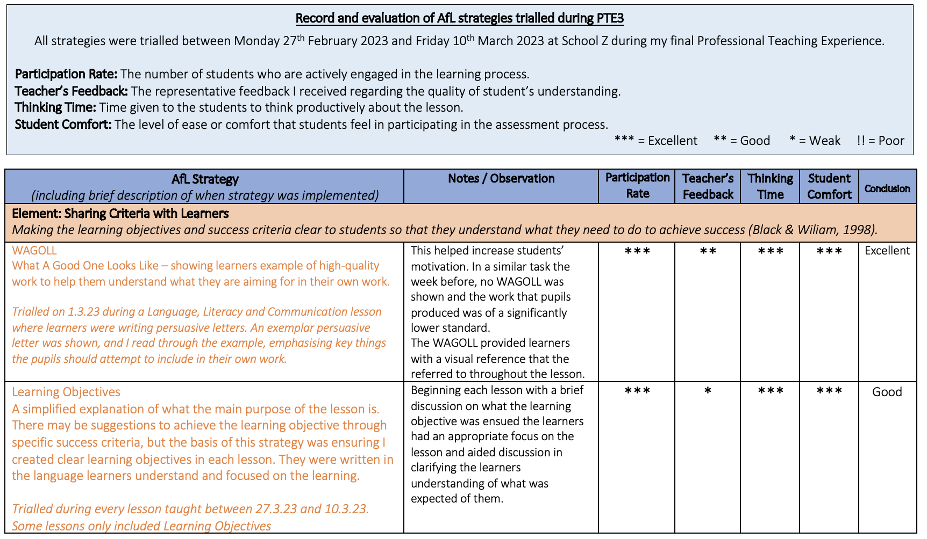

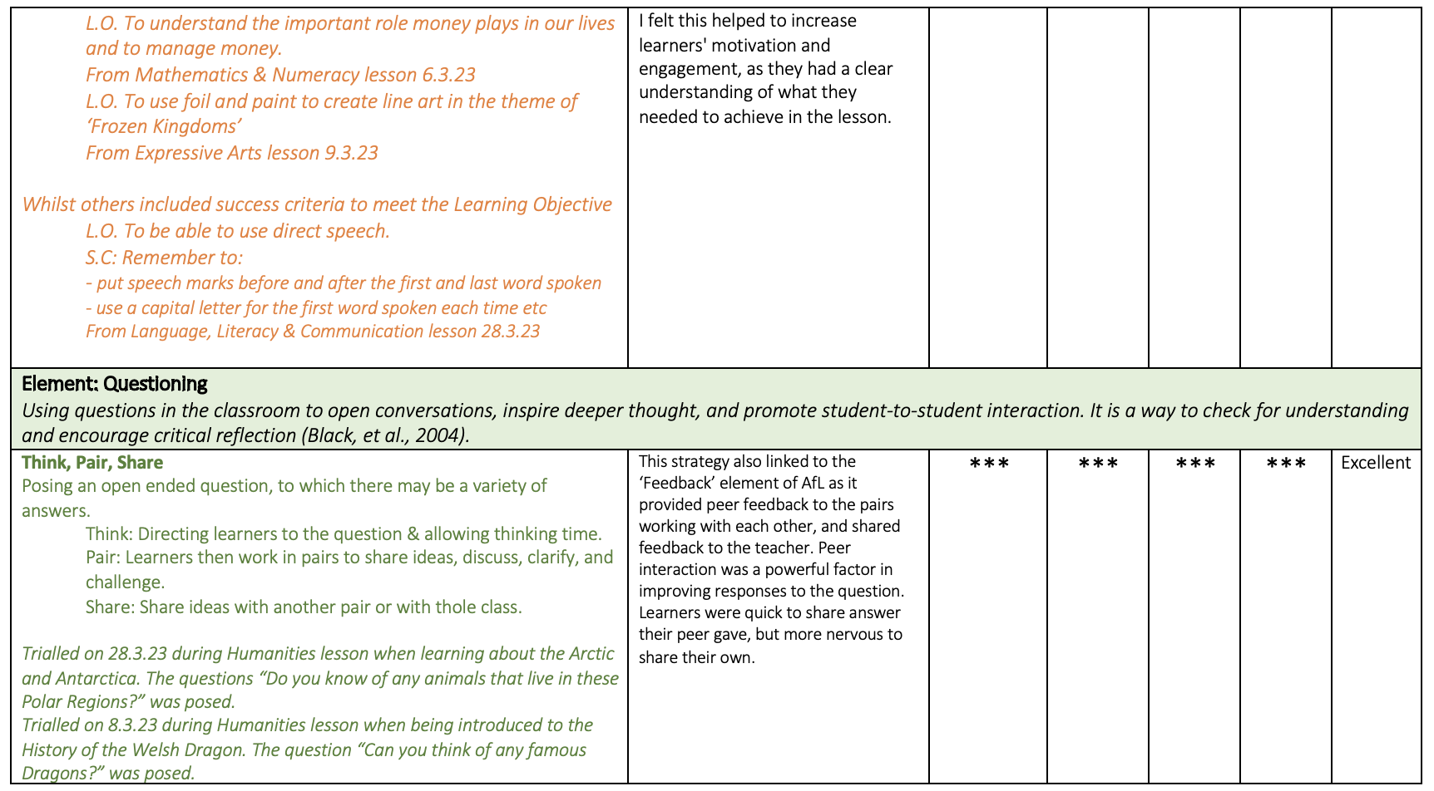

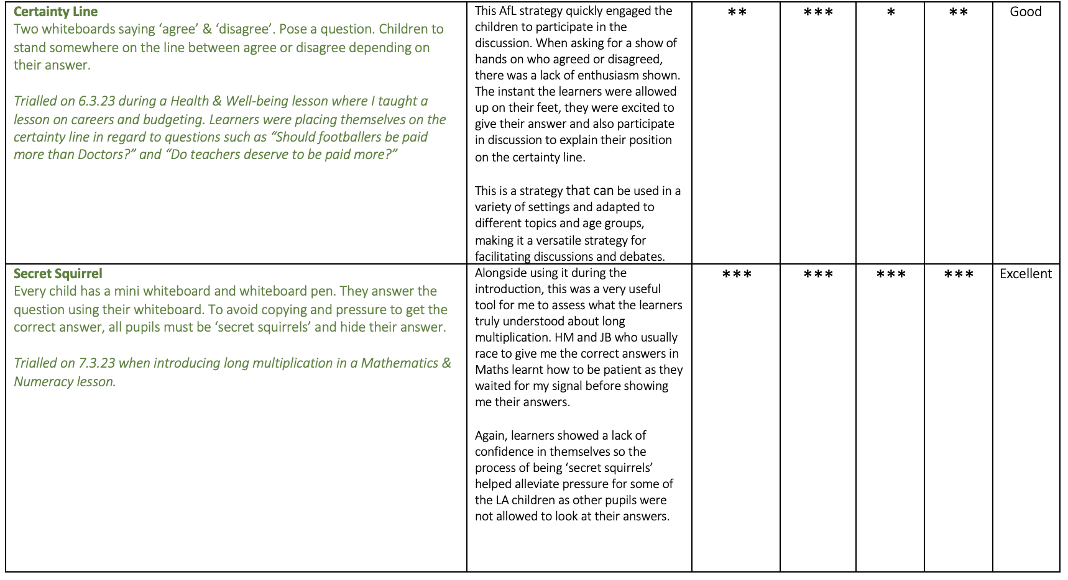
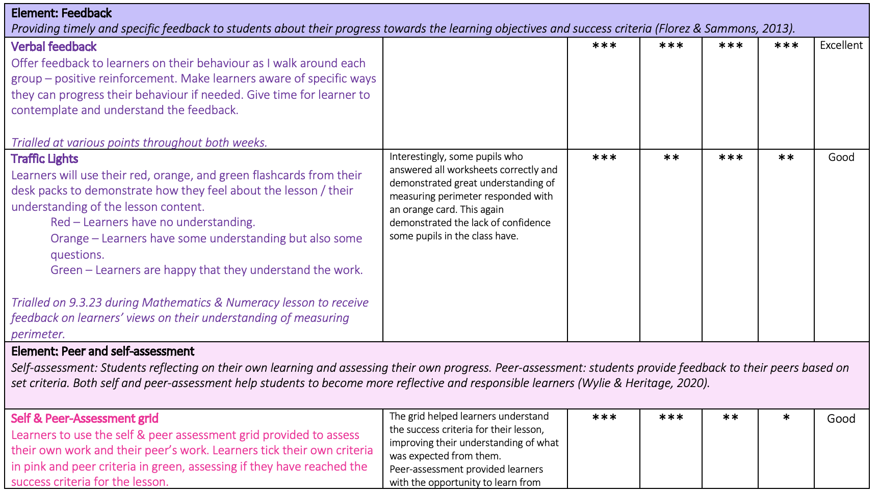

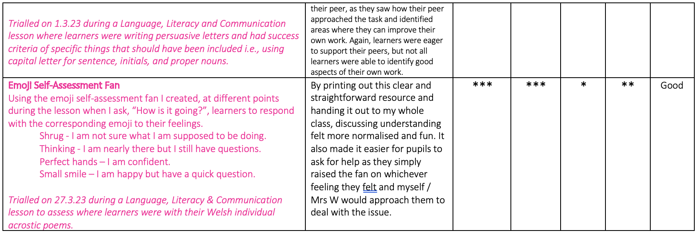

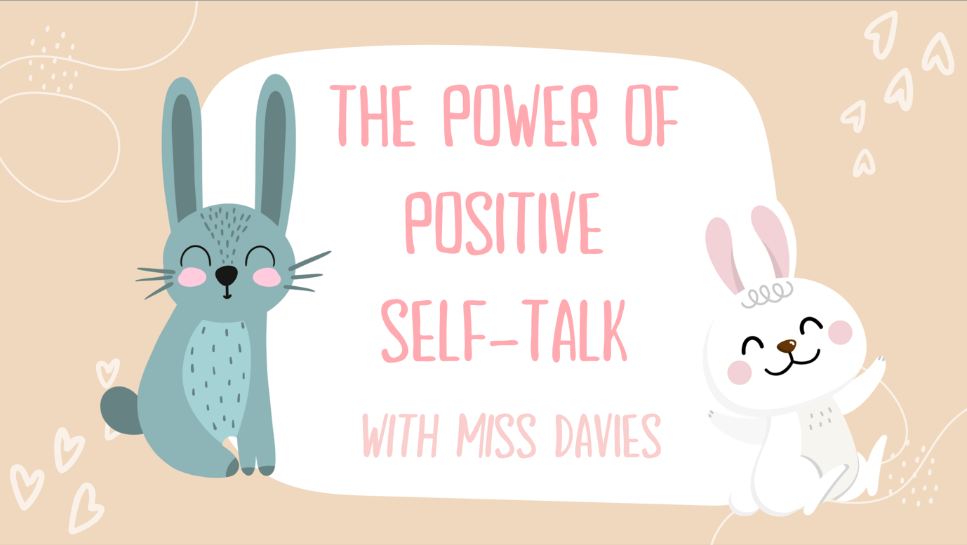
Appendix 2

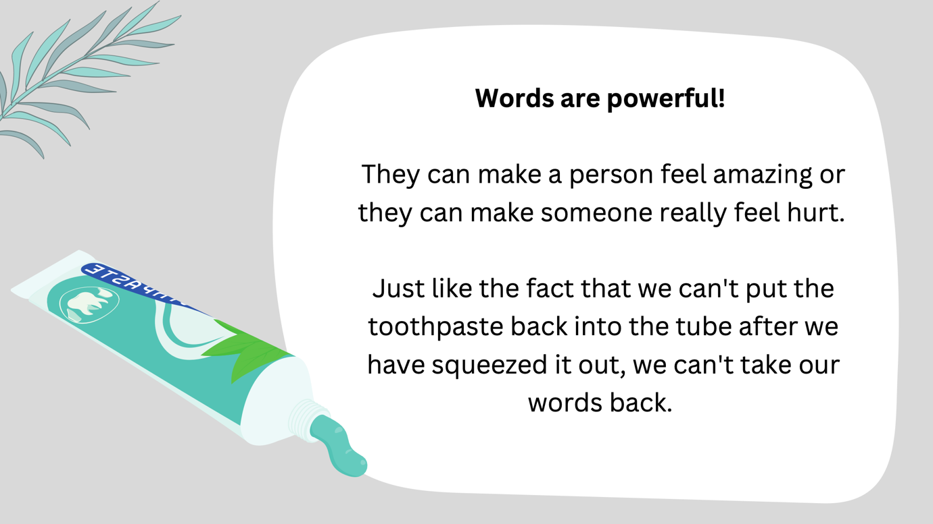

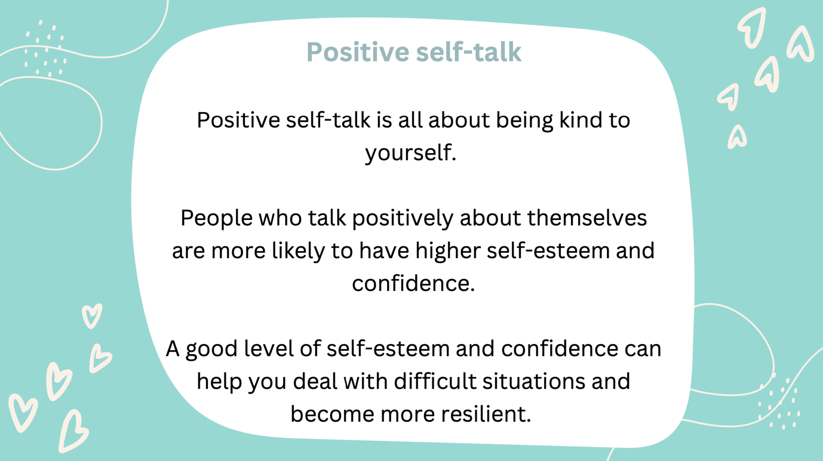

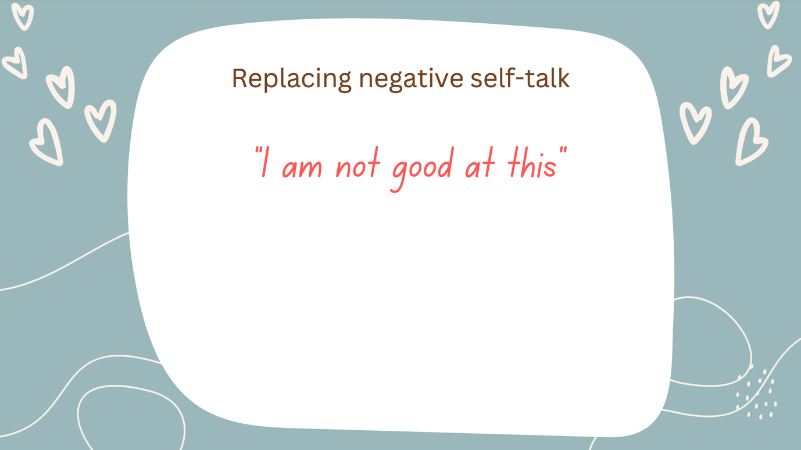

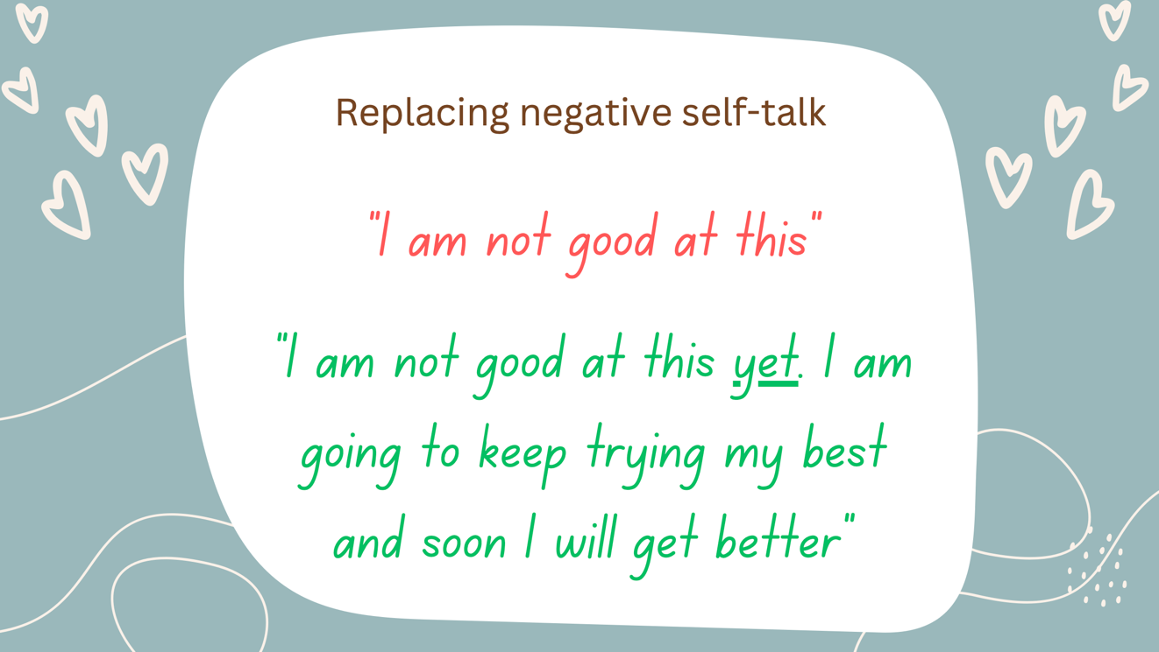

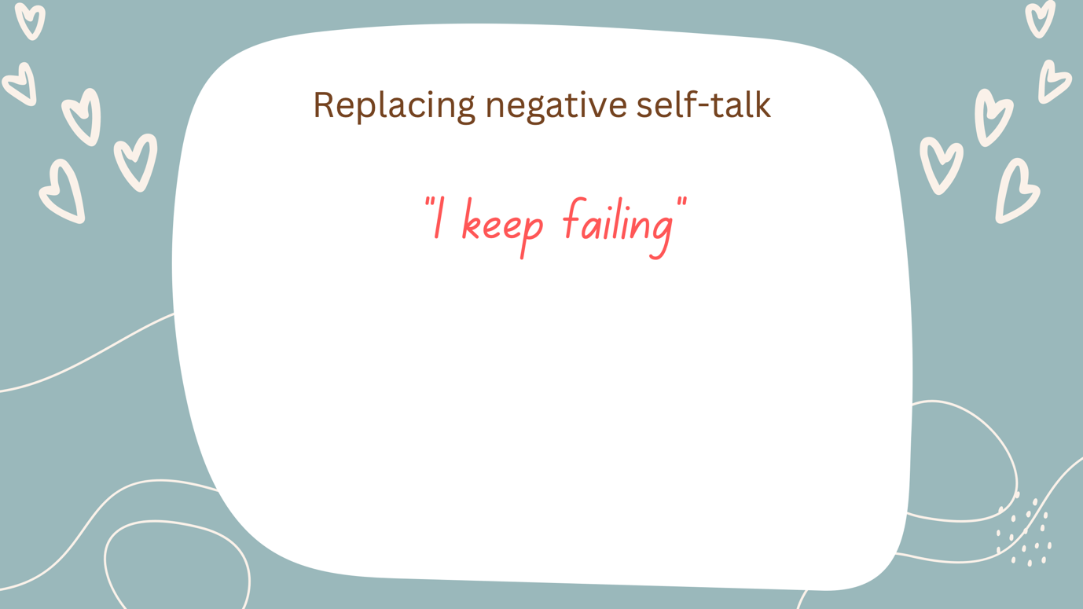

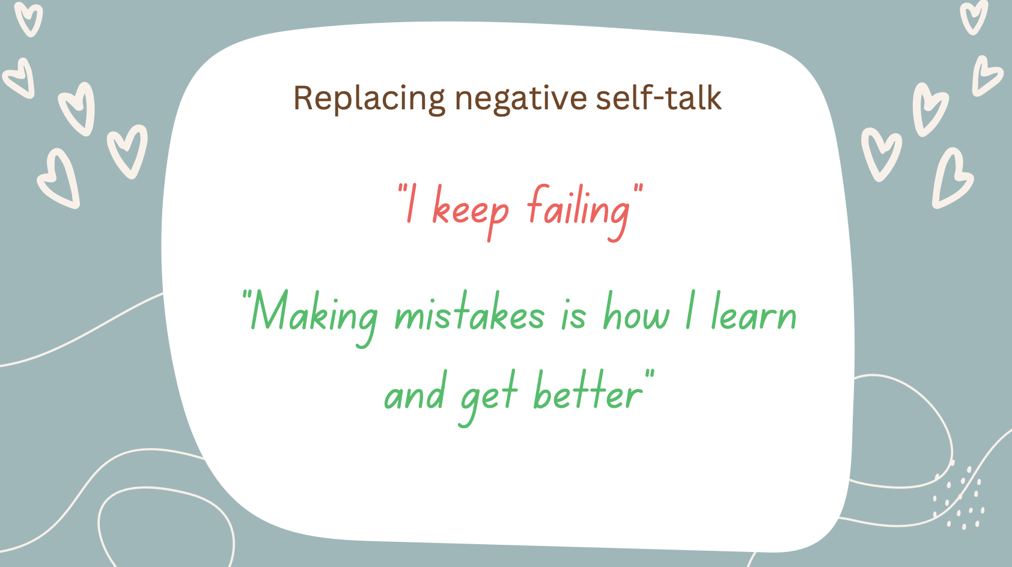

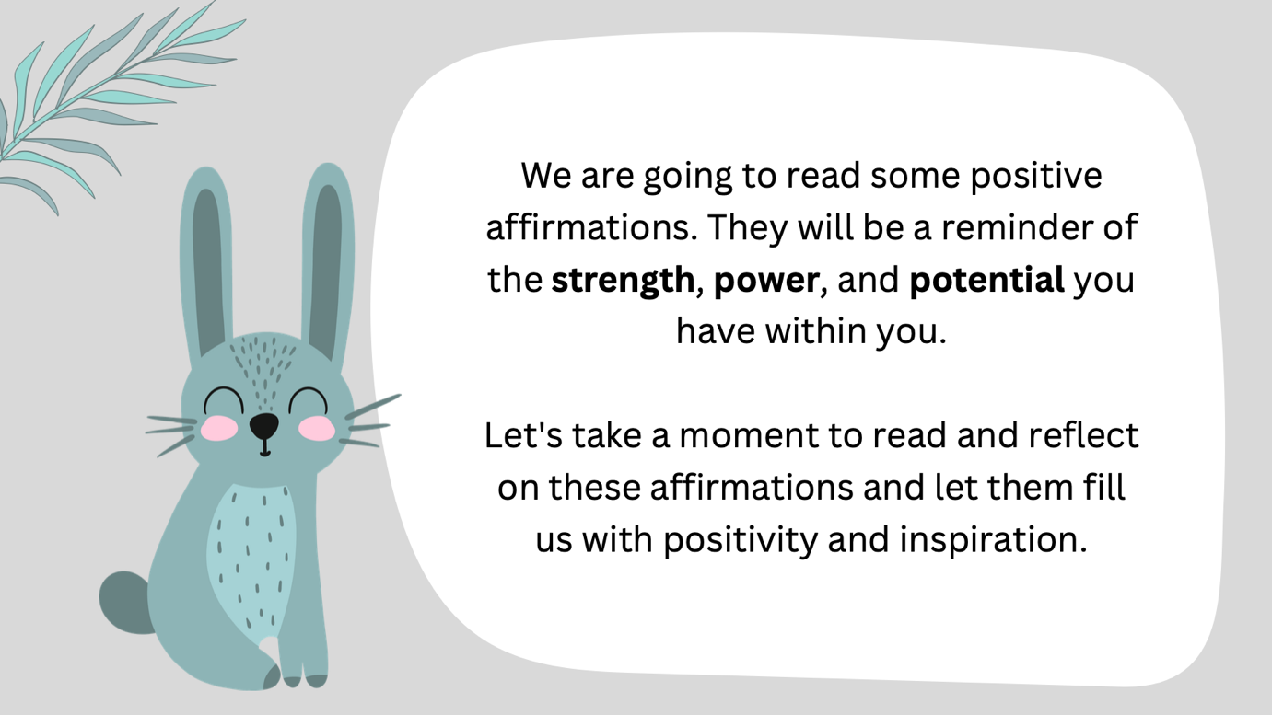







Appendix 3

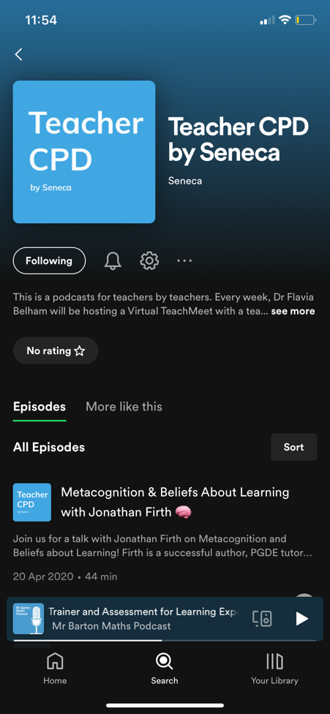
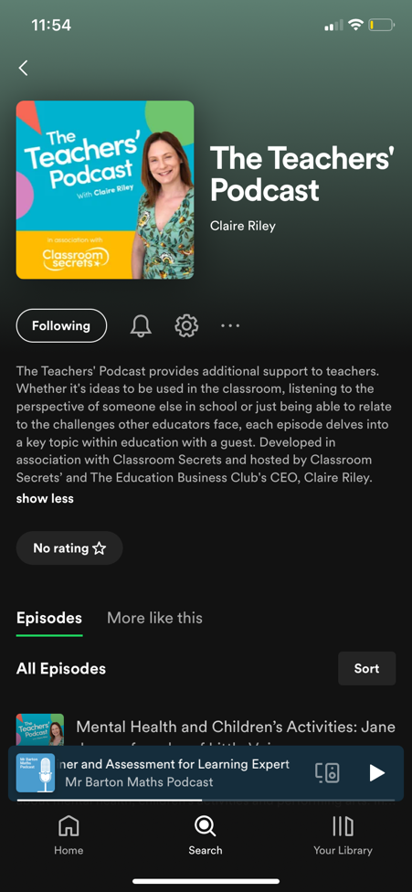
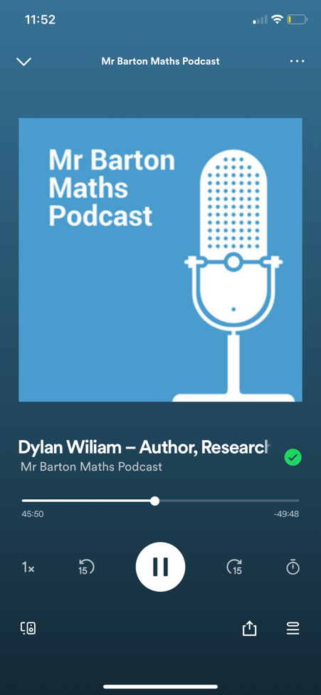
Podcasts

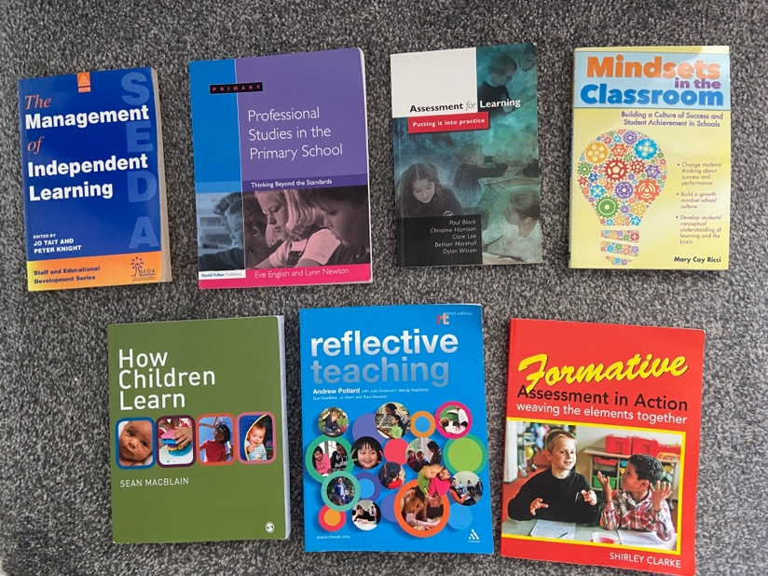
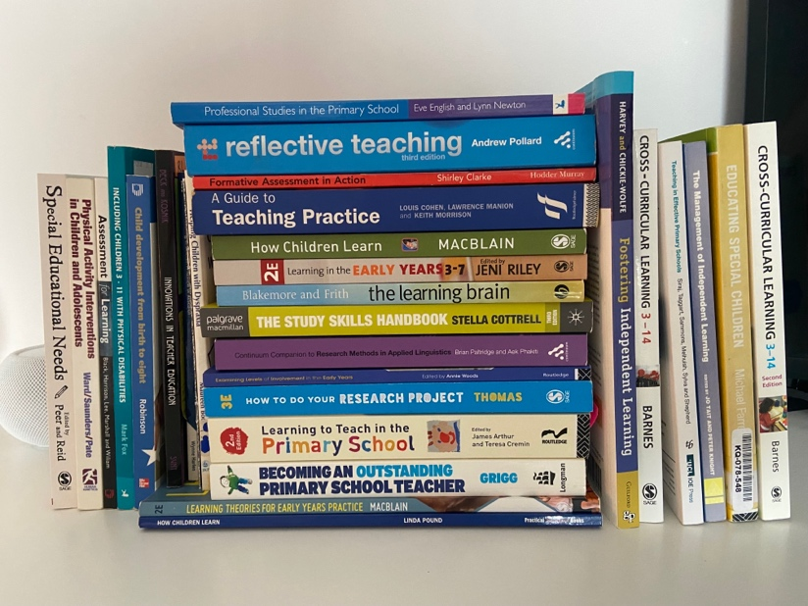
Literature

Consolidate previous learning from all university modules, with specific focus on notes taken from ECAD4008/5008/6008 lectures:


