Table of Contents
Introduction 2
The Concept and Importance of Marketing during the Covid-19 Crisis: A Look at Marriott International 2
SWOT Analysis of Marriott International during the Covid-19 Crisis 4
Strengths: 4
Weaknesses 5
Opportunities 5
Threats 5
Marketing strategies deployed by Marriott International during the Covid-19 Crisis 6
Product Strategy 6
Price Strategy 6
Place Strategy 6
Promotion Strategy 6
Competitive analysis of the strategies used by Marriott International 8
The impact of technology in the strategies implemented during the crisis by Marriot 10
Digital Marketing 10
Communication 11
Internationalisation 11
Evaluating the success of the strategies implemented by Marriott International 12
Managerial Implications of Marriott International's Marketing Strategies during the Covid-19 Crisis 13
Strategic Focus on Safety and Cleanliness 14
Leveraging Digital Marketing 14
Customer-Centric Approach 14
Utilising the Marketing Mix 15
Recommendations for Marriott International's Post-Pandemic Marketing Strategies 16
Maintaining Safety and Cleanliness Standards 16
Enhancing Digital Marketing Efforts 17
Strengthening Customer Relationships 17
Optimising the Marketing Mix 18
Conclusion 19
References 21

Introduction
The travel and tourist industry has been among those most severely impacted by the COVID-19 epidemic, which has presented businesses with hitherto unheard-of obstacles. Marriott International, a leader in the hospitality sector on a worldwide scale, was forced to innovate and adapt in the face of this crisis. The marketing ideas and tactics used by Marriott International in reaction to the COVID-19 problem are examined critically and evaluated in this research. It goes into detail on the company's strategic approach, including its SWOT analysis, marketing mix, stakeholder impact, competitive analysis, and the function of technology at this time. Additionally, it evaluates the efficiency of these tactics, giving readers a thorough insight of Marriott's adaptation and resilience in the face of a worldwide catastrophe. The report's management ramifications and suggestions for post-pandemic marketing tactics provide a glimpse into Marriott International's future course.

The Concept and Importance of Marketing during the Covid-19 Crisis: A Look at Marriott International
The crucial role that marketing plays in overcoming commercial crises has been highlighted by the COVID-19 epidemic. Marketing has changed throughout this time from being only a technique for advertising goods and services to being an essential tool for preserving client connections, establishing trust, and assuring business continuity (Hoekstra and Leeflang, 2020). During the COVID-19 crisis, Marriott International's marketing strategy has focused on adaptability, customer-centricity, and resilience (Santoki and Parekh, 2020). The business understood that the emphasis of marketing should change from selling to helping during a time of global crisis. This required being aware of the shifting wants and worries of the clientele and reacting in a sympathetic, adaptable, and creative manner (Jena Tesse Fox, 2020). Marriott International refocused its efforts on marketing initiatives that prioritized reassurance, cleanliness, and safety. The business started the "Commitment to Clean" campaign, emphasising improved safety and sanitary procedures throughout its facilities (Marriott, 2020). Rebuilding consumer faith in the security of hotel stays during the epidemic was made possible in large part by this effort.

Figure 1 Marriot international Commitment to Clean (Marriott, 2020)
With resources devoted to improving Marriott's online visibility and engagement, digital marketing became a major area of concentration. The business used its social media channels to interact with consumers, provide encouraging remarks, and convey updates (Varuni Khosla, 2022). Additionally, Marriott offered mobile check-in and mobile key services through its Marriott Bonvoy app, minimising physical touch and improving the guest experience (Bart Buiring, 2022). A dedication to its stakeholders was also shown by Marriott International through a number of marketing efforts. For instance, the business started the "Rooms for Responders" campaign, offering free or significantly reduced lodging to medical professionals as a way to demonstrate their commitment to CSR (Marriott, 2020). The use of digital engagement, empathy, and agility by Marriott International in its marketing strategy throughout the COVID-19 situation is crucial. The company's smart resource allocation to customer-centric and digital marketing strategies has been important in navigating the pandemic's obstacles

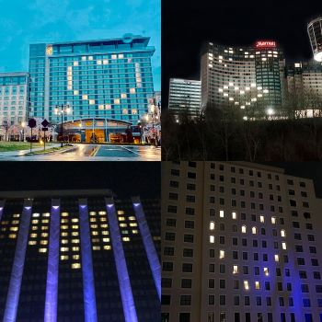
Figure 2 Marriot hotel during Rooms for Responders imitative (Mariana Pinedo, 2020)

SWOT Analysis of Marriott International during the Covid-19 Crisis

Strengths:
Strong brand recognition and a wide-ranging worldwide footprint of Marriott International have been key advantages during the epidemic. The business's strong digital infrastructure, which includes its cutting-edge reservation systems and the Marriott Bonvoy reward program, has also helped it to keep customers engaged during the crisis (Jena Tesse Fox, 2020). Additionally, Marriott's "Commitment to Clean" program, which demonstrates its dedication to health and safety, has been essential in regaining the confidence of its patrons.

Weaknesses
The pandemic revealed a number of operational flaws at Marriott. The firm was especially sensitive to travel restrictions and shifts in customer behaviour due to its substantial reliance on the luxury and foreign travel categories. In addition, despite the severe fall in reservations, Marriott had substantial financial difficulties due to its high fixed expenditures, which are related to property leases and employee pay (Seo, 2021).

Opportunities
The incident gave Marriott the chance to quicken its digital transformation and improve its health and safety procedures. The business might benefit from the rising demand for regional and ecotourism by modifying its services to meet these new market trends. Additionally, the disaster gave Marriott the chance to enhance its brand reputation by exhibiting corporate social responsibility, such through its "Rooms for Responders" project (Lodging, 2020).

Threats
A serious challenge to Marriott is the persistent ambiguity surrounding the epidemic. The company's operations may continue to be impacted by the possibility of protracted travel restrictions, modifications in customer behaviour, and an ongoing economic slump. In addition, Marriott is up against fierce competition from other hotels and other lodging options like Airbnb, which may be better equipped to adapt to shifting consumer tastes.
Strengths | weakness
- Strong brand reputation  - Extensive global presence  - Robust digital infrastructure  - Commitment to health and safety | - Reliance on international travel  - High fixed costs
Opportunities | Threats
- Digital transformation  - Adapting to emerging market trends  - Strengthening brand image | - Ongoing pandemic uncertainty  - Intense competition

Marketing strategies deployed by Marriott International during the Covid-19 Crisis
Marriott International used a variety of marketing techniques during the COVID-19 crisis to overcome the pandemic's unique hurdles. These strategies, which were based on the 4Ps—Product, Price, Place, and Promotion—of the marketing mix, were created to meet the demands of both internal and external stakeholders.

Product Strategy
Even amid the crisis, Marriott International, a company recognized for its upscale hotel brands, remained committed to providing top-notch hospitality services. The company's product approach was based on the demands of affluent tourists who were now looking for secure and sanitary lodging (Lodging, 2020). Marriott made sure that its consumers understood their dedication to health and safety. They modified their product offering to match the shifting demands of their clients throughout the epidemic by introducing improved cleaning methods and contactless services (Seo, 2021).

Price Strategy
Marriott was able to preserve its pricing power throughout the crisis. The company's pricing approach changed depending on the hotel, the client, and the region, but the core goal remained the same: to provide a premium experience that goes above and beyond what the client is willing to spend. Marriott was able to maintain its value offer and defend its pricing to consumers despite competition price discounting and volume reduction (Mariana Pinedo, 2020).

Place Strategy
Marriott's place strategy made use of its wide-ranging international footprint. Marriott made sure that their services were still available to clients by maintaining hotels and resorts in more than 131 countries. Additionally, the business has pushed its digital transition, allowing clients to access their services online and overcome the pandemic's physical limitations.

Promotion Strategy
During the COVID-19 issue, Marriott's advertising plan was mostly centred on online channels. To interact with its consumers, the business used its website, social media channels, and customer loyalty program, Bonvoy. In order to improve its online visibility, Marriott also made use of influencer partnerships and user-generated content. The company's marketing initiatives were created to reassure clients of their dedication to safety and cleanliness as well as to maintain the Marriott brand at the forefront of clients' thoughts during the crisis (Bart Buiring, 2022).
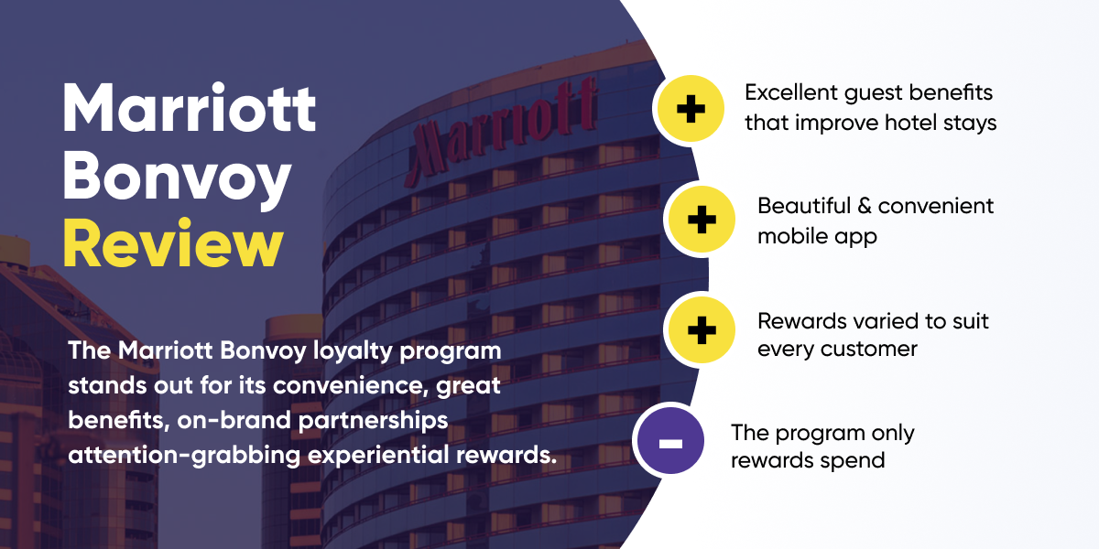
Figure 3 Review of Marriott's Bonvoy (Marriott, 2020)
These tactics had a considerable impact on Marriott's stakeholders. These tactics gave internal stakeholders, such workers, a feeling of direction and stability during a period of uncertainty. These tactics displayed Marriott's resiliency and adaptability to external stakeholders, including consumers and investors, which increased their trust in the brand (Kim and Han, 2022). It's crucial to remember that these methods' efficacy should be assessed in light of the overall industry trends and competitive environment. The pandemic had a particularly negative impact on the hotel sector, and despite Marriott's best efforts, the corporation nevertheless faced many obstacles (Le and Phi, 2021). Finally, Marriott's marketing initiatives during the COVID-19 issue were a tribute to the organization's flexibility and customer-focused philosophy. Marriott was able to handle the difficulties of the pandemic and preserve its place in the market by making use of the marketing mix's guiding principles (Jiang and Wen, 2020).

Competitive analysis of the strategies used by Marriott International
Marriott International was up against fierce competition from other firms in the hotel sector during the Covid-19 crisis. It's important to contrast Marriott's competitive tactics with those of its primary rivals, including Hilton, Hyatt, and Accor, in order to fully comprehend them (Sharma et al., 2021). During the crisis, Marriott's main tactic was to put its guests' and workers' welfare first. All of their properties now have improved cleaning procedures and social seclusion policies. To accommodate visitors' shifting travel plans, they also provided flexible booking choices and cancellations, which was a typical tactic among its rivals as well (Jiang and Wen, 2020). Marriott, though, distinguished out due to its creative use of technology. They hastened the rollout of contactless services including mobile requests, mobile key, mobile dining, and mobile check-in and check-out. This gave them a competitive edge and improved the client experience in addition to ensuring safety (Gerwe, 2021).
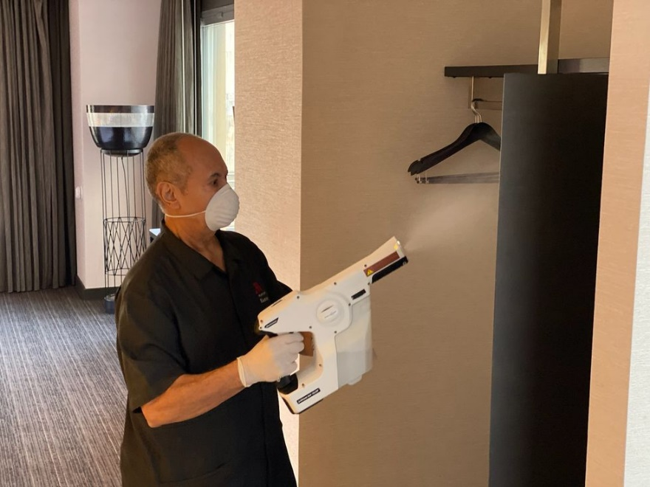
Figure 4 Marriot’s new electrostatic sprayer (Mariana Pinedo, 2020)
To keep customers engaged during the crisis, Marriott also made use of its reward program, Marriott Bonvoy. Their devoted clients were pleased when they extended the expiration dates for points and member status. Like many of its rivals, Marriott concentrated on cutting expenses and improving their liquidity position when it came to financial initiatives (Jena Tesse Fox, 2020). They stopped paying out dividends, buying back shares, and making pointless capital investments. In addition, they fired a large number of workers, which received negative feedback but was seen as essential given the situation (Bart Buiring, 2022). In contrast, Hilton also incorporated comparable safety protocols and money-saving techniques like clean stay. However, they placed greater emphasis on collaborations, such as their work with Lysol to improve cleaning techniques (Lodging, 2020).
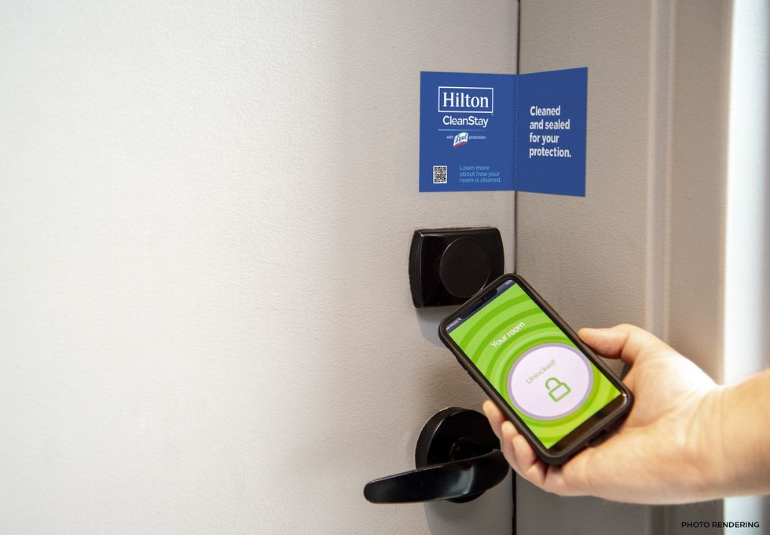
Figure 5 Hiltons Clean stay
On the other side, Hyatt highlighted its wellness programs and provided its visitors with materials for mindfulness and meditation. By introducing the "Hotel Office" idea, which allows guests to reserve hotel rooms as private offices, Accor adopted a somewhat different strategy. Given the rise in remote labour during the epidemic, this was a novel tactic (Seo, 2021).
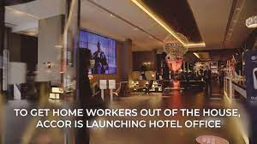
Figure 6 Accor Hotel office concept (Seo, 2021)

The impact of technology in the strategies implemented during the crisis by Marriot
Marriott International used technology during the Covid-19 crisis to adjust to the new normal and maintain the continuation of their services. The company's tactics were mostly concentrated on globalization, communication, and digital marketing.

Digital Marketing
With an emphasis on digital media, Marriott International changed its marketing approach from offline to online. The business ran a number of marketing initiatives, such "Golden Rule" and "Bonvoy," which received substantial digital platform promotion (Varuni Khosla, 2022).
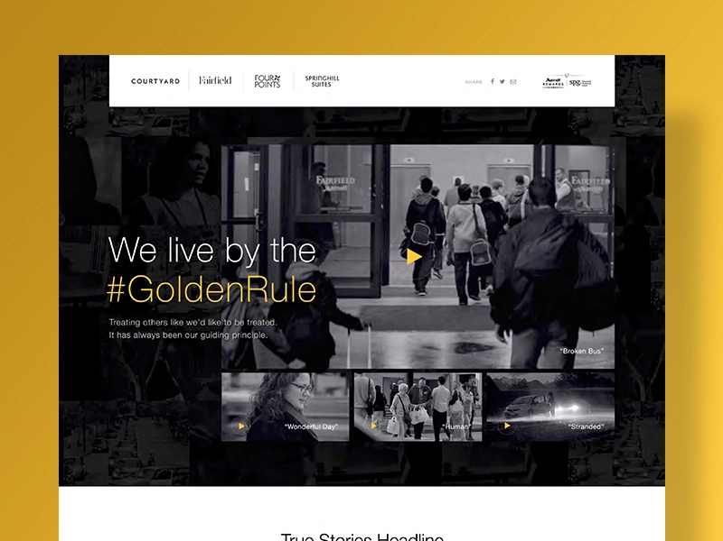
Figure 7 Screenshot of Marriot’s Golden rule (Joshua Hughes, 2017)
Additionally, they used their M-Live platform to interact personally with clients, making pertinent ideas and improving the entire customer experience (Emma Eversham, 2016).
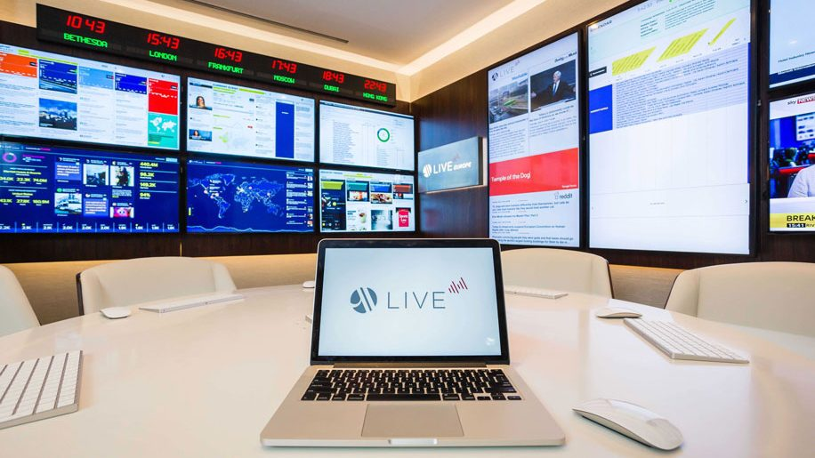
Figure 8 Marriot’s MLive Platform (Emma Eversham, 2016)
Additionally, the company's website was updated to feature all of its brands in-depth, luring customers to make reservations right away.

Communication
Marriott International utilizes technology to keep in touch with its stakeholders and consumers effectively. In order to keep consumers updated about their operations amid the crisis, the firm used social media channels, emails, and their website. They also shared safety policies and safeguards put in place at their hotels on social platforms to reassure guests.

Internationalisation
Marriott International has operations in more than 131 nations, and technology was essential to managing their operations throughout the crisis on a worldwide scale. The business employed technology to organize operations across many sites, ensuring that all of its hotels followed safety regulations and offered dependable service. To improve the experience of devoted consumers, Marriott International also released the Bonvoy App for both Android and iOS. Customers may gain admission to several athletic and entertainment events, receive discounts, and other perks using the app (Kim and Han, 2022).
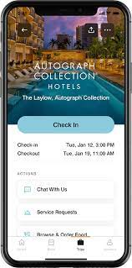
Figure 9 Marriot’s Bonvoy App (Seo, 2021)

Evaluating the success of the strategies implemented by Marriott International
Assessing the effects of these techniques on the company's performance and stakeholder satisfaction is necessary to determine if Marriott International's crisis management plans were successful. During the Covid-19 outbreak, Marriott International, like many other companies, had difficult obstacles. One of the most impacted sectors was the tourism and hospitality sector, with lockdowns and travel restrictions causing a significant drop in hotel reservations (Gerwe, 2021). Despite these obstacles, Marriott International adopted a number of marketing tactics to deal with the situation. The company's financial performance is one of the most important measures to assess the effectiveness of these initiatives. According to the 2020 Annual Report, the pandemic significantly decreased Marriott International's income (Marriott, 2020). However, the business was able to reduce some of the losses by cutting costs, changing their marketing techniques to concentrate on domestic and local tourism, encouraging staycations, and highlighting safety and cleanliness in its lodgings.
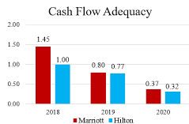
Figure 10 Cash Flow Adequacy of Marriot and Hilton before and after Pandemic (Kim and Han, 2022)
Another crucial statistic is customer satisfaction. During the crisis, Marriott International concentrated on preserving solid ties with its clients. They kept their clients informed of safety developments and offered flexible scheduling alternatives through constant communication. This aided in maintaining client loyalty and fostering trust through a trying period (Marriott, 2020). The firm improved its online presence and participation in terms of digital marketing. They used Marriott Bonvoy, their loyalty program, to provide members exclusive experiences and benefits, which helped to keep the brand in consumers' minds even when travel was prohibited. Even yet, Marriott might have maintained control over the marketing activities by routinely assessing and revising their tactics in light of market developments and client feedback. They may have boosted their focus on social responsibility and sustainability, which are increasingly significant issues for consumers, or looked into new partnerships and collaborations to provide their customers unique experiences.

Managerial Implications of Marriott International's Marketing Strategies during the Covid-19 Crisis
Marriott International is not an exception to the widespread effects of the Covid-19 outbreak on the hotel sector worldwide. The business responded to the problem by implementing a number of marketing tactics designed to lessen the pandemic's effects. With reference to pertinent marketing ideas and concepts, this section will examine the management consequences of these methods.

Strategic Focus on Safety and Cleanliness
The company's choice to emphasize cleanliness and safety in its marketing communications is a blatant example of social marketing ideals in action. According to this strategy, businesses should base their marketing choices on both the long-term wellbeing of society and the demands and requirements of their customers (Shin et al., 2021). This has entailed making sure guests feel comfortable and secure while visiting Marriott hotels in the context of the epidemic. In an effort to reassure guests and establish Marriott as a socially conscious brand, the business has aggressively highlighted its improved cleaning procedures and safety precautions. Managers should continue to emphasize cleanliness and safety in their marketing communications in the post-pandemic environment. This strategy will not only reassure consumers but also represent Marriott as a socially conscious company that is concerned with the welfare of its clients and the society at large (Hao, Xiao and Chon, 2020).

Leveraging Digital Marketing
Marriott has boosted its attention on digital marketing and internet interaction during the epidemic in addition to safety and hygiene. This change fits nicely with the marketing landscape's larger trend toward digitization. The necessity of leveraging digital platforms to connect with and engage with consumers is emphasized by the notion of digital marketing (Chaffey and Ellis-Chadwick, 2019a). Marriott has successfully adapted this idea by interacting with customer’s online, providing flexible booking alternatives, and offering virtual experiences. Managers should continue to spend in digital marketing as long as digital platforms continue to be essential for client interaction. This can entail investigating cutting-edge approaches to interact with customers online, such as targeted marketing, virtual interactions, and using data analytics to better understand consumer behaviour. By doing this, Marriott can maintain meaningful connections with its consumers even when there are few in-person contacts (Breier et al., 2021).

Customer-Centric Approach
The client-oriented marketing strategy is shown in Marriott's adaptable booking choices and emphasis on customer contact during the crisis. According to this idea, businesses should prioritize meeting consumer demands and fostering long-lasting connections (Kotler et al., 2018).
With relation to safety and flexibility in particular, Marriott showed a keen awareness of its clients' worries and demands in the midst of the epidemic. In response, the business introduced flexible booking choices and cancellation policies, which not only met the urgent demands of customers but also contributed to the development of trust and loyalty. Additionally, Marriott placed a high priority on customer interaction by regularly updating them on operational and safety improvements.
Managers should continue to focus on the consumer while developing their marketing plans. This entails keeping open and honest lines of contact with clients as well as comprehending and adapting to changing customer demands. Customer expectations may continue to shift in the post-pandemic period, and businesses who can adjust to these changes will have a competitive edge. Therefore, Marriott should keep listening to its consumers, modify its products in response to their comments, and communicate with them clearly.

Utilising the Marketing Mix
The necessity of a well-rounded marketing strategy is illustrated by Marriott's utilization of the marketing mix (product, price, place, and promotion) throughout the crisis. According to the marketing mix idea, efficient marketing plans should take into account each component of the mix as well as how they work together (Mansor et al., 2014).
Marriott changed their marketing strategy throughout the epidemic to reflect the shifting market dynamics. For instance, the business changed the products it offered to give improved safety features and flexible booking alternatives. Recognizing the heightened significance of online interaction and digital marketing during the pandemic, Marriott likewise modified their promotional strategy to concentrate on these areas.
Managers should continue to build their strategies using the marketing mix. This entails routinely evaluating and modifying the mix in response to consumer input and market changes. The marketing mix's dynamics may alter in the post-pandemic age. Customers' preferences for product characteristics or advertising methods, for instance, may change. As a result, Marriott should keep an eye on consumer opinions and market changes and modify its marketing mix as necessary.
.
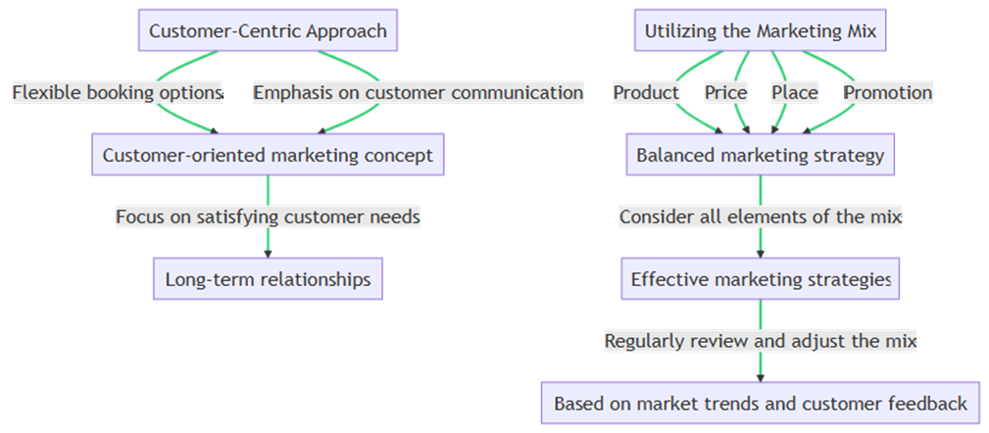
Figure 11 Managerial Implications of Marriott International's Marketing Strategies
Finally, the Covid-19 dilemma has brought to light the significance of flexibility and resiliency in marketing plans. The crisis response by Marriott International offers managers in the hospitality sector some very useful lessons. Marriott has shown a strategic reaction to the unique problems presented by the pandemic by prioritising safety and cleanliness, employing digital marketing, keeping a customer-centric strategy, and maximising the marketing mix.

Recommendations for Marriott International's Post-Pandemic Marketing Strategies
Marriott International will need to adjust its marketing techniques to the new normal as the globe progressively recovers from the Covid-19 epidemic. The following suggestions for Marriott's post-pandemic marketing tactics are based on the management implications identified in Task 2.

Maintaining Safety and Cleanliness Standards
It was a great tactic for Marriott International to put hygiene and safety first throughout the epidemic. But even after the epidemic, buyers will still place a high value on these characteristics. High safety and cleanliness standards should be upheld by Marriott, and these should be clearly communicated to guests. This might be accomplished by posting frequent updates highlighting the steps taken to maintain client safety on their website and social media platforms.
Marriott should think about collaborating with health and safety groups in addition to upholding high standards to further boost its reputation in this field. Such collaborations might assist Marriott in staying up to date with the most recent safety guidelines and best practices, which could subsequently be applied throughout its properties.
Additionally, Marriott may think about incorporating cleanliness and safety into their brand message and advertising initiatives. This would reassure clients and establish Marriott as a business that puts client satisfaction first. Marriott can continue to earn consumers' confidence and stand out in the cutthroat hotel industry by upholding strict safety and cleanliness standards (Brian King, 2021).

Enhancing Digital Marketing Efforts
As a result of the epidemic, the trend towards digitization has quickened, and Marriott has responded by stepping up its digital marketing initiatives. There is still space for development, though. In order to give consumers individualized experiences, Marriott should increase its investment in digital marketing tools. This may involve interactive online experiences, AI-driven suggestions, and virtual tours of properties.
Marriott might use data analytics in addition to these tactics to learn more about the tastes and behavior of its customers. Marriott would be able to create more specialized and successful marketing strategies as a result. For instance, Marriott may utilize data analytics to spot patterns in consumer preferences for facilities, popular vacation locations, or booking behavior. The relevance and efficacy of marketing communications might therefore be improved by using this information to customize marketing messages for specific customers.
Marriott might also investigate cutting-edge digital trends like augmented reality (AR) and virtual reality (VR). Customers' engagement might be further increased by using these technologies to offer immersive virtual tours of properties or one-of-a-kind online experiences. Marriott can keep connecting with and interacting with consumers in the increasingly digital post-pandemic environment by stepping up its digital marketing activities (Joshua Hughes, 2017), (Chaffey and Ellis-Chadwick, 2019b).

Strengthening Customer Relationships
It is great that Marriott had a customer-focused strategy throughout the epidemic. However, client expectations will continue to change in the post-pandemic age. The business should keep putting its efforts into cultivating enduring ties with its clients. Personalized communications, first-rate customer service, and loyalty programs might all help with this. In order to understand the changing requirements and expectations of their consumers, Marriott should also regularly solicit input from them.
Marriott may think about establishing a customer relationship management (CRM) system in addition to these tactics. Marriott can better manage customer interactions and data with the use of a CRM system, which will boost client happiness and loyalty. Additionally, the technology can offer insightful data on consumer behavior that can help shape future marketing plans (Jiang and Wen, 2020).
Additionally, Marriott has to continually innovating its reward programs to make them interesting and applicable to customers. This may entail providing more adaptable redemption alternatives, custom prizes, and unique experiences. Marriott can increase customer loyalty and encourage repeat business by fostering connections with its customers, which is essential in the cutthroat hotel sector (Brian King, 2021).

Optimising the Marketing Mix
Throughout the epidemic, Marriott has used the marketing mix well. The marketing mix's dynamics might alter in the post-pandemic age, though. Based on consumer feedback and industry changes, Marriott should assess and modify its marketing mix on a regular basis. For instance, pricing plans might need to be altered to account for modifications in consumer purchasing habits. To appeal to customers who are price conscious, Marriott can think about providing more flexible pricing alternatives or value-based pricing. Similar to this, it may be necessary to modify promoting tactics in light of the growing significance of digital media. To reach and interact with customers more successfully, Marriott may look at new digital marketing strategies like influencer marketing, content marketing, or social media campaigns. To broaden its reach in terms of distribution, Marriott can think about forging alliances or utilizing new channels. To reach more clients, Marriott, for instance, may collaborate with travel bureaus or internet travel companies.
Marriott may increase its competitiveness in the post-pandemic period by ensuring that its marketing strategies are in line with client wants and market trends by optimizing the marketing mix (Jake Mooney, 2020).

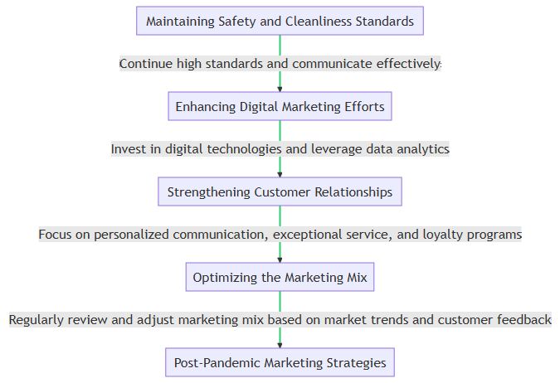
Figure 12 Recommendation for Marriot international
Marriott International has both possibilities and problems in the post-pandemic age. Marriott can successfully traverse the post-pandemic landscape and continue to provide its consumers with outstanding value by upholding safety and cleanliness standards, expanding digital marketing initiatives, developing customer connections, and optimising the marketing mix.

Conclusion
The Covid-19 epidemic has brought about hitherto unheard-of difficulties for the world's hotel sector, and Marriott International is no exception. But Marriott's tactical reaction, highlighted by an emphasis on cleanliness and safety, increased digital marketing activities, a customer-centric strategy, and efficient use of the marketing mix, has shown resilience and flexibility. It is essential for Marriott to carry out these initiatives as we enter the post-pandemic age while simultaneously making adjustments for changing market trends and client expectations. The suggestions made in this research provide Marriott a road map for navigating this new environment since they are based on pertinent marketing ideas and principles. Marriott can continue to provide outstanding value to its consumers and preserve its position as a leader in the international hospitality sector by upholding high safety standards, investing in digital technology, fostering customer connections, and optimising the marketing mix.

References
Bart Buiring (2022) Marriott’s pandemic business transformation, Think With Google. Available at: https://www.thinkwithgoogle.com/intl/en-apac/future-of-marketing/management-and-culture/marriott-pandemic-business-transformation/ (Accessed: 12 June 2023).
Breier, M. et al. (2021) ‘The role of business model innovation in the hospitality industry during the COVID-19 crisis’, International Journal of Hospitality Management, 92, p. 102723. doi: https://doi.org/10.1016/j.ijhm.2020.102723.
Brian King (2021) In the Face of a Pandemic, Marriott Leans on Its Values, The Wall Street Journal. Available at: https://deloitte.wsj.com/articles/in-the-face-of-a-pandemic-marriott-leans-on-its-values-01611259330 (Accessed: 12 June 2023).
Chaffey, D. and Ellis-Chadwick, F. (2019a) Digital Marketing: Strategy, Implementation & Practice, Google Books. Pearson UK. Available at: https://books.google.com.pk/books?hl=en&lr=&id=-1yGDwAAQBAJ&oi=fnd&pg=PT17&dq=Chaffey.
Chaffey, D. and Ellis-Chadwick, F. (2019b) Digital Marketing. Pearson.
Emma Eversham (2016) Marriott launches social marketing programme M Live in Europe, Restaurant Online. Available at: https://www.restaurantonline.co.uk/Article/2016/07/26/Marriott-launches-social-marketing-programme-M-Live-in-Europe (Accessed: 12 June 2023).
Gerwe, O. (2021) ‘The Covid-19 pandemic and the accommodation sharing sector: Effects and prospects for recovery’, Technological Forecasting and Social Change, 167, p. 120733. doi: https://doi.org/10.1016/j.techfore.2021.120733.
Hao, F., Xiao, Q. and Chon, K. (2020) ‘COVID-19 and China’s Hotel Industry: Impacts, a Disaster Management Framework, and Post-Pandemic Agenda’, International Journal of Hospitality Management, 90, p. 102636. doi: https://doi.org/10.1016/j.ijhm.2020.102636.
Hoekstra, J. C. and Leeflang, P. S. H. (2020) ‘Marketing in the era of COVID-19’, Italian Journal of Marketing, 2020(4), pp. 249–260. doi: 10.1007/s43039-020-00016-3.
Jake Mooney (2020) Marriott CEO details ‘heart-wrenching’ cost cutting in COVID-19 response , S&P Global Market Intelligence. Available at: https://www.spglobal.com/marketintelligence/en/news-insights/latest-news-headlines/marriott-ceo-details-heart-wrenching-cost-cutting-in-covid-19-response-57672019 (Accessed: 12 June 2023).
Jena Tesse Fox (2020) Marriott charts solvency plans amid COVID-19 pandemic, Hotel Management. Available at: https://www.hotelmanagement.net/operate/marriott-outlines-plans-for-staying-solvent-a-pandemic (Accessed: 12 June 2023).
Jiang, Y. and Wen, J. (2020) ‘Effects of COVID-19 on hotel marketing and management: a perspective article’, International Journal of Contemporary Hospitality Management. Emerald Publishing Limited, 32(8), pp. 2563–2573. doi: 10.1108/IJCHM-03-2020-0237.
Joshua Hughes (2017) Marriott Inspires Humanity with Golden Rule Strategy, Branding Forum. Available at: https://brandingforum.org/advertising/marriott-humanity-golden-rule/ (Accessed: 12 June 2023).
Kim, J. J. and Han, H. (2022) ‘Saving the hotel industry: Strategic response to the COVID-19 pandemic, hotel selection analysis, and customer retention’, International Journal of Hospitality Management, 102, p. 103163. doi: https://doi.org/10.1016/j.ijhm.2022.103163.
Le, D. and Phi, G. (2021) ‘Strategic responses of the hotel sector to COVID-19: Toward a refined pandemic crisis management framework’, International Journal of Hospitality Management, 94, p. 102808. doi: https://doi.org/10.1016/j.ijhm.2020.102808.
Lodging (2020) How Hotel Brands Are Responding to COVID-19 , Lodging. Available at: https://lodgingmagazine.com/how-hotel-brands-are-responding-to-covid-19/ (Accessed: 12 June 2023).
Mansor, M. H. et al. (2014) ‘Differentiating localization-based marketing strategy in emerging markets: The case of domino’s pizza in malaysia and india’, Proceedings of the 24th International Business Information Management Association Conference - Crafting Global Competitive Economies: 2020 Vision Strategic Planning and Smart Implementation, (March), pp. 577–584.
Mariana Pinedo (2020) How Marriott International’s Response to COVID-19 Set An Example For The Travel Industry, Medium. Available at: https://medium.com/marketing-in-the-age-of-digital/how-marriott-internationals-response-to-covid-19-set-an-example-for-the-travel-industry-2c2a70aba228 (Accessed: 12 June 2023).
Marriott (2020) Marriott International Launches Global Cleanliness Council to Promote Even Higher Standards of Cleanliness in the Age of COVID-19, Marriott. Available at: https://news.marriott.com/news/2020/04/21/marriott-international-launches-global-cleanliness-council-to-promote-even-higher-standards-of-cleanliness-in-the-age-of-covid-19 (Accessed: 12 June 2023).
Santoki, A. and Parekh, M. H. (2020) ‘Marketing strategies during COVID-19’, Journal of Critical Reviews, 7(11), pp. 4040–4045.
Seo, K. (2021) ‘Asset-light Business Model: Strategies for Hotels During the Pandemic’, Boston Hospitality Review.
Sharma, A. et al. (2021) ‘Hotels’ COVID-19 innovation and performance’, Annals of Tourism Research, 88, p. 103180. doi: https://doi.org/10.1016/j.annals.2021.103180.
Shin, H. et al. (2021) ‘The impact of hotel CSR for strategic philanthropy on booking behavior and hotel performance during the COVID-19 pandemic’, Tourism Management. Elsevier Ltd, 85(March). doi: 10.1016/j.tourman.2021.104322.
Varuni Khosla (2022) ‘Digital mktg exploded after covid; social media key too’ , Mint. Available at: https://www.livemint.com/companies/news/the-space-of-digital-has-completely-exploded-11670769168968.html (Accessed: 12 June 2023).

