Effective Teamwork and Communication

Student: Alexandra-Maria Cozma

Table of Contents
1. Introduction 3
2. Three models of communication 3
3. Communication skills 7
4. Advantages and disadvantages of technology in communication 8
5. Conclusion 9
6. References: 10

Introduction
Communication is considered the process of transmission of information between two or more parties by using a specific medium. It helps to develop meaning among individuals, groups or entities by using easily understandable signs, words, symbols or other semiotic conventions (Radovic Markovic and Salamzadeh, 2018). Communication helps to create a basis of coordination and decision-making, reduce complexities, increase efficiencies, enhance the morale of the associated parties etc. The barriers to communication include the inability to hear or read, lack of transparency and trust, cultural difference, the difference in communication style etc. Such barriers affect the efficiency of communication, create poor communication among the associated parties and lead to serious consequences.

Three models of communication
The concept of communication is described by different authors in their models based on their understanding and analysis. Here is a brief discussion of three models of communication: Shannon and Weaver Model, Schramm’s Model of Communication and Berol’s SMCR Model of Communication:
Shannon and Weaver Model: According to this model, the sender send the massage by using different technological medium (channels) like mobile, telephone etc. The sender encodes the message, and the receiver needs to decode it to understand. However, the decoding process might be disrupted due to noise (in the channel) or the lower capacity of the decoder (Kernbach et al. 2015). As air is considered the usual channel of communication, the noise includes the surrounding environment, people, vehicle etc. that interrupt the delivery process of the message and change to a different form. Due to the noise, the message is not delivered to the receiver in its original form and the receiver receives a changed/distorted form of the message.

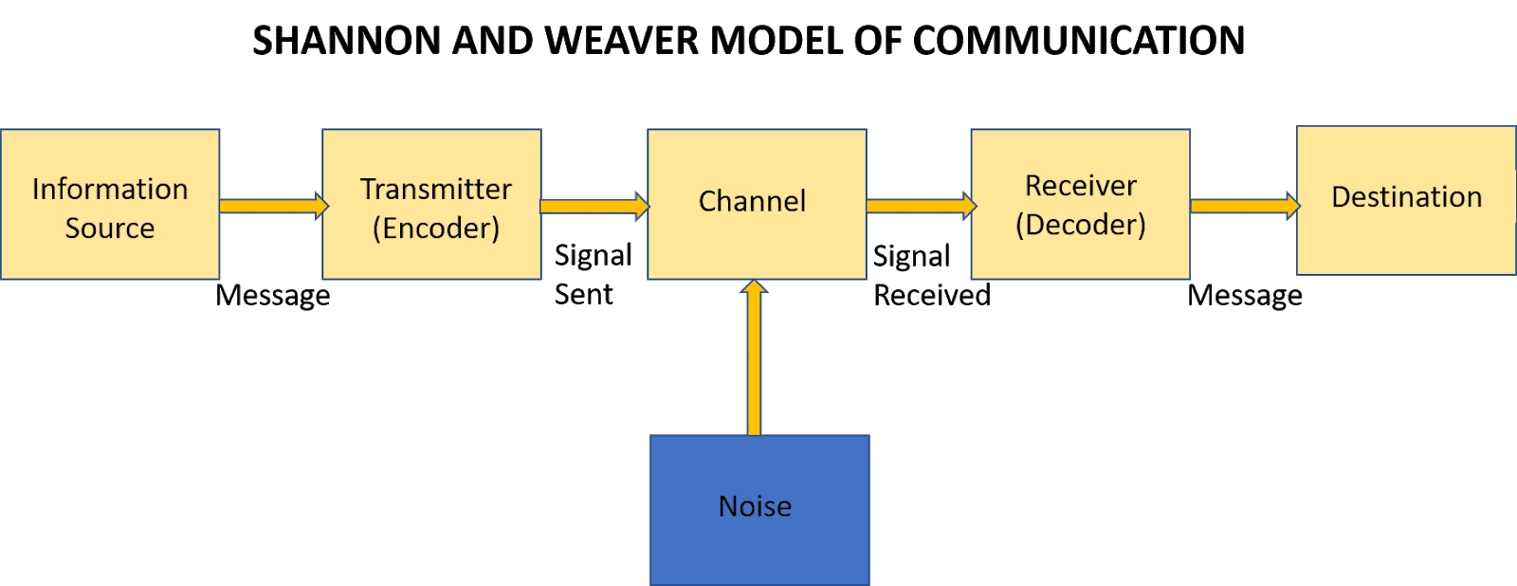

Figure: Shannon and Weaver Model of communication
Source: (Hänninen and Karjaluoto, 2017)
In the case study of Maria and Pedro, a similar situation is observed as Maria asked her husband Pedro to bring a chicken when he comes home. But due to noise in the channel, the message lost its original form, and the word “chicken” is changed to “kitchen”. As a result, Pedro failed to bring the chicken as he was asked. Such a type of misunderstanding in communication can be avoided by using a clear form of the communication channel, being aware of the presence of noise in the medium and avoiding noisy medium, repeating confusing words when messaging, using written communication method, if possible, etc.
I experienced a similar incident while working in my office last month. I work in the London office and telephone in our California office. As soon as the desk officer received my phone, I asked her about a client name “Harper & Co.” and send all relevant documents of the client. The next day when I received the documents, I noticed that the documents are labelled as “Sharper Inc.”. Due to the noise of the channel, my co-worker failed to receive the actual form of message and both of us had to work extra hours to compensate for this mistake.
Schramm’s Model of Communication: According to this model, communication is considered a two-way process involving at least two parties; the first party and the second party (Szkutak et al. 2020). The aim of encoding and decoding messages in communication is to help the receiver to understand the message and provide feedback. Schramm’s Model of Communication conclude that the communication process must be participatory as the sender passes data and information to the receiver in the form of a message and as soon as the receiver receives the message, he /she must understand and interpret it and provide feedback. If the sender does not receive any feedback on the message, the communication will be considered ineffective and incomplete.
Though both are closely related, Schramm’s Model of Communication is different from Shannon and Weaver Model of communication. Shannon and Weaver focused on reducing the presence of noise in the channels of communication and ensuring a clear and proper flow of the message (Wang et al. 2016). On the other hand, Schramm’s focuses on the response and feedback of the receiver and if the receiver fails to respond, the communication is incomplete.
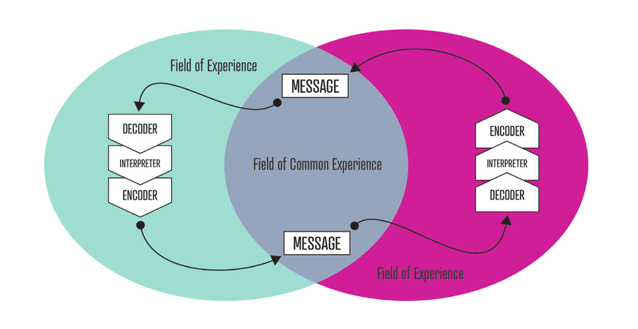
Figure: Schramm’s Model of Communication:
Source: (Malyuga and Orlova, 2017)
The misunderstanding in the communication can be avoided by actively convincing the receiver to provide feedback. After sending a message, it is important to ensure the receiver has received the intended form of the message, understand it and respond to the sender according to the message (Andrews, 2017).
Last week I was attending in a meeting with my colleagues and the heads of the departments where I work. In the meeting, I was scheduled to give a presentation on the progress of two different projects we were working on. While I was doing the presentation, the heads of the departments were discussing with themselves and provided little attention to my presentation. After completing the presentation, I faced no questions or received no feedback from any of the attendees (though I was expecting questions). I feel confused about whether I have successfully delivered the required information or not.
Berlo’s SMCR Model of Communication: The SMCR Model of Communication of Berlo focuses on describing the process of communication based on four interrelated components. These components are the sender, message, channel and receiver. These four components control the level of efficiency and completion of communication and help both the sender and receiver to participate in the process of communication. The message must be encoded before sending it and decoded after the receiver receives it (Pearson, 2017). The four components of communication are affected by different factors and to ensure the level of efficiency of communication, the negative impact of the unfavourable factors must be reduced.

Figure: Berlo’s SMCR Model of Communication
Source: (Kitchen and Burgmann, 2015)
Berlo’s SMCR Model of Communication is different from the other two models (Schramm’s Model of Communication and, Shannon and Weaver Model of communication) as it does not focus on the response of the receiver or the presence of noise in the communication channel. Rather this model focuses on understanding the impacts of four individual components of communication (Phutela, 2015).
In the case study of the professor, it is observed that the house of the professor was burnt to ashes but no one from the village came to help him. Because the professor failed to utilize the components of communication and subsequently failed to deliver a clear message to the receivers (by saying edifice instead of house and conflagration instead of fire). Such kind of misunderstanding can be avoided by conveying the message in such a way that the receiver can fully understand and interpret it and can make a response.
While I was working in my office, I heard one of my colleagues ask an intern to complete the “Low-hanging fruit” work before lunch hour. As the intern was new to the office environment and had no idea about the corporate jargon, failed to understand the meaning of “Low-hanging fruit”. Finally, he ended up loitering at different desks and trying to figure out what it means. Such kind of situation could be avoided if the intern was simply asked to complete the easy files before lunch hour.

Communication skills
Verbal, non-verbal and listening are the major communication skills that are used to make effective communication in different situations. Verbal communication can be both oral and written and considered the most widely used form of communication in everyday life. While making oral verbal communication (speaking), it should be clear, contain empathy to the other person, show sincerity and direct eye contact with the receiver (Marsen, 2020). Clarity in oral-verbal communication can be ensured by using easy and simple words, speaking slowly and using appropriate body language. On the other hand, while making written verbal communication, the language and writing style should be chosen based on the target audience.
Using silence and body language, instead of using words, is the core of non-verbal communication. As silence carries a message, the length and nature of silence should be determined based on the prevailing situation. Body language includes maintaining personal space while sending a message (sending it to the intended receiver), touching the receiver while making communication, posture (standing appropriately while making verbal communication) and appearance (the way an individual dresses or is groomed) (Slone and Gaffney, 2016). Listening is another major communication skill that helps to receive the message from the intended sender, interpret the message to understand the meaning of the message and make a response accordingly. If the intended receiver fails to listen to the message according, noise appears in the communication and the receiver fails to decode the message.
Active listening helps to understand the actual message, gather the required information from the message, provide support to the sender and other associated parties as per the direction of the message, make a response to the message and create a sense of cooperation (Campbell and Kresyman, 2015). To ensure active listening, it is important for the receiver to be fully aware and prepared to receive the message appropriately, express interest and focus on the sender and his/her message, be open-minded while making the communication and make no assumption based on perception, listen to the sender critically and in an unbiased way, reduce the presence of any sort of distraction and noise in channel etc. In addition, helping the sender and reflecting on the message (by repeating it to the sender) and not interrupting the sender while he/she sends a message is the key to receiving a clear message.
The case study of Max refers to the importance of active listening while Max; an event organiser was communicating with a client Tamara. Though the sender, Tamara sends the message properly, due to a lack of active and empathetic listening, Max failed to decode it properly and did not act accordingly. So, a misunderstanding took place and both the sender, and the receiver had to bear the consequences. An almost similar incident happened in my workplace two months earlier. One of our clients scheduled a meeting with the sales team in our office and I was advised to receive the client at 7 o clock. I reached my office early in the morning to receive the client at 7 am but he came at 7 pm. Such misunderstanding happened due to the lack of active listening of our representative and confirming the client regarding his message.

Advantages and disadvantages of technology in communication
Over the years, the use of technology in communication has increased as it provides some cutting-edge benefits to senders and receivers. From reducing costs to offering multiway channels, technology continues to help increase the efficiency of communication. At the same time, it creates some problems too. Here is a brief discussion of the advantages and disadvantages of technology in communication:
Advantages of technology in communication: Users can get information from various sources with the aid of the internet, search engines, and online connectivity. Such quick and simple access to information sources facilitates networking, communication, and research for both individuals and academic institutions (Civelek et al. 2016). Social media's emergence—Facebook, Twitter, Instagram, and others is regarded as a revolution in how technology is used for communication and for access to information in students live. These social networks let users to send and receive messages instantaneously from and to friends, family, coworkers, and other contacts by using mobile devices. A speedier means of communication in both the personal and professional spheres has been made possible by email and messaging services like WhatsApp, Telegram, etc. By utilising these channels, communication has become more convenient and quicker, while.
Disadvantages of technology in communication: Invasion of personal privacy is one of the biggest drawbacks of using technology for communication. It has become simple to obtain people's information thanks to the internet and platforms for online communication, which can then be used for malicious activities like identity theft and hacking (Pearson, 2017). Conversely, because of the overuse of the internet and other technology-based communication tools, there is a decline in the frequency of face-to-face conversation. Furthermore, using technology-based communication tools contributes to a variety of physical and mental issues, such as anxiety, sadness, eye strain, loss of confidence, etc.
Conclusion
To make effective communication, it is significant to associate both the sender and the receiver with the selected channel and reduce all sorts of difficulties associated with the process. In this Effective Teamwork and Communication assignment, the three models of communication are described based on the given case study. In addition, different types of communication skills are described by focusing on examples and case studies. Finally, the advantages and disadvantages of technology in communication are also discussed.

References:
Andrews, D.C., (2017). , A space for place in business communication research. International Journal of Business Communication, 54(3), pp.325-336.
Campbell Jr, C.L. and Kresyman, S., (2015)., Aligning Business and Education: 21st Century Skill Preparation. E-Journal of Business Education and Scholarship of Teaching, 9(2), pp.13-27.
Civelek, M.E., Çemberci, M. and Eralp, N.E., (2016)., The role of social media in crisis communication and crisis management. International Journal of Research in Business & Social Science, 5(3).
Hänninen, N. and Karjaluoto, H., (2017)., The effect of marketing communication on business relationship loyalty. Marketing Intelligence & Planning,
Kernbach, S., Eppler, M.J. and Bresciani, S., (2015). ,The use of visualization in the communication of business strategies: An experimental evaluation. International Journal of Business Communication, 52(2), pp.164-187.
Kitchen, P.J. and Burgmann, I.,( 2015)., Integrated marketing communication: Making it work at a strategic level. Journal of Business Strategy.
Malyuga, E.N. and Orlova, S.N.,( 2017)., Linguistic pragmatics of intercultural professional and business communication. Springer.,
Marsen, S., (2020). ,Navigating crisis: The role of communication in organizational crisis. International Journal of Business Communication, 57(2), pp.163-175.
Pearson, R., (2017)., Business ethics as communication ethics: Public relations practice and the idea of dialogue. In Public relations theory (pp. 111-131). Routledge.,
Phutela, D., (2015)., The importance of non-verbal communication. IUP Journal of Soft Skills, 9(4), p.43.
Radovic Markovic, M. and Salamzadeh, A., (2018)., The importance of communication in business management., In Radovic Markovic, M., & Salamzadeh, A. (2018)., The Importance of Communication in Business Management, The 7th International Scientific Conference on Employment, Education and Entrepreneurship, Belgrade, Serbia.,
Slone, A.R. and Gaffney, A.L., (2016). ,Assessing students’ use of LinkedIn in a business and professional communication course. Communication Teacher, 30(4), pp.206-214.,
Szkudlarek, B., Osland, J.S., Nardon, L. and Zander, L., (2020). ,Communication and culture in international business–Moving the field forward,. ,Journal of World Business, 55(6), p.101126. Wang, W.Y., Pauleen, D.J. and Zhang, T., (2016)., How social media applications affect B2B communication and improve business performance in SMEs. Industrial Marketing Management, 54, pp.4-14.

