Student Name: Diana Ispas (2030507)

EfFective Team work and communication

Table of Contents
INTRODUCTION 3
EFFECTIVE COMMUNICATION 4
Verbal Communication at a Workplace 4
Non-Verbal Communication 7
Written Communication 7
MODELS OF COMMUNICATION IN A BUSINESS AND TEAM 8
Shannon and Weaver Model 8
Interpersonal factors that influence effective communication in a team 9
ABILITY TO LISTEN 9
CONFLICT RESOLUTION 10
TUCKMANS THEORY IN COMMUNICATION 10
Forming 11
Storming 11
Norming 11
Performing 11
Transforming 11
PRACTICAL EXAMPLES OF POOR COMMUNICATION 12
Passive-aggressive communication by the supervisor 12
Mis-understanding between the team members in an office project 12
CONCLUSION 13
REFERENCES 14

INTRODUCTION
Effective communication is the ability to communicate personal viewpoints effectively and efficiently in a workplace that has a clear and concise meaning that the other person can understand. Employees and managers use verbal, non-verbal and written communication skills to share ideas and information in the formal working environment. The oral, visual and electronic modes of communication are used by the employees and management for interacting, presenting and interpreting the information that has been circulated within a team and organization. Visual communication skills are used to visualise data, oral communication skills are used for interacting in a team, and electronic communication such as emails are used to communicate formal information (Coffelt, T.A., Grauman, D. and Smith, F.L., 2019). Communication skills have a crucial role in building an effective team in a workplace. This report covers various aspects of communication skills, models of communication and effective team building.

EFFECTIVE COMMUNICATION
Effective communication is the ability to express one's personal view in a workplace in a manner that is clear and succinct and that the other person understands. Employees and supervisors use verbal, nonverbal, and written communication abilities to exchange ideas and information in the formal working environment. The communication pattern of the team reflects in the individual and team goal setting and overall team life. Tasks and goals are achieved through interpersonal solid interaction and clarity of communication among the team members.
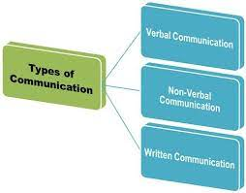
Figure- Types of Communications
Source- Businessjargons.com, 2021

Verbal Communication at a Workplace
Verbal communication at a workplace happens by communicating information and ideas through a communication medium such as group discussion, telephonic communication, supervising or presentation mediated by tone, pitch or speed of the communicator. Verbal communication has been considered as one of the most common modes of communication for the exchange of ideas within a team. The interpretation of verbal communication can vary and can be misinterpreted in a group that can cause several misunderstandings. In a formal work setting, every team member communicates and present their ideas which may or may not be well accepted by the other team members. The communication between an established team is seen to be better and well organized as compared to the new team.
Taking the reference of the case study The Apprentice, which had the problem of poor communication between the team, the main problem highlighted in the case study was that team was not able to perform due to weak interpersonal relationships and poor communication. The solution for creating a better team would be to create an open communication climate in the team where the leader and team members had a clear conversation regarding the team performance and strategy with active contribution from all the members of the group.
Verbal Communication | Implications | Interpretation of message
Group Discussion | Pros  - Simultaneous and transparent interaction between team members  - Good for brainstorming sessions  Cons  - Chances of heated communication  - Too many people speaking at one time and chances of missing key information or idea due to chaotic environment | - A lot of external noise to get clear communication  - Active listening skill is required to draw a conclusion from a group discussion  - High chances of misinterpretation of the message
Telephonic Communication | Pros  - Good for one to one communication between the colleagues  - Telephonic communication help in clarifying any specific issue in a project or work that needs close attention  Cons-  - A person cannot see non-verbal cues and may interpret the words from another person in the wrong way.  - No documentation or proof of the communication. | - The high clarity of message  - Low chances of misunderstanding in the communication  - A person cannot see the physical gesture, which is a drawback
Presentation | Pros-  - Good for formal communication data and describing complex charts and figures  - Good to pitch a project or business solution idea in a structured manner  Cons-  - The communication is done by a presenter on behalf of the entire team, and there may be miscommunication or gap between the team and presenter | - Highly focused conversation that is result-driven  - Open communication and low chances of misinterpretation of the words spoken by the presenter
Supervising | Pros  - Verbal communication helps in giving a clear line of command to the supervisors.  - Good for deligating day to day tasks.  Cons-  - It May come across as a rude or strict way of communication between the supervisor and team. | - Commands by the supervisor may be taken as strict verbal communication.
Table- Verbal Communication and possible interpretation of message

Non-Verbal Communication
Non-verbal communication has an equal role in building effective communication at the workplace and building a positive environment that promotes open communication between a team. Any corporate space where Managers have a positive attitude towards their teams, good body language and appreciative gestures has played an active role in creating a positive workspace. The non-verbal cues act helps in attaching meaning to the words spoken by the speaker and has a huge role in the way the speaker will interpret the message. A positive relationship between the leader and the employees has been seen when the leader uses positive gestures while communicating with employees (Ciuffani, 2017). Bad body language such as inappropriate hand gestures while communicating, avoiding eye contact, bad body postures act as a barrier in communication and set a wrong pace for effective communication.

Written Communication
Written communication is the way communication through written documents such as letters, reports, memos or emails through proper sentences, words and structure. Written communication forms an integral part of effective communication in an organization where there is a high dependency on documentation for keeping track of data and information. Written documents are informal tone and have essential information that various members of the team use.
Candidates who have strong communication skills and can effectively write information can use it as an employability skill for getting a good placement as strong written communication contributes to job readiness (Moore, T. and Morton, J., 2017).

MODELS OF COMMUNICATION IN A BUSINESS AND TEAM

Shannon and Weaver Model
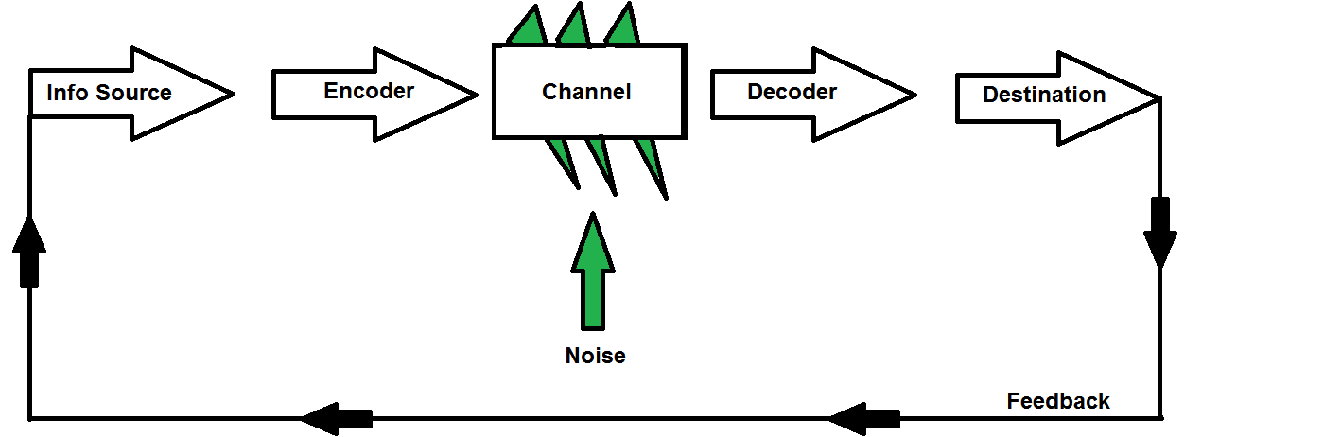
Figure- A linear model of communication
Source- Helpfulprofessor.com, 2021

A linear model of communication is the model that is based on uni-direction communication between the receiver and sender through a communication channel. Telephonic communication uses a linear model. Messages can be mid interpreted due to noise created in the communication channel in the linear model
2. Collin and Guetzkowr group communication model
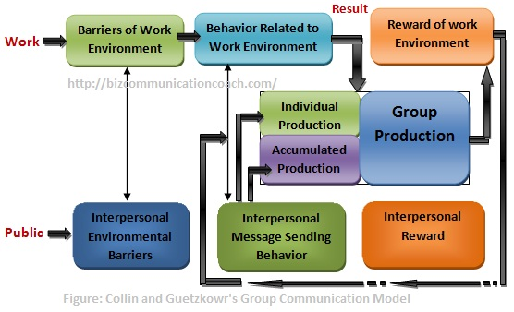
Figure- Collin and Guetzkowr group communication model
Source- bizcommunicationcoach.com, 2021

The communication between the groups and teams are analyzed under this model that has three important components that are group communication, group behaviour and organization environment. This model suggests that the potential barrier in group communication is interpersonal barriers and environmental barriers.
3. Interactional Model of Communication
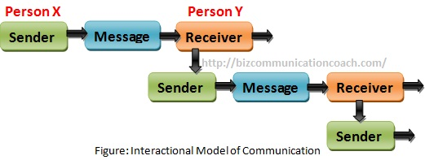
Source- bizcommunicationcoach.com, 2021
The interaction model of communication states that the two parties involved in the communication act as both sender and receiver and interact with each other. This model is used in many organizations.
4. Circular Model of communication
The transactional model of communication suggests there is a continuous exchange of information between the sender and the receiver. This model is based on a continuous cycle where the communication relies on the response of the receiver.

Interpersonal factors that influence effective communication in a team

ABILITY TO LISTEN
Listening skill has a crucial role in building effective communication in a team as it helps in understanding the viewpoint of other team member and help in creating a highly interactive team. Effective listening can help in solving team problems initially through listening within the lines and understanding the context of the other person through verbal and non-verbal communication such as body language, tone of voice and facial expressions that add value to the communication in a team. It is often seen that a good manager is an effective listener who listens and understand the viewpoint of the team members through being an active listener and right interpretation of the words of the speaker. Managers use listening skills to identify any possibilities of conflict in a team and use their leadership capability to avoid conflict in a team through coaching team members. Active listening has been an important part of problem-solving at the workplace and developing an interpersonal relationship that is useful for maintaining a healthy corporate relationship (Boak and Crabbe, 2019).

CONFLICT RESOLUTION
Poor communication is one of the main reasons for rising conflicts at the workplace. Conflicts arise in a team when there is a problem in understanding the personal viewpoint of the team members, and there is a lack of interpersonal relationships. Conflicts can be avoided at the workplace by setting clear expectations, avoiding personal differences, positive body language and a positive working environment (Furlong, 2020).

TUCKMANS THEORY IN COMMUNICATION
Tuckman Model is given by Bruce Tuckman which is used for team building and has five stages that are forming, storming, norming, performing and transforming. This model states that these stages are followed from initiation of the task till its completion by a team.
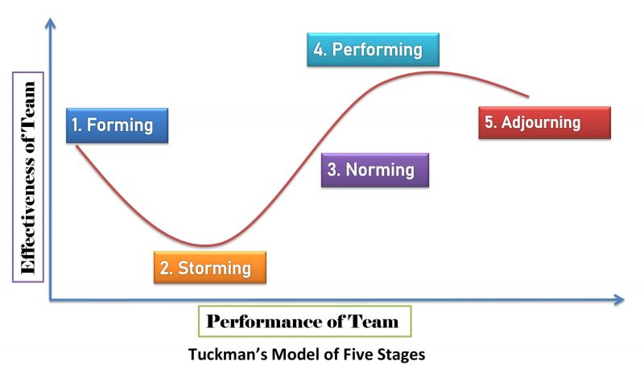
Figure- Tuckman’s Model of Five Stages
Source- newsmoor.com, 2021

Forming
The team is formed in the forming stage where different task is allocated at this stage to different team members. The communication between the team members is not strong at this stage as it is a newly formed team and each team member behave independently.

Storming
Storming stage in a team is when idea generation process is carried out and the success or failure on this stage depends on the team handling capabilities and leadership skills of the manager.

Norming
Norming stage is the third stage where the team work in coordination with each other by trusting each other. The team members take responsibility of their work and strong communication is built in the team

Performing
This is the stage where the team members achieve the goal set by the manager and give their best to achieve the objective of the team. If the other stages work well then, the team is successful to achieve the team goal.

Transforming
The team reaches this stage when all the other stages are successful and team moves to another task without breaking due to any mis-communication.

PRACTICAL EXAMPLES OF POOR COMMUNICATION

Passive-aggressive communication by the supervisor
- My friend is working in a digital content writing company that works in close deadlines. The manager assigns the daily tasks that need to be accomplished by the end of the day. There was one incidence when the manager called a group meeting and delegated tasks in an aggressive tone of voice that put the employees in a stressful mindset for the day. The employees felt poorly treated and faced negative working conditions.
- The problem in the communication was wrong body language, facial expressions and gestures. The tone of voice was aggressive that took the conversation in the wrong direction. The manager was not able to build effective communication between the team.
- Solution
- The solution for coping up with this situation for the manager is to pay attention to the tone of the voice and non-verbal cues. Trying to communicate the requirements of the company from employees can also be helpful in this case. Listening to the employee's viewpoint can also be useful in creating clear and transparent communication between the manager and employees, which is lacking as of now (Agarwal, 2019).

Mis-understanding between the team members in an office project
- One of the incidences at my workplace was that my team had to close a project in 2 days, and we were working on a close deadline. We had a team meeting where the final aspects of the project were discussed. The conversation got heated up regarding the responsibility dedicated to team members, which created misunderstanding between the team members
- Solution
- Emotional intelligence and listening skills are some of the most efficient skills to solve the problem of team coordination (Cui, 2021). Listening to the viewpoint of the team members, especially during a stressful time when the deadlines for task completion is close, sets an open communication environment. High emotional intelligence help in understanding the problem in a team and using analytical skills to solve a problem which can be helpful in this case.

CONCLUSION
Communication skills are one of the most important skills for working in a corporate work environment which is required to interact and share information in a corporate space. Communication skills have been highly ranked as the most desired employability skills in the modern business environment. Employees continuously interact with each other through verbal, nonverbal and written communication methods. Communication skills have proved to be one of the crucial factors in building an effective team where employees and managers work in an open communication climate by practising active listening, positive body language and clear verbal communication. The report has covered practical and theoretical analysis of the importance of communication skills and effective team building.

REFERENCES
Agarwal, U.A., 2019. Impact of supervisors’ perceived communication style on subordinate’s psychological capital and cyberloafing. Australasian Journal of Information Systems, 23.
Boak, G. and Crabbe, S., 2019. Evaluating the impact of coaching skills training on individual and corporate behaviour. European journal of training and development.
Ciuffani, B.M., 2017. Non-verbal Communication and Leadership: the impact of hand gestures used by leaders on follower job satisfaction (Bachelor's thesis, University of Twente).
Coffelt, T.A., Grauman, D. and Smith, F.L., 2019. Employers’ perspectives on workplace communication skills: The meaning of communication skills. Business and Professional Communication Quarterly, 82(4), pp.418-439.
Cui, Y., 2021. The role of emotional intelligence in workplace transparency and open communication. Aggression and Violent Behavior, p.101602.
Furlong, G.T., 2020. The conflict resolution toolbox: Models and maps for analyzing, diagnosing, and resolving conflict. John Wiley & Sons.
Moore, T. and Morton, J., 2017. The myth of job readiness? Written communication, employability, and the ‘skills gap in higher education. Studies in Higher Education, 42(3), pp.591-609.

