

Applied Computing

Wales Institute of Science and Art (WISA)

Advanced Networking (ACCA5024)

Lab 4: Working with IPv6 Addresses

Kindly note that the entire lecture session on IPv6 is available as a recorded session in Moodle for your future references.
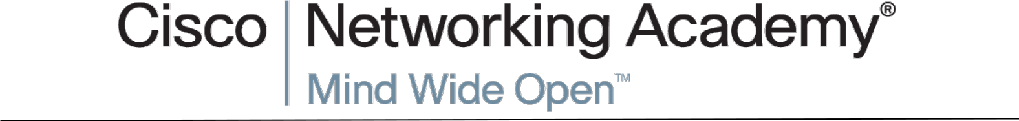

n.kaliyamurthy@uwtsd.ac.uk | 1

ACCA4024

Objectives

Task 1: Working with IPv6 Addresses

Task 2: Basic IPv6 Configurations

Required Resources

- 1 PC (Windows with Internet access)

- Optional:

- Packet Tracer (Latest version)

Topology
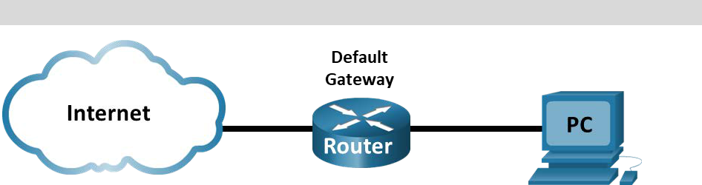

With the depletion of the Internet Protocol version 4 (IPv4) network address space and the adoption and transition to IPv6, networking professionals must understand how both IPv4 and IPv6 networks function. Many devices and applications already support IPv6. This includes extensive Cisco device Internetwork Operating System (IOS) support and workstation/server operating system support, such as that found in Windows and Linux.

This lab focuses on IPv6 addresses and the components of the address. In Task 1, you will identify the IPv6 address types and IPv6 addresses abbreviation. In Task 2, you will view the IPv6 settings on a PC.

2

ACCA4024

Different Types of IPv6 Addresses

In this part, you will identify the different types of IPv6 addresses and practice compressing and decompressing IPv6 addresses.

Match the type to IPv6 address

Give an example for the following address type with its corresponding IPv6 addresses.

Loopback address

::1

Global unicast address

2000::

Link-local address

FE80::

Unique-local address

FC00::

Multicast address

FF00::

Match the IPv6 to its type

Give an example for the following IPv6 addresses with its corresponding address type.

Fc21:42:b:1::cd4:23e4:67fa – Unique Local

2033:db08:0001:1:2002:a45d:259a:12ef -Global Unicast

2001:0db8:1:acad::fe55:6789:b210 – Global Unicast

::1 - Loopback

ff00::db7:4322:a231:67c - Multicast Address

fe80::3201:cc01:65b1 – Link Local

ff00:: - Multicast

ff02::2 - Multicast

3

ACCA4024

Practice compressing and decompressing IPv6 addresses

Using the rules of IPv6 address abbreviation, either compress or decompress the following addresses:

2002:0ec0:0200:0001:0000:04eb:44ce:08a2

2002:EC0:200:1::4EB:44CE:08a2
fe80:0000:0000:0001:0000:60bb:008e:7402

FE80::1:0:60BB:8E:7402

fe80::7042:b3d7:3dec:84b8

FE80:0000:0000:0000:7042:B3D7:3DEC:84B8

ff00::

FF00:0000:0000:0000:0000:0000:0000:0000

2001:0030:0001:acad:0000:330e:10c2:32bf

2001:30:1:ACAD::330E:10C2:32BF

4

ACCA4024

TASK 2

Examine a Host IPv6 Network Interface and Address

Check the IPv6 network settings of your PC to identify your network interface IPv6 address.

Check your PC IPv6 network address settings.

Verify that the IPv6 protocol is installed and active on your PC-A

(check your Local Area Connection settings).

Navigate to the Control Panel → click Network and Sharing Center icon → Click View network status and tasks.

In the Network and Sharing Center window, you will see your active networks.

On the left side of the window, click Change adapter settings.

You should now see icons representing your installed network adapters. Right-click your active network interface (it may be an Ethernet or a Wi-Fi), and then click Properties.

In the Properties window, scroll through the list of items to determine whether IPv6 is present, which indicates that it is installed, and if it is also check marked, which indicates that it is active.

Select the item Internet Protocol Version 6 (TCP/IPv6) and click Properties. You should see the IPv6 settings for your network interface.

Your IPv6 properties window is likely set to Obtain an IPv6 address automatically. This does not mean that IPv6 relies on the Dynamic Host Configuration Protocol (DHCP).

Instead of using DHCP, IPv6 looks to the local router for IPv6 network information and then auto-configures its own IPv6 addresses.

To manually configure IPv6, you must provide the IPv6 address, the subnet prefix length, and the default gateway. Click Cancel to exit the properties windows.

Note: The local router can refer host requests for IPv6 information, especially Domain Name System (DNS) information, to a DHCPv6 server on the network.

5

ACCA4024

After you have verified that IPv6 is installed and active on your PC, you should check your IPv6 address information.

Open a command prompt and type ipconfig /all and press Enter. Your output should look similar to this:

C:\Users\user> ipconfig /all

You can see from the output that the client PC has an IPv6 link-local address with a randomly generated interface ID.

Record your reflection

What does it indicate about the network regarding IPv6 global unicast address, IPv6 unique-local address, or IPv6 gateway address?
That the addresses were preferred, the gateway address is link local, the IP addresses have a lease expiry.

What kind of IPv6 addresses did you find when using ipconfig /all?
Global, link local

How do you think you must support IPv6 in the future?
By learning how it works as opposed to, and alongside IPv4. To prioritise IPv6 where I can

Do you think IPv4 networks continue on, or will everyone eventually switch over to IPv6? How long do you think it will take?
IPv4 will be around for a long time, years to come, because there are already workarounds for IPv4 in place. Due to the cost and labour in changing over from one to the other, business will dictate that it will only switch over completely when necessary.

6

