[Date]



MBA DISSERTATION

Course: Master of Business Administration: Entrepreneurship
Name: Chibueze C. Duru
Student No: 1709607
Supervisor:Tushara Balendran

Chibueze C. Duru
MBA DISSERTATION

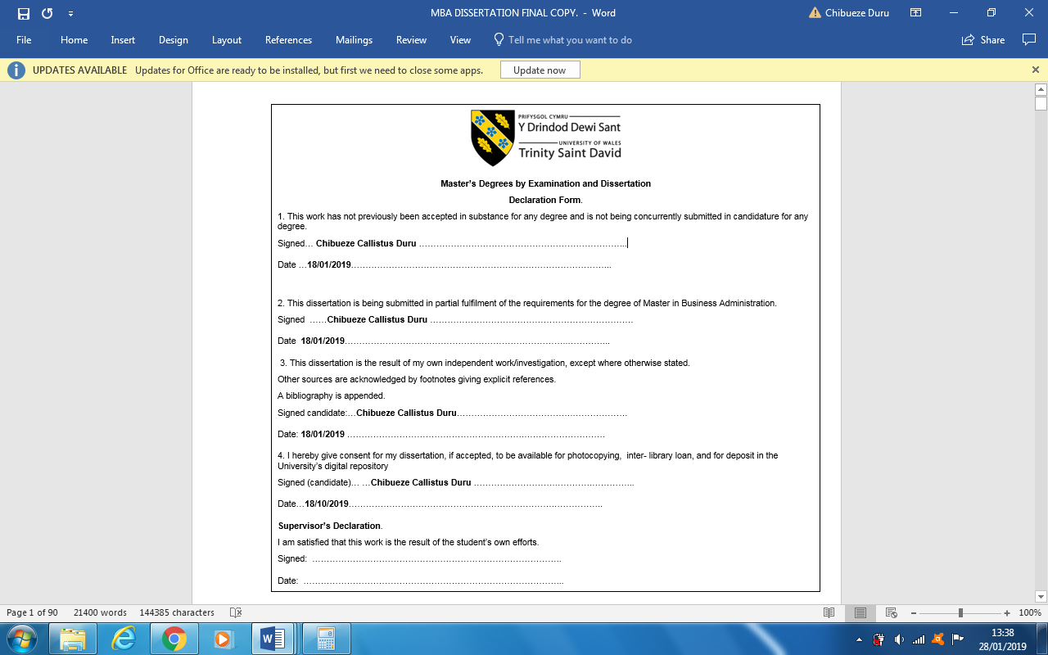



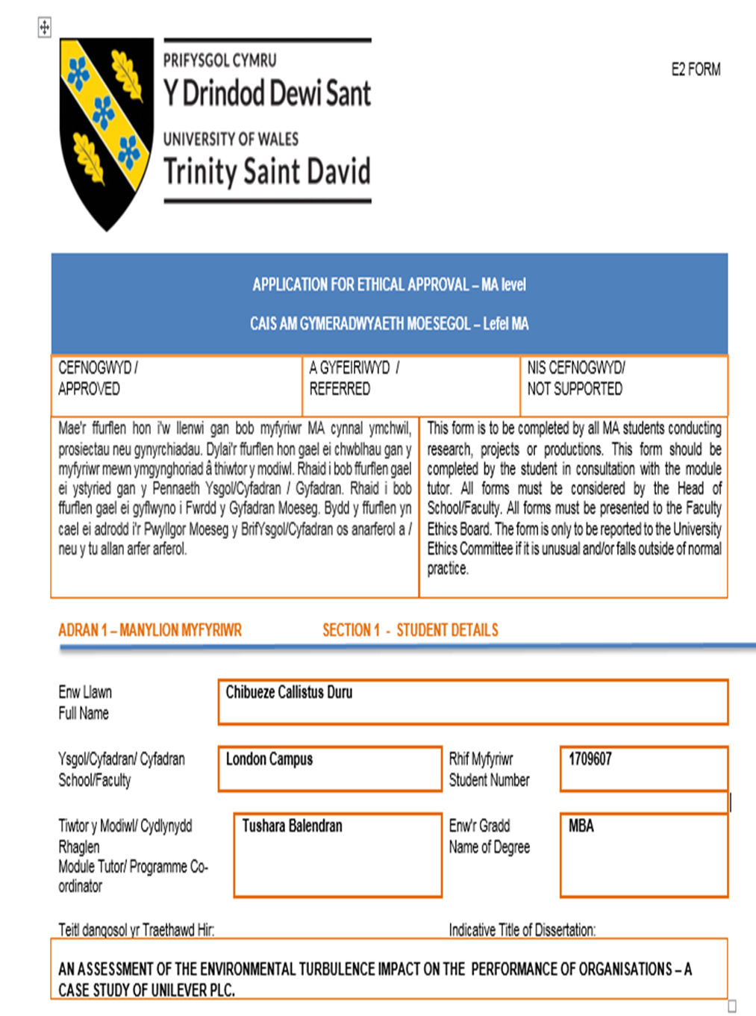

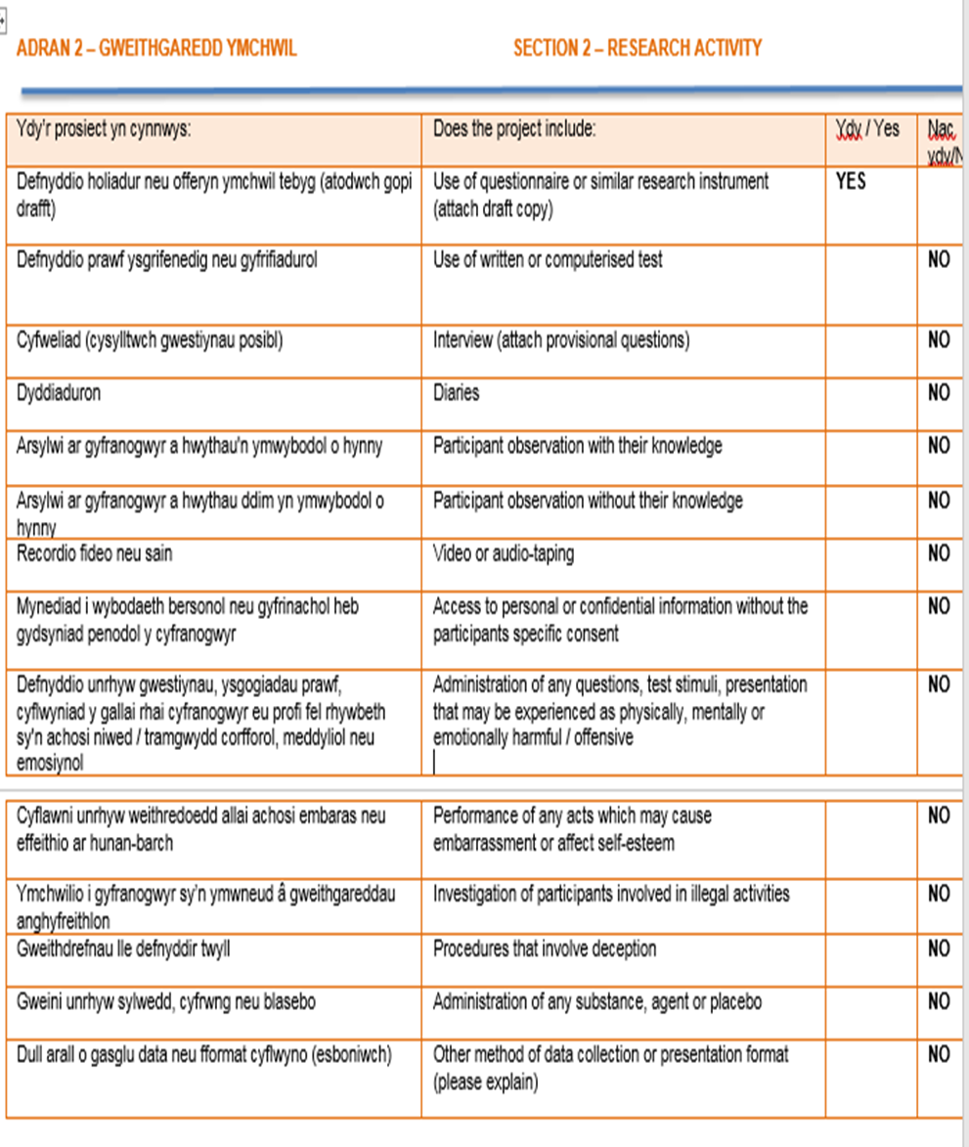

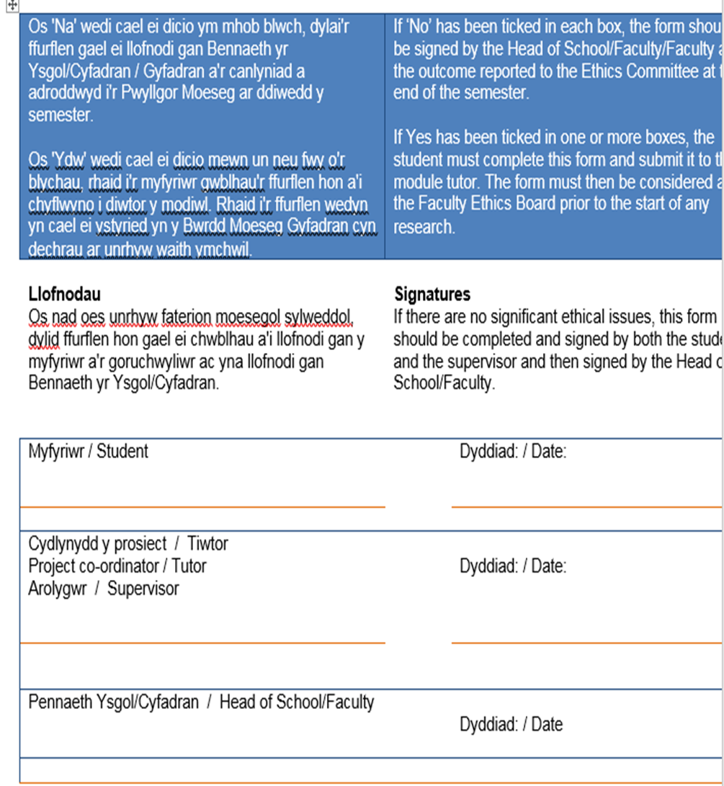

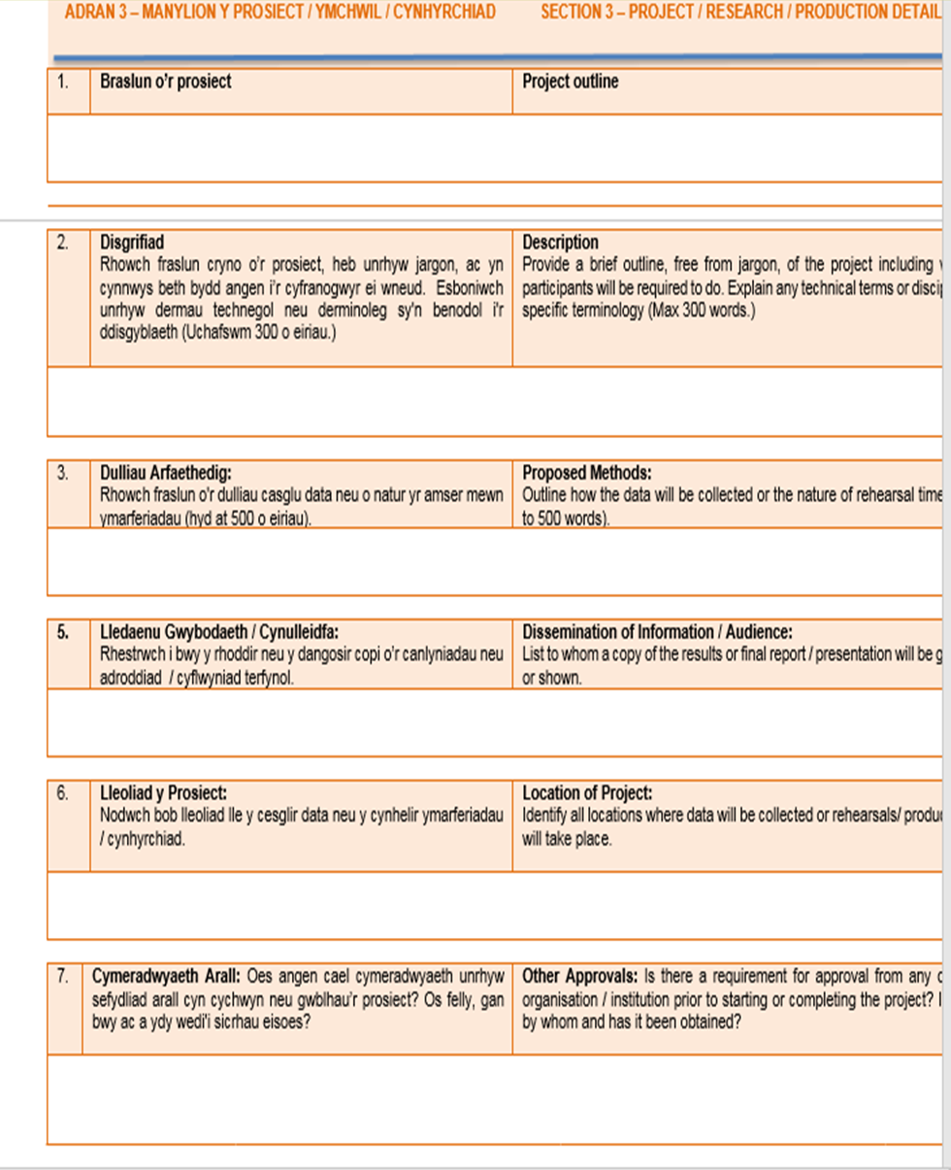

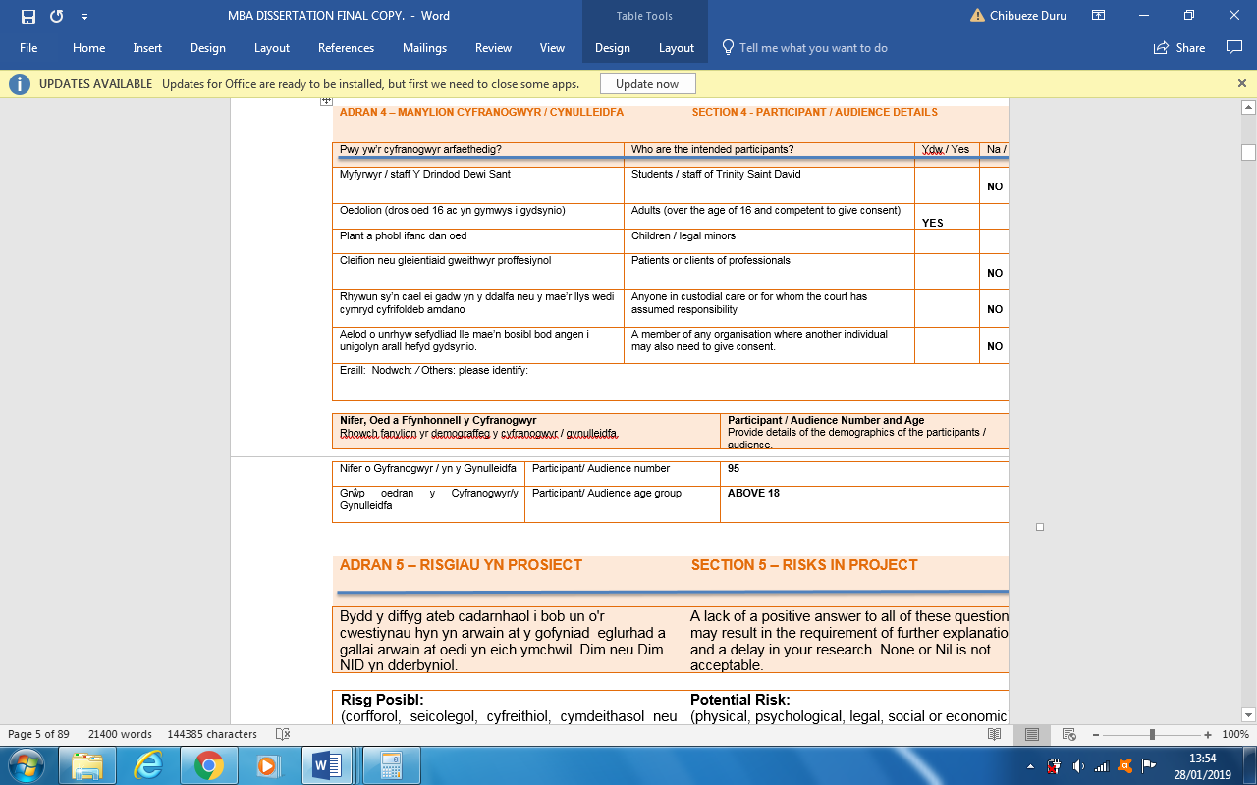

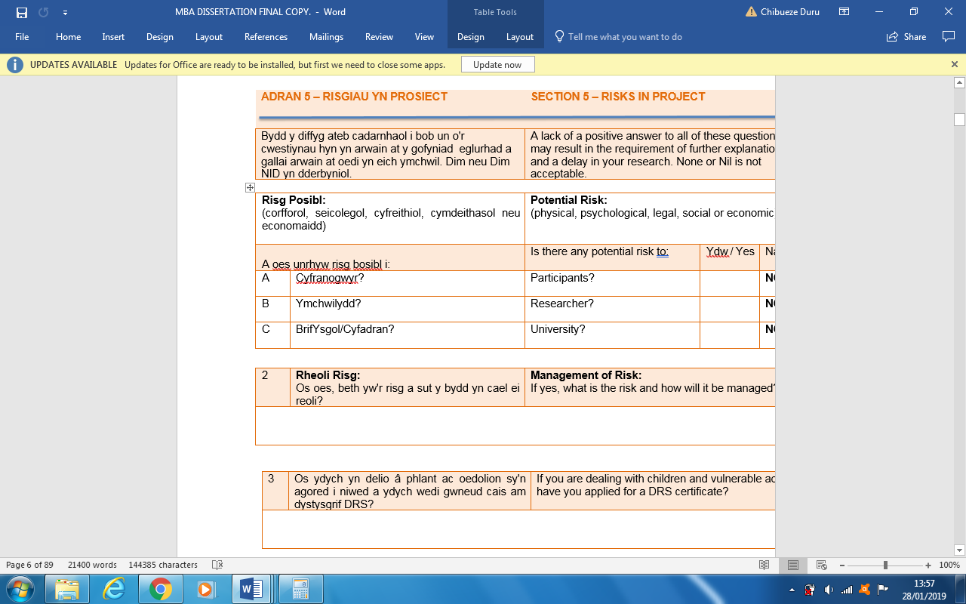

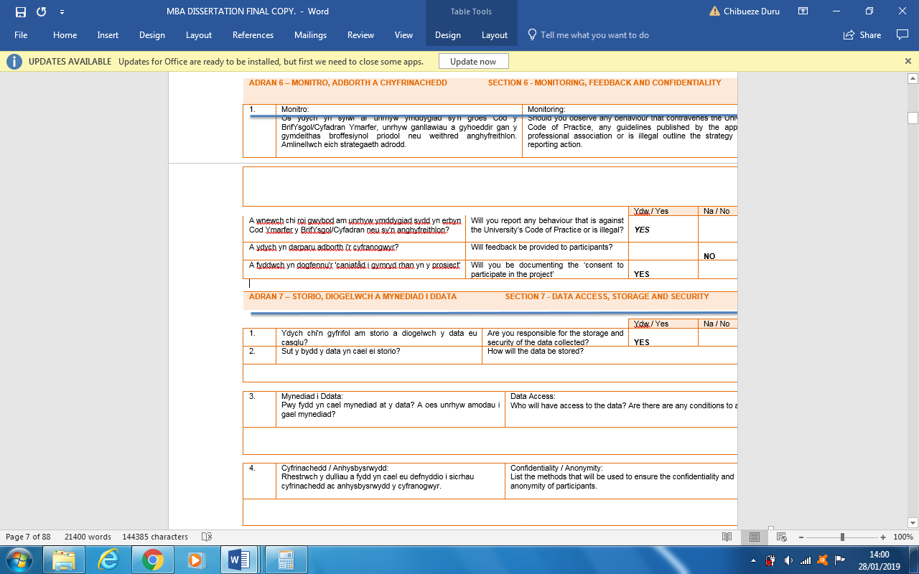
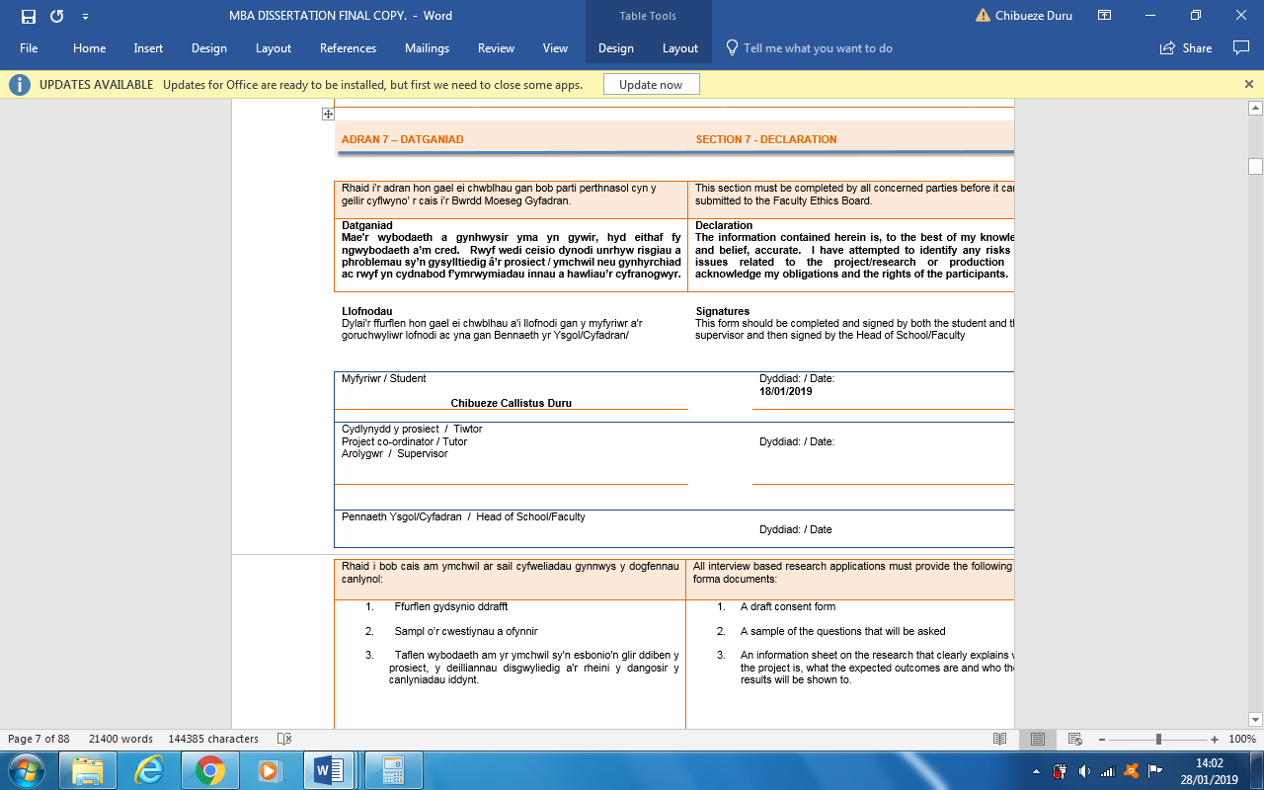

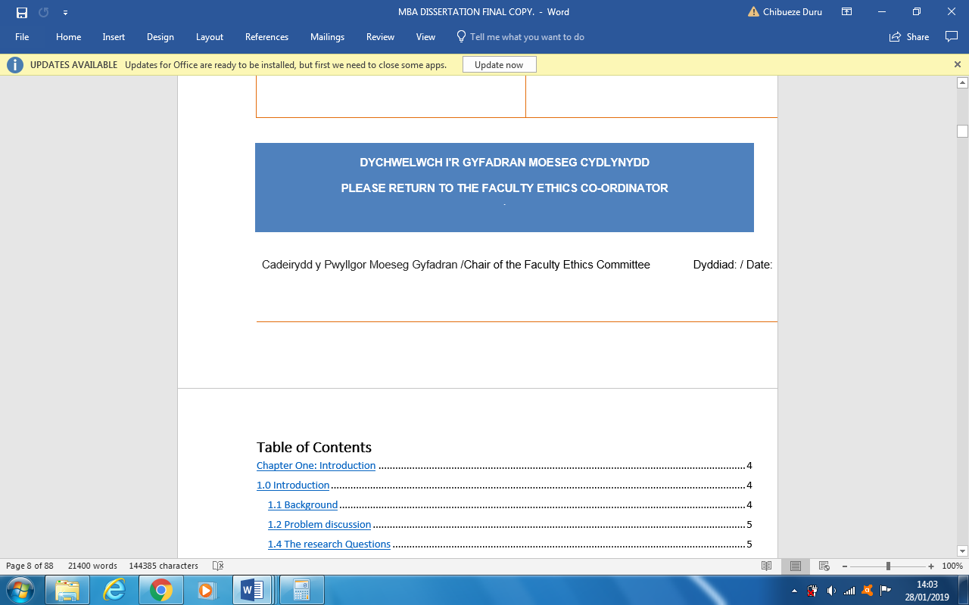

Abstracts
Organisations must develop strategies of survival in the environment where they operate because of the harsh environmental factors beyond their control. These factors influence their strategic choices and its industry competitiveness. Understanding the environment will also enable them to make strategic decisions that will permit them to reduce the impact of the environmental threats capable of having adverse effect on their performances. Organisations have become more competitive by managing the increasing turbulent environment created by the digital age.
This research study investigated the external competitive environment in which Unilever Plc operates and to ascertain how it affects its performance including the strategical responses of organisation in turbulence periods. The objectives of the present research were: to investigate the external environmental issues that affect the performance of Unilever Plc, to investigate the strategies adopted by Unilever Nigeria in turbulent environment periods and to establish best methods suitable for organisations during the period of turbulence.
For this research, data was collected from the employees of Unilever Nigeria by the researcher. The participation of the respondents was voluntary and that determined prominently the population of the participants. The researcher used semi-structured questionnaires to collect primary data. For analysis and interpretations, the researcher used statistical calculations such as frequency distribution, correlations analysis, analyses of variance (ANOVA) and cross-tabulations to draw conclusions on the findings using the SPSS.
From the findings of this research study, some of the causes of turbulence that affect organisations are external environmental factors, for example, political instability, government regulations, high interest and inflation rates etcetera. The study established also the importance of compliance to statutory regulations in the FMCG industry . Another indication of the study is the strong relationship between FMCG industry competition and new product development. New competitors come to the market with new products and services having the intention to give customers something different from what they usually obtain from the old products in the market. They offer innovative products with the intention of changing customer’s perceptions and attitudes towards the existing products in the market.

Acknowledgement

I owe an enormous debt of gratitude to the almighty God for his mercy and blessings upon me and my family.
I am thankful to and fortunate enough to get constant encouragement, support and guidance from my wife, Nkenta and children, Jessica, Silvia and Matteo which helped me in successfully completing my work. Also, I would like to extend my sincere esteems to Francis Adaji for his timely support.
I heartily thank my project supervisor, Tushara Balendran for her guidance and suggestions during this project work.
A very big thank you for all the lecturers that have moulded my knowledge up to this level. God bless you all.

Chibueze

Dedication

This work is dedicated to my parents

Ezinna Afred Duru and Ezinne Christana Duru

and my uncle

Mr Julius Udeogu

Table of Contents

Chapter One: Research Introduction 14
1.0 Introduction of Research Background 14
1.1 Problem discussion 15
1.2 Research Investigative Questions 15
1.3 The Relevance of the research 16
1.4 Dissertation Structure 16
Chapter Two: literature Review 17
2.0 Literature Review 17
2.1 External Environment Analysis 17
2.2 PESTLE analysis 18
2.2.1 Political factors 18
2.2.2 Economic dimensions Important to Unilever 19
2.2.3 Social Factors 19
2.2.4 Technological Factors 19
2.2.5 Ecological/Environmental Factors Affecting Unilever 20
2.2.6 Legal Factors Facing Unilever 20
2.2.7 Critical Analysis of PESTLE 21
2.3 Porter Five Forces 21
2.3.1 Threat of New Entry (Weak) 21
2.3.2 Bargaining Power of Suppliers (Moderate) 22
2.3.3 Bargaining Power of Buyers (Strong) 22
2.3.4 Threat of Substitution (Weak) 22
2.3.5 Competitive Rivalry (Strong) 23
2.3.6 Critique of Porter Five forces 23
2.4 Analysis of the Internal Environment 24
2.4.1 The SWOT Analysis Model 24
2.4.2 Critique of the SWOT Analysis Model 25
2.5 The Strategic Responses of Organizations to Environmental Turbulence 26
2.5.1 Generic Strategies 26
2.5.2 Unilever uses broad differentiation 27
2.5.3 Critique of Porter Generic Strategies 27
2.6 Ansoff Matrix 28
2.6.1 Market Penetration (Unilever’s Primary Strategy). 28
2.6.2 Product Development (Unilever’s Secondary Strategy). 29
2.6.3 Market Development (Unilever’s Supporting Strategy) 29
2.6.4 Diversification (Unilever’s Supporting Strategy). 30
2.6.5 Critique of Ansoff Matrix 30
2.7 Corporate Restructuring 30
2.9 Critique of Corporate Restructuring strategy 31
2.9 Business Strategic Framework 31
Chapter Three: Methodology 33
3.0 Research Introduction 33
3.1 Research Objectives. 33
3.2 Research Onion 34
3.2.1 Research Philosophy 34
3.2.2 The Deductive Research Strategy 35
3.2.3 Strategy 35
3.2.4 Research Approaches 36
3.2.4.1 The Qualitative Approach 36
3.2.4.2 The Quantitative Approach 37
3.3 Choices 37
3.3.1 Critical Evaluation of Mixed Method 37
3.4 Time Horizon 37
3.5 Data Collection 38
3.6 Research Sample 39
3.6.1 Population 39
3.6.2 Sampling Frame 39
3.6.3 Sample strategy 39
3.7 Sample Size 40
3.8 Reliability and validity 40
3.9. Data Analysis 41
3.10 Limitations of the Research 41
3.11 Ethical Consideration 41
CHAPTER FOUR: Presentation and Interpretation of Findings 43
4.0 Introduction 43
4.1 General information 43
4.2 Age 43
4.3 Gender 44
4.4 Years of Working Experience 45
4.5 Participants’ highest level of Education 46
4.6 The impact of external environmental factors on the Performance of the FMCG Industry 47
4.7 The impact of Statutory Regulations on Organisation’s Performance 47
4.8 Economic Factors 48
4.9 Social Factors 49
4.10 Experience and Technological Change 50
4.11 Industry Competition and New Product Development 51
4.12 Relationship between Industry competition and new market development 54
4.13 The Relationship Between Gender and New Products in the Market 54
4.14 Organisation Performance 55
4.15 Predictable Social Change Effect on Businesses Environments 57
4.16 Organizational Capacity Building and Adaptability 57
4.17 Strategic Responses engaged by Unilever in Turbulence Periods 58
4.18 Diversification 59
4.19 Corporate Restructuring 60
4.20 Best Practices/ tools Adopted by Unilever in Turbulent Environmental Periods 63
4.21 Uncertainty and Strategic Response 65
4.22 Summary of Presentation and Interpretation of Results 66
Chapter Five: Summary and Discussion of the Research Findings 68
5.0 Introduction 68
5.1 Summary 68
5.2 Research discussion of the findings 70
5.2.1 Competitive Environment and Organisational Performance 70
5.2.2 Strategies Adopted by Unilever Nigeria in turbulent Environmental periods 71
5.2.3 Strategy in Turbulent Environmental Periods 73
Chapter six: Conclusion and Recommendation 75
6.0 Conclusion 75
6.1 Linking with Objectives 76
6.1.1 Objective One: to investigate the external environmental issues that affect the performance UnileverPlc. 76
6.1.2 Objective Two: to investigate the strategies adopted by Unilever Nigeria in turbulent environmentperiods 76
6.1.3 Objectives Three: to establish best practice suitable for organisations in turbulent times. 77
6.2 Recommendations 77
6.2.1 Industry External Competitive Environment and Organisational Performance 77
6.2.2 Strategic Responses Employed by Unilever Nigeria 78
6.2.3 Best practices suitable for organisations in environmental turbulence periods. 78
7.0 Limitations of this Research 78
8.0 Future Scope of the Research 79
References 79
Appendices…………………………………………………………………………………………..80

List of Figures

Figure. 2.1 External Environment Analysis 23
Figure 2.2 PESTLE Analysis Strategy Framework 24
Figure 2.3 The SWOT Analysis Model 30
Figure 2.4 Generic Strategies 32
Figure 2.5 Ansoff Matrix 33
Figure 2.6 Business Strategic Framework 37
Figure 3.2 Work plan 43
Figure 4.1 Age group 49
Figure 4.2 Gender 50
Fig. 4.3: Years of Work Experience 51
Fig. 4.4: Participants’ Level 8of Education 52
Figure 4.5 Compliance with Statutory Regulations 53
Figure 4.6 High interest rate 54
Table 4.7: Social factor analysis. 54
Figure 4.8: Employees’ Work Experience and Changes in Technology 56
Figure 4.9: Industry Competition and development of new market, diversification and new product development 57
Figure 4.9 Industry Competition 58
Figure 4.10 Industry Competition and New Market 59
Figure 11 Gender and New Products in the Market 60
Figure 4.12: Organisation performance 61
Figure 4.13: Organisation capacity 61
Figure 4.14 predictable Social Changes 62
Figure 4.15: Organisation Capacity Building and Adaptability 63
Figure 4.16: Diversification 64
Figure 4.17: Corporate Restructuring 66

ABBREVIATIONS

CSR -Corporate Social Responsibility
D -Diversification
EU -European Union
FMCG - Fast Moving Consumer Good
IC -Industry Competition
NA -Not Available
PESTLE -Political, Economic, Social, Technological, Legal and Ecological
PLC -Public Liability Company
PIU -Political Instability and Uncertainty
P&G -Procter and Gamble
NMD -New Market Development
NMP -New Product Development
SPSS -Statistical Package for the Social Sciences
SWOT -Strengths, Weaknesses, Opportunities and Threats
SW -Social Welfare
UK -United Kingdom

Chapter One: Research Introduction

1.0 Introduction of Research Background

Organisations must develop strategies of survival in the environment where they operate because of the harsh environmental factors beyond their control. These factors influence their strategic choices and its industry competitiveness. The good understanding of the environment is the beginning of their success. The management must constantly scan their business environment to identify gaps to convert into opportunities of generating extra revenue for the organisation. Understanding the environment will also enable them to make strategic decisions that will permit them to reduce the impact of the environmental threats capable of having adverse effect on their performances. According to Mintzberg et al. (2009) managers must make strategies capable of matching internal capabilities with external possibilities.
There are various sources that lead to environmental changes such as innovative technologies, rapid economic change and political drifts, instabilities in societal values and changes in consumers preferences (Karake, 1997). Based on the view of Rigby (2001) company managers need to change the theory of ‘one strategy fits all’ during the period of environmental turbulence. Rigby further said that the survival in turbulence time depends on the revision of the business contents such as the industry sources, the level of the environmental turbulence, the strategic position of the organisation within the industry and its financial strength. “External environment is a source of uncertainty and constraints that creates more problems for some organisations than others” (Pearce and Robinson, 2008). Most of the economic factors that evolve constantly are government economic regulations, consumer buying habit such as taste or trend, new technologies, all these create turbulence (Perrot, I2011). Millennium organisations must have the capability of forecasting and predicting future changes and developing strategies to cope with them (Karake, 1997). To address the issues of uncertainty and dynamism, it is mandatory to gather information about the environment in which they operate. According to Khandwalla (1977) environmental turbulence is unpredictable, very dynamic and fluctuating. The postulation of Ansoff and McDonnell (1990) is that an organisation can achieve a good return of investment aligning its strategic aggressiveness and general management to the environment turbulence.

1.1 Problem discussion
Organisations have become more competitive by managing the increasing turbulent environment created by the digital age. Based on the theory of Thomson (1997) before an organisation can control change and development, they must control the environmental forces that provides growth and change opportunities also those that pose threat to its existence.
In addition to the ongoing political uncertainty, fast moving consumer goods (FMCG) firms must adopt strategies to survive this technological disruption. For example, the recent devaluation of the pounds and the uncertainty of future trade deals due to Brexit. Currency devaluation has resulted in a higher cost of imported raw materials and this reduces profitability- the challenge is managing price changes whilst currency is volatile and ensuring the Supply Chain Process operates unhindered by political decisions regarding the movement of goods and services.
Consumers now pay more attention to the environment and expect brands to be socially responsible by ensuring that their growth is sustainable and ethical. Organisations such as Unilever have taken measures to reduce the carbon footprint of their value chain to maintain the good name of their brand - as Warren Buffett (n.a) famously said: "It takes 20 years to build a reputation and five minutes to ruin it".
Though many see the FMCG industry as stable and safe, the reality is political and technological disruption doesn't discriminate- it affects all industries and even big, diversified FMCG companies such as Unilever must prepare for the future.

1.2 Research Investigative Questions
1. What are the impacts of external competitive environment on the performance of Unilever?
2. What are the strategic responses adopted by Unilever Plc in turbulent environments?
3. What are the best practices/ tools in Turbulent Times?
These questions will be approached through surveys and literature review. Conclusion will be drawn after analysing and comparing the result of the findings.

1.3 The Relevance of the research
The researcher’s aim is to shed more light on the various types of strategies organisations use in turbulence periods. The result of the study will aid the management of organisations in understanding the environment where they operate and formulate strategies suitable in dealing with the challenges caused by the dynamic nature of the environment. The result will help as a source of reference for students and policy makers in creating favourable operating environments that will enhance the growth of entrepreneurs.

1.4 Dissertation Structure
This work is divided in six chapters. Chapter One: General information that includes, age, years of working experience and gender. Chapter Two: literature review of relevant theories. Chapter Three: Research Methodology. Chapter Four: presentation and analysis of the research finds. Chapter Five: Summary and discussion. Chapter Six: Conclusion and recommendations.
Literature review will be discussed in the next chapter.

Chapter Two: literature Review

2.0 Literature Review
According to Cooper (1988) literature review has the function of describing, summering, evaluating and/or integrating the content of primary reports.
In this chapter, an empirical literature analysis consisting of summaries of similar studies by other researchers will be done to support this work using articles from reviewed journals, academic journals, books including online sources. The objectives of the research were met using the literature to show how the independent variable; external environment affect the dependent variable; firm performance. This chapter also covers how organisations respond to turbulence.

2.1 External Environment Analysis
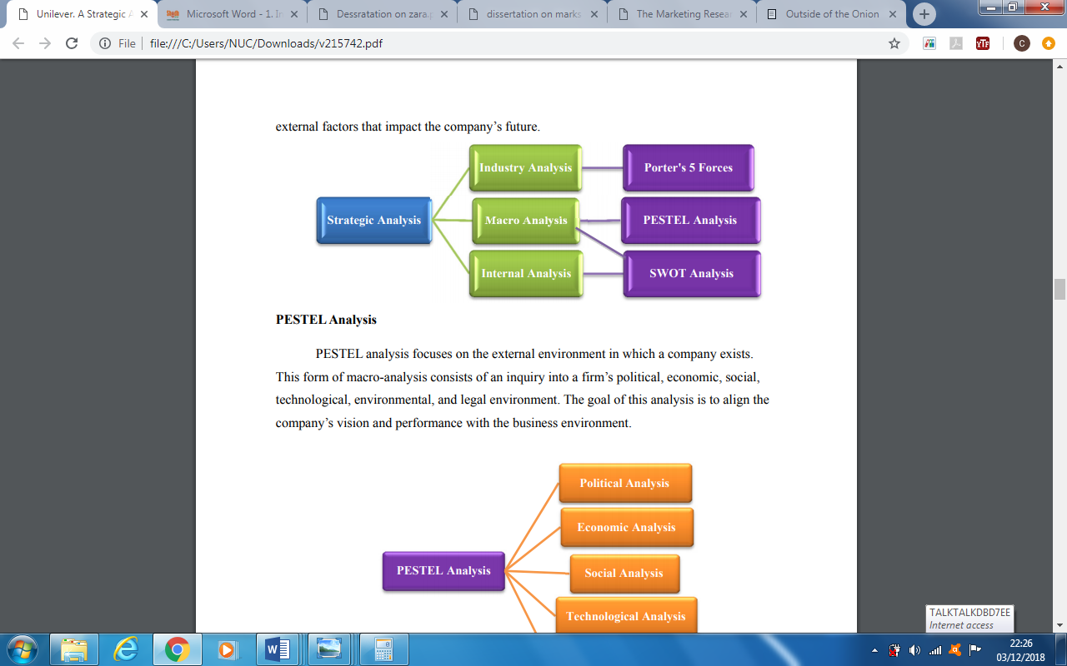
Figure. 2.1 External Environment Analysis (Pearce and Robinson, 2008).
Generally, the external environment greatly impacts the performance of business organisations (Boyne and Meier, 2009). In the “Logic of governance” of Lynch et al. (2000), the authors included political issues, economic issues, legal issues and social issues of organisational context. They claim that the effect of these environmental factors are directly related to the performance of organisations.

2.2 PESTLE analysis
PESTLE is a very important analytical tool for businesses to study the environment in which they operate.
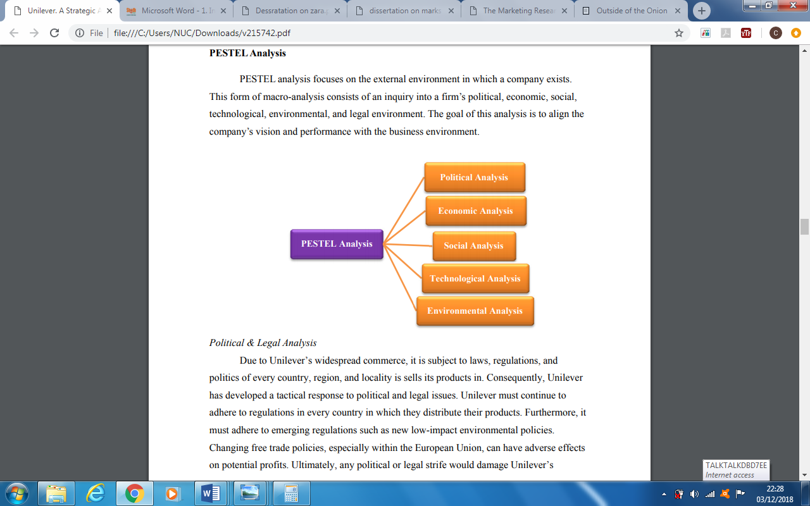
(Pearce and Robinson, 2008).

Figure 2.2 PESTLE Analysis Strategy Framework

2.2.1 Political factors
The speculation of the uncertainties of politics influences the economic transactions of all nations (Beaulieu et al., 2005). For example, Brexit. Therefore, when formulating company policies, the national political direction and stability must be considered because legal and regulatory parameters are based on political issues (Pearce and Robinson, 2009). For example, company’s’ operation strategy can be affected by tax programs, environmental pollution regulations, employment laws and anti-trust laws.
Unilever should capture political stability as an opportunity to increase its market share. As for example, strategic implementation challenges are minimised in the Germany due to its political stability and the Brexit is affecting strategic decision of most of the global organisation in the United Kingdom. The European political issues pose as potential threat to the operations of organisations like Unilever in the consumer goods market. However, Unilever has more opportunities offered by the growth of global trade agreements between most nations in the world. But they must adopt strategies to manage the challenges associated with the political European Union conditions.

2.2.2 Economic dimensions important to Unilever
As a global organisation the gross performance of Unilever depends on the economies around the world because they operate in more than 200 countries worldwide.
Most of the developing nations are increasing their minimum wages, thereby, increasing the buying powers of the consumers. This presents an opportunity for Unilever to gain more profit from higher potential sales. However, this external environmental factor can also be a threat as regards to an increasing cost of production for Unilever that has manufacturing facilities in most of these countries. The demographic growth of most of the developing nation is an opportunity Unilever should embrace. For example, China and India are very attractive markets because of their population. The economic stability of most of the industrialised nations like United Kingdom and United States of America cushions business from risks in other markets, as it facilitates the gradual but steady growth.

2.2.3 Social Factors
Cultural values such as belief, attitudes, opinions and lifestyle are the societal environmental factors that influence the operations of organisations (Ireland, et al, 2013). “Culture is a collective programming of the mind” (Hofstede, 1991). A change in the attitude of people in the society, changes also the demand for the various products and services (Pearce and Robinson, 2009).
The manufacturing of health products that directly takes care of consumers’ interest in health wellbeing will enable Unilever to achieve sustainable growth. Additionally, due to the environmental awareness, Unilever should use modern technologies to improve their environmental impact that will enable them to attract more customers. For instance, by using new and more energy-efficient technologies, Unilever can reduce its energy consumption. There is a great opportunity for growth by targeting female environmentalist consumers worldwide.

2.2.4 Technological Factors
The 21st century has witnessed a great technological innovation and for companies to progress in this century technological know-how is very essential (Euchner, 2011).
The fully automation production system presents an opportunity for Unilever to increase its operational efficiency. For example, Unilever can enhance its supply chain and distribution efficiencies through the application of new technologies. However, technology increases competitiveness of other organisations in the local market and from this point of view can be considered as a threat in the consumer goods industry. The rapid progress of competitors’ research and development investment threatens the competitive advantage of Unilever. Low cost of transportation reduces the operation cost contributing to business growth. On the other hand, low transport cost is also a threat, the reduction of transportation cost increases competitiveness which leads to market share and profit reduction of companies such as Unilever.

2.2.5 Ecological/Environmental Factors Affecting Unilever
There are some external ecological trends and condition that have impact on the Fast Moving consumer Goods industries such as Unilever.
Unilever should improve its environmental program to attract the environmentalists. They can achieve this by enhancing its sustainability program thereby, strengthening its competitiveness against other industry competitors. Unilever should use its corporate social responsibility strategy to effectively achieve this program. For example, reducing environmental impact through product innovation and internal business processes. Their effort in reducing environmental impact will support their ability to satisfy increasingly complex environmental programs. This provides an opportunity to gain competitive advantage through corporate responsibility.

2.2.6 Legal Factors Facing Unilever
Global companies are affected by the external legal environmental factors in their host nations. Unilever being present in more than 200 nations of the world is exposed to most of these factors.
There is an opportunity for Unilever to boost its corporate image by matching their CSR strategy with environmental regulations of their respective host countries. Additionally, the growth of the company can be enhanced by strengthening international patent laws. For example, patent related problems can be reduced in developing nations by new patent laws.

2.2.7 Critical Analysis of PESTLE
The weaknesses of PESTLE are over simplification of information used in making strategic decision, implementation and priority of the factors. Investment in this analysis has to be done periodically in other to be effective. The access to quality external information may be costly or sometimes restricted. Organisational decision made are based on assumptions, making such decision subjective. For example, Brexit has created much uncertainty in the business world. Decisions made in this moment might impact positively or negatively an organisation based on the final agreement between EU an UK. PESTLE does not cover all environmental factors; some environmental changes may not be noticeable during their initial stages but can have adverse effect on organisations. Environmental factors are not stagnant, they change constantly making the result of PESTLE analysis subject to constant evaluation.

2.3 Porter Five Forces
According to Tarzijan and Ramirez (2011), Industry environment has a direct consequence on the profitability of organisations. The potentiality of their profit is directly related to the threat of new competitors in the market, the negotiating power of consumers and suppliers, availability of alternative products and the industry rivalries (Porter, 1979).

2.3.1 Threat of New Entry (Weak)
The market of consumer goods is made up of established companies such as Unilever and new companies. The new entrants have great influence on the industry environment because their intention is to share the existing customers with the old players of the industry. Due to the low switching cost new entrant can put up a fierce competitive fight in the market against firms like Unilever pushing the consumers to try new products. However, due to the difficulty of building a brand as strong as Unilever or some other big players like Procter and Gamble, this weakens the threat of new entrants. As well, the new entrants lack high organisational efficiencies, established distribution channels and the high economies of scales that enables Unilever to achieve competitive pricing.

2.3.2 Bargaining Power of Suppliers (Moderate)
Karake (1997) defined suppliers power as the ability of the suppliers in getting good prices. An input supplier price increase increases the output price and can cause environmental turbulence. In a market with less suppliers, suppliers have a high bargaining power (Porter, 2008). Suppliers play very important role in the business of consumer goods; their decisions affect the level of raw materials available to firms like Unilever.
This external force exerts moderate force on Unilever due to the large number of products under their production. Generally, the number of suppliers contributes to their power. For example, the higher number of suppliers in this industry the lesser their power becomes, and this restricted their influence on companies such as Unilever.

2.3.3 Bargaining Power of Buyers (Strong)
The reason consumers bargain for higher quality products and services is to reduce their cost (Bhattacharyya and Nain, 2011). Inferior products sometimes have short life span. According to Pearce and Robinson (2009) consumers use the strategy of playing competitors against each other to obtain price reduction. The purchasing power of consumers is high when the make bulk purchases because they can easily switch to another supplier, especially, when the switching cost is insignificant (Ireland et al, 2013). Therefore, an industry where the consumer has more power faces more environmental turbulence (Karake, 1997). The performance of companies such as Unilever depends on the response of the customer to their products.
The low switching cost enables consumers to easily switch from Unilever’s product, for example, to that of Procter and Gamble (P&G) or to other competitors. The intensity of the of consumers’ bargaining power is influenced by external environmental factors. Also, modern technologies have put consumers in condition to compare the quality of goods and it influences their buying decisions when transferring from Unilever to other providers. Bulk purchasers have stronger bargaining power than individual consumers over companies like Unilever.

2.3.4 Threat of Substitution (Weak)
According to Porter (2008), substitute is when in the market exists other similar product or service capable of providing the same function. For example, videoconferencing is a substitute for travelling to a location for a business meeting. Porter further stated that industry’s profitability suffers when the threat of substitute is high. Product substitute affects the level of industry’s environmental turbulence and uncertainty (Karake, 1997). That the survival of the existing product is threatened because new substitute brings new technologies and curiosity. The theory of Ireland (2013) is that any action taken by an organisation provokes a competitive response. Simon et al (2010) argue that within an industry, companies are seldom similar as they seek to differentiate themselves in their capabilities and resources. Threats that emerge from product substitutes reduce the revenue of companies that manufacture the original products. In this case, if consumers of Unilever find substitutes to their products, it will reduce the volume of sales of those products and the Unilever’s revenue.
The low cost enables consumers to easily switch from Unilever’s products to other similar products in the market. The force of product substitute is very strong in the business of consumer goods. Nevertheless, due to low availability of substitutes in this industry the intensity of the force is weak. For example, the accessibility of Unilever Close-Up toothpaste is easier than homemade organic dentifrice. Relatively, there is insignificant cost difference between most substitutes and the original goods in the market. This weakens the intensity of the threat of product substitute.

2.3.5 Competitive Rivalry (Strong)
Porter states that “rivalry among existing firms takes forms such as: price discounts, new product introduction, advertising campaigns and service improvements” (Porter 2008). Competition is a strong force in the business of consumer goods. The big players of this industry have huge financial and technological capabilities thereby making the competition very fierce.
In the consumer goods industry, there are many competitors that impose a strong force on Unilever. The intensity of the competition makes these firms very aggressive trying to survive from all the external environmental forces exerting pressures on them. The low switching cost makes it difficult to build and maintain a large database of loyal customers. This factor makes the force of competitive rivalry strong.

2.3.6 Critique of Porter Five forces
According to Speed (1989) porter five forces can be criticised for two reasons: firstly, the choice is made arbitrarily and secondly, the strategy gives no suggestion on the method suitable for the analysis based on these forces, no proposed counteractions. The non-consideration of the impact of the suppliers’ complementary products and the environment in which industries operate has made most scholars to challenge its validity (Grant, 2005). The five forces do not consider environmental changes and that firms can create values and gain competitive advantage through other sources such as innovation and technological breakthrough. The model is static based on the opinion of Hill and Jones (2007), the model represented just a snapshot of a constantly changing situation, it does not record the changes arising in the industry. The authors further claimed that the Porter overrated the role of industry as determinant of organisation’s profit neglecting the differences between individual companies.

2.4 Analysis of the Internal Environment

2.4.1 The SWOT Analysis Model
According to Humphrey (2005) SWOT analysis examines the internal and external environment of organisation highlighting possible internal and external environmental factors that will enhance or may compromise its future performance. Precisely, the SWOT analysis underlines the organisation’s internal strengths and weaknesses including opportunities and threats in its operative external environment.

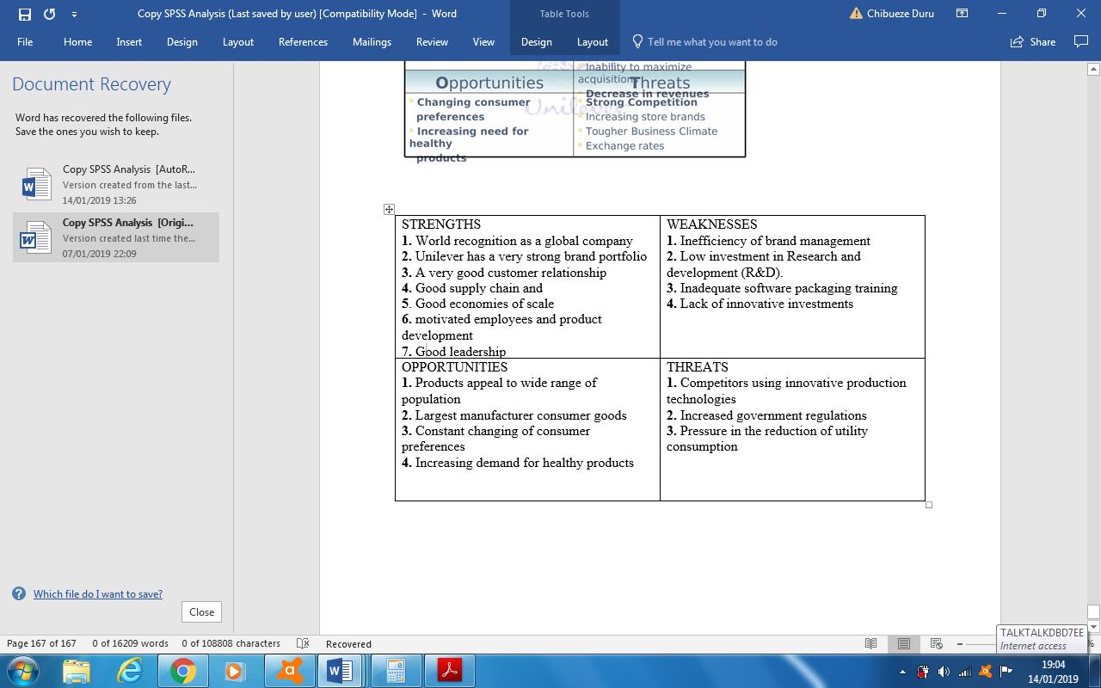

Figure 2.3 The SWOT Analysis Model

The main strengths of Unilever are its product diversification, diverse brand portfolio, very good leadership, motivated employees and product development including a very large investment is research and development (Unilever Communications, 2013).
Unilever’s greatest weaknesses are composed of the structural, organisational and mission-based issues. The rise in consumers’ purchasing power in developing nations is one of the external factors that can benefit Unilever by establishing a positive position in the customer’ minds. For example, Unilever gained customer and loyalty support through its dedication to the environment (Emerald Publishing Group, 2013a). Apart from the fierce competition Unilever is facing, the health of their revenue is threatened by political uncertainties, financial costs such as tax increase, information technology risks and government environmental regulations in various nation where they operate (Unilever Communications, 2018).
While global development provides economic growth opportunities for organisations like Unilever, their success is equally threatened by the increasing concern about the environmental impact of technology and industry rivalries.

2.4.2 Critique of the SWOT Analysis Model
The opinion of Wheelan and Hunger (2002) is that SWOT analysis as a technique lacks in quality and quantity. That SWOT does not prioritise issues and does not provide solutions or offer alternative decisions. The use of SWOT is expensive because it requires experience and training for a systematic construction and use. According to Dess et. al (1997) SWOT analysis is primarily a static assessment that focuses too much on the present condition of an organisation and more especially, strength does not often lead to competitive advantage. Valentin (1989), the factors used in SWOT analysis do not consider all environmental sectors and there is no clear evidence of benefits and disadvantages of sustainability. Even if SWOT generates many outcomes, it does not take into consideration probability. Listing strengths and opportunities on paper is prone to bias and it is very different from testing and experiencing organisational strengths at work. SWOT is expensive because the analysis need to be repeated every time one or more of these environmental factors change.

2.5 The Strategic Responses of Organizations to Environmental Turbulence
According to Ansoff and McDonnell, (1990), business organisations react differently to environmental changes and gradually respond to minimise the shift from the historical behaviour amid the firms and the environment. The authors retain that business approach requires a radical revolutionary change instead of suppressing and minimising it, an entrepreneur pursues change.
Ireland et al., (2009) retained competitive response to be a strategic action carefully orchestrated and executed by an organisation to counter effect its competitors’ action. Dess et al (2008) argue that an organisation needs to have a good prediction of the competitors’ action before initiating a response. Developing response strategy is very essential for organisations to be competitive.

2.5.1 Generic Strategies

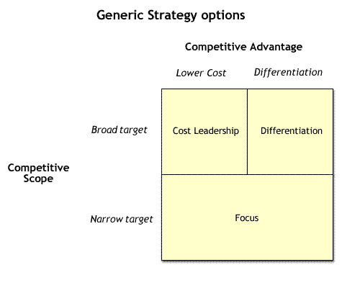
(Porter, 1985)

Figure 2.4 Generic Strategies

A generic strategy is the main idea regarding the capability of an organisation to compete in the market place (Pearce and Robinson, 2008).
Unilever gained competitive advantage through cost leadership and satisfaction of their customers’ specific needs and preferences. According to Porter (1985) generic strategy ensures organizations’ competitiveness essential for its growth and resilience. In relation to Unilever, product development method integrated with research to address market needs was used to achieve competitive advantage. Unilever used appropriate mixture of intensive strategies to sustain growth. The condition of the consumer goods market influences how Unilever shifts its prioritisation of strategies for intensive growth. To ensure success in its global operations they used both generic competitive strategy and intensive growth strategies.

2.5.2 Unilever uses broad differentiation
Unilever adopted the strategy of broad differentiation to gain competitive advantage among its rivals. Generic strategy enables organisations to focus on the features or characteristics that distinguishes their products from other competitors. For instance, Unilever uses Dove Cream Bars to satisfy the need of its customers that require soaps that are not hash or drying. Using the generic strategy, Unilever aligned its vision and mission statements of supporting global sustainability and increasing vitality in consumers’ lives.

2.5.3 Critique of Porter Generic Strategies
The generic strategies’ have the limitation of not providing relevant strategic routes in fast developing markets (Lynch, 2003). Cost leadership presents the risk of companies focusing on reduction of costs sometimes compromising other vital success factors, at times losing vision of the main reason why they embarked on such strategy. Cost leadership needs high sales volume and experience gained can be cancelled by technological changes. Finally, competitors matching your prices and inflation can annul the perceived price differential.

2.6 Ansoff Matrix
Ansoff (1990) matrix is useful for organisation to tackle environmental issues when seeking for growth. Products
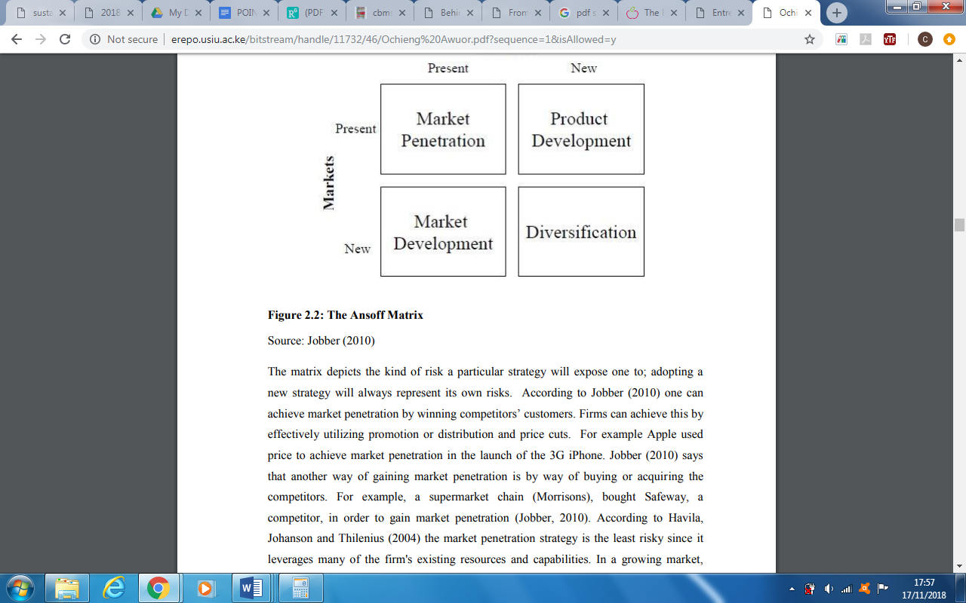
Figure 2.5 Ansoff Matrix (Jobber, 2010)
There are various risks attached to a particular strategy. The adoption of a new strategy represents its own risk. The only way to achieve market strategy is winning the competitors (Jobber, 2010).

2.6.1 Market Penetration (Unilever’s Primary Strategy).
Through market penetration, Unilever was able to achieve the intensive growth strategy that enabled its sales volume, revenue and corresponding business growth. For example, they aggressively marketed their home care products in the United states and Canada and was able to capture customers away from competing home care firms. Generic strategy of differentiation allowed Unilever to distinguish their products by making them more competitive and attractive than others in the same market. The main limitation of market penetration: it does not allow for any company growth by focusing on retaining only the existing customers.

2.6.2 Product Development (Unilever’s Secondary Strategy).
Product development means creating new product for the existing market (Edwards, 2008). This strategy can be achieved through the expansion of an existing product line with many varieties (Jobber, 2010). A good example is Apple that extended its product line iPod with iPod Nano, shuffle and touch, giving their customers a greater variety of choice (Jobber, 2010). Although, new product development has the benefit of reaching the customers before other competitors, but it is expensive, time consuming and your competitors may introduce to the market products that the compensate the deficiencies of your product. Your competitors might introduce products that fulfil the gap in your first release, practically, making your product obsolete.
The intensive growth strategy of Unilever used new product development to satisfy the needs of their customers. Using new versions or entirely new of their personal care products, Unilever was able to increase its market share. This innovation contributed to improvement of their marketing mix and benefited them financially.

2.6.3 Market Development (Unilever’s Supporting Strategy)
Market development means creating new market for the existing product that includes the option of adding a market segment or geographical regions. The reason organisations develop new market development is to be able to manage their risks by creating opportunities that generate extra income (Etzel, et al., 2007). The reason is that the uncertainties of market development are bigger than those of market penetration.
Unilever uses market development strategy to support its intensive growth strategy. The system they adopt is entering new market or market segments. For illustration, the opportunity of increasing their growth is marketing new products to meet customer requirements in certain markets. In any case, Unilever is already present in all sort of consumer goods market in the whole world. The objective of Unilever’s market development strategy is to make the brand more visible using marketing campaigns to highlight the potential benefits of its current products to capture new customers. The limitation is that it requires entering a new market with unknown parameters and a high risk of failure.

2.6.4 Diversification (Unilever’s Supporting Strategy).
Among the four growth strategies, diversification is the riskiest because it entails the creation of both product and market, sometimes, the organisation may not have the core competencies, but it can be profitable (Jobber, 2010). For example, Honda, an established manufacturer of motorcycles to cars and Apple from making computers to iPod and iPhone (Mitchell, 2005). There are several advantages of diversification strategy such as securing a position in an attractive industry and reducing its business risk that leads to a good return above industry average (Ireland et al 2013). Too much of diversification may lead to performance decline and organisation’s units in the business are divested (Hayward and Shimizu, 2006)
Unilever supports their intensive growth strategy through diversification focusing on the establishment of new businesses that will enable the company to grow. For example, from 2009 – 2010, Unilever acquired other businesses like personal care business of Sara Lee Corporation to achieve diversification, thereby, attracting target consumers. Although diversification increases the visibility of an organisation, but it is the riskiest among the generic growth strategies proposed by Ansoff because it requires entering a new market with unknown parameters.

2.6.5 Critique of Ansoff Matrix
This frame work has the limitation that it must be used with other theoretical frameworks. It is useful for laying strategies for company growth, but its simplicity is generally criticised because external environmental factors are not considered. It focuses mainly on market potential instead of the resources that will enable the organisations to support the strategy. The Matrix is not appropriate for a company that its objective is survival because it outlines only strategies for growth. The pursuit of a particular strategy does not guarantee success because decisions made based on any strategy is still subjective, therefore, increasing the risk of bias by management personnel. Another important risk is that all information used in decision making is based on forecast and this is a further risk.

2.7 Corporate Restructuring
According to Lee and Madhaven, (2010), restructuring strategy allows organisation to make business or financial structural changes. According to Pearce and Robinson (2008) organisations restructure to function more efficiently based on the notion that some business activities are strategically important to their success than others. The most popular types of restructuring adopted by organisations are: business process re-engineering, downscaling and controlled business buyouts (Pearce and Robinson, 2008; Ireland et al., 2013).
Downscoping is getting rid of businesses that are not related to organisations’ core business. Downscoping can impact positively the performance of a company than downsizing because it enables companies to concentrate with their capabilities and resources on its core business (Bergh and Lim, 2008).
In an attempt to revive Unilever, the management launched a strategy called Path to Growth strategy in 2000 in response to the company’s years of slow performance attributed to inadequate corporate strategy, high numbers of low-volume brands, low global presence and mediocre presence in developing markets. The aim of path to grow strategy is to achieve in five years the reduction of company’s brand portfolio to 400 core brands, much focus on research and development of products and new markets using product innovation to fuel internal growth (Unilever.com, 2018). The strategy was adopted to build brand value that will enable Unilever to gain pricing power among its competitors.

2.9 Critique of Corporate Restructuring strategy
Downsizing does not always guarantee organisational performance (Ireland et al.,2013). Employees panic wondering how they will be affected by the change causing more stress and less focus on their actual work. Employees who leave the company also leave with their experience, skills and knowledge of company projects that they possess.
Sometimes investors react negatively to a restructuring situation due to the fear of losing money. Their reactions may have negative impact which can result in dropping of stock prices for companies that are publicly traded. Restructuring particularly in tough economic periods sometimes shifts company image leaving customers and the other stakeholders questioning the future of the company.

2.9 Business Strategic Framework

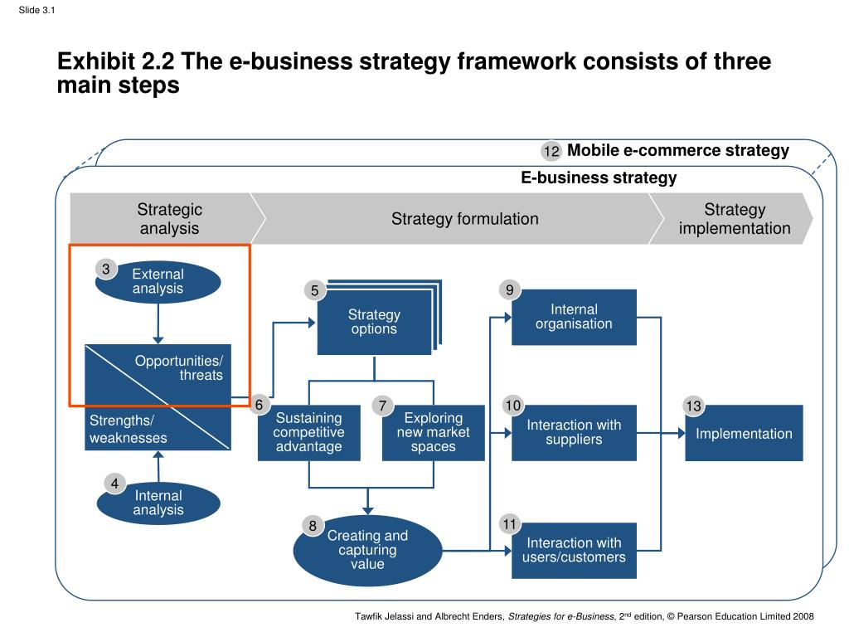

Figure 2.6 Business Strategic Framework (Pearson Education, 2018)

There are three steps in business strategy framework namely: strategic analysis, strategic formulation and strategic implementation. Industries such as Unilever are impacted by macro-environment which can be classified as remote macro-environment such as legal/political, economic, social and technological environmental factors (PESTLE). Industry macro environment includes company, consumers and competitors (FIVE FORCES).
Strategic formulation: Competitive advantage is jointly determined by industry and firms’ effects. While the Strategic Position of a company is determined by its business strategy composed of two primary competitive levers such as value and cost. Practically, strategic position is based on value creation and cost, the more the gap between value and cost, the greater the competitive advantage.
Business strategy perhaps leads to competitive advantage by performing the same activity as your competitors using different methods or performing different activities. The main cost drivers are input factors like lower cost of raw material, money and cost of labour including economies of scales because increased output decreases the cost of products per unit.
The research methodology will be discussed in the following chapter.

Chapter Three: Methodology
3.0 Research Introduction
3.1 Research Objectives

The main objectives of this study are:
1. to investigate the external environmental issues that affect the performance of Unilever Plc.
2. to investigate the strategies adopted by Unilever Nigeria in turbulent environmental periods
3. to establish best practice suitable for organisations in turbulent times.

3.2 Research Onion
The research onion shows the required procedures to be taken in development of a research strategy (Saunders et al., 2007). The authors provided an effective progression useful in designing research methodology in the research onion. According to Bryman (2012) the usefulness of the onion depends on its adaptability to any type of methodology.
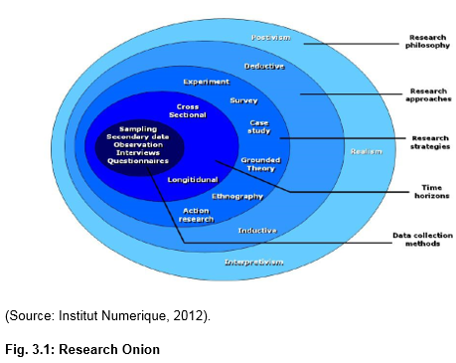

3.2.1 Research Philosophy
“A research philosophy is all the beliefs concerning the nature of the reality of the subject to be studied” (Bryman, 2012). According to May (2011), the selection of research philosophy depends on the topic to be investigated and the aims objectives. The researcher after considering the two key ontological frameworks stated by Zikmund et al., (2013) opted for positivism instead of constructionism. The assumption of positivism is that reality does not depend on the subject being studied, that reality exists independently. That, phenomena are consistent between subjects (Newman, 1998). Other reasons for adopting the method for this study are, its suitability for any sample size used in a quantitative analysis and is good for descriptive research projects because its standardisation facilitates the codification of the gathered data but has the problem of capturing complex interplay in one measure.

3.2.2 The Deductive Research Strategy
This study considered the deductive method capable of meeting the the main objectives of the research by answering all the research questions. The choice of the research method is determined by research questions and objectives (Saunders et al., 2009). This study’s choice of the deductive method matched the earlier choice of positivist method that gives the possibility of testing the reliability of the prevailing theories on the topic of the research. Snieder and Larner (2009) concurred that the positivist method allows the formulation of hypotheses and the expected result can be tested statistically to an acceptable level of probability, yet the argument of some critics is that this approach lacks in encouraging divergent thinking and has the risk of limiting the scope of creativities.

3.2.3 Strategy
Surveys: This study used survey based on questionnaire for data collection. Surveys are suitable for quantitative research projects using a sample to represent the population (Bryman & Bell, 2011). Survey is a convenient data gathering method for this study that provided a precise and good statistical result representing a large population. Only that, it can allow the respondents to provide false information and some inappropriate questions might not make it suitable for controversial issues.
Case study research: This research used case study to investigate further the consequences of environmental changes on organisations. According to Silverman (2013), case study gives a comprehensive understanding of the real nature of any specimen and also enables the establishment of cultural importance and context in differences among cases. Although, it is suitable in gaining a comprehensive knowledge of the research context, but as an evaluation tool it has the limitations of a descriptive case study being qualitative and unreliable, suitable for only single or small clusters of projects making it impossible for their results to be generalised to the entire portfolio of projects. External vs. internal validity is another weakness of case study. The problematic task of construct validity in case study research can be overcome by using multiple evidence and reviewing the draft of the case study report using more informants (Yin 1994).
An archival research strategy uses existing materials to conduct the research study (Flick, 2011). The researcher used a systematic literature review to establish the sum of knowledge on the influence of environmental factors on organisations’ performance. Using the archival research method saved a substantial amount of time, effort, and money for this research because data are already collected. Conversely, its limitations to this study were, previous research being incomplete that was not suitable to address certain key issues of this study thereby, making the result of the research unreliable. The inability of the researcher to control the academic quality of the various sources of the articles used in the literature review.

3.2.4 Research Approaches
The researcher adopted mixed methods based on the research problems and the type of data required for their solution. According to Guba and Lincoln (1994), the difference between the two is the use of numbers and statistics. Qualitative is exploratory while quantitative is confirmatory (Dolan,1984).

3.2.4.1 The Qualitative Approach
Qualitative method is used in this research for data collection by using open ended questions that give the respondents the possibility of giving more detailed answers to determine the effects of the environmental changes on the organisation. Qualitative method does not allow the researchers to impose their opinion upon the participants and its main objective is to study the participants’ own interpretation of the reality (Bryman & Allen, 2011).
Qualitative method enabled this study to produce more in-depth and comprehensive information by allowing the researcher to use subjective information and participants in the description of the context of the variables under study. Although, the qualitative method was useful for this research, but it made it difficult to detect the researcher’s bias and establishing the reliability and validity of the procedures and information. Due to the in-dept and comprehensive data collection method required, its scope is limited in this research.

3.2.4.2 The Quantitative Approach
Quantitative research uses a formal, objective and systematic procedure to obtain information using numerical data (Burns and Grove, 2005). This research used closed-ended questionnaires for the quantitative data collection to produce numerical data that will be analysed mathematically and statistically.
Quantitative data is considered to be reliable, easy to understand but it gives subjective narrow results that represents a reality without providing any description. Quantitative data pictures the symptoms and not the real problem.

3.3 Choices
“Research onion choices comprised the mono method, the mixed method, and the multi-method” (Saunders, Lewis, & Thornhill, 2007). ). In this research mixed method is used for data collection.

3.3.1 Critical Evaluation of Mixed Method
Although mixed method offers an-dept and comprehensive information of the problem than either using the methods individually but due to its weakness of making the creation of the research design too complex, the researcher consumed a lot time in creating this study’s research design. In this study, the method complicated the planning and implementation of one method by drawing on the findings of another. The researcher transformed with difficulty the data to enable the integration of both methods during the analysis. The reason is that unequal evidence within the study might occur due to inequality between different methods, which can make the interpretation of the results very difficult or inaccurate.

3.4 Time Horizon
The time horizon defines the estimated time framework necessary for a project to be completed (Saunders et al., 2007). The estimated time projected for the completion and submission of this research is sixteen weeks as graphically illustrated below.

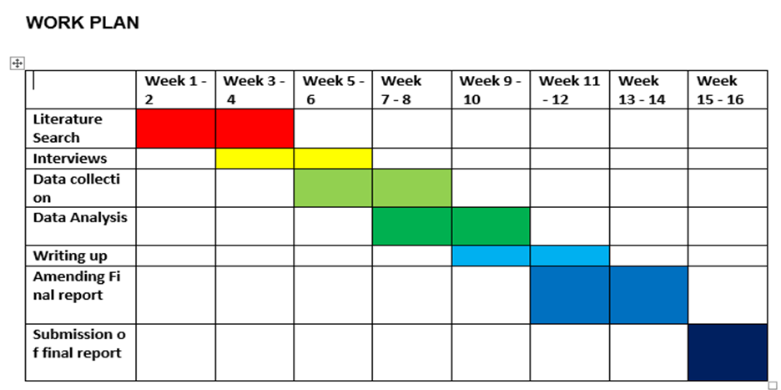

Figure 3.2 Work plan

3.5 Data Collection
According to Bryman, (2012) the gathering of data and its analysis depend on the adopted methodological style. In this study, to ensure high reliability and validity, mixed method was used for data collection (Saunders, Lewis, & Thornhill, 2007).
The researcher used questionnaire as the primary source of quantitative data collection in this research. Sekaran (2003) stated that a questionnaire is a pre-formulated question to which respondents record their answers. While the primary qualitative source of data for this research is gathered through open ended questions.
Although, using questionnaire as data collection method has its advantages such as reducing the chance of bias because the respondents are asked the same question, its administration is not expensive, and it facilitates the process of gathering data from many audience. But its limitations are not to be under minded for example, the researcher found it very difficult and time consuming to write the survey questions. Since the questionnaires can be completed by the respondents alone, the researcher of this project cannot say for sure who completed it due to lack of contact with respondents. The major deficiency is that due to cultural and educational background all respondents may not attribute the same meaning to a particular item or have a common understanding of a particular question. Finally, closed ended questionnaire does not allow probing for more details, this is why the researcher included some open-ended questions.
Saunders et al. (2006), secondary data are existing data from other studies that can be reused during other circumstances for other reasons. For example, the researcher collected secondary data from previous works, websites and peer reviewed articles from previous studies on similar topics. Secondary data is generated from other researchers’ work or opinion (Newman, 1998).
While secondary data collection can be economically cheaper and rapid using information system, but the limitations are not negligible. Secondary data must be carefully gathered from the right sources making sure that they are linked appropriately to the study undertaken. According to Zikmund (2013), it is very essential to examine carefully the circumstances behind the creation of the secondary data, if not it will be valueless for further research. The researcher making use of secondary data must know the period these data refer to.

3.6 Research Sample

3.6.1 Population
The size of a sample and the method of selection in a quantitative study can be useful in establishing the reliability of the outcome of the research. The employees of Unilever were the target population. Population is the large collection of individuals or elements used as source of reference in a research study (Cooper and Schindler, 2008). The reason of choosing employees of FMCG industries is that they are involved in the process of formulating and implementing strategies.

3.6.2 Sampling Frame
Cooper and Schindler (2008), sample frame refers to the entire list of elements that is closely related to the population from which the samples of a study is chosen. The sampling frame of this study was obtained from the FMCG industry where Unilever operates.

3.6.3 Sample strategy
Bryman (2012) defined sample as a segment that represents the population and sample techniques are the appropriate methods of selecting sample size for the broader study. The two types of sampling methods are probabilistic and non-probabilistic. According to Palinkas et. al. (2015) probabilistic sampling can be classified as simple random, stratified, cluster, systematic and multistage sampling methods. Probabilistic sampling methods is attributed with the advantages of possessing minimum discrepancy in the data collection process and being cost effective. The limitation is the risk of selecting specific class of samples only.
Non-probability sampling method, according to Cooper and Schindler (2008) is subjective and non-random giving the interviewer the possibility of choosing the sample elements. In this study, the main limitations of non-probabilistic method, it made data collection more time consuming and expensive than the probabilistic method. The two types available are purposive and convenience. This research used the convenience sampling technique because it can be used for both qualitative and quantitative studies while purposive sampling can be used only in qualitative studies (Explorable.com. 2009). The adoption of this method by the researcher facilitated data collection from different segments of the organisation’s employees that are knowledgeable enough about the topic.

3.7 Sample Size
Newman, (1998) stated that sample size represents the population to be studied and its size is vital in a quantitative study for the reliability of the research’s result. The sample size for this research is constituted of 95 participants working in Unilever Plc Nigeria. The reason of choosing employees of Unilever mainly the managers was that they are knowledgeable about the formulation and implementation of strategy.

3.8 Reliability and validity
Validity is the explanation of how the data collection covers all aspects of the topic under study (Ghauri and Gronhaug, 2005). It means basically “measuring what is intended to be measured” (Field, 2005). This research is carefully detailed using SPSS for data analysis and tables to reach a high degree of reliability and clear picture of the research findings. As specified by Saunders et al., (2007) to obtain a high reliability level if the research is replicated the other researcher should follow accurately the same procedure used by the original researcher.

3.9. Data Analysis
The researcher used descriptive statistics to transform the collected data into tables, graphs, and percentages in the presentation and interpretation of the findings. Descriptive analysis examines situations to describe the norm (Waliman, 2011). The main short shortcomings of descriptive analysis: Its main objective is description and not the determination of cause and effect, including lack of truthfulness of the participants. The researcher can pick only information which supports her/his research hypothesis and ignoring others that do not, might lead to bias.
SPSS enabled the researcher to use the following tools: correlation, regression, frequency, percentage and crosstabulation for data analysis. The benefit of correlation is the possibility of establishing the relationship between variables. Conversely, its weaknesses are the impossibility of making casual conclusions in this study because the variables cannot be controlled. Another limitation is it required this study to use many participants and intrusiveness is usually low. Although, the regression analysis is good in establishing the relationship between the variables, but it has the weakness of using incomplete data and false conclusion that a correlation is causation.

3.10 Limitations of the Research
This study is wholly based on Unilever Nigeria Plc and the result cannot be generalised because it does not represent the entire picture of the organisation working in more than 200 countries of the world.
The non-availability of research fund allocation to this study is one the main limitation of this research. Most of the work done or supposed to be done in this work required substantial capital but were limited to the financial possibility of the researcher. The overall effectiveness and reliability of a research could be influence by insufficient finance encountered by the researcher (Saunders et al., 2011). The sixteen-week time slot provided to the researcher was another vital factor that could challenge the accuracy of this research.

3.11 Ethical Consideration
In this research, the privacy and anonymity of the participants were of paramount importance and the researcher observed all the ethical principles. According to Beauchamp and Childress, (2009) autonomy, non-maleficence, beneficence and justice consideration must form part of a research. Researchers must obtain permission from the participants (Saunders et al., 2009). The researcher informed the participant all implications of their involvement in the study and informed them of their right of participation or withdrawal from the study without any exercise of pressure.
The presentation and interpretation of research findings will be discussed in the following chapter.

CHAPTER FOUR: Presentation and Interpretation of Findings

4.0 Introduction
The present chapter will illustrate the outcomes of the study on how environmental factors affect the performance of FMCG organisations during turbulent periods. There are four sections in this chapter as follows: Section one: general information. Section two: analysis of the strategies of external factors. Section three: Strategic analysis applied by organisation for survival. Section four: analysis of the best strategic practice. Finally, the summary of the research findings and analysis.

4.1 General information
This chapter will give information regarding the response rate, participants’ age in percentage, work experience and their educational level. These variables provided different levels of understanding the answers provided by the participants that contributed enormously to the analysis.
The response rate, 120 questionnaires were sent out, but only 95 responses were received which implies that the research had a response rate of 79.2%. It was established that 84.2% of the participants have higher education qualification.

4.2 Age
Q: Please tick your appropriate age group.
The FMCG industry employs workers of different age groups, the researcher aimed at establishing the age categories of the participants. The age groups of the respondents are graphically represented in the figures below.

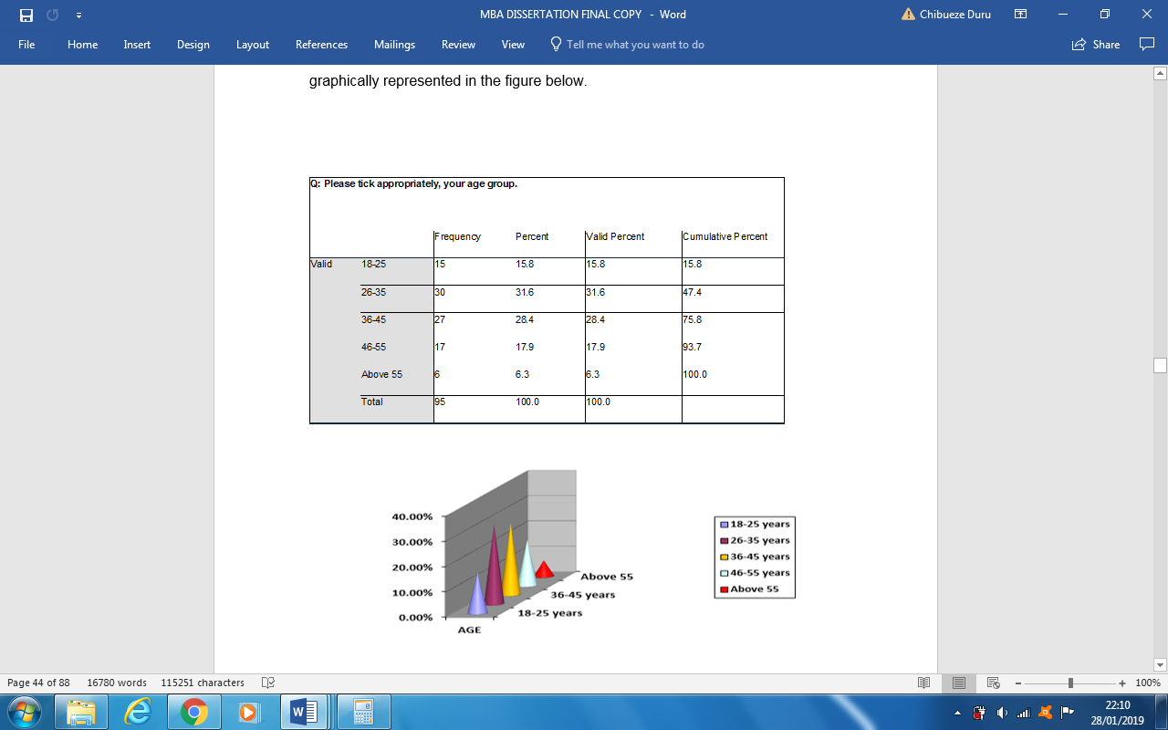

Figure 4.1 Age group

The graph above represented the participants’ age ranging from 18 years to above 55 years. The group with the highest number of participants is 26 years to 35 years, seconded by 36 to 45 years. This implies that the FMCG industry has 77.9% workforce is between 26 to 45 years. 6.3% of above 55 years are still working probably because of the increase of pension age, for example, in the UK the current state pension age is 63 for women and 65 for men (www.gov.uk, 2019).

4.3 Gender
Q: Please tick your appropriate gender.

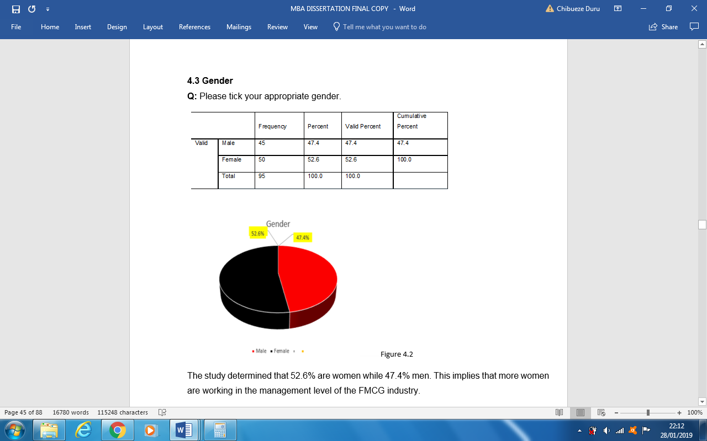

Figure 4.2 Gender
The study determined that 52.6% are women while 47.4% men. This implies that more women are working in the management level of the FMCG industry.

4.4 Years of Working Experience
Q: Please tick your appropriate years of experience.
In organizational decision, experience is very important at any senior management level. Experience enables senior managers to make decisions that are beneficial to the organisation. Formulation and implementation of policies and strategies require experienced employees to be carried out. The researcher wants to find out the reliability of strategies based on the experience of the participants. Gender is the dependent variable. The following table contains the responses of the participants based on their gender and experience.
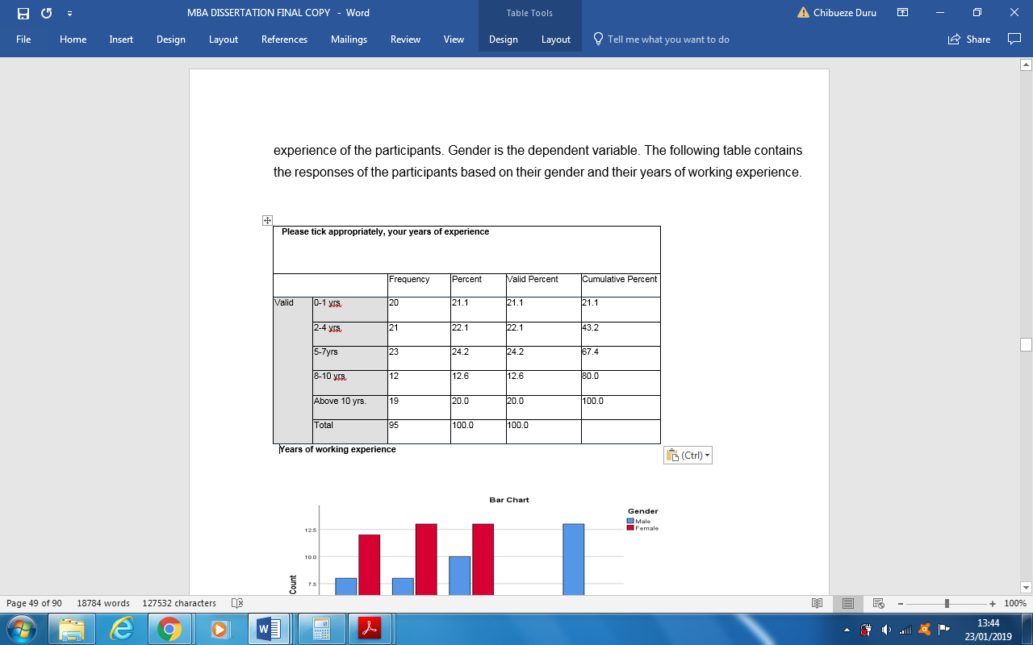
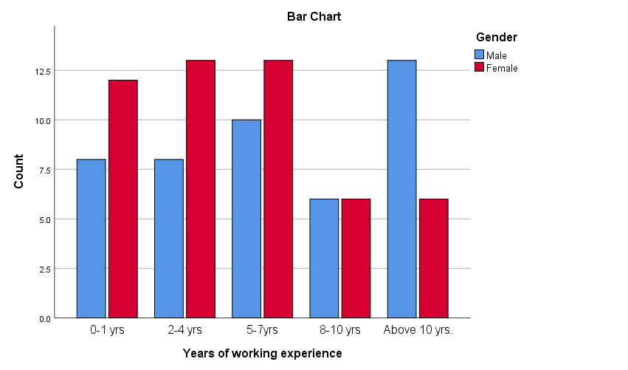

Figure 4.3: Years of Work Experience
The table above shows that 27.4% of male participants have working experience of 1 to 7 years while 40% of the female participants have working experience in the same period as male folks. 13.7% male above 55 have working experience of above 10 years, contrary to 6.3% of the female that have over ten years of working experience in the FMCG industry. This implies that in the FMCG industry, there are more men with longer experience than women, maybe because of the time-off women take to raise their families. This study establishes that more women are eager to work at the entry working level than men but due to family engagements do not remain constantly in employment like their male counterparts.

4.5 Participants’ highest level of Education
Q: Please tick your appropriate educational level.
In the senior management level, education is very important for policy formulation. Organisations train their employees equipping them with sufficient knowledge and expertise that help in the optimal performance of their duties. The researcher wanted to know the educational attainment of the participants and its influence on how they respond to the survey questions.
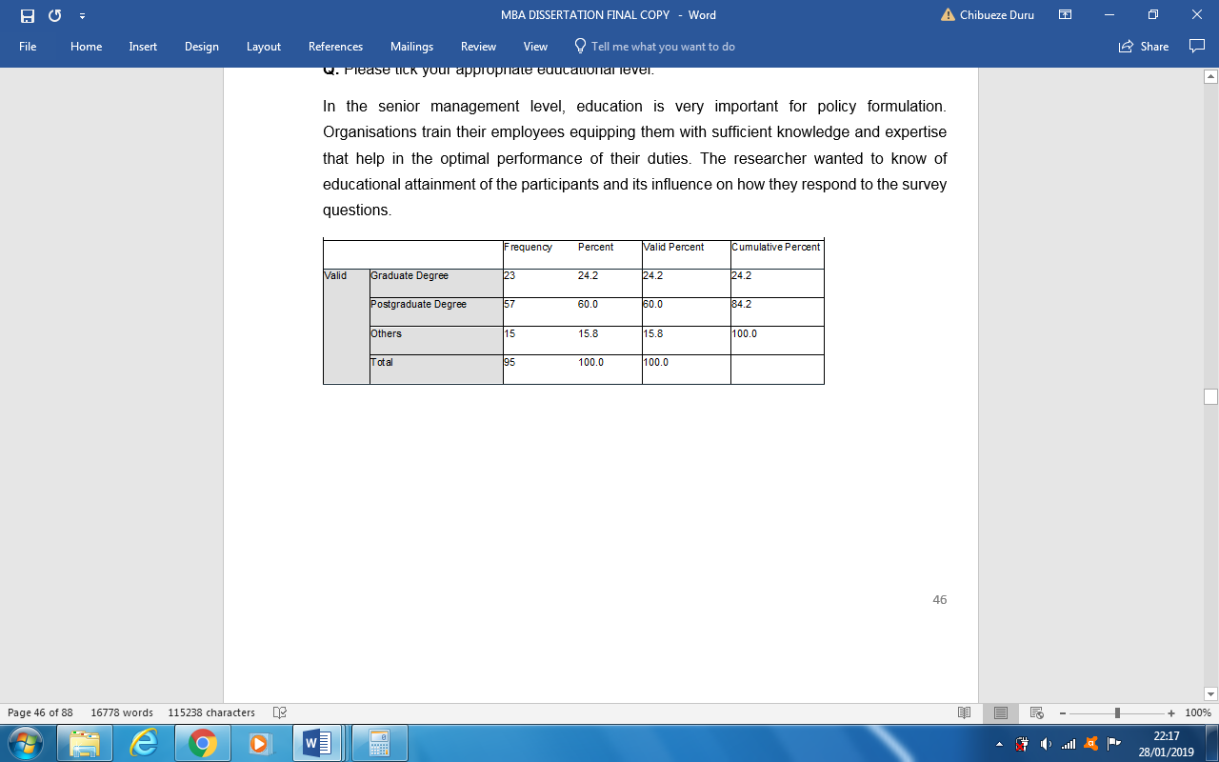
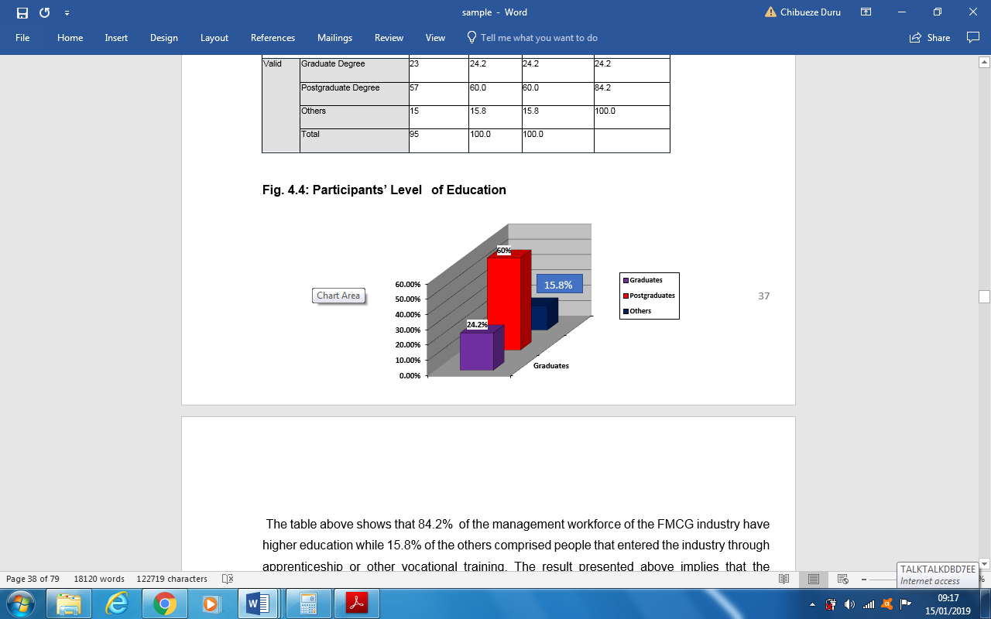

Figure 4.4: Participants’ Level of Education

The table above shows that 84.2% of the management workforce of the FMCG industry have higher education while 15.8% of the others comprised people that entered the industry through apprenticeship or other vocational training. The result presented above implies that the management of the FMCG industry employs highly skilled people that can formulate and implement operational strategies adequately.
The next section 4.2 will present the analysis on the external environmental factors affecting the FMCG industry performance.

4.6 The impact of external environmental factors on the Performance of the FMCG Industry
All organisations operate in an ever-changing business environment and their survival depends on the smartness of their strategy formulation and its implementation. The capacity of scanning and comprehending the variable environmental factor are very essential to the operations of organizations. This section presents the outcome of different types of environmental variables that influences positively or negatively the operations of most organisations.

4.7 The impact of Statutory Regulations on Organisation’s Performance
Q: How do you think that the following environmental factors affect the performance of your organisation?

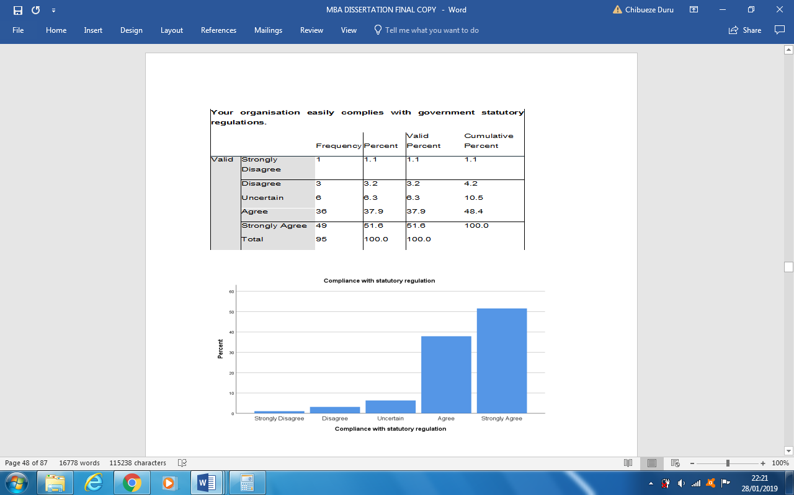

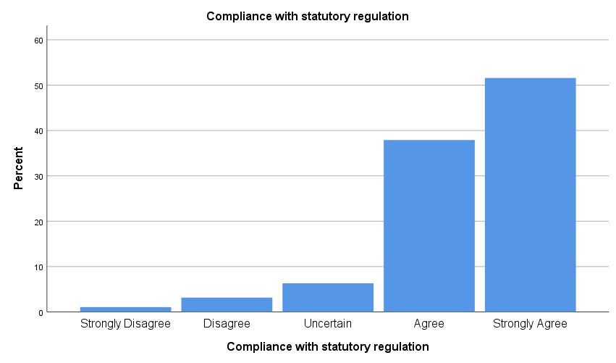

Figure 4.5 Compliance with Statutory Regulations
The researcher asked the participants whether their organisation easily complies with government statutory regulations. 89.5% agreed that their organisation complies with government laws. 6.3% have doubt while 4.2% disagreed. The above chart shows that compliance to statutory regulations is very important in the FMCG industry. Industries invest in new technologies upgrading their operational systems to comply with technological changes. Based on this result, the participants agreed that statutory regulations and uncertainty caused by political instability play important roles in the determination of how their organisations manage their daily affairs.

4.8 Economic Factors
The table below shows that about 63.2% of the participants agreed that economic factors affect the performance of their organisation while 11.6% were not sure. 25.3% responded negatively.
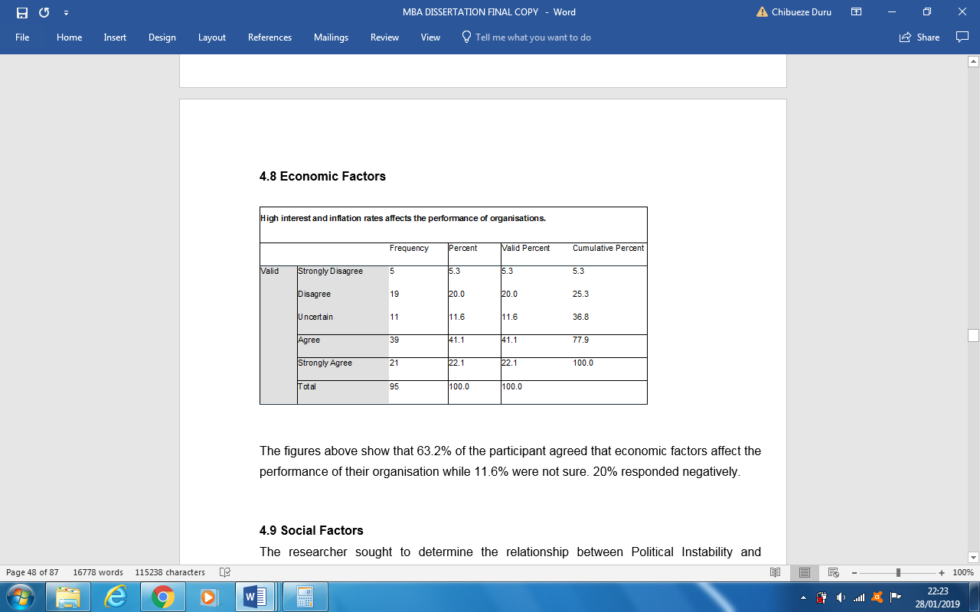

Figure 4.6 High interest rate

4.9 Social Factors
The researcher sought to determine the relationship between Political Instability and Uncertainty and Social changes with correlation analysis as shown below.

Table 4.7: Social factor analysis.
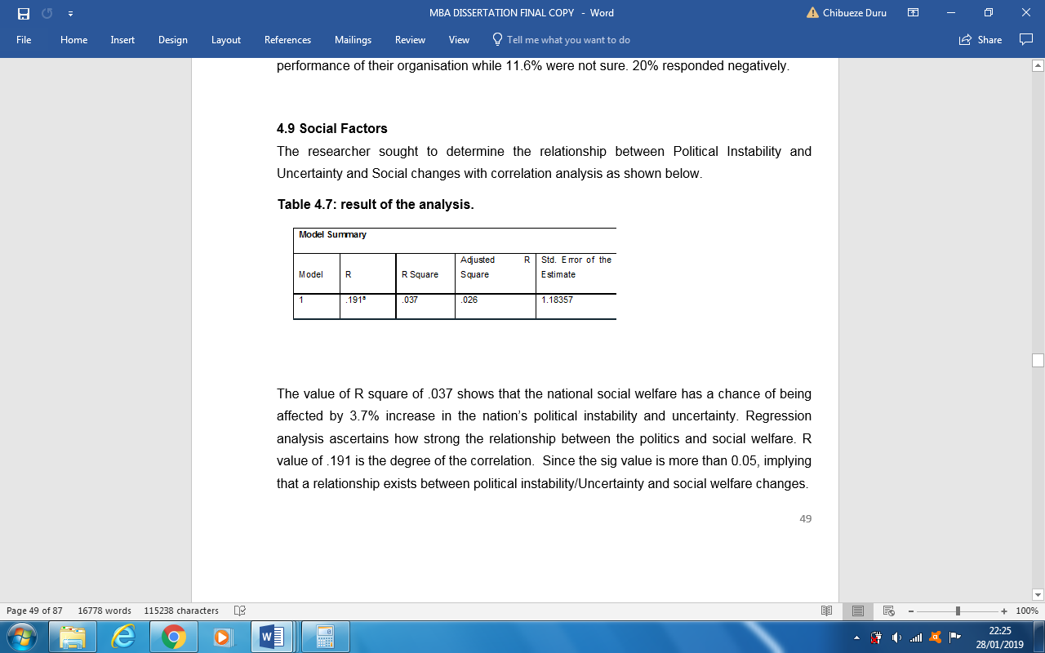
The value of R square of .037 shows that the national social welfare has a chance of being affected by 3.7% increase in the nation’s political instability and uncertainty. Regression

analysis ascertains how strong the relationship between the politics and social welfare. R value of .191 is the degree of the correlation. Since the sig. value is more than 0.05, implying that a relationship exists between political instability/Uncertainty and social welfare changes.

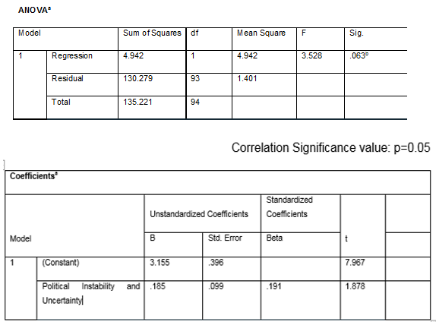

The regression equation is developed using the figures in the above table.
Where: SW represent Social Welfare
PIU is political Instability and Uncertainty
The output of this regression analysis means that social welfare SW changes if political Instability and Uncertainty PIU increase by one unit.
Therefore, social welfare will change by the sum of 0.185 unit of PIU plus the constant B value of 3.155.
The regression line equation: SW = 3.155+ .185PIU

4.10 Experience and Technological Change
As noted earlier in this research, most of the participants have worked in this sector for more years and have acquired the experience to judge whether the technological improvement leads to quality output within the shortest period using minimum resources. The tabulation between years of working experience and technological investment is created. The chart below shows, the relationship between the two variables.
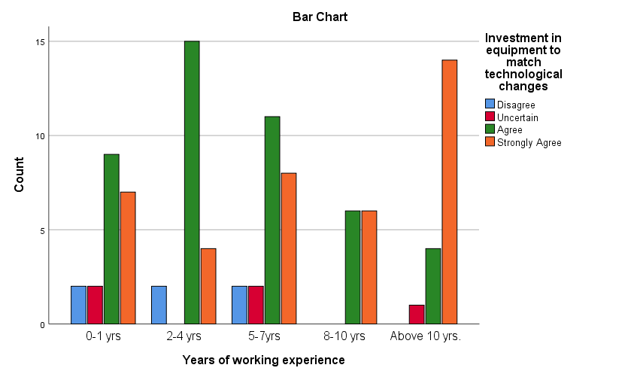

Figure 4.8: Employees’ Work Experience and Changes in Technology

The graph above shows that years of working experience is directly related to employees’ recognition of the importance of technological innovation in the workplace. The result shows that 88.4% of the participants voted for technological innovations while 6.3% considered workplace technological innovations as a threat to employment or maybe because of their learning difficulties of new technologies. Only 5.3% were not sure of the role technological innovations play in the work place. The desire for innovative technologies reduces above 10 years of working experience to 14.7% because the older generation finds it difficult to cope with new generation technologies, therefore, they consider them to be a threat to their employment. This study shows that the desire for technological innovation grows proportionately with working experience and decreases as the population grows older. This implies that employees that have many years of working experience know the importance of technological innovation for organisations to remain competitive in the market than other employees with less years of working experience.

4.11 Industry Competition and New Product Development
The use of a suitable strategy to introduce new products into the market creates the benefit of having a competitive edge over other rivals. Organisations make huge investments in researching and developing products to best satisfy customer needs and increase their market share including their revenue. The researcher sought to establish the relationship between industry competition with new market development, diversification and new product development using correlation and regression analysis as presented in the tables below.

Figure 4.9: Industry Competition and development new market, diversification and new product development
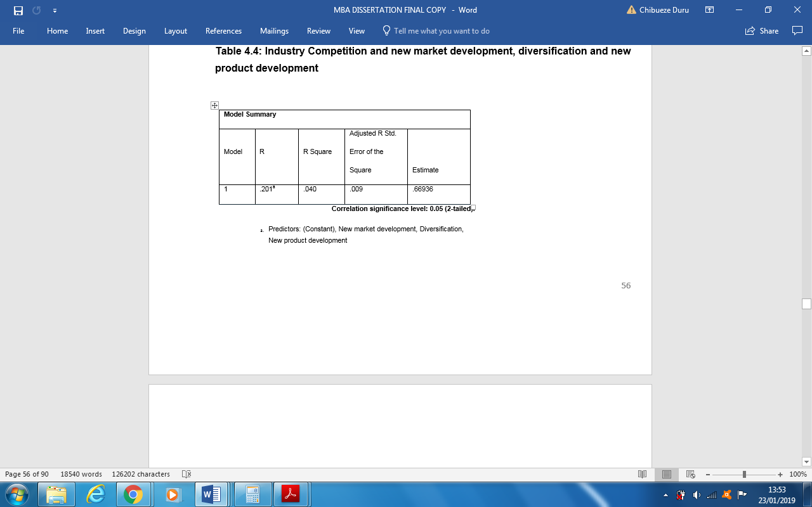

The value of R square of .040 shows that industry competition has a chance of being influenced by 4% increase in one of the following: new market development, diversification, new product development, corporate Restructuring. The study through the regression analysis ascertained how the dependent and independent variables are strongly related. R value is the degree of the correlation. P = .288, since the value of p is more than 0.05, it means that a strong relationship exists between industry competition and new market development, diversification, new product development, corporate Restructuring.
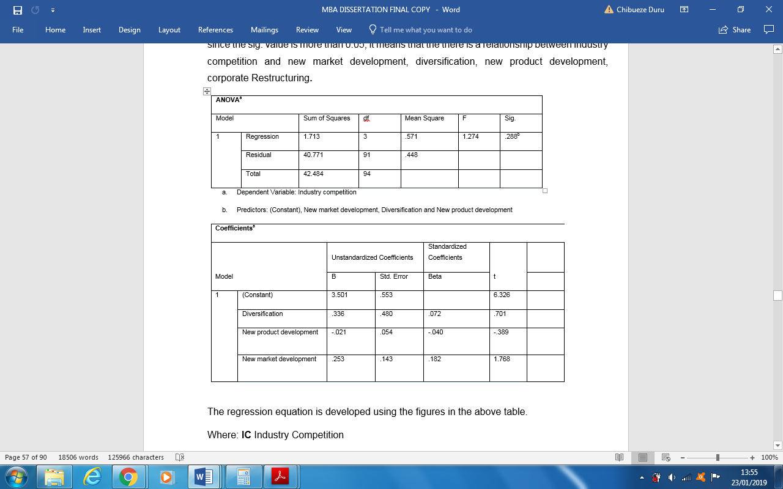

Figure 4.9 Industry Competition

The regression equation is developed using the figures in the above table.
Where: IC Industry Competition
NMD is New Market Development
D is Diversification
NMP is New Product Development

The output of this regression analysis means that industry competition IC changes for every increase in one unit of NMD, D, and NMP. plus the constant B value of 3.501.
Therefore, the regression line equation:
IC = 3.501+.336D+ (-.021NMP) + .253NMD
The above analysis reveals that there is a significant association among FMCG industry competition and new products development. New players compete with new ideas and product innovations to revolutionise customer preferences and perceptions, thereby threatening the existence of the old products in the market. These results imply that according to the participants, competition and new products influence the daily processes of FMCG organisations.

4.12 Relationship between Industry competition and new market development
To determine whether industry competition is affects new market development, the researcher used Kendell and Spearman’s correlation coefficients analysis.
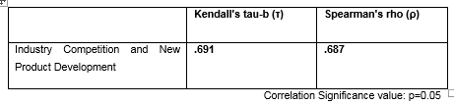

Figure 4.10 Industry Competition and New Market

The above table shows that new product development is important in industry competition with the p values more than 0.05. It implies that new product development has a strong relationship with industry competition.

4.13 The Relationship Between Gender and New Products in the Market
Every innovative product has its market appeal. Most products are developed based on customers’ tastes while others are preferred after customers have tasted them and identified their quality. The researcher sought to find out how customer preferences led to the development and adoption of new products into the industry market. The critical factor used in determining tastes is gender. The outcome is represented in the figure below.
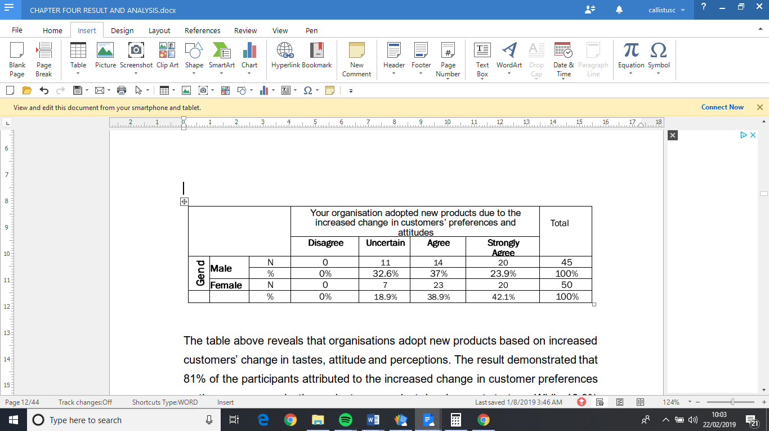

Figure 11 Gender and New Products in the Market

The table above reveals that organisations adopt new products based on increased customers’ change in tastes, attitude and perceptions. The result demonstrated that 81% of the participants attributed to the increased change in customer preferences as the reason organisations adopt new product development strategy. While 18.9% were not sure of the actual reason companies introduce new products to the market.

4.14 Organisation Performance
Q: The performance of our organisation is determined by environmental factors
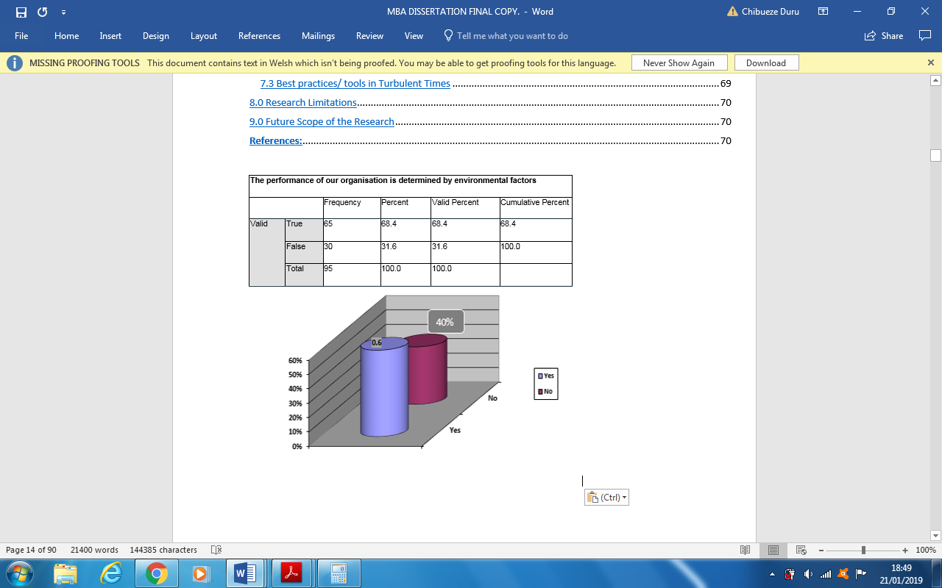

Figure 4.12: Organisation performance

The participants were asked if the performance of their organisation is determined by environmental factors. 68.4% responded yes while the rest 31.6% said no. This implies that organisation’s performance is determined by environmental factors and the capability to manage its resources.

Q: Your organisation’s capability matches their strategies

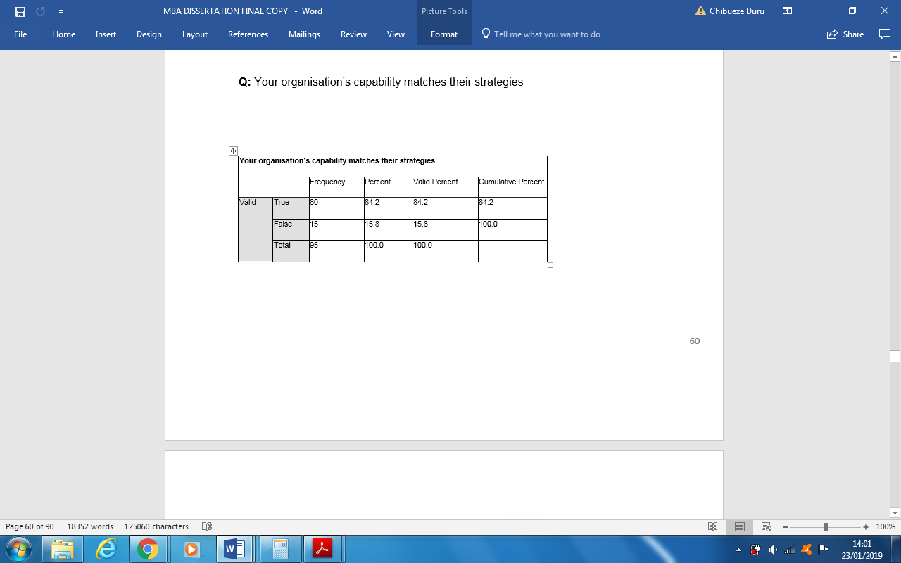

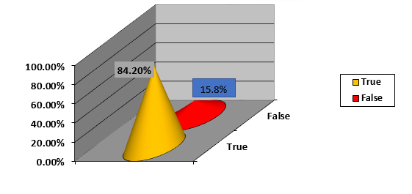

Figure 4.13: Organisation capacity

When the participants were asked if their organisation matches their strategies with changes due to turbulence environment, 84.2% responded yes while 15.8% responded negatively.

4.15 Predictable Social Change Effect on Organisations Operations
Culture as defined by Hofstede (1991) is mental programming of the society’s constituents. People are culturally programmed to pursue change whenever it occurs. Every change has consequence on business environments and influences the daily operations of organisations. Through business strategies organisations use their strengths to maximise the opportunities and minimise the threats that come with these changes. The researcher aims at assessing how the environmental independent variables such as ethical standards, religious orientations impact the performance of organisations and how organisations react for survival. The table below represents the outcomes of the study in percentages.
Q. Your organisation always forecast social changes that they expect could affect their business.

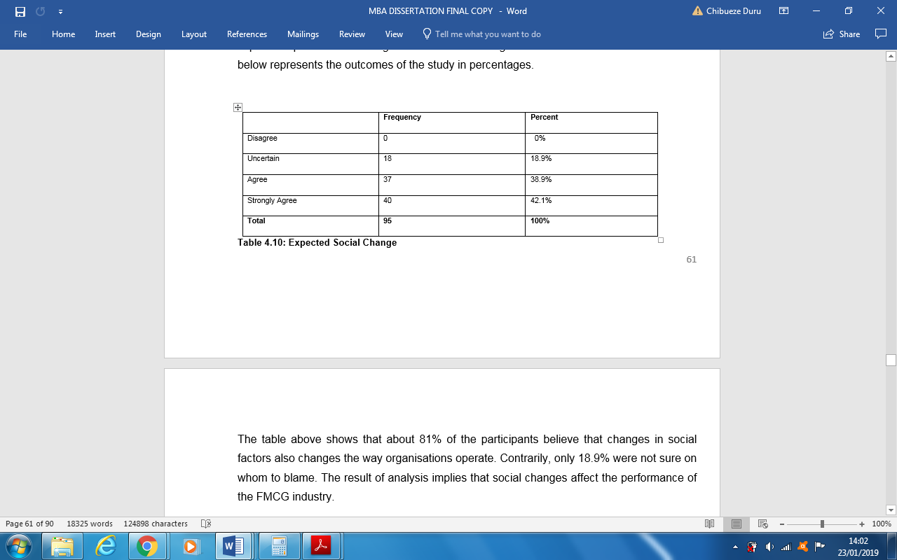

Figure 4.14 predictable Social Changes

The table above shows that about 81% of the participants believe that changes in social factors also changes the way organisations operate. Contrarily, only 18.9% were not sure on whom to blame. The result of analysis implies that social changes affect the performance of the FMCG industry.

4.16 Organizational Capacity Building and Adaptability
The aim of every business is to improve its performance using lesser input to achieve maximum output. Since, human factor is the most important element among the factors of production such as process, technology and people, organisations sought to invest in staff capacity building. The researcher to understand the perception of the participants whether their organisation is being improved through capacity building.
Q. Your organisation ensures that they adapt to environmental changes through the continuous building of staff capacity.
True | 100 | 100%
False | 0 | 0%
Total | 95 | 100%
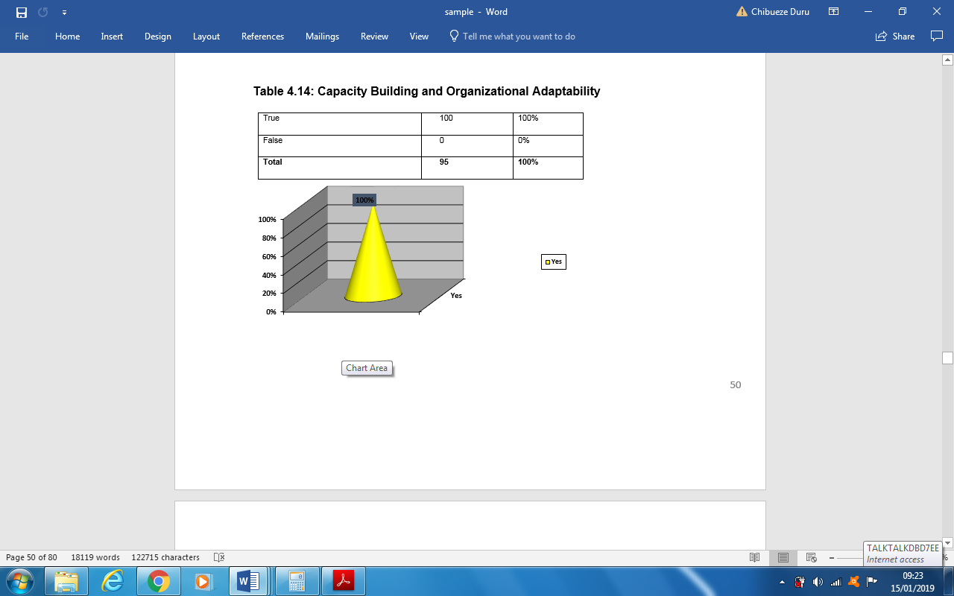

Figure 4.15: Organisation Capacity Building and Adaptability

As shown in the table above, 100% of participants totally agreed that capacity building on the staff enables organisations to adopt survival business strategies in turbulence periods. This implies that staff capacity is a necessity for FMCG organisations to ensure that they adapt to any environmental changes and to achieve competitive advantage.

4.17 Strategic Responses engaged by Unilever in Turbulence Periods
An organisation is a legal entity as such has its ways and mechanisms that enable it to operate. Strategies are among the mechanisms organisations use for survival in the ever-changing environment of the 21st business world. This research sought to find the various types of strategies firms use in their daily operations

4.18 Diversification
Q: Has there been any business acquisition to enable diversification in your organisation?
Diversification as discussed earlier, is one of the strategies suitable for responding to environmental changes. The researcher asked the participants if their respective organisations have adopted this strategy to cope with environmental changes. The table above is used to represent how the participants responded to the question.
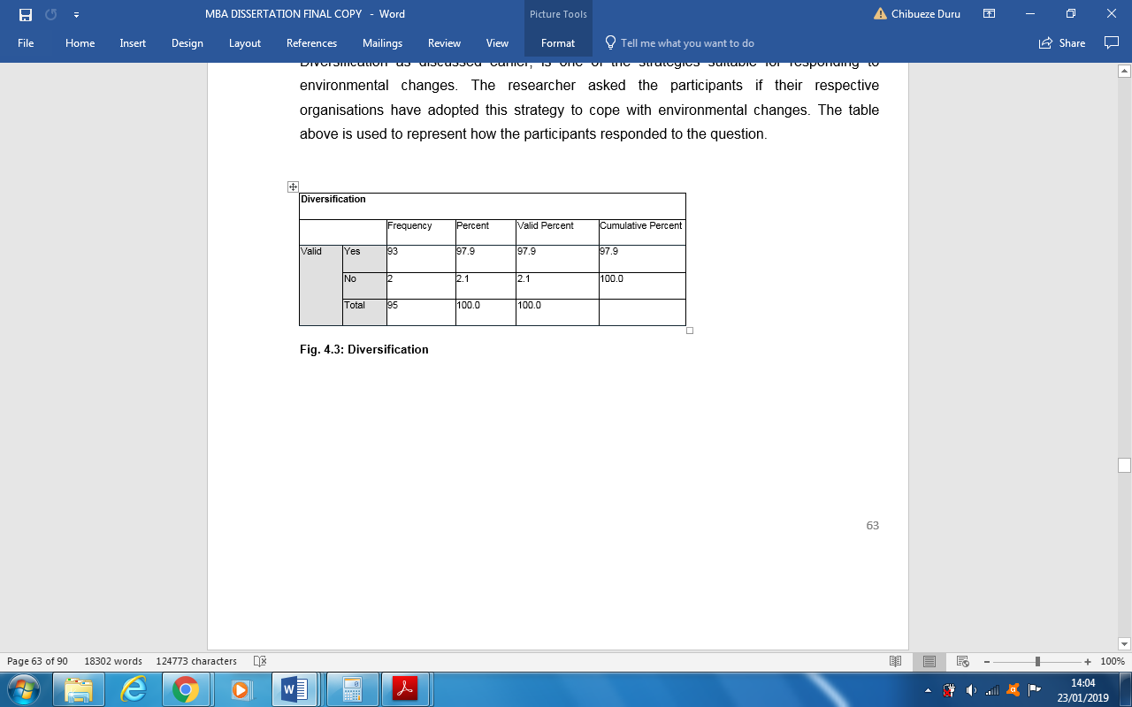

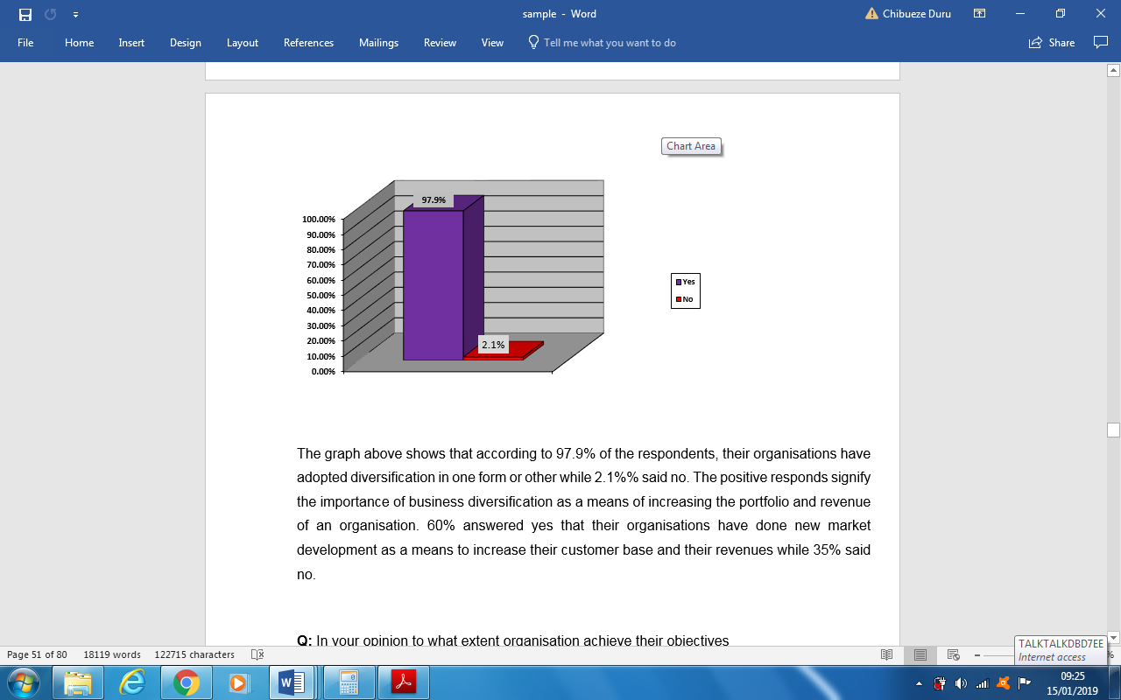

Figure 4.16: Diversification

The graph above shows that according to 97.9% of the respondents, their organisations have adopted diversification in one form or other while 2.1%% said no. The positive responds signify the importance of business diversification as a means of increasing the portfolio and revenue of an organisation. 60% answered yes that their organisations have done new market development as a means to increase their customer base and their revenues while 35% said no.

Q: In your opinion, to what extent did your organisation achieve their objectives?
The researcher further asked to the participant if in their opinion the extent the organisation achieved their objectives. Most of the respondents believed that through diversification, their organisations were able to meet their objectives by a large extent. Some of the participants believed that diversification had a moderate impact on the success of their organisations. Very few of the participants attributed the success of diversification to the performance of their organisations.

4.19 Corporate Restructuring
Q: Has your organisation done recently any corporate restructuring of their business?
Corporate restructuring strategy is a suitable method of responding to environmental changes. The response of the participants on the adoption of restructuring strategy by their organisations to survive in time of turbulence environmental changes is graphically represented below.

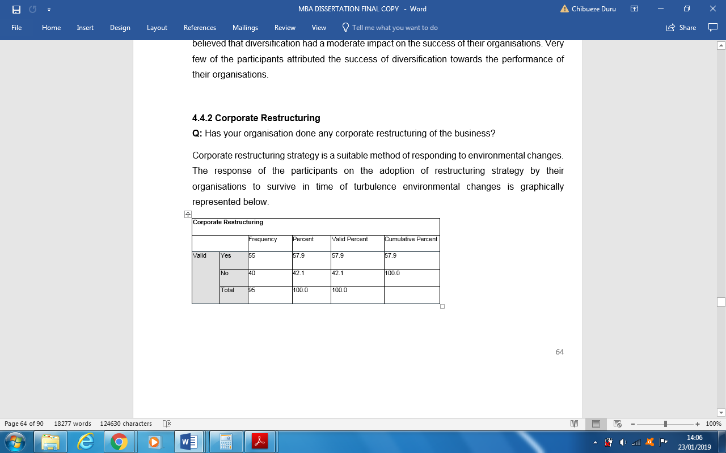

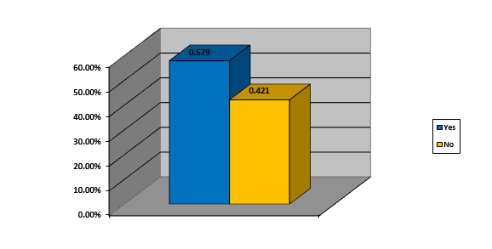

Figure 4.17: Corporate Restructuring

The message from the above table is that most FMCG organisations have undergone corporate restructuring to survive in turbulent periods. 57.9% of the participants confirmed that their organisations have restructured to be more competitive in the industry market while 42.1% claimed that their organisations have adopted different survival strategies.

Q: If Yes, please give description of the type of restructuring___________. Can you explain if the objectives of the restructuring were met?
The research asked the participants to state the effectiveness of corporate restructuring over the entire performance of the organisations. Some participants claimed that the strategy helped their organisation to streamline and align business operations, resources and people. Most participants indicated that it helped in the reorganization of business departments, organizational structure, efficient management of the value chain and some further claimed that their organisation used downsizing to reduce operational cost and downscoping to reduce their business units.
According to some respondents, apart from the limitations of restructuring such as employee lay-off, it has the capacity of increasing the efficiency of an organisation. Restructuring improves performance because it reduces cost, increases productivity and maximizes profit. Summarily, the respondents indicated that restructuring improves business performance through creation of focus and clarity of new ideas. Observations from most participants, divestment helped their organisations to save cost and stabilize financial statements of their organisation, although it is one of the strategies less practiced. On the other hand, downsizing helps organisations to maximize business outcome and asset base. Through downsizing, organisations combine units and resources (lean production process), cost control achieving profit maximization. Most participants claimed that new market development helped their organisations to expand their business network by reaching many customers that increased their revenues.
Organisations undertake various types of operation activities such as downsizing, divestment, product development and creation of new market to be more competitive than their rivals. This research study aims at determining from the participants whether their organisations have responded to the ever-changing business environment using any of these activities.

Q: Have you conducted in the recent time any of the following activities in your organisation: creation of new product and new market? If yes, please explain
The participants were asked if their organisations have in the recent time embarked on new product development. From the result, it implies that 100% of the organisations in the FMCG industry have adopted product development strategy, 73.7% of the organisations have created a new market, 73% of the organisations have undertaken downscoping and 68% of the organisations used divestment as a strategical approach to respond to turbulent environments. The outcome of the research implies that FMCG organisations prefer to increase their performance through product development and new market than downscoping or divestment, but the high percentages scored by downscoping and divestment might mean that organisations use these strategies to reposition themselves in the market to maximise profits by capturing more market shares rather than as survival strategies.
The participants were further, asked to express how the activities affected the business operations of their organisations. Some participant sustained that product development help their organisations to expand their target market and meet the needs of their current customers. Also, product development enabled their organisations to achieve growth through product improvement that fits the market. Finally, most of the participants concurred that product development creates more revenue and improves the performance of organisations.

4.20 Best Practices/ tools Adopted by Unilever in Turbulent Environmental Periods
Every organisation has its strategic ways of survival in turbulent times. Organisations adopt through experience acquired by knowledge sharing to choose the best practices capable of enabling them to survive the economic or organizational crisis. The researcher used this study to find out from the study sample population the best practices adoptable by organisations in the turbulent times. The table below features the best strategical practices that will enhance or maintain the performance of organisations.
The table below contained answer from the participants on the best practices of their organisations

Organisational Best Practices | TRUE | FALSE
Your organisation matches the capability of their management/employees to the environmental changes. | 100% | 0%
Your organisation’s capability is responsive to the changes in the environmental. | 71.6% | 28.4%
Your organisation has good system to mitigate risks and responds to environmental changes according to the level/type of environmental uncertainty | 95.8% | 4.2%
The strategies of your organisation are aligned to the environmental turbulence to achieve operational excellence. | 76.8% | 23.2%
Your organisation assesses their business capability before setting future projections during the period of environmental turbulence and uncertainty. | 73.7% | 26.3%
Your organisation determines their performance using only financial measures. | 60% | 40%
The performance of your organisation is determined by environmental factors. | 65% | 32.6%
The success of your organisation is determined by its capability to manage the turbulent environmental factors. | 67.4% | 40%

Table 4.18: The Best Strategic Practices

This means that for organisations to endure in turbulent periods, it is imperative to assess the environment where they operate before making strategic decisions. It can be deduced from the result that organisations make survival strategic decisions based on the nature of the environmental uncertainty. Based on these results, it is a good practice to align strategies to match the environmental turbulence level.

4.21 Environmental Uncertainty and Strategic Response
Organisations must learn to use their strength in the transformation of opportunities into revenues but must be alert on the uncertainties that hide under opportunities. Every industry has different challenges and the capability of knowing the right strategies and their implementation. This research sought to know if the level or type of environmental uncertainty determines the organizational strategic response using a cross tabulation between the level of education attained by the employees and the types of strategic response adopted by organisations during the periods of uncertainty.

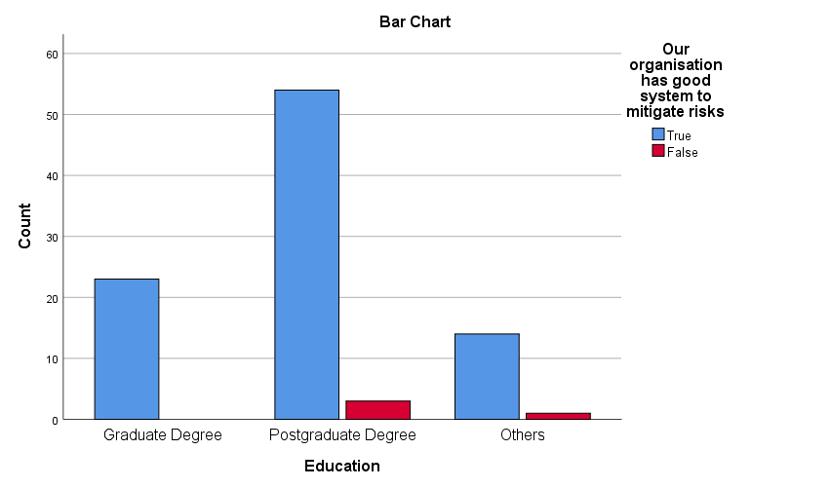

Figure 4.19: Uncertainty and Strategic Response

The outcome of this analysis is that 95.8% of the participants positively responded that their organisations have good system to mitigate risks and to responds to environmental changes according to the level/type of environmental uncertainty. 56% have postgraduate Education, 24.2% graduates and 14.7% with other levels of education. This implies that employees of the industry understand the importance of organisations matching environmental uncertainty with the right survival strategies based on their level of education.

4.5.2 Q: Please state how your organisation use the following activit1es?
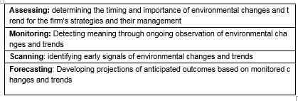

4.22 Summary of Presentation and Interpretation of Results
The chapter started with analysis of the background of the participants. The response rate, 120 questionnaires were sent out, but only 95 responses were received which implies that the research had a response rate of 79.2%. It was established that most of the participants have higher education qualification, with their ages starting from 18 to above 55 years.
The first objective is the analysis of the external environmental factors that affect Unilever’s performance. Environmental factors such as compliance to statutory rules, continuous investment in new equipment, anticipated changes social attitudes due to customer preferences were found to be critical to organisational performance. Other business operating environmental factors that affect performance are political and legal factors. In conclusion of the first objective, the study identified technological changes also threat of new entry to the FMCG industry as external environmental factors that can impact negatively the performance of industry organisations.
The second objective is analysed in this section: the strategies adopted by Unilever in turbulent periods. In the quest to identify the right strategic response suitable for responding to environmental turbulence periods, different types of strategies were analysed. Among them, new product/market development, diversification and corporate restructuring were the most used by organisations.
Finally, this last section provided the analysis of the best strategic methods adopted by Unilever Nigeria in turbulent environmental periods. The study indicates that organisations make a strategic decision of survival based on the type and level of environmental business uncertainties.
This study further established that organisational success entirely depends on the following factors: capability to mitigate on risks, adequate financial controls and the capacity of its manpower. Finally, from the findings of the study, emerged the importance of environmental analysis such as scanning, monitoring, assessing and forecasting. Before an organisation can forecast accurately, they need to first scan the environment and monitor the variables identified. Then they can assess the impact the identified variables will have on the performance of the organisation. Based on the outcome of the assessment a strategic decision can be made on how to achieve the forecasted objectives.
The following chapter will discuss the summary and discussion of the research findings

Chapter Five: Summary and Discussion of Findings

5.0 Introduction
This research has the aim of investigating the external business environment in which Unilever Plc operates in turbulence periods and to ascertain how it affects its performance including the strategic responses used in the industry to survive in turbulence periods. The key outcomes of this research are summarised here. The outcome of the study will be discussed basing on the specific three points of the research.

5.1 Summary
This research study investigated the external competitive environment in which Unilever Plc operates and to ascertain how it affects its performance including the strategical responses of organisation in turbulence periods. The objectives of the present research were: to investigate the external environmental issues that affect the performance of Unilever Plc, to investigate the strategies adopted by Unilever Nigeria in turbulent environment periods and to establish best methods suitable for organisations in during the period of turbulence.
For this study, the researcher used semi-structured questionnaires to collect primary data from the employees of Unilever Nigeria. The population sample size of this study was 95 in which 40 from the management and 55 from non-management levels. The participation of the respondents was voluntary and that determined prominently the population of the participants. Through a senior management staff of the organisation the questionnaires were distributed to the other participants via e-mail and responses were later forwandered to the researcher. For analysis and interpretations, the researcher used SPSS for statistical calculations such as frequency distribution, correlations analysis, analyses of variance (ANOVA) and cross-tabulations to draw conclusions on the findings.
From the findings of this research study, some of the causes of turbulence that affect organisations are external environmental factors, for example, political instability, government regulations, high interest and inflation rates etcetera. The study established also the importance of compliance to statutory regulations in the FMCG industry . Statutory regulations force organisations to invest in new technologies to match the technological changes in the industry and society. Another indication of the study is the strong relationship between FMCG industry competition and new product development. New competitors come to the market with new products and service having the intention to give customers something different from what they usually obtain from the old products in the market. They offer innovative products with the intention of changing customer’s perceptions and attitudes towards the existing products in the market.
The findings indicated that organisations, in response to the environmental turbulence adopt strategies such as: diversification of business, corporate restructuring, new product development and creation of new market. Another important recognition from the study is the assessment of the current business position before setting strategical future direction in times of environmental turbulence. This statement was supported by 73.7%% of the participant that the type of environmental uncertainty determines the type of survival strategic decisions organisations make.

5.2 Research discussion of the findings

5.2.1 Competitive Environment and Organisational Performance
From the findings, 89.5% of the participants agreed that their organisation complies with government laws. Pearce and Robinson (2009), government laws on business regulations are sometimes restrictive, they have a tendency of reducing potential profits of organisations. Contrarily, Ireland et al (2013) disagreed and argued that they can improve some society factors like attitudes, customers’ perception and trends including some of the external environmental factors that affect the organisations’ performance. According to Kane (2012), regulations encourages customer confidence that can turn into customer loyalty resulting to good organisation performance.
The findings indicated that FMCG industry performance depends on the economic factors and this was confirmed by 63.2% of the participants claiming that high interest and inflation rates influence the performance of their organisations. The outcome agrees with Boyd and Champ (2003)‘s argument, that economic development of a nation is affected by inflation. These findings imply that the performance of FMCG organisations are affected by the country’s economic situation. The percentage means that the performance of the FMCG industry does not rely wholly on the economy. FMCG organisations are the producers of essential commodities for daily consumption and people do not stop eating or using hygiene products due to a bad economy. 37.8% of their performance depends mainly on other variables such as their capability of making and implementing strategies. From the findings 77% of the participants retained their organisations capable of aligning their strategies so that it will match the external turbulence environment. Also, 79% of the participants claimed that social factors like the change of consumption pattern, tastes and lifestyle influence organisation performance. From the study, it emerged that consumers are in control of their buying habit. Since there is no cost to switch from a brand to another, the consumers demand for improvement in products and services for brand loyalty. Khan (2014) stated that organisations that offer high quality services to their customers will gain their loyalty.
A strong connection exists between legal and technological dimensions as emerged from the outcomes of this research study. This implies that the FMCG firms invest in technologies and update their systems according to the statutory regulations to survive through technological changes. Technology enables the FMCG organisations to register more profits by reducing certain production costs. Organisations that adopt technological innovations have the benefit of capturing higher market share and earning high returns than those that do not (Ireland et al., 2013). According to 77% of the participants, organisations should always improve their operation processes and innovate their systems to attain operational excellence. In support of the findings, Pearson and Robinson (2009) stated that continuous scanning of external environment will enable organisations to identify new emerging technological innovations that would grant them the opportunity to be more competitive than their rivalries. Buchanan and Huczynski (1997), the improvement of productivity through technical innovation leads to lower prices. The limitation of technology is employees’ role substitution, the replacement of employees with technology.
For correlation analysis, Kendall's tau and Spearman correlation coefficient were adopted in measuring the relationship between competition and new products development. With p value bigger than the set correlation significance p = 0.05. It implies that there is an association between the dependent and the independent variables. It means that competition in the industry will push FMCG organisations to develop new products to gain competitive edge over other rivalries. This agrees with Porter (2008), industry rivalry among existing organisations can be in form of new product development.

5.2.2 Strategies Adopted by Unilever Nigeria in turbulent Environmental periods
Based on the response of 98% of the participants, Unilever has adopted diversification from the conventional method. This shows that Unilever is ready to risk trading in areas where they lack core competence. Jobber (2011), diversification is one of the riskiest business growth strategy because sometimes it requires organisations acting outside their core competence. Most of the participants believe that their organisations have achieved success through diversification. While some claimed that the success obtained was to a moderate extent. Very few of the participants said that diversification is not rewarding maybe because their organisation is doing a business that is unfamiliar and full of inevitable risks. The fear of business fiasco was confirmed by Wowak and Hambricks (2010) claiming that if an organisation governance mechanism is weak, over diversification might fail to yield average returns.
When asked whether their organisations have undertaken product development in recent times, 100% of the participants responded yes. This implies that there is a connection between new product development and organisations’ performance. Product development helps organisations to expand their target market. It also enables organisations to match the taste of their current customers and increase their customer database. This finding agrees with Etzel et al. (2007)’s theory that organisations develop new products to give the customers varieties of products to choose from. Organisations increase their business portfolio for more profit and improved performance by offering new products that fit the market.
The findings showed that Unilever through the new market creation has responded aggressively to the changing environment. 63% of the participants concurred that Unilever has undertaken new market creation. Most participants claimed that new market development helped their organisations to expand their business network by reaching many customers. This implies that new market development impacts positively the performance of organisations. New market development helps organisations to expand their target market by tapping into previously unexploited markets. This result fits with Perreault et al. (2011)’s statement that through market development, organisation push their current products and services to new markets to improve their visibility thereby, increasing their sales. The benefits of new market creation, it helps in the acquisition of new customers, improve business results and increases product visibility, product range and incomes. The main limitation of new market development is the uncertainties caused by different national cultures that influence consumers’ behaviours.
Observations from most participants, divestment helped their organisations to save cost and stabilize financial statements of their organisation, although it is one of the strategies less practiced. This outcome agrees with the finding of Bergh and Lim (2008)’s that divestment positively impacts the performance of an organisation by allowing it to concentrate only on its core business.
On the other hand, downsizing helps organisations to maximize business outcome and asset base. Through downsizing, organisations combine units and resources (lean production process), cost control achieving maximum profit. In contradiction to this finding, the theory of Ireland et al (2013) states that organisations do not always achieve good performance through downsizing.

5.2.3 Strategy in Turbulent Environmental Periods
The indication from the findings of this research is that it is important for organisations to assess their current position before making any future business decision in times of environmental turbulence and uncertainty. This is confirmed by 74% of the participants, that their organisation assesses their business capability before setting future projections during the period of environmental turbulence and uncertainty. Perrot (2011) agrees with this finding by claiming that the formulation and implementation of strategy must match the level of the turbulence. The study also determined the importance of aligning the organisation’s strategies to match the environmental turbulence as claimed by 77% of the participants. This agrees with Ansoff and McDonnell (1990) postulation that an organisation’s strategy must be aligned to the environmental turbulence to achieve optimal return on its investments. Hundred percent (100%) of the participants agreed that their organisations match their management/employees’ capability to the environmental changes. According to Ansoff and McDonnell (1990), it is important for organisations to match general management capability to their strategies in other to achieve optimum return on their investments. The success of any organisation in turbulent times depends on the adequacy of the survival measures adopted to ensure optimum returns.
The researcher tried to establish how the dependent and the independent variables are related, for example: a dependent variable– Social Factors and independent variables- Political Instability and Uncertainty. The model summary of the correlation analysis revealed the relationship between the dependent and the independent variables. R=0 .037, this infers that 3.7% changes in social welfare in turbulent times is credited to changes in Political Instability and Uncertainty. 96% of the participants said that their organisation has good system to mitigate risks and responds to environmental changes according to the level/type of environmental uncertainty. If organisations do not manage adequately environmental risks, it may lead to business fiasco or huge loss of profits (Burnaby and Hass, 2009). Contrarily, Chavan (2009) disagreed with this conclusion by arguing that too much dependence on financial measures encourages short-term investments thereby, sacrificing the value addition of long-term investments to the organisation.
The study further established the importance of environmental analysis for organizational success. The study determined the roles played by environmental analysis tools such as environmental scanning, monitoring, forecasting and assessing.
According to Choo (2001), it is imperative for organisations to understand external forces of change through environmental scanning. Jelonek (2006) concurred stating that organisations enhance performance by using scanning to exploit early opportunities. On the other hand, Moon et al. (1998) believed that accurate forecasting enables organisations to offer quality products and services to their customer and consequently ensures organisational success. Ireland at al. (2013) claim that environmental assessment is significant because it allows the acquisition of data helpful in strategic decision making.
The following chapter will discuss the conclusion and recommendation for improvements of future studies.

Chapter six: Conclusion and Recommendation

6.0 Conclusion
In this section the researcher presented the conclusion of the findings and recommendations for future studies on similar topics.
The study has established that organisations need adequate measures to survive in difficult environmental periods. The research established the relationship between the different key success factors such as building of staff capacity, not relying only on financial measures for its performance and having a well-defined system for risk mitigation.

6.1 Linking with Objectives
In this section of the conclusion, the researcher will link his practical experience acquired from the various research methods and the theoretical knowledge gained from the literature review basing on the objectives of this research.

6.1.1 Objective One: to investigate the external environmental issues that affect the performance Unilever Plc.
There are various environmental factors and conditions faced by organisations and some of them are beyond their control, thereby, influencing their strategic choices including their competitiveness in the industry. Environmental factors such as compliance to statutory laws, continuous investment in new equipment, anticipated changes of social attitudes due to customer preferences were found to be critical to organisational performance. Other business operating environmental factors that affect performance are political and legal factors. In conclusion of the first objective, the study identified technological changes including threat of new entry to the FMCG industry as external environmental factors that can impact negatively the performance of industry organisations.

6.1.2 Objective Two: to investigate the strategies adopted by Unilever Nigeria in turbulent environment periods
In the quest to identify the right strategic response suitable for responding to environmental turbulence periods, different types of strategies were analysed. Among them were new product/market development, diversification and corporate restructuring were the most used by organisations.
It is a good practice for organisations to develop strategies to cope with their business environment based on continuous forecast and prediction. Apart from monitoring the environmental changing conditions, managers need to formulate strategies that can help the organisation to navigate through turbulence in equal measure. Environmental factors are not identical in nature and impact organisations differently. Every level of turbulence is unique, so, there is no formula for one solution fits all because what functioned previously might not work in a different level of turbulence.

6.1.3 Objectives Three: to establish best practice suitable for organisations in turbulent times.
Through the best practices organisations achieve optimum return on capital investment, the alignment of organisational strategies and the capability of managing changes in the environment is the key. From the findings, there are other measures for performance other than financial measures. Organisations must involve their employees when deciding about their welfare such as training and constantly motivate them to achieve operational excellence which is vital in process and systems. The study indicates that organisations make a strategic decision of survival based on the type and level of environmental business uncertainties.
This study further established that organisational success entirely depends on the following factors: capability to mitigate on risks, adequate financial controls and the capacity of its manpower. Finally, from the findings of the study, emerged the importance of environmental analysis such as scanning, monitoring, assessing and forecasting. Before an organisation can forecast accurately, they need to first scan the environment and monitor the variables identified. Then, they can assess the impact of the identified variables will have on the performance of the organisation. Based on the outcome of the assessment a strategic decision can be made on how to achieve the forecasted objectives.

6.2 Recommendations

6.2.1 Industry External Competitive Environment and Organisational Performance
Unilever should concentrate more on the study of how changes in the environment affect the performance of the FMCG organisations. As one of the largest manufacturers of consumer goods, Unilever should use this strength to produce goods that are durable in any economic environment. As a multinational company, Unilever should integrate international employees to enrich their cultural business experience in all processes.

6.2.2 Strategic Responses Employed by Unilever Nigeria
There is need for more research to establish the effects of tactical response adopted by FMCG organisations and if they are adequate in determining an organisation’s relevance and profitability during the turbulence periods. Unilever should invest more in research and development, it has the benefit of improving organisational business processes by increasing productivity and cutting costs making it possible to gain more competitive edge over industry rivals.

6.2.3 Best practices suitable for organisations in environmental turbulence periods.
Unilever should invest more to diminish the environmental footprint of their products to improve the health and wellbeing of the society. They should adopt strategies that will make their products sustainable not only in their factories but at every stage in their life-cycle. This implies collaborating with all stakeholders to create major changes that will help in addressing the biggest environmental challenges of the world, ‘Pollution’. They should also create a sustainable living plan for their suppliers and employees in the developing countries where they operate. To be able to measure with rapid environmental changes, Unilever should invest adequately in the software packaging training. Giving their employees the opportunity to acquire more employability skills that will enhance their performance and make the organisation achieve competitive advantage.

7.0 Limitations of this Research
There are some circumstances such as lack of fund and time that limited the generalizability of the outcome of this research. This research study can be considered to be cross sectional; therefore, time was one of the major limitations. The lack of enough time allocated to this study contributed to the small sample size used in data collection. The questionnaires were distributed to the participant via a third party, so the researcher cannot give accurate account of how it was done, although, the responses were directly mailed to the researcher for data analysis. All participant of the survey were voluntary partakers and the researcher accompanied the questionnaires with an explanation of how it will be used including the destruction of the papers at the conclusion of the research study. This research study survey was anonymous, and the respondents were not obligated to answer all the questions, so this affected the sample size. The researcher focused only on Unilever Nigeria due to time factor, convenience and finance, therefore, this impacts negatively the generalizability of the results obtained. Comprehensive research needs financial and human resource to complete (Collis and Hussey, 2013).

8.0 Future Scope of the Research
The researcher was not able to use ample sample size to conduct this research because of insufficient time and finance. This research study can give useful outcome in future if the researcher is given enough time and finance that will enable using the suitable sample size and enough time to reconduct the study. The knowledge gained will be beneficial in understanding the effective of strategies in turbulent periods.

References

- Ansoff, H. I. & McDonnell, E.J (1990). Implanting Strategic Management. New York, NY: Prentice Hall.
- Banister, P., Bunn, G., Burman, E., & Daniels, J. (2011). Qualitative Methods in Psychology: A Research Guide. London: McGraw-Hill International.
- Bhattacharyya, S. & Nain, A. (2011). Horizontal acquisitions and buying power: A product market analysis. Journal of Financial Economics, 99(1), pp. 97-115.
- Beaulieu, M., Cosset, J. & Essaddam, N., (2005). The Impact of Political risk on the Volatility of stock Returns: The Case of Canada. Journal of Intenational Business Studies 36(6); 701-718.
- Bergh, D. D. & Lim, E.N. K (2008). Learning how to restructure: Absorptive capacity and improvisational views of restructuring actions and performance. Strategic Management Journal, 29, pp. 593-616.
- Boyd J. And Champ B., (2003). Inflation and Financial Market Performance: What We Learned in the Last Ten Years? Federal Bank of Cleverland, Working Paper No. 03/17.
- Boyne, G.A & Meier, K. J (2009). Environmental Turbulence, Organizational stability and Public Service Performance. Administration & Society, 40(8), pp. 799-824.
- Bryman, A. (2012). Social research methods (5th ed.). Oxford: Oxford University Press.
- Bryman, A., & Allen, T. (2011). Education Research Methods. Oxford: Oxford University Press.
- Bryman, A., & Bell, E. (2011). Business Research Methods (3rd ed.) Oxford: Oxford University Press.
- Buchanan, D. and Huczynski, A. (1997). Organizational behaviour. London [etc.]: Prentice Hall.
- Burnaby, P. & Hass, S. (2009). Ten steps to enterprise-wide risk management, Corporate Governance, 9 (5): 539-557.
- Burns, N., & Grove, S. K. (1997). The Practice of Nursing Research Conduct, Critique, & Utilization. Philadelphia: W.B. Saunders and Co.
- Chavan, M. (2009). The balanced scorecard: a new challenge. Journal of Management Development, 28(5); 396-406.
- Choo, C.W. (2001). Environmental Scanning as Information seeking and Organizational Learning, Information Research, 7(1).
- Collis, J. & Hussey, R. (2013). Business Research: A practical guide for undergraduate and postgraduate students. New York, NY: Palgrave Macmillan
- Cooper, C. R., & Schindler, P. S. (2008). Business research methods (10 ed.). Boston: McGraw-Hill.
- Dess, G.G., Lumpkin, G.T, & Eisner, A.B (2008). Strategic Management: creating competitive advantages, 4th Ed. New York, NY: McGraw - Hill.
- Edwards, C. (2008). How the HP got the Wow! Back, Business Week, 22 December, 60-1.
- Euchner, J. (2011). Managing disruption: An interview with Clayton Christensen. Research Technology Management, 54(1), pp. 1-17.
- Etzel, M.J., Walker, B.J., & Stanton, W.J. (2007). Marketing, 14th Edition. New York, NY: McGraw-Hill.
- Explorable.com. (2009). Convenience Sampling. from https://explorable.com/convenience-sampling. (Retrieved 18/11/2018).
- FIELD, A. P. 2005. Discovering Statistics Using SPSS, Sage Publications Inc.
- Flick, U. (2011). Introducing research methodology: A beginner’s guide to doing a research project. London: Sage.
- GHAURI, P. & GRONHAUG, K. 2005. Research Methods in Business Studies, Harlow, FT/Prentice Hall.
- Gill, J. and Johnson, P., (2002). Research Methods for Managers, 3rd edition: London, UK: Sage.
- Goddard, W. & Melville, S. (2004). Research Methodology: An Introduction, (2nd ed.) Oxford: Blackwell Publishing.
- GOV.UK. (2019). Check your State Pension age. [online] Available at: https://www.gov.uk/state-pension-age [Accessed 22 Feb. 2019].
- Hill C. & Jones G. (2004). Strategic management; An integrated Approach, 6th edition New York, NY : Houghton Mifflin Company.
- Hofstede, G. (1991). Cultures and organizations: Software of the mind. London: McGraw-Hill.
- Ireland, R.D., Hoskisson, R.E., & Hitt, M.A. (2013). The Management of Strategy: Concepts and Cases. 8th Ed. Mason, OH: South-Western Cengage Learning.
- Institut Numerique, (2012). Research Methodology, http://www.instut-numerique.org/chapter-3-research-methodology-4ffbd6e5e3391. (retrieved on 03/12/2019).
- Jobber, D. (2010). Principles and Practice of Marketing. 6th Edition. New York: McGraw- Hill.
- Kane, E. (2012). The Inevitability of Shadowy Banking. Federal Reserve Bank of Atlanta.
- Karake, Z.A. (1997). Managing Information resources and environmental turbulence. Information Management & Computer Security, Vol. 5 No.3, pp. 93-99.
- Khan M. T. (2014). Customer Loyalty Programs – Concept, Types, Goals and Benefits (A Conceptual and Review Paper). International Journal of Information, Business and Management, 6(1), 74-93.
- Khandwalla, P.N. (1977). The Design of Organizations. New York, NY: Harcout, Brace, Jovanovich.
- Lee, D., & Madhaven, R. (2010). Divesture and firm performance: A meta-analysis. Journal of Management, 36 pp. 1345-1371.
- Lynch, R. (2008). Corporate Strategy. Harlow, Essex, UK: Pearson Education
- Lynn, L., Heinrich, C., & Hill, C. (2000). Studying governance and public management: challenges and prospects. Journal of Public Adminstration Research and Theory, 10, pp. 236-261.
- May, T. (2011). Social research: Issues, methods and research. London: McGraw-Hill International.
- Mitchell, A. (2005). After Some Innovation? Perhaps you Just Need to Ask Around, Marketing Week, 16 June, 28-9.
- Mintzberg, H., Ahlstrand, B., & Lampel, J. (2009). Strategy Safari: The Complete guide through the wilds of strategic management, 2nd Ed. New York, NY: Prentice Hall.
- Monette, D.R., Sullivan, T. J., & DeJong, C. R. (2005). Applied Social Research: A Tool for the Human Services, (6th ed.), London: Brooks Publishing.
- Moon, M.A., Mentzer, J.J., Smith, C.D. & Gaver, M.S. (1998). Seven Keys to Better Forecasting, Business Horizons, 44-51.
- Newman, I. (1998). Qualitative-quantitative research methodology: Exploring the interactive continuum. Carbondale: Southern Illinois University Press.
- Pearce, J.A. & Robinson Jr, R.B. (2008). Strategic Management; Formulation: Formulation, Implementation and Control. New York, NY: McGraw-Hill.
- Pearce, J.A. & Robinson Jr, R.B. (2009). Strategic Management; Formulation: Formulation, Implementation and Control. New York, NY: McGraw-Hill.
- Perrot, B.E (2011). Strategic Issues Management as a change catalyst. Strategy & Leadership, Vol. 39 No. 5, pp. 20-29.
- Perreault, W.D, Cannon, J.P & McCarthy, E.J (2011). Basic Marketing: A Marketing Strategy Planning Approach. New York, NY: McGraw-Hill.
- Podsakoff, P. M., MacKenzie, S. B., & Podsakoff, N. P. (2012). Sources of method bias in social science research and recommendations on how to control it. Annual Review of Psychology, 63, pp.539-569.
- Porter, M.E.(2008). The five competitive forces that shape strategy. Harvard Business Review. January 8, pp. 78 -93.
- Porter, M.E (1979). How Competitive Forces Shape Strategy. Harvard Business Review Book. March – April, pp. 11-25.
- Rigby, D.K. (2001). Situational Strategies: A management tool for turbulent times. Strategy & Leadership, Vol. 29 No. 6, pp.8-12.
- Saunders, M., Lewis, P., & Thornhill, A. (2007). Research Methods for Business Students, (6th ed.) London: Pearson.
- Saunders, M., Lewis, P., & Thornhill, A. (2000) Research Methods for Business Students, 2nd edition, London: Prentice Hall.
- Saunders, M., Lewis, P., Thornhill, A. (2006). Research Methods for Business Students (fourth edition), London: Pearson Education Ltd.
- Sekaran, U. (2003). Research methods for business (4th ed.). Hoboken, NJ: John Wiley & Sons.
- Silverman, D. (2013). Doing Qualitative Research: A practical handbook. London: Sage.
- Sirmon, D.G., Hitt, M.A, Arregle, J. & Campbell, J. (2010). The dynamic interplay of capability strengths and weaknesses: Investigating the bases of temporary competitive advantage. Strategic Management Journal, 31(13), pp.1386-1409.
- Snieder R. & Larner, K. (2009). The Art of Being a Scientist: A Guide for Graduate Students and their Mentors, Cambridge: Cambridge University Press.
- Tarzijan, J.J., & Ramirez, C.C. (2011). Firm, industry and corporation effects revisted: A mixed multilevel analysis for Chilean companies. Applied Economic Letters, 18(1): 95-100.
- Wheelen TL, Hunger JD. 2000. Strategic Management and Business Policy – Entering 21st Century Global Society. Seventh Edition. Prentice-Hall: New Jersey.
- Wiles, R., Crow, G., & Pain, H. (2011). Innovation in qualitative research methods: a narrative review. Qualitative Research, 11(5), pp.587-604.
- Wowak, A.J & Hambrick, D.C (2010). A model of person-pay interaction: How executives vary their responses to compensation arrangements. Strategic Management Journal, 31, pp. 803-821.
- Valentin E. K. (1989) The Missing Link in Decision Support Systems? Journal of Computer Information Systems, Volume 29, 1989 - Issue 4 Published Online: 01 Feb 2016.
- Zikmund W.G; Babin B.J; Carr J.C and Griffin M. (2013). Business research methods. Cengage Learning.

Appendices



