University of Wales Trinity Saint David
Wales Institute of Science & Art

Motorcycle Geometry Analysis and Dynamic Handling Investigation
Motorcycle Technology (ACHA4027)

Ollie Gooch
2501626
12/12/2025
Contents
1 Introduction 4
2 Geometry Data Collection 5
2.1 Rake and Trail 5
2.1.1 Aprilia Data 5
2.1.2 Kawasaki Data 5
2.2 Wheelbase, Wheel Radius, and Sprocket Radius 5
2.2.1 Aprilia Data 6
2.2.2 Kawasaki Data 6
2.3 Swingarm 6
2.3.1 Aprilia Data 6
2.3.2 Kawasaki Data 7
2.4 Position of Front Sprocket and Pivot 7
2.4.1 Aprilia Data 7
2.4.2 Kawasaki Data 7
2.5 Schematic Diagram 7
2.5.1 Aprilia Schematic 8
2.5.2 Kawasaki Schematic 8
2.6 Centre Of Gravity 9
2.6.1 Aprilia Data 9
2.6.2 Kawasaki Data 10
3 Comparison of Handling 11
3.1 Final Schematics 11
3.1.1 Aprilia Schematic 11
3.1.2 Kawasaki Schematic 11
3.2 Final Comparison 12
4 Gear Ratios & Maximum Speed Calculation 13
4.1 Gear Ratios 13
4.2 Horsepower 14
4.3 Driving Force 15
4.4 Resistive Forces 16
4.4.1 Frontal Area 17
4.5 Resistance Graph 18
4.6 Is Theoretical Top Speed Possible 19
5 Geometry of Modern Motorcycles 20
5.1 Aprilia RS 660 20
5.2 Yamaha R7 20
6 Recommended Alterations 21
6.1 Aprilia 21
6.2 Kawasaki 21
7 Conclusion 22
8 References 23

Introduction
Motorcycle geometry plays a crucial role in determining how a bike handles. Key parameters such as rake, trail, wheelbase, and centre of gravity influence stability, agility, and the way a motorcycle responds under braking, acceleration, and cornering. This report examines the geometries of two motorcycles, calculates their centre of gravity positions, and presents schematic diagrams to illustrate these findings. Their handling characteristics will then be compared and analysed under dynamic conditions.
For one of the motorcycles, gear ratios will be used to calculate a theoretical top speed. By estimating frontal area and aerodynamic drag, the analysis will assess whether the available power is sufficient to achieve this speed.
Finally, geometry data from two modern motorcycles will be reviewed to show how design choices are tailored to specific applications. These insights will be used to suggest improvements to the original measured bikes.
The two bikes that will be measured are the 1996 Aprilia RS250 and the 1989 Kawasaki ZXR750.

Geometry Data Collection

Rake and Trail
The first geometry data that was collected was the rake and trail of the bike. The trail is difficult to measure so it was calculated from rake angle, triple clamp offset, and front wheel radius. The equation for trail is as follows:
$$Trail= \frac{(Wheel Radius × \sin\left(Rake Angle\right) - Triple Clamp Offset}{cos⁡(Rake Angle)}$$

Aprilia Data
Wheel Radius (mm): | 285
Rake Angle (degrees): | 25.5
Triple Clamp Offset (mm): | 36
Trail (mm): | 96.0526

Kawasaki Data
Wheel Radius (mm): | 285
Rake Angle (degrees): | 24.5
Triple Clamp Offset (mm): | 32.25
Trail (mm): | 94.44091

Wheelbase, Wheel Radius, and Sprocket Radius
The rest of the geometric data was simple to measure and can be done with a metre ruler, this included the wheelbase, both front and rear wheel radius as well as front and rear sprocket radius.

Aprilia Data
Wheelbase (m) | 1.35
FW Radius (m) | 0.285
RW Radius (m) | 0.305
RAV (m) | 0.295
FS Radius (m) | 0.036
RS Radius (m) | 0.115

Kawasaki Data
Wheelbase (m) | 1.445
FW Radius (m) | 0.284
RW Radius (m) | 0.303
RAV (m) | 0.2935
FS Radius (m) | 0.042
RS Radius (m) | 0.123

Swingarm
To calculate the Length of the swingarm, a number of different measurements must be taken. This includes chain size, front and rear sprocket teeth, number of chain links, and distance from front sprocket to pivot. The distance from front sprocket to pivot can be measured with a vernier calliper and the front and rear sprocket teeth are etched onto the sprockets themselves.
Swingarm length can be found with the following formula.
$Swingarm Length=0.5×\left(Chain Count-0.5 ×\left(Front Sprocket+Rear Sprocket\right)\right)×25.4 ×Chain Size-Distance from Front Sprocket to Pivot$

Aprilia Data
Chain size ("): | Front Sprocket: | Rear Sprocket: | Chain: | Distance from FS and Pivot (mm): |  | Swing arm Length (mm):
5/8 | 14 | 42 | 110 | 112 |  | 539

The chain size and link count were found online from (Sprocket Calculator, 2025) and were determined to be 520 pitch for the chain size (equivalent to 5/8 inches) and 110 for the chain count.

Kawasaki Data
Chain size ("): | Front Sprocket: | Rear Sprocket: | Chain: | Distance from FS and Pivot (mm): |  | Swing arm Length (mm):
5/8 | 15 | 47 | 112 | 90 |  | 553

The chain size and link count were found online from different listings and were determined to be 530 pitch for the chain size (also equivalent to 5/8 inches) and 112 for the chain count.

Position of Front Sprocket and Pivot
To get the proper position of the swingarm and front sprocket for the technical diagram, the height of the pivot and front sprocket from the floor must be measured. This is easily done with a tape measure with the bike under its own weight.

Aprilia Data
Fork Length (m) | 0.69
Pivot Height (m) | 0.405
FS Height (m) | 0.41

Kawasaki Data
Fork Length | 0.7
Pivot Height | 0.41
FS Height | 0.415

Schematic Diagram
Using all the previous data collected, a schematic diagram can be produced for each bike. This displays both wheels as well as front and rear sprockets. It also includes the swingarm and forks. This can be used to effectively compare the two bikes.

Aprilia Schematic

Figure 2.1

Kawasaki Schematic

Figure 2.2

Centre Of Gravity
An important part of how a is to compare their centre of gravity. To work out their centre of gravities, you must measure the front and rear wheel weight while the bike is level and while it is lifted (with both the rider on and off the bike).
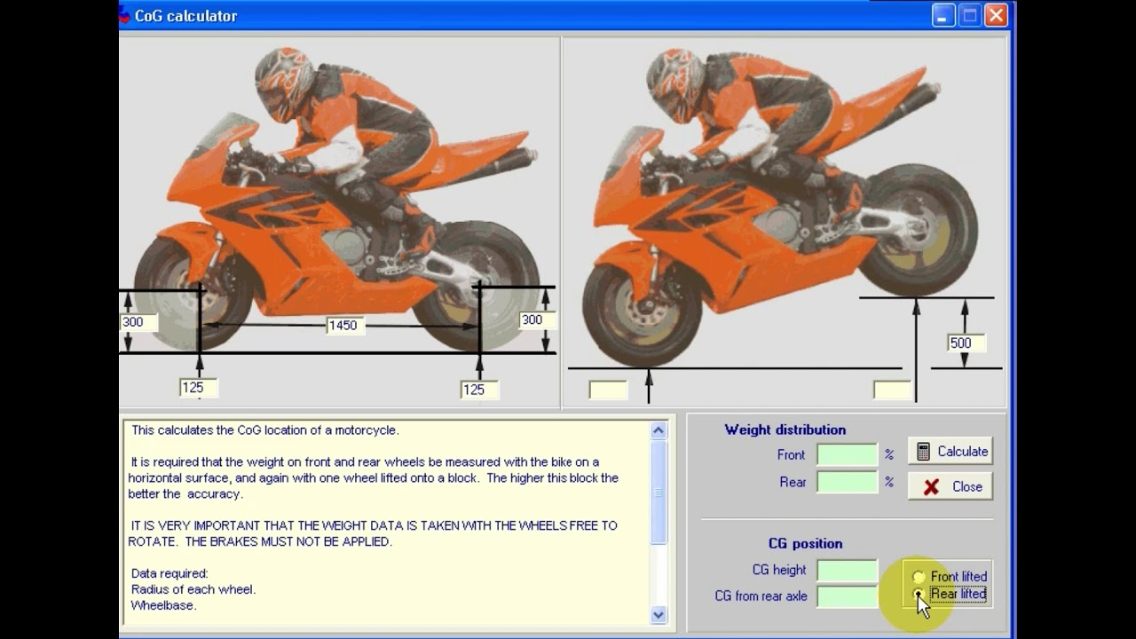
Figure 2.3
(MotoChassis, 2018)
With this information, the centre of gravity was calculated for both the Aprilia and the Kawasaki.

Aprilia Data

 | Level | Level W Rider | Lifted | Lifted W Rider |  | X CoG (m) | Y CoG (m) | X CoG W Rider (m) | Y CoG W Rider (m)
Front Wheel (kg) | 71.5 | 99.1 | 79.35 | 119.7 |  | 0.653 | 0.543 | 0.726 | 0.713
Rear Wheel (kg) | 66.95 | 115.45 | 59.05 | 94.85
Weight of Bike (kg) | 138.45 |  | Stool Height (m) | 0.4 |  | %front | %rear | %front W Rider | %rear W Rider
Rider Weight (kg) | 76.1 |  | Lifted Angle (°) | 17.235 |  | 0.516 | 0.484 | 0.462 | 0.538
Total Weight (kg) | 214.55
Stool Weight (kg) | 0

Kawasaki Data

 | Level | Level W Rider | Lifted | Lifted W Rider |  | X CoG (m) | Y CoG (m) | X CoG W Rider (m) | Y CoG W Rider (m)
Front Wheel (kg) | 105.85 | 150.4 | 114.85 | 175.7 |  | 0.669 | 0.524 | 0.755 | 0.713
Rear Wheel (kg) | 91.25 | 164.6 | 82.2 | 138.3
Weight of Bike (kg) | 197.1 |  | Stool Height (m) | 0.4 |  | %front | %rear | %front W Rider | %rear W Rider
Rider Weight (kg) | 117.9 |  | Lifted Angle (°) | 16.070 |  | 0.537 | 0.463 | 0.477 | 0.523
Total Weight (kg) | 315
Stool Weight (kg) | 0

Comparison of Handling

Final Schematics
With the centre of gravity data added, an improved schematic could be made for each bike. In the schematics below, you can see the centre of gravities with and without the rider on the bike. This will aid in the comparison of the two bikes.

Aprilia Schematic

Figure 3.1

Kawasaki Schematic

Figure 3.2

Final Comparison
The first aspect to consider is trail. A longer trail increases stability at speed but makes cornering more difficult. The Kawasaki’s trail is slightly shorter than the Aprilia’s, which in theory should make it more agile. However, its greater size and weight reduce this advantage, so the difference in handling may be less pronounced.
The wheelbase also plays a role. A shorter wheelbase improves agility but reduces stability at high speed. The Kawasaki’s longer wheelbase, combined with its higher weight, suggests better stability and higher top‑speed capability, though it may feel less responsive in corners compared to the Aprilia.
Finally, the centre of gravity influences balance and manoeuvrability. A higher centre of gravity aids quick direction changes but reduces stability. With a rider, both bikes are similar, but without one the Kawasaki sits slightly lower, reinforcing its bias toward stability and top‑speed performance rather than sharp cornering.

Gear Ratios & Maximum Speed Calculation
This chapter will cover, for one of the measured bikes, the theoretical top speed of the bike. Then, using the frontal area of the bike, consider the forces acting against the bike and determine whether the theoretical top speed is possible. The bike that will be considered is the Aprilia RS 250.

Gear Ratios
To calculate the theoretical top speed of the bike, the first part is to find the gear ratios for each gear as well as the primary (ratio between crankshaft and input shaft of the gearbox) and final gear ratios (ratio between front and rear sprocket). The data was found in the service manual for the Aprilia (manualslib, 2014).
Using these values, the theoretical top speed at each gear can be calculated as well as how much the RPM falls by when changing up a gear.
 | In: | Out:
Primary: | 23 | 59
Final: | 14 | 42
RPM: | 12500
 | In: | Out: | Ratio: |  | Speed km/h: | Revs: | Falls:
1st: | 11 | 27 | 2.455 |  | 77 | 12500
 |  |  |  |  |  | 8275 | 4225
2nd: | 16 | 26 | 1.625 |  | 116 | 12500
 |  |  |  |  |  | 9502 | 2998
3rd: | 17 | 21 | 1.235 |  | 153 | 12500
 |  |  |  |  |  | 10579 | 1921
4th: | 22 | 23 | 1.045 |  | 181 | 12500
 |  |  |  |  |  | 10960 | 1540
5th: | 24 | 22 | 0.917 |  | 206 | 12500
 |  |  |  |  |  | 11455 | 1045
6th: | 25 | 21 | 0.840 |  | 225 | 12500

Horsepower
To be able to determine the driving force of the bike and compare it with wind resistance, a dyno graph of the Aprilia must be used. This has been supplied by (University of Wales Trinity Saint David, 2019). This is the data reduced down to serve the purposes of this chapter. The torque in Nm and power in kW has been calculated from the horsepower and the RPM.

$$Torque=\frac{Horsepower ×7217}{RPM} Power \left(kW\right)=Horsepower ×0.7457$$

RPM: | Power (hp): | Torque (Nm): | Power (kW):
5500 | 16.422 | 21.55 | 12.25
6000 | 21.625 | 26.01 | 16.13
6500 | 24.01 | 26.66 | 17.90
7000 | 26.674 | 27.50 | 19.89
7500 | 30.463 | 29.31 | 22.72
8000 | 32.44 | 29.26 | 24.19
8500 | 37.86 | 32.15 | 28.23
9000 | 46.883 | 37.59 | 34.96
9500 | 53.555 | 40.68 | 39.94
10000 | 56.569 | 40.83 | 42.18
10500 | 60.771 | 41.77 | 45.32
11000 | 64.553 | 42.35 | 48.14
11500 | 66.444 | 41.70 | 49.55
12000 | 63.121 | 37.96 | 47.07
12500 | 58.083 | 33.53 | 43.31

Driving Force
However, to determine the driving force, the speed for each gear must be collected. This can be done in the same way as the gear ratios earlier.
Road Speed 1st (km/h): | Road Speed 2nd: | Road Speed 3rd: | Road Speed 4th: | Road Speed 5th: | Road Speed 6th:
33.84 | 51.12 | 67.24 | 79.45 | 90.62 | 98.89
36.92 | 55.76 | 73.36 | 86.68 | 98.86 | 107.88
39.99 | 60.41 | 79.47 | 93.90 | 107.09 | 116.87
43.07 | 65.06 | 85.58 | 101.12 | 115.33 | 125.86
46.15 | 69.71 | 91.70 | 108.35 | 123.57 | 134.85
49.22 | 74.35 | 97.81 | 115.57 | 131.81 | 143.84
52.30 | 79.00 | 103.92 | 122.79 | 140.04 | 152.83
55.38 | 83.65 | 110.04 | 130.02 | 148.28 | 161.82
58.45 | 88.29 | 116.15 | 137.24 | 156.52 | 170.81
61.53 | 92.94 | 122.26 | 144.46 | 164.76 | 179.80
64.61 | 97.59 | 128.37 | 151.69 | 173.00 | 188.79
67.68 | 102.23 | 134.49 | 158.91 | 181.23 | 197.78
70.76 | 106.88 | 140.60 | 166.13 | 189.47 | 206.77
73.84 | 111.53 | 146.71 | 173.35 | 197.71 | 215.76
76.91 | 116.18 | 152.83 | 180.58 | 205.95 | 224.74

Finally, using the speed and horsepower for each RPM, the driving force can be found.
Driving Force 1st (N): | Driving Force 2nd: | Driving Force 3rd: | Driving Force 4th: | Driving Force 5th: | Driving Force 6th:
1303 | 862 | 656 | 555 | 486 | 446
1572 | 1041 | 791 | 670 | 587 | 538
1612 | 1067 | 811 | 686 | 602 | 552
1663 | 1101 | 837 | 708 | 621 | 569
1772 | 1173 | 892 | 755 | 662 | 606
1769 | 1171 | 890 | 754 | 661 | 605
1943 | 1287 | 978 | 828 | 726 | 665
2273 | 1505 | 1144 | 968 | 849 | 778
2460 | 1628 | 1238 | 1048 | 919 | 842
2468 | 1634 | 1242 | 1051 | 922 | 845
2525 | 1672 | 1271 | 1076 | 943 | 864
2560 | 1695 | 1289 | 1091 | 956 | 876
2521 | 1669 | 1269 | 1074 | 941 | 863
2295 | 1519 | 1155 | 977 | 857 | 785
2027 | 1342 | 1020 | 863 | 757 | 694

These data points can be plotted on a graph of driving force against speed. This will display both the peak driving force for each gear as well as the driving force at maximum speed. This can be compared with the resistive forces to determine whether the theoretical top speed is possible.

Figure 4.1

Resistive Forces
There are 3 main resistive forces that might be considered. Aero drag, rolling resistance, and moving up an incline. In this chapter, only the first two will be covered. Rolling resistance is constant and is approximately $0.02×mass×gravity$
Aero drag is slightly more complicated:
$$Aero Drag=0.5×Density of Air ×Drag Coefficient×Frontal Area × Velocity^2$$
Density of air is about 1.225 kg/m^3 (IERE, 2025) and the drag coefficient of a motorcycle tends to be around 0.7 (Cooper, no date).
The only value left to be calculated is the frontal area of the bike.

Frontal Area
To determine the frontal area of the Aprilia, with a person on the bike, a picture must be taken from head on. The picture can then be exported to a CAD software and an object in the picture of known length can be used to scale the image. The outline of the bike can be traced, and the area within the outline can be calculated by the software.
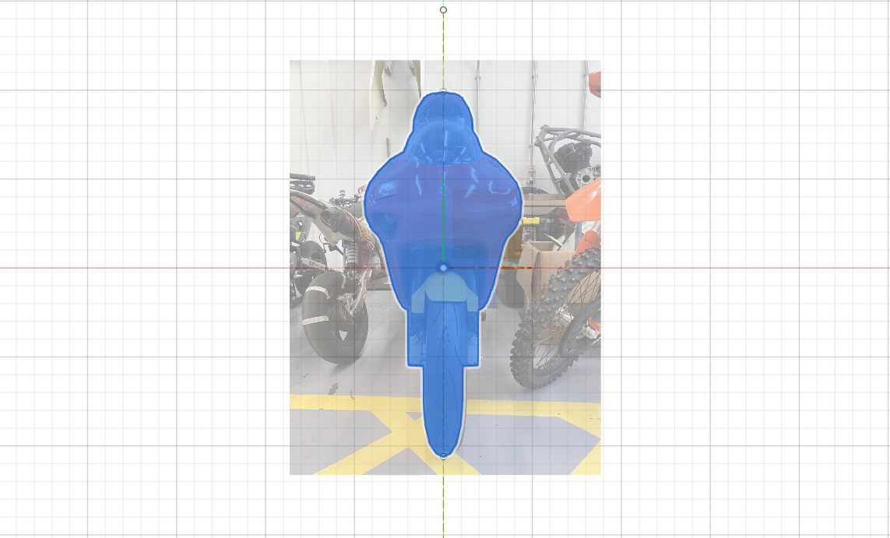
Figure 4.2
After scaling the CAD sketch to the front tyre width of 110mm, the frontal area of the bike could be calculated by the software. It was determined to be 2.351 x10^5 mm^2 or rather 235100mm^2. When converted to m^2, it gives a final area of 0.2351m^2. Adding this to the data gives us a formula for resistive forces at a given speed.
Mass: | 138.45 | kg
Frontal Area: | 0.2351 | m^2
Drag Coefficient: | 0.7
CdA: | 0.16457 | m^2
Velocity in km/h: | 25 | km/h
Velocity in m/s: | 6.944 | m/s
Gradient of Slope: | 0 | %
Angle of Slope: | 0.000 | °
Aero Drag: | 4.861 | N
Rolling Resistance: | 27.164 | N
Resistance due to Gradient: | 0.000 | N
Total Resistive Force: | 32.025 | N
Power needed: | 222.396 | W

Resistance Graph
Plotting this against multiple different speeds will give a curve of resistance against speed.
Velocity (km/h) | 0 | 25 | 50 | 75 | 100 | 125 | 150 | 175 | 200 | 225 | 250 | 275
Drag (N) | 27.164 | 32.025 | 46.608 | 70.914 | 104.941 | 148.691 | 202.162 | 265.356 | 338.272 | 420.910 | 513.271 | 615.353

Figure 4.3

Is Theoretical Top Speed Possible
By plotting both the resistance curve and the driving force on the same graph, it can be determined whether its theoretical top speed is limited by the resistive forces or not.

Figure 4.4
As shown on the graph, the drag from rolling resistance does not exceed the driving force at the Aprilia’s theoretical top speed. This means that that the theoretical top speed of the bike (roughly 225 km/h) is attainable.

Geometry of Modern Motorcycles
The two bikes I will be comparing to the 1996 Aprilia RS 250 and the 1989 Kawasaki ZXR750 are the 2020 Aprilia RS 660 and the 2022 Yamaha R7 (respectively).

Aprilia RS 660
This bike is a larger version of the RS 250 and has been very successful recently in British Superbikes. Since it has a much larger engine size, it is noticeably heavier, with a weight of 169kg. It has a wheelbase of 1.37m, only slightly longer than the RS 250. It also has a slightly longer trail of 104mm, compared with the RS 250s 96mm trail.
Both differences in geometry would suggest that the RS 660 remains a very agile bike with good cornering capabilities, however, with its longer wheelbase and trail, it will be more stable at high speeds compared to the RS 250. This is because the RS 660 has a larger engine with a higher top speed so it would be more beneficial to increase the stability at those higher speeds rather than focus entirely on the cornering, otherwise, too much time would be lost on the straights.
Data from (ultimateSPECS, 2023).

Yamaha R7
The Yamaha R7 is part of Yamaha’s middleweight super sport line. It competes in its own championship, the R7 cup. Compared to the ZXR750, it has a shorter wheelbase of 1.405m as well as a trail of 90mm, only slightly shorter than the Kawasaki.
This combined with the smaller engine size of 689cc shows that the R7 is much better suited to cornering than the Kawasaki but should still maintain enough stability at high speeds to make use of its decent top speed. This is suited to the R7 cup as, although top speed is important, lots of the track involves cornering and so it is beneficial to be more agile in the corners.
Data from (ultimateSPECS, 2023)

Recommended Alterations

Aprilia
Although the RS 660 has a longer wheelbase and trail, these changes may not translate positively to the RS 250. Since the RS 250 does not reach extremely high top speeds, it is more beneficial to prioritize cornering handling.
This could be achieved by slightly reducing the trail, which would make the bike more responsive and agile. Alternatively, shortening the wheelbase would have a similar effect. However, excessive reduction in either dimension could make the bike unstable too low speeds, so adjustments made must be careful.

Kawasaki
The ZXR750 is a relatively heavy motorcycle with a long wheelbase, so improving its ability to tip into corners would be beneficial.
As with the Aprilia, this can be achieved by reducing the trail or shortening the wheelbase, both of which enhance cornering agility. However, because the ZXR750 has a much higher top speed than the RS 250, these reductions must be more conservative. Excessive changes would compromise stability at high speeds before it would be an issue on the RS 250, making the bike very unsafe.

Conclusion
This report has shown the impact that geometric qualities of a motorcycle have on the handling characteristics by measuring two different bikes and analysing the results.
The Aprilia is more suited to lower speed tight cornering with a shorter wheelbase and smaller engine. The Kawasaki, being longer, heavier, and equipped with a much larger engine, is more suited to high-speed stability.
Additionally, this report also investigated, using gear ratios and dyno graphs, what the limiting factor was for the Aprilia and whether the drag would stop the bike from reaching its theoretical top speed.
Finally, the two measured bikes were compared with two other modern motorcycles of similar purposes and suggestions were made to improve the original bikes.

References
Cooper, K. no date, Motorcycle Aerodynamics, https://badcurator.org/resources/Magazines/Cycle_Sep76/Motorcycle-Aerodynamics.pdf (Accessed 11/12/25)
IERE, 2025, What is the density of the air?, https://iere.org/what-is-the-density-of-the-air/ (Accessed 11/12/25)
Manualslib, 2014, Aprilia RS 250 motorcycle service and repair manual, https://www.manualslib.com/manual/812603/Aprilia-Rs-250.html?page=18#google_vignette (Accessed 11/12/25)
MotoChassis, 2018, Locating motorcycle Centre of Gravity, https://www.youtube.com/watch?v=pNAlkOaeW1s (Accessed 11/12/2025)
Sprocket Calculator, 2025, Aprilia RS 250 (1995-2004), https://sprocketcalculator.com/bike-aprilia-rs-250-1995-2004https://sprocketcalculator.com/bike-aprilia-rs-250-1995-2004 (Accessed 09/12/2025)
ultimateSPECS, 2023, Aprilia RS 660 Specs, https://www.ultimatespecs.com/motorcycles-specs/aprilia/aprilia-rs-660-2023 (Accessed 11/12/2025)
ultimateSPECS, 2023, Yamaha R7 Specs, https://www.ultimatespecs.com/motorcycles-specs/yamaha/yamaha-r7-2023 (Accessed 11/12/2025)
University of Wales Trinity Saint David, 2019, Aprilia RS 250 Base Run, unpublished internal data

