
Factory Control – ACMA6001
Control Technology

July 14, 2023
University of Wales Trinity Saint David

Adam Evans 2005959

Table of Contents
Adam Evans 2005959 0
Table of figures 1
Introduction 2
Main Project 2
Task 1 – review of current PLC’s 2
Task 2 -Factory IO 5
Flow Chart 5
Factory IO 6
Task 3 – Ladder Logic 7
Task 4 and 5 – HMI Device 12
Works Cited 14

Table of figures
Figure 1 - Siemens SIMATIC S7-1500 PLC 3
Figure 2- Micro850 Programmable Logic Controller Systems 3
Figure 3 - Mitsubishi MELSEC-Q-Series PLC System 4
Figure 4 -CP1L Series 4
Figure 5 - Factory IO simulation 6
Figure 6 - Cross reference 6
Figure 7 - Start / Stop button drivers. 7
Figure 8- TIA tags start / stop 7
Figure 9- start / stop ladder logic 7
Figure 10 - about to start 8
Figure 11 - Ladder logic 1 8
Figure 12 - ladder logic 2 9
Figure 13 - Ladder logic 3 10
Figure 14 - Ladder logic 4 10
Figure 15 - ladder logic 5 10
Figure 16 - ladder logic 6 10
Figure 17 - ladder logic 7 11
Figure 18 - Ladder logic 8 11
Figure 19 - ladder logic 9 11
Figure 20 - HMI main screen 12
Figure 21 - Alarm Screen 12

Introduction

The following report has been written by Adam Evans student number 2005959 ,using Factory IO to design a factory layout which is capable of sorting 4 different types of boxes, through size configuration and weight to determine which conveyor track the box will follow. This is all programmed using ladder logic on Siemens TIA software that links to Factory IO allowing the simulation to accrue.
Different types of PLC within the current industrial environment will be reviewed. Also considering the Pros and Cons of using PLC within an industrial environment.

Main Project

Task 1 – review of current PLC’s

Programmable logic controls or PLC for short is a digital operating system similar to a personal computer as it is equipped with programable memory. However, these are found across industrial environments. As PLC’s these are deigned to operate within harsh environment such as dusty area, areas which are subjected to extreme temperature or wet and dry areas, Which PC wouldn’t be able to withstand. [1]
There are four main types of PLC which are typically used Modular PLC, Soft PLC, Slot PLC and Compact each one of these have their own uses which are selected for the type of use they are required for.
Modular PLC
PROS | CONS
- Quick start up times | - The cost is high if not necessary
- Functions can expand if necessary | - They take up a lot of room
- Good real time behaviour | - They can be complex to configure
- Dedicated PLC
- Add extra modules if needed

Compact / slot and soft PLC
PROS | CONS
- Easy to use | - Can’t expand memory
- Low in cost | - Slow start up
- Compact in size | - Can be unstable with higher loads
- Can have own power supply
[2]
Within Marelli the types of PLC’s that are used are Modular PLC, the reason for selecting this type of PLC is so that machines are future proofed as the type of product which we produce is very similar apart from a few design changes, the PLC can be programmed to deal with the new product as well as keep the older product on the machine. These programs can be then selected using the HMI (human machine interface ) allowing the operator to build multiple products on one machine.
PLC have been replacing the hard-wired circuits which were typically found in industry as they can control multiple operations with one small PLC, unlike the large wired systems. Fault finding is also made much easier as the PLC can provide you with information to what the fault is unlike the wired system where you would need to interrogate each relay which would take a lot of time. [3]
The common brands which are used within industries are Siemens, Allen Bradley, Mitsubishi and Omron.
Example of Siemens PLC (Figure 1 - Siemens SIMATIC S7-1500 PLC )
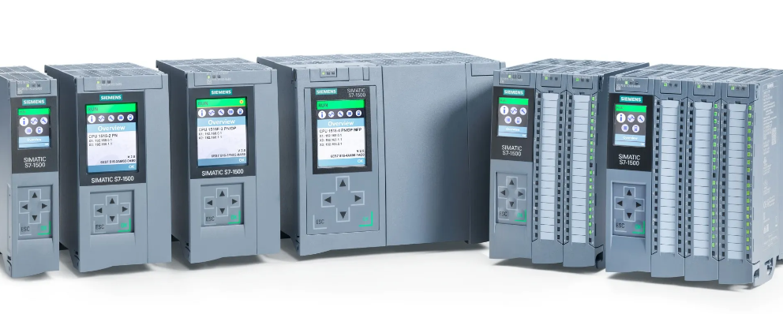
Figure 1 - Siemens SIMATIC S7-1500 PLC
Example of Allen Bradley PLC (Figure 2- Micro850 Programmable Logic Controller Systems)
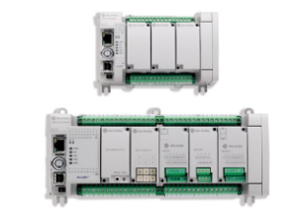
Figure 2- Micro850 Programmable Logic Controller Systems
Example of Mitsubishi PLC (Figure 3 - Mitsubishi MELSEC-Q-Series PLC System)
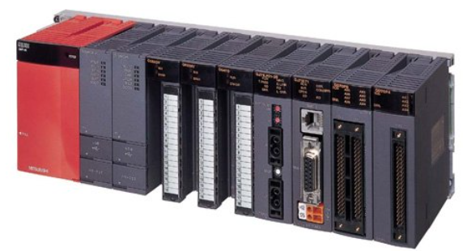
Figure 3 - Mitsubishi MELSEC-Q-Series PLC System

Example of Omron PLC ( Figure 4 -CP1L Series)
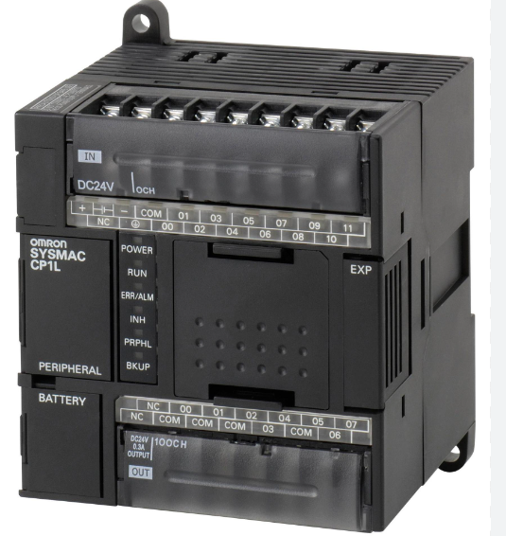
Figure 4 -CP1L Series

Task 2 -Factory IO

Before you design a factory or write a program you need to understand what the process is and how it needs to flow, the best way to do this is to write an operational flow chart which will map out your process. It can also be used as a reference tool when auditing the process or seeing how you can improve the process going forward. Although a flow chart is not detailed as in literature it will provide pictures of the separate steps in sequential order. [4]

Flow Chart
Start

Active pusher
Product on conveyor
Height sensor triggered.

YES

No
Continue Conveyor
Product Conveyor
Height sensor triggered.
YES
End Shoot Product A

No
Continue Conveyor
Active pusher

Product Conveyor
End Shoot Product B

<4.5Kg
Ready Weight

>4.55Kg
Sort right
Sort forward
Product Conveyor
Product Conveyor
End Shoot Product D
End Shoot Product C

Factory IO
With the operational flow chart written it can now be turned into the factory layout using simulation software Factory IO. This is shown below in Figure 5 - Factory IO simulation. Aswell as the layout configuration guarding has also been positioned around the perimeter of the cell for safety.

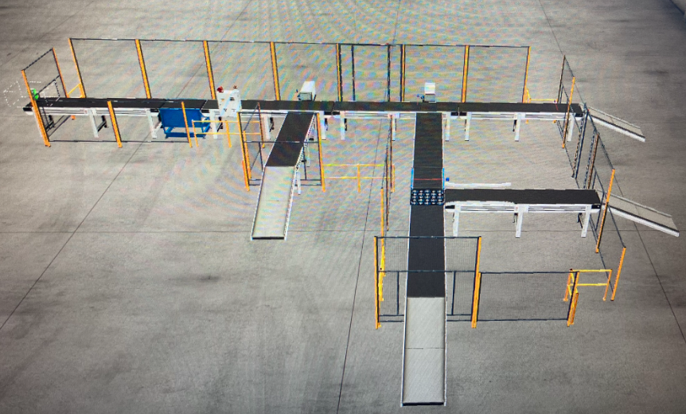
Figure 5 - Factory IO simulation
This can be cross referenced against the operational flow chart to ensure all aspects are met prior to programming. Figure 6 - Cross reference
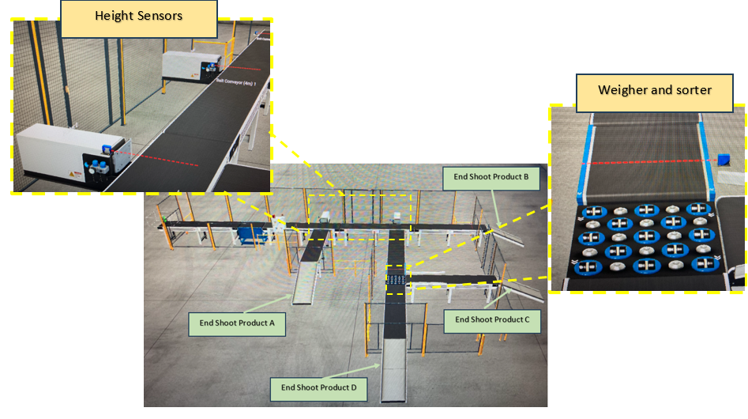
Figure 6 - Cross reference

Task 3 – Ladder Logic

Ladder logic is one of the most popular ways of writing a program for a PLC, the reason behind this is that is uses easy graphics that can be read by engineer, electricians and students as the symbols come from electrical diagrams. [5]
To write the ladder logic a program called siemens TIA v14 is to be used but before any program can be written to items which have been used to create the factory layout need to be assigned against drivers which will be used when writing the program, this firstly done in the Factory IO software and then assigned into the program via the tags page.
For example, the start and stop button have been assigned against the reference I24.0 and I24.1 (Figure 6 - Start / Stop button drivers.)
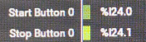
Figure 7 - Start / Stop button drivers.
This is then written into the program matching these references. Figure 7- TIA tags start / stop
Figure 8- TIA tags start / stop
When writing the ladder logic these tags will then be used as they correspond to the assigned references with the Factory IO software.

Figure 9- start / stop ladder logic
As shown in Figure 8- start / stop ladder logic the start stop buttons are now written into the program against the output of a memory function “Flag”. This memory function isn’t part of the Factory IO it is only for the use within the program and acts as a trigger to allow element of the program run / stop.
For example, when the “start button” is pressed, and both the “stop button” and “e-stop” button are in the open position the “Flag” is activated. This then is used though out the program to start the cell where the “flag” is the input to ladder logic. This is shown in Figure 9 - about to start where the input “Flag” triggers a timer for 3 seconds sounding a siren and continuously runs a warning light when the “Flag” is active.

Figure 10 - about to start

This method writing is applied throughout the ladder logic program.
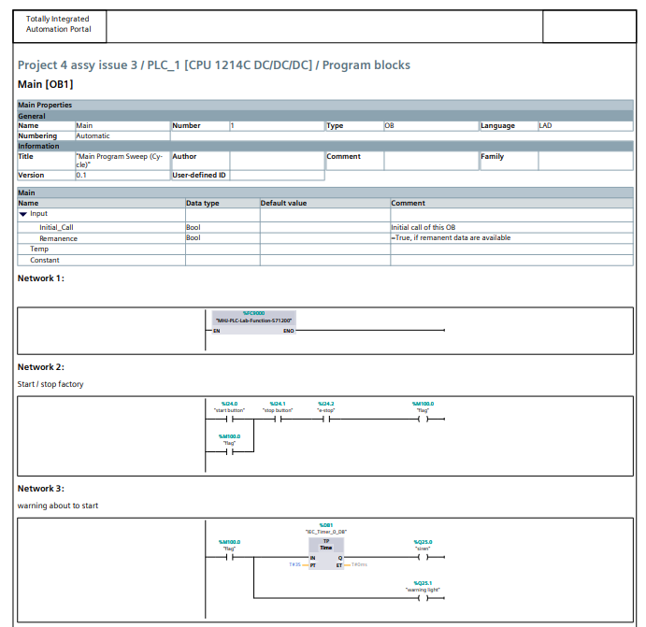
Figure 11 - Ladder logic 1

Network 4 – operators and turns on the conveyor bets within sequence of each other in intervals of 0.5 seconds of each other.
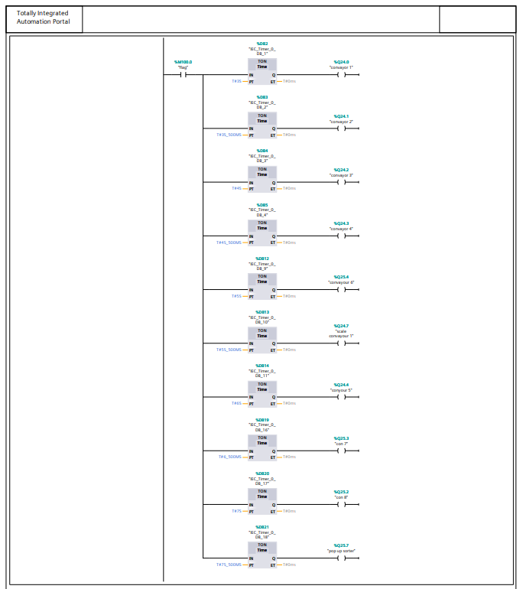
Figure 12 - ladder logic 2

Network 5 – activates the pushers when the sensors are met, the timing on these determines if the pusher will push the box onto the joining conveyor correctly ensuring it is not over hanging or worse case pushes it off the conveyor onto the floor.
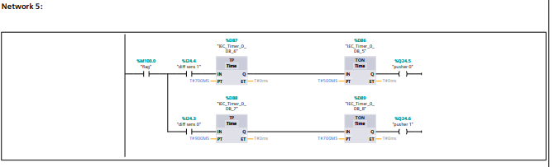
Figure 13 - Ladder logic 3
Network 6 – Is linked to a counter which will count the number of times the pushers are activated.
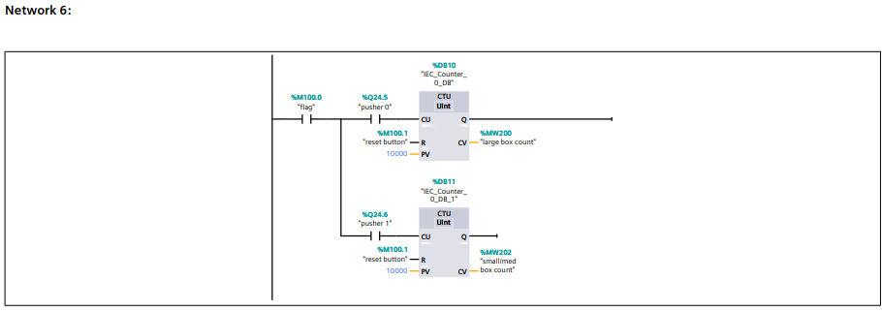
Figure 14 - Ladder logic 4
Network 7 – Will provide warning lights during on the maintenance HMI display

Figure 15 - ladder logic 5
Network 8, 9,10 and 11 - control the weighing operation and the divert part of the program.

Figure 16 - ladder logic 6

Figure 17 - ladder logic 7

Figure 18 - Ladder logic 8
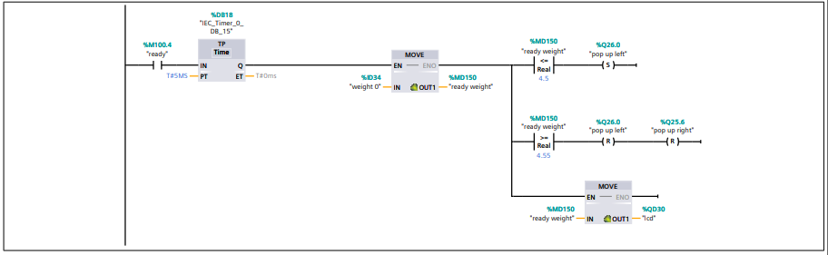
Figure 19 - ladder logic 9

Task 4 and 5 – HMI Device

A HMI device (Human machine interface) is usual mounted on the out side of a control panel or near to where the operator is working. This can provide the user with basic instructions to follow, product count or assist in fault finding is alarms / error messages are programmed into the device. [6]
Within Siemens TIA the HMI can be created and simulated so ensure it is functioning correctly, this can have multiple screen interface which user can navigate through.
Main screen which the operator can use to start / stop and look at the count of the products. Figure 10 - HMI main screen
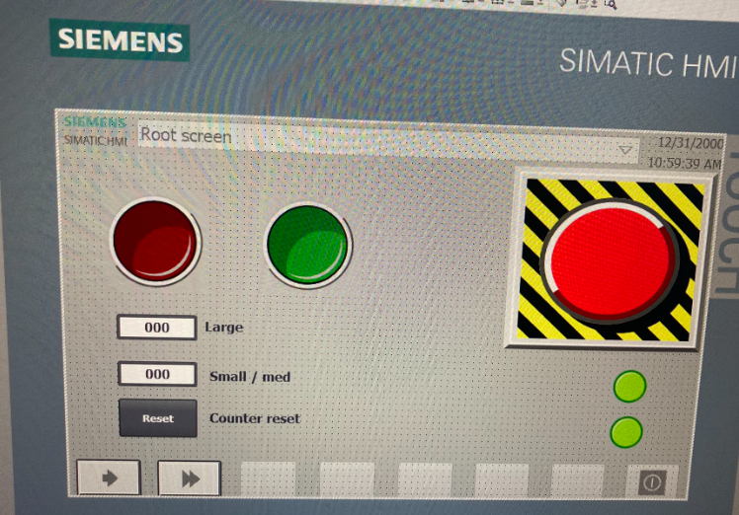
Figure 20 - HMI main screen

Alarm screen which will tell the user what warning has been activated against what alarm. Figure 11 - Alarm Screen
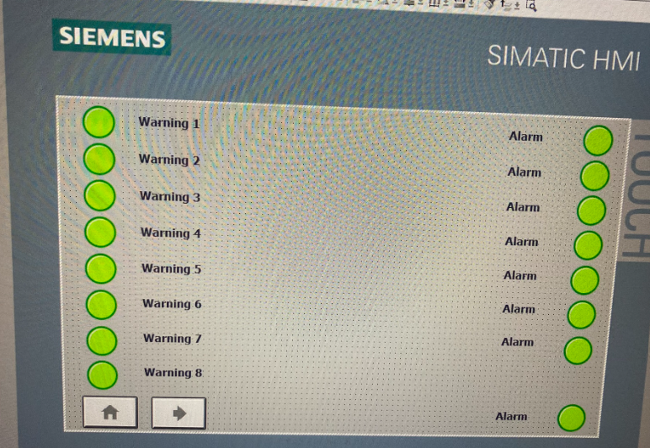
Figure 21 - Alarm Screen

Works Cited

[1] | V. Muthukrishnan, “www.electrical4u.com,” electrical4u, 11 4 2021. [Online]. Available: https://www.electrical4u.com/programmable-logic-controllers/. [Accessed 2 7 2023].
[2] | UK.RS-Online, “https://uk.rs-online.com/,” uk.rs-online, 2 7 2023. [Online]. Available: https://uk.rs-online.com/web/content/discovery/ideas-and-advice/plcs-programmable-logic-controllers-guide. [Accessed 2 7 2023].
[3] | deltaelectronicsindia, “https://deltaelectronicsindia.com,” deltaelectronicsindia, 15 2 2020. [Online]. Available: https://deltaelectronicsindia.com/faq-items/what-are-the-advantages-of-plc/#:~:text=Flexible%20in%20Nature%3A%20One%20model,the%20PLC%20based%20control%20panels.. [Accessed 2 7 2023].
[4] | ASQ Quality Press, “asq.org,” ASQ Quality Press, 2 7 2023. [Online]. Available: https://asq.org/quality-resources/flowchart. [Accessed 2 7 2023].
[5] | ladder-logic, “https://ladderlogicworld.com,” ladder-logic, 2 7 2023. [Online]. Available: https://ladderlogicworld.com/ladder-logic-basics/#:~:text=Ladder%20logic%20is%20the%20most,to%20ladder%20logic%20relatively%20easy.. [Accessed 2 7 2023].
[6] | aveva, “https://www.aveva.com,” aveva, 2 7 2023. [Online]. Available: https://www.aveva.com/en/solutions/operations/hmi/#:~:text=Human%20Machine%20Interface%2C%20often%20known,complex%20data%20into%20useful%20information.. [Accessed 2 7 2023].
[7] | K. Terry, “https://www.isixsigma.com/new-to-six-sigma/dmaic/what-dmaic/,” 1 5 2022. [Online]. Available: https://www.isixsigma.com/new-to-six-sigma/dmaic/what-dmaic/.

