

Programme: Master of Business Administration
Module code: LCMB7023
Module: Human Capital Management
Assignment Title: Assessment component 1: Individual report
Word count: 2622
Student Name: Mayuri Prajapati
Student ID Number: 2542276

Table of Contents
Task A: Socialisation, Identity and Business Activism 3
1.1 Critique of Traditional Onboarding versus Strategic Socialisation 3
1.2 Strategic Socialisation Framework for HUM 5
1.3 Organisational Identification and Ethical Professionalism 9
1.4 Developing Business Activists 10
Task B: Strategic Job Design for Innovation 13
2.1 Contemporary Job Design Challenges at HUM 13
2.2 Critique of Traditional versus Contemporary Job Design 15
2.3 Job architecture model for HUM 15
2.4 Theoretical support for the model 19
2.5 Stimulating Intrinsic Motivation and Innovation 23
Task C: Reflective Report 24
3.1 AI as a Decision Support Tool in HR 24
3.2 Personal Capability Development Plan 27
Reference list 28

Task A: Socialisation, Identity and Business Activism

1.1 Critique of Traditional Onboarding versus Strategic Socialisation
- Traditional onboarding
Traditional onboarding is a practice focusing on administrative and organisational policy-dependent practices that emphasise role clarification and procedural transparency. As argued by Patel and Mohanty (2023), the limitations of traditional onboarding is a lack of workplace flexibility, which reduces employee engagement due to fragmented capability development with high employee attrition risks.
- Strategic Organisational Socialisation
Workforce behaviour, values and identity control are facilitated in the strategic organisational socialisation process based on organisational objectives. The alternative of strategic organisational socialisation is necessary as it addresses stakeholder conflicts such as lack of synchronisation between teams, resulting in employee disagreement (Chukwuma et al., 2025). On the other hand, Psychological Contract Theory employs trust, commitment and obligations to ensure professional identity through negotiations and reconstruction of responsibilities (Diehl et al., 2026).
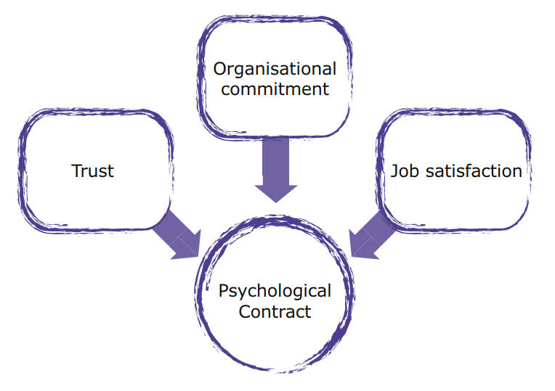
Figure 1: Elements of psychological contract theory
(Source: Influenced by Diehl et al., 2026)
- Critical discussion for Helios Urban Mobility (HUM)
Dimension | Traditional Onboarding | Strategic Socialisation | Critical Evaluation for HUM
Primary focus & Time horizon | The first few weeks develop orientation and compliance | Continuous process ensures identity and capability development | Strategic socialisation has been viewed as an alternative technique to traditional onboarding to improve the efficiency of short-term induction, and productivity.
Learning approach and policy integration | Compliance with process and policy with an orientation approach | Experiential learning through capability development and mentoring for talent integration | Unlike the administrative control of traditional approach, socialisation ensures an innovation agenda through capability building within an 8-month target period.
Employee relationship and stakeholder interest | Role-dependent transactional employment relationship is established | Relational psychological contracts with organisational identity and stakeholder-oriented behaviour are emphasised | Strategic socialisation reduces risks of violating ethical professionalism norms at HUM’s.
Organisational outcome | Efficient operational adjustment | Business activism with identification and innovation | HUM’s focus for employee engagement with organisational renewal and innovation is aligned with strategic socialisation concepts
Table 1: Comparison of strategic socialisation and traditional onboarding
(Source: Frögéli et al., 2023)

1.2 Strategic Socialisation Framework for HUM
HUM is proposed to adopt a staged framework based on principles of strategic socialisation, involving pre-boarding, early integration and continuous development.
Stage | Objectives | Strategies | Expected Outcomes
Pre-boarding | To improve psychological attachment with uncertainty reduction | - Digital onboarding portal  - AI-enabled welcome platform  - Specialist mentor allocation  - Culture handbook distribution | Boosting employee engagement while considering inputs from KPIs such as task completion rates and frequency of task escalation
First 90 Days | To enhance social integration and competence acquisition | - Buddy systems  - Cross-functional projects  - Structured learning pathways  - Innovation workshops | Increased recognition promotes self-efficacy, leading to faster adjustment for acceptance with reduced time for acculturation,as per stages of adjustment
Year One | To improve capability through identity acceptance and leadership orientation | - Rotational assignments  - Development centres  - Internal mobility opportunities  - Innovation communities Career planning | Individual recognition improves retention, supporting innovation capability and leadership readiness
Table 2: Strategic socialisation framework
(Source: Basile et al., 2025)
The framework establishes the potential strategies aligned with objectives of HUM to gain optimised performance results. Social cognitive theory also highlights the interrelationships between behaviour, competence and professional identities to obtain holistic performance through observation, social interaction and modelling that embeds the developmental socialisation process.
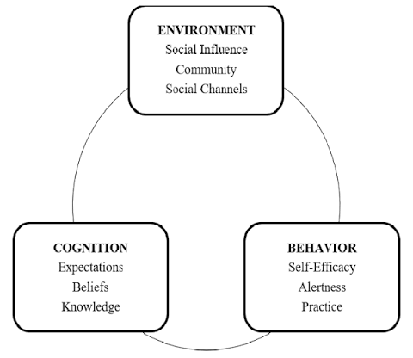
Figure 2: Social cognitive theory
(Source: Mir et al., 2024)
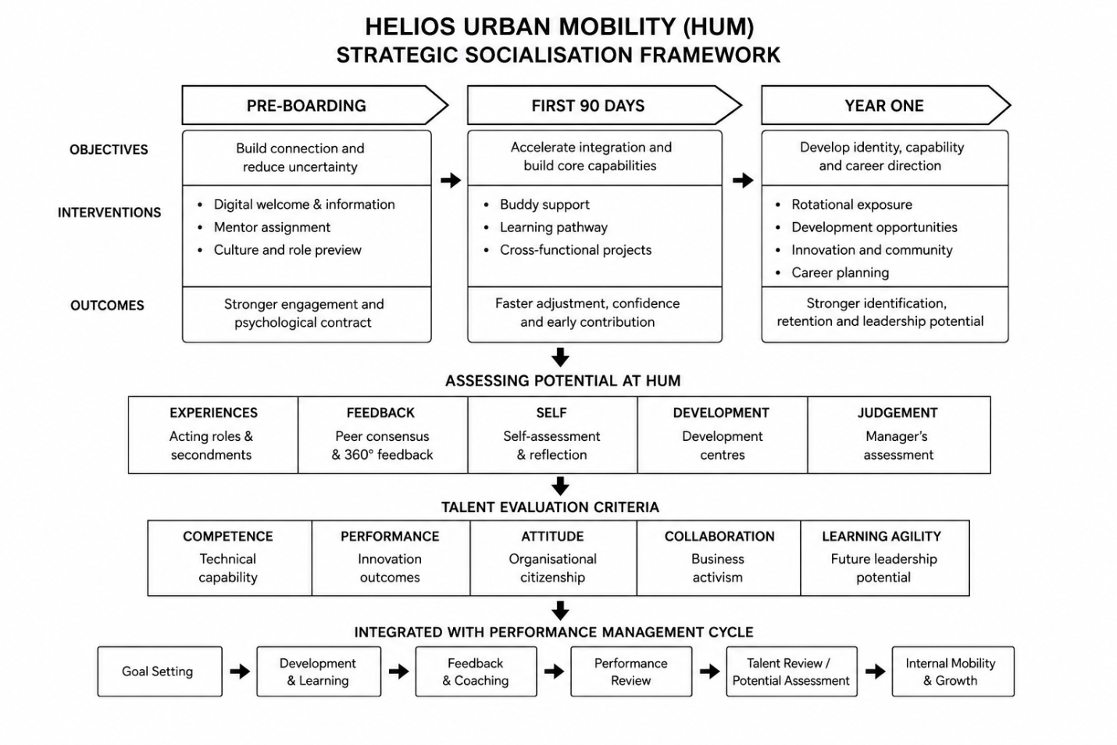
Figure 3: Diagrammatic representation of socialisation framework (adopted)
(Source: Self-developed)
The framework emphasises long-term investment in human capital for growth and opportunities through systematic developmental pathways. Singapore's developmental philosophy also highlighted sustained investment in capability enhancement through continuous learning, which can improve the socialisation position of HUM through strategic processes of talent adaptation. Hence, spontaneous evolution of employees with talent management objectives and innovation-oriented business activism can enhance attrition.
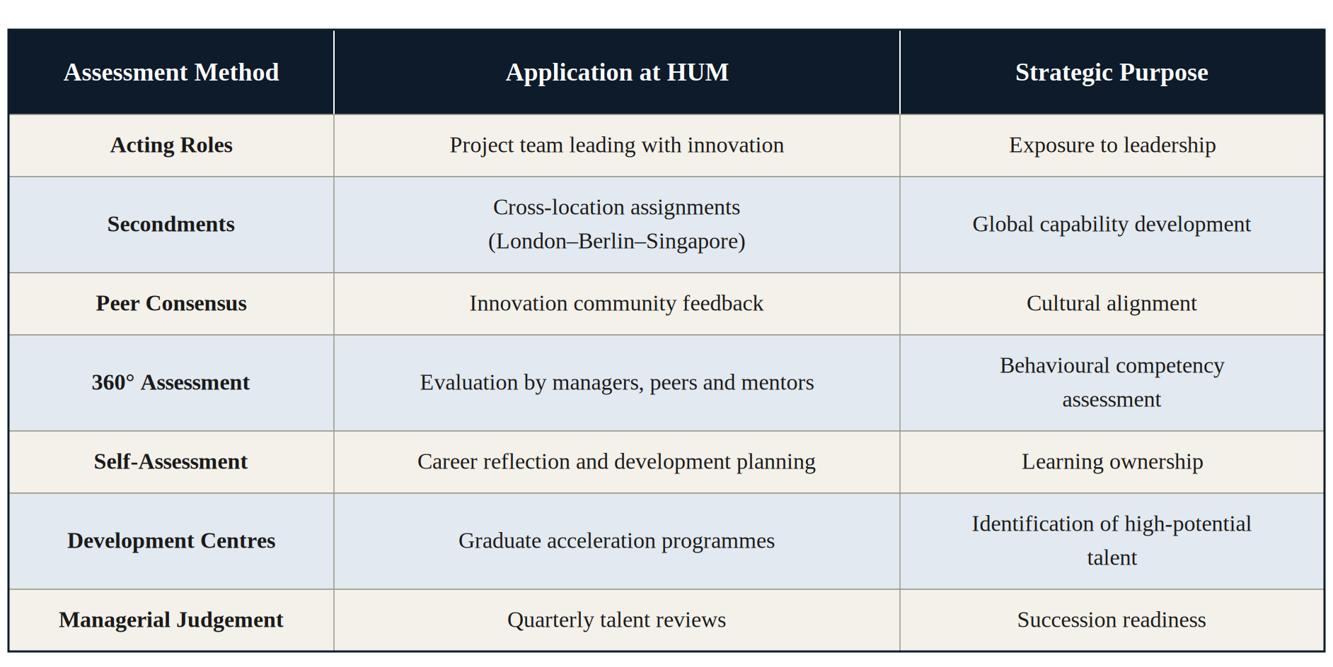
Table 3: Assessment potential through assessment matrix
(Source: Influenced by Yakob, 2026; Week 3)
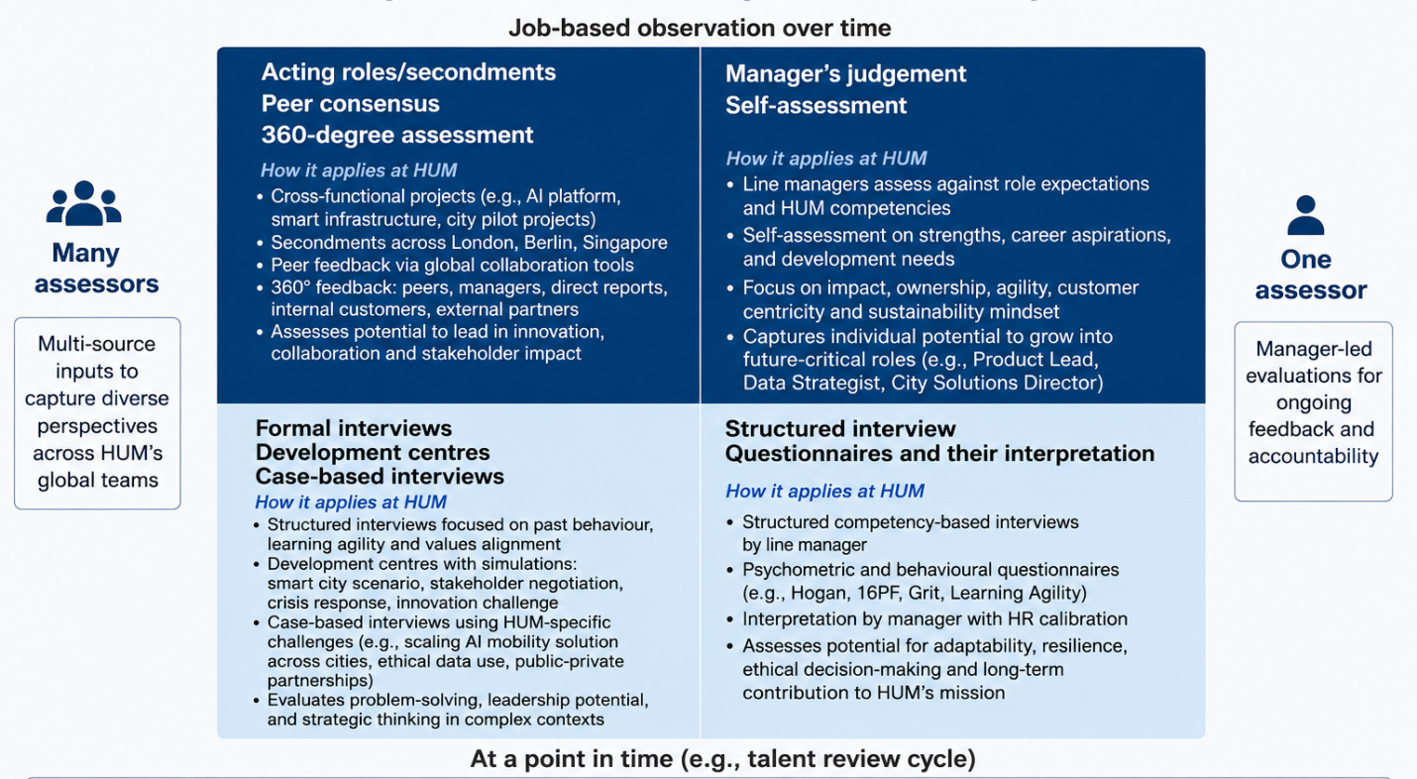
Figure 4: Assessing potential as HUM< with integrated assessment matrix
(Source: Self-developed; Week 3)
Criteria | Application at HUM
Competence | Digital expertise with technical capabilities
Performance | Project contributions with innovation outcomes
Attitude | Organisational engagement and cultural alignment
Collaboration | Business activism, stakeholder engagement and knowledge sharing
Learning Agility | Adaptability showing continuous learning and future leadership potential
Table 4: Talent evaluation criteria
(Source: Influenced by Urme, 2023, Week 5)
This developmental approach is perceived to be effective when combined with a performance management cycle where developmental feedback, coaching and talent reassessment can be done after goal setting to ensure capability progression under strict monitoring. Hence, the integrated system can ensure HUM’s success.

1.3 Organisational Identification and Ethical Professionalism
- Standard behavioural expectations and goal acknowledgement with individual target alignment are key factors associated with organisational identification and ethical professionalism.
- HUM needs to heighten the strategic purpose with transparency and engagement through motivation by following the principles of Goal Setting Theory in the light of enhanced commitment and performance while achieving individual performance standards (Ab Rahman, 2025).
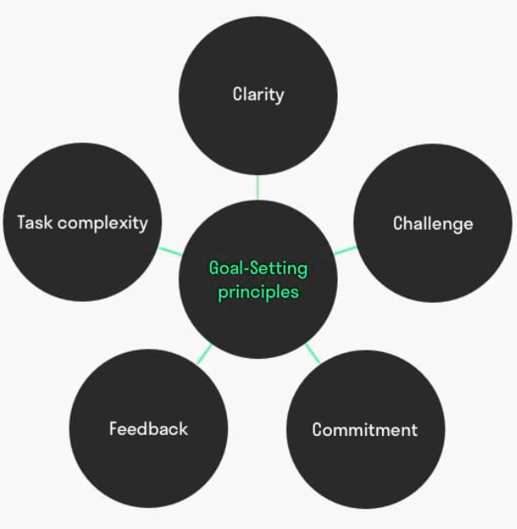
Figure 5: Goal Setting theory
(Source: Influenced by Ab Rahman, 2025)
- Therefore, the integration of sustainability objectives and innovation targets with stakeholder-oriented targets is essential to obtain employee engagement with a sense of belongingness.
- On the other hand, Thiruppathi (2026) suggested that overreliance on performance options based on goal-oriented strategies reduces ethical judgement. Addressing this critique, goal-setting processes must focus on integrating ethical standards, collaborative objectives and developmental feedback to ensure professional conduct with commitment.

1.4 Developing Business Activists
- Strategic capability with business activism
Organisational transformation is supported by employees operating as strategic contributors, as emphasised in the HR Champion Model by Ulrich (1997) (week 1 HCM lecture session). HUM is represented as a knowledge-intensive organisation and requires standardisation of organisational citizenship behaviour. However, stakeholder conflicts occurred due to a lack of ethical professional standard in conducting organisational tasks and ensuring supplier sustainability (Oldham et al., 2025). Professional development opportunities have been increased significantly through engagement that showed a 19% increase in retention preferences (Gallup, 2026). Hence, graduate attrition and sustainable growth opportunities can be facilitated at HUM.
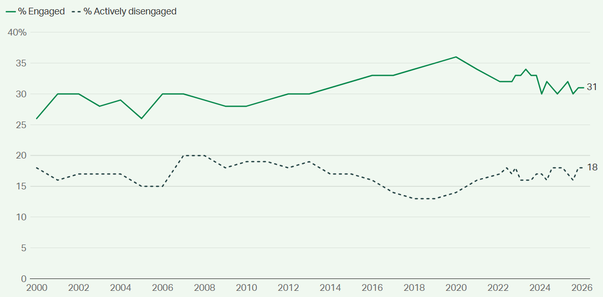
Figure 6: Engagement rate of employees
(Source: Gallup, 2026)
To facilitate the business activist approach at HUM, innovation could, cross-city sustainable initiatives, digital employee voice platforms, and stakeholder engagement forums are to be established with an integration strategy. It will aim to enhance innovation capabilities of the concerned agents, leading to ethical decision-making and long-term organisational resilience.
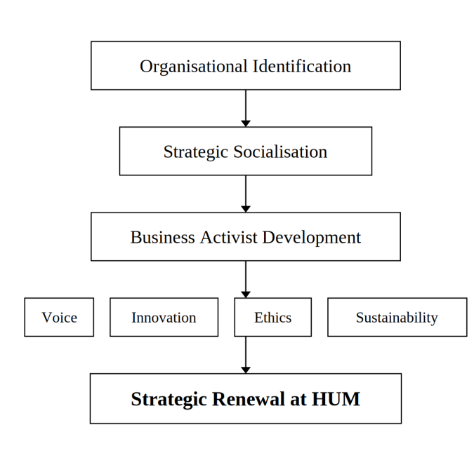
Figure 7: Business activist architecture
(Source: Self-developed)
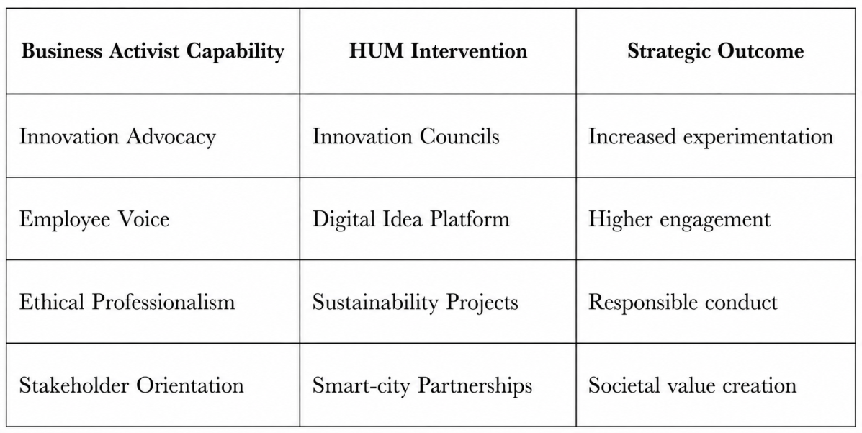
Table 5: Strategic aspects to develop business activism at HUM
(Source: Self-developed)

Task B: Strategic Job Design for Innovation

2.1 Contemporary Job Design Challenges at HUM
HUM’s low employee engagement stems from the traditional skill-based job role distribution across its multinational teams, which causes high attrition among potential graduates. Switching tasks can make employees 40% less productive in 2026, as their focus is fragmented every 2 minutes and they spend 20-40%of the week in meetings, substantiating the need to uphold a structured and effective job design (Lucas, 2026). Blanchard’s Performance model implies that performance is directly proportionate to employees’ ability, their motivation, and the workplace environment (Week 2 HRM lectures, p. 9). The practical implementation challenges included AI-based recruitment bias, increasing technology costs, variation in skill assessment accuracy and manager resistance (Nejad, 2025). Also, the challenge of collaborating across cross-functional team members resonates with Tuckman’s “Storming” stage, as global employee engagement decreased by 26% even for leaders (Gallup, 2026).
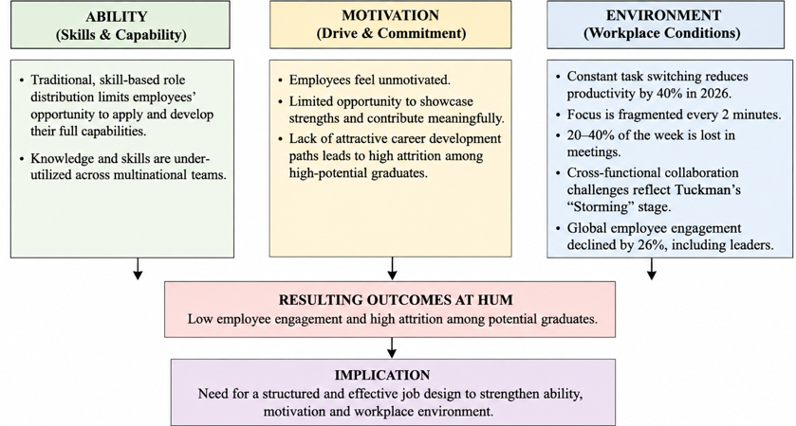
Figure 8: Blanchard’s Performance model
(Source: Inspired by Week 2 HRM Lecture, p.9)
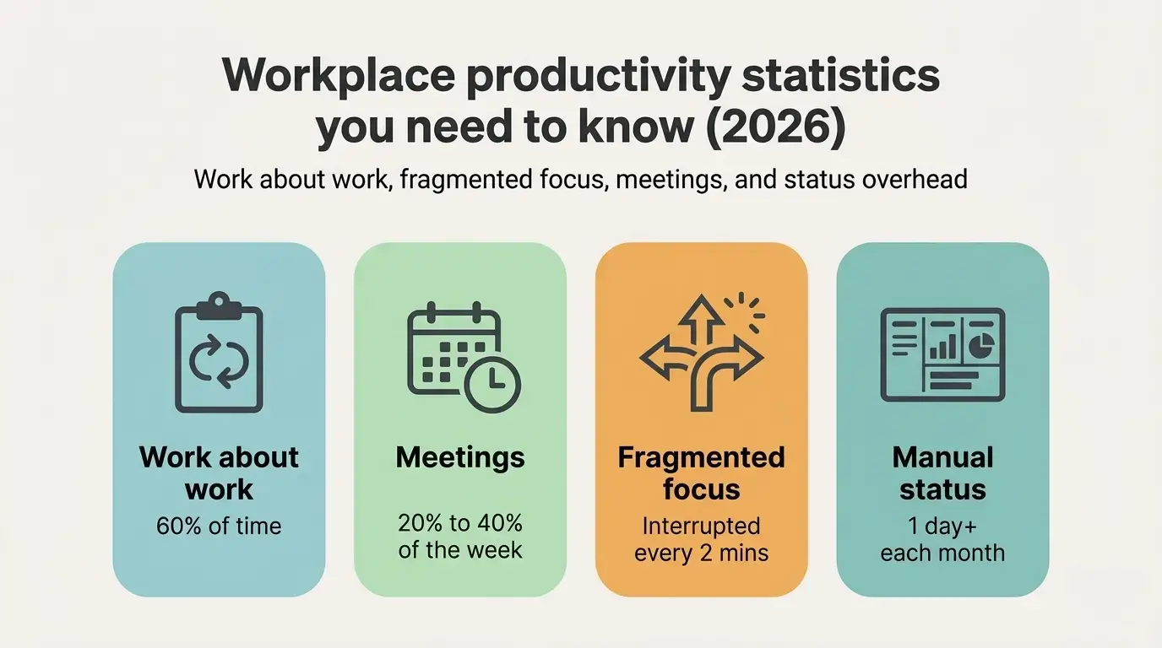
Figure 9: Factors impacting employee productivity
(Source: Lucas, 2026)
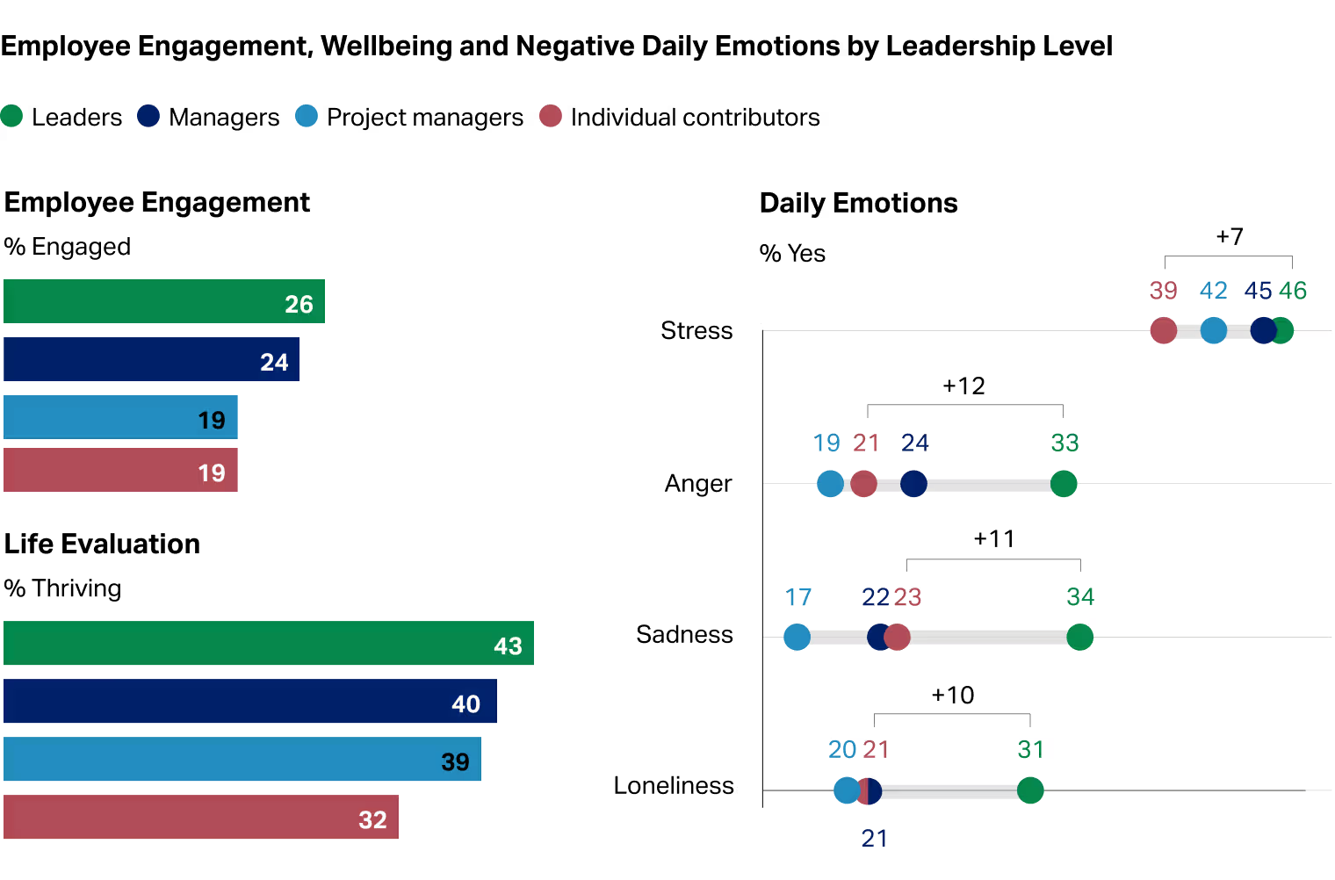
Figure 10: Decreasing employee engagement in 2026
(Source: Gallup, 2026)

2.2 Critique of Traditional versus Contemporary Job Design
Work standardisation, efficiency and task specialisation are part of scientific management that is adopted in traditional job design approaches. This approach is effective in stable operation and environment, while its limitation can be seen when knowledge-intensive operations are integrated in organisations like HUM. On the other hand, contemporary job design facilitates flexibility, autonomy and creativity, leading to employee empowerment to support performance improvement. In this case, job crafting, internal talent marketplace and skill-based architecture are essential. The shift from traditional strategy to contemporary approaches is essential to control global employee engagement, which is reported to decline to 20% in 2025 and result in approximately US$10 trillion in global productivity loss (Gallup, 2026). Emphasising intrinsic motivation, adaptability, and innovation under contemporary approach may generically roll ambiguity with increased flexibility and reduced coordination challenges to obtain robust performance management systems.
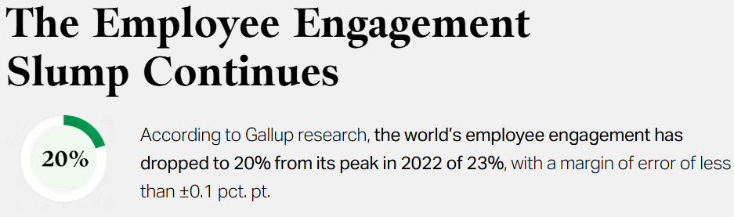
Figure 11: Employee engagement slump
(Source: Gallup, 2026)

2.3 Job architecture model for HUM
The proposed job-design architecture for HUM includes the following overlapping layers.
Layer 1: Foundation of skill-based architecture
Employees are assigned tasks based on their technical skills, leadership abilities, emotional intelligence, and interpersonal skills (Nikou et al. 2022). Employees are assigned a digital skill profile, where their professional skills are updated after each task or project. Around 75% of organisations recruit competency-focused skill set instead of degrees in 2026 (Rusia, 2026). For the HRs of HUM, this helps to proceed with data-informed succession planning, and for employees to remain motivated to improve their performance.
Layer 2: Optimised personnel allocation
Aligning with the concept of “Internal Talent Marketplace”, which is growing at a CAGR of 16.2% till 2034, HUM can employ AI tools that help to assign tasks on the basis of an employee's skill set (Data Intello, 2026). This creates improved scope of cross-team collaboration and refined talent management.
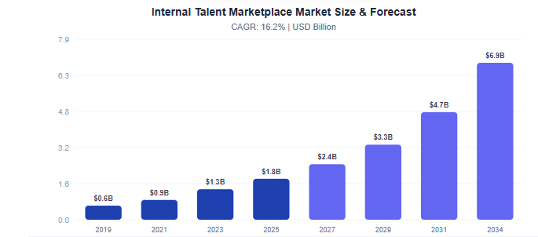
Figure 12: Growth of Internal Talent Marketplace
(Source: Data Intello, 2026)
Layer 3: Job enrichment with career development scope
HUM should allow employee’s autonomy from project initiation till the project is completed, supported by AI monitoring tools. An application of “Job Characteristics Model” shows that job enrichment occurs as a balance between ‘core job characteristics’, ‘critical psychologial states’ and ‘outcomes’ is established (Recruitment and Performance Management, p.8). 40% improved task effectiveness can be achieved as employees work in atmosphere that values autonomy and feedback while allowing application of diverse skills to complete tasks. This may result in improved recruitment practices, reducing the attrition rate, accelerating employee engagement for HUM, and consequently creating future career advancement scope.
Layer 4: Employee empowerment
Aligned with “Job crafting theory”, employees are given autonomy in their task execution, take part in innovative projects as per their skill set. Overall, a culture of continuous learning is established, which fosters creativity.
Expected outcome: A combined application of job-characteristics model, job crafting and skills-based architecture help graduates to become aware of upskilling needs in the evolving business ecosystem to achieve 12%-15% better professional outcomes.
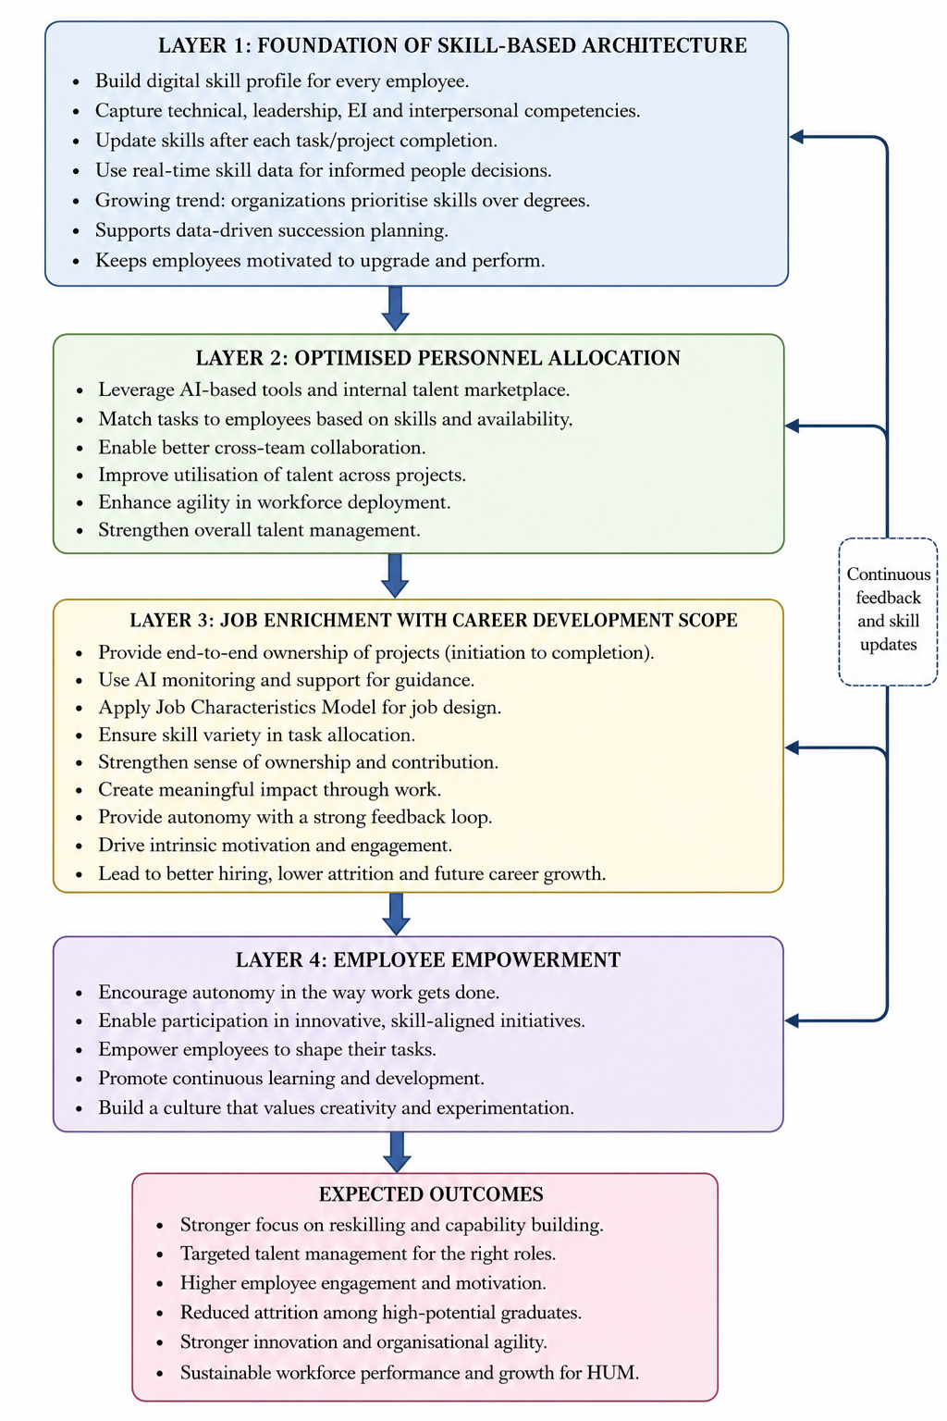
Figure 13: Diagrammatic representation of the proposed job-design architecture
(Source: Self-developed)

2.4 Theoretical support for the model
- Job Characteristics Model
Skill variety
Employees are assignment on the basis of technical complement, prioritising skill-based talent deployment, intentionally, creating scope for increased job motivation and engagement.
Task identity
Employees take control of the project, as leaders become their mentors, enhancing their engagement and productivity.
Task significance
After completion the tasks leave meaningful and lasting impression on employees, which help to foster innovative mindset.
Autonomy
Employees are given full authority in managing their projects and they are empowered in decision-making.
Feedback
The AI-led digital skill profile keeps employees updated about reskilling and upskilling, which not only promotes skill enhancement and career development opportunities, but also improves their performance.
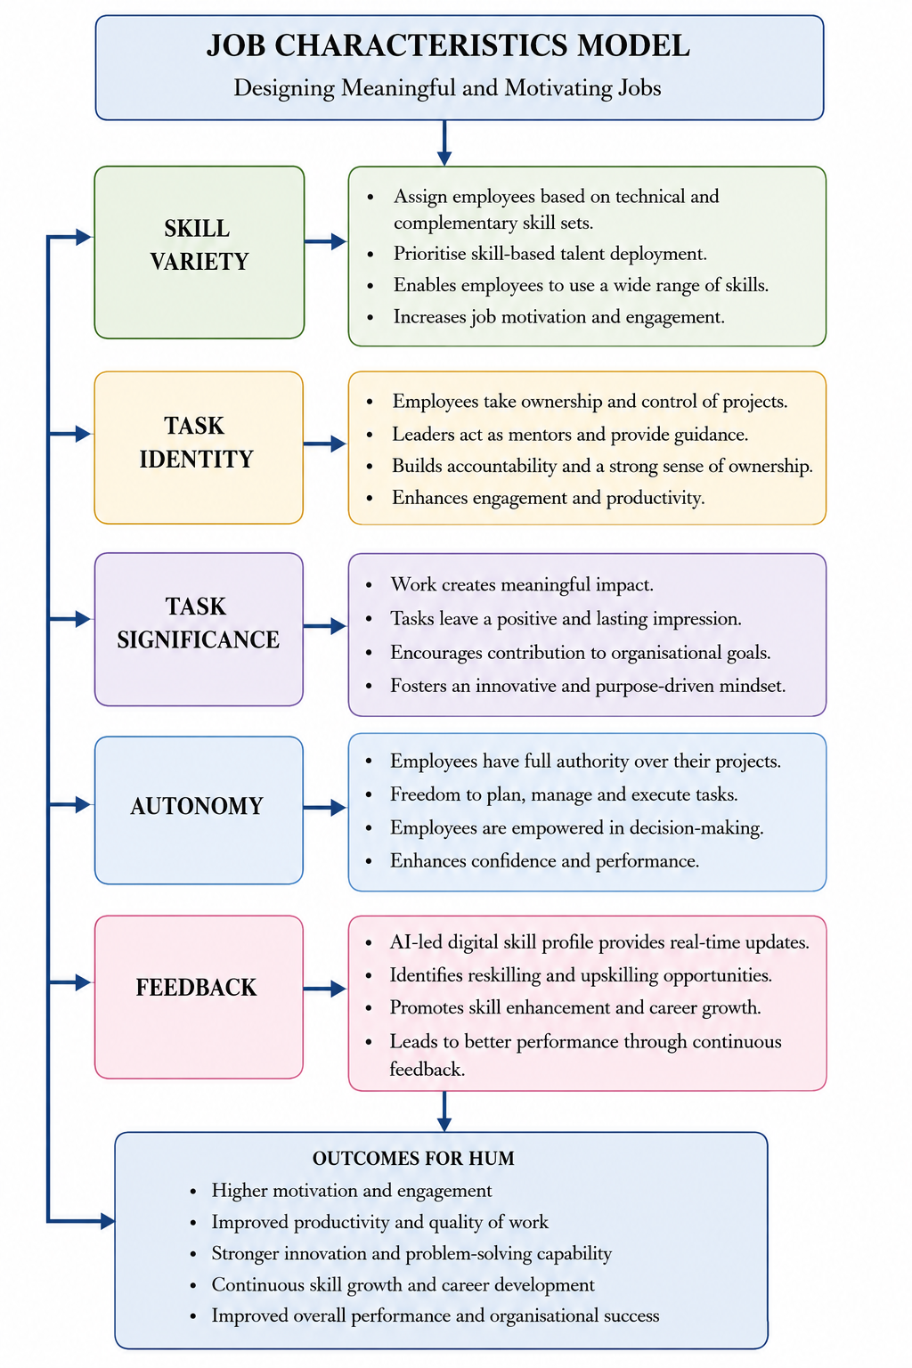
Figure 14: Illustrative representation of Job characteristics model
(Source: Self-developed)
- Job Crafting Strategy
Task crafting
Employees are allowed to take proactive decisions and can reshape their tasks and responsibilities, increasing employee engagement.
Cognitive crafting
The employee-centric job design allows employees to form deep connections with their tasks as they execute their tasks understanding the underlying meaning of their tasks
Relational crafting
On the basis of job nature and responsibilities, the employees form deep interpersonal relationship and informal interactions with colleagues in cross-functional tasks to improve their performance and enhancing knowledge sharing.
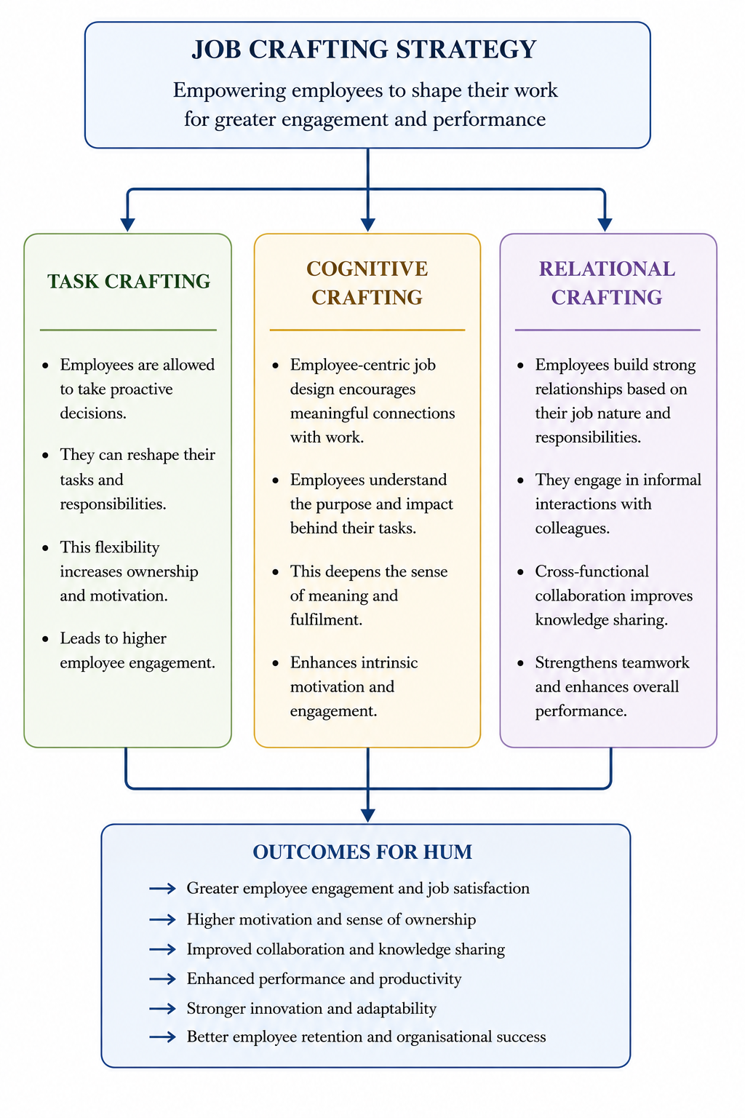
Figure 15: Illustrative representation of Job crafting theory
(Source: Self-developed)

2.5 Stimulating Intrinsic Motivation and Innovation
It is imperative for HUM to drive motivation for the employees from within to increase retention of future leaders. According to Control theory, employees intend to close the gap between their current professional position and their inspirational job positions (Week 1 HCM Lecture, p. 10). A sense of autonomy can make them feel empowered and generate intrinsic motivation. The digital skill profile helps the employees to keep track of their performance, and motivates them to improve their productivity. Consequently, according to the Guest model, HUM should strive to foster mutual trust by strengthening their employee reskilling initiatives to facilitate succession planning to live to the promise they make to the employees (Week 1 HCM Lecture, p. 14). These theories help HUM to encourage employees to improve their engagement and productivity, ultimately reducing attrition rate.

Task C: Reflective Report

3.1 AI as a Decision Support Tool in HR
HR functions are influenced by artificial intelligence (AI) adoption that supports evidence-based decision-making for planning talent acquisition and performance management, as well as employee development strategies. The Deloitte (2026) report indicated 76% of HR leadership cases where piloting or AI adoption has supported HR function, with 64% of improvement cases considering productivity and decision quality. As a specific learning experience, I can say that AI assisted in refining job search so that accurate matches of skills and available jobs can be ensured.
Following the CIPD profession map, evidence-based practice with technology and people orientation is required for situational decision-making with ethical practices. Considering this principle, the predictive capability of AI can support identification of workforce trends and the personalisation of learning interventions, leading to informed decisions among HR professionals (Johnson, 2023). In considering AI as a decision-support tool, key challenges encountered are lack of transparency, algorithmic bias and excessive dependence on automation, which reduce process transparency and employee trust.
Considering the systematic training design model, changes in thinking approach occured as I purposefully applied the learning pathway based on needs assessment, learning, application and evaluation to improve AI capability. Furthermore, knowledge transfer, continuous upskilling and reflective improvement are essential for continuous professional development.

AI Capability | HR Application | Ethical aspect
Predictive Analytics | Planning employee unit | Consideration for organisational context
Screening resume | Recruitment | Limiting algorithmic bias
Sentiment Analysis | Employee engagement | Interpretative management approaches
Analytics for individual learning | Personalised development | Designing career aspirations and operational goals
Scenario Modelling | Strategic planning for HRM | Improved ethical decision-making
Table 6: AI as a decision support tool in HR with ethical aspects
(Source: Rodgers et al., 2023)
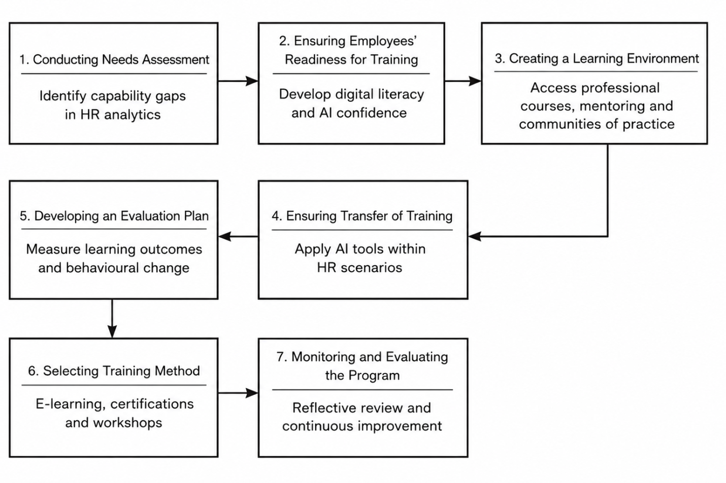
Figure 16: Design of systematic training for AI development in professional development
(Source: Adopted from Week 7)
Considering the Gibbs’ reflective cycle, I have understood that AI has the potential to significantly improve organisational opportunities by considering evidence-based data decisions. Despite the benefits, I maintained cautiousness regarding its ethical risks and algorithmic bias-related challenges. After a critical evaluation and analysis of AI adoption in the HRM process, I consider that AI can be used as a complementary tool in planning HR management and improving performance outcomes without replacing human judgement (Madanchian et al., 2023). Finally, the focus of future application will be on continuous learning, responsible AI application and ethical awareness to enhance professional outcomes.

3.2 Personal Capability Development Plan
Capability area | CIPD professional map domain | Development activity | Timeline
Goal 1: To improve AI and digital HR skills
People analytics and digital HR | Technology and people | Certification course completion  Participation in webinar and workshops | 6 months
Goal 2: Evidence-based critical thinking skills for decision-making
Evidence-based, practical, and analytics | Evidence-based practices | Professional HR and analytics training  Data interpretation and AI workshops | 6-12 months
Goal 3: Ethical leadership capability and strategic analysis of the situation
Ethical decision-making and strategic influence | Professional courage and influence with ethical practice | Participation in a mentoring program  Altered leadership programs and workshops | 12 months
Table 7: Professional development plan focusing on capabilities
(Source: Influenced by Retno et al., 2024)

Reference list
Ab Rahman, M.R.Z.B., (2025). Why Goal Setting Theory is the Most Relevant in Today’s Workforce?. Malaysian Journal of Business, Economics and Management, pp.41-48. https://doi.org/10.56532/mjbem.v4i1.90
Basile, G., Tani, M. and Nevi, G., (2025). Firm socialisation: ambidexterity or new business paradigm?. SINERGIE, 43(1), pp.97-120. https://dx.doi.org/10.7433/s126.2025.05
Chukwuma, I.O., Chukwuma, P.C., Alaefule, F.O. and Alaefule, J.A. (2025). Organizational Socialisation and Employee Engagement. IJBTSR International Journal of Business and Technology Studies and Research, [online] 6(2), pp.11 pages-11 pages. doi:10.5281/zenodo.15076103.
Data Intello, (2026). Internal Talent Marketplace Market. Available at: https://dataintelo.com/report/internal-talent-marketplace-market [Accessed on: 03/07/2026]
Deloitte (2026). Deloitte: In a New Era of Work, Winning Organizations Will Build the Human Advantage. Available at: https://www.deloitte.com/us/en/about/press-room/deloitte-report-winning-organizations-will-build-the-human-advantage.html (Accessed: 27 June 2026)
Diehl, M.R., Kevätsalo, A. and Coyle‐Shapiro, J., (2026). Psychological Contracts With Purpose: A Review and Path Forward. Journal of Organizational Behavior. https://doi.org/10.1002/job.70108
Frögéli, E., Jenner, B. and Gustavsson, P., (2023). Effectiveness of formal onboarding for facilitating organizational socialization: A systematic review. PloS one, 18(2), p.e0281823. https://doi.org/10.1371/journal.pone.0281823
Gallup (2026). Employee Engagement. Available at: https://www.gallup.com/394373/indicator-employee-engagement.aspx (Accessed: 23 June 2026)
Gallup (2026). State of the Global Workplace 2026. Available at: https://www.gallup.com/workplace/349484/state-of-the-global-workplace.aspx (Accessed: 26 June 2026)
Gallup, (2026). State of the Global Workplace 2026. Available at: https://www.gallup.com/workplace/349484/state-of-the-global-workplace.aspx [Accessed on: 05/07/2026]
Johnson, S., (2023). Artificial Intelligence in Workforce Skill Development and Career Mapping. International Journal of Scientific Research in Computer Science, Engineering and Information Technology, 9(5), pp.394-413. https://l1nq.com/chs5yya
Lucas, (2025). Workplace productivity statistics you need to know (2026). Available at: https://www.breeze.pm/articles/workplace-productivity-statistics [Accessed on: 06/07/2026]
Madanchian, M., Taherdoost, H. and Mohamed, N., (2023). AI-based human resource management tools and techniques; a systematic literature review. Procedia Computer Science, 229, pp.367-377. https://doi.org/10.1016/j.procs.2023.12.039
Mir, H., Rana, S., Waqar, A., Fadzil, A.F.M. and Jamil, M., (2024). Navigating the Social Phenomenon: A Strategic Exploration of Social Media Engagement in Social Venture Creation. CARC Research in Social Sciences, 3(1), pp.131-138. https://doi.org/10.58329/criss.v3i1.114
Nejad, Z.Z., Mehdi Sabokro and Eeva-Liisa Oikarinen (2025). Challenges in adopting and using online recruitment tools from employers’ perspective. International journal of organizational analysis. doi:10.1108/ijoa-10-2023-4050.
Nikou, S., De Reuver, M. and Mahboob Kanafi, M., (2022). Workplace literacy skills—how information and digital literacy affect adoption of digital technology. Journal of Documentation, 78(7), pp.371-391. https://doi.org/10.1108/JD-12-2021-0241
Oldham, S., Gay, P. du and Spence, L.J. (2025). Navigating Firm–Stakeholder Conflicts of Values: A Deweyan Ethical Perspective. Business &amp; Society. doi:10.1177/00076503251332223.
Patel, P. and Mohanty, R., (2023). Trends in onboarding improve the employee retention: an in-depth literature review. Journal of Applied Management-Jidnyasa, pp.39-50. https://www.simsjam.net/index.php/Jidnyasa/article/view/173075
Retno, B., Samsuddin, H., Nitawati, E.Y., Soelistya, D. and Putrianti, F.G., (2024). Human resource management strategy the role of managers and career development. Jurnal Ilmiah Manajemen Kesatuan, 12(4), pp.951-960. https://doi.org/10.37641/jimkes.v12i4.2677
Rishabh Rusia, (2026). Top 50 Skills-Based Hiring Trends and Statistics for 2026. Available at: https://www.imocha.io/blog/skills-based-hiring-trends [Accessed on: 04/07/2026]
Rodgers, W., Murray, J.M., Stefanidis, A., Degbey, W.Y. and Tarba, S.Y., (2023). An artificial intelligence algorithmic approach to ethical decision-making in human resource management processes. Human resource management review, 33(1), p.100925. https://doi.org/10.1016/j.hrmr.2022.100925
Thiruppathi, K.T.M., (2026). Business Management. Tamil Nadu: Shanlax Publications.
Urme, U.N., (2023). The impact of talent management strategies on employee retention. International Journal of Science and Business, 28(1), pp.127-146. https://doi.org/10.58970/IJSB.2209
Yakob, R., (2026). Towards a dynamic state-change assessment model of talent development. International Journal of Sports Science & Coaching, 21(3), pp.1403-1417. https://doi.org/10.1177/17479541251364730

