7004 Assignment
Design, conduct and critically evaluate a close-to-practice research project focusing on the model of the transformative teacher in developing practice that has a positive impact on the learner.
2305535
Word count: 4112

Introduction
The aim of this essay is to research what year 6 teachers and TA’s perceive their verbal feedback and how it affects pupil learning. The interest for this essay came from wanting to ensure I use the most effective methods when giving feedback to my learners and identifying the importance of verbal feedback for pupil learning. This links to the PLP due to assessment for learning is one of the pedagogy strands included in the professional standards. Assessment for learning is also highlighted in the Curriculum for Wales documents and the study wished to focus on one aspect to research thoroughly and see how it could improve my future practice.
The research took place in School X. School X has 311 pupils on roll including part-time nursery pupils and 4 specialist teaching facilities for autism and learning difficulties. School X has 55% of children eligible for free school meals (eFSM) and identifies 50% of their pupils with Additional Learning Needs (ALN). Very few of the pupils in School X come from an ethnic minority background and very few speak Welsh at home.
The research for this essay took place within a Year ⅚ class in School X with 22 pupils in the class. The class consists of 1 permanent class teacher and 1 teaching assistant. The class has 4 learners with additional learning needs.

The research question for this case study is:
What are Year ⅚ teachers perceived effectiveness of verbal feedback on pupil learning?

Literature Review
This section will review literature based on findings from academics on verbal feedback in the classroom and the effectiveness on learning.
Porte et al., (2007) states that receiving feedback from a more knowledgeable other is more effective on learning than simply retrieving information. When regularly testing students on their skills, verbal feedback is vital to seeing improvements between tests (Porte et al., 2007). When carrying out a study with student doctors, it was clear from a study that giving constructive verbal feedback between examinations was overall more helpful to the students and left long lasting success for these students (Porte et al., 2007). When reviewing the literature as a whole, the findings of the study were based on the comparison of two feedback methods, verbal and computer generated. The authors were all medical professionals or PhD academics who would be knowledgeable in the area and equipped with experience in carrying out academic studies. The although the literature has high credibility from the evidence provided, the literature was published in 2007 which may be seen as less credible than a recent study.
Similarly, a study using verbal feedback in different scenarios supports the idea that verbal feedback is highly beneficial to learning. A study was carried out, teaching individuals certain movements and providing different groups with feedback at different points (Niznikowski, Sadowski and Mastalerz, 2013). The literature explains that the study found that there was a significant improvement of performance for those who received verbal feedback throughout the process of the learning phase rather than just at the end of the process (Niznikowski, Sadowski and Mastalerz, 2013). This argues that verbal feedback is effective, especially throughout the learning process and it best effective when given at many different points in learning. The paper explains all phases of the research process including giving statistics and figures from the result of the study carried out. The paper was published in 2013 and the study was carried out in the same year, this gives credibility to the source however the findings could be different if studied at a recent date.
A further article that supports the idea of verbal feedback is beneficial to learners is based on a study that discussed the opinions of verbal feedback with learners. The literature suggests that feedback is the idea of being aware of what you already know and what is yet to be learned (Kerr, 2017). The study explored students perception of verbal feedback in their classroom and when they found it most beneficial to them (Kerr, 2017). The learners found they had clarity in their performance and learning when they received verbal feedback and found it beneficial when regularly discussing with their teachers what they knew and what was yet to be learned (Kerr, 2017). The literature has many factors that support its credibility such as providing literature around the focus area of feedback and discussing the strengths and limitations of their findings. The literature was also published in 2017 which makes this a more credible source than literature that may have been published at an earlier date.
In a book surrounding the improvement of verbal feedback for learners in a higher educational setting, it is discussed that learning depends on feedback student receive and that feedback should be efficient and occur regularly (Knight, 2017). The chapter on improving feedback to and from a learner discusses also that due to the expanding educational system, it can potentially be demanding to maintain levels of good quality feedback (Knight, 2017). This literature is credible due to it being written to support practitioners in supporting learners with feedback. The literature is also reliable due to the original literature being published in 1996 and then edited in 2017 to support its reliability further.

All of the literature discussed has drawn positive results of case studies that suggest that verbal feedback is beneficial to learning. All of this literature has relevance to this study because there are discussions and findings from wider scenarios and school scenarios which allows verbal feedback to be studied on a wider scale. The literature has allowed for the research question to be formed because there are positive views and findings from case studies that support the relevance of verbal feedback. Although this literature is supportive to verbal feedback, there are some gaps including the lack of study around this area and also studies based on primary school learning. This case study should strive towards filling these gaps in literature and looking into verbal feedback on an in-depth level in a primary school setting.

Explanation of Case study
Case study research has been described as methodology research that is typical used in real life scenarios such as with a person or group of people (Heale and Twycross, 2018). Case study research allows a researcher to take a broad topic and narrow it down into research questions that are more accessible to investigate (Heale and Twycross, 2018). Case study research allows you to look at relevant literature and other findings of a topic that interests the researcher and then uses data analysis to describe findings to add research to gaps in the field (Hancock, Algozzine and Lim, 2021).
Whilst using case study research could potentially be the most effective way of looking for findings, there are strengths and limitations to using the method (Hancock, Algozzine and Lim, 2021). A strength is that using case study research allows for in-depth understanding of the research topic in a real-life context (Hancock, Algozzine and Lim, 2021). Moreover, case study research allows for new ideas to be generated and for findings to be categorised using a holistic approach with researchers using evidence and literature to explore an outcome (Mcleod, 2019). Some limitations to using case study research is firstly the literature reviewed to support findings can be biased. Researchers could unintentionally introduce bias by selectively choosing research that aligns with how they perceive the research topic (Pannucci and Wilkins, 2011). This could also make the research lack generalizability due to the use of specific literature. A further limitation to case study research includes the limited control from external variables but also the significant time and resources it takes could be challenging and overwhelm researchers (Pannucci and Wilkins, 2011). The limitations to case study research also admit that large volumes of data are collected which can also be time consuming for researchers and this results in data analysis not being as in-depth as possible (Mcleod, 2019). A factor to mention would also be that because case studies often collect data from one person/ category of people it can be difficult to suggest that the investigation supports the circumstances or views of a wider community of people in similar instances (Mcleod, 2019). The participants in this case study included teachers from school X in Year 5/6. School x had an assessment policy with verbal feedback being a highlighted part of the policy for teachers to use when assessing and feeding back to learners.

Research Methods
This research study used two methods of research collection which were questionnaires and observations. To make this research as ethical as possible the questionnaire responses were anonymous and information of the research study and permission forms were given to participants in order for them to be aware of what theme of study they were participating in. These methods were initially chosen because the observations and questionnaires would be of teaching staff which is possibly the best way to collect data without having to have parental consent which can prolong the research process under a smaller timescale. A questionnaire is used in research to ask a series of questions with the intention of gathering information to answer a research question (Mcleod, 2023). Also, a questionnaire can be a cost-effective way for researchers to collect data and it is helpful when sending out a questionnaire for a pilot sample to be sent out to check for reliability (Europe PMC, 2016).
The strengths of using a questionnaire to collect data include that they are efficient in gathering information and practical for gathering information from large populations (Mcleod, 2023). This is also useful for ensuring anonymity for ethical considerations as questionnaires can be sent out electronically. Another strength for using questionnaires to collect data are the types of data that can be collected through the method. Both open- ended and closed-ended questions can be asked to participants through questionnaires meaning both quantitative and qualitative data can be collected (Mcleod, 2023). When gathering this data, questionnaires make it more accessible for researchers to quantify the data, allowing for clear results to be displayed in numerical form (Lindemann, 2023). This is helpful to displaying the data collected and statistical analysis to find trends in the data to understand results. The questions used for this research (Appendix 1) were close ended questions which allowed for the data collected to be easily displayed in a graph which made the findings more accessible to discuss. The questions were short in order for the participants to not get distracted when answering the questions and this also allowed a higher probability for the participants to answer without bias (Lindemann, 2023). The questions were general however this allowed for the response to be clear. The structure of the questionnaire included tick boxes and a scale which could be displayed with ease within a graph.
A further strength of using questionnaires for data collection is the flexibility of the method. Questionnaires can be edited and redistributed if the researcher found it necessary to modify a question for certain circumstances (Lindemann, 2023). This ensures that all questions are relevant and up-to-date should a circumstance occur that the questionnaire would need editing which makes it simple to reinvolve participants over an interview (Lindemann, 2023). During this research, no editing of the questionnaire was needed however this would have been easily accessible due to there being only 4 participants who were relevant to the research.
Questionnaires are an effective way of collecting data however some limitations to the method should be discussed (Mcleod, 2023). With data collection of open and closed ended questions being so accessible with questionnaires, the type of questions used can form limitations. Closed- ended questions can lack detail so participants are not fully sharing their ideas of the research area with open-ended questions being time consuming to collect and analyse for researchers (Mcleod, 2023). This limitation considers that the type of questioning used in questionnaires should be appropriate for the target participants and researchers should acknowledge this before sending it out to participants (Mcleod, 2023). Response bias can also be a limitation to using questionnaires as a research method. Participants could feel compelled to answer questions a certain way depending on the theme of the questionnaire or who the researcher is (Lindemann, 2023). This could be diffused by researchers using samples of responses to present data however this could be difficult depending on the number of responses (Lindemann, 2023).
Observation was the second research method used for this research (see Appendix 2). Observation allows for researchers to complete a study from observing participants in their natural environment (Baker, 2006). Observation allows the researcher to be involved in the field with the possibility of getting to know the environment well in order to achieve the best outcome for research and understand the participants (Baker, 2006).
One of the strengths of observation as a research method is that it is an easy and practical way to gather data (Gilmartin-Thomas, Liew and Hopper, 2018). During the research the observation took place daily in the classroom environment where feedback from teacher to pupil was not limited. This is also a further strength to observation as the research takes place within an environment so the hypothesis is clear and collecting data can be simple (Gilmartin-Thomas, Liew and Hopper, 2018). The research took place in a classroom so the opportunities to observe verbal feedback being given came naturally which supported participants being unable to have bias.
A limitation to using observation as a research method is that key information might be missed due to the researchers focus in certain circumstances (Furst, 1993). The research for this study took place in school x in a classroom of 22 pupils so this limitation could occur as the learners work in focus groups so key data could be missed when a teacher is giving verbal feedback to a pupil.

Data presentation and Analysis method
When presenting the data from the questionnaires completed by the participants, graphs and charts were used. This is because graphs are a clear way to present quantitative data from closed-ended questions and many people describe graphs as the easiest way to present their data for observers (Ehrenberg, 1978). Graphs and tables are described as the core for understanding data in order to make a judgement on a research topic and can strengthen and support the data collected for the reader (Vandemeulebroecke et al., 2018). Using graphs to present data is beneficial in a small research study with less detailed questions making this the ideal way to present the data collected from the questionnaires (Ehrenberg, 1978). For the data retrieved from the questionnaires to contain as much confirmability and trustworthiness as possible, the data was collected using short, simple questions so the participants did not lose focus and the data would be clear to retrieve from the results and present in a graph.
The data from the observation was presented using thematic analysis. Thematic analysis is a method of presenting qualitative data which is displayed by gathering themes in the data and coding them in order for it to be clear for both researcher and reader (Caulfield, 2022). The data collected from the observations was put into themes and then coded in order to discuss the findings appropriately. Thematic analysis is beneficial to presenting data when there is dialogue used for participants to give opinions on a topic (Caulfield, 2022). Thematic analysis is best used to present the data form the observations of this research due to the nature of the research. Dialogue from teachers giving verbal feedback meant that numerical data did not apply to this form of research so presenting the data with quoted from the observations taken was more applicable. To ensure trustworthiness of the data collected, all relevant data collected included direct quotes of what was observed at the time. This made it more accessible to only use relevant information to categorise the data into themes and provide codes for data presentation.

Ethical Considerations
When carrying out research, it should be ensured that everything a researcher involves in the study is carried out ethically (Yip, Han and Sng, 2016). In this study the ethical considerations included information retrieval and participation. Prior to the research process, an ethics form (see appendix 3) was completed in order to gain ethical approval from the ethics board. The process allowed myself to confirm the research process that would be followed and the ethical considerations surrounding this. The research was carried with two methods which included observation and questionnaires. When carrying out this research consent forms were supplied to participants in order for them to be aware of the research being carried out and the requirements of them as participants. Participants were fully informed of the process including the option to opt out at any time without having to disclose a reason.
When participating in the questionnaire, participants were informed that their responses would be anonymous throughout and there would be no way of any other parties having access to their identity or IP address. As approved by the ethics board, the participants of the questionnaires and observations were adults over the age of 18 so there was no parental consent required however consent forms were given to participants both at the time of completing the questionnaire and also the observations so all participants were aware that they were observed. Any data collected from the research process was collected with permission and the participants were non-identifiable at all times. During the research process and continuing after I ensured that I adhered to the UWTSD code of ethics of research standards and data protection protocols and ensured all data was/is anonymous and stored correctly.

Discussion
This section discusses the findings based on the questionnaire and observations carried out for the research study. The data from the questionnaires were displayed in graphs whereas the observational findings were categorised using thematic analysis.
The results from the questionnaires show that the participants mostly believed that verbal feedback was beneficial to pupil learning. Question one suggested that all participants felt they regularly gave verbal feedback to learners throughout the school day.

Figure one: participant results from question one.
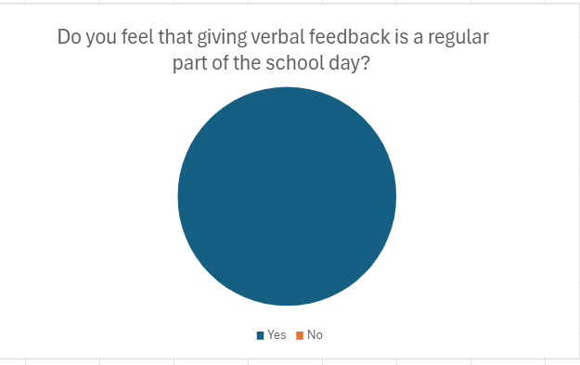

When participants were asked to scale how beneficial verbal feedback was for pupils, all participants opted that verbal feedback was beneficial or extremely beneficial for pupils in their class.

Figure 2: participants results from question two.
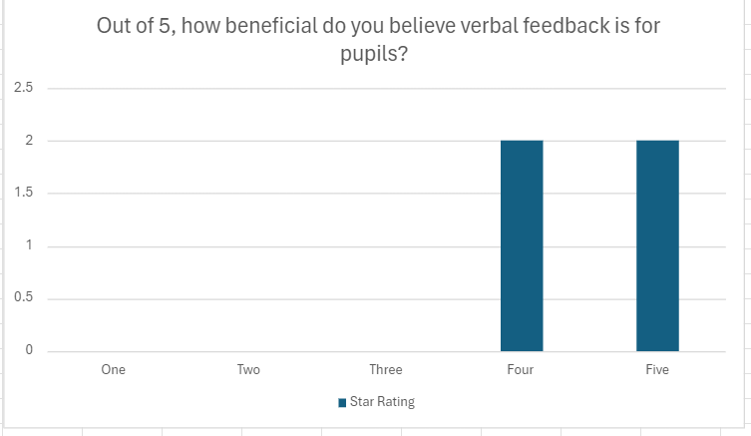
All participants answered question three alluding that they believed that verbal feedback had the most improvements for pupil learning.

Figure three: participants results from question three.
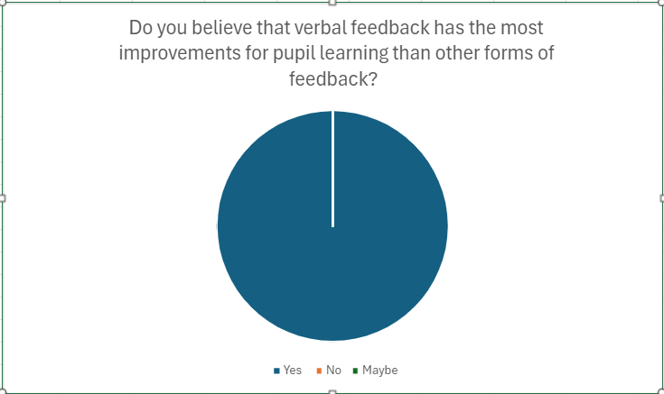

When answering question four, over half of participants displayed that they had been in a situation in their career where verbal feedback was a major factor for a pupil’s improvement in performance.

Figure four: participants results from question four.
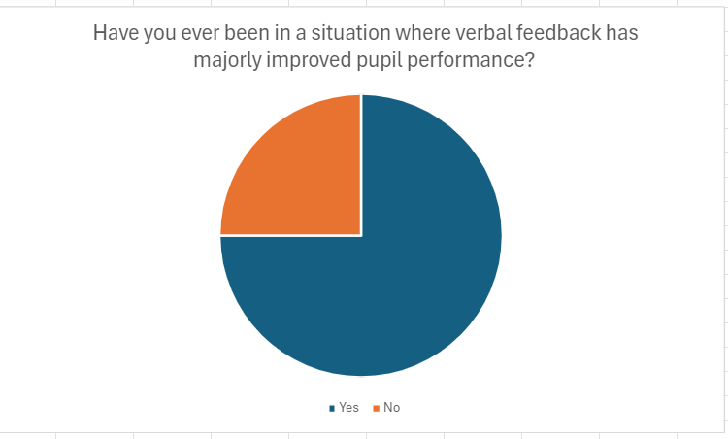

Finally, when the participants were asked if teachers should be given more support or advice on the benefits of verbal feedback, most participants agreed it would be useful to their practice.

Figure five: participants results from question five.
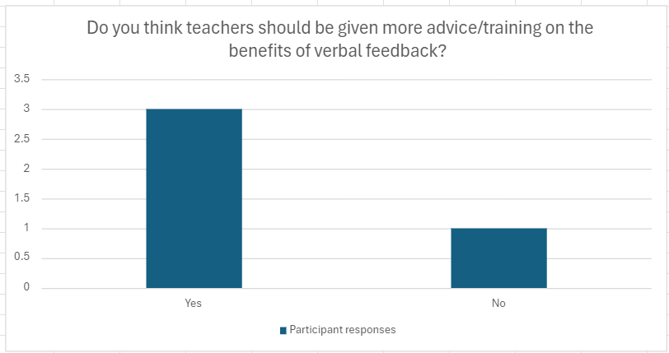
From the results of the questionnaires, it can be gathered that overall participants from school x felt they were using verbal feedback often in their daily teaching with more pupil learning improvement when using this method of feedback. As suggested in literature, giving verbal feedback to learners from a more knowledgeable other is more beneficial to pupil learning (Porte et al., 2007). This suggests that teachers from school x believe verbal feedback to have great effect on pupil learning. It can also be gathered from the data that most teachers from school x believe training and advice on verbal feedback would be beneficial to learners as they could potentially provide better verbal feedback with this advice. This means for school x that teachers value the opportunity for verbal feedback which should reflect in pupil learning.

The observations from this research were carried out over a three-day period. From the observations two main themes were highlighted overall from the data collected.

Verbal feedback given from general work
When the participants observed gave verbal feedback from general classwork, the participants had less written corrections when marking pupil work. This saved time when marking books and allowed pupil and teacher to have greater communication being able to discuss the work in-depth which according to the participants, improved pupil performance in areas such as spellings. When giving verbal feedback from general classroom work, the participants were working in focus groups with the learners. This gave the participants more time to give their feedback and work closely with the learners to correct any misconceptions the learners had. However it should be noted, when observing the participants in general classroom work, the participants focused on these groups specifically meaning pupils doing independent work did not have the same support as those in a focus group.

Verbal feedback given from assessment
This theme was observed from tasks such as weekly spelling and times table testing which were available at the time of observation. The participants gave feedback to pupils individually after the assessments had been self-marked by learners. When observing this, the participants showed that they gave each individual a comment on their assessment score and discussed an area that the learner could work on in future such as specific times tables. This gave the teachers from school x an opportunity to give verbal feedback to the whole class but basing it specifically to the learner.

From the data collected in observations it can be suggested that teachers in school x try to give verbal feedback wherever possible however at times it can be difficult to do this for all pupils in every activity. The data suggests that when teachers from school x do have the opportunity to give verbal feedback they apply it well and teachers mostly support their learners verbally. As literature alludes, giving verbal feedback throughout a learning process rather than at the end is more beneficial to pupil learning (Niznikowski, Sadowski and Mastalerz, 2013). This can be supported in the data where teachers from school x have the opportunity to do this using focus groups where appropriate to the learning to support the learners and give feedback throughout a task.

Conclusions and Recommendations
In reflection of the research study the methods used to collect data would be reliable in the school context when researching the effectiveness of verbal feedback in the classroom. This is due to the relevance of asking teachers who give verbal feedback daily, their feelings on the matter but also observing how they use verbal feedback in the classroom. The methods would be valid due to this reason also. Observations work well in the classroom environment as this is a natural area that verbal feedback would occur and it is beneficial to use a questionnaire in a research study to ensure the anonymity of the participant to gather truthful, non-bias results. The findings from this study would be able to be generalised because many teachers use verbal feedback as an initial method of assessing learning due to the reform of the Assessment for learning with the Curriculum for Wales (Hwb, 2022). When carrying out future research it would be beneficial to have more of an in-depth approach when carrying out a questionnaire and use a range of closed and open-ended questions due to the lack of detail with close-ended questions. When discussing the professional teaching standards, this study linked to the standards due to assessment for learning being one of them. This means that using positive and effective feedback skills allows practitioners to perform good practice aligning with the professional standards.

In light of the research, recommendations that could be made are that teachers could be provided with training and advice to ensure they are feeding back to learners with higher quality feedback and they are more aware of the benefits this has to pupil learning. Another recommendation that could be made from the research is too discover when best to provide verbal feedback opportunities in school and what this means for pupils learning outcomes. The findings of this study could be used in further research to support schools in providing professional learning opportunities to teachers on forms of feedback that would be most beneficial to their learners and what outcomes can potentially arise from good quality verbal feedback.

Reference List
Baker, L., M. (2006). Observation: A Complex Research Method . [online] Library Trends. Available at: https://scholar.google.co.uk/scholar_url?url=https://www.ideals.illinois.edu/items/3831/bitstreams/13598/data.pdf&hl=en&sa=X&ei=65k2ZoqqHYPZsQLY8qXICA&scisig=AFWwaebQn8ufXzSWRacKIaz4dC77&oi=scholarr [Accessed 2024].
Caulfield, J. (2022). How to Do Thematic Analysis | Guide & Examples. [online] Scribbr. Available at: https://www.scribbr.co.uk/research-methods/thematic-analysis-explained/.
Ehrenberg, A.S.C. (1978). Graphs or Tables. The Statistician, 27(2), p.87. doi:https://doi.org/10.2307/2987904.
Europe PMC (2016). Europe PMC. [online] Europepmc.org. Available at: https://europepmc.org/article/med/10095687.
Furst, D.E. (1993). Comparing the strengths and weaknesses of observational and experimental studies using a postmarketing surveillance study as a protypic example. Seminars in Arthritis and Rheumatism, [online] 23(2 Suppl 1), pp.57–61. doi:https://doi.org/10.1016/s0049-0172(10)80008-3.
Gilmartin-Thomas, J.F., Liew, D. and Hopper, I. (2018). Observational Studies and Their Utility for Practice. Australian Prescriber, [online] 41(3), pp.82–85. doi:https://doi.org/10.18773/austprescr.2018.017.
Hancock, D.R., Algozzine, B. and Lim, J.H. (2021). Doing Case Study Research: A Practical Guide for Beginning Researchers. [online] Google Books. Teachers College Press. Available at: https://books.google.co.uk/books?hl=en&lr=&id=G3FEEAAAQBAJ&oi=fnd&pg=PP1&dq=what+is+case+study+research&ots=iqUauBV14o&sig=eDyq1C1WlJTiw6-aBnnFEMcX_fc&redir_esc=y#v=onepage&q=what%20is%20case%20study%20research&f=false [Accessed 3 May 2024].
Heale, R. and Twycross, A. (2018). What Is a Case study? Evidence Based Nursing, 21(1), pp.7–8.
hwb.gov.wales. (2022). Curriculum for Wales: continuing the journey - Hwb. [online] Available at: https://hwb.gov.wales/curriculum-for-wales/curriculum-for-wales-continuing-the-journey#:~:text=curriculum%20and%20assessment.-.
Kerr, K. (2017). Exploring student perceptions of verbal feedback. Research Papers in Education, 32(4), pp.444–462. doi:https://doi.org/10.1080/02671522.2017.1319589.
Knight, P. (2017). Assessment for learning in higher education. London ; New York: Routledge, An Imprint Of Taylor And Francis Group.
Lindemann, N. (2023). 12 Advantages and disadvantages of questionnaires. [online] Pointerpro. Available at: https://pointerpro.com/blog/questionnaire-pros-and-cons/#:~:text=By%20offering%20structured%20responses%2C%20standardized.
Mcleod, S. (2019). Case Study Research Method in Psychology. [online] Simply Psychology. Available at: https://www.simplypsychology.org/case-study.html.
Mcleod, S. (2023). Questionnaire: Definition, examples, design and types. [online] Simply Psychology. Available at: https://www.simplypsychology.org/questionnaires.html.
Niznikowski, T., Sadowski, J. and Mastalerz, A. (2013). The Effectiveness of Different Types of Verbal Feedback on Learning Complex Movement Tasks. Human Movement, 14(2). doi:https://doi.org/10.2478/humo-2013-0009.
Pannucci, C.J. and Wilkins, E.G. (2011). Identifying and Avoiding Bias in Research. Plastic and Reconstructive Surgery, [online] 126(2), pp.619–625. Available at: https://www.ncbi.nlm.nih.gov/pmc/articles/PMC2917255/.
Porte, M.C., Xeroulis, G., Reznick, R.K. and Dubrowski, A. (2007). Verbal feedback from an expert is more effective than self-accessed feedback about motion efficiency in learning new surgical skills. The American Journal of Surgery, 193(1), pp.105–110. doi:https://doi.org/10.1016/j.amjsurg.2006.03.016.
Vandemeulebroecke, M., Baillie, M., Carr, D., Kanitra, L., Margolskee, A., Wright, A. and Magnusson, B. (2018). How can we make better graphs? An initiative to increase the graphical expertise and productivity of quantitative scientists. Pharmaceutical Statistics, 18(1), pp.106–114. doi:https://doi.org/10.1002/pst.1912.
Yip, C., Han, N.-L. and Sng, B. (2016). Legal and ethical issues in research. Indian Journal of Anaesthesia, [online] 60(9), pp.684–688. Available at: https://www.ncbi.nlm.nih.gov/pmc/articles/PMC5037952/.

Appendix

Appendix 1- Questionnaire questions
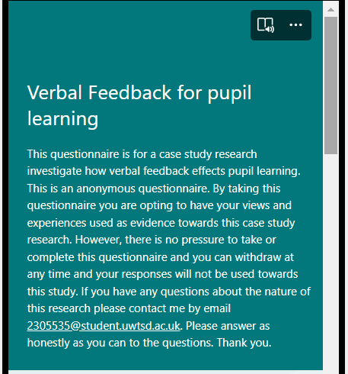

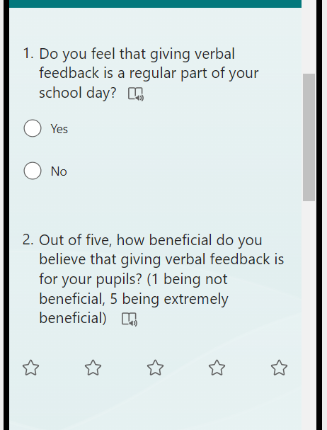

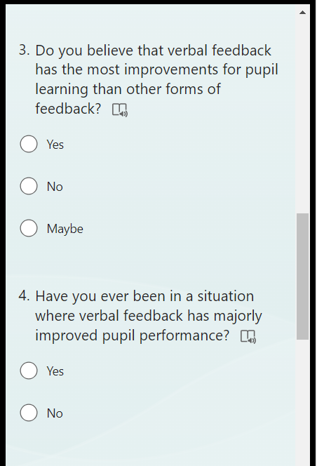

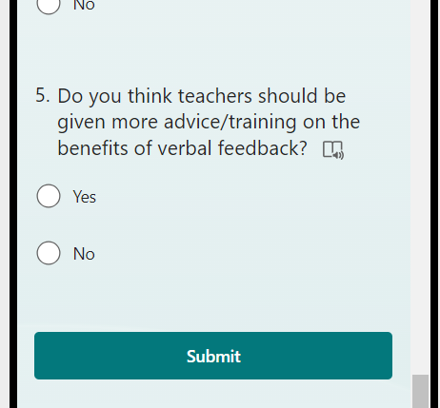

Appendix 2- Observation schedule
Monday- Morning 9:30-11:45 Times table test
Afternoon N/A
Tuesday- Morning 9:30-11:45 Spelling test
Afternoon General work
Wednesday- Morning 9:30-11:45 General work
Afternoon N/A

Appendix 3- Ethics form



