
APPENDIX GA36c

LEVEL 6 ASSESSMENT SPECIFICATION

Student name: |  | Student ID number:
Programme:
Module: | Identity and Myth: The Normans and their World
Module code: | HPHI6009 | Contribution to Overall Module Assessment (%): | 50%
Lecturer: | H Webster | Internal Verifier:
Assignment Title: | Portfolio (C1) | Word count (or equivalent): | 2500
Submission deadline: | 18 April; 25 April | Return date of provisional marks & written feedback: | 25 April; 2 May
Submission method: | All written assessments, where practical and possible, must be submitted via Turnitin unless otherwise instructed by the Lecturer. (Please DO NOT put this assessment specification into Turnitin or it will match many similarities with other students’ submissions.)  Alternative submission method (if applicable):  Late submission of the assessment will result in a late penalty mark. Penalties for late submission: Up to one week late, maximum mark of 40%. Over one week late, 0%. Only the Extenuating Circumstances Panel may approve a change to submission dates.
Academic honesty / referencing: | Academic honesty is required. In the main body of your submission you must give credit to authors on whose research and ideas your work is based. Append to your submission a reference list that indicates the books, articles, etc. that you have used, cited or quoted in order to complete this assessment.

Module Learning Outcomes
(from module syllabus)
By the end of the assessment of the module you should be able to:
• demonstrate a critical understanding of the Normans as a phenomenon;
• demonstrate a critical understanding of the distinctive contribution of the Norman myth to the historiography of the middle ages;
• demonstrate advanced skills in the handling and interpretation of relevant primary source material.

TASK DESCRIPTION

Write 2 Commentaries of 1250 words – one on a textual source, one on a visual source from the selection below.

Dudo of St Quentin, Gesta Normannorum

Chapter 10: Rollo sees the town of Rouen and determines to settle there in fulfilment of his dream-vision
Thus in the eight hundred seventy sixth year from the lord's incarnation, noble Rollo, forsaking the bed of the River Schelde on the advice of his fideles, launched his sails before the ship-bearing winds and came by ship to Jumièges, having traversed the deep where the cerulean whirlpool of the Seine, flowing with its crystal-clear courses and lapping the fragrant grasses of its elevated banks and, going to the open main of the inundating sea, discharges itself, and is often repelled, according to the intervals of the moon, by a more swollen billow of the sea itself. And seeing the monastery of Saint Peter and reckoning the place to be holy and embellished with abodes of monkish habitation, he hesitated to linger there, but steered his ships to the other side of the river, to the chapel of Saint Vedast, and he placed upon the altar of Saint Vedast the body of a certain virgin, Hameltrude by name, which he had carried there with him, and a name from the virgin's name has forever stuck to this chapel. And that place is called at Saint Hameltrude by the residents. Thus the inhabitants of Rouen, poor men and destitute merchants, and the dwellers in that region, hearing that a plentiful multitude of Normans was at Jumièges, came of one mind to Bishop Franco of Rouen, in order to take counsel about what to do. But Franco immediately sent to Rollo, that he might give a guarantee of safety to himself and to those abiding in the district. Truly Rollo, ascertaining that there lingered in the town and in its territory none except a defenceless mass, gave the bishop a guarantee of safety on the strength of his own assurance. And then, pursuing a course of navigation beneficial to himself, he came to Rouen and secured his ships, plentifully furnished with a very large warband, at the gate which is connected to the church of Saint Martin. Moreover, coming down off the ship and surveying the town at a swift pace, he saw its monuments laid in ruins, and large stones torn away from sanctuaries, churches shaken from their foundations and walls smashed on every side, and a small and defenceless band, and he began to be perplexed in spirit. And to fasten his sight in sole contemplation, recalling the vision which he had had beyond the sea.

APOSTROPHE
Oh Rollo, mighty duke and most superior leader,
Through Christ’s gift this town will flourish under your leadership,
It will be built at a future time, once the realm has been calmed by peace,
Once the Franks have been devoured by war, and the populace broken.
Behold the mount of the church where you kept seeing yourself rejoice,
Behold here the font of the bath where you were cleansed of leprosy.
This fatherland is to be built by your followers, themselves renewed in the font.
To the peoples in that town you will give laws and alliances
And rights likewise, with the fear of strict penalty.
Marvellously, then, in the coming time of your descendants
Fierce ages will grow tame, wars having been banished,
And ungodly fury, sitting on its arms, will challenge no one
With its cry, the strength of ungodliness having been undone.
Rather, let the fierce wolf graze at the same time in the sheep's field.

Amatus of Montecassiono The History of the Normans

Book One

[We find in the first chapter of the History of the Normans that] at the end of France there is a plain filled with woods and fruit trees. In this narrow place lived a great number of very robust and strong people who had previously lived on an island called ‘Nora’. And for this reason they were called ‘Normans’ that is men of ‘Nora’, for ‘man’ in the German language is the equivalent of [the French word] ‘home’. This people had increased to such a number that the fields and orchards were not sufficient for producing the necessities of life for so many.

Therefore, they scattered here and there throughout different parts of the world, that is, in various lands and countries [for different countries are called ‘climes’ according to the diverse disposition of heaven]. Abandoning little in order to acquire much, these people departed, but they did not follow the custom of many who go through the world placing themselves in the service of others; rather, like the ancient warriors, they desired to have all people under their rule and dominion. They took up arms, breaking the bond of peace, and created a great army foot soldiers and horsemen. Now we shall tell you how they scattered throughout the world and made their way.

Geoffrey Malaterra The Deeds of Count Roger of Calabria and Sicily and of Duke Robert Guiscard his brother

To all those throughout Sicily to whom the name of bishop or cleric has been assigned, Brother Geoffrey Malaterra signifies himself with the signing of his name. Handed down from the ancient philosophers to the generations who have followed them, the custom has grown up that the deeds of brave men should be recorded in writing and transmitted to posterity. This prevents actions which ought to be remembered, and those who have performed them, being consigned to oblivion; and, even more, it enables those deeds which have been entrusted to writing and are read about and known by future generations, to make those who did them seem to live on through the memory of their lives. So Sallust argues - an author much admired by historians - when he writes at the beginning of his book, saying: 'Every man who wishes to rise superior to the animals should strive his hardest to avoid passing his life in obscurity, like the beasts of the field which go with their faces to the ground and are the slaves of their bellies'.
[ . . . ]
They are a most astute people, eager to avenge injuries, looking rather to enrich themselves from others than from their native fields. They are eager and [indeed] greedy for profit and power, hypocritical and deceitful about almost everything, but between generosity and avarice they take a middle course. Their leaders are however very generous since they wish to achieve a great reputation. They know how to flatter, and are much addicted to the cultivation of eloquence, to such an extent that one listens even to their young boys as though they were trained speakers. And unless they are held in thrall by the yoke of justice, they are a most unbridled people. When circumstances require they are prepared to put up with hard work, hunger and cold; they are much addicted to hunting and hawking, and they delight in fancy clothes and elaborate trappings for their horses and decorations on their other weapons. They derive the name of their land from their own name: north in the English language means 'the northern wind' [aquilonis plaga], and since they come from the north they are called Normans and their land Normandy.

William of Poitiers Gesta Willelmi ducis Normannorum et regis Anglorum
About the same time, Edward, king of the English, who had already appointed William as his heir, and who held him in the same affection as a brother or son, gave more serious evidence of his intentions than before. He decided to anticipate the implacable decree of death, whose approaching hour this man, who aspired to heaven by the saintliness of his life, now felt. In order to confirm his promise by an oath, Edward sent to William Harold, the most prominent of his subjects in wealth, honour and power, and whose brother and nephew had already been given as hostages to ensure this succession. This was a measure of the utmost wisdom because its authenticity and authority would restrain the dissensions among the whole English nation, if - as might be expected from the vagaries and perfidy of their behaviour - they had tried to rebel against it.
Harold, as he was on his voyage to carry out this mission, and had already escaped the dangers of the crossing, landed in Ponthieu, where he fell into the hands of count Guy. He and his attendants were captured and thrown into prison, a misadventure which a man of his standing would willingly have exchanged for shipwreck. For the lure of gain has led certain nations in Gaul into an accursed practice, barbarous and totally foreign to Christian justice. They set ambushes for rich or powerful men, throw them into prison, and submit them to outrages and tortures. Overcome with misfortunes, and almost on the point of death, they are only released on the payment of a huge [sum of money].
Duke William, informed of the fate of the man who had been sent to him, hastily dispatched an embassy and snatched him from prison by prayers and threats, and went to meet him with due honour. Guy behaved well: without being persuaded to do so by the lure of gain or the constraint of force, he led him in person to the castle of Eu, and presented to the duke a man whom he could freely have tortured, killed or sold. As a suitable reward, William gave him vast and rich lands, and added large sums of money as well. As for Harold, William brought him into Rouen, the capital of his principality, with all honour; here his varied hospitality and attention restored and made joyful the men who had suffered such hardship on the way. William doubtless congratulated himself on having a guest of such distinction, an ambassador from his relation and dear friend: he hoped that he would be a faithful mediator between himself and the English, for whom he was second only to the king.
At a gathering at Bonneville, Harold took an oath of faithfulness to him according to the sacred rite of the Christians. And, as highly respected men of the utmost sincerity have related, who were witnesses to the event, in the last item in the oath that was drawn up, he pronounced, clearly and of his own free will, these words: that he would be the agent of duke William at the court of king Edward for as long as the king lived; that he would try with all his authority and power, to ensure for him the possession of the kingdom of England on Edward's death: and that meanwhile, he would hand over the castle of Dover, fortified under his direction and his own expense, to a garrison of the duke's knights; that he would deliver, at the same time, in various places in the kingdom, other castles to be fortified in the duke's orders; and that he would also provide abundantly for the provisioning of the garrisons. The duke, having received Harold as his vassal, and before he had taken this oath, conferred on him, at his request, all the lands he held, with full powers. For it was feared that Edward, who was already ill, would not live much longer. After this, because he knew that Harold was bold and eager for new glory, he provided him and his company with weapons, armour and the finest horses, and took them with him to fight in Brittany. He treated him as a guest and ambassador, but now made him almost one of his companions, in order to strengthen the ties between them by doing him honour. For Brittany had treacherously begun an armed rebellion against Normandy.
...
When he returned to his quarters, the duke, having detained his very dear guest Harold for some time, sent him home loaded with presents, worthy of the rank of the two of them, both of him on whose behalf he had been sent and of him whose honour he had thus increased. In addition, one of the two hostages, his nephew returned with him, freed as a mark of respect to his person

Extracts from the Domesday Survey
INSTRUCTIONS FOR COLLECTION OF THE DOMESDAY RETURNS.
Here is subscribed the inquisition of lands as the barons of the king have made inquiry into them; that is to say by the oath of the sheriff of the shire, and of all the barons and their Frenchmen, and the whole hundred, the priests, reeves, and six villagers of each manor; then, what the manor is called, who held it in the time of King Edward, who holds now; how many hides, how many plowlands in demesne, how many belonging to the men, how many villagers, how many cottagers, how many slaves, how many free-men, how many socmen, how much woods, how much meadow, how many pastures, how many mills, how many fish-ponds, how much has been added or taken away, how much it was worth altogether at that time, and how much now, how much each free man or socman had or has. All this threefold, that is to say in the time of King Edward [the Confessor, 1003?-1066], and when King William [the Conqueror--or the Bastard, c.1028-1087] gave it, and as it is now; and whether more can be had than is had.
Fredrebruge Hundred and half Glorestorp. Godwin, a freeman, held it. Two plowlands of land in the time of King Edward. Then and afterwards 8 villagers; now 3. Then and afterwards 3 cottagers; now 5. At all times 3 slaves, and 30 acres of meadow. At all times 2 plowlands in demesne. Then half a plowland of the men, and now. Woods for 8 swine, and 2 mills. Here are located 13 socmen, of 40 acres of land. When it was received there were 2 riding horses, now 1. At all times 8 swine, then 20 sheep, and it is worth 60 shillings.
There is situated there, in addition, one demesne farm, as the manor of Heuseda. In the time of King Edward, 1 plowland of land; then and afterwards 7 villagers, now 5. At all times 12 cottagers, and 3 slaves, and 40 acres of meadow; 1 mill. Woods for 16 swine and 1 salt pond and a half. Then 1 riding horse, and now 14 swine, 30 sheep, and 50 goats. In this demesne farm are located 3 socmen, of 10 acres of land, and it is worth 30 shillings. The two manors have 2 leagues in length and 4 furlongs in breadth. Whosoever is tenant there, returns 12 pence of the twenty shillings of geld.

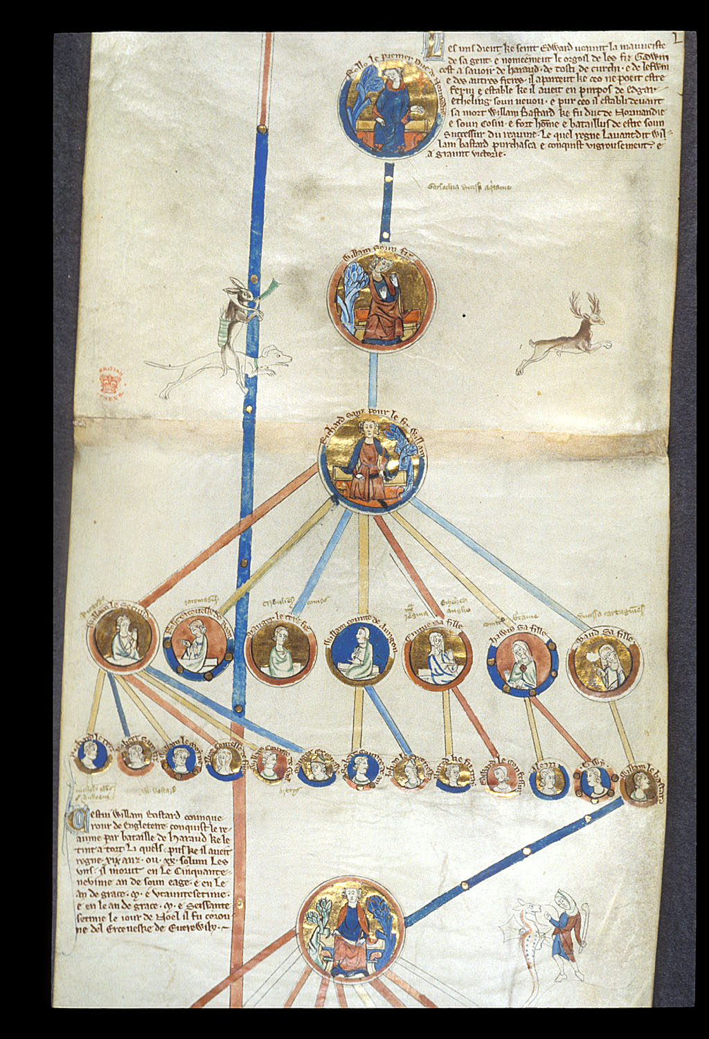
Royal 14 B V: Membrane 4 and 5 Rollo and his descendants

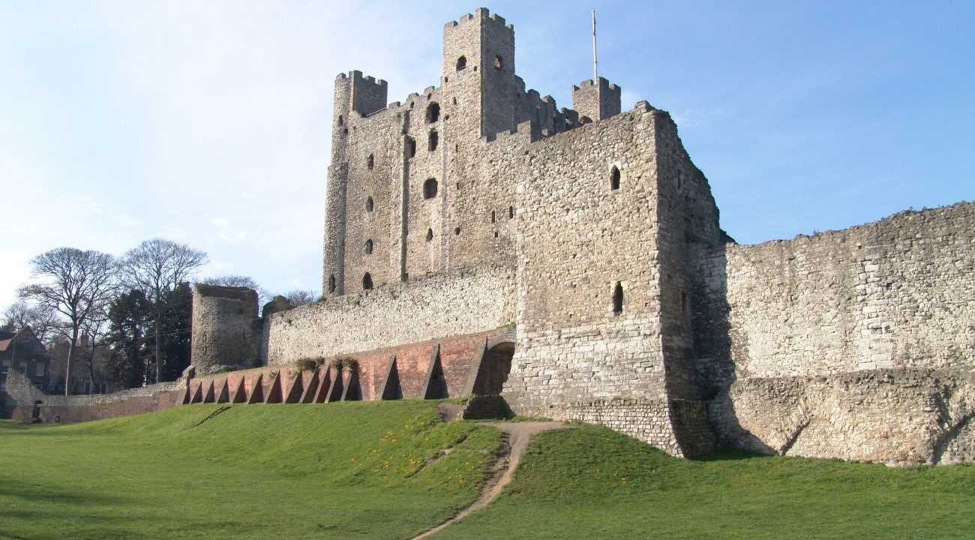 Rochester Castle, England

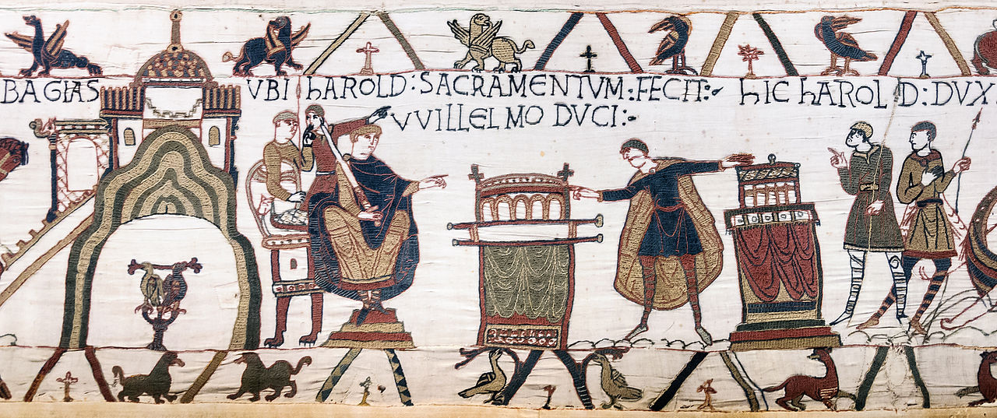
Scene from the Bayeux Tapestry; Harold swears an oath to William

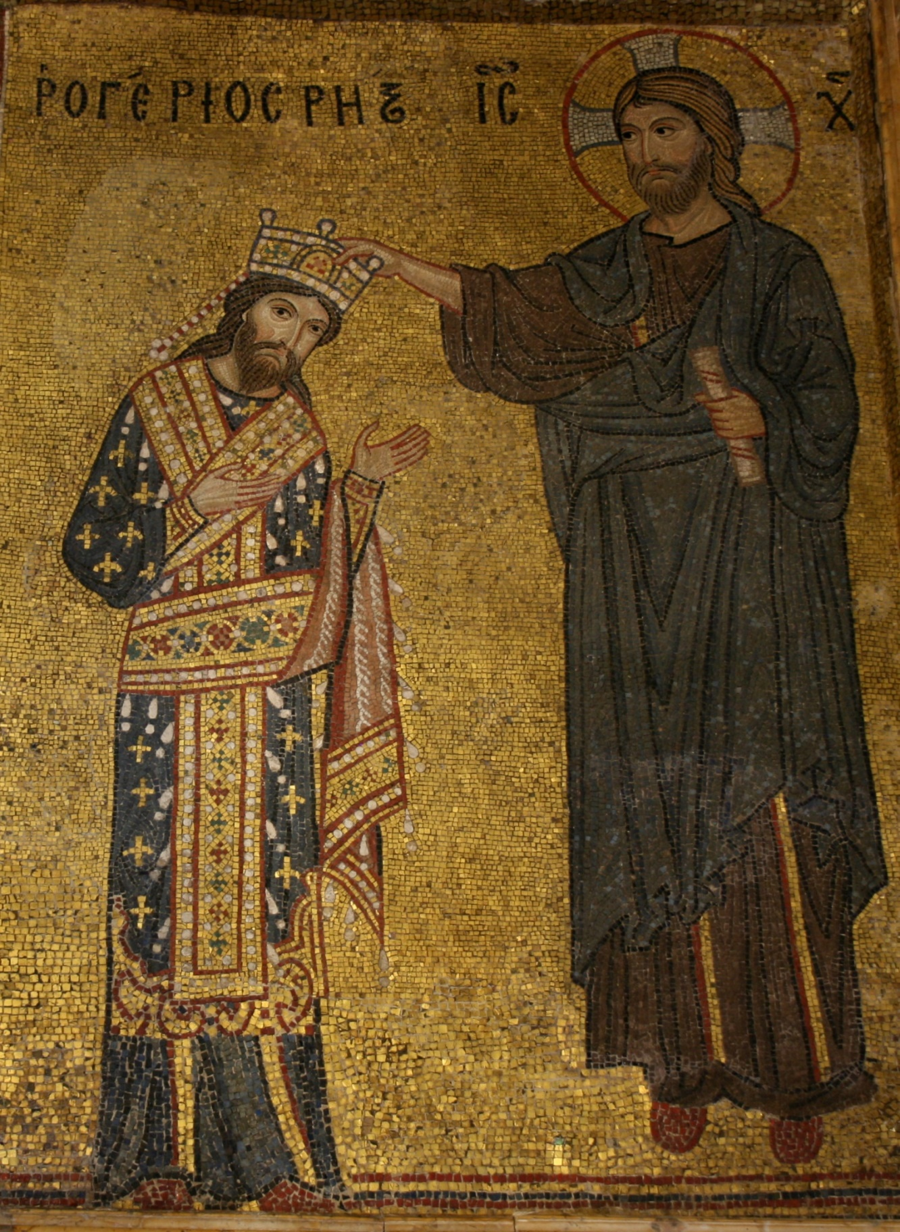
Detail from the mosaic with Roger II receiving the crown from Christ, Martorana, Palermo

GUIDANCE FOR Students IN THE COMPLETION OF TASKS

NOTE: The guidance offered below is linked to the five generic assessment criteria overleaf.

- Engagement with Literature Skills
Your work must be informed and supported by scholarly material that is relevant to and focused on the task(s) set; you should make use of scholarly reviews and primary sources, where appropriate (for example, refereed research articles and/or original materials appropriate to the discipline). You should provide evidence that you have accessed a wide range of sources, which may be academic, governmental and industrial; these sources may include academic journal articles, textbooks, current news articles, organisational documents, and websites. You should consider the credibility of your sources; academic journals are normally highly credible sources while websites require careful consideration/selection and should be used sparingly. Any sources you use should be current and up-to-date, mostly published within the last five years or so, though seminal/important works in the field may be older. You must provide evidence of your research/own reading throughout your work, using a suitable referencing system, including in-text citations in the main body of your work and a reference list at the end of your work.

Guidance specific to this assessment:

- Knowledge and Understanding Skills
At level 6, you should be able to demonstrate coherent and detailed knowledge and a systematic understanding of the subject area, at least some of which is informed by the latest research and/or advanced scholarship within the discipline. You should be aware of the uncertainty, ambiguity and limits of knowledge. Your work must demonstrate the growing extent of your knowledge and systematic understanding of concepts and underlying principles associated with the subject area. Knowledge relates to the facts, information and skills you have acquired through your learning. You demonstrate your understanding by interpreting the meaning of the facts and information (knowledge). This means that you need to select and include in your work the concepts, techniques, models, theories, etc. appropriate to the task(s) set. You should be able to explain the theories, concepts, etc. meaningfully to show your understanding. Your mark/grade will also depend upon the extent to which you demonstrate your knowledge and understanding; ideally each should be complete and detailed, with comprehensive coverage.

Guidance specific to this assessment:

- Cognitive and Intellectual Skills
You should be able to: critically evaluate evidence, arguments, assumptions, abstract concepts and data some of which are at the forefront of a discipline (and that may be incomplete) to devise and sustain arguments, to make judgements and/or solve problems; describe and comment upon particular aspects of current research, or equivalent advanced scholarship, in the discipline Your work must contain evidence of logical, analytical thinking, evaluation and synthesis. For example, to examine and break information down into parts, make inferences, compile, compare and contrast information. This means not just describing what! But also justifying: Why? How? When? Who? Where? At what cost? At all times, you must provide justification for your arguments and judgements. Evidence that you have reflected upon the ideas of others within the subject area is crucial to you providing a reasoned and informed debate within your work. Furthermore, you should provide evidence that you are able to make sound judgements and convincing arguments using data and concepts. Sound, valid conclusions are necessary and must be derived from the content of your work. Where relevant, alternative solutions and recommendations may be proposed.

Guidance specific to this assessment:

- Practical Skills
At level 6, you should be able to apply the methods and techniques that you have learned to review, consolidate, extend and apply your knowledge and understanding, and to initiate and carry out projects. You will deploy accurately established techniques of analysis and enquiry relevant to the discipline, and apply them in complex and unpredictable contexts, to devise and sustain arguments and/or to solve problems. You should be able to frame appropriate questions to achieve a solution - or identify a range of solutions. You should be able to demonstrate how the subject-related concepts and ideas relate to real world situations and/or a particular context. How do they work in practice? You will deploy models, methods, techniques, and/or theories, in that context or circumstances, to assess current situations, perhaps to formulate plans or solutions to solve problems, or to create artefacts, some of which may be innovative and creative. This is likely to involve, for instance, the use of real world artefacts, examples and cases, the application of a model within an organisation and/or benchmarking one theory or organisation against others based on stated criteria. You should show awareness of the limitations of concepts and theories when applied in particular contexts.

Guidance specific to this assessment:

- Transferable Skills for Life and Professional Practice
Your work must provide evidence of the qualities and transferable skills necessary for graduate-level employment requiring the exercise of initiative and personal responsibility and decision-making in complex and unpredictable circumstances. This includes demonstrating: the learning ability for professional development to advance existing skills and acquire new competences of a professional nature that will enable you to assume significant responsibility within organisations; that you can initiate and complete tasks and procedures, whether individually and/or collaboratively; that you can use appropriate media to effectively communicate information, arguments and analysis in a variety of forms to specialist and non-specialist audiences; fluency of expression; clarity and effectiveness in presentation and organisation. Work should be coherent and well-structured in presentation and organisation.

Guidance specific to this assessment:

Student FEEDBACK FORM

This section details the extent to which the assessment criteria are demonstrated by you, which in turn determines your mark. The marks available for each category of skill are shown. Lecturers will use the space provided to comment on the achievement of the task(s), including those areas in which you have performed well and areas that would benefit from development/improvement.

Generic Assessment Criteria | Marks available | Marks  awarded
1. Engagement with Literature Skills
.
2. Knowledge and Understanding Skills

3. Cognitive and Intellectual Skills

4. Practical Application Skills

5. Transferable Skills for Life and Professional Practice

Assessment Mark (Assessment marks are subject to ratification at the Exam Board. These comments and marks are to give feedback on module work and are for guidance only until they are confirmed. ) | Late Submission Penalties (tick if appropriate) |  | %
 | Up to 1 week late (40% Max) |  | %
 | Over 1 week late (0%) |  | %

GENERIC ASSESSMENT CRITERIA

Level 6
In accordance with the Framework for Higher Education Qualifications, at the end of Level 6 students should have coherent and detailed knowledge and a systematic understanding of their subject area, at least some of which is informed by the latest research and/or advanced scholarship within the discipline. They will be able to accurately deploy established techniques of analysis and enquiry within a discipline, using their conceptual understanding to devise and sustain arguments and/or to solve problems. They should be aware of the uncertainty, ambiguity and limits of knowledge. They should be able to critically evaluate evidence, arguments, assumptions, abstract concepts and data (that may be incomplete), to make judgements, and to frame appropriate questions to achieve a solution - or identify a range of solutions. They will apply the methods and techniques that they have learned to review, consolidate, extend and apply their knowledge and understanding, and to initiate and carry out projects. They will have the ability to manage their own learning, and to make use of scholarly reviews and primary sources (for example, refereed research articles and/or original materials appropriate to the discipline). They will demonstrate the qualities and transferable skills necessary for employment requiring: the exercise of initiative and personal responsibility; decision-making in complex and unpredictable contexts; the learning ability needed to undertake appropriate further training of a professional or equivalent nature.

Level 6 | FAIL | MARGINAL FAIL | SATISFACTORY  (3rd / Pass) | GOOD  (2.2 / Pass) | VERY GOOD  (2.1 / Merit) | EXCELLENT  (1st / Distinction) | EXCEPTIONAL  (1st / Distinction)
Category | 0-29% | 30-39% | 40-49% | 50-59% | 60-69% | 70-84% | 85-100%
Engagement with literature (including reading, referencing,  academic conventions and  academic honesty) | Little or no evidence of reading and/or reliance on inappropriate sources.  Views and findings mostly unsupported and non-authoritative.  Referencing conventions used incoherently or largely absent. | Poor engagement with essential reading. No evidence of wider reading. Reliance on inappropriate sources, and/or indiscriminate use of sources. Heavily reliant on information gained through class contact. Inconsistent and weak use of referencing. | Engagement with a limited range of mostly relevant and credible sources. Some omissions and minor errors.  Referencing conventions evident though not always applied accurately or consistently. | Engagement with an appropriate range of research-informed literature, including sources retrieved independently. Some over-reliance on texts. Referencing may show minor inaccuracies or inconsistencies. | Engagement with a wide range of research-informed literature, including sources retrieved independently.  Selection of relevant and credible sources. Very good use of referencing, with no/very few inaccuracies or inconsistencies. | Engagement with an extensive range of relevant and credible literature, informed by the latest research. Consistently accurate application of referencing. | Exceptional engagement with an extensive range of relevant and credible literature, informed by the latest research. High-level referencing skills consistently and professionally applied.
Knowledge and understanding (Coherent and detailed knowledge and systematic understanding of the subject area, at least some of which is informed by the latest research and/or advanced scholarship within the discipline.) | Major gaps in knowledge and systematic understanding of the subject matter. Substantial inaccuracies. No awareness of knowledge of the latest research and/or advanced scholarship within the discipline. | Gaps in knowledge, with only superficial systematic understanding. Some significant inaccuracies and/or irrelevant material. No awareness of knowledge of the latest research and/or advanced scholarship within the discipline. | Limited knowledge and systematic understanding of the relevant concepts and principles within the subject area which to some limited extent, is informed by current research and scholarship. | Knowledge is reasonably detailed, accurate with a good systematic understanding of the field of study and to some extent, current research and scholarship. | Knowledge is reasonably extensive coherent and detailed. Exhibits very good understanding of the breadth and depth of established views, and the work is, at least in part, well-informed by current research and scholarship. | Excellent coherent and detailed knowledge and systematic understanding of the principles and theories of current research and scholarship. Clear awareness of challenges to established views and the limitations of the knowledge base. | Exceptionally coherent and detailed knowledge and systematic understanding of the principles and theories of the subject, well-informed by current research and scholarship. A critical, sophisticated and nuanced awareness of the ambiguities and limitations of knowledge.
Cognitive and intellectual skills  (Conceptual and critical thinking, analysis, synthesis and evaluation of research, assumptions, abstract concepts and data (that may be incomplete); logic, argument and judgement.) | Wholly or almost wholly descriptive work. Little or no analysis, synthesis or evaluation.  Failure to develop arguments, leading to illogical or invalid judgements. Unsubstantiated generalisations, made without use of any credible evidence. | Largely descriptive work, with superficial use of critical evaluation. Weak development of arguments and judgements. Information accepted uncritically, uses generalised statements made with scant evidence and unsubstantiated opinions. Ideas sometimes illogical and contradictory. | Limited attempt at critical thinking, analysis, synthesis and evaluation, tending towards description.  Some evidence to support emerging arguments and judgements but these may be underdeveloped or with a little inconsistency / mis-interpretation.  Asserts rather than argues a case. | Some critical thinking, analysis, synthesis and evaluation. Can analyse new and/or abstract concepts and data without guidance.  An emerging awareness of different stances and ability to use evidence (that may be incomplete) to support the argument.  Mostly valid arguments and logical judgements. Some tendency to assert/state opinion rather than argue on the basis of reason and evidence. | Sound critical thinking, analysis, synthesis and evaluation demonstrating critical thinking. Ability to devise and sustain persuasive arguments, and to review the reliability, validity and significance of evidence (that may be incomplete) to make mostly appropriate and valid judgements. | Excellent critical thinking, analysis, synthesis and evaluation. Ability to investigate contradictory or incomplete information and make strong, persuasive, arguments and sophisticated judgements. Some evidence of independent thought and ability to ‘see beyond the question’, suggesting a grasp of the broader field and wider concepts. | Exceptional critical thinking, analysis, synthesis and evaluation based on judiciously selected evidence.  Ability to investigate contradictory or incomplete information and make strong, persuasive, arguments and sophisticated, nuanced, judgements. Evidence of independent thought and ability to ‘see beyond the question’, suggesting an outstanding grasp of the broader field and wider concepts.
Practical skills  (Apply/deploy accurately established tools and techniques; initiate and carry out projects; formulate solutions to solve problems in complex and unpredictable contexts.) | Limited or no use of methods, materials, tools and/or techniques.  Little or no appreciation of the context of the application.  Limited understanding of the application of theory to practice or making appropriate links between the two.  Very weak problem-solving skills in complex and unpredictable contexts. | Rudimentary application of methods, materials, tools and/or techniques but without consideration and competence. Flawed appreciation of the context of the application.  Weak understanding of the application of theory to practice, with only occasional evidence of making appropriate links between the two. Weak problem-solving skills in complex and unpredictable contexts. | An adequate awareness and mostly appropriate application of well-established methods, materials, tools and/or techniques.  Basic appreciation of the context of the application. Theoretical knowledge and understanding applied in practice, but not always making logical links between the two.  Can identify problems and propose basic solutions in complex and unpredictable contexts without fully appreciating the complexity. | A good and appropriate application of standard methods, materials, tools and/or techniques.  Clear appreciation of the context of the application. Mainly consistent, accurate and logical application of theory to practice, making appropriate links between the two  Can identify problems and propose mostly appropriate solutions in complex and unpredictable contexts. | A very good application of a range of methods, materials, tools and/or techniques.  Very good consideration of the context of the application, with perceptive insights. Can identify problems and propose appropriate solutions in complex and unpredictable contexts.  Evidence of some innovation and creativity. | An advanced application of a range of methods, materials, tools and/or techniques.  The context of the application is well considered, and insightful.  Application and deployment extend beyond established conventions. Can identify complex problems and propose excellent solutions. Innovation and creativity evident. | Exceptional levels of application and deployment skills in unpredictable, practical contexts, drawing skilfully on the latest research within the discipline. Can identify complex problems and propose sophisticated solutions. Assimilation and development of cutting edge processes and techniques.
Transferable skills for life and professional practice  (Exercise of initiative and personal responsibility; professional development; initiate and complete tasks and procedures: individually and/or collaboratively; use appropriate media to communicate effectively; fluency of expression; clarity and effectiveness in presentation and organisation.) | Communication medium is inappropriate or misapplied.  Work is poorly structured, disorganised and/or confusingly expressed. Very weak use of language and/or very inappropriate style. Little or no evidence of autonomy (or collaboration, where relevant) in the completion of tasks. Little or no evidence of the skills required in graduate employment. | Communication medium is poorly designed and/or not suitable for the audience.  Work is poorly presented in a disjointed manner. It is loosely, and at times incoherently, structured, with information and ideas often poorly expressed. Weak use of language and/or inappropriate style. Weak independent initiative (or collaboration, if relevant). Limited evidence of the skills required in graduate employment. | Can communicate in a suitable medium but with some room for improvement.  Mostly ordered presentation and structure in which relevant ideas / concepts are reasonably expressed. Work may lack coherence in places. Can work as part of a team, but with limited involvement in group activities.  Demonstrates the basic skills required in graduate employment, with some areas of minor weakness. | Can communicate effectively in a suitable format, but may have minor errors.  Mostly coherent, organised work, in a suitable structure and is for the most part clearly expressed. Can work effectively independently and/or as part of a team, with clear contribution to group activities.  Demonstrates the skills required in graduate employment, with some areas of strength and some of minor weakness. | Can communicate well, confidently and consistently in a suitable format.  Work is coherent, fluent, well-structured and organised. Can work very well autonomously and/or as part of a team, with very good contribution to group activities.  Demonstrates very good graduate employment skills, with just occasional minor weakness. | Can communicate professionally confidently and consistently in a suitable format.  Work is coherent, very fluent and is presented professionally. Can work autonomously with initiative. Where relevant can work professionally within a team, showing leadership skills as appropriate, managing conflict and meeting obligations. Demonstrates excellent graduate employment skills and an appetite for further development. | Can communicate with an exceptionally high level of professionalism.  Work is exceptionally coherent, very fluent and is presented professionally. Can work exceptionally well and professionally within a team, showing advanced leadership skills. Demonstrates exceptional graduate employment skills and an appetite for further development.

THIS DOCUMENT IS ALSO AVAILABLE IN WELSH

