Personal Development Portfolio

Name: Rajwinder Kaur
Student Number: 2432689
Module Code & Title: LCHS4009 Professional Development within Health and Social Care
Lecturer: Olubukola Adegbite
Assignment Title: Career Portfolio

Chosen Job Advertisement

Healthcare Assistant (Zero Hour) – Birmingham
Employer: Prometheus Safe and Secure
Salary: £14–£16 per hour
Contract: Bank / Part-time
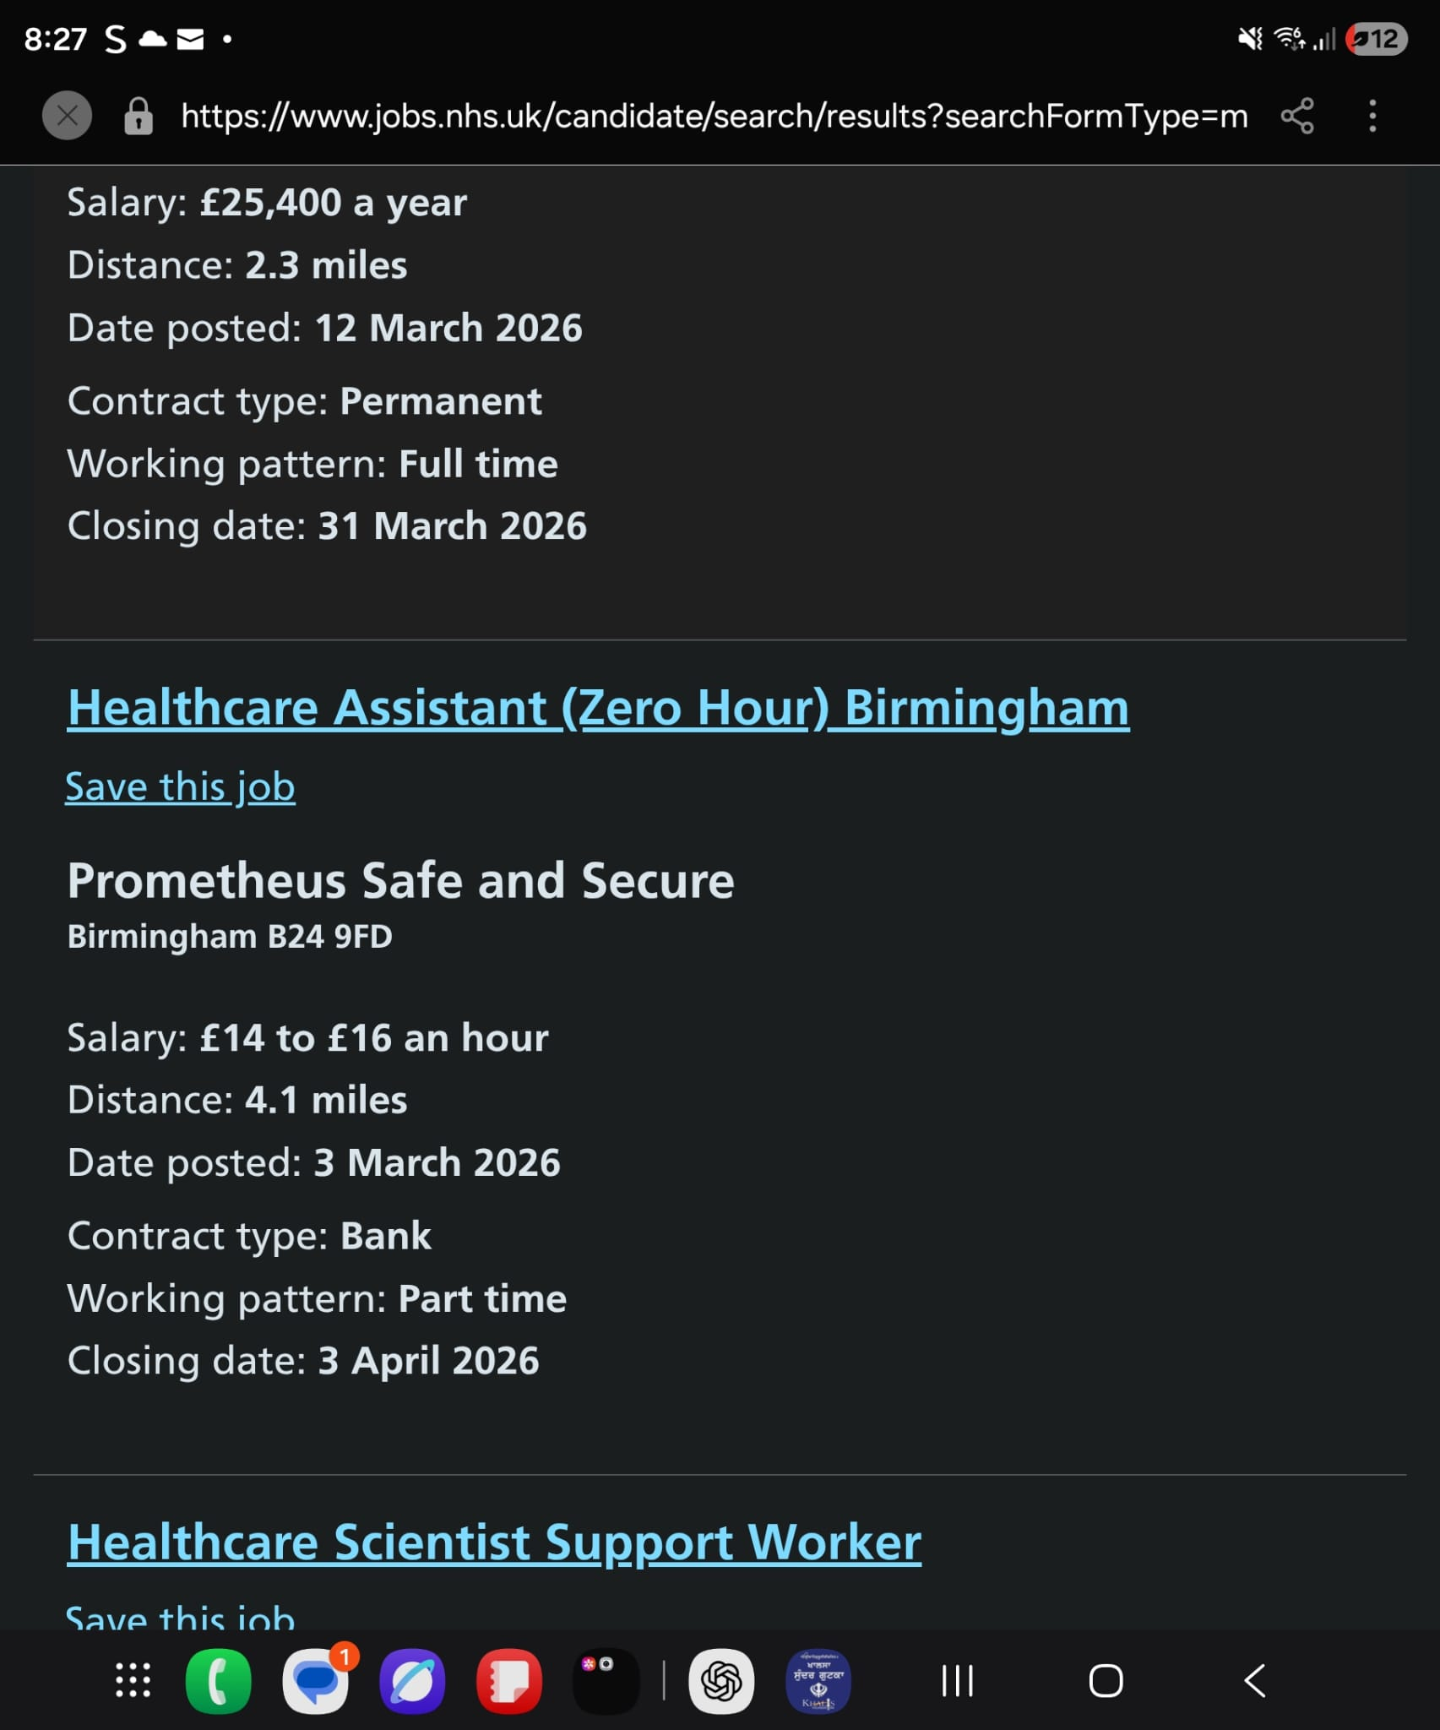

Task 1: Curriculum Vitae

Rajwinder Kaur
Address: 35 Achal Close, CV4 4PRE
Phone: 07305339011
Email: Tinakaur26@gmail.com

Personal Profile
A compassionate and motivated Health and Social Care student with experience in care settings. I am committed to providing person-centred care, promoting dignity, and supporting individuals with their daily needs. I am reliable, hardworking, and able to work effectively both independently and as part of a team.

Education
Level 4 Health and Social Care, UWTSD (2024)
- Studied safeguarding, communication, equality and diversity, and care values

GCSEs
- English and Maths

Work Experience
Volunteer Care Assistant, RSD Healthcare (2025)
- Assisted with personal care and mobility support
- Supported emotional wellbeing of service users
- Followed care plans and health and safety procedures
- Maintained hygiene and infection control standards

Key Skills
- Communication: Clear and respectful interaction with patients
- Teamwork: Ability to work effectively with colleagues
- Empathy: Understanding and responding to patient needs
- Organisation: Good time management and task prioritisation

Achievements
- Successfully completed coursework
- Positive feedback from placement supervisors

Interests
- Volunteering
- Community involvement
- Health and wellbeing

References
Available upon request

Task 2: Personal Statement

I am applying for the Healthcare Assistant role because I am passionate about helping people and improving their quality of life. My long-term career goal is to become a registered nurse, and this role will help me gain valuable experience in the healthcare sector.

Through my Health and Social Care studies, I have developed knowledge of person-centred care, safeguarding, communication, and equality. Person-centred care ensures that individuals are treated with dignity and respect (NHS, 2024). I understand the importance of maintaining confidentiality and supporting individuals according to their needs.

During my volunteering experience, I supported individuals with daily activities such as mobility and emotional support. This helped me develop strong communication skills and the ability to work with vulnerable individuals. I learned how to respond to different situations in a calm and professional manner.

One of my key strengths is my caring and empathetic nature. I am patient and understanding, which helps me build trust with patients. I am also reliable and organised, ensuring tasks are completed efficiently. I can work well as part of a team and understand the importance of collaboration in healthcare settings (Skills for Care, 2023).

I believe I would be a valuable employee because I am motivated and willing to learn. I am committed to providing high-quality care and supporting patient wellbeing. I am flexible and able to work different shifts, which is important for this role.

In conclusion, I am enthusiastic about starting my career as a Healthcare Assistant. I am confident that my skills, experience, and personal qualities make me suitable for this role.

Task 3a: SWOT Analysis

Strength – Communication: I communicate clearly and respectfully, which helps build trust with patients and colleagues.

Weakness – Experience: I have limited professional experience, but I am actively working to improve this through volunteering and training.

Opportunity – Training: Opportunities in healthcare will allow me to gain new skills and progress in my career.

Threat – Competition: There is high competition for healthcare roles, which means I must continue improving my skills.

Task 3b: Personal Development Plan

Goal 1: Improve communication skills (6 months)
Action: Attend workshops and practise during placements
Monitoring: Feedback from supervisors

Goal 2: Gain more practical experience (1 year)
Action: Apply for part-time roles and volunteering
Monitoring: Record experience and feedback

Goal 3: Progress to nursing career (2 years)
Action: Apply for university nursing course
Monitoring: Track application progress and results

Task 4: Reflection

Description:
I completed a presentation as part of my assessment. I used slides to explain key information about my topic and aimed to communicate clearly with the audience.

Feelings:
At the beginning, I felt nervous and lacked confidence. However, as I continued presenting, I became more comfortable. I felt proud that I completed the presentation successfully.

Evaluation:
One strength of my presentation was that my content was clear and well organised. My slides supported my points effectively. However, I relied too much on my notes and did not maintain enough eye contact with the audience.

Analysis:
The feedback from my lecturer highlighted that I need to improve my confidence and communication skills. According to Gibbs (1988), reflection helps individuals learn from experience and improve future performance. My lack of eye contact may have reduced audience engagement, which is an important skill in both presentations and healthcare communication.

Conclusion:
I learned that preparation and practice are important for building confidence. I also realised that communication skills are essential in healthcare roles.

Action Plan:
In the future, I will practise presentations more, reduce reliance on notes, and improve eye contact. I will also seek feedback to continue improving my skills.

References

Gibbs, G. (1988) Learning by Doing: A Guide to Teaching and Learning Methods. Oxford: Oxford Polytechnic.

NHS (2024) Healthcare assistant role. Available at: https://www.jobs.nhs.uk (Accessed: 23 March 2026).

Skills for Care (2023) Working in care. Available at: https://www.skillsforcare.org.uk (Accessed: 23 March 2026).

