Chinese balloons over North America

  - L5 - Electromagnetic Radiation (ACDA5009)

James Howe
1910319
UWTSD

Wales Institute for Science and Art
University of Wales Trinity Saint David



Contents
1. Background 3
2. Issue 4
3. Recommendation 4
4. Timing 4
5. Discussion 4
5.1 EMR Spectrum Analysis 5
5.1.1 Gamma Ray 5
5.1.2 X-ray 6
5.1.3 Ultraviolet 6
5.1.4 Visible 7
5.1.5 Infrared 7
5.1.6 Microwave 7
5.1.7 Radio 8
5.2 Surveillance 8
5.3 Test of Response 8
6. Appendix 8
7.1 References 9

1. Background
A high-altitude balloon was spotted in North American airspace between the 28th of January and the 4th of February 2023 that was determined to be Chinese-operated. China claimed it was a civilian weather balloon that was used for “mainly meteorological” purposes [1].
High-altitude balloons are usually filled with helium or hydrogen that can attain an altitude in the range of 18 and 37km, for reference commercial airliners operate at 12km (40,000 ft).
An F-22 fighter jet shot down the balloon with an AIM-9 Sidewinder air-to-air missile on the 4th of February 2023 over the Atlantic Ocean where Navy divers recovered the sunken debris for analysis [2].
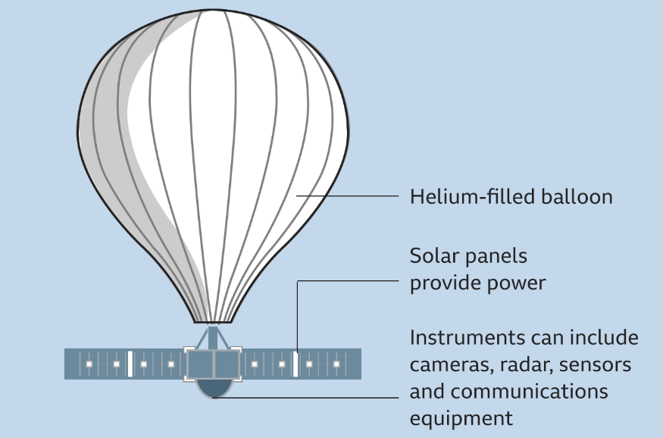
Figure 1 - High Altitude Balloon [1]
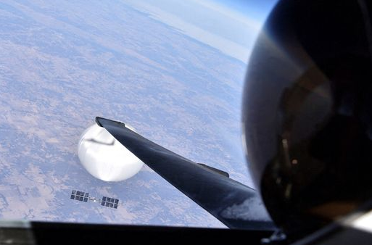
Figure 2 - Pilot's View [3]

2. Issue
Media speculation and public reactions created issues where misinformation spread quickly and the classified nature of the true information made it difficult to rule out false claims. The threat to national security leaves a small list of official sources that are inundated by newspaper articles.
“China’s surveillance balloons have flown over more than 40 countries and are directed by the Chinese military” [4] where the UK is likely to be a target of Chinese surveillance, making it relevant to the defence sector.

3. Recommendation
In this report, various aspects of a high-altitude balloon-based communication system were investigated. Technologies that could be used in the balloons, including photovoltaic cells, vapor lamps, and antennas for the reception of various frequencies of radiation were explored. It was determined that the potential threat of surveillance from these balloons and how data could be intercepted wirelessly would be the balloon’s main purpose. Finally, the military's detection and response capabilities for such balloons were questioned leading to a secondary data collection purpose.
Through the use of the electromagnetic spectrum the balloon could possess an invaluable data collection capability to a foreign power. However, the likelihood of a weapon utilising the EM spectrum being on-board was quelled by the inverse square law the waves follow that would require the balloon to have a completely impractically sized power source.

4. Timing
Although this event is in the past, it is a realistic assumption that not only will it happen again, but it will happen in the UK. Lessons can be learnt concerning the detection of these balloons to facilitate a faster response time to limit their effectiveness. No urgent action required.

5. Discussion

5.1 EMR Spectrum Analysis
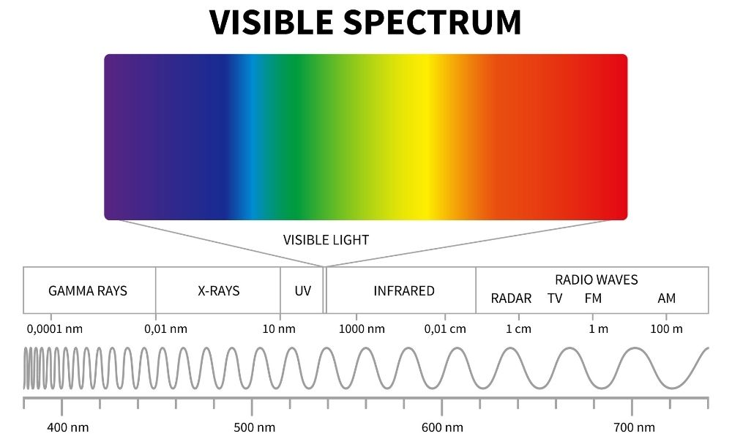
Figure 3 - The Electromagnetic Spectrum [5]

5.1.1 Gamma Ray
Gamma Rays can be created through nuclear decay, particle collisions, annihilation and nuclear fusion. Gamma rays are the most energetic form of electromagnetic radiation (EMR) with the shortest wavelengths and correspondingly, the highest frequencies. They are highly penetrating and can travel long distances through mediums.
A nucleus can emit a gamma ray in order to release excess energy when undergoing nuclear decay along with helium nuclei and electrons. Particle collisions such as a high energy photon and an electron emits gamma rays through Compton scattering, where the photon transfers some of its energy to the electron and is emitted again as a lower energy photon in a random direction [6]. When a particle and its corresponding antiparticle collide, annihilation occurs and the energy is converted into gamma rays. During nuclear fusion the excess energy generated when two atomic nuclei combine is released as gamma rays.
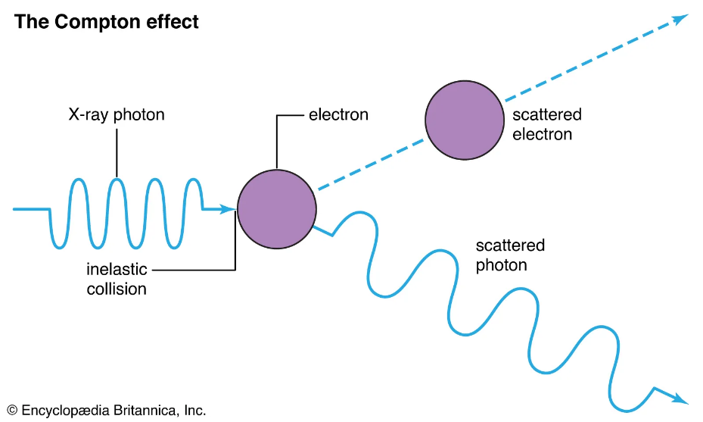
Figure 4 - The Compton Effect [7]
Gamma rays are commonly used for medical imaging and radiation therapy but they can also be harmful to living organisms when absorbed in large amounts as they can ionise atoms with their high energy, causing damage to biological tissues. It is unlikely the balloon would be equipped with gamma ray emitters as the short wavelength makes it difficult to focus them over long distances. Diffraction is a phenomenon that occurs when a wave passes through a narrow opening or around an obstacle, causing the waves to spread out. Gamma rays are easily diffracted by small obstacles such as the atoms in a thin layer of material due to their short wavelength [8] and as a result focusing gamma rays over to a specific point over a long distance is difficult.

5.1.2 X-ray
When high-energy electrons collide with a metal such as tungsten, molybdenum or copper, X-rays can be created. The high-energy electron can knock out one or more electrons from the target’s atom’s inner shell which creates an ionised atom [9]. Energy is released in the form of X-rays when the electron(s) move from the outer shell to the inner shell to fill the vacancies.
X-rays are also commonly used in medicine as they can be used to create images of bones and internal organs [10]. The bones scatter the incident X-rays and where they aren’t detected a picture can be formed. X-rays can be hazardous to human health as they can remove electrons from atoms in the body if they are energetic enough. This ionisation can cause cancer, genetic mutations and damage to the structure of cells and DNA. As X-rays follow the inverse square law, their intensity would be reduced a great amount covering the distance between the balloon and any target on the ground, the source intensity would have to be incredibly strong which would require a significant power source that would be too large and heavy to be equipped on a balloon.

5.1.3 Ultraviolet
A natural source of ultraviolet (UV) radiation is the sun which provides most of the UV that reaches the Earth’s surface. Artificial sources of ultraviolet (UV) such as electric arcs and mercury lamps use the excitation of atoms to emit high-energy photons in the UV range of the EMR spectrum. As the electric arc forms, the electrons in the plasma collide with atoms in the surrounding gas causing them to ionise and they can then emit UV photons when they return to their ground state.
UV radiation can be used to sterilise surfaces and water by killing bacteria and viruses and is commonly used in hospitals, laboratories and processing facilities [11]. It can also be used to cure adhesives and resins by initiating chemical reactions that cause bonds to form that either harden or soften the compound. UV radiation causes certain substances to emit visible light in a phenomenon known as fluorescence. Bodily fluids or trace evidence can be detected in forensic science using this property.
Although UV radiation can be harmful to living organisms through skin burns, eye damage or skin cancer, this context would provide technical limitations as UV is absorbed by the atmosphere and the inverse square law would demand a powerful source.
The 20-30m solar array onboard the balloon would provide a similar output to that of a regular rooftop array, around 10kW of power [12]. This is enough to power a mercury vapour lamp that is used to kill bacteria and viruses for disinfection purposes or a pulsed xenon lamp that is used for surface disinfection or water treatment. The type of UV the mercury lamp emits is of note though as UV-C (a specific range of wavelengths, 200-400nm) is the highest energy form of UV and is the most dangerous. However, these devices operate at up to a metre away from the target, with one of these onboard, the incident radiation from 18,000m away is practically zero (see appendix). 3.086×10⁻⁷ W would reach ground level and in comparison 0.1-10W of UV radiation from the sun impacts the human body regularly. Thus UV radiation can be eliminated as a potential threat.

5.1.4 Visible
Visible light is the section of the EMR spectrum that is visible to the human eye, with wavelengths ranging from 400 – 700nm. Humans perceive colour using the different ways light interacts with objects such as absorption, reflection and transmission. An object will appear red because it reflects mostly red light whilst absorbing the other colours.
Visible light can be produced through incandescence where electricity passes through a filament and heats it to a high temperature and the thermal radiation causes the hot filament to emit visible light. The sun produces a range of EMR as a result of its nuclear reactions which includes Earth’s primary visible light source. It is used for photography, optical communications such as Visible Light Communication (VLC) Systems, medical applications such as the treatment of psoriasis and spectroscopy where the visible light allows the analysis of the chemical and physical properties of materials.
VLC could be used in the balloon as a data transmission method. The intensity of LEDs are rapidly modulated to encode digital data in a series of light pulses which can then be interpreted by a receiver device. VLC provides a high speed and wireless data connection which the balloon could use to transmit data to the ground station and VLC is more resistant to interference compared to radio waves.

5.1.5 Infrared
Infrared (IR) has a wavelength between 0.7 and 1µm. It is generated by any object that is above absolute zero where the higher the temperature the higher the intensity of the radiation. During heating the atoms in an object vibrate and rotate more rapidly which produces IR radiation, lasers can target specific atoms to emit photons of a specific wavelength.
IR is used in wireless short range communication in applications such as a TV remote. Spectroscopy uses IR radiation to analyse the chemical composition of materials and it is also used in night vision to capture images in dark environments.
The balloon will use IR to generate electricity using photovoltaic cells that are tuned to utilise a wide wavelength range to power its onboard systems. These cells generate electricity through the voltaic effect where IR radiation causes electrons to be knocked loose which allows electrons to flow from another semiconductor material. IR voltaic cells require a material with a lower bandgap energy than visible light cells as the IR imparts less energy on the electrons.

5.1.6 Microwave
With wavelengths between 1mm and 1m, microwave radiation can be created in microwave ovens using a magnetron, or naturally through lightning strikes.
A magnetron generates microwaves by using a high energy electron stream called an electron beam that is generated by a heated cathode that releases electrons which are then accelerated and focussed into a narrow beam by using EM fields. This electron beam enters a resonant cavity which oscillates at the same frequency as the generated microwaves. A waveguide then directs the microwaves to the target [13].
The balloon could utilise microwaves in long range communication as the waves can penetrate through clouds and the atmosphere. Microwaves can provide a radar imaging capability that creates high-resolution images of the ground targets. A microwave pulse is emitted and the time it takes to return to the source after reflecting off of an object is measured. Collecting multiple distances over a small area would provide a point cloud that can be used to generate an image of the object. The balloon would need to utilise a parabolic dish antenna that can receive wavelengths between 1mm and 1m. Fortunately, the diameter of the dish would optimally be equal to the wavelength of the received signal and a 1m dish would certainly be able to fit onto these large balloons.

5.1.7 Radio
Radio waves have the longest wavelengths in the EMR spectrum between 1mm and 100km. They are generated through the movement of charged particles like an electron in a conductor as they create a changing electrical field. This field in turn creates a magnetic field and combined together they create radio waves.
A dipole antenna is used to receive radio waves by inducing a current in the antenna when radio waves are detected. Longer antennas can receive higher frequency waves and shorter antennas can receive lower frequencies. A radio wave with a frequency 100 MHz would have a wavelength of 3 metres which would require a half wave dipole antenna of 1.5m or a quarter wave dipole antenna of 0.75m long [14]. The balloon would easily be able to be equipped with multiple radio wave antenna

5.2 Surveillance
If the balloon is equipped with the range of EMR capabilities described above, the major threat the balloon poses is surveillance. The interception and collection of data from electronic devices can violate privacy rights and civil liberties by decoding radio signals by tuning a receiver to particular frequency bands.
The movements and activities of people can be tracked, personal information can be collected and private communications can be eavesdropped. In particular, military targets are at threat here as data can be gathered about routines, infrastructure and conducted activities that the knowledge of would benefit a foreign power.

5.3 Test of Response
By evaluating how well a system responds to a stimulus can identify issues in the system or areas that need improvement. In this scenario, a test of response can be employed to learn intricate details about the emergency service and military response time.
A fake emergency could be created from the balloon’s EMR suite to test the response time and ability of emergency services in remote areas or somewhere that could be a future target.
The response time of the military can be tested by how long the balloon takes to be detected and how long it takes for a decision to be made on how to respond to the potential threat. The action taken is of particular importance as data can be collected from the capabilities of the F-22 Raptor used to take the balloon down and in particular the signature of the Sidewinder missile [15] that was fired. This data would allow the foreign nation to develop countermeasures for the missile and gives an upper hand in aerial combat.

6. Appendix
To expand on section 5.1.3 Ultraviolet, UV curable resins have been incorporated into energetic materials to create high performance composite explosives. Trimethylbenzoyl-diphenylphosphine oxide (TPO) has been used as a photo initiator in conjunction with hexanitrohexaazaisowurtzitane (CL-20) as the explosive component. Whilst reducing the impact sensitivity of the CL-20 the addition of the TPO allowed the CL-20 to cure in just 3 minutes of UV exposure, showing a rapid curing speed [16].
With an output of 100W (I₁) at the source and a distance of 18,000m (d),
$$I_{2}= \frac{I_{1}}{d^{2}} I_{2}= \frac{100}{{18000}^{2}}= \frac{100}{324000000}$$
The resulting power (I₂) is $3.086×{10}^{-7}W$.

In 5.1.7 Radio, the wavelength can be calculated using this equation:
$$λ= \frac{v}{f}= \frac{3×{10}^{8}}{100×{10}^{6}}=3m$$
Where λ is the wavelength (m), v is the velocity (m/s) and f is the frequency (Hz).

7.1 References

[1] | BBC News, “Chinese spy balloon over US is weather device says Beijing,” BBC News, 3 February 2023. [Online]. Available: https://www.bbc.com/news/world-us-canada-64515033. [Accessed 23 April 2023].
[2] | H. Cooper, “U.S. Navy Divers Work to Recover Debris From Chinese Spy Balloon as Diplomacy Dwindles,” The New York Times, 2023.
[3] | A. Culbertson, “US releases photo of Chinese 'spy balloon' taken by pilot before it was shot down,” Sky News, 3 April 2023. [Online]. Available: https://news.sky.com/story/us-releases-photo-of-chinese-spy-balloon-taken-by-pilot-before-it-was-shot-down-12817535. [Accessed 8 May 2023].
[4] | E. Wong, “Chinese Balloon Had Tools to Collect Electronic Communications, U.S. Says,” The New York Times, 2023.
[5] | Gamma Scientific, “Electromagnetic Spectrum 101,” 2 July 2021. [Online]. Available: https://gamma-sci.com/2021/07/02/electromagnetic-spectrum-101-radio-microwave-and-infrared/. [Accessed 10 May 2023].
[6] | P. Christillin, “Nuclear Compton scattering,” Journal of Physics G: Nuclear Physics, vol. XII, no. 9, p. 837, 1986.
[7] | Britannica, “Compton Effect,” 12 February 2023. [Online]. Available: https://www.britannica.com/science/Compton-effect. [Accessed 10 May 2022].
[8] | D. B. Sirdeshmukh, “Gamma-Ray Diffraction – A Powerful Tool in Crystal Physics,” Current Science, vol. LXXII, no. 9, pp. 631-640, 1997.
[9] | G. Lloyd-Jones, “Basics of X-ray Physics,” February 2016. [Online]. Available: https://www.radiologymasterclass.co.uk/tutorials/physics/x-ray_physics_production. [Accessed 10 May 2023].
[10] | A. Thomas, “The first 50 years of military radiology 1895–1945,” European Journal of Radiology, vol. LXIII, no. 2, pp. 214-219, 2007.
[11] | Y.-J. Kim, “Inactivation of foodborne pathogenic bacteria in water and stainless steel surfaces by vacuum-UV amalgam lamp and low-pressure mercury UV lamp irradiation,” Innovative Food Science & Emerging Technologies, vol. LXXXIV, 2023.
[12] | K. Bose, “Leaked document claims Chinese spy balloon uses solar to power data collection,” 18 April 2023. [Online]. Available: https://www.energylivenews.com/2023/04/18/leaked-document-claims-chinese-spy-balloon-uses-solar-to-power-data-collection/. [Accessed 10 May 2023].
[13] | P. Redhead, “The Invention of the Cavity Magnetron and its Introduction into Canada and the U.S.A.,” Physics in Canada, vol. LVII, no. 6, p. 321, 2001.
[14] | W. Stutzman, Antenna Theory and Design, John Wiley & Sons, 2012.
[15] | J. Garamone, “F-22 Safely Shoots Down Chinese Spy Balloon Off South Carolina Coast,” US DoD, 4 Febraury 2023. [Online]. Available: https://www.defense.gov/News/News-Stories/Article/Article/3288543/f-22-safely-shoots-down-chinese-spy-balloon-off-south-carolina-coast/. [Accessed 10 May 2023].
[16] | H. Guo, S. Xu and H. Gao, “CL-20 Based Ultraviolet Curing Explosive Composite with High Performance,” Propellants, Explosives, Pyrotechnics, vol. XLIV, no. 8, pp. 935-940, 2019.

