design of an unsigned two number uneven parallel multiplier and the design of a FSM in hardware and vhdl
Jacob Nicolas Williams (1603333)

Table of Contents
Introduction 1
Task 1 1
What is a Binary Multiplier? 2
Array Multiplier 2
Wallace Tree Multiplier 2
Braun Multiplier 2
Booth’s Multiplication Algorithm 2
Dadda Multiplier 3
Table Comparison 4
Half Adder 4
Truth Table 4
Design 5
Full-Adder 5
Truth Table 5
Design 6
12x4 Multiplier 6
Line 0 Module 7
Line 0 Test Bench 10
Line X Module 18
Line X Test Bench 25
12x4 Multiplier Code 37
Task 2 37
FSM Next State Tables 37
FSM Proteus Design 38
FSM Code 39
Module 40
Test Bench 44
Bibliography 49

Introduction

In this assignment, I will research the different types of binary multipliers and

Task 1
In this task, I will research, compare and contrast the different types of binary multipliers there are and come to a conclusion on which multiplier I think is the best. And I will design, simulate and synthesise a 12 bit x 4 bit unsigned number multiplier based upon a simple parallel Braun multiplier.

What is a Binary Multiplier?
A binary multiplier is a combinational logic circuit used in digital systems to perform the multiplication of two binary numbers. These are most commonly used in various applications especially in the field of digital signal processing to perform the various algorithms. Commercial applications like computers, mobiles, high speed calculators and some general-purpose processors require binary multipliers. Compared with addition and subtraction, multiplication is a complex process. In multiplication process, the number which is to be multiplied by the other number is called as multiplicand and the number multiplied is called as multiplier. (Electronics Hub, 2015)

Array Multiplier

Wallace Tree Multiplier
Wallace multiplier uses full adders and half adders to reduce the partial product tree to two rows, and then a final adder is used to add these two rows of partial products. ... The speed of the RCW multiplier is expected to be the same as of TW multiplier due to the equal number of reduction stages in both multipliers. (Yassif, 2014)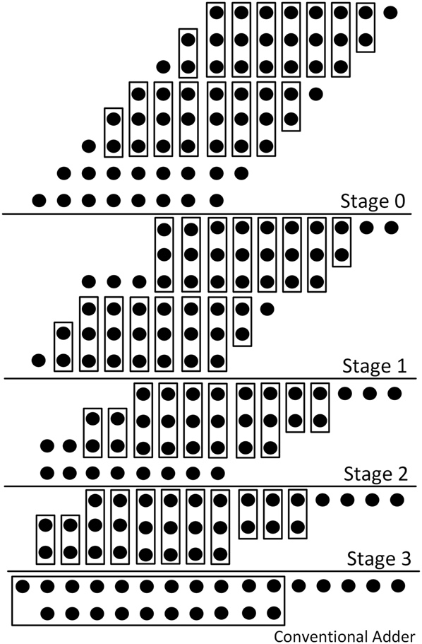

Braun Multiplier

Booth’s Multiplication Algorithm
Booth algorithm gives a procedure for multiplying binary integers in signed 2’s complement representation in efficient way, i.e., less number of additions/subtractions required. It operates on the fact that strings of 0’s in the multiplier require no addition but just shifting and a string of 1’s in the multiplier from bit weight 2^k to weight 2^m can be treated as 2^(k+1 ) to 2^m.
As in all multiplication schemes, booth algorithm requires examination of the multiplier bits and shifting of the partial product. Prior to the shifting, the multiplicand may be added to the partial product, subtracted from the partial product, or left unchanged according to following rules:
- The multiplicand is subtracted from the partial product upon encountering the first least significant 1 in a string of 1’s in the multiplier
- The multiplicand is added to the partial product upon encountering the first 0 (provided that there was a previous ‘1’) in a string of 0’s in the multiplier.
- The partial product does not change when the multiplier bit is identical to the previous multiplier bit.
(geeksforgeeks, 2020)

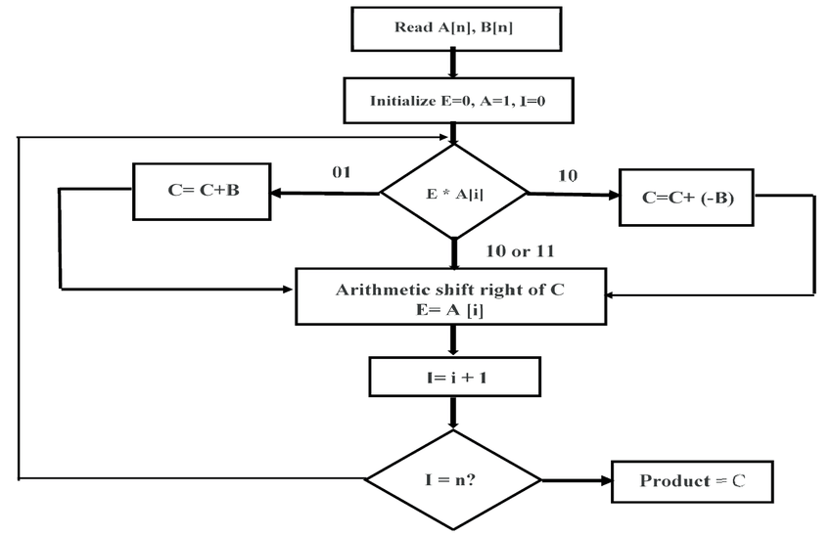

Dadda Multiplier
Dadda multiplier consists of three stages. The partial product matrix is formed in the first stage by N2 AND stages. In the second stage, the partial product matrix is reduced to a height of two. Dadda replaced Wallace Pseudo adders with parallel (n, m) counters. (Ramesh, n.d.)
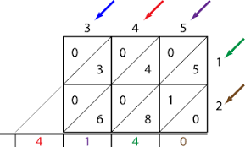

Table Comparison

Conclusion

Half Adder
The half adder works by combining the operation of basic logic gates. The simplest of these is only using AND or XOR gates. It can also be converted into a circuit that only uses AND, OR and NOT gates. (Techopedia Inc., 2021)

Truth Table
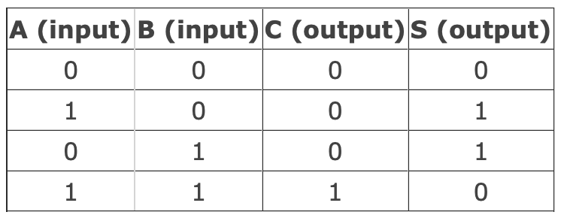

Design
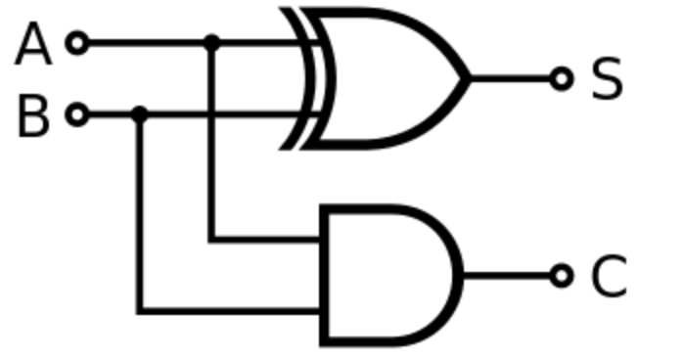

Full-Adder

Truth Table
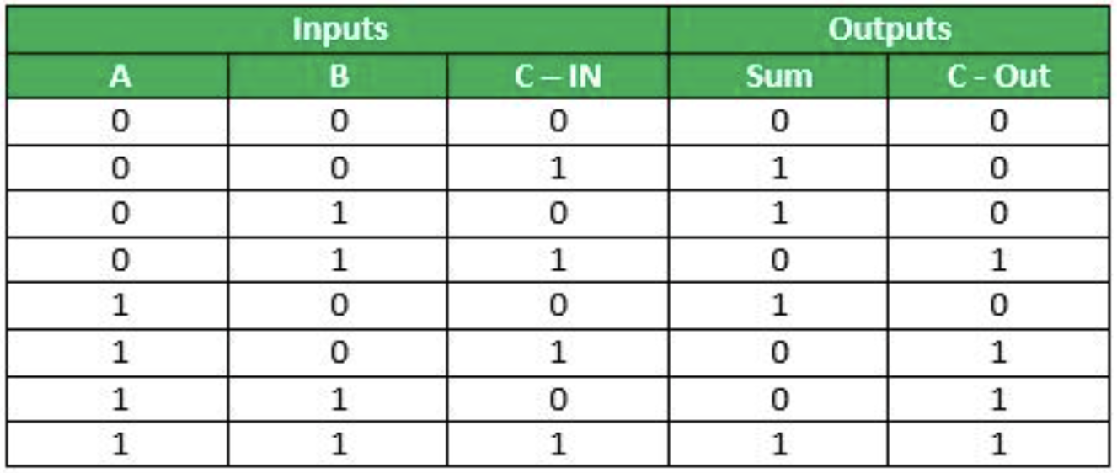

Design
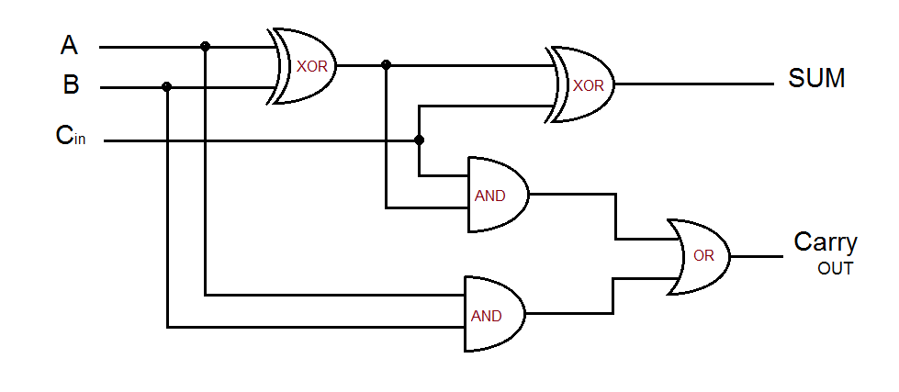

12x4 Multiplier

Line 0 Module
----------------------------------------------------------------------------------
-- Company:
-- Engineer: Jacob Williams
--
-- Create Date: 17:38:01 04/19/2021
-- Design Name:
-- Module Name: Line_0 - Behavioral
-- Project Name:
-- Target Devices:
-- Tool versions:
-- Description:
--
-- Dependencies:
--
-- Revision:
-- Revision 0.01 - File Created
-- Additional Comments:
--
----------------------------------------------------------------------------------
library IEEE;
use IEEE.STD_LOGIC_1164.ALL;

-- Uncomment the following library declaration if using
-- arithmetic functions with Signed or Unsigned values
--use IEEE.NUMERIC_STD.ALL;

-- Uncomment the following library declaration if instantiating
-- any Xilinx primitives in this code.
--library UNISIM;
--use UNISIM.VComponents.all;

entity Line_0 is
Port ( A1 : in STD_LOGIC;
A2 : in STD_LOGIC;
A3 : in STD_LOGIC;
A4 : in STD_LOGIC;
A5 : in STD_LOGIC;
A6 : in STD_LOGIC;
A7 : in STD_LOGIC;
A8 : in STD_LOGIC;
A9 : in STD_LOGIC;
A10 : in STD_LOGIC;
A11 : in STD_LOGIC;
A12 : in STD_LOGIC;
B : in STD_LOGIC;
Q1 : out STD_LOGIC;
Q2 : out STD_LOGIC;
Q3 : out STD_LOGIC;
Q4 : out STD_LOGIC;
Q5 : out STD_LOGIC;
Q6 : out STD_LOGIC;
Q7 : out STD_LOGIC;
Q8 : out STD_LOGIC;
Q9 : out STD_LOGIC;
Q10 : out STD_LOGIC;
Q11 : out STD_LOGIC;
Q12 : out STD_LOGIC);
end Line_0;

architecture Behavioral of Line_0 is

begin

Q1 <=A1 and B;
Q2 <=A2 and B;
Q3 <=A3 and B;
Q4 <=A4 and B;
Q5 <=A5 and B;
Q6 <=A6 and B;
Q7 <=A7 and B;
Q8 <=A8 and B;
Q9 <=A9 and B;
Q10 <=A10 and B;
Q11 <=A11 and B;
Q12 <=A12 and B;

end Behavioral;

Line 0 Test Bench
--------------------------------------------------------------------------------
-- Company:
-- Engineer: Jacob Williams
--
-- Create Date: 16:31:32 04/21/2021
-- Design Name:
-- Module Name: C:/Users/Jacob/Desktop/ELECTRONICS_2/ISE/Multi_12x4_line0/Line_0_TB.vhd
-- Project Name: Multi_12x4_line0
-- Target Device:
-- Tool versions:
-- Description:
--
-- VHDL Test Bench Created by ISE for module: Line_0
--
-- Dependencies:
--
-- Revision:
-- Revision 0.01 - File Created
-- Additional Comments:
--
-- Notes:
-- This testbench has been automatically generated using types std_logic and
-- std_logic_vector for the ports of the unit under test. Xilinx recommends
-- that these types always be used for the top-level I/O of a design in order
-- to guarantee that the testbench will bind correctly to the post-implementation
-- simulation model.
--------------------------------------------------------------------------------
LIBRARY ieee;
USE ieee.std_logic_1164.ALL;

-- Uncomment the following library declaration if using
-- arithmetic functions with Signed or Unsigned values
--USE ieee.numeric_std.ALL;

ENTITY Line_0_TB IS
END Line_0_TB;

ARCHITECTURE behavior OF Line_0_TB IS

-- Component Declaration for the Unit Under Test (UUT)

COMPONENT Line_0
PORT(
A1 : IN std_logic;
A2 : IN std_logic;
A3 : IN std_logic;
A4 : IN std_logic;
A5 : IN std_logic;
A6 : IN std_logic;
A7 : IN std_logic;
A8 : IN std_logic;
A9 : IN std_logic;
A10 : IN std_logic;
A11 : IN std_logic;
A12 : IN std_logic;
B : IN std_logic;
Q1 : OUT std_logic;
Q2 : OUT std_logic;
Q3 : OUT std_logic;
Q4 : OUT std_logic;
Q5 : OUT std_logic;
Q6 : OUT std_logic;
Q7 : OUT std_logic;
Q8 : OUT std_logic;
Q9 : OUT std_logic;
Q10 : OUT std_logic;
Q11 : OUT std_logic;
Q12 : OUT std_logic
);
END COMPONENT;

--Inputs
signal A1 : std_logic := '0';
signal A2 : std_logic := '0';
signal A3 : std_logic := '0';
signal A4 : std_logic := '0';
signal A5 : std_logic := '0';
signal A6 : std_logic := '0';
signal A7 : std_logic := '0';
signal A8 : std_logic := '0';
signal A9 : std_logic := '0';
signal A10 : std_logic := '0';
signal A11 : std_logic := '0';
signal A12 : std_logic := '0';
signal B : std_logic := '0';

--Outputs
signal Q1 : std_logic;
signal Q2 : std_logic;
signal Q3 : std_logic;
signal Q4 : std_logic;
signal Q5 : std_logic;
signal Q6 : std_logic;
signal Q7 : std_logic;
signal Q8 : std_logic;
signal Q9 : std_logic;
signal Q10 : std_logic;
signal Q11 : std_logic;
signal Q12 : std_logic;
-- No clocks detected in port list. Replace <clock> below with
-- appropriate port name

BEGIN

-- Instantiate the Unit Under Test (UUT)
uut: Line_0 PORT MAP (
A1 => A1,
A2 => A2,
A3 => A3,
A4 => A4,
A5 => A5,
A6 => A6,
A7 => A7,
A8 => A8,
A9 => A9,
A10 => A10,
A11 => A11,
A12 => A12,
B => B,
Q1 => Q1,
Q2 => Q2,
Q3 => Q3,
Q4 => Q4,
Q5 => Q5,
Q6 => Q6,
Q7 => Q7,
Q8 => Q8,
Q9 => Q9,
Q10 => Q10,
Q11 => Q11,
Q12 => Q12
);

-- Stimulus process
stim_proc1: process
begin
-- hold reset state for 10 ns.
wait for 10 ns;
A1 <= not A1;
end process;
stim_proc2: process
begin
-- hold reset state for 20 ns.
wait for 20 ns;
A2 <= not A2;
end process;
stim_proc3: process
begin
-- hold reset state for 40 ns.
wait for 40 ns;
A3 <= not A3;
end process;
stim_proc4: process
begin
-- hold reset state for 80 ns.
wait for 80 ns;
A4 <= not A4;
end process;
stim_proc5: process
begin
-- hold reset state for 160 ns.
wait for 160 ns;
A5 <= not A5;
end process;
stim_proc6: process
begin
-- hold reset state for 320 ns.
wait for 320 ns;
A6 <= not A6;
end process;
stim_proc7: process
begin
-- hold reset state for 640 ns.
wait for 640 ns;
A7 <= not A7
end process;
stim_proc8: process
begin
-- hold reset state for 1280 ns.
wait for 1280 ns;
A8 <= not A8;
end process;
stim_proc9: process
begin
-- hold reset state for 2560 ns.
wait for 2560 ns;
A9 <= not A9;
end process;
stim_proc10: process
begin
-- hold reset state for 5120 ns.
wait for 5120 ns;
A10 <= not A10;
end process;
stim_proc11: process
begin
-- hold reset state for 10240 ns.
wait for 10240 ns;
A11 <= not A11;

end process;

stim_proc12: process
begin
-- hold reset state for 20480 ns.
wait for 20480 ns;
A12 <= not A12;
end process;
stim_proc13: process
begin
-- hold reset state for 40960 ns.
wait for 40960 ns;
B <= not B;
end process;

END;

Line X Module
----------------------------------------------------------------------------------
-- Company:
-- Engineer: Jacob Williams
--
-- Create Date: 11:51:15 04/22/2021
-- Design Name:
-- Module Name: Assignment_LineX - Behavioral
-- Project Name:
-- Target Devices:
-- Tool versions:
-- Description:
--
-- Dependencies:
--
-- Revision:
-- Revision 0.01 - File Created
-- Additional Comments:
--
----------------------------------------------------------------------------------
library IEEE;
use IEEE.STD_LOGIC_1164.ALL;

-- Uncomment the following library declaration if using
-- arithmetic functions with Signed or Unsigned values
--use IEEE.NUMERIC_STD.ALL;

-- Uncomment the following library declaration if instantiating
-- any Xilinx primitives in this code.
--library UNISIM;
--use UNISIM.VComponents.all;

entity Assignment_LineX is
Port ( A0 : in STD_LOGIC;
A1 : in STD_LOGIC;
A2 : in STD_LOGIC;
A3 : in STD_LOGIC;
A4 : in STD_LOGIC;
A5 : in STD_LOGIC;
A6 : in STD_LOGIC;
A7 : in STD_LOGIC;
A8 : in STD_LOGIC;
A9 : in STD_LOGIC;
A10 : in STD_LOGIC;
A11 : in STD_LOGIC;
B : in STD_LOGIC;
P1 : in STD_LOGIC;
P2 : in STD_LOGIC;
P3 : in STD_LOGIC;
P4 : in STD_LOGIC;
P5 : in STD_LOGIC;
P6 : in STD_LOGIC;
P7 : in STD_LOGIC;
P8 : in STD_LOGIC;
P9 : in STD_LOGIC;
P10 : in STD_LOGIC;
P11 : in STD_LOGIC;
P12 : in STD_LOGIC;
Q1 : out STD_LOGIC;
Q2 : out STD_LOGIC;
Q3 : out STD_LOGIC;
Q4 : out STD_LOGIC;
Q5 : out STD_LOGIC;
Q6 : out STD_LOGIC;
Q7 : out STD_LOGIC;
Q8 : out STD_LOGIC;
Q9 : out STD_LOGIC;
Q10 : out STD_LOGIC;
Q11 : out STD_LOGIC;
Q12 : out STD_LOGIC;
Q13 : out STD_LOGIC);

end Assignment_LineX;

architecture Behavioral of Assignment_LineX is

COMPONENT halfadder

PORT(

A : IN std_logic;
B : IN std_logic;
Sum : OUT std_logic;
Carry : OUT std_logic);

END COMPONENT;

COMPONENT fulladder

PORT(

A : IN std_logic;
B : IN std_logic;
C : IN std_logic;
Sum : OUT std_logic;
Carry : OUT std_logic);

END COMPONENT;

signal s0 : STD_LOGIC;
signal s1 : STD_LOGIC;
signal s2 : STD_LOGIC;
signal s3 : STD_LOGIC;
signal s4 : STD_LOGIC;
signal s5 : STD_LOGIC;
signal s6 : STD_LOGIC;
signal s7 : STD_LOGIC;
signal s8 : STD_LOGIC;
signal s9 : STD_LOGIC;
signal s10 : STD_LOGIC;
signal s11 : STD_LOGIC;
signal c0 : STD_LOGIC;
signal c1 : STD_LOGIC;
signal c2 : STD_LOGIC;
signal c3 : STD_LOGIC;
signal c4 : STD_LOGIC;
signal c5 : STD_LOGIC;
signal c6 : STD_LOGIC;
signal c7 : STD_LOGIC;
signal c8 : STD_LOGIC;
signal c9 : STD_LOGIC;
signal c10 : STD_LOGIC;

-- and gate sequence.
begin
s0 <= A0 and B;
s1 <= A1 and B;
s2 <= A2 and B;
s3 <= A3 and B;
s4 <= A4 and B;
s5 <= A5 and B;
s6 <= A6 and B;
s7 <= A7 and B;
s8 <= A8 and B;
s9 <= A9 and B;
s10 <= A10 and B;
s11 <= A11 and B;

HA1: halfadder

Port Map
( s0, P1, Q1, c0);
FA1: fulladder
Port Map
( s1, P2, c0, Q2, c1);
FA2: fulladder
Port Map
( s2, P3, c1, Q3, c2);
FA3: fulladder
Port Map
( s3, P4, c2, Q4, c3);
FA4: fulladder
Port Map
( s4, P5, c3, Q5, c4);
FA5: fulladder
Port Map
( s5, P6, c4, Q6, c5);
FA6: fulladder
Port Map
( s6, P7, c5, Q7, c6);
FA7: fulladde
Port Map
( s7, P8, c6, Q8, c7);
FA8: fulladder
Port Map
( s8, P9, c7, Q9, c8);
FA9: fulladder
Port Map
( s9, P10, c8, Q10, c9);
FA10: fulladder
Port Map
( s10, P11, c9, Q11, c10);
FA11: fulladder
Port Map
( s11, P12, c10, Q12, Q13);

end Behavioral;

Line X Test Bench
--------------------------------------------------------------------------------
-- Company:
-- Engineer: Jacob Williams
--
-- Create Date: 14:04:12 04/23/2021
-- Design Name:
-- Module Name: C:/Users/Jacob/Desktop/ELECTRONICS_2/ISE/Assignment_Multi_12x4_LineX/Assignment_LineX_TB.vhd
-- Project Name: Assignment_Multi_12x4_LineX
-- Target Device:
-- Tool versions:
-- Description:
--
-- VHDL Test Bench Created by ISE for module: Assignment_LineX
--
-- Dependencies:
--
-- Revision:
-- Revision 0.01 - File Created
-- Additional Comments:
--
-- Notes:
-- This testbench has been automatically generated using types std_logic and
-- std_logic_vector for the ports of the unit under test. Xilinx recommends
-- that these types always be used for the top-level I/O of a design in order
-- to guarantee that the testbench will bind correctly to the post-implementation
-- simulation model.
--------------------------------------------------------------------------------
LIBRARY ieee;
USE ieee.std_logic_1164.ALL;

-- Uncomment the following library declaration if using
-- arithmetic functions with Signed or Unsigned values
--USE ieee.numeric_std.ALL;

ENTITY Assignment_LineX_TB IS
END Assignment_LineX_TB;

ARCHITECTURE behavior OF Assignment_LineX_TB IS

-- Component Declaration for the Unit Under Test (UUT)

COMPONENT Assignment_LineX
PORT(
A0 : IN std_logic;
A1 : IN std_logic;
A2 : IN std_logic;
A3 : IN std_logic;
A4 : IN std_logic;
A5 : IN std_logic;
A6 : IN std_logic;
A7 : IN std_logic;
A8 : IN std_logic;
A9 : IN std_logic;
A10 : IN std_logic;
A11 : IN std_logic;
B : IN std_logic;
P1 : IN std_logic;
P2 : IN std_logic;
P3 : IN std_logic;
P4 : IN std_logic;
P5 : IN std_logic;
P6 : IN std_logic;
P7 : IN std_logic;
P8 : IN std_logic;
P9 : IN std_logic;
P10 : IN std_logic;
P11 : IN std_logic;
P12 : IN std_logic;
Q1 : OUT std_logic;
Q2 : OUT std_logic;
Q3 : OUT std_logic;
Q4 : OUT std_logic;
Q5 : OUT std_logic;
Q6 : OUT std_logic;
Q7 : OUT std_logic;
Q8 : OUT std_logic;
Q9 : OUT std_logic;
Q10 : OUT std_logic;
Q11 : OUT std_logic;
Q12 : OUT std_logic;
Q13 : OUT std_logic
);
END COMPONENT;

--Inputs
signal A0 : std_logic := '0';
signal A1 : std_logic := '0';
signal A2 : std_logic := '0';
signal A3 : std_logic := '0';
signal A4 : std_logic := '0';
signal A5 : std_logic := '0';
signal A6 : std_logic := '0';
signal A7 : std_logic := '0';
signal A8 : std_logic := '0';
signal A9 : std_logic := '0';
signal A10 : std_logic := '0';
signal A11 : std_logic := '0';
signal B : std_logic := '0';
signal P1 : std_logic := '0';
signal P2 : std_logic := '0';
signal P3 : std_logic := '0';
signal P4 : std_logic := '0';
signal P5 : std_logic := '0';
signal P6 : std_logic := '0';
signal P7 : std_logic := '0';
signal P8 : std_logic := '0';
signal P9 : std_logic := '0';
signal P10 : std_logic := '0';
signal P11 : std_logic := '0';
signal P12 : std_logic := '0';

--Outputs
signal Q1 : std_logic;
signal Q2 : std_logic;
signal Q3 : std_logic;
signal Q4 : std_logic;
signal Q5 : std_logic;
signal Q6 : std_logic;
signal Q7 : std_logic;
signal Q8 : std_logic;
signal Q9 : std_logic;
signal Q10 : std_logic;
signal Q11 : std_logic;
signal Q12 : std_logic;
signal Q13 : std_logic;
-- No clocks detected in port list. Replace <clock> below with
-- appropriate port name

BEGIN

-- Instantiate the Unit Under Test (UUT)
uut: Assignment_LineX PORT MAP (
A0 => A0,
A1 => A1,
A2 => A2,
A3 => A3,
A4 => A4,
A5 => A5,
A6 => A6,
A7 => A7,
A8 => A8,
A9 => A9,
A10 => A10,
A11 => A11,
B => B,
P1 => P1,
P2 => P2,
P3 => P3,
P4 => P4,
P5 => P5,
P6 => P6,
P7 => P7,
P8 => P8,
P9 => P9,
P10 => P10,
P11 => P11,
P12 => P12,
Q1 => Q1,
Q2 => Q2,
Q3 => Q3,
Q4 => Q4,
Q5 => Q5,
Q6 => Q6,
Q7 => Q7,
Q8 => Q8,
Q9 => Q9,
Q10 => Q10,
Q11 => Q11,
Q12 => Q12,
Q13 => Q13
);

-- Stimulus process
stim_proc: process
begin
-- hold reset state for 10 ns.
wait for 10 ns;
A0 <= not A0;
end process;
stim_proc2: process
begin
-- hold reset state for 20 ns.
wait for 20 ns;
A1 <= not A1;
end process;
stim_proc3: process
begin
-- hold reset state for 40 ns.
wait for 40 ns;
A2 <= not A2;
end process;
stim_proc4: process
begin
-- hold reset state for 80 ns.
wait for 80 ns;
A3 <= not A3;
end process;
stim_proc5: process
begin
-- hold reset state for 160 ns.
wait for 160 ns;
A4 <= not A4;
end process;
stim_proc6: process
begin
-- hold reset state for 320 ns.
wait for 320 ns;
A5 <= not A5;
end process;
stim_proc7: process
begin
-- hold reset state for 640 ns.
wait for 640 ns;
A6 <= not A6;
end process;
stim_proc8: process
begin
-- hold reset state for 1280 ns.
wait for 1280 ns;
A7 <= not A7;
end process;
stim_proc9: process
begin
-- hold reset state for 2560 ns.
wait for 2560 ns;
A8 <= not A8;
end process;
stim_proc10: process
begin
-- hold reset state for 5120 ns.
wait for 5120 ns;
A9 <= not A9;
end process;
stim_proc11: process
begin
-- hold reset state for 10240 ns.
wait for 10240 ns;
A10 <= not A10;
end process;
stim_proc12: process
begin
-- hold reset state for 20480 ns.
wait for 20480 ns;
A11 <= not A11;
end process;
stim_proc13: process
begin
-- hold reset state for 40960 ns.
wait for 40960 ns;
P1 <= not P1;
end process;
stim_proc14: process
begin
-- hold reset state for 81920 ns.
wait for 81920 ns;
P2 <= not P2;
end process;
stim_proc15: process
begin
-- hold reset state for 163840 ns.
wait for 163840 ns;
P3 <= not P3;
end process;
stim_proc16: process
begin
-- hold reset state for 327680 ns.
wait for 327680 ns;
P4 <= not P4;
end process;
stim_proc17: process
begin
-- hold reset state for 655360 ns.
wait for 655360 ns;
P5 <= not P5;
end process;
stim_proc18: process
begin
-- hold reset state for 1310720 ns.
wait for 1310720 ns;
P6 <= not P6;
end process;
stim_proc19: process
begin
-- hold reset state for 2621440 ns.
wait for 2621440 ns;
P7 <= not P7;
end process;
stim_proc20: process
begin
-- hold reset state for 5242880 ns.
wait for 5242880 ns;
P8 <= not P8;
end process;
stim_proc21: process
begin
-- hold reset state for 10485760 ns.
wait for 10485760 ns;
P9 <= not P9;
end process;
stim_proc22: process
begin
-- hold reset state for 20971520 ns.
wait for 20971520 ns;
P10 <= not P10;
end process;
stim_proc23: process
begin
-- hold reset state for 41943040 ns.
wait for 41943040 ns;
P11 <= not P11;
end process;
stim_proc24: process
begin
-- hold reset state for 83886080 ns.
wait for 83886080 ns;
P12 <= not P12;
end process;
stim_proc25: process
begin
-- hold reset state for 167772160 ns.
wait for 167772160 ns;
B <= not B;
end process;
END;

12x4 Multiplier Code

Task 2
The aim of this task is to design, simulate and synthesise the FSM described by the state diagram below as both a VHDL and discrete gate solution. 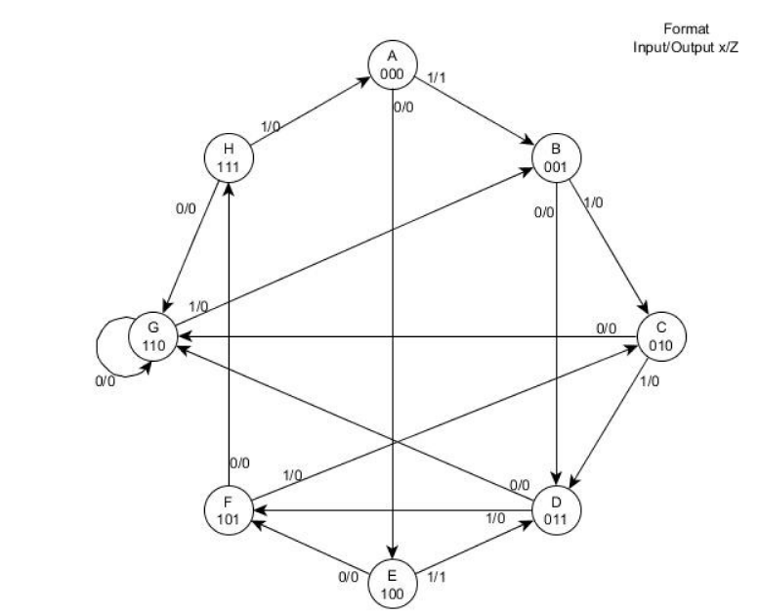

FSM Next State Tables
From observing the diagram above, it allowed me to create the tables necessary to calculate the next state of the FSM.

FSM Proteus Design
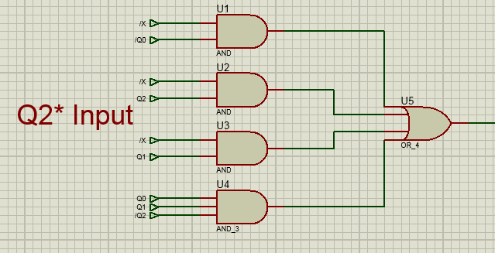

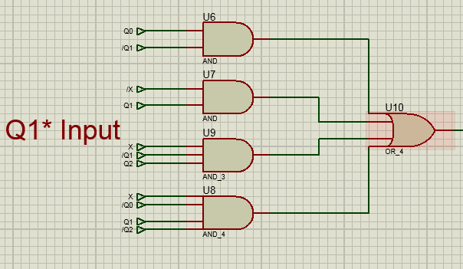

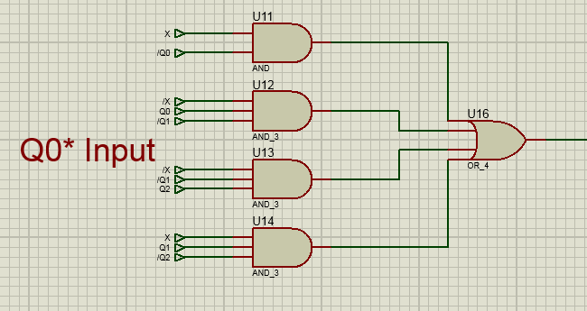

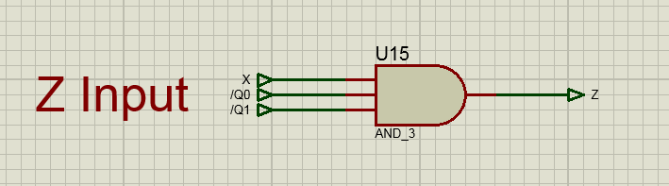

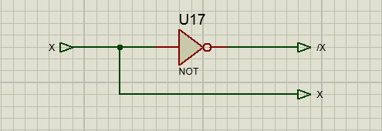

FSM Code

Module
----------------------------------------------------------------------------------
-- Company:
-- Engineer: Jacob Williams
--
-- Create Date: 13:42:07 04/30/2021
-- Design Name:
-- Module Name: Assignment_FSM - Behavioral
-- Project Name:
-- Target Devices:
-- Tool versions:
-- Description:
--
-- Dependencies:
--
-- Revision:
-- Revision 0.01 - File Created
-- Additional Comments:
--
----------------------------------------------------------------------------------
library IEEE;
use IEEE.STD_LOGIC_1164.ALL;

-- Uncomment the following library declaration if using
-- arithmetic functions with Signed or Unsigned values
--use IEEE.NUMERIC_STD.ALL;

-- Uncomment the following library declaration if instantiating
-- any Xilinx primitives in this code.
--library UNISIM;
--use UNISIM.VComponents.all;

entity Assignment_FSM is
Port ( X : in STD_LOGIC;
CLCK : in STD_LOGIC;
Z : out STD_LOGIC;
Y : out STD_LOGIC_VECTOR (2 downto 0));
end Assignment_FSM;

architecture Behavioral of Assignment_FSM is

type state_type is (state_A, state_B, state_C, state_D, state_E, state_F, state_G, state_H);
signal present_state : state_type := state_A;
signal next_state : state_type := state_A;

begin

state: process (present_state,X)

begin

if X='0' then
case present_state is
when state_A => next_state <= state_E;Y <="000"; Z <='0';
when state_B => next_state <= state_D;Y <="001"; Z <='0';
when state_C => next_state <= state_G;Y <="010"; Z <='0';
when state_D => next_state <= state_G;Y <="011"; Z <='0';
when state_E => next_state <= state_F;Y <="100"; Z <='0';
when state_F => next_state <= state_H;Y <="101"; Z <='0';
when state_G => next_state <= state_G;Y <="110"; Z <='0';
when state_H => next_state <= state_G;Y <="111"; Z <='0';
when OTHERS => NULL;
end case;
else if X='1' then
case present_state is
when state_A => next_state <= state_B;Y <="000"; Z <='1';
when state_B => next_state <= state_C;Y <="001"; Z <='0';
when state_C => next_state <= state_D;Y <="010"; Z <='0';
when state_D => next_state <= state_F;Y <="011"; Z <='0';
when state_E => next_state <= state_D;Y <="100"; Z <='1';
when state_F => next_state <= state_C;Y <="101"; Z <='0';
when state_G => next_state <= state_B;Y <="110"; Z <='0';
when state_H => next_state <= state_A;Y <="111"; Z <='0';
when OTHERS => NULL;
end case;
end if;
end if;

end Process State;
clocked: Process (Clck)
begin
if((Clck='1') and (Clck'last_value='0')) Then
present_state <= next_state;
end if;
end Process clocked;

end Behavioral;

Test Bench
--------------------------------------------------------------------------------
-- Company:
-- Engineer: Jacob Williams
--
-- Create Date: 14:03:17 04/30/2021
-- Design Name:
-- Module Name: C:/Users/Jacob/Desktop/ELECTRONICS_2/ISE/Assignment_FSM/Assignment_FSM_TB.vhd
-- Project Name: Assignment_FSM
-- Target Device:
-- Tool versions:
-- Description:
--
-- VHDL Test Bench Created by ISE for module: Assignment_FSM
--
-- Dependencies:
--
-- Revision:
-- Revision 0.01 - File Created
-- Additional Comments:
--
-- Notes:
-- This testbench has been automatically generated using types std_logic and
-- std_logic_vector for the ports of the unit under test. Xilinx recommends
-- that these types always be used for the top-level I/O of a design in order
-- to guarantee that the testbench will bind correctly to the post-implementation
-- simulation model.
--------------------------------------------------------------------------------
LIBRARY ieee;
USE ieee.std_logic_1164.ALL;

-- Uncomment the following library declaration if using
-- arithmetic functions with Signed or Unsigned values
--USE ieee.numeric_std.ALL;

ENTITY Assignment_FSM_TB IS
END Assignment_FSM_TB;

ARCHITECTURE behavior OF Assignment_FSM_TB IS

-- Component Declaration for the Unit Under Test (UUT)

COMPONENT Assignment_FSM
PORT(
X : IN std_logic;
CLCK : IN std_logic;
Z : OUT std_logic;
Y : OUT std_logic_vector(2 downto 0)
);
END COMPONENT;

--Inputs
signal X : std_logic := '0';
signal CLCK : std_logic := '0';

--Outputs
signal Z : std_logic;
signal Y : std_logic_vector(2 downto 0);

BEGIN

-- Instantiate the Unit Under Test (UUT)
uut: Assignment_FSM PORT MAP (
X => X,
CLCK => CLCK,
Z => Z,
Y => Y
);
-- Stimulus process
stim_proc: process
begin
-- hold reset state for 10 ns.
wait for 10 ns;
CLCK <= not CLCK;
end process;
-- Stimulus process
stim_proc2: process
begin
wait for 100 ns; -- step through 0,1,2,3,5,2
X <= '0';
wait for 40ns;

-- step through 0,4,5,7,6 then 6 repeats
X <= '1';
-- goto 1
wait for 20ns;
X <= '0';
-- goto 3
wait for 20ns;
X <= '1';
-- goto 5
wait for 20ns;
X <= '0';
-- goto 7
wait for 20ns;
X <= '1';
-- goto 0
wait for 20ns;
X <= '0';
-- goto 4
wait for 20ns;
X <= '1';
-- goto 3
wait for 20ns;
X <= '0';
-- goto 6
wait for 20ns;
X <= '1';
-- goto 1
wait for 20ns;
X <= '0';
-- goto 3
wait for 20ns;
X <= '0';
-- goto 6
wait for 20ns;
end process;

END;

Bibliography
Electronics Hub, 2015. Electronics Hub. [Online]
Available at: https://www.electronicshub.org/binary-multiplication/
[Accessed 27 04 2021].
geeksforgeeks, 2020. geeksforgeeks. [Online]
Available at: https://www.geeksforgeeks.org/computer-organization-booths-algorithm/
[Accessed 27 04 2021].
Ramesh, A. P., n.d. IJCSET. [Online]
Available at: http://www.ijcset.com/docs/IJCSET11-02-02-01.pdf
[Accessed 27 04 2021].
Techopedia Inc., 2021. Techopedia. [Online]
Available at: https://www.techopedia.com/definition/7509/half-adder
[Accessed 29 04 2021].
Yassif, S., 2014. Hindawi. [Online]
Available at: https://www.hindawi.com/journals/vlsi/2014/343960/
[Accessed 27 04 2021].

