Effective Teamwork and Communication
Student’s Name: ROXANA-MARIA TARABUTA
Student’s ID: 1914418
LECTURER NAME : EJIRO ESOHWODE

Table of Contents
Introduction 3
Identification of Stakeholders 4
Communication Strategy 4
Identification of Target Groups 5
Identifications of Objectives 5
Methods of Communicating with different groups 6
Briefing for the Group Members 6
Conclusion 12
Reference List 13

Introduction
In order to understand the progress of the organisation, it is significant to analyse the teamwork and communication medium being used in the workplace to achieve the business objectives in a desired way. It is relevant to understand that the growth of the organisation depends entirely on the ways in which effective teamwork flourishes in the workplace. With the aid of this, it becomes easier for companies to focus on executing their operational activities in a hassle free manner and address the demands of the consumers in the market. The study will help to understand the importance of developing an effective communication strategy that could be implemented in the workplace for enhanced operational outputs. The later section of the study deals with a range of theories and models related to communication and it helps to present a clear idea about the ways in which a multinational car manufacturing company like BMW will be able to present their activities in a profitable manner.

Identification of Stakeholders
In order to understand the relevance of their business, it is imperative for the higher officials to focus on identifying the key stakeholders. Their employees and customers are two of their key stakeholders and besides this; their suppliers could be considered one. It is essential for the organisation to make sure that they are being able to maintain healthy relationship with their stakeholders, so that it aids them to conduct their business operations in a smooth manner. This can be done by enhancing the means of communication in the workplace This aids them to focus on the employees and monitor their performance in a significant manner.

Communication Strategy
Developing an effective communication strategy is considered vital for the success of BMW in the market. The management authority of the company should focus on verbal and non-verbal means of communication amongst the workers, as it is essential for understanding their problems and complexities. This can be considered as one of the most effective means to gain control in the workplace. Their communication strategy should be designed in such a manner that it is capable of encoding and decoding messages in a simple manner could be considered useful for a workplace.
This will help to encourage teamwork amongst the employees and develop an environment of harmony amongst the workers. This eases the process of achieving the business objectives in a desired manner by mitigating the workplace challenges in the right way. With the aid of the aforementioned strategy, it can be analysed that the process of communication is eased, and employees are able to share their grievances with the organisation in a hassle-free manner. Moreover, it will reduce the mistakes in the operational activities by enhancing the performance of the workers in a significant way.

Methods of Communicating with different groups
Communication is the key to success within the organisational premises. However, it is important to understand that the process of communication should be developed in such a manner that it eases the process of transferring and receiving messages in a programmed manner. Shannon and Weaver Model is considered highly relevant for enhancing the process of communication at the workplace. This model is designed to develop the effective communication between sender and receiver and identify the noise factors that affect communication. The model is applied mostly for the technical communication in which sender encodes the messages and send it to receiver through technological channels. Sender, encoder, channel, decoder and receiver are the five major aspects of the model.
The role of the sender is to select the information that should be transferred and is responsible for selecting the medium to transfer the message. However, the role of the encoder is to decode the human language into machine signals by using radio waves and certain binary digits. Therefore, the encoder is responsible for using ideas into words and communicating them in the workplace with utmost ease. The third aspect of the model is channel. Channel can be regarded, as the medium through with the sender is able to send the message to the receiver in a hassle-free manner. This medium is used to ensure that the information transfer is being done successfully without any discrepancies in the process.
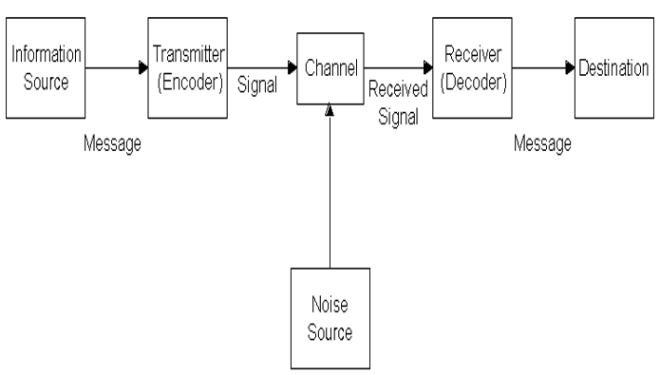

However, in the process of this model, noise interrupts the message that is being transferred from one dimension to the other. Internal and external noise plays a crucial role in terms of hampering the process of transferring information from one point to another). Decoder plays a significant role in terms of decoding the message into simpler language that could be easily understood by the receiver. Apart from this, the receiver is the person that receives the final message that has been transferred. The model would be effective, if the employees are able to function as a team and focus on attaining the business objectives for the organisation in a desired manner Proper commination between the employees is necessary to identify the issues faced by the dealers and the management of an organisation take effective decisions to reduce the conflict between them and improve the services. Therefore, it can be clearly understood that the use of Shannon and Weaver Model of communication could be used effectively in the workplace by keeping the employees engaged in terms of completing their assigned tasks in a significant manner.
Another effective communication model that could be used is the David Berol’s SMCR model. SMCR is the abbreviated version of sender, message, channel and receiver. The first aspect of the model is source or sender. As per this model, the sender and receiver require to have some factors such as communication skill, knowledge, attitude, culture and social systems. Maintaining a positive attitude and familiarity with the subject of the message is essential to make the message meaningful and effective for both. Alongside, social factors such as religion, rules, beliefs, values and law create differences in messages that also affect communication. Besides, the messages are affected by the factors like elements, content, code, structure and treatment. Henceforth, it is very much necessary for the sender to communicate a simple, clear and valuable content to make the receiver understand the purpose of the communication. Elements like non-verbal signs and gesture is also essential to improve the communication clarity and reduce misconception.
According to this model, channel includes five senses of human being like hearing, touching, tasting, seeing and smelling in which hearing is utilised for verbal communication and other aspects are used for non-verbal communication. It contains a code that should be decoded by the receiver to receive the message in a precise manner. This helps them to analyse the content of the message and forward the same to the receiver in for a detailed study of the same. However, message is the next aspect of the model that contains a wide variety of information that is essential for developing the organisational expertise in a better.
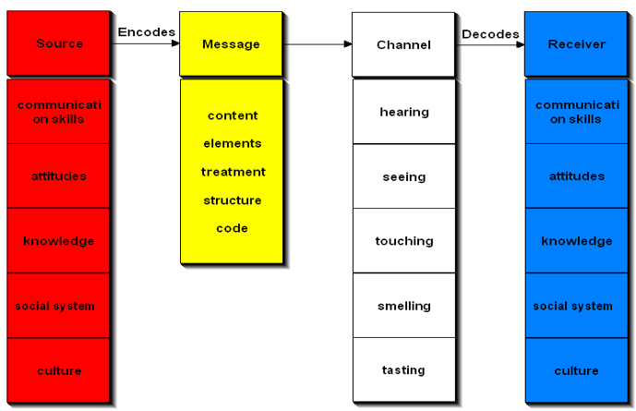
It verifies the communication skills of the sender in such a way that they are competent enough to perform knowledge transfer in the workplace. The sender should have the required knowledge and understanding of the message that will be transferred. This allows them to ensure that they are using the shared information within the organisational premises. This can be done by focusing on the performance of the employees in terms of developing their collaborative functioning within the workplace. The receiver should be capable of communicating the message to the other employees in the workplace. This will help them to focus on understanding their roles and responsibilities in the workplace for dealing with the challenges and complexities in a better way. This would allow them to enhance their level of organisational productivity and make sure that the workers are able to perform effective communication in the workplace.
Osgood-Schramm model of communication is also effective for an organisation to communicate the messages with the stakeholders and dealers. It is circular method of communication that consists of a sender who encodes a message and a receiver who decodes the message. The model emphasises on the encoding and decoding of a message and ideas of interpretation is central to this model. As per this model, Message meaning can be connotative or denotative. The model also approaches that the communication is incomplete until and unless a sender receivers’ feedback from the recipient. The communication is conducted between two people in which one-person act as receiver and another is sender. However, the model also considers a field of experiences or community at the time of communicating that enhances the capability of receiver to understand a message. In the messages with denotative meaning, misunderstanding and misinterpretation is low because it is same as all individuals On the contrary, messages with connotative meaning includes emotional factors in which the meaning of the message is distorted due to wrong gestures and body movements.
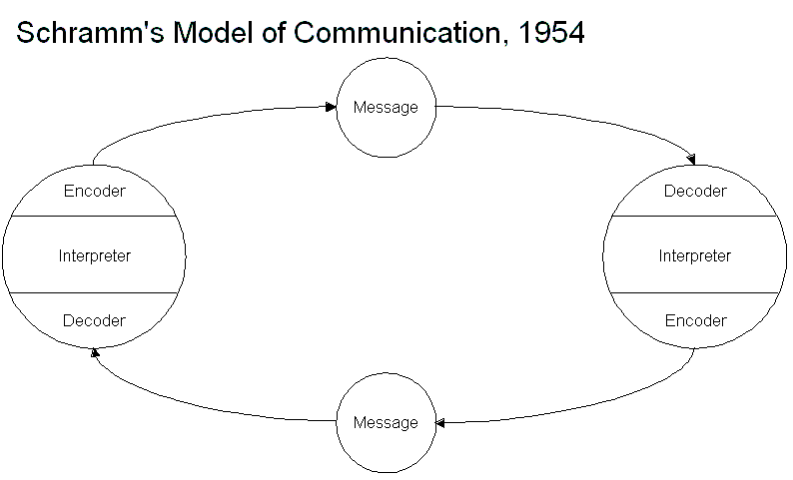
This model is effective to communicate the stakeholders at the time of one-to-one communion in business. Connotative messages have emotional approaches that is necessary to make friendly working environment in the workplace. It reduces the possibilities of conflict. Communication with the dealers and management can be circular with the help of this model and therefore Circular commination can reduce miscommunicate and misunderstanding between other dealers and it can enhance their motivation in work. It is also beneficial for reducing absence of the employees that is necessary to boost their performance and commitment to the organisation.
Therefore, the use of the mentioned models will help to develop the process of effective communication in the workplace by dealing with the issues in a significant manner. With the aid of this, it becomes easier for the higher officials to ensure that the information is being transferred to the different departments in a hassle-free manner.

Briefing for the Group Members.

It is essential for the higher officials to brief the guidelines to the group members. This can be considered as one of the most effective and efficient techniques that would allow them to nurture the process of operations in the workplace by binding the employees in teams It is useful, as it aids to increase the communication level in the workplace for better operational outcomes. As a result, in most cases, it is witnessed that companies prefer using Schramm’s Model of Communication. According to this model, communication can be considered circular in nature. This model is useful, as it can decode the message that has been sent to the receiver in the workplace. As a result, the management authority can have a clear idea about the ways in which communication can be enhanced by mitigating the workplace complexities in a positive way. It is imperative to communicate about the changes that are about to take place in the organisation. It will prepare the employees to face challenges with a positive attitude and engage in effective team working for gaining sustainable outcomes in the business.
The group members should be aware of the tasks and their roles in terms of completing the same. This is important, as they are focused on achieving the business objectives that would allow them to perform in a desired manner and face the intense level of competition from other car manufacturing companies in the nation. However, the employees should be aware of the ways in which effective communication can be established and make the most of it by transferring information across the different departments for using the same in a desired manner It clearly states the significance of teamwork and effective means of communication in the workplace by developing the operational activities for dealing with the significant challenges in a desired way. It can be used for identifying the challenges that persist in the workplace and collaborative functioning amongst the employees would aid in the process of overcoming the same quite easily without facing any problems in the process.

Conclusion
The above-mentioned discussions help to understand the effectiveness of teamwork in the workplace and help to gain a clear understanding of effective communication that might lead to organisational success in the market. The study sheds light on the ways in which employees should look to execute their activities for better operational outcomes in the workplace. This signifies the importance of teamwork in terms of achieving the business goals for enhanced operational expertise. However, the study explains the significance of some of the most important models that are responsible for developing effective communication in the workplace. This can be considered useful for the higher officials as well as the employees, as it aids them to speak about their grievances in the workplace and overcome the same without facing further challenges in the process. Therefore, the presence of effective communication and teamwork would help the organisation to overcome the barriers and operate to the best of their abilities.

Reference List
Banks, P., 2017. Why communication is important to organizational success.
Brock, S.E., McAliney, P.J., Ma, C.H. and Sen, A., 2017. Toward more practical measurement of teamwork skills. Journal of workplace learning.
Gai, W., Du, Y. and Deng, Y., 2019. Communication and Diffusion of Emergency Warning. In Decision-making Analysis and Optimization Modeling of Emergency Warnings for Major Accidents (pp. 65-87). Springer, Singapore.
Khawam, A.M., DiDona, T. and Hernández, B.S., 2017. Effectiveness of teamwork in the workplace. International Journal of Sciences: Basic and Applied Research (IJSBAR), 32(3), pp.267-286.
Lantz Friedrich, A., Sjöberg, A. and Friedrich, P., 2016. Leaned teamwork fattens workplace innovation: The relationship between task complexity, team learning and team proactivity. European Journal of Work and Organizational Psychology, 25(4), pp.561-569.
Mishra, S., 2017. Shannon and Weaver model of communication.
Munir, Z.A., Shukor, S.A.M., Sundaram, V.P.K., Dzulkipli, M.R. and Shaharudin, N., 2017. Engaging the Echo Boomer: Teamwork at Workplace. Advanced Science Letters, 23(11), pp.10519-10523.
Nabie, A. and Ome, B., 2016. Effective communication: a key component to reduce workplace stress. International Advanced Journal of Teaching and Learning, 2(5), pp.15-21.
Razak, M.I.H.M., Athmar, W.A.W., Durani, N., Salleh, A.J. and Hamdan, N.I.B., 2019. Effective Communication as a Tool for Achieving Organizational Goals. KnE Social Sciences, pp.380-387.
Rubtcova, M. and Pavenkov, O., 2018, September. Transformation of the Classical Model of Mass Communication in the Modern Society. In RF-269th International Conference on Management, Economics & Social Science-ICMESS (pp. 22-23).
Sapienza, Z.S., Veenstra, A.S., Kirtiklis, K. and Giannino, S.S., 2016. The Transmission Model of Communication: Toward a Multidisciplinary Explication. ETC.: A Review of General Semantics, 73(4), p.321.
Scott, B.B. and Queen’s, I.R.C., 2017. Creating a Collaborative Workplace: Amplifying Teamwork in Your Organization.
Sharma, P. and Rani, A., 2018. Role of effective communication between mentoring and employee satisfaction: pls approach. Prestige International Journal of Management & IT-Sanchayan, 7(1), pp.33-43.
.

