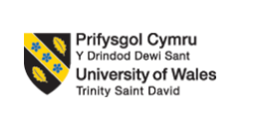

STUDENT ID: 2431302
STUDENT NAME: Md Shah Alam
MODULE CODE: LCMB7024
MODULE NAME: Marketing Management
ASSESMENT TITLE: Boots Botaniq: A New Sustainable Brand for Boots
LECTURER: Dr Laila Maazouz
Word Count: 2500 words

Table of Contents
Element 1: STDP Analysis for Boots Botaniq 3
1.1 Introduction 3
1.2 Segmentation 3
1.2.1 Demographic 3
1.3 Targeting 4
1.4 Differentiation 4
1.5 Positioning 5
Element 2: Marketing Mix 6
Element 3: Marketing Strategy Pitch 10
Element 4: Reflection 11
4.1 Reflection on Brand Development 11
4.2 Reflection on Pitch Preparation 11
4.3 Key Skills 11
4.4 Self-Evaluation for Future Improvement 12
5. Reference 13

Element 1: STDP Analysis for Boots Botaniq

1.1 Introduction
Boots is the UK's premier wellness and beauty retailer, and it has been operating for 175 years, so it has listened, learned, and innovated, and continues to challenge itself (Boots, 2024). The purpose of Boots is to provide the best care to customers and patients, as its priority is health and beauty (BOOTS, 2025). Boots Botaniq is a new brand of Boots, which will offer new skin-care products to its consumers. It will include new sustainable products made from natural ingredients. In this new brand, Boots will introduce new products for face and body care, such as Gentle Cleanser, Hydrating Moisturiser, and Night Cream for both men and women. For all of these products, sustainable packages will be used that are recyclable. Zhang et al. (2024) claim that Plant-Based Fibers help to recycle products multiple times, as they grow from natural fibers.
Hence, Boots will use these natural ingredients so that the company can recycle its packaging easily to maintain environmental sustainability. Avocado oil will be used for the production as it is a natural ingredient. According to Amra et al. (2022), Avocado hydrates the dry, desquamated skin by penetrating deeper into its layers. Avocado oil is important for the skin for both males and females because it provides deep moisturiser via fatty acids and vitamins to protect against damage. Hence, it is effective for Boots to maintain the ESG (Environment, Social, and Governance) goals.

1.2 Segmentation

1.2.1 Demographic
Age: 20 – 45
Gender: Both male and female
Income: Middle to Upper-middle class consumers
Employment: Students, Professionals, and Workers in multiple sectors
Interest: Sustainability, Eco-conscious, Health-conscious, Skin-care, and environmentally friendly consumers. These are selected because Boots Botaniq will provide value to consumers’ health and skin, as well as environmental sustainability. Therefore, people who provide value to their skin and health, as well as the environment, are the core targeted consumers.
Geographic Location: Urban and suburban areas, such as London, Bristol, Liverpool, Manchester, and Chelsea. Clark (2024) claims that 58.8 million people live in the urban areas of the UK. Hence, urban and suburban areas are important locations for Boots to get a wide range of targeted customers.

1.3 Targeting
The new brand of Boots is called Boots Botaniq, where this brand will introduce new products for both men and women, which will provide priority to sustainability and skin care. Therefore, the core consumers for this new brand are those people who provide value to sustainability and are conscious about their skin. Moran (2025) found that 67% of people provide value to sustainability in their lifestyle. Watty (2022) also found that people in the UK are willing to pay more 10% for sustainable products. Furthermore, Reeves (2025) found that according to a survey, more than half reported feeling self-conscious about their complexion, with 38% admitting to thinking about it on a regular basis, irrespective of the environment. Therefore, these people are the ideal consumers for Boots. Hence, this new brand of Boots will target these people in urban and suburban areas in the UK.

1.4 Differentiation
Maintaining environmental sustainability and health are important in this world. UNEP (2025) claims that every year, 19-23 million tonnes of plastic garbage flow into aquatic environments, damaging lakes, rivers, and oceans. The United States Environmental Protection Agency (2024) reported that plastic pollution threatens the marine ecosystem because it increases the risk of marine creatures swallowing plastic, choking, or getting involved in plastic fragments. Boots Botaniq is a sustainable new brand of Boots because, under this brand, sustainable products will be introduced. Under this brand, Boots will use Plant-Based Fibers for the packaging so that it will be easy for the company and consumers to recycle it (Zhang et al., 2024). Chemical materials are harmful to the skin, which can result in serious injuries. According to Liang (2020), chemicals can disrupt the epidermis' barrier function, leading to skin dehydration and irritation. Hence, Boots will use natural ingredients to produce new products under Boots Botaniq. This way, new products of Boots cannot harm the skin of users. Therefore, these initiatives differentiate Boots from other health and beauty companies in the marketplace.

1.5 Positioning
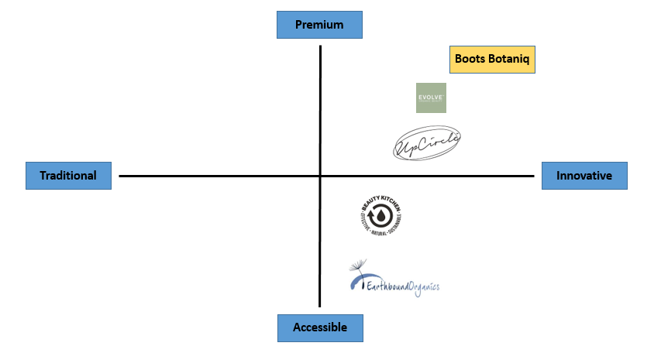
Figure 1: Market Positioning of Boots Botaniq
Boots Botaniq of Boots is a sustainable brand of the company where this brand will promote sustainable products to meet ESG goals. Boots Botaniq not only provides sustainable products but also chemical-free skin care products to consumers. Its competitors are Evolve Organic Beauty, UpCircle, Beauty Kitchen, and Earth Bound. Evolve Organic Beauty uses PET plastic and it is totally recyclable and, when disposed of, does not leech any toxins into the soil (Evolve Organic Beauty, 2025). Similarly, UpCircle uses aluminum for its packaging, and it is also 100% recyclable (UpCircle Beauty, 2025). However, Boots Botaniq will use Plant-Based Fibers for packaging for its new products. Plant-based fibers are 100% biodegradable, and they are better than PET plastic and aluminum. Therefore, the packaging of Boots Botaniq is more sustainable than its competitors. Hence, this innovation of Boots Botaniq will give it the top position in the marketplace.

Element 2: Marketing Mix
The 7Ps of Marketing Mix include Product, Price, Place, Promotion, People, Process, and Physical Evidence (Joseph and María, 2024). The 7Ps of Marketing Mix are crucial for businesses to develop an effective marketing strategy by developing a structured model of planning, developing, evaluating, and refining (Joseph and María, 2024). Therefore, it is important for Boots to develop its new brand, Boots Botaniq, in an effective way to get the best outcomes.
Product: The product is the most important aspect of the marketing mix since it has a direct impact on consumer experience and pleasure. BBC Bitesize (2024) reported that businesses guide the product's cycle from inception to development by balancing layout, customer demands, and market realities.
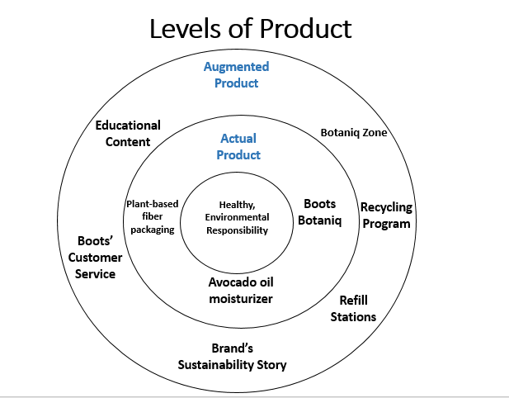
(Kotler et al., 2020)

A proper level of product is designed for the new brand, Boots Botaniq, to ensure benefits. Kotler et al. (2020) claim that levels of product are designed to focus on customer needs and guide value creation. Hence, Boots will introduce sustainable products, such as body cream, moisturiser, and night cream that are beneficial for both the environment and skin under the new brand Boots Botaniq. Boots will use Plant-Based Fibers in its production so that users can easily recycle the packaging for new purposes (Zhang et al., 2024). In this way, they can prevent plastic pollution, which is harmful to both the environment and health. Moreover, Boots will use 100% natural ingredients in its production to produce new products for the Boots Botaniq.
Price: Price is also an important aspect of the marketing mix because this can also play a vital role in attracting consumers. A competitive price is effective for businesses to reach a wide range of consumers in the world. According to Zhang, Choi, and Cheng (2023), by offering strategic rates rather than rivals, organizations can grow revenue, improve brand loyalty, and eventually improve customer satisfaction. Therefore, it is important for Boots to provide competitive prices for its new products under Boots Botaniq to get benefits and advantages from the marketplaces. A value-based pricing strategy is used for pricing because this supports the brand positioning. According to Kotler et al. (2020), a value-based pricing strategy is directly interconnected with pricing and support benefits by providing value to customer needs.
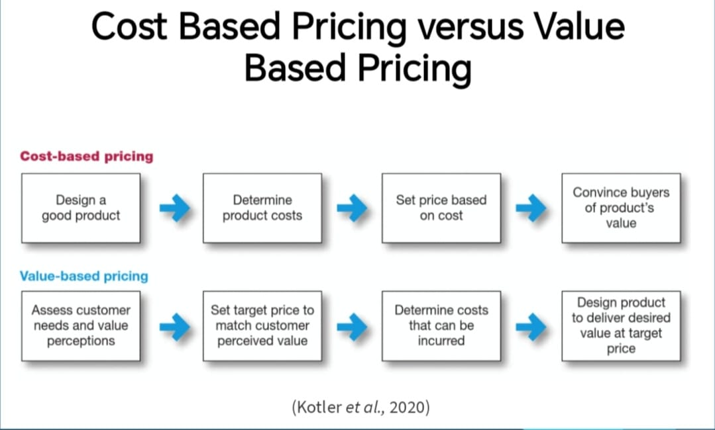
(Kotler et al., 2020)

Beauty Kitchen is a core competitor of Boots because the company also provides products that are made of natural ingredients. For example, the price of a face mask of 60ml is 20 pounds from Beauty Kitchen (Beauty Kitchen, 2025). Similarly, 30ml of the facial oil of Earth Bound is 24.58 pounds (Earth Bound, 2025). Hence, Boots must provide a competitive price for its products, which will be 18-23-pound range.
Place: It is important for Boots to know from which place consumers can make a purchase to get these products. Boots has more than 1,800 in the UK to operate its business efficiently (Boots, 2025a). Boots will distribute its new products to all its stores. Therefore, people can get their desired products from those stores in the UK. Moreover, Boots has a unique website, where the company shares its activities and products (Boots, 2025b). People can order their products online from the website of Boots website and can get home delivery. This is an easy method for people because they do not need to go to stores to buy products. Therefore, people can get products from Boots through stores or the website.
Promotion: After producing new products for Boots Botaniq, it is important to promote them to a wide range of consumers in the UK. There are several methods available to promote new products of Boots, such as Social Media Marketing (SMM), influencer marketing, paid ads, etc. According to a survey, it is found that 70% of people in the UK use social media every day (Statista, 2024). Hence, it will be a crucial method for the brand promotion of Boots. Boots can also use influencer marketing to promote the new brand Boots Botaniq. According to Benevento et al. (2025), frequent relationships among influencers and followers increase perceptions of authenticity, creating trust and positive brand attitudes. Influencers can promote new products of Boots to their followers, and so Boots will get a wide range of consumers for its new brand. Moreover, Boots can display its new brand Boots Botaniq on its website, where its regular customers can learn about this new brand. In this way, Boots can promote its new products to a wide range of consumers.
People: Employees of Boots are the core people of the company, as they will ensure customer satisfaction in purchasing. Hence, they need effective training to maintain the new brand Boots Botaniq. Heinrich (2025) claims that employee training is essential for organizational performance because it equips employees with the appropriate skills and information. Hence, Boots must arrange a training program for employees in the company to provide knowledge about Boots Botaniq. As a result, employees can provide the best to customers by providing information on how Boots Botaniq is effective for the environment and skin.
Process: Boots must build a mechanism for customers, where they can be aware of its new brand, Boots Botaniq. If customers get a new experience from Boots, it will increase customer satisfaction. Customer satisfaction is important for a company because it leads to customer engagement and loyalty (Einstein, 2025). Therefore, in-store, Boots must be simple and hygienic. Boots must make the payment process easy for consumers so that they cannot find difficulties on the website. Boots can introduce short videos or blogs for consumers so that they can know more about Boots Botaniq and its new brand products.
Physical Evidence: Boots must build strong and effective physical evidence for Boot Botaniq for the consumers. Boots can build the Botaniq Zone, where it will be shown how products are manufactured through natural ingredients. It will increase consumer trust and attract more eco-conscious people to its stores. Boots can build a refill station for consumers in every store so that consumers can refill their packaging. In this way, Boots will gain trust and reputation from consumers, which is important for the company to maintain business operations.

Element 3: Marketing Strategy Pitch
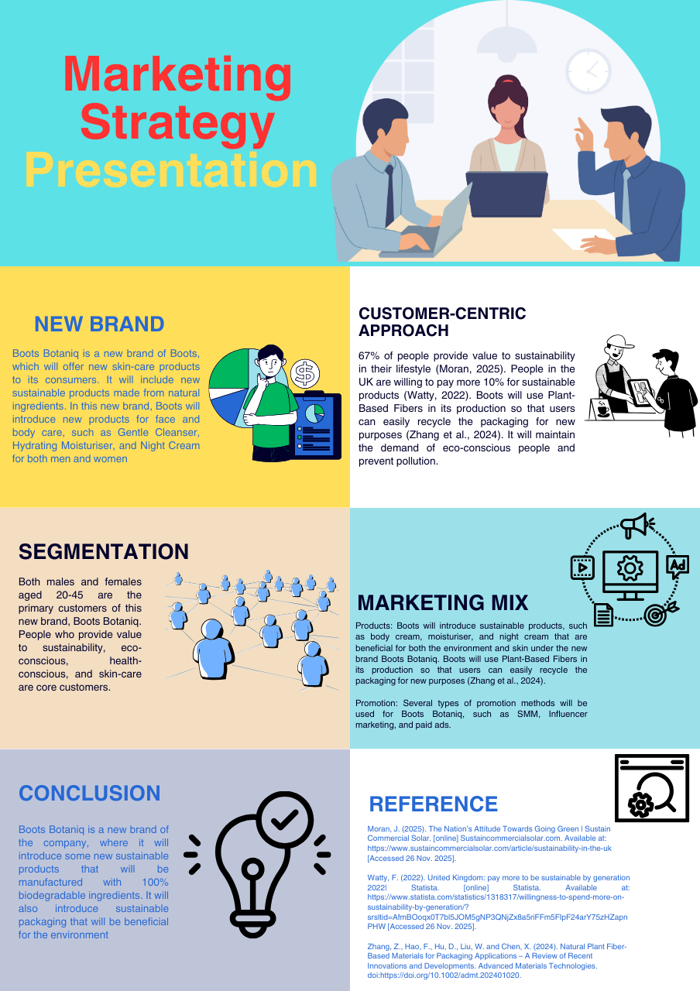

Element 4: Reflection

4.1 Reflection on Brand Development
I have built a strategic brand development for Boots called Boots Botaniq, which will ensure sustainability, as well as skin care. I have obtained great experience in building a new brand for Boots to introduce new sustainable products to consumers. I have faced challenges in building a new brand from a simple concept of sustainability, and developing a new sustainable brand. First, I have to research the market and find that consumers are moving to sustainable habits and becoming conscious about environmental sustainability. Second, I have researched the target audience for the new brand by analysing the market segmentation. The most challenging part for me is to build an effective and proper marketing strategy by following the 7Ps of Marketing Mix.

4.2 Reflection on Pitch Preparation
Preparing a pitch is important for me to define how this new brand will be effective in the marketplace for Boots. Developing pitch helps me to identify the core strategy for promoting the new brand Boots Botaniq to a wide range of consumers in the UK. I have found some effective messages, which can attract more sustainable conscious people. This practice process helps me build confidence and guides me to manage time properly. As a result, I can deliver the pitch in a particular time effectively. It was a great experience for me to critically highlight the difference between deep analysis and effective communication for marketing. Moreover, I have also gained knowledge about several marketing methods, which are effective for brand promotion.

4.3 Key Skills
I have gained several skills while building a new brand for Boots, which will increase its reputation and strengthen its relationship with consumers. I gained strategic thinking skills when I was preparing to build a new brand for Boots. I have to evaluate the market properly, and this forces me to deep analysis. Then I have obtained the concept to build a sustainable brand. I have also gained critical analysis skills in this brand development. When I apply the 7Ps of Marketing Mix, I have to analyse deeply to build a strategic marketing strategy for Boots Botaniq. I have critically analysed all the criteria that need to be met properly. Hence, these two skills are effective for me in my future life.

4.4 Self-Evaluation for Future Improvement
This practice of brand development helps me to identify my strengths and weaknesses in building a strategic brand and marketing strategy. I have struggled to fix a competitive price for new products under Boots Botaniq. However, I have gained some strategic skills, such as strategic thinking and critical analysis. These two skills will guide me to develop a new brand in the future for new companies. With the help of these two skills, I will cover my gap and strengthen my key areas properly.

5. Reference
Amra, K., Momin, M., Desai, N. and Khan, F. (2022). Therapeutic benefits of natural oils along with permeation enhancing activity. International Journal of Dermatology, [online] 61(4), pp.484–507. doi:https://doi.org/10.1111/ijd.15733.
BBC Bitesize (2024). How is product important to the marketing mix? - BBC Bitesize. [online] BBC Bitesize. Available at: https://www.bbc.co.uk/bitesize/articles/zqgh46f [Accessed 26 Nov. 2025].
Beauty Kitchen (2025). AO Night Halo Potent Sleep Mask 60ml. [online] Beauty Kitchen. Available at: https://beautykitchen.co.uk/collections/mask/products/abyssinian-oil-night-halo-potent-sleep-mask?variant=55048574796163 [Accessed 26 Nov. 2025].
Benevento, E., Aloini, D., Roma, P. and Bellino, D. (2025). The Impact of Influencers on Brand Social Network growth: Insights from New Product Launch Events on Twitter. Journal of Business Research, [online] 189, p.115123. doi:https://doi.org/10.1016/j.jbusres.2024.115123.
BOOTS (2025). Boots UK - Our purpose and values. [online] www.boots-uk.com. Available at: https://www.boots-uk.com/about-boots-uk/our-purpose-and-values/ [Accessed 26 Nov. 2025].
Boots (2024). Boots UK - about Boots UK. [online] Boots-uk.com. Available at: https://www.boots-uk.com/about-boots-uk/ [Accessed 26 Nov. 2025].
Boots (2025a). Boots in numbers. [online] www.boots-uk.com. Available at: https://www.boots-uk.com/about-boots-uk/our-purpose-and-values/boots-in-numbers/ [Accessed 26 Nov. 2025].
Boots (2025b). Pardon Our Interruption. [online] Boots.com. Available at: https://www.boots.com/?srsltid=AfmBOooHJt3r0oE0bE469uoLDvRjyROC4k16AD_nnhk0HKu--xCRUJyk [Accessed 26 Nov. 2025].
Clark, D. (2024). UK urban and rural population 2024| Statista. [online] Statista. Available at: https://www.statista.com/statistics/984702/urban-and-rural-population-of-the-uk/?srsltid=AfmBOoqIYKo6hz3IyvPTyvByrDlOgAD1-4gLmoZBV80ENbFTLIYLV5Ut [Accessed 26 Nov. 2025].
Earth Bound (2025). Night Repair Facial Oil (V) 30ml. [online] Earthbound Organics. Available at: https://www.earthbound.co.uk/products/night-repair-facial-oil-30ml [Accessed 26 Nov. 2025].
Einstein, B. (2025). How to Foster Customer Engagement & Acquisition. [online] Business Insights Blog. Available at: https://online.hbs.edu/blog/post/customer-engagement [Accessed 26 Nov. 2025].
Evolve Organic Beauty (2025). Eco Friendly. [online] Evolve Organic Beauty. Available at: https://www.evolvebeauty.com/en-int/pages/eco-friendly?srsltid=AfmBOopDuIXvIu8rSYV4l0BdvY4BI7jyxqQK7P3lhCsgJeaDsGl9d0Mv [Accessed 28 Nov. 2025].
Fleck, A. (2024). Infographic: The World Is Flooded With Plastic Waste. [online] Statista Daily Data. Available at: https://www.statista.com/chart/32385/global-plastic-waste-production-by-application/ [Accessed 28 Nov. 2025].
Grand New Horizon (2024). UK Organic Skin Care Market Size & Outlook, 2030. [online] Grandviewresearch.com. Available at: https://www.grandviewresearch.com/horizon/outlook/organic-skin-care-market/uk [Accessed 28 Nov. 2025].
Heinrich, A. (2025). 5 Benefits of Corporate Employee Training & Development. [online] Business Insights Blog. Available at: https://online.hbs.edu/blog/post/employee-training-development [Accessed 26 Nov. 2025].
Joseph, D. and María, R. (2024). Effect of the 7P’s of the Marketing Mix on the Sales Strategies of a Private University: a comprehensive analysis using the neutrosoph-ic PEST-SWOT approach. [online] UNM Digital Repository. Available at: https://digitalrepository.unm.edu/nss_journal/vol74/iss1/48.
Kotler, P., Armstrong, G., Harris, L.C. and He, H. (2020). Principles of Marketing. 8th ed. Hoboken: Pearson.
Liang, W. (2020). Toxicity and effect of chemicals in skin care products on human health. IOP Conference Series: Earth and Environmental Science, 512(1), p.012081. doi:https://doi.org/10.1088/1755-1315/512/1/012081.
Miles, S. (2024). 89% of consumers value small business ethical values. [online] Startups Magazine. Available at: https://startupsmagazine.co.uk/article-89-consumers-value-small-business-ethical-values [Accessed 28 Nov. 2025].
Moran, J. (2025). The Nation’s Attitude Towards Going Green | Sustain Commercial Solar. [online] Sustaincommercialsolar.com. Available at: https://www.sustaincommercialsolar.com/article/sustainability-in-the-uk [Accessed 26 Nov. 2025].
NYTLicensing (2023). What Is Educational Content Marketing? [online] NYTLicensing. Available at: https://nytlicensing.com/latest/marketing/why-educational-content-strategy-so-valuable/ [Accessed 28 Nov. 2025].
Reeves, M. (2025). New UK survey shows lasting mental health toll of skin conditions beyond summer. [online] The Scotsman. Available at: https://www.scotsman.com/health/new-uk-survey-shows-lasting-mental-health-toll-of-skin-conditions-beyond-summer-5300642 [Accessed 26 Nov. 2025].
Statista (2024). Topic: Social media usage in the UK. [online] Statista. Available at: https://www.statista.com/topics/3236/social-media-usage-in-the-uk/?srsltid=AfmBOooECeApKWt5tx7xUrbXSI9U4yMzVgqGFAj3EcF1X1VmqRgdgPIE#topicOverview [Accessed 26 Nov. 2025].
The Boots Group (2020). Environmental Social Governance - The Boots Group. [online] Thebootsgroup.co.uk. Available at: https://www.thebootsgroup.co.uk/environmental-social-governance [Accessed 28 Nov. 2025].
UNEP (2025). Plastic Pollution. [online] UNEP - UN Environment Programme. Available at: https://www.unep.org/plastic-pollution [Accessed 26 Nov. 2025].
United States Environmental Protection Agency (2024). Impacts of Plastic Pollution. [online] www.epa.gov. Available at: https://www.epa.gov/plastics/impacts-plastic-pollution [Accessed 26 Nov. 2025].
UpCircle Beauty (2025). Our Packaging. [online] UpCircle Beauty. Available at: https://upcirclebeauty.com/pages/our-packaging [Accessed 28 Nov. 2025].
Watty, F. (2022). United Kingdom: pay more to be sustainable by generation 2022| Statista. [online] Statista. Available at: https://www.statista.com/statistics/1318317/willingness-to-spend-more-on-sustainability-by-generation/?srsltid=AfmBOoqx0T7bl5JOM5gNP3QNjZx8a5riFFm5FIpF24arY75zHZapnPHW [Accessed 26 Nov. 2025].
YEC (2024). Council Post: The Power Of Storytelling For Your Business: Unleashing Your Inner Storyteller. Forbes. [online] 12 Aug. Available at: https://www.forbes.com/councils/theyec/2023/06/08/the-power-of-storytelling-for-your-business-unleashing-your-inner-storyteller/ [Accessed 28 Nov. 2025].
Zhang, T., Choi, T.-M. and Cheng, T.-C.E. (2023). Competitive pricing and product strategies in the presence of consumers’ social comparisons. European Journal of Operational Research, 312(2). doi:https://doi.org/10.1016/j.ejor.2023.06.023.
Zhang, Z., Hao, F., Hu, D., Liu, W. and Chen, X. (2024). Natural Plant Fiber‐Based Materials for Packaging Applications – A Review of Recent Innovations and Developments. Advanced Materials Technologies. doi:https://doi.org/10.1002/admt.202401020.

