Student Name : Alina Smalbergher
Student ID Number : 2114414
Module : Foreign Languages & Cultural Awareness (BMIH5003)
Lecturer name : Jinping Li

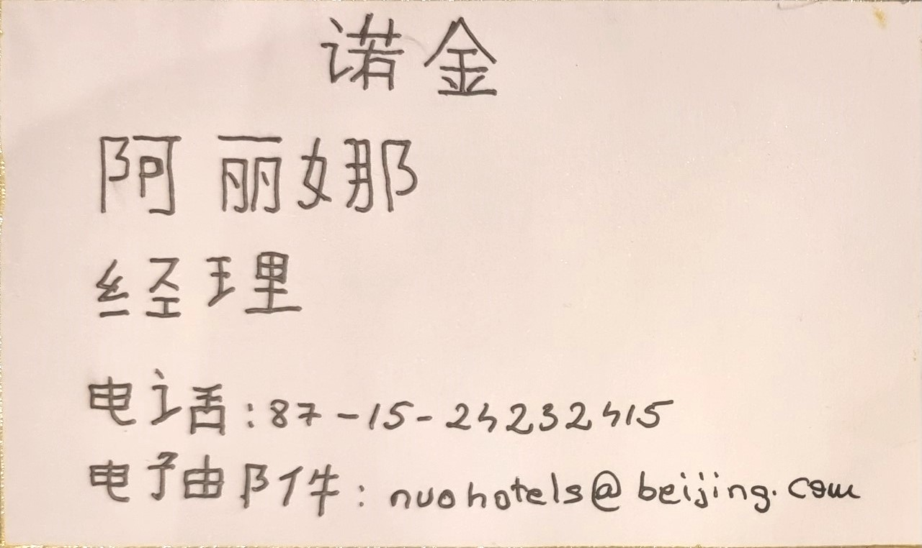
Business Card

