

Postgraduate/Distance Learning
Assignment coversheet & feedback form

THIS SHEET MUST BE THE FIRST PAGE OF THE ASSIGNMENT YOU ARE SUBMITTING (DO NOT SEND AS A SEPARATE FILE)

For completion by the student:
Student Name: Whitney Hill / 2209673@student.uwtsd.ac.uk
Module code: HPCA 7028  Module title: Sacred Skies | Student ID number: 2209673 |  |  | Educational support needs:  Yes/No
Module tutor: Dr Bernadette Brady

Assignment due date: 2 May 2024
If your module has multiple submissions please indicate which piece of work this is.

1st 2nd 3rd 4th 5th 6th
I confirm that this is my original work and that I have adhered to the University policy on plagiarism.
Signed …Whitney Hill…………………………………………………………
Email submission: if you are submitting this form via email, please tick this box □
(as a substitute for your signature) to confirm that you agree to the above declaration.
Assignment Mark
Final Mark | WILL BE GIVEN ON TURNITIN

NB. All marks are provisional until confirmed by the Final Examination Board.

PLEASE NOTE: ALL COMMENTS WIL BE POSTED ON TURNITIN

For completion by Marker 1 :
Comments:

Marker’s signature: |  |  | Date:
For completion by Marker 2/Moderator:

Comments:

Marker’s Signature: |  | Date:
AGREED INTERNAL MARK (where necessary):

Comment on process of arriving at agreed mark:

External Examiner’s comments (if relevant)

External Examiner’s Signature: |  | Date:

A Critical Examination of the Sky in Relation to Material Culture
The Sky and the Built Environment at the Temple of Hathor in Dendera

Word count: 4624

Introduction
Understanding how people of the past viewed the sky can provide insights not only into their cultural cosmology, but also into how that culture may have been influenced by others. This paper examines the range of possible cultural influences on representations of the sky in the Graeco-Roman period of ancient Egypt through a critical assessment of the round and rectangular zodiacs in the Temple of Hathor at Dendera in Qena, Egypt.
The Temple of Hathor consists of a main temple oriented to the north to face a bend in the Nile rather than the usual east-west orientation. It is an imposing structure at roughly 40 meters wide and 80 meters long. A smaller temple to Isis, two birth houses, a sanatorium, a sacred lake, and a chapel to Osiris are also on the grounds, surrounded by mud-brick walls. It was built during the Ptolemaic period, when rulers with foreign Macedonian origins were building, rebuilding, or embellishing Egyptian-style temples in an effort to both establish their legitimacy and drive economic activity. According to David Peacock, the Roman rulers who followed and added to it ‘inherited pharaonic religion, on which a classical gloss had been superimposed, largely during the preceding Ptolemaic period.’ Furthermore, Peacock writes,

‘Only in Egypt, and perhaps to some extent in the Greek lands of the north-eastern Mediterranean, is the Roman period an essay in continuity with what went before. At least one of the reasons for this must lie in pharaonic architecture. The creation of a landscape dominated by buildings made of massive blocks of stone, which were not easily swept away, must have been a major factor.’

This continuity with what went before is evidenced in the Ptolemaic and Roman rulers following in the footsteps of their pharaonic Egyptian predecessors in the aforementioned building and expansion of massive temples to Egyptian deities, including at the Temple of Hathor. Chris Brennan notes that in parallel, Hellenistic astrology was developing out of a blend of Mesopotamian and Egyptian traditions in Hellenistic Egypt toward the end of that period. Given this blending in not only the traditions of rulership and their expression via architecture but also in the practices associated with looking at and representing the sky, Greek, Roman, and other cultural influences would likely have made their way into the details of the temple, including in the representation of the constellations and planets.

Methodology
Because travel to Egypt was not possible for the author at the time of writing, this work is based on examinations of temple features via digital and textual means, including photographs and Google Earth. It also relies upon the findings of other scholars who were able to visit in person and described what they saw. As such, this paper is effectively a survey of the prevailing theories around the influences present in each of the zodiacs.
While not visiting the location in person limits the ability to note contextual or unique observations of the site itself, J. McKim Malville and John L. Ninnemann have called out the value of using digital photography as making possible the addition of ‘thick descriptions’ of possible cultural meaning in describing a site, as well as adding reproducibility to the research.
In addition to reviewing the art itself, the broader impacts of politics, war, and trade provide a contextual backdrop for understanding the social landscape contemporary ancient Egyptians may have been navigating at the time of these artifacts’ creation.

The Dendera Zodiacs in Context
Although both the round and the rectangular zodiacs are located within the same temple complex, they were not created at the same time. With the round zodiac being created circa 50 BCE and the rectangular one being in the hypostyle hall built in the first century CE under the direction of the Roman emperor Tiberius around 20 CE, there is a gap of not only time but also rulership and culture. The first zodiac would have been created in the Greek-influenced Ptolemaic period, which lasted from 332-30 BCE, and the second would have been during the Roman period which followed, from 30 BCE to 395 CE. Although these are typically combined into the ‘Graeco-Roman period’ in Egyptian studies, there may be some shifts in the celestial representations influenced by the change in the origins and cultures of the ruling class funding the temple works.
The original intended audience for both zodiacs is those who would have had access to the inner areas of the temple, likely only priests. As Wilkinson notes in writing on Egyptian temples generally, ‘the outer court was often accessible to the common people, at least in part or on special occasions’ and architecture or lighting preserved ‘the privacy of the inner sacred areas of the temples’ including the hypostyle halls. This suggests that the zodiacs within the temple proper would have been reserved for the priests’ viewing or use, not that of the general public. As such, beyond any aesthetic value both zodiacs may have served religious purposes, including religious instruction in the workings of the heavens, the myths behind them, or both.

The Round Zodiac
This zodiac represents constellations and planets for the Ptolemaic period of ancient Egypt. It is made of sandstone and measures 2.55 metres by 2.53 metres. It was originally set in the ceiling of the Chapel of Osiris, but the original is now in the Musée du Louvre in Paris, as shown in Figure 1 below.

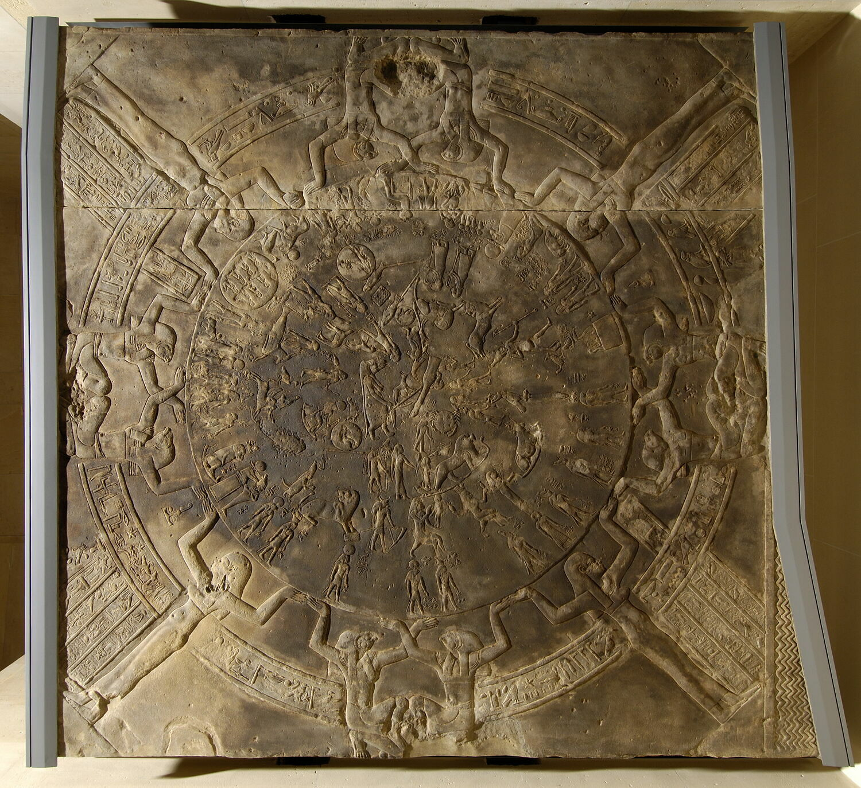
Figure 1: Musée du Louvre / Christian Décamps (photographer), ‘Zodiaque de Dendéra’. From the Musée du Louvre website, accessed 30 March 2024.

According to Juan Antonio Belmonte and José Lull, this is the only round celestial diagram in Egypt, although they note the presence of one in a museum in Athens. The note does not make it clear whether the round celestial diagram in Athens is of Egyptian or Greek origin, but the general uniqueness of the round Dendera zodiac’s format combined with its creation relatively late in ancient Egyptian history raises a question of whether its shape is due to foreign influences.
Belmonte and Lull have identified multiple sets of images representing different portions of the sky present in the round zodiac: a set of 36 decans, some southern constellations, the zodiacal constellations of the ecliptic, some northern constellations, divinities, eclipses, the planets (including the Sun and Moon), and a few unidentified constellations (Figure 2).

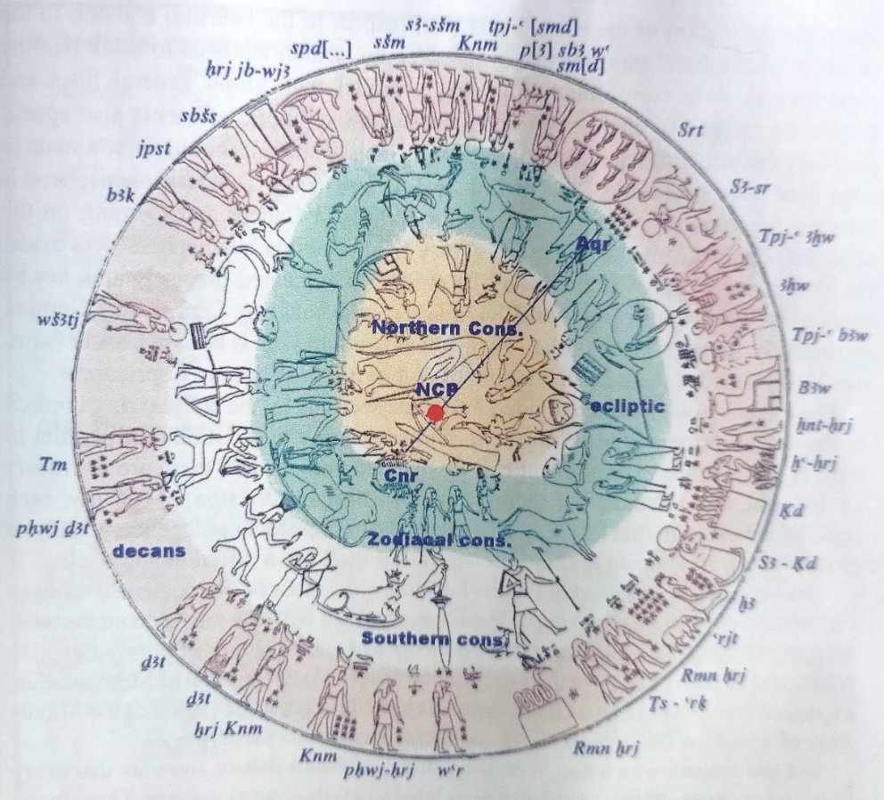
Figure 2: A representation of the Dendera round zodiac with colours indicating different sets of celestial representations. From Belmonte and Lull (2023).

According to Neugebauer and Parker, the decans shown are from the Tanis family. There are several known decan families; the date range for the Tanis family spans from the Twenty-sixth Dynasty (664-525 BCE) to the Graeco-Roman period through about 69-96 CE, making these a contemporaneous choice.

The Rectangular Zodiac
In addition to the round zodiac, there is a rectangular zodiac filling the ceiling of the Great Vestibule/outer hypostyle hall at the northern end of the Temple of Hathor. This zodiac is effectively broken into several parts by pillars. It represents the zodiacal constellations, two sets of decans, and the procession of the sun and moon at large scale. A composite image of the ceiling created by Peter Rowland and edited by Bernadette Brady is shown in Figure 3 below, followed by a close-up of some of the detail in Figure 4.

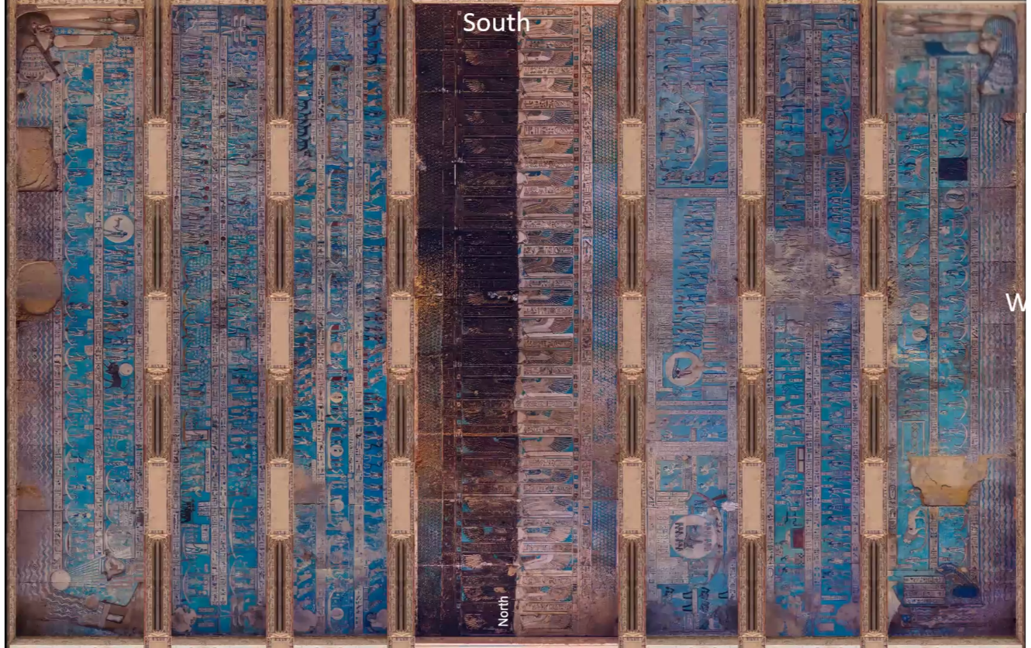
Figure 3: Reconstructed composite image of the rectangular zodiac in the hypostyle hall of the Temple of Hathor at Dendera. Based on screenshots from Bernadette Brady's presentation on the cosmology of the hypostyle hall (2023). Image compiled by Perter Rowland, edited by Bernadette Brady, and used with permission.
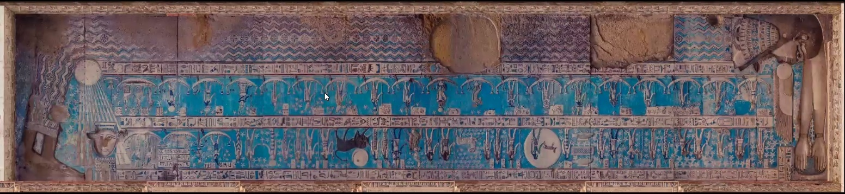
Figure 4: Detail of the eastern side of the rectangular zodiac in the hypostyle hall of the Temple of Hathor at Dendera. Screenshot from Bernadette Brady's presentation on the cosmology of the hypostyle hall (2023). Original image compiled by Perter Rowland, edited by Bernadette Brady, and used with permission.

As explained by Brady, this ceiling lays out the Egyptian cosmology and reminds sky and priests what is necessary to preserve and continue order/ma’at, indicating that there is an instructional use for the ceiling.
Although this zodiac covers similar themes and includes many of the same celestial bodies or concepts as the round zodiac, the rectangular layout includes two separate decanal lists: an earlier family of decans, Seti I B, as well as the Tanis family.

Comparing the Zodiacs
The size and shape are the most obvious differences between the two zodiacs. While this may simply be a factor of the space available to place each sky representation, there may be other reasons.
For example, other representations of or references to the sky in Ancient Egypt tended to be rectangular, such as the tomb ceiling of Senmut which includes circles in the imagery but is overall rectangular in shape. In a slightly different example of representing the sky, the coffin lids documented by Neugebauer and Parker show the decanal lists in tables of hieroglyphics interspersed with images. The decanal tables on tomb ceilings and coffin lids were intended to be symbolic instructions, which according to Belmonte and Lull would ‘enable the deceased to know the hours and the paths marked by the stars’. Likewise, the rectangular zodiac on the ceiling of the Temple of Hathor’s hypostyle hall was, as noted previously, intended to remind or instruct priests on their duties toward maintaining the order and harmony of the cosmos and the earthly plane.
One question to consider is whether the rectangular layout is intended to be informative or instructive in nature (whether symbolically for the dead or practically for the living) and the unique round layout is intended to be something more of a snapshot in time or a commemoration of sorts. Adding to this question is the differing locations of the two zodiacs, with one being in the hypostyle hall of the main temple and the other being in a chapel. Perhaps the different placements combine with the differing layouts to indicate different purposes.
With this brief overview of the zodiacs themselves, it is possible to review the influences on the rendering of the stars and planets.

Views on Influences
Egyptian Foundations
Because the Temple of Hathor is in Egypt and dedicated to an Egyptian goddess, an examination of cultural influences must start with the ‘home’ culture.
Belmonte and Lull note several clear examples of the Egyptian influences on the round zodiac. First, the inclusion of the decans in the outer ring is a distinctly Egyptian inclusion. The use of the decans for time-keeping goes back to the First Intermediate Period and the Twelfth Dynasty, carrying through to their usage on the temple and chapel ceilings at Dendera as noted above. While Hellenistic astrology adopted and adapted the Egyptian idea of decans as a division of the sky, Demetra George explains that the Greek astrological decans use even, ten-degree intervals for a different purpose. Therefore, the specific depictions of the decans on both the round and rectangular zodiacs are evidence of an ongoing Egyptian influence in the representation of the sky, despite the more recent Greek and Roman rulership and funding for the temple.
There are also some Egyptian influences in how the planets are represented. For example, Saturn, called ‘Horus bull of the sky’ or ‘Horus the bull’ by the Egyptians, is represented as a bull-headed figure in both the round and rectangular zodiacs as shown in Figure 5 below.

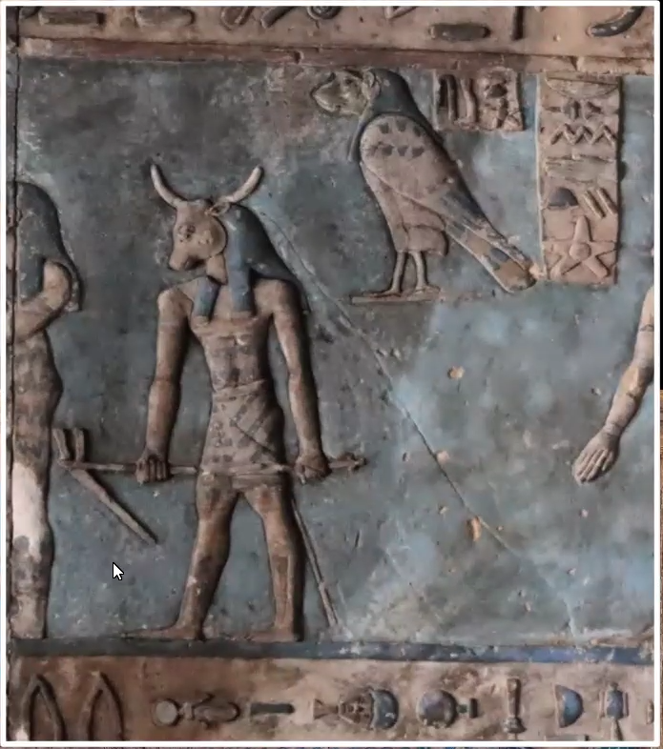
Figure 5: Carved figure of Saturn from the rectangular zodiac in the hypostyle hall of the Temple of Hathor at Dendera. Screenshot from Bernadette Brady's presentation on the cosmology of the hypostyle hall (2023).

Likewise, Jupiter, called ‘Horus who bounds the two lands’ or ‘Horus who illuminates the two lands’ by the Egyptians is represented by a falcon-headed figure reminiscent of the Egyptian god Horus in the rectangular zodiac. In these two examples, a long-standing association between Egyptian gods and their depictions is maintained through the Greek- and Roman-era constructions of each artifact. Other examples come from the replacing of Castor and Pollux with the Egyptian deities Shu and Tefnut in both Dendera zodiacs, as noted by Belmonte and Lull, or in the depiction of the constellation Aquarius as Hapy, the god of the Nile inundation, in the rectangular zodiac as noted by Brady and shown in Figure 6.

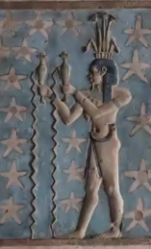
Figure 6: Detail of the rectangular zodiac showing the constellation Aquarius as the Egyptian god Hapy. Screenshot from Bernadette Brady's presentation on the cosmology of the hypostyle hall (2023).

Additionally, classical Egyptian constellations including Meskhetyu and Reret are featured within the round zodiac. The use of Egyptian gods in depictions created in the Graeco-Roman era could be an effort on the Greek and Roman rulers’ parts to establish or maintain legitimacy by allowing connections with the past, or it could be an effort on the part of the Egyptian creators to retain elements of their own culture while appeasing new rulers. However, the explanation could be simpler; Belmonte and Lull propose that the inclusion of traditional Egyptian elements ‘would have completed the image of the “firmament” in such a way that all of them filled empty spaces in order to avoid the dreaded horror vacui’. If this was the case, then the inclusion of the strictly Egyptian elements would have been a case of using the familiar traditional elements to complete a work rather than trying to integrate new introductions. It may also be possible that multiple or all of these considerations played a role.
Regardless of the reasons, it is clear that the sculptors retained important Egyptian conceptualizations of the night sky beyond the decans in both zodiacs.

Mesopotamian Influences
Mesopotamian cultures also had a long history of astronomy, one which has shown up in the Dendera zodiacs. In writing on Mesopotamian astronomical texts, E.C. Krupp states that ‘most of the surviving astronomical texts were written between 650 and 50 B.C.’, which puts them well within the date range necessary to influence Egyptian astronomical representations. Early trade links and later conquests by the Persians would have provided opportunities for Mesopotamian knowledge of all kinds to be disseminated in Egypt.
In their review of the zodiacs at Dendera, Neugebauer and Parker state that, ‘The basic pictorial elements for the zodiacal signs are, however, undoubtedly of Babylonian origin as is evident, e.g. from the figure of the goat-fish (Capricorn), the double-headed archer on a winged, scorpion-tailed horse (Sagittarius), the ear of corn (in Virgo), etc.’ This can be confirmed by looking at the detail of the zodiacs. Referencing Franz Boll’s work Sphaera, Joachim Quack writes that a winged representation of Sagittarius comes from the Babylonian narûs or kudurrus, whereas the Greek version is typically shown without wings. Figure 7 below shows a winged representation of Sagittarius (circled in red) between the scorpion of Scorpio and the Babylonian fish-goat of Capricorn, suggesting that the round zodiac used the Babylonian contribution despite this being a Ptolemaic-era creation.

Figure 7: Detail of the round zodiac focusing on the depiction of the constellation Sagittarius. From the Musée du Louvre website.

As a further example, Tamsyn Barton notes that the Mesopotamian version of the zodiac includes the Balance (Libra) and the Scorpion (Scorpio), whereas the Greeks included Libra as part of the scorpion’s claws and the Egyptians called Libra ‘Horizon’. In Figure 8, we can see a set of scales depicted next to the scorpion on the round zodiac, confirming the Mesopotamian influence.

Figure 8: The depiction of the zodiacal constellation Libra as a balance in the round zodiac. From the Musée du Louvre website.

In addition to the representations of zodiacal constellations, Neugebauer and Parker also note that the planets are shown in their signs of exaltation. According to F. Rochberg-Halton, the exaltations are an import from Babylonian astrology to Greek astrology—if somewhat adapted from the original concept of the bīt niṣirti—so this is another example of Babylonian influence even if it is passed through the Greek tradition.
In all these examples, the Babylonian influence does not fully replace the Egyptian concepts. Nicholas Campion writes that at Dendera, the round zodiac from the roof of the East Osiris Chapel incorporates both Egyptian constellations and Babylonian ones, which may have been

‘an attempt, if an ultimately unsuccessful one, to merge the two systems rather than replace one by the other. The Babylonian component features the planets in their own zodiac signs, the significance of which may be found in later texts.’

Campion adds that the later rectangular zodiac ‘makes it easier to locate the Egyptian constellations in relation to the Babylonian, the point being that the two systems were combined.’ That this effort to blend but not replace was undertaken across two separate works created roughly 80 years apart shows a remarkable persistence in Egyptian culture.
These examples demonstrate that while Egyptian conceptions of the sky continued to be transmitted via sculpture through the Graeco-Roman period, new influences were being blended in. The inclusion of planets in their signs of exaltation on the round zodiac suggests not only Babylonian, but also some Greek influence in the cosmology of the Dendera zodiacs.

Greek Influences
Egypt was invaded by the Macedonian Alexander the Great in 332 BCE. The subsequent rulers of the Ptolemaic dynasty blended Greek and Egyptian culture and politics, for example in structures like a pavilion constructed in Alexandria which, as Alan B. Lloyd states, ‘was designed to make statements about Ptolemaic kingship: it combined at several points Greek and Egyptian motifs’ as part of propaganda efforts. This blending for the purpose of gaining acceptance from the populace likely extended to the temples they supported.
However, there may have been a wholesale replacement rather than blending in some cases. Speaking generally on the use and depictions of constellations, Belmonte and Lull write that

‘during the Ptolemaic era a notable change occurs in the Egyptian heavens when zodiacal constellations of Mesopotamian origin are introduced. With this change the ancient Egyptian constellations occupying the zodiacal band were eliminated, or at best minimized, in favour of the new constellations.’

So, while the depiction of the constellations and planets may be done in an Egyptian style both artistically and mythologically and use Mesopotamian representations, the use of the zodiac itself might be a Greek introduction present in both the round and rectangular artifacts. This is, of course, in addition to the placement of the planets near their signs of exaltation in the round zodiac, mentioned previously.
While this is an instance of general replacement of some Egyptian constellations in the zodiacal band, Greek influences also appear to have been blended right into the Egyptian-Babylonian mélange already noted. Campion says, ‘Babylonians and Greeks were mixing freely, so much so that the labels may be meaningless’ and adding that there was ‘a transitional period in which the Hellenized Babylonian constellations were used alongside ancient Egyptian asterisms and the 36 decans.’ This is indeed visible in both the zodiac in the Osiris chapel and that in the hypostyle hall.
Although the zodiac may have been a Greek introduction, there are questions as to whether there was any further Greek influence on the representation of constellations in Egypt. Quack notes the presence of the constellations of Hydra and Corvus on the round zodiac, but the absence of the crater that would typically be included by the Greeks. While he also states that further study is needed, this suggests that perhaps the Greek influence on the zodiacs at Dendera may be more as a channel of transmission than a stylistic or mythological contribution. Brennan covers how Greek and Roman writers from the first century CE onward tended to ascribe the origins of astrology to (possibly fictional) ancient Egyptian or Mesopotamian sources in an effort to establish a sort of pedigree so it is possible that this is a factor in the celestial representations of the Graeco-Roman period as well.
After the Ptolemaic dynasty ended, Egyptian rule was taken over by the Roman empire, introducing another sphere of influence to the Temple of Hathor.

Roman Influences
In writing about the Roman period, Peacock says that

‘Visitors to the ancient temples of Egypt usually think that they are looking at masterpieces of the Dynastic era, but in many cases—Dendera, Edfu, Kom Ombo, Esna, and Philae, for example—the extant structures are substantially Ptolemaic and Roman.’

This illustrates the extensive and direct influence the Romans had not only at Dendera, but at religious sites across Egypt—influence we would expect to see reflected in the decorations of the temples themselves. To this point, Peacock adds further that in the Temple of Hathor, ‘The ornament is characteristically Egyptian, but many of the subjects are Roman emperors’, another example of the political blending documented with the Ptolemies. It would be a logical extension of thought to consider that this same blending would occur in other aspects of the temple’s decorations.
Indeed, Brady notes that with the construction of this portion of the temple being funded by the Romans, the creation of the rectangular zodiac would have been undertaken ‘with a nod to the Romans’. Wilkinson says outright that the signs of the zodiac were introduced by the Romans and Brady also notes that the rectangular zodiac at Dendera uses the ‘beginnings of the Roman-Mesopotamian zodiac’, so this could offer evidence of Roman influence in celestial representations. However, these latter points contradict what Belmonte and Lull said about the zodiac being introduced in the preceding Ptolemaic period. One reconciling possibility is that there was a combination of Greek and Roman influence in the later part of the period, when the round zodiac is estimated to have been created. According to Toby Wilkinson, the Romans’ political and military engagements in Egypt increased during the rule of Ptolemy VI in 168 BCE and continued increasing through the end of Ptolemaic rule, so attempting to cleanly demarcate the start and end of any given culture’s influence may be not only an unrealistic endeavour but also a potentially inaccurate one.
Additionally, in an alternative to the question posited above regarding the shape as instructive (rectangular) versus snapshot (round), Brady says that the circular format was done in appeasement of the Tiberius and the Romans because ‘sacred space for the Egyptians is not round’ but rather square. These ideas need not be mutually exclusive. However, the estimated creation date of the round zodiac circa 50 BCE predates the start of the Roman period in 30 BCE, raising the question of timing and influence, but as the dates of the round zodiac’s creation are estimates there is room for varying hypotheses.

Conclusion
The fluid and shifting nature of the political, religious, and military landscapes during the late Ptolemaic and early Roman periods of ancient Egypt, combined with existing trade links and prior invasions, makes it difficult to decisively state that there was any primary influence on the Temple of Hathor at Dendera in general and the representation of constellations and planets in the zodiacs in particular, or when that influence would have started. Instead, the Dendera zodiacs demonstrate an effort to merge the established styles, beliefs, and practices of the Egyptian past with the need to reflect shifts in the hands of power and the cultural influences (and resources) that came with them during the Graeco-Roman period.
The strongest influences on both zodiacs appear to be Egyptian and Mesopotamian, with Egyptian sky concepts such as the decans and the depictions of the planets and certain constellations being maintained in both. Mesopotamian influences are evident in the representations of the zodiacal constellations and, via Greek reinterpretation, in the depiction of the planets in the round zodiac near their signs of astrological exaltation.
Clear and direct evidence of Greek influence was not uncovered in reviews of secondary sources beyond mentions of the introduction of the zodiac to Egypt, which some authors attribute to the Romans and others to the mixing of Egyptian and Mesopotamian cultures prior to the Graeco-Roman period.
It seems that despite the Hellenistic- and Roman-era construction of the Temple of Hathor at Dendera and the contemporary features displayed elsewhere (e.g. depictions of Roman emperors), the influence of Egypt and Mesopotamia was not easily shaken off—a consideration which may have been intentional as an effort to legitimize new rulership, or yet another example of the persistent nature of pharaonic architecture and Egyptian practices and myth.

Bibliography
Barton, Tamsyn, Ancient Astrology (New York: Routledge 1994)

Belmonte, Juan Antonio and José Lull, Astronomy of Ancient Egypt: A Cultural Perspective (Cham, Switzerland: Springer Nature Switzerland, 2023)

Brady, Bernadette, ‘The Temple of Hathor − Dendera: The Cosmology of the Hypostyle Hall’ [PowerPoint presentation] (2023), Available at: https://us02web.zoom.us/rec/share/INxC1Ap1lKy-yOKcEVhXbWFoqQvrjVB_mZnjJ6JKImFm3XMM5L-6pBvJ687wMNxQ.iPEoDpvfZ1dtxIKL [Accessed 29 February 2024]

Brennan, Chris, Hellenistic Astrology: The Study of Fate and Fortune (Denver: Amor Fati Publications, 2017)

Campion, Nicholas, A History of Western Astrology, Volume 1: The Ancient and Classical Worlds (London: Bloomsbury Academic, 2008)
George, Demetra, Ancient Astrology in Theory and Practice: A Manual of Traditional Techniques, Volume One: Assessing Planetary Condition (Auckland: Rubedo Press, 2019)

Google Earth 10.49.0.0, Dendera Temple to Hathor (2023), 26.141° N, 32.670° E elevation 72m. 2D and 3D buildings data layer <https://earth.google.com/web/ > [accessed 23 March 2024]

Krupp, E.C., Echoes of the Ancient Skies: The Astronomy of Lost Civilizations (Garden City, NY: Dover Publications, 2003)

Lloyd, Alan B., ‘The Late Period’, in The Oxford History of Ancient Egypt, ed. by Ian Shaw (Oxford: Oxford University Press, 2003), pp. 364-387

Lloyd, Alan B., ‘The Ptolemaic Period’, in The Oxford History of Ancient Egypt, ed. by Ian Shaw (Oxford: Oxford University Press, 2003), pp. 388-413

Malville, J. McKim, and John L. Ninnemann, ‘Archaeoastronomy and Cultural Astronomy as Scientific Disciplines: Falsifiability and Photo Documentation’, Culture and Cosmos, vol. 21 no 1 (2017), pp. 173-192 <doi.org/10.46472/CC.01221.0219>

Musée du Louvre / Décamps, Christian (photographer), ‘Zodiaque de Dendéra’ <https://collections.louvre.fr/en/ark:/53355/cl010028871> [accessed 30 March 2024]

Neugebauer, O. and Richard A. Parker, Egyptian Astronomical Texts, Vol. I: The Early Decans (Providence, Rhode Island: Brown University Press, 1960)

Neugebauer, O. and Richard A. Parker, Egyptian Astronomical Texts, Vol. III: Decans, Planets, Constellations and Zodiacs (Providence, Rhode Island: Brown University Press, 1969)

Peacock, David, ‘The Roman Period’, in The Oxford History of Ancient Egypt, ed. by Ian Shaw (Oxford: Oxford University Press, 2003), pp. 414-436

Quack, Joachim, ‘Egypt as an astronomical-astrological centre between Mesopotamia, Greece, and India’, in The Interactions of Ancient Astral Science, ed. by David Brown (Bremen: Hempen 2018) <https://doi.org/10.11588/ propylaeumdok.00005323> [accessed 21 April 2024]

Quack, Joachim Friedrich, ‘The Planets in Ancient Egypt’, Oxford Research Encyclopedia of Planetary Science, 23 May 2019 <https://doi.org/10.1093/acrefore/9780190647926.013.61> [Accessed 29 February 2024]

Rochberg-Halton, F., ‘Elements of the Babylonian Contribution to Hellenistic Astrology’, Journal of the American Oriental Society, vol. 108 no. 1 (Jan. – Mar. 1988), pp. 51-62 <https://www.jstor.org/stable/603245> [accessed 30 March 2024]

Shaw, Ian, ‘Egypt and the Outside World’, in The Oxford History of Ancient Egypt, ed. by Ian Shaw (Oxford: Oxford University Press, 2003), pp. 308-323

Wilkinson, Richard H., The Complete Temples of Ancient Egypt (New York: Thames & Hudson 2000)

Wilkinson, Toby, The Rise and Fall of Ancient Egypt (New York: Random House, 2013)

Richard H. Wilkinson, The Complete Temples of Ancient Egypt (New York: Thames & Hudson 2000), p. 149.
Google Earth 10.49.0.0, Dendera Temple to Hathor (2023), 26.141° N, 32.670° E, elevation 72m. 2D and 3D buildings data layer <https://earth.google.com/web/ > [accessed 23 March 2024]
Wilkinson, The Complete Temples of Ancient Egypt, p. 149.
Alan B. Lloyd, ‘The Ptolemaic Period’, in The Oxford History of Ancient Egypt, ed. by Ian Shaw (Oxford: Oxford University Press, 2003), pp. 388-413 (p. 407).
David Peacock, ‘The Roman Period’, in The Oxford History of Ancient Egypt, ed. by Ian Shaw (Oxford: Oxford University Press, 2003), pp. 414-436 (p. 428).
Peacock, ‘The Roman Period’, p. 436.
Chris Brennan, Hellenistic Astrology: The Study of Fate and Fortune (Denver: Amor Fati Publications, 2017), p. 9.
Brennan, Hellenistic Astrology, p. 16.
J. McKim Malville and John L. Ninnemann, ‘Archaeoastronomy and Cultural Astronomy as Scientific Disciplines: Falsifiability and Photo Documentation’, Culture and Cosmos, vol. 21 no 1 (2017), pp. 173-192 (p. 191-192) <doi.org/10.46472/CC.01221.0219>.
Musée du Louvre / Décamps, Christian (photographer), ‘Zodiaque de Dendéra’ <https://collections.louvre.fr/en/ark:/53355/cl010028871> [accessed 30 March 2024].
O. Neugebauer and Richard A. Parker, Egyptian Astronomical Texts, Vol. III: Decans, Planets, Constellations and Zodiacs (Providence, Rhode Island: Brown University Press, 1969), p. 204.
Lloyd, ‘The Ptolemaic Period’, p.388.
Peacock, ‘The Roman Period’, p. 415.
Wilkinson, The Complete Temples of Ancient Egypt, p. 62.
Wilkinson, The Complete Temples of Ancient Egypt, p. 65.
Neugebauer and Parker, EAT Vol. III, p. 72.
Décamps, ‘Zodiaque de Dendéra’.
Juan Antonio Belmonte and José Lull, Astronomy of Ancient Egypt: A Cultural Perspective (Cham, Switzerland: Springer Nature Switzerland, 2023), p. 287.
Belmonte and Lull, Astronomy of Ancient Egypt, p. 287-290.
Neugebauer and Parker, EAT Vol. III, p. 72.
Neugebauer and Parker, EAT Vol. III, p. 140-141.
Bernadette Brady, ‘The Temple of Hathor − Dendera: The Cosmology of the Hypostyle Hall’ [Powerpoint presentation] Available at: https://us02web.zoom.us/rec/share/INxC1Ap1lKy-yOKcEVhXbWFoqQvrjVB_mZnjJ6JKImFm3XMM5L-6pBvJ687wMNxQ.iPEoDpvfZ1dtxIKL [Accessed 29 February 2024], 00:57:40.
Neugebauer and Parker, EAT Vol. III, p. 78-79.
Neugebauer, O. and Richard A. Parker, Egyptian Astronomical Texts, Vol. I: The Early Decans (Providence, Rhode Island: Brown University Press, 1960), Plates 24-25.
Neugebauer, O. and Richard A. Parker, Egyptian Astronomical Texts, Vol. I: The Early Decans (Providence, Rhode Island: Brown University Press, 1960), Plates 1-23.
Belmonte and Lull, Astronomy of Ancient Egypt, p. 117.
Belmonte and Lull, Astronomy of Ancient Egypt, p. 114.
Demetra George, Ancient Astrology in Theory and Practice: A Manual of Traditional Techniques, Volume One: Assessing Planetary Condition (Auckland: Rubedo Press, 2019), p. 221.
Joachim Friedrich Quack, ‘The Planets in Ancient Egypt’, Oxford Research Encyclopedia of Planetary Science, 23 May 2019 <https://doi.org/10.1093/acrefore/9780190647926.013.61> [Accessed 29 February 2024], p. 7.
Quack, ‘The Planets in Ancient Egypt’, p. 7.
Quack, ‘The Planets in Ancient Egypt’, p. 11.
Belmonte and Lull, Astronomy of Ancient Egypt, p. 290.
Brady, ‘The Temple of Hathor − Dendera: The Cosmology of the Hypostyle Hall’, 00:37:40.
Belmonte and Lull, Astronomy of Ancient Egypt, p. 292.
Belmonte and Lull, Astronomy of Ancient Egypt, p. 306.
E.C. Krupp, Echoes of the Ancient Skies: The Astronomy of Lost Civilizations (Garden City, NY: Dover Publications, 2003), p. 27.
Ian Shaw, ‘Egypt and the Outside World’, in The Oxford History of Ancient Egypt, ed. by Ian Shaw (Oxford: Oxford University Press, 2003), pp. 308-323 (p. 313).
Alan B. Lloyd, ‘The Late Period’, in The Oxford History of Ancient Egypt, ed. by Ian Shaw (Oxford: Oxford University Press, 2003), pp. 364-387 (p. 375).
Neugebauer and Parker, EAT Vol. III, p. 203.
Joachim Quack, ‘Egypt as an astronomical-astrological centre between Mesopotamia, Greece, and India’, in The Interactions of Ancient Astral Science, ed. by David Brown (Bremen: Hempen 2018) <https://doi.org/10.11588/ propylaeumdok.00005323> [accessed 21 April 2024], p. 83.
Tamsyn Barton, Ancient Astrology (New York: Routledge 1994), p. 24.
Neugebauer and Parker, EAT Vol. III, p. 73.
F. Rochberg-Halton, ‘Elements of the Babylonian Contribution to Hellenistic Astrology’, Journal of the American Oriental Society, vol. 108 no. 1 (Jan. – Mar. 1988), pp. 51-62 (p. 57) <https://www.jstor.org/stable/603245> [accessed 30 March 2024].
Nicholas Campion, A History of Western Astrology, Volume 1: The Ancient and Classical Worlds (London: Bloomsbury Academic, 2008), p. 183.
Campion, A History of Western Astrology, p. 183.
Lloyd, ‘The Ptolemaic Period’, p.388.
Lloyd, ‘The Ptolemaic Period’, p.401.
Belmonte and Lull, Astronomy of Ancient Egypt, p. 271.
Campion, A History of Western Astrology, p. 182.
Quack, ‘Egypt as an astronomical-astrological centre between Mesopotamia, Greece, and India’, p. 84.
Brennan, Hellenistic Astrology, pp. 24-29.
Peacock, ‘The Roman Period’, p. 428.
Peacock, ‘The Roman Period’, p. 428.
Brady, ‘The Temple of Hathor − Dendera: The Cosmology of the Hypostyle Hall’, 00:35:18.
Wilkinson, The Complete Temples of Ancient Egypt, p. 149.
Brady, ‘The Temple of Hathor − Dendera: The Cosmology of the Hypostyle Hall’, 00:27:50.
Toby Wilkinson, The Rise and Fall of Ancient Egypt (New York: Random House, 2013), p. 460.
Brady, ‘The Temple of Hathor − Dendera: The Cosmology of the Hypostyle Hall’, 00:35:30.
Brady, ‘The Temple of Hathor − Dendera: The Cosmology of the Hypostyle Hall’, 00:30:48.

