
Skills for the Workplace
Module Assignment Submission
Student Name: | Sadia Kiyani
Student Number: | 1711581
Module No: | BMSK4003
Module Title: | Digital Skills and Research Methods

Statement of Confirmation of Authenticity
By the act of making this submission, the student declares that this is the work of the student named above. The work has not, in whole or in part, been knowingly presented elsewhere for assessment, or where assessment has been built on a previous assessment, this has been identified. Where materials have been used from other sources it has been properly acknowledged. If this statement is untrue, the student acknowledges that an assessment offence has been committed.
Attention is drawn to the plagiarism and unfair practice policies of both the University and of ILM.

Contents
Introduction 3
Cloud Storage 3
OneDrive Vs Google Drive 3
Tablets and Smartphones 4
Apple Vs Samsung 4
Advantages and disadvantages 4
Increasing Employability 4
Social Media 5
Facebook 5
Twitter 7
LinkedIn 8

Introduction
This report is focused on the use of technologies such as tablets and smartphones, and cloud storage. In the 21st century technology has become a necessity, the functioning of our daily lives depends on it since we need smartphones to make calls, access emails or to even make payments. Many other services have also become internet based such as reading the news and viewing entertainment services such as movies and sports games can be accessed through smartphones, tablets and laptops. This report will discuss how these technologies are used in the workplace; benefits and setbacks of using these; how they can help to improve efficiency in the workplace as well as how these technologies can increase employability.

Cloud Storage
Cloud storage is online space that is used to securely store data such as files or photos. The user simply can upload their desired files to an internet server. These files are password protected and can then be accessed from other devices through an established internet connection. Along with storing files online cloud storage can also offer other uses and for businesses and companies such as helping to reduce the costs of expenses used for managing paper files (Galvin, 2018). Other uses of cloud storage include providing backup files in case of server failures; it also improves flexibility for companies as the data can be accessed from anywhere and anytime; it is extremely cost effective and cheaper than having to maintain company servers (Hendricks, 2018).

OneDrive Vs Google Drive
Two of the major providers of cloud storage are Google Drive and OneDrive. Google drive offers storage space from 15GB to 30TB. The 15GB plan is free for all users with a Google account and the 100GB plan costs £1.59 per month and offers Google Docs for free for all users. On the other hand, OneDrive only offers a free 5GB plan and increases up to 50GB for £1.59 per month with a maximum of 1000 GB. OneDrive also offers Office 365 services for plans upwards of 50GB. Both forms of cloud storage also offer file sharing as well. Google Drive allows the user to share folders and files with other users as well as to Gmail, Twitter and Facebook. Similarly, OneDrive also allows the user to do the same and provides the user with more options such as LinkedIn. Both services also allow automatic synchronisation of files and documents. Bothe services also have security features to ensure the safety and confidentiality of files and documents. Google and OneDrive offer two-factor authentication which requires a security code to successfully log in from any devices that are not usually used on the user’s account. OneDrive also offers two-factor authentication. The files and documents stored in the Google data center are encrypted. However, the same cannot be said for OneDrive as they are kept in plain text. Therefore, files and data stored in OneDrive are more susceptible to cybercrime and ransomware (Gildred, 2018).

Tablets and Smartphones
Smartphones are handsets that include a wide range of functions such as making calls, sending text messages, browsing the web, online shopping, making payments and gaming. Smartphones in the 21st century will most likely have a touchscreen and a sizable storage space for storing photos videos and downloading apps (uSwitch Mobile Phone Deals, 2017).

Apple Vs Samsung
Two of the major provider for tablets and smartphones are Apple and Samsung. Both providers ensure ease of access to their users through ensuring that applications and settings. Samsung also offers their users to access functions such as disabling cameras and microphones whereas, apple doesn’t. however, it can be argued that Apple’s operational system is easier than Samsung’s as it can be hindered by ads. Both products aim towards a minimalist finish and design however, the iPhone has a longer durability than Samsung’s which is easily dented. Both also have a wide variety of apps available from the Appstore or from Google play. In terms of display apple is preferable when it comes to the quality of their displays. However, Samsung has had more significant improvements to their displays when compared to Apple’s. Both phones have a similar cost but nevertheless Samsung is more affordable than Apple (Johnson, 2017).

Advantages and disadvantages
All technology has its advantages and disadvantages when being used in the workplace. Some advantages of using mobile phones at work are that they help employees to increase their mobility as work can be done from anywhere, whether its at from home or from the commute to work. They also enable workers to keep contact with the office as well as customers and suppliers and can quickly update them on deliveries, collections or other general updates. On the other hand, some disadvantages of using mobile phones can be that they may decrease employee productivity as constantly being on the phone can disrupt the workflow; mobile phones allow workers to always be available, which can interfere with their free time. Another setback of smartphones is that it can be costly for businesses and companies to provide all employees with smartphones as well as having to deal with damages and repairs (nibusinessinfo.co.uk, 2018).

Increasing Employability
The use of these technologies helps increase employees’ digital literacy. It is vital that employees have digital literacy skills as it allows them to gain functional skills to successfully use and communicate through modern technology. Digital literacy can also be defined as “the ability to understand and use information in multiple formats from a wide range of sources when it is presented via computers” (Gilster, 1997). Digital skills can also have many other benefits for employees such as helping them to learn faster; saving money; helps job seekers to connect with new employers through sites such as Indeed and LinkedIn.

Social Media

Facebook
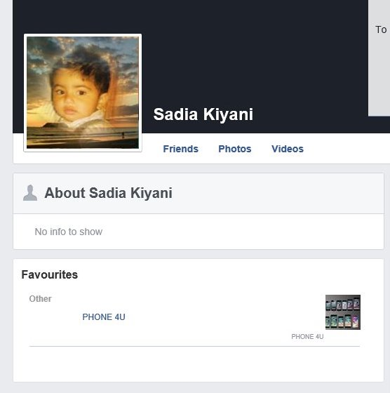
https://www.facebook.com/sadia.kiyani.501


Twitter
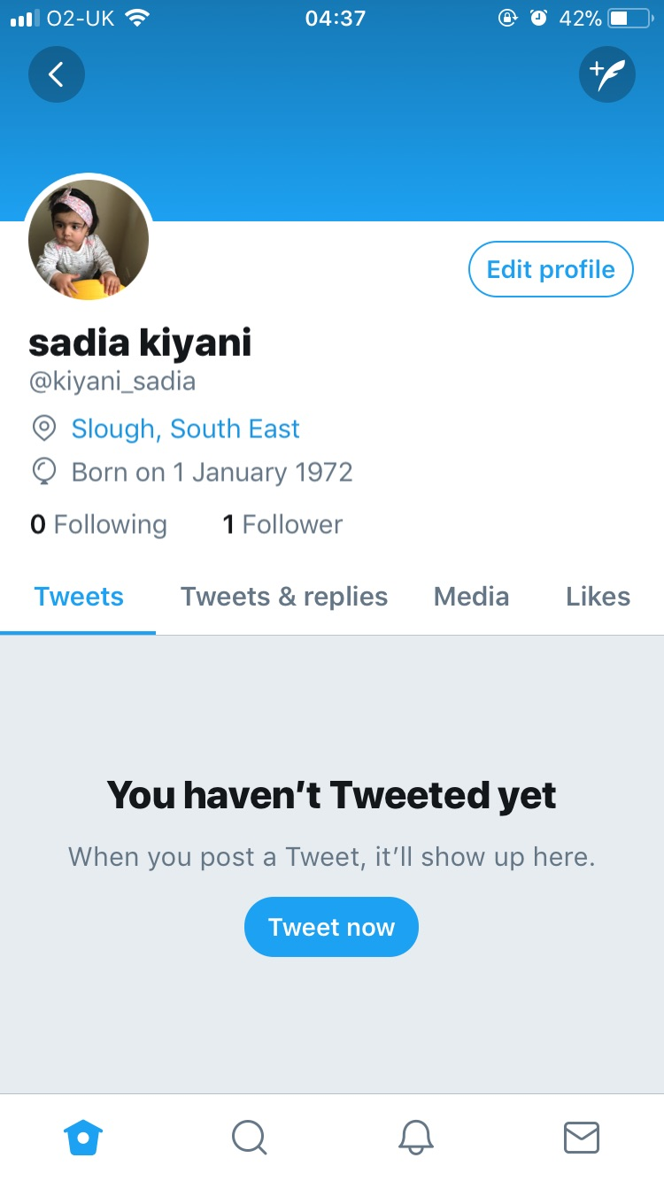

LinkedIn
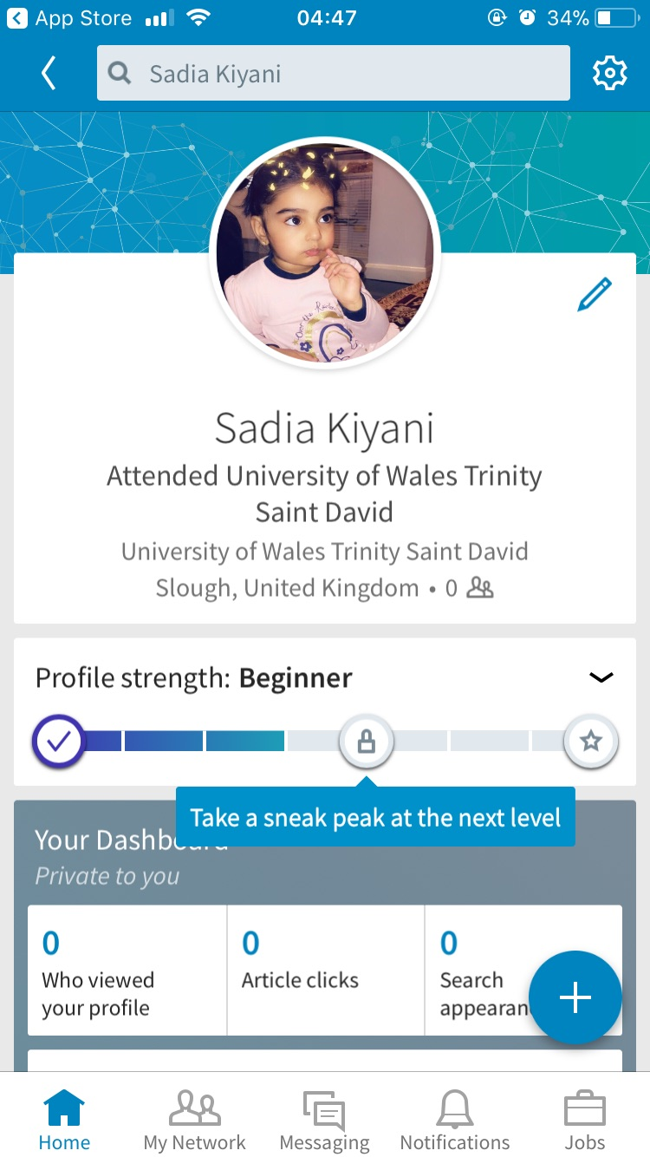

Bibliography
Galvin, C. (2018). How Businesses Use Cloud Storage. [online] The ChannelPro Network. Available at: http://www.channelpronetwork.com/article/how-businesses-use-cloud-storage [Accessed 3 May 2018].
nibusinessinfo.co.uk. (2018). Advantages and disadvantages of mobile phones in business. [online] Available at: https://www.nibusinessinfo.co.uk/content/advantages-and-disadvantages-mobile-phones-business [Accessed 4 May 2018].
nibusinessinfo.co.uk. (2018). Advantages and disadvantages of mobile phones in business. [online] Available at: https://www.nibusinessinfo.co.uk/content/advantages-and-disadvantages-mobile-phones-business [Accessed 4 May 2018].
Johnson, Z. (2017). Android vs. iPhone: Which better for Biz - business.com. [online] business.com. Available at: https://www.business.com/articles/samsung-android-vs-apple-iphone-which-is-better-for-business/ [Accessed 4 May 2018].
uSwitch Mobile Phone Deals. (2017). What is a smartphone?. [online] Available at: https://www.uswitch.com/mobiles/guides/what-are-smartphones/ [Accessed 4 May 2018].

