Student Name: Tasmia Bano
Student ID: 2433992
Module Code: BMHP 5032
Module Name: Introduction to Physiology
Lecturer: Gillian Weaver and Robert Nartowski
Assignment Title: Component 1: Written Assignment (Case Study Report)

Contents
1. Introduction 2
2. How Blood Sugar Levels Are Maintained at a Safe and Effective Level for the Body's Needs 3
3. How Oxygen and Glucose Are Used to Produce Energy Through Cell Metabolism 4
4. How Recording and Tracking Blood Sugar Levels Helps Individuals with Type 2 Diabetes to Safely Manage Their Condition 5
5. Evidence-Based Recommendations on How Lifestyle Changes Could Help Improve Their Condition 6
6. Conclusion 7
References 9

Introduction
Diabetes is a chronic condition of the metabolism, where the level of glucose (blood sugar) in the blood is not controlled. Glucose is the body's primary source of fuel and carbohydrates are the source of glucose. (Cleveland Clinic, 2022). Insulin is a hormone the body needs to get glucose from the blood to the cells to use for energy. Diabetes occurs when the body does not make enough insulin or can't use the insulin it produces. The diabetes has a numerous variety and the most common being Type 1 diabetes (T1D) and Type 2 diabetes (T2D). Type 1 Diabetes is an autoimmune disorder that is caused by the damage of the cells in the pancreas which produce insulin (Cleveland Clinic, 2023). Usually, type 2 diabetes is a consequence of insulin resistance and/or inadequate insulin production. If a woman is diagnosed with diabetes during pregnancy, it's called "gestational diabetes" and is a risk factor for Type 2 diabetes.
There are several risk factors associated with Type 2 Diabetes. Some of these factors include obesity, physical inactivity, poor nutrition, age, and family history of diabetes, high blood pressure, smoking and ethnicity. Being overweight, especially if excess fat is around the abdomen, increases the risk for developing insulin resistance (Adeva et al., 2024). Not being active, smoking and high calorie foods can contribute to the risk. Today, there are changes in lifestyle such as less active lifestyles and more processed foods which make Type 2 diabetes more likely. By 2050, 1 in 8 adults will have diabetes (13.0%) 853 million people (as shown in Figure 1) (Murphy, 2025). Hence, it is crucial to inform patients about diabetes and factors which can influence their blood glucose levels to enhance the health outcomes and prevent diabetes complications.
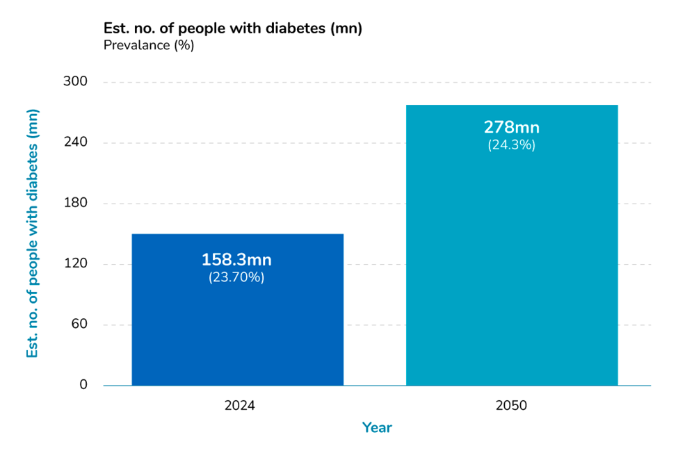
Figure 1 No of people with Diabetes
Source (Muphy, 2026)

How Blood Sugar Levels Are Maintained at a Safe and Effective Level for the Body's Needs
Regulating blood sugar is essential to provide a steady supply of energy to the body's cells, and to prevent an excessive rise or fall in blood sugar. The regulation is under the control of the coordinated activities of the hormone triggered by insulin and glucagon from the pancreas. After eating, carbohydrates are turned into glucose, which is absorbed into the blood (Lema, 2021). Pancreas increases its insulin secretion when blood glucose increase. Eventually, over time, blood sugar will be sufficiently brought back under control as glucose is taken into the cells from the blood (Hantzidiamantis, 2024). Glucagon is made by the pancreas when the blood glucose level falls, for example, during fasting or activity. Glucagon stimulates the liver to release glucose from its stored glycogen and into the blood. This action enables proper regulation of blood sugar and allows for a continuous supply of energy for the organ system, particularly to the brain.
In healthy individuals, blood glucose is maintained near a set point by negative feedback (Ahmed and Khalique, 2020). However, with a person suffering from diabetes, it does not work. In Type 2 diabetes, however, the cells may only partially respond to insulin resulting in a lack of uptake of glucose. This helps maintain the balance of blood sugar and maintains its level appropriately high for a period. A prolonged period of high blood glucose is called hyperglycaemia and can cause harm to the blood vessels and nerves. High blood glucose (glycaemia) can damage blood vessels and nerves with the passage of time. This increases the likelihood of getting many serious diseases, such as heart, kidney, nerve and eye diseases. On the other hand, hypoglycaemia (Uncontrolled Low Blood Glucose) causes dizziness, confusion, sweating and loss of consciousness (Paluchamy, 2019). The aim is to get good blood sugar control using medications and the use of lifestyle changes like exercise and nutrition to keep the blood sugar level in range so that targeted for A1C.

How Oxygen and Glucose Are Used to Produce Energy Through Cell Metabolism
The body requires energy for its essential activities such as moving around, breathing, building up and repairing. The energy generated is energy generated in the cells' mitochondria in cellular respiration (Petrescu and Petrescu, 2021).
The overall equation for aerobic respiration is: $$C_{6}H_{12}O_{6}+6O_{2}→6CO_{2}+6H_{2}O+ATP$$
In this process, the food's glucose is supplied to the cell with the help of insulin. Respiration of oxygen in lungs and carriage to tissue in blood. In the mitochondria, glucose is broken down, freeing up potential energy that is stored in its structure (bbc, 2024). This energy goes into molecules of ATP carbon dioxide and water are waste products. The steps include glycolysis (decomposition of glucose into smaller molecules), import of the glucose molecule breakdown product in mitochondria during the citric acid cycle and the electron transport chain. Along with these reactions, these molecules are transported into the mitochondria where the remainder of the reactions occur in the cycle and electron transport chains. In general, oxygen plays a role in electrons acceptance and ATP efficient generation (Biro 2022). If there is not enough glucose activity in the blood stream, then the diabetic may have a shortage of insulin activity.

How Recording and Tracking Blood Sugar Levels Helps Individuals with Type 2 Diabetes to Safely Manage Their Condition
Blood sugar level monitoring is amongst the most important steps of diabetes care. Blood glucose monitoring and self-measurement provide the person with and their health care provider with information about glucose control and help create a pattern of glucose monitoring that can signal to the individual or provider for the need for action (Weinstock et al., 2020). Regular blood glucose checking provides a lot of clear data about the effect of food, activity, medicine, sickness or stress on blood glucose control. This allows patients to keep track of this throughout time and take appropriate actions regarding lifestyle and treatment. Like, blood glucose can enhance in a patient after eating meals that contain lots of sugars or carbohydrates.
Blood sugar monitoring also helps in the recording of hyperglycaemic periods and hypoglycaemic periods. This early detection of a problem reading allows them to act early enough to avoid complications (Perazzo et al., 2022). Reviewing the posted blood sugar readings assists health care providers make decisions regarding treatment effectiveness and arrive as close to evidence-based conclusions as possible for changes to the medicine. It can gain insight into how well current management is considering target blood glucose ranges.
In addition, self-monitoring contributes to the involvement of the patient and self-care. They start to understand their illness more and are gaining confidence in their situation. Patients with active monitoring had better glycaemic control and fewer complications from their diabetes (Cheng et al. 2019). Another way to check long-term blood sugar level is through the HbA1c test, which is done regularly each day. The blood test can indicate that the average blood sugar over the last 3 months is. This blood test allows to get an overall picture of how diabetes is managed. Self–monitoring combined with periodic testing of HbA1c gives a general view of blood glucose control and helps to figure out to control diabetes safely and efficiently (Garg and Hirsch, 2018). Reducing glucose fructose corn syrup intake is important in managing diabetes’ as it helps miaintain stable blood sugar levels.

Evidence-Based Recommendations on How Lifestyle Changes Could Help Improve Their Condition
The ideal treatment for Type 2 Diabetes is: Make some lifestyle changes. The bottom line is that a diet, exercise program, smoking cessation and weight control program are all intertwined to help keep blood sugars in better control and to prevent complications. There must be a Healthy Diabetic Diet for all diabetics (Hu et al., 2018). Eating more whole-grains, fresh fruits and vegetables, lean foods, legumes and healthy fats, and fewer sugars, saturated fat and refined carbohydrates, should be encouraged. Low glycaemic index (GI) foods are foods that will increase blood glucose (BG) levels slowly and not cause a rapid increase in blood glucose (BG). Part size is also important since eating too much food can result in obesity and thus insulin resistance.
Furthermore, exercise increases the sensitivity of body's cells that can utilize glucose. Exercise can also be used to lower blood sugar, lessen heart issues and weight loss. For adults, activity guidelines are 150 minutes of moderate activity such as brisk walking, cycling or swimming (CDC, 2023). Strength training activities to be carried out at least two times a week as well. Exercise has been shown to be effective in improving diabetes control and lower blood Ha1c (Boniol et al., 2017). Likewise, there's also an overweight problem that is additionally solved because of pressure drops on insulin resistance. The impact of weight loss can be significant when gaining weight-loss while having Type 2 diabetes. For people that lose 5-10% of body weight, it has been found that their body is more insulin sensitive and will experience the following positive effects: decreased blood glucose, decreased blood pressure, improved cholesterol (Ryan and Yockey, 2017). Maintaining a healthy diet and regular exercise and behavioural controls can aid in a healthy weight.
Type 2 diabetes. Nicotine has been shown to have an adverse effect on insulin activity and its effect of causing an increase in insulin resistance. People with diabetes experiencing secondary complications of the disease, such as smokers are more vulnerable to heart and blood vessel diseases, stroke, kidney disease and poor circulation (Śliwińska and Milnerowicz, 2017). Not smoking contributes to better overall health, reduces the risk for cardiovascular conditions and helps to manage diabetes. All health care workers should advise and encourage staff to quit smoking and make appropriate referral. Furthermore, hormones like cortisol, adrenaline etc. may control blood glucose and stress would be a factor that can influence it. These hormones can make your body less responsive to glucose control and can make glucose control in diabetes more challenging.

Conclusion
Diabetes is a medical disease caused by uncontrolled increase in blood sugar (glucose) level. Risk factors are associated with a lot of factors to develop Type 2 diabetes such as obesity, dietary habits, sedentary lifestyle, smoking and family history are some. Insulin/glucagon regulates the entry and storage of glucose in the body and is essential for maintaining a normal blood glucose range. If the glucose molecules and oxygen are used in the process to produce ATP (Energy) then the process is cellular respiration. In diabetes the mechanism may not work as it should, which results in raised blood sugar. Through monitoring and tracking, individuals can keep their blood-sugar levels in check, gain insight into blood-sugar patterns, prevent fluctuations and respond to blood-sugar changes by engaging in successful treatment, while communicating with health-care providers. Monitoring is vital to disease management and self-management should be a part of monitoring. Taking prescribed medication, eating a healthy diet, daily exercise and control of body weight as well as quitting smoking and cigarettes and manage stress are all essential steps to take that can help you control your blood sugar levels and prevent any future problems. Type 2s can manage their diabetes and their health through education, self-monitoring, and positive lifestyle changes.

References
Adeva-Andany, M.M., Domínguez-Montero, A., Adeva-Contreras, L., Fernández-Fernández, C., Carneiro-Freire, N. and González-Lucán, M. (2024) Body fat distribution contributes to defining the relationship between insulin resistance and obesity in human diseases. Current diabetes reviews, 20(5), pp.66-96.
Ahmed, A. and Khalique, N. (2020) Molecular Basis of Blood Glucose. Blood Glucose Levels, p.11.
bbc (2024). Aerobic and anaerobic respiration - What happens during cellular respiration? - OCR 21C - GCSE Biology (Single Science) Revision - OCR 21st Century. [online] BBC Bitesize. Available at: https://www.bbc.co.uk/bitesize/guides/zwy6gdm/revision/2.
Biro, G.P. (2022) Oxygen and ATP: the Energy Economy of the Cell. In Blood substitutes and oxygen biotherapeutics (pp. 21-32). Cham: Springer International Publishing.
Boniol, M., Dragomir, M., Autier, P. and Boyle, P. (2017) Physical activity and change in fasting glucose and HbA1c: a quantitative meta-analysis of randomized trials. Acta diabetologica, 54(11), pp.983-991.
CDC (2023). Physical activity for adults: An overview. [online] Physical Activity Basics. Available at: https://www.cdc.gov/physical-activity-basics/guidelines/adults.html.
Cheng, L.J., Wang, W., Lim, S.T. and Wu, V.X. (2019) Factors associated with glycaemic control in patients with diabetes mellitus: A systematic literature review. Journal of clinical nursing, 28(9-10), pp.1433-1450.
Cleveland Clinic (2022). Glycogen: What it is & Function. [online] Cleveland Clinic. Available at: https://my.clevelandclinic.org/health/articles/23509-glycogen.
Cleveland Clinic (2023). Type 1 diabetes. [online] Cleveland Clinic. Available at: https://my.clevelandclinic.org/health/diseases/21500-type-1-diabetes.
Garg, S.K. and Hirsch, I.B. (2018) Self-monitoring of blood glucose. Diabetes technology & therapeutics, 20(1_suppl), pp.S-3.
Geetanjali, G., Wahane, A. and Sharma, A. (2023) Exploring effective strategies for stress management: enhancing mental well-being through mindfulness, CBT, exercise, and relaxation techniques. Bulletin of Environment, Pharmacology and Life Sciences, 12(5), pp.345-348.
Hantzidiamantis, P.J., Awosika, A.O. and Lappin, S.L. (2024) Physiology, glucose. In StatPearls [Internet]. StatPearls Publishing.
Hu, Y., Zong, G., Liu, G., Wang, M., Rosner, B., Pan, A., Willett, W.C., Manson, J.E., Hu, F.B. and Sun, Q. (2018) Smoking cessation, weight change, type 2 diabetes, and mortality. New England Journal of Medicine, 379(7), pp.623-632.
Murphy, J. (2025). UK Diabetes Statistics. [online] Guides. Available at: https://www.chemist-4-u.com/guides/diabetes/diabetes-statistics/.
Paluchamy, T. (2019) Hypoglycemia: essential clinical guidelines. In Blood glucose levels. IntechOpen.
Pan, B., Wu, Y., Yang, Q., Ge, L., Gao, C., Xun, Y., Tian, J. and Ding, G. (2019) The impact of major dietary patterns on glycemic control, cardiovascular risk factors, and weight loss in patients with type 2 diabetes: a network meta‐analysis. Journal of Evidence‐Based Medicine, 12(1), pp.29-39.
Parker, J. (2020) Glucose metabolism, energy production and regulation of cellular and whole-body metabolism. Journal of the Australasian College of Nutritional and Environmental Medicine, 39(1), pp.29-33.
Perazzo, D., Moore, R., Kasparian, N.A., Rodts, M., Horowitz-Kraus, T., Crosby, L., Turpin, B., Beck, A.F. and Hutton, J. (2022) Chronic pediatric diseases and risk for reading difficulties: a narrative review with recommendations. Pediatric Research, 92(4), pp.966-978.
Petrescu, F.I.T. and Petrescu, R.V.V. (2021) Healthy lungs maintain a young and energetic body. Independent Journal of Management & Production, 12(8), pp.2117-2139.
Ryan, D.H. and Yockey, S.R. (2017) Weight loss and improvement in comorbidity: differences at 5%, 10%, 15%, and over. Current obesity reports, 6(2), pp.187-194.
Schubert-Olesen, O., Kröger, J., Siegmund, T., Thurm, U. and Halle, M. (2022) Continuous glucose monitoring and physical activity. International Journal of Environmental Research and Public Health, 19(19), p.12296.
Śliwińska-Mossoń, M. and Milnerowicz, H. (2017) The impact of smoking on the development of diabetes and its complications. Diabetes and Vascular Disease Research, 14(4), pp.265-276.
Weinstock, R.S., Aleppo, G., Bailey, T.S., Bergenstal, R.M., Fisher, W.A., Greenwood, D.A. and Young, L.A. (2020) The role of blood glucose monitoring in diabetes management.

