

Postgraduate/Distance Learning
Assignment coversheet & feedback form

THIS SHEET MUST BE THE FIRST PAGE OF THE ASSIGNMENT YOU ARE SUBMITTING (DO NOT SEND AS A SEPARATE FILE)

For completion by the student:
Student Name: Maria Luis Neiva Duarte Almeida

Module code:HPCA7008  Module title: Heavenly Discourses | Student ID number: 1916359 |  |  | Educational support needs:  Yes/No  NO
Module tutor: Bernadette Brady

Assignment due date: 24/08/2020
If your module has multiple submissions please indicate which piece of work this is.

1st 2nd 3rd 4th 5th 6th
I confirm that this is my original work and that I have adhered to the University policy on plagiarism.
Signed ……………………………………………………………
Email submission: if you are submitting this form via email, please tick this box
(as a substitute for your signature) to confirm that you agree to the above declaration.
Assignment Mark
1st Marker’s Provisional mark
2nd Marker’s/Moderator’s provisional mark
Agreed Internal Mark:

External Examiner’s mark (if relevant)
Final Mark

NB. All marks are provisional until confirmed by the Final Examination Board.

For completion by Marker 1 :
Comments:

Marker’s signature: |  |  | Date:
For completion by Marker 2/Moderator:

Comments:

Marker’s Signature: |  | Date:
AGREED INTERNAL MARK (where necessary):

Comment on process of arriving at agreed mark:

External Examiner’s comments (if relevant)

External Examiner’s Signature: |  | Date:

Introduction

The aim of this research project is to study the full experience of observing the conjunctions of Moon and Jupiter, Moon and Saturn, Moon and Venus and of Moon and Mars, and analyse how those aspects affected my feelings and my thoughts. On the month of July, I was able to observe the conjunctions of the full Moon and Jupiter and of Moon and Venus. Due to weather conditions, I couldn’t observe the other two, Moon and Saturn and Moon and Mars.
Along with the observation of these specific conjunctions, I found myself exploring the sky every night, taking my family with me on that journey. We followed the full Moon in the beginning of July and we tracked Jupiter and Saturn at dinnertime.
Instead of focusing on the meaning of those specific Moon conjunctions and its effects on me my thoughts related not only with my fearful relationship with astrology but also about the role of astrology in nowadays. How can we use astrology to improve our lives? Can we use astrology to prevent something from happen? Or is it only advantageous to prepare ourselves for what is coming?
I concentrated my research on the work of two astrologers, Liz Hathway and Bernadette Brady, in order to get answers to my questions and, hopefully, to find some peace of mind, using reflexivity as a methodological approach.
The discussion reviews three themes that are: Learning from the past, Marking a transition and Enjoying the view.

Academic rational and Methodology

This exercise was more profound than I was expecting, thus it dragged me away from (what I thought it was) my objective of analysing how those conjunctions would affect my feelings and emotions, to a wider interior universe. I realised that I’ve feared and avoided astrology all my life until few months ago, when I’ve decided to start studying it. Maybe my fear of what the skies might have predestined to me indicate that I take astrology seriously enough but it also might show my lack of knowledge of what astrology is, or can be, in our days. Maybe my idea of a fatalistic birth chart is out of date.
My research aims to deconstruct the fatalistic idea that I’ve always had regarding astrology and also to understand how astrologers today can contribute for a better understanding of what astrology can do for us as individuals and as community. For that, I’ve looked into the work of Liz Hathway regarding the Saturn Return and Bernadette Brady’s research on flu pandemics.
Although my focus was the conjunctions of the Moon and Jupiter, Saturn, Venus and Mars throughout July, I stared at the night sky almost every night, following Jupiter and Saturn, the Moon, and some bright stars as Antares. The conjunction of the Moon and Saturn and Moon and Mars were impossible to see because the sky was too cloudy. The truth is that I didn’t even bother to put the alarm clock to see if the clouds were gone at the exact time of the conjunctions. Looking back, was I unconsciously avoiding the malefic planets?
My sky journal is therefore a compilation of notes from those nights and some photographs of the sky at night and at dawn when the Moon and Venus were conjunct.
The methodological approach leaned on a reflexive research. Charlotte Davies claimed that researchers must be aware of ‘their necessary connection to the research situation and hence their effects upon it’ and indeed, throughout this process I felt as if I was the one being under research.

Literature review

Liz Hathway conducted a research related to the sun-sign Capricorn and its ruler planet, Saturn, and on the effects of the Saturn Return, a term conceived by Grant Lewi who researched on the cycles of Saturn for fourteen years. Hathway explained the Saturn Return as being ‘The length of time that Saturn requires to pass through the entire zodiac and to return to the position it held in the sky at the time of birth’. This return takes approximately 29,5 years. Her aim was to understand how Capricorn and Saturn were worked by other contemporary astrologers, how they used the astrological stereotypes inherited from old times, interpreted their meaning and worked them, and also their personal experiences regarding the Saturn Return. Also, Hathway studied how the interpretations of Capricorn and Saturn had evolved through time, focusing her research either from an historical and cultural point of view, recurring to a reflexive and qualitative research methodology with working groups.
It is interesting to see how the interpretations of Saturn and Capricorn had changed throughout the ages, indicating that astrology and its stereotypes are understood differently depending on the culture context and period of time. Hathway concluded
that some of the negative characteristics shared by the old astrological texts and the contemporary astrologers of the research group could be traced back to the myth of Kronos, as its cold nature and melancholic humor. But what once was considered a negative characteristic, Capricorn’s ambition, might be seen know as a positive attribute, as Hathway suggested saying that ‘In a society in which success is considered important, it is even possible that for contemporary astrologers, ambition is becoming a positive Capricorn trait.’
On her research, Hathway covers both first and second return of the planet, explaining the meaning of each of them, citing the ideas of Lewi and Erin Sullivan. According to Lewi, the first return brings ‘a complete revision of ideas and plans, so that by the time the aspect is passed you are a new person, living a new life with a deeper purpose’. Regarding the second return, Hathway wrote the following: ‘The second return (at age 59-60 years), Sullivan claimed, is about ‘reaping the rewards of life’s journey’ (Sullivan 2000:86). Depending on one’s attitude, this could be either a liberating experience or ‘a time of ossification and physical death’. The reports Hathway got from the work groups regarding the effects of the Saturn Return coincided with the ideas of Lewi and Sullivan.
Hathway suggested that the event of the Saturn Return should be lived as a re-enactment of the old rites of passage, recalling Mircea Eliade’s ideas, stating that ‘The potential to renew one’s life, to experience a rite of passage, also introduced the possibility to re-enchant one’s own life or to re-invent one’s self anew.’

Bernadette Brady conducted a research on astrological patterns in order to find out whether the Covid-19 pandemic followed the pattern of previous flu pandemics. The Zoom conference Astrology and Research Flu Pandemic happened in May 21st and is online on Youtube. Brady’s research was divided into two parts, one regarding the relationship between Neptune and the Stars and the other related to planetary analysis. The first one, as Brady explained in the beginning of the presentation, ‘Provides an overview of the situation and some hints at timing, but do not provide answers to predicting any future flu pandemics’ and the second ‘Provides a set of horoscopic flu trigger events that can be used to look for future pandemics.’
Brady focused on the city of Wuhan, China, as it was the place where the pandemic started, to track Neptune throughout the months. Some aspects between the planet and few stars were relevant to understand that we were under a difficult situation, but it was not possible to predict specifically a flu pandemic. So, a planetary analysis was conducted in order to find more information. Brady started by analysing the planetary charts of all the recorded flu pandemics since 1510 up to 2020, noticing that the planets Saturn, Neptune and Uranus were consistently present in specific positions.
Another relevant element found was that of Neptune among the stars of the constellation Aquarius. Brady explored the mythological aspects of that constellation as it was something that could be ‘useful as astrology pushes into twentieth century and beyond’. Aquarius represents the source of all life and is related with climate change and the environment, one of the most debated themes of our time. Brady raised a question based on the evidence that the flu pandemics have its origins in an unbalanced environmental situation created by human behavior, in this case the close contact with animals: ‘Can we think of outer planets moving through the stars of Aquarius marking times of environment issues of mis-management?’
Returning to the planetary analysis, Brady used the software JigSaw, developed by herself, to find out whether there was a common pattern to the eight pandemics charts analysed. A fifth harmonic pattern was generated by the software, revealing that there were indeed common factors between the pandemics. The pattern was used then to track possible future pandemics through a transit sheet spanning from 2020 to 2040. In twenty years, it was possible to detect eight potential flu patterns, but only two of them were happening in the same fifth harmonic pattern, the Covid-19 in 2020 and another in 2028.
Brady concluded the presentation saying that ‘this may or may not work for the future, but it is definitely based on what has happened in the past which is one of the ways that we work with astrology, we learn from the past and see if we can use that to look into the future.’

While the research presented by Hathway was focused on individual occurrences, Brady’s research was focused on a worldwide event which happens to affect each one of us, directly or indirectly. Both of them studied repeated occurrences which allowed them to anticipate identical forthcoming events. While Hathway worked with groups of astrologers that contributed with their experiences, Brady developed her research through digital programs to find common patterns on the flu pandemics. Hathway suggested that the self-awareness of the Saturn Return could enable a preparation for it, minimizing its possible negative effects. Brady proposed that we should pay attention to the connection between outer planets moving through Aquarius and environmental issues, a pattern that could be used by us to monitor our behavior towards our planet.

Discussion

Learning from the past

Astrology is not a static discipline. It had evolved throughout the times and each epoch and society had interpreted it through the lens of its own culture. Nevertheless, the link to the old astrological stereotypes is still very present. Both Hathway and Brady support their theories on the mythological aspects and ancient meaning of the celestial bodies. The old negative characteristics of Saturn and Capricorn are still present today, though some of them are now viewed from a lighter or even positive perspective, confirming that astrological stereotypes can change depending on the cultural contexts.
The Aquarius, the ancient one, is still considered by Brady the one that gives life and represents the balance of nature, so it is meaningful when Neptune, the one that ‘can annihilate without you knowing’, is in its flow. The ancient knowledge is still valuable and meaningful today.
Through different methodologies, the astrological research carried out by both Hathway and Brady, provided a consistent body of evidence to be used to anticipate forthcoming events.
On July 17th I wrote on the sky journal:

‘It’s 5:30 am. I can’t hardly believe that I’m feeling so awake at this time. The sky is beautiful! It is clear from clouds and the sun is rising, the light is simply beautiful. The moon and Venus are almost aligned, in the constellation of Taurus, which I can’t see. So, whatever this conjunction means, does it affect everybody in the same way? Well, right now all I can think is how fascinating the sky is.’

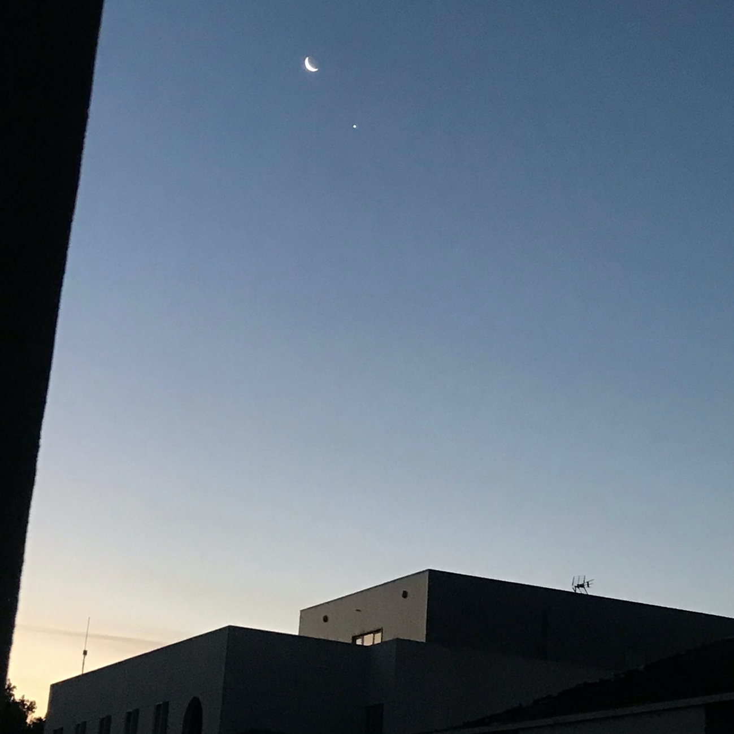
Conjunction of the Moon and Venus. Photo taken on July 17th, 5:45 am.

Marking a transition

Hathway’s research is centred in the individual experience of the Saturn Return, a very personal and life changing event. For that reason, Hathway considered that such moment should be embraced and marked as a passage ritual. The reports regarding the second Saturn Return were very consistent experience wise – it was a difficult and painful period of time. Nevertheless, Hathway suggested something that made me think that is up to us the way we face difficult times if we were aware of them: the second Saturn Return could be either an experience of freedom or one of petrification ‘depending on one’s attitude’. Hayhway continued saying that ‘Furthermore, since astrologers are able to know in advance when the Saturn Return will occur, if they understand its meaning, then it has the potential to not only mark a transition but also to actively affect one.’
Brady’s research concerns us all, thus it is a collective issue. My experience of the confinement due to the flu pandemic brought out many questions about our attitude towards our planet, the consumerist way of living, our relationship with the others and most of all, with ourselves. This is also a time of transition, both individual and collective, not only caused by planetary aspects but by us as well. I believe that although there are planetary combination that affects human mis-management, we still are capable of having a conscious behaviour.
Another major transition in the world of astrology is the technological tools available to do research. The effective and free of errors information that the programs are able to provide are a reliable way of tracking patterns and of predicting future events.
Our awareness of what’s about to come might not be sufficient to prevent it, but I would like to believe that that knowledge could help us to better deal with it, treating it as a new phase of our lives and embracing it as a transition to become wiser.

On August 15th I wrote on my sky journal:

‘When I see Jupiter and Saturn in the sky I keep thinking of the next great conjunction of Saturn and Jupiter next December, in Aquarius. All the astrological websites talk about it as an event that will bring major changes in our lives. I feel anxious about it and at the same time very curious. How painful is this transition to a new era going to be?’

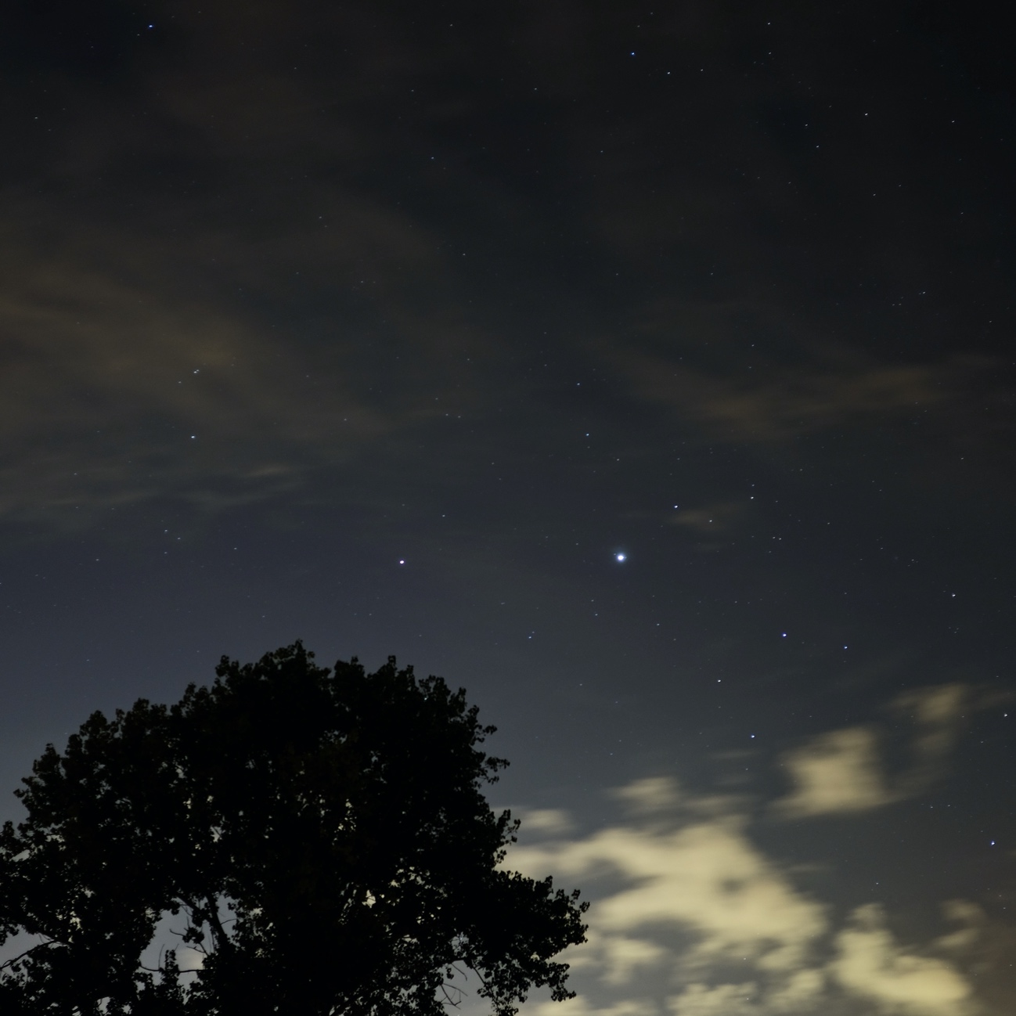
Jupiter and Saturn. Photo taken on August 15th, 11 pm.

Enjoying the view

The personal exercise of observing specific planetary aspects expanded to a daily family gathering looking up to the night sky. For the first time, I noticed that Jupiter and Saturn were rising in the night sky around dinnertime, right in front of our eyes. The first rising was Jupiter, with its amazing brightness and then Saturn, much smaller and pale. The kids were excited to now about those planets and the enthusiasm never faded, so every night while having dinner they would wait anxiously for the planets to appear. Until bedtime, they would track them down as they moved through the sky. The observation of Saturn and Jupiter turned out to be some kind of a family ritual at dinnertime.
In her psychological approach to astrology, Liz Greene suggested that ‘Because our perceptions are invariably distorted by our individual complexes, we are inclined to interpret transits and progressions not according to what they might mean, but according to what our complexes tell us they will 'do' to us’. So, the idea that the planetary aspects might be just one layer of the many which affects our existence, seems to be plausible to me and somehow reassuring.

On July 9th I wrote on my sky journal:

‘These moments with the kids at night looking at the sky are incredible! Can we just appreciate the night sky without worry about the possible effects that the planets and stars have on us? Am I even able to do that?’

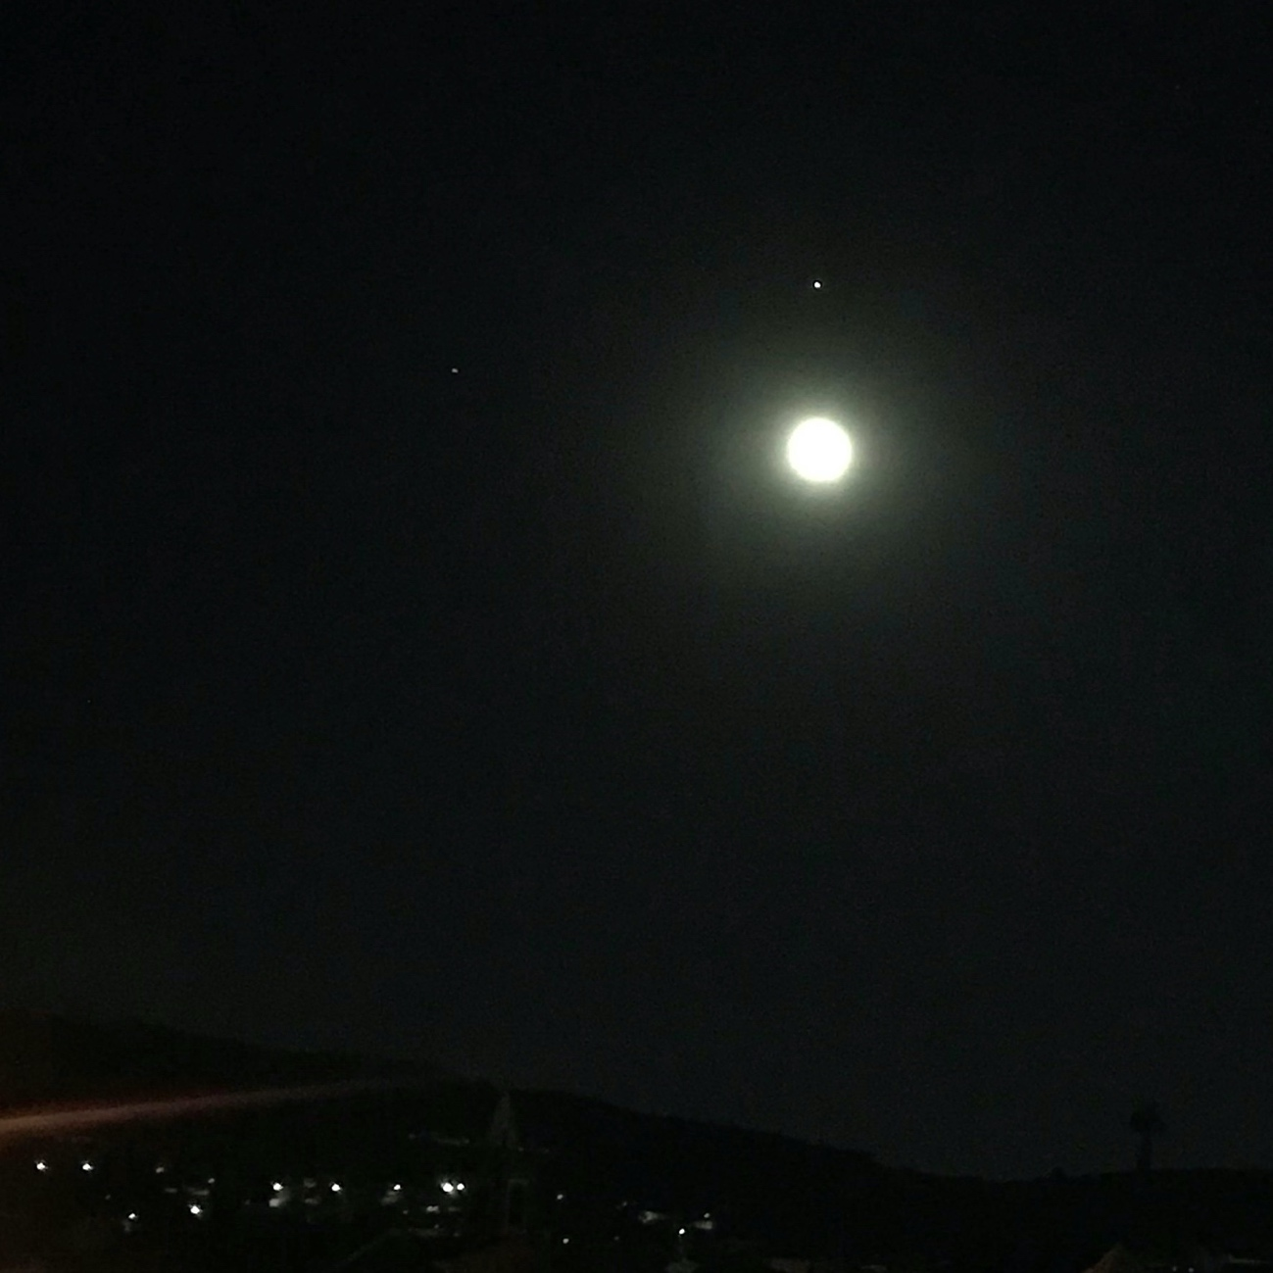
Conjunction of the Moon and Jupiter, Saturn on the left. Photo taken on July 6th, 12:10 am.

Knowing the notions that are the basis of astrology is fundamental to understand the meanings inherited from the past. These meanings can evolve through times and acquire new connotations that can ease fearful minds like mine. The prediction of future events can be extremely useful, if not to prevent them, at least to prepare for them.
Now looking back, I’m thinking if it was a message from the skies, just being able to observe the Moon along with the benefic planets. Can I expect a beautiful future? I guess it is up to me the way I react to what life will bring.

Conclusion

The aim of my research project was to analyse the effects that the observations of the conjunctions of Moon and Jupiter, Saturn, Venus and Mars, had on my feelings and emotions. Due to weather conditions, only two conjunctions were observed, Moon and Jupiter and Moon and Venus. The motion of Jupiter and Saturn was also tracked almost every night during dinnertime, although without prior intention. The process of observing the sky brought out many questions regarding the role of astrology nowadays and whether astrology can be used to improve our lives. I also struggled with my fearful relationship with astrology and for that reason I looked for contemporaneous researches on astrology that would help me to look at astrology with hope instead of fear.
The astrological stereotypes, although deeply rooted in ancient knowledge, can evolve through the time, bringing new meanings and minimizing the idea of a destiny plotted only by the stars.
Through the work of Liz Hathway and Bernadette Brady, I found that astrology can help us to reinvent ourselves and the way we live, both by giving meaning to crucial moments of our lives as co-creators, and by making us aware of possible future events, in order to prepare ourselves.

Bibliography

Bernadette Brady, ‘Astrology and Research Flu Pandemic’. <https://www.youtube.com/watch?v=hO3IMm_LGCk> [accessed 19 August 2020].

Davies, Charlotte Aull, Reflexive Ethnography: A Guide to Researching Selves and Others, 2 edition (London ; New York: Routledge, 2007). p.7.

Greene, Liz, ‘The Horoscope in Manifestation’ (presented at the Centre for Psychological Astrology, Regents College, 1996) <https://www.astro.com/astrology/in_transits_e.htm>

Hathway, Liz, ‘Saturn: An Auto-Ethnographic Enquiry into Contemporary Astrological Practice’, Journal for the Study of Religion, Nature and Culture, 13.1 (2019), 61–76.

Charlotte Aull Davies, Reflexive Ethnography: A Guide to Researching Selves and Others, 2 edition (London ; New York: Routledge, 2007). p.7.
Liz Hathway, ‘Saturn: An Auto-Ethnographic Enquiry into Contemporary Astrological Practice’, Journal for the Study of Religion, Nature and Culture, 13.1 (2019), 61–76. p 62. [hereafter, Hathway, Saturn]
Hathway, Saturn. p.69.
Hathway, Saturn. p.69.
Hathway, Saturn. p.70.
Hathway, Saturn. p.71.
Bernadette Brady, ‘Astrology and Research Flu Pandemic’, Research in JigSaw for Windows with Co-Creator Bernadette Brady <https://www.youtube.com/watch?v=hO3IMm_LGCk> [accessed 19 August 2020]. [hereafter, Brady, Flu Pandemic]
Brady, Flu Pandemic. 2’49’’
Brady, Flu Pandemic. 38’40’’
Brady, Flu Pandemic. 39’
Brady, Flu Pandemic. 58’
Brady, Flu Pandemic. 4’15’’
Hathway, Saturn. p.70.
Hathway, Saturn. p.71.
Liz Greene, ‘The Horoscope in Manifestation’ (presented at the Centre for Psychological Astrology, Regents College, 1996) <https://www.astro.com/astrology/in_transits_e.htm> [accessed 21 August 2020].

