This piece of writing will use the Entrecomp Framework to evaluate personal creativity and enterprise skills. Consideration will be made on how I could develop the creative and enterprise skills of primary learners through personal pedagogy.

Creativity is an elusive concept and has many definitions (Joubert, 2001). There are often several misconceptions relating to creativity, several people only associate creativity with the arts and believe that it cannot be taught (Fisher and Williams, 2009). Edward Storey argues that there cannot be an objective criteria for creativity meaning therefore it cannot be taught (David, 1982). Conversely, a study conducted by Land and Jarman (1992) suggests that creativity can be taught and it is non-creative behavior that is learned. Modern era research for creativity began after Guildford’s (1949), address to the American Psychological Association arguing that researchers up to that point, emphasized convergent thinking skills and ignored divergent thinking skills (Jones and Wyse, 2013). Creativity can be defined as the capability to solve problems and fashion products to result in new questions (Gardner, 1997). Similarly, Lucas (2001), defines creativity as a state of mind where all our intelligences work together. Though, there is extensive research and ideas based on defining creativity, for the purpose of this essay creativity will be defined as, “imaginative activity fashioned so as to produce outcomes that are both original and of value” (NACCEE, 1999 p.30). However, Craft (2000), has a much broader definition of creativity, she views the core of creativity as possibility thinking. Craft (2000), refers to possibility thinking as rejecting to be effected by events, but being imaginative to find solutions or make sense of the problem. The diversity between definitions of creativity can be due to it being seen as property of people, a process or a product (Fisher and Williams, 2009). The move away from defining creativity as a set entity which is dependent on individual judgement, is significant for teachers as they are sometimes required to assess the extent to which work is creative (Jones and Wyse, 2013). The World Economic Forum argues that creativity is a skill that every student needs in the 21st century (Soffel, 2016), this is also noticed by Donaldson (2015), who when revising the curriculum in Wales identifies creativity as being one of the key purposes of education.

In addition to creativity, enterprise also has many definitions. There is no single definition, and perspectives have changed over time as they have been influenced by context. Defining enterprise solely as a means that occurs within business would be an extremely constricted way to approach the subject. The balance between economic, cultural and social motive all influence different perspectives of enterprising (Lowe and Marriott, 2006). Enterprising individuals create and pursue more opportunities for themselves and inevitably take risks (Lowe and Marriott, 2006). Casson (1982), describes enterprise as a multifaceted activity, which involves a variety of skills; risk taking, decision making and coordinating scarce resources. Lowe and Marriott (2006, p.1), describe enterprise as “the art, or science of not standing still”. Whereas the Davies Review (2002), broadly described enterprise as the capability to deal with ambiguity and react positively to change, to generate and implement new ideas and ways of doing things, to take reasonable risk and act upon them throughout personal and working life. This particular definition, meets the criteria of the four purposes of the new curriculum in Wales (Donaldson, 2015), aiming for children to gain the skills and attitudes to continue to learn throughout their lives. Learning can be a key element of entrepreneurship; however, this does not solely related to theory and knowledge, many entrepreneurs usually learn by doing (Lowe and Marriott, 2006). If learning is an important aspect of entrepreneurship, it leads to question whether the current education systems inspires learners to be enterprising. However, with the curriculum in Wales evolving and one of Donaldson’s four purposes aiming for children to be “enterprising, creative contributors who are ready to play a full part in life and work” (Donaldson, 2015 p.29), could be the development that is needed for education in Wales, to allow the next generation of learners to be both enterprising and creative individuals.

A constructivist perspective identifies how learning and teaching are concerned with the co-construction of meaning, therefore may be considered as creative acts (Carlile and Jordan, 2012). Creative teaching focuses on the creativity of the teacher, whereas teaching for creativity focusses on the creativity of the learner (Craft, 2005 and Carlile and Jordan, 2012). Therefore, teachers’ own creative ability is important throughout education as teachers cannot develop the creativity of learners if their own creativity is suppressed (NACCCE 1999 and Desailly, 2015). The UK Quality Assurance Agency guidance for enterprise and entrepreneurship education (QAA, 2012), clearly stated the need for advancing creative capacity and recognition of opportunities in children. Creative teachers are able to recognize and encourage learners’ creativity by appreciating ideas that they may not have thought of and can see different ways of doing things (Desailly, 2015). A study carried out by Robert Steinberg (1999), identified how by assessing children in ways that recognize and value their creativity, their academic ability advances. This is also supported by Eckhoff and Urbach (2008) and Freucnd and Holling (2008), who all identify how creativity enhances learning and academic success. Creative and enterprising activities can regain the interest of children who are disengaged and can also motivate teachers who have been disheartened by teaching in a rigid curriculum with limited flexibility (Fisher and Williams, 2009). Conversely, Feldhusen and Treffinger (1975), found that in theory 96% of teachers support the idea that creativity should be fostered within the classroom. Yet, in classroom practice they found that teachers often dislike traits linked to creativity such as boldness and desire for originality.

There are also many challenges that can occur for creative and enterprising teachers. Carlile and Jordan (2012) and Kennedy (2005), identify how some teachers may have the best intentions but may struggle with their own wariness of learners’ responses resulting in possible disruption of the lesson plan. The fear of chaos within the classroom and the desire many teachers have of an orderly classroom can become a constraint on creative teachers and limit the development of both creative and enterprise skills (Carlile and Jordan, 2012 and Kennedy, 2005). School management policies and strict timetables with little freedom also inhibit creative teaching (Carlile and Jordan, 2012). Professor Dai Smith (2013), recognized the importance of creativity and suggested that the Welsh Government should enhance the current curriculum in Wales to include creativity as a core theme across the curriculum alongside literacy and numeracy. From almost the beginning of relevant research (Torrance, 1965), it has been evident that teachers favour punctuality, obedience and receptiveness to the teachers’ thoughts. High skills in memorization and correct recall are often ideal to critical or independent thinking (Cropley, 2004). This was also relevant during Professional Teaching Experience (PTE), where a very experienced teacher who had been in the profession for over forty years found it difficult to adapt to change in her pedagogy and expected punctuality, accurate recall and receptiveness from the children within the class. These findings have also been demonstrated around the world in countries such as Australia (Howieson, 1984), Nigeria (Obouche, 1986) and Turkey (Oral and Guncer, 1993). This leads to suggest that teacher training and the education systems around the world need to evolve to allow children to improve their creative and enterprise skills, and be prepared for the future. The importance of teachers having strong enterprise skills can relate to entrepreneurship in education being vital for developing entrepreneurial skills, attitudes and behaviors that act as the foundations of economic growth (World Economic Forum, 2009 and Penaluna et al, 2015). This is important for education at all levels, there is often the misconception that enterprise skills are not relevant in the primary school, however the World Economic Forum (2009), found that the earlier and more widespread the exposure to enterprising and innovation, students are prone to become entrepreneurial at some point in their lives.

The Entrecomp Framework

The Entrecomp Framework consists of three interrelated and interconnected competence areas with each area made up of five competences, which create the building blocks of entrepreneurship (McCallum et al, 2018). This framework will be used as a tool to aid reflection and identify current personal enterprise and creative abilities, and identify the next progression steps. The Entrecomp Framework provides a way for readers to recognize the learning outcomes and identify which proficiency level they are at. This shows boundaries that can be pushed forward, to achieve greater impact through value creating endeavors (McCallum et al, 2018). The framework aims to create a bridge between education and work, by contributing increased understanding and promotion of entrepreneurship competence (Entrecomp, 2016). The comprehensiveness of the framework is one of the main benefits, however it should only be used as a starting point and would need to be tailored to the context of use in order to implemented successfully. It is also important to note how the framework has not been adapted to, or tested in real settings (McCallum et al, 2018). Not all areas within the framework are applicable to teaching as there are elements within the framework which specifically relate to business.

Reflecting upon personal creativity utilizing the Entrecomp Framework it is evident that a ‘best fit’ solution has been used throughout, as the areas of progression can overlap and skills can be applicable from two or more levels of proficiency. It is important that I understand my own creative abilities and show readiness to model my own creative working process with children, as it is one of the foundations of supporting them to recognize and make the most of their own creativity (Desailly, 2015). Creativity involves being curious and open, for this thread I believe I am currently at a level two, as I am showing awareness of overcoming functional fixedness (see appendix one). This can be evident when using resources in the outdoor learning area for a Foundation Phase lesson. Twigs were broken into half’s and quarters, the children were required to show the twig as whole, half and a quarter to show their understanding of fractions. Chalk was also used on the playground to practice writing fractions and drawing diagrams to support their writing. This evidence shows overcoming functional fixedness as the twigs were being used not as a part of a tree but to represent fractions. The playground was also utilized in way that it is not traditionally used, showing opportunity to overcome functional fixedness to enhance children’s learning. Pound and Lee (2015) and Estyn (2011) identify the importance of outdoor provisions and the link it produces between mathematical understanding and creative development. In order to progress into the next level of proficiency I need to begin to take risks in order to develop creativity. Risk taking is an important element of creativity as without risk taking there can be no innovation (Beetlestone 1998, Craft, 2000, 2005, Cropley, 2004 and Jones and Wyse 2013). In order to achieve this, I will aim to introduce new pedagogical and AFL strategies within the class such as whole brain teaching and the learning pit. From previous PTE, I have felt hesitant to introduce or adapt strategies that are new to the class due to the fear of failure, and felt more confident using strategies that were already in place by the class teacher that I knew were successful. With Donaldson (2015) underlining the four purposes based on taking risks, it is important that risk taking is modeled and an environment is created where taking risks is encouraged and removes the fear of failure for the children (deBono,1971 and Beetlestone,1998). However, by creating an environment in which children feel they can take risks, they then need to experience success very soon after to avoid lowering their self-esteem (Beetlestone 1998 and Cropley 2004).

Evaluating my ability to develop ideas I believe I am in-between a level two and level three. Although, a best fit solution for this thread would be a level two as evidence shows personal ability of divergent thinking focusing on the element of elaboration (see appendix two). Elaboration includes the ability to develop or enrich an idea (Kousoulas and Mega, 2009). Divergent thinking emerged in the 1960s, explaining how divergent thinkers were more likely to make additional imaginative connections than convergent thinkers (Hudson, 1966,1968, Guildford, 1957 and Torrence 1962, 1963). Guildford (1957), believes that within divergent thinking is where we find the most obvious indications of creativity. Evidence of elaboration is shown from PTE reports where I was able to work as a valued member of the planning team to plan and create lessons of value for the children. The notion of different thinking forms has persisted in de Bono’s (1971) lateral thinking work and in Gardner’s (1983) multiple intelligences. It can be argued that all children begin as divergent thinkers and gradually become convergent thinkers as they mature (Beetlestone, 1998). This supports Gardner (1957) view of there being a loss of creativity in older children and Robinson and Aronica (2016), idea that schools kill creativity in children. In order to improve my own creative abilities, to limit the loss of creativity in children (Gardner, 1957), I need to develop my ability to prototype. This can be carried out within the classroom to develop both my own and the children’s creative abilities. This can be completed during PTE where I have found that children in the Foundation Phase working in the enhanced provisions would often forget what was expected at each area or would need help completing a skill. To overcome this to ensure I am experimenting with different techniques to generate alternative solutions (Becigalupo et al, 2016), and children inhabiting into a digital world (Donaldson, 2015 and Grigg, 2015), videos will be recorded on the iPad for the children to scan the QR code to access the video showing them what is expected at the provision, including a reminder of how to complete a math skill for example. However, this will be dependent on the funding in which the school receives for technology as the National Literacy Trust (2019), argues that the limited access to technology in schools is limiting pupils’ progression.

Relating to defining problems I am currently at a level two, again showing divergent thinking focusing on the element of fluency. This is evident when carrying out a Rube Goldberg machine in order to try and pop a balloon. Fluency was shown by my ability to consider numerous ideas to allow for an increased number of possible solutions. Fluency, alongside originality, elaboration and flexibility were the four elements of divergent thinking that Torrance (1999), measured. Fluency is seen as an important factor of creativity, as it is also measured in the Wallach and Kogan Test (1965). This also demonstrates one of the 16 habits of mind, involving creating, imagining and innovating (Costa and Kallick 2008). In order to develop and move along the Entrecomp Framework (Becigalupo et al, 2016), collaboration needs to be developed in order to take part in group dynamics to define open ended problems (Becigalupo et al, 2016). To develop personal collaboration, during PTE I will aim to play an active role within the school by participating in staff meetings offering suggestions, creating links with the community and parents. This will also contribute to achieving the QTS standards as the standard for collaboration aims for teachers to work with all partners to extend professional effectiveness (Welsh Gov, 2017). This is also supported by Donaldson (2015) who states that the possibility of success will be enhanced by an increase in collaboration between schools and the community.

The Entrecomp Framework discusses designing value as a thread within creativity. I am currently at a level one, showing ability to assemble objects that create value (Becigalupo et al, 2016). This is evident during PTE (see appendix three), where resources were created that aided the learning of the children and had an impact on the classroom experience (Grigg, 2015). The resources that were created were specific to the lesson meaning they were not already available. This required me to design and create resources that would aid and scaffold the learning (Vygotsky, 1962). In order to progress, I need to develop my ability to improve existing products so that they better meet my needs and those around me (Becigalupo et al, 2016). To achieve this, I will aim to revise successful pedagogy that I have used and have witnessed to meet the needs of children in my class. This will develop my ability to elaborate on previous pedagogy and pedagogy that I have seen. Strong pedagogical knowledge makes the curriculum accessible for all learners (Grigg, 2015). This also links to Donaldson (2015), where the new curriculum for Wales aims for pedagogy that utilizes the wider skills within and across each Area of Learning and Experience, focusing on problem solving, creative and critical thinking which is likely to initiate powerful learning for pupils.

The final thread within creativity is being innovative. I believe I am currently at a level two showing awareness of how innovations have transformed society (Becigalupo et al, 2016). This is shown during PTE where the teacher and I were brainstorming lesson ideas, resulting in developing one of my ideas (see appendix four). I was then able to reflect upon the lesson identifying the impact it had on the learning (see appendix five). Dewey (1998), argues that the ability to reflect on practice is truly educative in value and reflective thinking involves overcoming the inertia to accept suggestions. To show progression, understanding needs to be shown between different types of innovations and judge if an idea is innovative or new to me (Becigalupo et al, 2016). This will be achieved by continuing to deepen my understanding of pedagogy and techniques that are used for successful teaching. By doing this, I will also develop the habit of mind which focusses on remaining open to continuous learning (Costa and Kallick, 2008), which will enable me to identify if techniques are innovative or simply new to me. This will also help with defining my own personal pedagogy and tailoring it to meet the needs of children in the 21st century. This will be influenced by Donaldson (2015), who identifies the change that is needed for education in Wales to ensure children are able to continue to learn throughout their lives and are prepared for jobs of the future. This is supported by the National Assembly for Wales (2017), if the new curriculum in Wales is going to be successful then the quality of teaching is going to be the most important influence on how well learners develop.

The Entrecomp Framework also discusses uncovering needs within the spotting opportunities competence (Becigalupo et al, 2016). With enterprising individuals creating and pursing more opportunities for themselves (Lowe and Marriott, 2006), I believe this will be a useful thread to measure my enterprising skills. For this thread, I believe I am at a level four showing awareness of the different needs children may have and differentiating activities based on their needs to create value and support their learning (see appendix one and three). Differentiation is an important means for removing potential barriers to learning and create opportunities for all children to achieve (Kerry, 2002 and Grigg, 2015). However, it is important that differentiation does not demotivate learners, as research shows that lower attaining pupils are at risk of demotivation when they realize that certain levels are beyond them (Lord and Jones, 2006). Estyn (2018) notices good practice of differentiation where support for teachers is given in the form of a staff handbook on differentiation to ensure effective learning in all classes. This could also be an effective tool to ensure there is a continuum of learning throughout education as proposed by Donaldson (2015). To show progression I need to develop my ability to identify the needs of children and involve the relevant partnerships. To achieve this, I need to develop my divergent thinking to analyze and create the best solutions to meet the needs of the learner. Thinking interdependently (Costa and Kallick, 2008), with other professionals will benefit the process of meeting the needs of learners and develop my own knowledge and understanding of internal and external agencies that are available to support the needs of children.

The significance of creativity and enterprise for children in the 21st century is crucial for social and economic growth (World Economic Forum, 2019) The importance of creativity is not a modern idea, Frobel (1826) related creativity and imagination with the inner life of the child. With the world we live in evolving rapidly the challenges that children will face in the future are uncertain making creative and enterprise skills vital for learners to be valued and successful members of society (Donaldson, 2015, Duffy, 1998, and Cropley, 2004). If we want children to understand science and technology of the future, it will require them to think creatively (Duffy, 1998). Bruner (1986), has debated that there has been strong significance placed on logical and systematic thought while intuitive thought has not received the same attention. This has resulted in a generation which over-emphasizes the ability to retain and repeat facts, being impartial and dispassionate (Duffy, 1998). However, despite research showing the importance of creativity beyond academic success the relationship has not been accepted by all, Ai (1999), argues that creativity only contributes to academic success.

Creativity in children can be seen as one of Gardner (1978), multiple intelligences which covers various functions of the brain. This is a fundamental component, without which learners will only operate on a narrow cognitive level. The creative aspect of the brain can help to explain and understand abstract concepts, allowing the learner to have a better understanding, particularly in subjects such as mathematics and science which are often challenging to understand (Beetleston 1998, and Duffy, 1998).

Education in Wales has great potential to develop children’s creativity and enterprise skills. With creative learning in Wales being a joint commitment between the Welsh Government and the Arts Council for Wales (Smith, 2013), they aim for children to develop their creative skills and have set targets to improve attainment through creativity, as well as to support teachers to develop their own skills (Arts Council of Wales, 2018). Governments have taken many approaches to try and embody the spirit and ideals of enterprise. The Davies Review (2002), discusses the role of education in developing an enterprise culture, involving enterprise projects in schools and creating a more confident view of business in careers advice. This commitment alongside the introduction of the new curriculum for Wales (Donaldson, 2015), which has a strong focus on creativity, enterprise and learning through experience should allow children to develop strong creative and enterprise skills. However, this will be dependent on the attitude that teachers have towards enterprise and creativity within education. Estyn (2017), also found that despite the commitment from the Welsh Government and the importance of creativity in education, pupils still do not have enough opportunities to participate in creative activities.

Teachers should foster creativity (Craft, 2000 and NACCE, 1999), which requires commitment to space including physical and conceptual. Creating an environment that fosters creativity involves not only the layout of the classroom but also resources (Runco,1990). Shallcross (1981), and Frost (1997), argue the importance for children to have sufficient space and time to express themselves and be free to be creative. Therefore, I am going to create an environment and resources that fosters creativity. However, I will need to be careful with my approach as Shallcross (1981), identifies that too often teachers have a tendency to intervene earlier than needed when learners are working something out, which often discourages rather than encourages learning. To overcome this, the environment will have easy access to resources for children to support them with problem solving and imaginative play (Beetlestone, 1998 and Craft, 2000).
The environment will create opportunity for children to take risks. In Maslow’s hierarchy of needs (1954), creativity and self-actualization are at the top of the scale, and as a result will only be achieved if the other more basics needs have been met. This can be met by a supportive environment being created that encourages children to take risks which is an important element within creativity (Beetlestone, 1998). The children will be encouraged to use the resources in a variety of ways with there being no fixed boundaries, as children naturally often do not see boundaries. Using resources across the curriculum in unusual ways will also encourage them to make connections and develop their divergent thinking skills (Beetlestone, 1998)

Conversely, this does not limit the importance of structure and content, Malguzzi (1993), made numerous observations relating to the best conditions to develop children’s creativity throughout their daily experiences. He argued that the most favorable situation for creativity includes the interaction with adults and peers. However, there are several elements that can limit developing creativity, including the pressure faced by teachers to develop literacy and numeracy, a lack of training and the strain between meeting the needs of the class and inspiring children’s personal interests (David, 2003 and Downing et al., 2003). This may be overcome by drawing upon children’s natural curiosity (Beetlestone, 1998 and Donaldson, 2015) and adopting a holistic approach to the curriculum. Vygotsky (1962) also identifies the importance of social interaction, modelling and scaffolding children’s understanding from what they know to what they do not as a vital part of development. Nevertheless, with the new curriculum in Wales aiming to give more freedom and flexibility for teachers to teach in more creative ways (Donaldson, 2015), should limit the elements that can suppress enterprise and creative development in education (David, 2003 and Downing et al., 2003). I will need to ensure that the learning involves more than just completing a task. Complex interactions will be required between the child, the teacher and context. This includes activities that appear to be simply about play or creativity should be unraveled so that it is evident that more than rote learning or other pencil and paper tasks which often promote limited challenge are taking place (Beetlestone, 1998).

Runco (2003), argues that teachers should show an interest in children’s creative potential. With my chosen phase being the Foundation Phase, I am going to encourage children to participate in imaginative play. Research suggests that active involvement in imaginative play is a key element for creativity to develop in an educational setting (Mellou, 1994, Tegano et al., 1991, Prentice, 2000 and Russ 1996). This will be encouraged by having a role play area in the classroom, ensuring they have enough opportunity to participate in imaginative play and provide learners with open ended resources. Research has also shown that adults can help children develop their imaginative play skills, by rewarding positive outcomes for their creative ability and engagement (Russ, 2013). Estyn (2019), notices an increase in motivation and positive behavior in schools when a reward system is in place. This has also been evident during PTE, where Class Dojo has been a successful tool used to reward and motivate learners. However, rewarding children to encourage engagement is not successful for all, if a child has the mind set of not wanting to do something then they will not, learners need to take some responsibility of their learning (Grigg, 2015). Conversely, caution would need to be taken with this approach as Malaguzzi (1993) and Russ (1996), argue that teachers also have the ability to suppress opportunities of creative development by being over prescriptive. This was also noted by Estyn (2017), where over structured task in the Foundation Phase limited learners’ creativity. This shows how teachers limit creativity by having low expectations of what leaners can achieve while discouraging fantasy (Malaguzzi, 1993 and Russ, 1996). Therefore, I will need plan activities carefully, ensuring that children have enough knowledge in order to solve problems without being discouraged (Beetlestone 1998), while also offering scaffolding to learners, but giving them sufficient time to creatively solve the problem. This will be challenging to know when is the correct time to intervene without suppressing learners’ creativity. However, I will aim to place the emphasis on the creative process and model to the learners my own creative process rather than the outcome, as learners may not have developed all of the skills required for the creative outcome (Craft, 2003 and Tegano et al.,1991). This will encourage the children continue to develop their creativity and not be disheartened by the outcome. I will also need to ensure that the children feel they can achieve what they set their minds to. This can be adapted in the primary classroom by positive reinforcement, and modelling to the children a growth mindset developing their habit of mind that remains open to continuous learning (Costa and Kallick, 2008).

In conclusion, this piece of writing has highlighted the elusive concept of creativity and enterprise while emphasizing the benefits and limitations of teachers own creative and enterprise skills. It is argued that teachers need to be aware of their own creative and enterprise abilities in order to develop creativity and enterprise in children. Therefore, the Entrecomp Framework was utilized to reflect upon my own creative and enterprise skills and used to identify and set targets on how to develop my own creativity and enterprise. Clear targets were set that can be achieved through PTE and help model my own creative process and journey to the children. These targets will also support me in preparation for the implementation of the new curriculum in Wales where enterprise and creativity are one of the four main purposes of the curriculum. This is also highlights the potential that education in Wales has to develop children’s’ creativity and enterprise skills, with not only the implementation of the new curriculum but the joint commitment between the Welsh Government and the Arts Council for Wales to prioritize creativity in schools. Recommendations were made as to how to develop children’s creative and enterprise skills through personal pedagogy. However, from personal reflection of these recommendations I believe this will be more achievable after achieving QTS where I will have full control of most of the elements that can help develop children’s creativity, such as the environment, resources, timetable and topics and pedagogical techniques. I feel I will also have a lot more time to fine tune the details within the class to ensure learners are given enough opportunities to participate in activities that will develop their creativity and enterprise skills.

Reference List

Ai, X. (1999) Creativity and academic achievement: an investigation of gender differences, Creativity Research Journal, 12, pp 329-38.

Arts Council of Wales (2018) Creative learning through the arts. Available at https://arts.wales/about-us/strategy/creative-learning Accessed on 04.01.20.

Bacigalupo, M., et al. (2016). EntreComp: The entrepreneurship Competence Framework. Luxembourg: Publication Office of the European Union.

Beetlestone, F. (1998) Creative children, imaginative teaching. Buckingham: Open University Press.

Best, D. (1982) Can creativity be taught?. British Journal of Educational Studies, 30(3), pp.280-294.

Bruner, J. (1986) Actual Minds, Possible Worlds. Harvards: Harvard University Press.

Carlile, O. and Jordan, A. (2012) Approaches to creativity. Berkshire: Open University Press.

Casson MC. 1982. The Entrepreneur: An Economic Theory. Martin Robertson: Oxford, U.K. [Casson MC. 2003. The Entrepreneur: An Economic Theory (2nd edn). Edward Elgar: Cheltenham, U.K.].

Costa, A. and Kallick, B. (2008) Learning and leading with habits of mind. Beaurguard: ASCD.

Craft, A. (2000) Creativity Across the Primary Curriculum, Abingdon: Routledge.

Craft, A. (2005) Creativity in Schools: Tension and Dilemmas. Abingdon: Routledge

Cropley, A. (2004) Creativity in education and learning. Abingdon: Routledge.

Davies, H. (2002) The Howard Davies Review of Enterprise and Economy in Education. Norwich: HMSO.

David, T. (2003) What Do We Know about Teaching Young Children? A Professional User Review of UK Research Based on the BERA Academic Review ‘Early Years Research: Pedagogy, Curriculum and Adult Roles, Training and Professionalism’. Nottingham: British Educational Research Association

deBono, E. (1971) The Use of Lateral Thinking. Harmondsworth: Penguin.

Desailly, J. (2015) Creativity in the Primary Classroom. 2nd ed. London: SAGE.

Dewey, J. (1998) How we think. Boston: Houghton Mifflin.

Donaldson, G. (2015) Successful Futures. Independent Review of Curriculum and Assessment Arrangements in Wales. Available at:
https://dera.ioe.ac.uk/22165/2/150225-successful-futures-en_Redacted.pdf

Downing, D., Johnson, F. and Kaur, S. (2003) Saving a Place for the Arts? A Survey of the Arts in Primary Schools in England (LGA Research Report No. 41). Slough: NFER

Duffy, B. (1998) Supporting creativity and imagination in the early years. Maidenhead: Open University Press.

Eckhoff, A. and Urbach, J.2008. Understanding imaginative thinking during childhood: Sociocultural conceptions of creativity and imaginative thought. Early Childhood Education Journal, 36(2): 179–85

Estyn. (2011) Outdoor learning: an evaluation of learning in the outdoors for children under five in the Foundation Phase. Cardiff: Crown

Estyn. (2017) The Annual Report of Her Majesty’s Chief Inspector of Education and Training in Wales 2016-2017. Cardiff: Crown.

Estyn. (2018) Improving Teaching. Available at https://www.estyn.gov.wales/sites/www.estyn.gov.wales/files/documents/Improving%20teaching.pdf Accessed on 03.01.20

Estyn. (2019) Successful behaviors through reward-based programs. Available at https://www.estyn.gov.wales/effective-practice/successful-behaviours-through-reward-based-programme Accessed on 05.01.20

Feldhusen, J. F and Treffinger, D.J (1975) Teachers’ attitudes and practices in teaching creativity and problem solving to economically disadvantaged and minority children, Psychology Reports, 37, pp 1161-62.

Fisher, R. and Williams, M. (2009) Unlocking Creativity Teaching Across the Curriculum. 2nd ed. New York: Routledge.

Freund, P. and Holling, H.2008. Creativity in the classroom: A multilevel analysis investigating the impact of creativity and reasoning ability on GPA. Creativity Research Journal, 20(3): 309–18

Frobel, F. (1826) The Education of Man. New York: Appleton

Frost, J. (1997) Creativity in Primary Science. Buckingham: Open University Press.

Gardner, H. (1983) Frames of Mind: The Theory of Multiple Intelligences. New York: Basic Books.

Gardner, H. (1997) Extraordinary Minds. New York: Basic Books.

Grigg, R. (2015) Becoming an outstanding primary school teacher. 2nd ed. New York: Routledge.

Guilford, J.P. (1957) Creative abilities in the arts, Psychological Review, 64: 110-18.

Howieson, N (1984) Is Western Australia neglecting the creative potential of its youth?, Paper presented at the 1984 Annual Conference of the Australian Psychological Society, August 12-17 Perth.

Hudson, L. (1966) Contrary Imagination. Harmondsworth: Penguin.

Hudson, L, (1968) Frames of Mind. Harmondsworth: Penguin.

Jones, R. and Wyse, D. (2013) Creativity in the primary curriculum. Milton Park, Abingdon, Oxon: Routledge.

Joubert, M.M. (2001) The art of creative teaching: NACCCE and beyond’, in A. Craft, B. Jeffrey and M. Leibling (eds), Creativity in Education. London: Chapman.

Kennedy, M. (2005) Inside Teaching: How Classroom Life Undermines Reform. Cambridge, MA: Harvard University Press.

Kerry, T. (2002) Learning Objectives Task Setting and Differentiation. Cheltenham: Nelson Thornes.

Kousoulas, F. and Mega, G. (2009) Students' Divergent Thinking and Teachers' Ratings of Creativity: Does Gender Play a Role?. The Journal of Creative Behavior, 43(3), pp.209-222.

Land, G. and Jarman, L. (1992) Breakpoint and beyond. Harper.

Lowe, R. & Marriott, S. (2006) Enterprise: Entrepreneurship and Innovation, Oxford: Butterworth Heineman.

Lucas, B. (2001) ‘Creative teaching, teaching creativity and creative learning’, in A. Craft, B. Jeffrey and M. Leibling (eds), Creativity in Education. London: Chapman.

Malaguzzi, L. (1993) ‘History, ideas, and basic philosophy: an interview with Lella Gandini.’ In: Edwards, C., Gandini, L. and Forman, G. (Eds) The Hundred Languages of Children: The Reggio Emilia Approach – Advanced Reflections. Second edn. Greenwich, CT: Ablex Publishing.

Maslow, M. (1954) Motivation and Personality. New York: Pemguin.

Mellou, E. (1994) The case of intervention in young children’s dramatic play in order to develop creativity’, Early Child Development and Care, 99, 53–61.

McCallum, E., et al. (2018) Entrecomp into Action: Get Inspired, Make it Happen. Luxembourg: Publications Office of the European Union.

NACCEE (1999) All our Futures: Creativity, Culture and Education, London: DfEE.

National Assembly for Wales (2017) Report on the Teachers’ Professional Learning and Education inquiry. Available at https://www.assembly.wales/laid%20documents/cr-ld11338/cr-ld11338-e.pdf Accessed on 02.01.20

National Literacy Trust (2019) Lack of access to technology in schools is holding pupils back. Available at https://literacytrust.org.uk/news/lack-access-technology-schools-holding-pupils-back/ Accessed on 01.01.20

Obouche, N M (1986) The ideal pupil as perceived by Nigerian (Igbo) teachers and Torrance’s creative personality, International Review of Education, 32, pp 191-96

Oral, G and Guncer, B (1993) Relationship between creativity and nonconformity to school discipline as perceived by teachers of Turkish elementary school children, by controlling for their grade and sex, Journal of Instructional Psychology, 20, pp 208-14.

Penaluna, K., Penaluna, A., Usei, C. and Griffiths, D., (2015) Enterprise education needs enterprising educators. Education & Training, 57(8), pp. 948-963.

Pound, L. and Lee, T. (2015) Teaching mathematics creatively. 2nd ed. New York: Routledge.

Prentice, R. (2000) ‘Creativity: a reaffirmation of its place in early childhood education’, Curriculum Journal, 11, 2, 145–58.

Quality Assurance Agency (2012) “Enterprise and entrepreneurship education: guidance for UK higher education providers”, available at: www.qaa.ac.uk/en/Publications/Documents/
enterprise-entrepreneurship-guidance.pdf Accessed on 23.12.19.

Robinson, K. and Aronica, L. (2016 Creative schools. London: Penguin Books.

Runco, M.A. (1990) ‘The divergent thinking of young children: implications of the
research’, Gifted Child Today, 13, 4, 37–9.

RUNCO, M.A. (2003) ‘Education for creative potential’, Scandinavian Journal of Educational Research, 47, 3, 317–24.

Russ, S.W. (1996) ‘Development of creative processes in children’. In: Runco, M.A. (Ed.) Creativity from Childhood through Adulthood: The Developmental Issues (New Directions for Child Development No. 72). San Francisco, CA: Jossey-Bass.

Shallcross, D. (1981) Teaching Creative Behavior. Buffalo, NY: Prentice Hall.

Smith, D. (2013) An Independent report for the Welsh Government into Arts in Education in the Schools of Wales, Available at https://gov.wales/sites/default/files/publications/2018-04/independent-report-for-the-welsh-government-into-arts-in-education-in-the-schools-of-wales_0.pdf Accessed on 23.12.19

Soffel, J. (2016) What are the 21st-century skills every student needs?. [online] World Economic Forum. Available at: https://www.weforum.org/agenda/2016/03/21st-century-skills-future-jobs-students/ Accessed on 29.12. 19.

Steinberg, R.J. (ed.) (1999) Handbook of Creativity. Cambridge: Cambridge University Press.

Tegano, D.W., Moran, J.D. and Sawyers, J.K. (1991) Creativity in Early Childhood Classrooms (NEA Early Childhood Education Series). West Haven, CT: National Education Association.

Torrance, E.P. (1962) Guiding Creative Talent. Englewood Cliffs, NJ: Prentice Hall.

Torrance, E.P (1963) Education and The Creative Potential. London: Oxford University Press.

Torrance, E P (1965) The Minnesota Studies of Creative Thinking: Widening horizons in creativity. New York: Wiley

Torrance, E P (1999) Torrance Test of Creative Thinking: Norms and Technical Manual, Scholastic Testing Services, Bensenville, IL.

Vygotsky, L. (1962) Thought and Language, Cambridge, MA: The MIT Press.

Wallach, M M and Kogan, N (1965) Modes of Thinking in Young Children, Holt. New York: Rinehart and Winston.

Welsh Government (2017) Professional Standards for Teaching and Leadership. Cardiff: Crown.

World Economic Forum (2009) “Educating the next wave of entrepreneurs: unlocking
entrepreneurial capabilities to meet the global challenges of the 21st century”, report of the
Global Education Initiative, Geneva, 23 April.

World Economic Forum (2019) 5 things you need to know about creativity. Available at https://www.weforum.org/agenda/2019/04/5-things-you-need-to-know-about-creativity/ Accessed on 04.01.20

Appendix One.
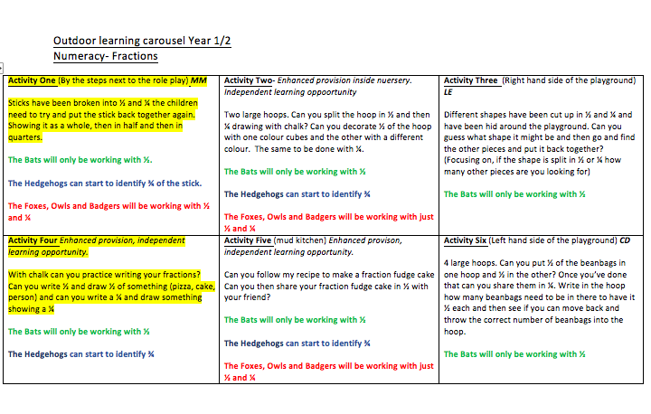

Appendix Two
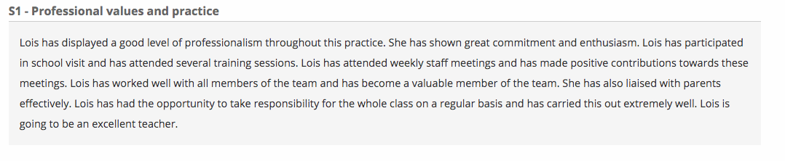

Appendix Three
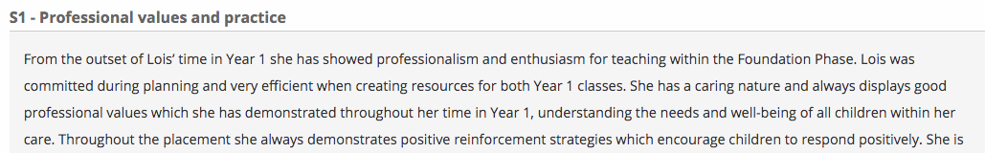

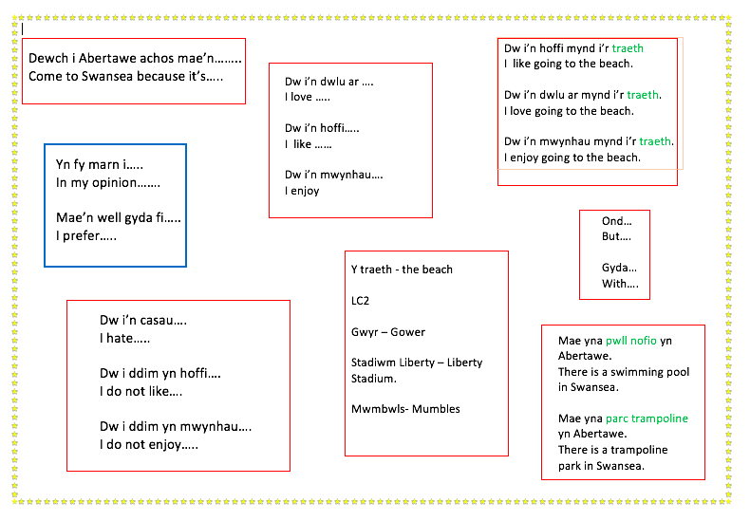

Appendix Four.
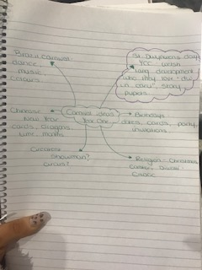

Appendix Five



