
materials engineering
Plastics in Civil Engineering



Jonathan Triggs
1807834

Contents
Plastic Properties 3
Thermosetting Plastics 3
Thermoplastics 3
Elastomeric Polymers 3
Uses of plastics in Civil Engineering 4
02 Arena 4
National Aquatics Center, Beijing 4
Waste Plastics in Road Construction 4
Overview 4
Asphalt Surfacing 4
Pre-Formed Recycled Plastic Roads 5
Plastics Evaluation 6
References 7

Plastic Properties

Thermosetting Plastics
Thermoplastics are plastics that when molded into its desired shape it stays in that shape meaning that they cannot be re-molded. Thermoplastics tend to be harder and more durable allowing greater loads to be applied to them. These properties are because thermosetting plastics have much larger polymer chains in their molecular structure as well as this, thermosets have cross linked molecular chains.
Depending on the thermosetting plastics properties dictates the process which can be used to mold these plastics. An example of one of these processes is compression molding. This process involves having firstly heating the plastic along with a heated hydraulic press to simply push down on the plastic to mold it into its desired shape. Thermoplastics are also good insulators and in correlation to this, thermoplastics also have good heat resistance. Due to them being molded into 1 final shape it takes a lot more heat for them to deform and thermoplastics tend to turn black and start to burn instead of losing its solid property easily. Due to the fact thermoplastics burn instead of them being able to melt and re-molded this makes it incredibly difficult for them to be recycled. Thermoplastics cannot just be collected and melted to be made into something new instead to recycle thermoplastics its new use must be in a process that uses its original shape or shredded up to be implemented into a new product. An example of the use of thermosetting plastics in construction would be its use in electrical components like a plug socket due to its good electrical insulation and heat resistant properties. (OsbourneIndustries, 2018)

Thermoplastics
Thermoplastics are plastics that can continually softened and in turn be re-molded into shape. Thermoplastics can keep their shape and are ridged once cooled down from the molding process, but thermoplastics do not tend to be as strong as thermo setting plastics. A thermoplastics molecular structure is made up from more liner polymer chains, Different from thermosetting plastics as they have fewer cross links in their molecular structure.
Thermoplastics are prone to stress cracking and failure a lot sooner than thermo setting plastics when a load is applied to them. Thermoplastics heat resistance is poor. However, Thermoplastics are very useful due to how easy it is work with them. The process of heating a thermoplastic to be able to re-mold it into any desired shape is an effective process. This process of being able to re-mold them also makes thermoplastics easily recyclable. An Example of a thermoplastic is acrylic. Acrylic is widely used throughout the construction industry everywhere in the world. A common example of this would it used as Perspex. (DesignBuidlings, 2019)

Elastomeric Polymers
An elastomeric polymer is a solid but has high elasticity. An elastomer can be stretched to many times it original shape but will return to its original shape once the force is released. This means that an elastomer will not keep its shape well and instead of being rigid and resisting a force it will bend with the force. This is caused by their molecular structure. An elastomers molecular structure is much more random than thermosetting and thermoplastics. Due to this the links between molecules are not structured and can be described like spaghetti. (BYJUS, n.d.)This feature allows it to be stretch and not permanently deform the original shape.
Rubber is a very popular example of an elastomeric polymer. Rubber can be highly durable and corrosion resistant making it very versatile in terms of what environment it can be used in and kept in for a long period of time. Due to it being water resistant rubber is used as seals to keep products watertight like in drainage pipes. To do this it uses its elasticity to be able to get pushed up to tight to a pipe therefore can be used to fill gaps between two pipes that would not be water tight by themselves due to the gaps. (DesignBuidlings, 2020)

Uses of plastics in Civil Engineering

02 Arena
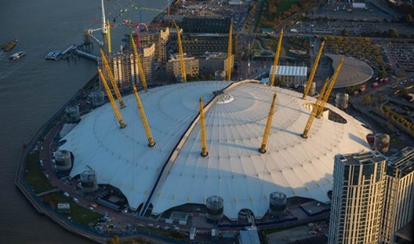
A range of plastics are used throughout civil engineering for different purposes. Due to it being so lightweight and as well as this it being good at resisting water Polytetrafluoroethylene can be seen throughout the world being used on large structures. This can be seen at the 02 arena in London which is covered by a large plastic sheet. This plastic is perfect for its job as it does not need as much structural support as glass would and keeps it watertight. However, consideration must be taken to thew wind loads that this plastic sheet will take.
(The02.co.uk)

National Aquatics Center, Beijing
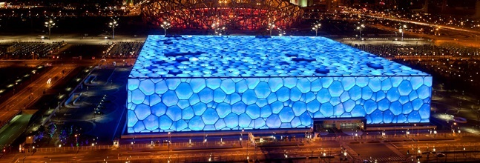
The national aquatics centers is made up of an outer skin made of Ethylene tetrafluoroethylene (ETFE). This is an example of a durable plastic that can be used as a roof in structures. This plastic again can be a great alternative to traditional building materials as it provided water proofing as well as it being able to house LED Lights which make it more aesthetically pleasing. (Allen, 2016)
(Allen, 2016)

Waste Plastics in Road Construction

Overview
Due to so much plastic and in turn waste plastic being produced around the world it would be very sustainable and effective if new processes were developed to incorporate some of these plastics. The benefits of using recycled plastics also include the reduction in the use of raw materials, energy savings as well as using up the plastic instead of letting it all go to land fill. The problem with plastics not finding a purpose after use and getting chucked away is that plastics never fully degrade. This causes a major negative impact to our environment as plastic can affect habitats around the world including land and sea. The construction industry consumes 22% of all plastic worldwide and this is equal to 10million tones of plastic each year. (PlasticsEurope, n.d.) The concept of using recycled plastic in road construction is not completely new but it is becoming more prominent as we strive towards being more sustainable.

Asphalt Surfacing
A method of incorporating waste plastics into construction is its implementation into asphalt surfacing. This research has been conducted on the base of replacing the fine aggregates we use in normal asphalt surfacing and replacing them shredded waste recycled plastics. However, you cannot just use any plastic in asphalt manufacturing this is because some types of plastics will not be able to withstand the bitumen process which includes heating the mixture to high temperatures.
Studies have been based on the role of the waste plastic either acting as an extender or a modifier. Using the plastics as an extender is the process of just replacing some of the original raw aggregates we find in normal asphalt. This process just increases the amount of asphalt we get but has no effect on the asphalt’s performance. This can be used to great efficiency if the plastics can be shredded to the correct size and shape. Studies have also been conducted to use waste plastics to modify the performance of a bitumen material. These studies generally conclude that waste plastics cause a noticeable change in the binder properties. In a study by Dalhat & Wahhab (2017) they found that adding recycled HDPE, LDPE and polypropylene in the mix gave it higher resilience. Although this study was carried out in a lab and was not entirely realistic to the conditions it will face in a real scenario. It is a promising step towards the implementation of waste plastics and more research could be conducted to ensure that it could be viable process. (Dalhat, 2017)
The process of adding the recycled plastics to the mix can either be done in a dry process or a wet process. The dry process is when the plastic is added to the aggregate before the addition of the binder to mix it together. The wet process is when the plastic is added into the binder before it is mixed with the aggregates. Ideally to make the asphalt so that it is 100% recycled plastic, plastic would need to add at both stages and just consists of plastic and no other raw materials. However, this would drastically reduce the quality of the final asphalt as plastic has been found to work as effectively as the raw materials, we use today to completely replace them. (Chrisinia Chin and Peter Damen, 2019)

Pre-Formed Recycled Plastic Roads
Another great example of a company incorporating waste plastics into their construction process is PlasticRoad. They have created a bike path out of mainly recycled plastic which claims to be 3x more durable than a standard tarmac road. The beauty of this project is that the road structure is pre molded. This means that the road can just be lifted into place and requires little building time as well as it being easy to build repairs can be done just as easy as all it takes for is for the pre molded road section to be lifted out and replaced by a new one. Another useful feature of this road is that its hollow center allows for services to run through. (Road, 2018)
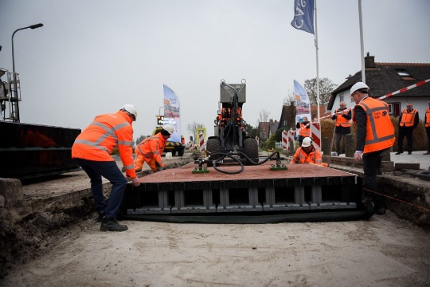
Although at first all the features of this road are beneficial its real test is whether it will be able to withstand the test of time. Due to it being hollow and it being plastic, the weather along with the constant weight running on the path could cause the plastic to deform especially if they are going to implement them into roads for heavy vehicles. As well as this placing these paths down instead of existing paths will be virtually impossible if there are existing services running beneath. The implications of getting the services to run through these premade blocks if they are already laid will not make the process worth the hassle. Although this could be a great way of progressing with fresh building sites as long these pre molded paths are proved that thy can stand the test of time.
(www.plasticroad.eu)

Plastics Evaluation
To ensure that we move forward with sustainability I think that it is crucial that the continuing development of implementing plastic to create a design that is efficient is crucial. The process of replacing the raw materials that we use in construction with recycled plastic could be a huge step into becoming more sustainable. However, to do this the quality, structural performance and the durability of the final product must be considered.
How the plastic is shredded up into smaller pieces can play a big factor to this. We know that depending on whether aggregates are smooth or rough on the surface and depending if they have sharp edges plays apart in affecting products strength. An example of this would be in the use of using plastics in concrete replacing the aggregates. We know that If the aggregates in concrete have sharp edges and are rough in touch this allows for better bonding of the cement to the aggregate creating a stronger mix. Plastics can be shredded up into to sharp pieces but generally a plastics surface is smooth which will cause a week bond within the concrete. Research would need to be carried out counteract this problem and give the plastic surfaces a rough finish to allow strong bonds. A process of coating the aggerate before mixing it with the cement could be a possibility. But making sure the process of doing this does not out-weight the sustainability of just using raw materials.
The Processing methods of implementing the plastics must also be efficient. The emissions that these processes will give off must also be considered. There is no point in making a product more sustainable if the process in making the product is not sustainable itself.
Also, whilst there may be many environmental benefits to using recycled plastics more research must be carried out to ensure that the work force working with these materials are safe from things such as the fumes to ensure that no long term health effects a start to occur.
Being able to use recycled plastics efficiently could also have major benefit to the cost of a product. If a company produces a lot of waste plastics and they can then re-use that waste, companies will start to become more self-sufficient. This would mean that either companies will be to re-use their own product and save buying more in or they will be able to offer their recyclable plastic to external companies and they will be able to create products for them at a discounted cost.

References
Allen, E., 2016. Innovative Plastic Architecture. [Online]
Available at: https://www.architecturaldigest.com/gallery/innovative-plastic-buildings
[Accessed November 2020].
BYJUS, n.d. Elastomers. [Online]
Available at: https://byjus.com/physics/elastomers/
[Accessed Novmeber 2020].
Chrisinia Chin and Peter Damen, 2019. Viability of Using Recyled Plastics in Asphalt and Sealing Applications, Sydney: Austroads Ltd..
Dalhat, M. ,. &. W. H., 2017. Performance of recyled plastic waste modified binder in saudi arabia. International Jounel of 1pavement Engineering, 18(4), pp. 349-57.
DesignBuidlings, 2019. Thermoplastic materials in buildings. [Online]
Available at: https://www.designingbuildings.co.uk/wiki/Thermoplastic_materials_in_buildings
[Accessed Novemeber 2020].
DesignBuidlings, 2020. Rubber in the Construction Industry. [Online]
Available at: https://www.designingbuildings.co.uk/wiki/Rubber_in_the_construction_industry
[Accessed Novemeber 2020 ].
Federation, B. P., n.d. Construction. [Online]
Available at: https://www.bpf.co.uk/innovation/Construction.aspx
[Accessed November 2020].
Janson, J. A., 2016. PlasticsEgnineering. [Online]
Available at: http://read.nxtbook.com/wiley/plasticsengineering/september2016/
[Accessed November 2020].
OsbourneIndustries, 2018. Uses & Applications of Thermosetting Plastics. [Online]
Available at: https://www.osborneindustries.com/news/thermosetting-plastic-uses-applications/
[Accessed Novemeber 2020].
PlasticsEurope, n.d. PLASTICS IN BUILDING AND CONSTRUCTION. [Online]
Available at: https://www.plasticseurope.org/en/about-plastics/building-construction#:~:text=In%202018%2C%20total%20plastic%20waste,recovery%20rate%20to%2073.5%20%25.%E2%80%9D
[Accessed November 2020].
Road, P., 2018. The Plastic Road. [Online]
Available at: https://www.plasticroad.eu/
[Accessed November 2020].

