Assignment 1 - Blog Submission

Student Name: Evelyn Jeannette Ramirez de Martinez

Student ID: 2520056

Names of all students in your assignment group:
- Omrakha Hassan 2500918
- Beth Woolley 2517506
- Salma Shnnib 2332494
- Karla Flores Feltrin 2503091

Link to Individual Blog / Social Media site:
https://www.instagram.com/p/DQy0YEZjLdm/?igsh=MTVmajFzbG81Zjdq
https://www.instagram.com/p/DQy1fVADEuj/?igsh=MTBsY2R2d2pnc3Y2cQ==
https://www.instagram.com/p/DQy27x_DKnU/?igsh=MTFveGd0YTljYXdmZw==
https://www.instagram.com/p/DQy6tyIjEu7/?igsh=MTc2b2ppaXI4a2E3aA==

Words included in your individual Blog / Social Media Posts (including reference list): - Copy and paste the words from your blog or social media site
Social media posts: 722 words.
Evaluation of marketing theory that underpins your blog / social media site: 882 words. 1604 words in total of 1500 +10% maximum.

POST 1:

A Warm Christmas for Everyone!
It’s Christmas time, and the homeless won’t have anything to do with it.
This wonderful time of the year, when the lights on the Christmas tree are shining, is a time to share with your family and friends, enjoy a warm meal together, and, of course, have somewhere to sleep.
Have you ever considered that the person living on the streets one day could one day be you or a member of your family?
Here are some ways to get involved:
- Donate clean clothes. We welcome clothing donations for both men and women in all sizes.
- Giving food to stock our food bank.
- Serve warm food for Christmas lunch. Join us in preparing and serving warm meals for a Christmas lunch that brings hope.
- Spend time together. Take a moment to listen to their unique stories and make them feel important.
It is time to act. With your help, together we make a significant difference in reaching out to more homeless people in need. #AllIWantForChristmasIsYourHelp
Donate here, now. https://www.crisis.org.uk/get-involved/donate-to-crisis-at-christmas/

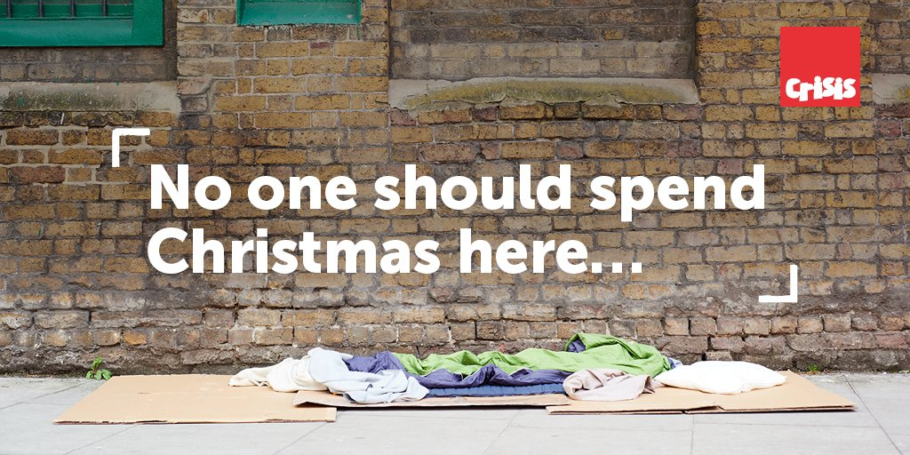


POST 2

No one should be alone this Christmas!
Christmas is meant to be the season of love and understanding, but for the homeless, it is just another cold night on rough streets.
This Christmas time, we aim to make a difference by changing that. Your donations can give someone a safe, warm bed and a hot meal for just one night. The donation is not the final solution, but it can make someone feel seen, cared for, and remembered, giving them a reason to leave the streets.
Even a small contribution can help in this long way. Every pound helps them to provide warmth, food, and a little hope to someone who needs it the most.
Let’s make sure no one spends a night alone in the cold. Please do not forget to share this post and help us reach as many people as possible.
It is time to act. Together, we make a significant difference in reaching out to more homeless people in need #makingthedifferenceinChristmas #changinglives.
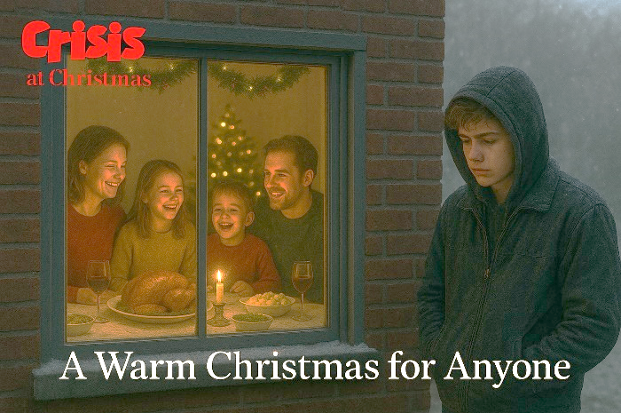
Donate here, now. https://www.crisis.org.uk/get-involved/donate-to-crisis-at-christmas/

POST 3:

We believe in second chances!

At Crisis, we believe that everyone deserves a second chance. Homelessness can happen to anyone, a lost job, a health issue, or a family breakdown, and it doesn’t define who you are.
Education is one of the most powerful tools to break the cycle of poverty and homelessness. That is why we offer short courses, practical training programmes, and opportunities to get GCSEs in English and Maths. Through education, people gain more than just qualifications; they find confidence, purpose and hope for the future.
Our employability programme helps the homeless to reach their potential, develop the skills employers are looking for, and take the next step towards college or a career. The closer they get to their brighter future, the further they get from being on the rough streets again.
Education transforms life. Even though they cannot change their past, they can build their future.
Because the homeless deserve more than a place to live. They deserve the chance to learn, work, and build a future they can be proud of. #changinglivesthrougheducation
For more information about our programme, visit https://www.crisis.org.uk.




POST 4:

We believe in second chances!

At Crisis, we assert that the homeless deserve a second chance.
Let’s see one of our testimonials: Hannah, at only 18 years old, was living on the rough streets because her mother passed away 3 years ago, and her father left her house. As a young adult with no alternatives, she was forced to live on the streets of Swansea. With the help of our advisors, she got in touch with the Crisis Skylight Centre, where she could access a place to live, education, and food. Through her educational steps, she could get a job. Now, she works as a teacher’s assistant, and her testimonial has helped many young people in the same situation.
Like Hanna, many people need your attention. How can you help?
- Donate books. The books that you don’t use can help someone get knowledge.
- Volunteer your time to teach. If you have abilities in English and maths, you can help transfer your proficiency.
- If you are a business owner, create opportunities for employability.
Donate today by accessing the QR Code. Allow someone access to learning, to work, and to build a brighter future. #changinglivesthrougheducation


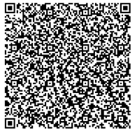

This document explores an individual evaluation of the campaign in how charities use marketing to connect with the public, their effectiveness in raising awareness, encouraging support, using strategies like storytelling, emotional appeals, audience segmentation and the theories used, in this we decided to use as a model Crisis which is a charity which helps homeless.
Crisis is a non-profit organisation operating across England, Scotland and Wales that supports people experiencing homelessness or at risk of becoming homeless. Their objective is to end homelessness through research and the implementation of various programmes and services, including employability initiatives, working with local councils and private landlords to secure housing, and advocacy for policy changes, healthcare services, and other necessary support. In the digital age, Crisis is no exception in having an online presence, which is vital for charities (Crisis 2025). My posts reach the audience on the Instagram platform, one of the most used platforms nowadays (Lee and Kim, 2020). However, this is the only thing I would change if I were to write a post on a blog instead of Instagram, due to format differences and character limits. I try to create posts that make emotional appeals, encouraging actions such as giving donations, sharing, commenting, and establishing a strong connection with the audience, helping Crisis to attract and support more people in need (Bennett, 2017). My posts are not just a source of information about homelessness; they are a pivotal part of Crisis’s marketing strategy, allowing them to reach new audiences and build lasting relationships with supporters (Pansoni and Gistri, 2025).
Marketing is defined as the communication channel that connects customers and products, letting customers know what products or services can fulfil their needs (Lee, 2013). Crisis is the link between the public and individuals in need, satisfying the audience’s needs, making a high emotional involvement in the causes, making a long-term connection with them and incentivising them to donate, demonstrating to them how their help will improve one cause, and following legal standards to have the certainty that it is not a fake cause (Pansoni and Gistri, 2025). My posts help the marketing efforts of Crisis in many ways, such as through fundraising appeals and the use of storytelling to show the human side of homelessness. In one of them, I share a story of a homeless woman and her journey to success with the help of Crisis, creating a sense of connection to the cause (Pansoni and Gistri, 2025). Sharing real stories helps build trust and demonstrate transparency in how donations are used, which strengthens Crisis's reputation (Wymer and Čačija, 2023).
Marketing segmentation is pivotal in charities because it seeks to link consumers with products that satisfy their needs, and this approach increases the effectiveness of marketing, ensuring that resources are focused where they have more impact (Webber, 2011). Crisis can adapt its campaigns to each group’s specific needs by segmenting its audience into separate segments based on demographics, interests, behaviours, or geographic location (Dibb and Simkin, 2009). The audiences for my post can be donors who can be motivated by testimonies or stories, volunteers who try to get experience or help the community, the general public that is educated and informed about a cause, and the people who will benefit from them by accessing services or support (Pansoni and Gistri, 2025).
There are three key attributes that successful marketing communication sources possess: credibility, attractiveness, and expertise (Ilieva et al., 2024). The main objective of Crisis posts is to educate, inspire, and encourage action (Pansoni and Gistri, 2025). My posts aim to raise awareness about homelessness and the issues involved, such as mental health challenges, lack of affordable housing, and limited opportunities for those affected. Each post helps support these aims (Crisis 2025).
The main objective in my posts is to raise awareness of homelessness. I aim to engage my audience by using headings and images that are visually powerful and engaging. Calls to action, such as “donate now”, are included at the end of every post to guide people toward taking the next step (Serrano-Malebran, Vidal-Silva and Veas-González, 2023). I have created links that the public can easily donate to, and I used the correct warm tone and clear language so that people of all ages and backgrounds can easily understand the message, fostering compassion and a desire to help (Pansoni and Gistri, 2025).
The metrics used in my posts are the interactions on social media, as the followers actively engage with content through likes, shares, comments, donations and feedback. Social media allows users to check this information, as well as their followers' growth (Ilieva et al., 2024; Pansoni and Gistri, 2025).
I included the Source of Credibility Theory in my posts to show how public beliefs, attitudes, and behaviours contribute to endorsed objectives of donations (Ilieva et al., 2024). Also, donor behaviour and campaign success are explained and predicted by the Theory of Reasoned Action (Muhammad Tabish, Bashir and Nadeem, 2025). These theories explain why using credible sources increases trust and motivates them to donate.
In conclusion, Crisis’s posts are essential to the organisation's purpose, because they raise awareness and encourage support for our cause. Stories that make a connection with people and motivate them to action help them gain the trust of their supporters and motivate them to act.

Bennett, R. (2017) ‘Relevance of Fundraising Charities’ Content-Marketing Objectives: Perceptions of Donors, Fundraisers, and Their Consultants’, Journal of Nonprofit & Public Sector Marketing, 29(1), pp. 39–63. Available at: https://doi.org/10.1080/10495142.2017.1293584.
Crisis (2025), Crisis – Together we will end homelessness. [Online] Available at: https://www.crisis.org.uk/ [Accessed 26 October 2025].
Dibb, S. and Simkin, L. (2009) ‘Bridging the segmentation theory/practice divide’, Journal of Marketing Management, 25(3–4), pp. 219–225. Available at: https://doi.org/10.1362/026725709X429728.
Ilieva, G. et al. (2024) ‘Social Media Influencers: Customer Attitudes and Impact on Purchase Behaviour’, Information (Basel), 15(6), p. 359. Available at: https://doi.org/10.3390/info15060359.
Lee, D. (2013) ‘What is Marketing?’, Public Services Quarterly, 9(2), pp. 169–171. Available at: https://doi.org/10.1080/15228959.2013.785900.
Lee, D. (2013) ‘What is Marketing?’, Public Services Quarterly, 9(2), pp. 169–171. Available at: https://doi.org/10.1080/15228959.2013.785900.
Lee, S. and Kim, E. (2020) ‘Influencer marketing on Instagram: How sponsorship disclosure, influencer credibility, and brand credibility impact the effectiveness of Instagram promotional post’, Journal of global fashion marketing, 11(3), pp. 232–249. Available at: https://doi.org/10.1080/20932685.2020.1752766.
Muhammad Tabish, Muhammad Adnan Bashir and Shazleen Nadeem (2025) ‘Impact of Influencer Marketing on the Purchase Intention of Consumers, International journal of experiential learning & case studies Online, 10(1). Available at: https://doi.org/10.22555/ijelcs.v10i1.1239.
Pansoni, S. and Gistri, G. (2025) ‘Does the end justify the means? The persuasive power of emotions in charity advertising: a systematic literature review’, Italian Journal of Marketing, 2025(2), pp. 91–130. Available at: https://doi.org/10.1007/s43039-025-00114-0.
Serrano-Malebran, J., Vidal-Silva, C. and Veas-González, I. (2023) ‘Social Media Marketing as a Segmentation Tool’, Sustainability, 15(2), p. 1151. Available at: https://doi.org/10.3390/su15021151.
Webber, R. (2011) ‘In which contexts do different market segmentation strategies work best?’, Journal of direct, data and digital marketing practice, 12(4), pp. 310–314. Available at: https://doi.org/10.1057/dddmp.2011.6.
Wymer, W. and Čačija, L.N. (2023) ‘Online social network fundraising: Threats and potentialities’, Journal of philanthropy and marketing, 28(4). Available at: https://doi.org/10.1002/nvsm.1782.

