

Module Name: Enterprise Development and Commercial Innovation
Module Code: (BMBS5000)
Student Name: Patrycja Torunska
Student Number: 2431559
Academic interview
Lecturer: Chris Wilkin
Deadline: 12/10/2026


AI Acknowledgement
I acknowledge the use of ChatGPT, HubSpot’s Make My Persona tool and the VPC example available at meetriver.com during the development of this project in October 2026. HubSpot’s tool was used as a starting framework for structuring the buyer persona, and the VPC example helped me understand how to organise the Value Proposition Canvas. ChatGPT was used to support brainstorming, identify search terms for library research, explain concepts, organise ideas and check grammar and language.
I confirm that I have not presented any AI generated text as my own work. I confirm that I have copies of my drafts, notes, and other resources I used before, and after the use of AI tools which I may be asked to provide in evidence.

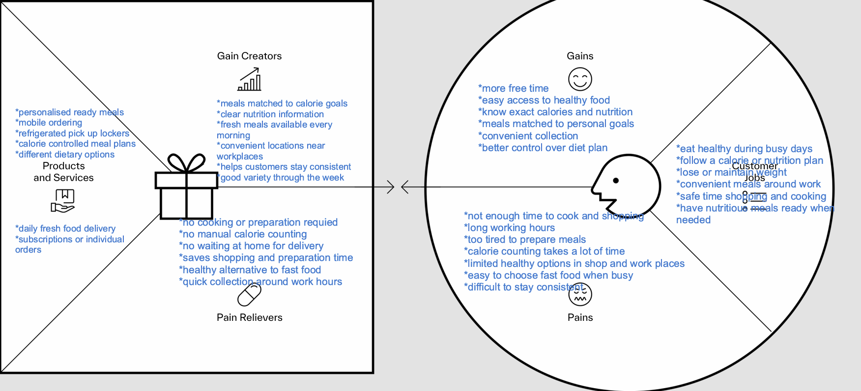

Mind map

https://mm.tt/map/4090397819?t=KbvTnOSZ39

VPC

References:
Barringer, B.R. and Ireland, R.D. (2022) Entrepreneurship : successfully launching new ventures. Updated sixth edition. Harlow, England: Pearson.
BOZU (n.d.) BOZU: Home page. Available at: https://bozu.co.uk/ (Accessed: 12 October 2026).

Kotler, P. et al. (2024) Principles of marketing. Nineteenth edition. Harlow, England: Pearson. Available at: https://ezproxy.uwtsd.ac.uk/login?url=https://www.vlebooks.com/product/openreader?id=TrinityStD&accId=8886856&isbn=9781292449333&uid=^u.

Mellor, R.B. and Coulton, G. (2009) Entrepreneurship for everyone : a student textbook. Los Angeles ; SAGE. Available at: http://www.myilibrary.com?id=256052.

Osterwalder, A., Pigneur, Y. and Clark, T. (2010) Business model generation : a handbook for visionaries, game changers, and challengers. 1st ed. Wiley.

Prep Kitchen (n.d.) Order meals. Available at: https://prepkitchen.co.uk/order (Accessed: 12 October 2026).

Saebi, T. (2015) “Evolution, Adaptation, or Innovation?,” Business Model Innovation. Oxford: Oxford University Press. Available at: https://doi.org/10.1093/acprof:oso/9780198701873.003.0008.

Sam, L. et al. (2020) “The relationship between perceived time pressure and food practices among UK adults in employment,” Proceedings of the Nutrition Society, 79(OCE3). Available at: https://doi.org/10.1017/S0029665120007417.

Saunders, M.N.K., Lewis, P. and Thornhill, A. (2023) Research methods for business students. Ninth edition. Harlow, England: Pearson.

Shepherd, D.A. and Patzelt, H. (2021) Entrepreneurial Strategy. Springer Nature. Available at: https://doi.org/10.1007/978-3-030-78935-0.

Shepherd, D.A., Patzelt, H. and Breugst, N. (2024) 66 simple rules for entrepreneurs : a roadmap for improved performance. 1st ed. 2024. Cham: Springer Nature. Available at: https://doi.org/10.1007/978-3-031-62032-4.

Tessaro, J.A., Harms, R. and Schiele, H. (2023) “How startups become attractive to suppliers and achieve preferred customer status: Factors influencing the positioning of young firms,” Industrial marketing management, 113, pp. 100–115. Available at: https://doi.org/10.1016/j.indmarman.2023.05.024.

