

MODULE CODE: Digital Skills for Personal Development and Business Growth BMSW4008

ASSESSMENT COMPONENT: PORTFOLIO

STUDENT NAME: Alexandru-Neculai Boboc

STUDENT NUMBER: 2522670

LECTURER: Phillipa Fitzgerald

DATE: 16/03/2026
Contents
Task 1 3
Assessment of Digital Skills 3
References 3
Task 2 4
LinkedIn Learning Certificates for Office365 4
Task 3 5
Essay on Relevance of Excel in professional and personal life. 5
References 5
Task 4 6
7 Minute Reflective Presentation 6
References 6

Task 1

Assessment of Digital Skills
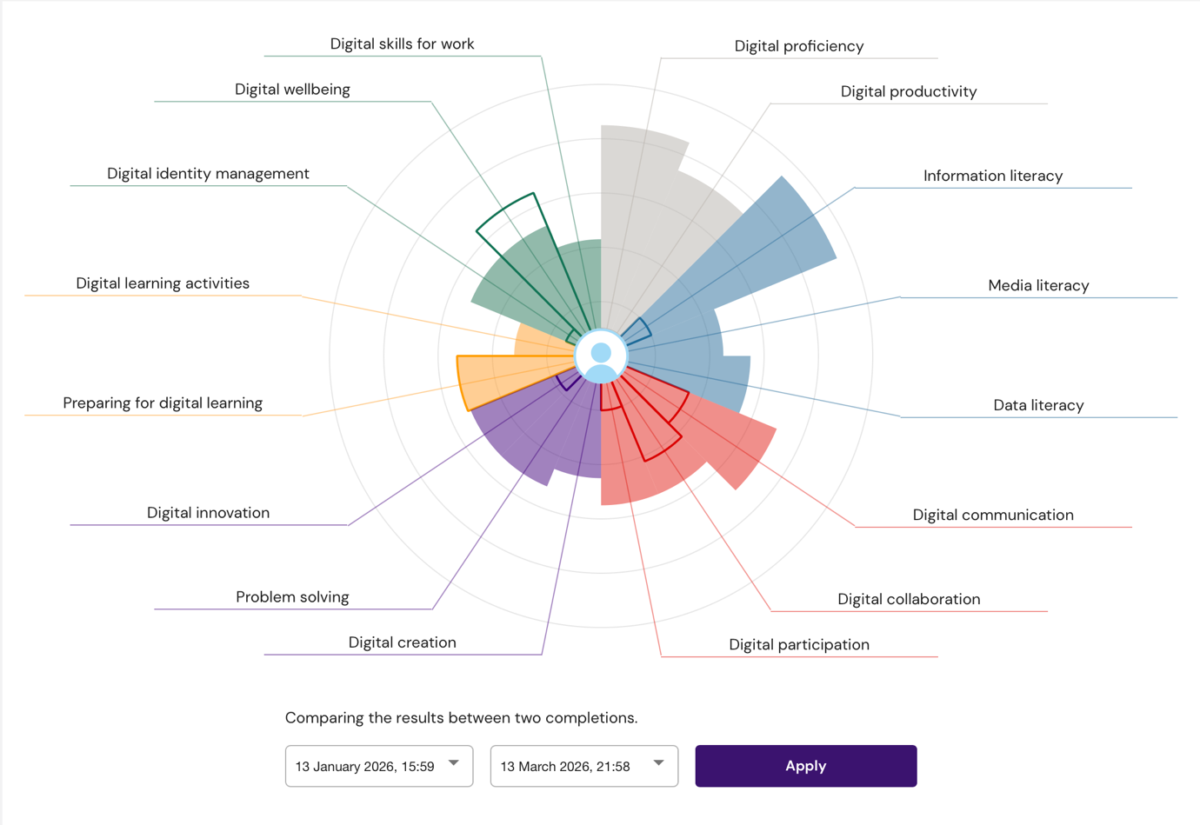

Digital skills are very important in modern education and also in the workplace. Many work today are done using computers, digital device and online tools. Students are expected to use digital technology to complete assignments, communicate with lecturers and work with other students. In the workplace, employees also need digital skills to communicate, analyse information and complete tasks. Because of this, developing digital skills is essential for both academic success and future career opportunities (European Commission, 2022).

To understand my current level of digital skill, I completed the JISC Digital Discovery Tool using my university email account. This tool helps students measure their digital skills in different areas such as digital communication, information literacy, digital learning, data literacy and digital wellbeing. The results are presented in a graphical report which shows strengths and areas that need improvement. After completing the assessment, I was able to reflect on my own digital skills and understand where I am confident and where I need more development. Digital capability frameworks are commonly used in higher education to support students in improving their digital competence (Redecker, 2017).

According to my results, one of my strongest areas is information literacy. This means that I am comfortable finding and using information from online sources. During my studies I search for information using google, academic websites and online library. I understand that it is important to check if the information I find is reliable before using it in my assignments. Being able to find and use information effectively is an important skill because it supports learning and helps students complete research tasks (Belshaw, 2014).

Another area where I feel confident is digital communication. I regularly use digital communication tools such as email and teams to communicate with lecturers and classmates. For example, I use Outlook to send emails and organise messages, and I use Moodle to access course materials and submit assignments. These tools make communication easier and allow students to stay connected with their course activities. Digital communication is also important in the workplace because many organisations rely on online communication platforms for teamwork and collaboration (Van Laar et al., 2017).

Although the report shows some strong areas, it also highlights areas where my digital skills can be improved. One area that needs improvement is digital creation. Digital creation involves producing digital content such as documents, presentations, charts or other forms of digital media. While I am able to create basic documents and presentations, I would like to improve my skills in using more advanced features in tools such as Microsoft Word, Excel and PowerPoint. Learning how to create better digital content will help me present information more clearly in my assignments and improve the quality of my work (Ng, 2012).

Another area that I need to develop is digital problem solving and innovation. Sometimes I rely only on basic digital tools instead of exploring other technologies that might help me work more efficiently. For example, there are many useful functions in Excel and other digital tools that I have not used before. By learning more about these tools, I will be able to solve problems more effectively and complete tasks more efficiently. Developing digital problem-solving skills is important because technology is constantly changing and workers need to adapt to new tools and systems (Van Laar et al., 2017).

To improve these areas, I have created a simple action plan using SMART goals, which means the goals are specific, measurable, achievable, relevant and time-based. My first goal is to improve my digital creation skills by completing LinkedIn Learning courses related to Microsoft Office applications such as Excel, Word and PowerPoint. These courses will help me understand how to use more advanced features. My second goal is to practise using Excel regularly so that I can improve my data handling and analysis skills. I plan to spend time each week practising formulas, charts and other Excel features.

Improving my digital skills will benefit both my academic studies and my future career. In my studies, stronger digital skills will help me complete assignments more efficiently and present my work more clearly. In the workplace, digital skills are highly valued by employers because they help employees communicate effectively and solve problems using technology. Developing strong digital skills is important for career development and employability in a digital society (European Commission, 2022).
Overall, the JISC Digital Discovery Tool helped me understand my current level of digital skill. It showed my strengths in areas such as information literacy and digital communication, while also highlighting areas that require improvement. By following my action plan and continuing to practise digital skills, I hope to improve my abilities and become more confident in using digital technologies.

References
- Belshaw, D. (2014) The Essential Elements of Digital Literacies. London: Self-published.
- European Commission (2022) Digital Economy and Society Index Report. Brussels: European Commission.
- Ng, W. (2012) ‘Can we teach digital natives digital literacy?’, Computers & Education, 59(3), pp.1065-1078.
- Redecker, C. (2017) European Framework for the Digital Competence of Educators (DigCompEdu). Luxembourg: Publications Office of the European Union.
- Van Laar, E., Van Deursen, A., Van Dijk, J. and De Haan, J. (2017) ‘The relation between 21st-century skills and digital skills’, Computers in Human Behavior, 72, pp.577-588.

Task 2

LinkedIn Learning Certificates for Office365


Task 3

Essay on Relevance of Excel in professional and personal life.
Introduction

Microsoft Excel is one of the most widely used digital tools in the modern world. It is part of the Microsoft Office package and is mainly used for creating spreadsheets, analysing data and organising information. Excel is commonly used in education, business organisations and personal financial management. Because of its wide range of functions, Excel has become an important tool for handling large amounts of data and making sense of information. In today’s digital society, having basic Excel skills is considered an important digital competency for both students and employees (Albright and Winston, 2017).
Excel allows users to organise information in rows and columns, which makes data easier to read and analyse. It also includes many useful functions such as formulas, charts, tables and sorting tools that help users understand data more clearly. As organisations continue to rely on data for decision making, the ability to use spreadsheet software like Excel has become a valuable skill. Therefore, learning Excel can help individuals improve their productivity and work more efficiently.

Excel for Data Organisation and Management

One of the most important features of Excel is its ability to organise and manage data effectively. Businesses and organisations often collect large amounts of information related to sales, employees, finances and customers. If this data is not organised properly, it can be difficult to analyse and understand. Excel allows users to store data in structured tables which can easily be sorted, filtered and analysed.

For example, a business may use Excel to store information about its customers, including contact details, purchase history and payment information. By organising this data into a spreadsheet, employees can quickly find the information they need and update records when necessary. Excel also allows users to filter data so that specific information can be displayed when required. This makes it easier for organisations to manage their data efficiently (Evans, 2018).

In addition, Excel provides tools that help users maintain accuracy when managing data. For example, formulas can automatically calculate totals and averages, which reduces the risk of human error. This makes Excel a reliable tool for managing information in both small and large organisations.

Excel for Data Analysis

Another important function of Excel is data analysis. Data analysis involves examining information in order to identify patterns, trends or relationships. Excel provides a range of tools that help users perform calculations and analyse data quickly. These tools include formulas such as SUM, AVERAGE and COUNT, as well as more advanced features like pivot tables and conditional formatting.

For example, a company might use Excel to analyse monthly sales data. By calculating the total sales for each month and comparing the results, the company can identify which months are the most profitable. Charts and graphs can also be created to visually represent this data, making it easier for managers to understand the results.

Data analysis is important because it helps organisations make informed decisions. When managers have access to clear and accurate data, they are able to identify problems and plan strategies for improvement. Excel supports this process by providing tools that allow users to analyse information quickly and effectively (Camm et al., 2018).

Excel for Budgeting and Financial Planning

Excel is also widely used for budgeting and financial planning. Both individuals and organisations can use spreadsheets to track income and expenses. By recording financial information in Excel, users can see how money is being spent and identify areas where costs can be reduced.
For example, many households use Excel to create a monthly budget. A spreadsheet can include income sources such as salaries or benefits, and expenses such as rent, food, utilities and transportation. Using formulas, Excel can automatically calculate the total income and total expenditure for each month. This allows individuals to understand their financial situation and manage their money more effectively.

Budget spreadsheets are also commonly used in businesses. Companies often create financial reports that track expenses and revenue over time. These reports help managers monitor financial performance and make decisions about budgeting and investment. Excel makes this process easier because it can perform calculations automatically and display the results in charts or graphs (Atrill and McLaney, 2019).

Practical Use of Excel in This Assignment

As part of this assignment, an Excel spreadsheet was created to represent the income and expenditure of a typical family of four. The spreadsheet included several sources of income such as wages, benefits and other financial support. It also included a range of household expenses such as rent, council tax, utilities, food and childcare.

Excel formulas were used to calculate the total monthly income and total monthly expenses. The SUM formula was used to add together the values in the income and expenditure columns. This allowed the spreadsheet to automatically calculate the remaining balance after expenses were deducted from income. This type of spreadsheet can be very useful for families because it helps them understand how much money they earn and how much they spend each month.

In addition, charts can be created in Excel to visually show how money is spent in different categories. For example, a pie chart could be used to show the proportion of income spent on housing, food or transport. Visual representations such as charts make financial information easier to understand.

Excel for Reporting and Decision Making

Excel also plays an important role in reporting and decision making. Many organisations rely on data reports to evaluate performance and identify areas that need improvement. Excel allows users to create detailed reports that summarise information in a clear and organised format.

For example, a manager might create a report that shows the monthly expenses of a company. By analysing this report, the manager can determine whether costs are increasing or decreasing over time. If expenses are too high, the organisation can take action to reduce costs. Excel helps managers make these decisions by presenting information in a clear and structured way.

Reports created in Excel often include charts, tables and summaries that help decision makers understand the data quickly. Because of this, Excel is often used by accountants, managers and analysts in many different industries (Phillips, 2019).

Conclusion

In conclusion, Microsoft Excel is a powerful and widely used tool that supports many important activities in both personal and professional environments. It allows users to organise data, perform calculations, analyse information and create visual reports. Excel is commonly used for tasks such as budgeting, financial planning, data analysis and reporting.

The spreadsheet created for this assignment demonstrates how Excel can be used to manage household income and expenses effectively. By using formulas and tables, the spreadsheet automatically calculates totals and provides a clear overview of financial information. This shows how Excel can be a practical tool for everyday financial management.

Developing Excel skills is important because many workplaces require employees to work with data and spreadsheets. Individuals who understand how to use Excel effectively are better prepared to analyse information and support decision making. For this reason, learning Excel is an important step in developing strong digital skills for both academic study and future employment.

References

- TaskAlbright, S. and Winston, W. (2017) Business Analytics: Data Analysis and Decision Making. Boston: Cengage Learning.
- Atrill, P. and McLaney, E. (2019) Accounting and Finance for Non-Specialists. 11th ed. Harlow: Pearson.
- Camm, J., Cochran, J., Fry, M., Ohlmann, J., Anderson, D. and Sweeney, D. (2018) Essentials of Business Analytics. Boston: Cengage Learning.
- Evans, J. (2018) Business Analytics: Methods, Models and Decisions. 2nd ed. Pearson.
- Phillips, J. (2019) Excel for Business Professionals. New York: McGraw-Hill Education.
- Microsoft (2023) Microsoft Excel documentation and support. Available at: https://support.microsoft.com
- McKinney, W. (2022) Python for Data Analysis. 3rd ed. O’Reilly Media.

Task 4

7 Minute Reflective Presentation
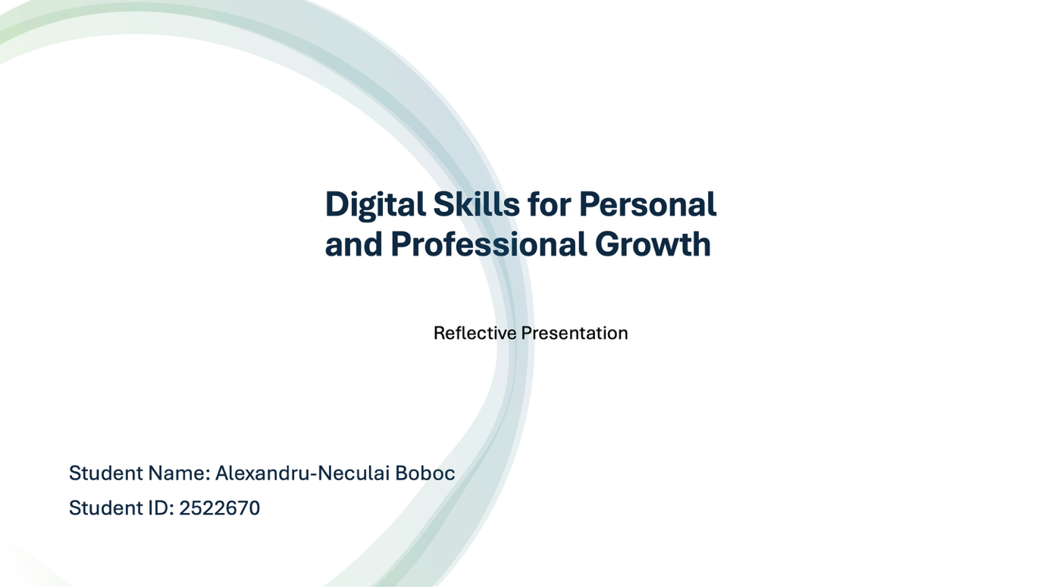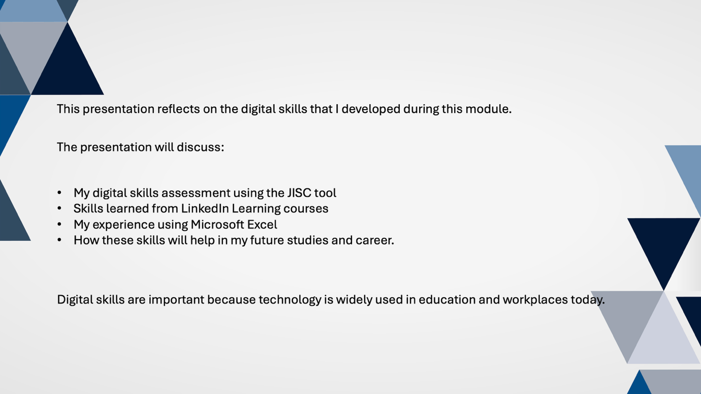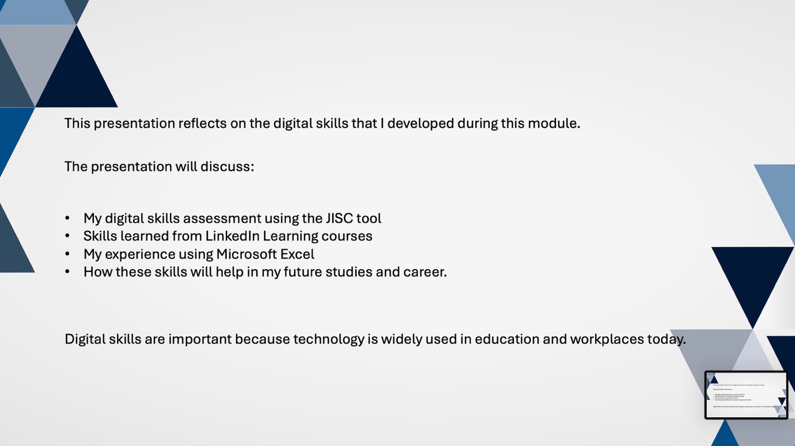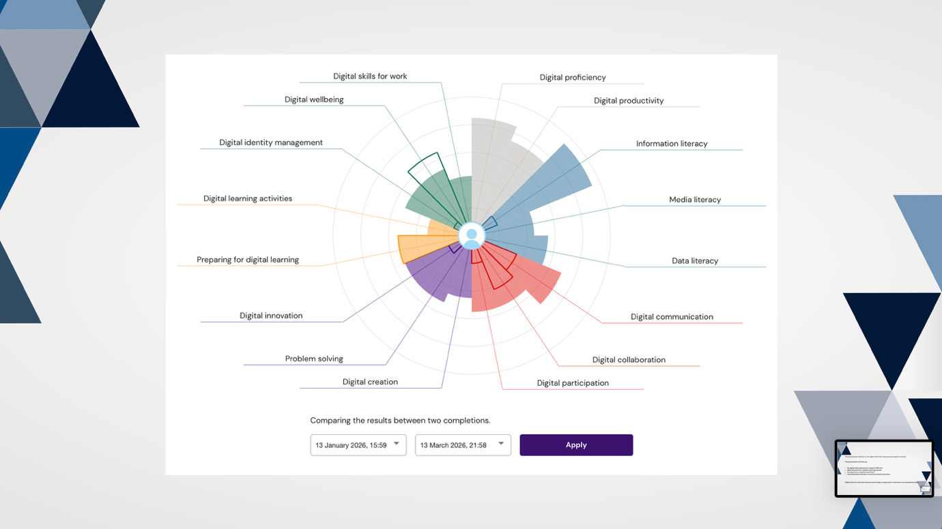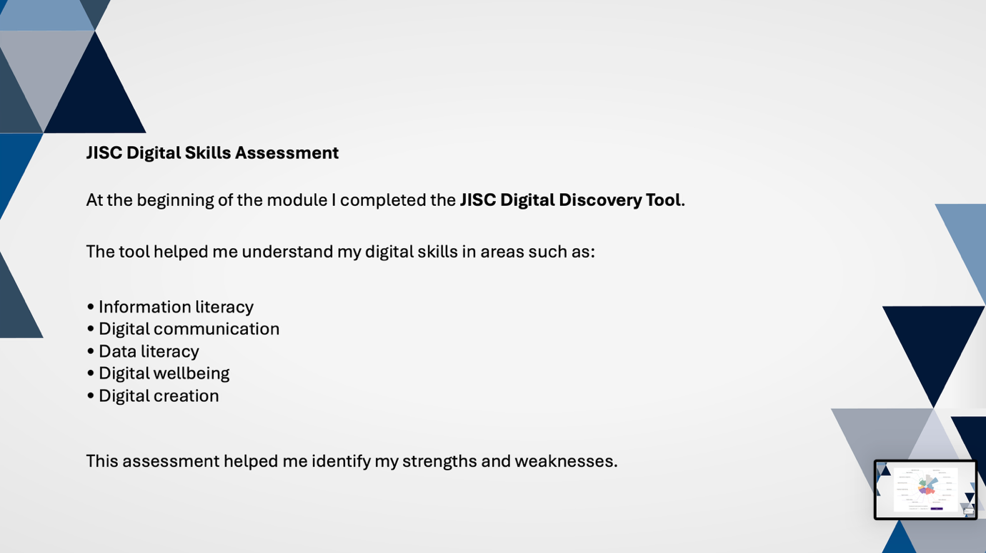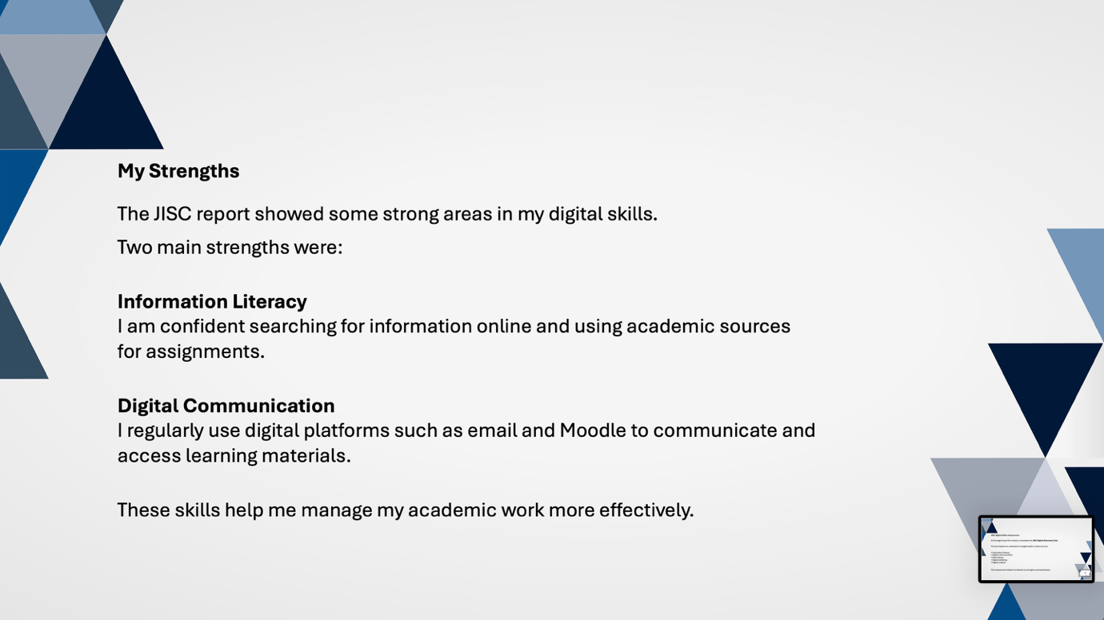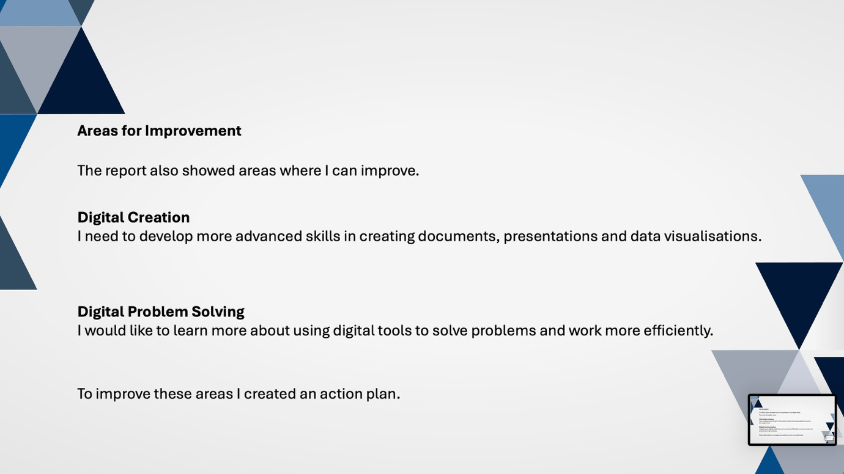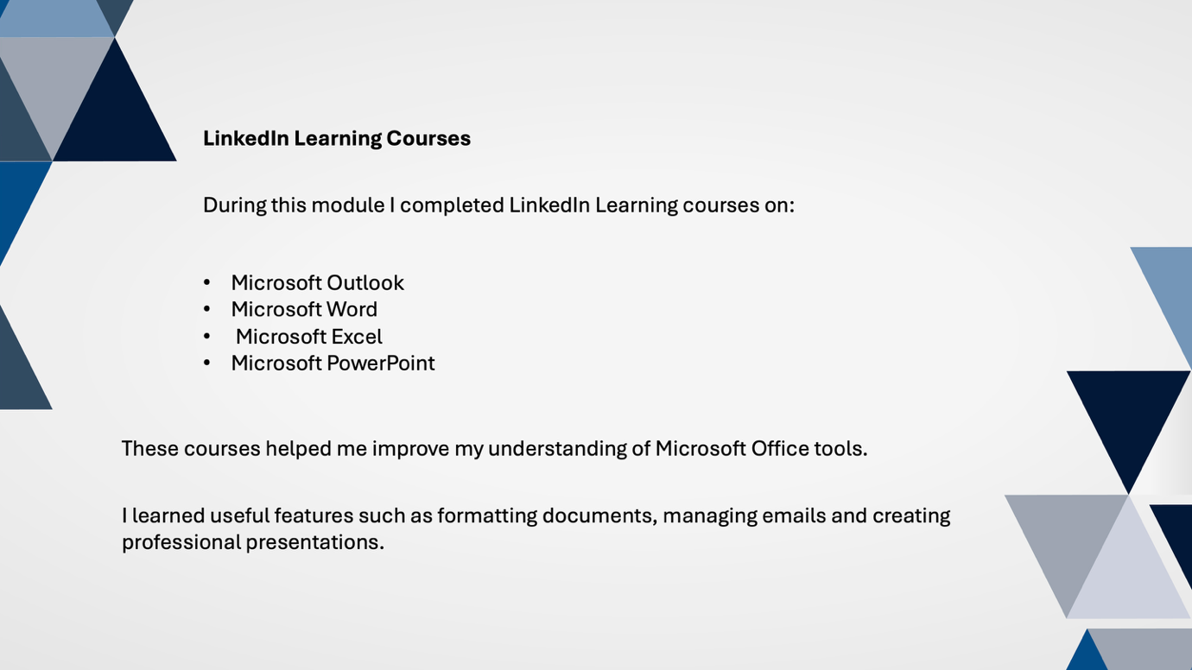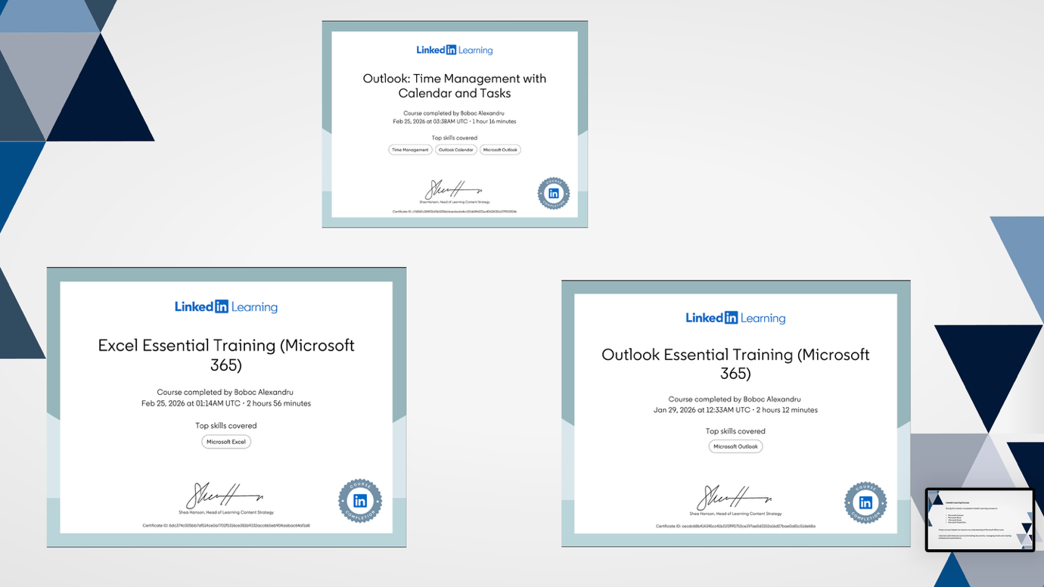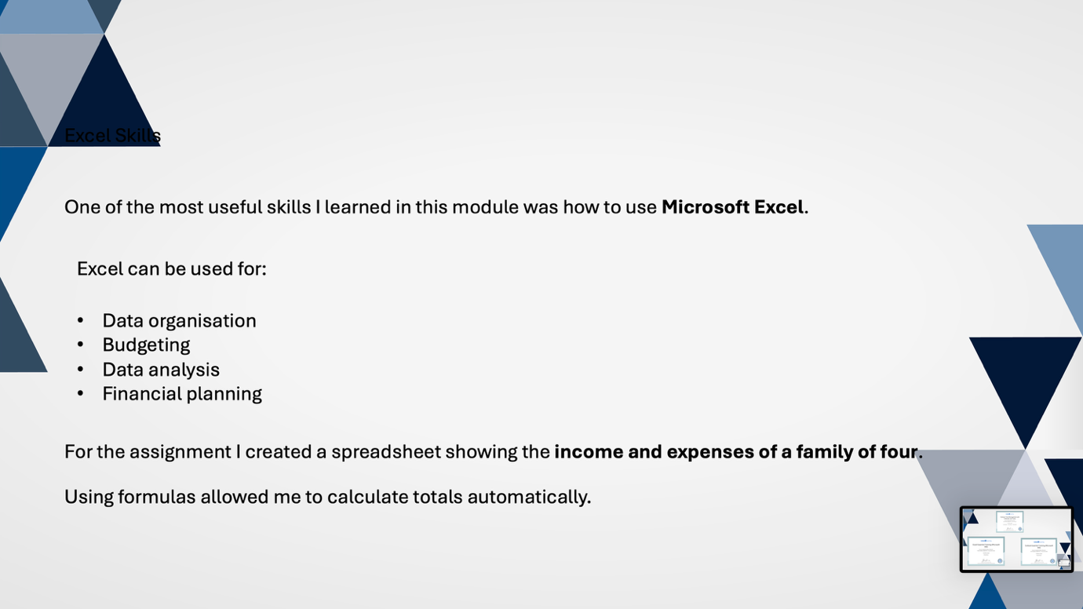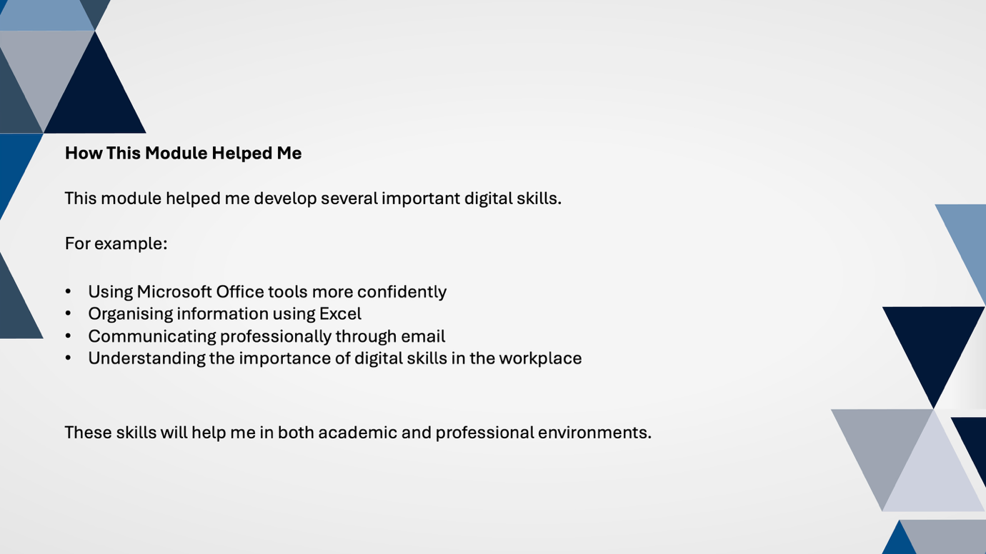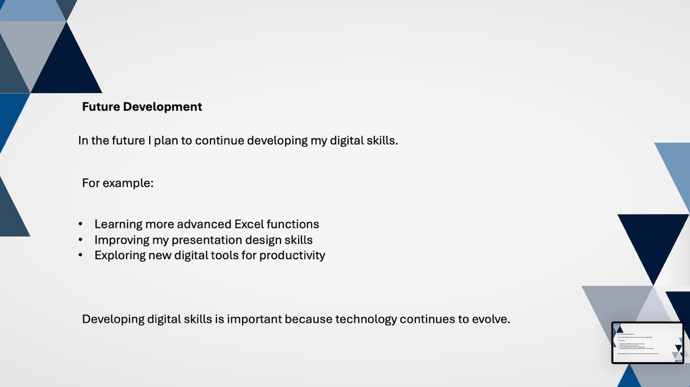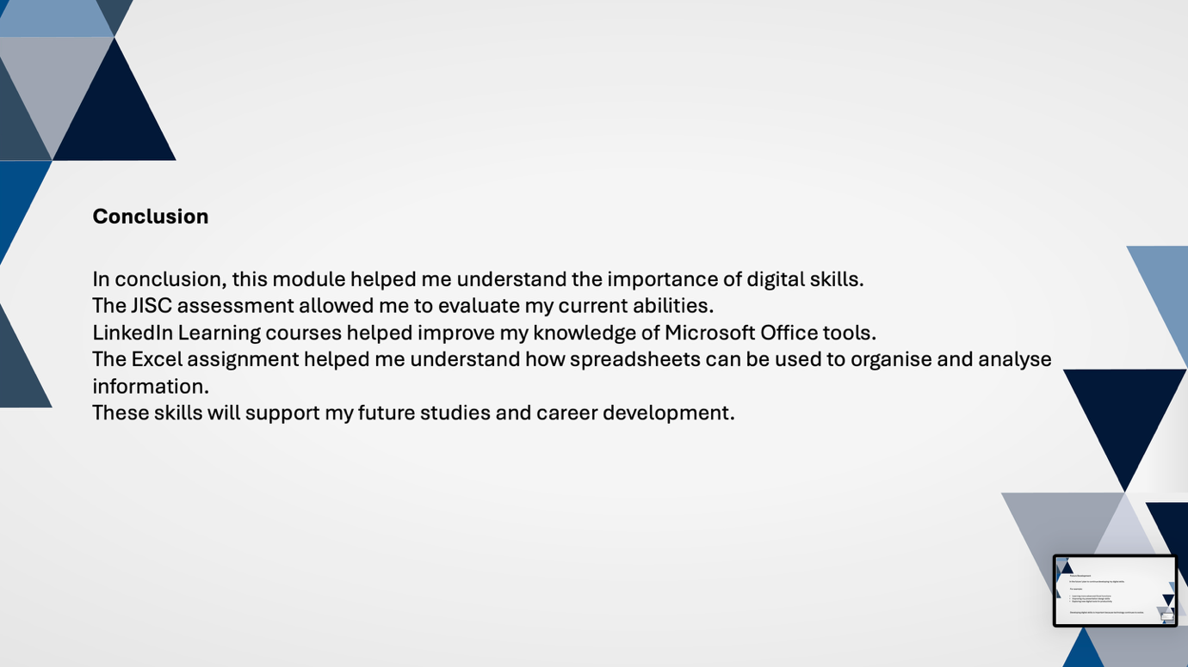

References

