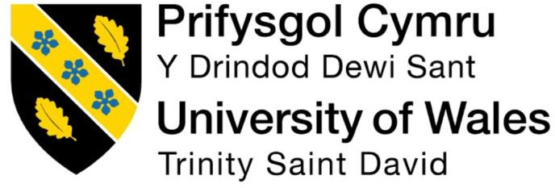

Course: MBA IB (Masters in Business Administration)
Module Name: Human Capital Management
Code of Module: LCMB7O23
Title: The influence of national and international labour markets on HRM and IHRM strategies

Name of Professor: Ejike Udeogu
Student Name: Naveenkumar Jayakannu
Student ID: 2438827
Date of Submission: 17th October 2025

Index
Topic | Pg. No
Introduction | 3
1. Reshaping of Labor Market, Impacts & Implications | 4
2. Key Demographic and Geopolitical factors influencing labour market and how they create challenges. | 6
3. Addressing of the skill gaps & Talent Shortages | 8
4. Reflective of study | 10
Conclusion | 13
References | 14

Introduction
The relationship between national and international labour markets and Human Resource Management (HRM) and International Human Resource Management (IHRM) strategies is a fundamental aspect of contemporary business, profoundly influencing how organizations secure, manage, and develop their workforce across different contexts. As managing human resources in an international context, compared to a domestic one, introduces a heightened level of complexity. This complexity largely stems from navigating the distinct national labour markets characterized by unique cultural norms, legal frameworks, industrial relations, and supply/demand dynamics for specific skills. In essence, labour market conditions whether domestic or global, tight or loose directly shape strategic HRM decisions regarding recruitment, compensation, retention, and training, requiring a proactive and context-sensitive approach to people management to achieve competitive advantage.
- Reshaping of Labor Market, Impacts & Implications
Technological advancements, primarily driven by Artificial Intelligence (AI), automation, and ubiquitous digital platforms, are fundamentally restructuring how work is organized, executed, and valued.

A. Automation and Job Displacement/Augmentation
Automation, particularly robotic process automation (RPA) and machine learning (ML), is eliminating routine and repetitive cognitive and manual tasks [Acemoglu & Restrepo, 2019].
- Job Displacement and Polarization: Roles focusing on routine clerical, administrative, and assembly-line jobs are most vulnerable to displacement and "hollowing out," leading to labor market polarization (Frey & Osborne, 2017; Raj & Seamans, 2019).
- Job Augmentation: AI often enhances, rather than replaces, human roles. It shifts the human worker's function from "executor" to that of "supervisor, coordinator, and creator. This augmentation drives the demand for non-routine, knowledge-intensive tasks, fostering upskilling in roles that require problem-solving and creativity (Felten et al., 2023; Bessen, 2019).

B. The Rise of Digital Platforms and the Gig Economy
Digital platforms fragment traditional employment structures, leading to the rapid growth of the gig economy.
- Flexibility vs. Precarity: While platforms offer workers unprecedented flexibility and organizations global, on-demand talent [ALBI Marketing, 2024], this often comes at the expense of stability. Gig workers, frequently classified as independent contractors, may be left without institutional support, benefits, or the regulatory protections afforded to employees [Bales et al., 2020].
- Algorithmic Management: In many platform-based environments, traditional HRM functions (performance monitoring, task assignment, and dispute resolution) are replaced by automated systems, which can be opaque and prioritize efficiency over worker equity [Brown et al., 2019].
Impacts of Technological Advancements on Labour Markets affects by Job Displacement and Creation where Automation and AI are replacing routine, repetitive tasks (e.g., manufacturing, data entry, customer service). New roles are emerging in AI development, data science, cybersecurity, digital marketing, and remote collaboration. the net impact depends on industry, region, and the speed of adoption. Also Changing Skill Demands like Soft skills (emotional intelligence, adaptability, creativity) are increasingly valued alongside digital literacy. Reskilling and upskilling have become essential as employees must adapt to rapidly changing job requirements. Finally Remote and Platform-based Work. Growth in remote work and gig economy platforms (e.g., Upwork, Uber) is changing the nature of employment contracts and work environments. Flexibility is increasing, but so are issues like job precarity and lack of benefits.
Implications HRM & IHRM Strategies
The implications for HRM & IHRM strategies are even more pronounced, as organizations with a global workforce must consider local regulations, cultural norms, and the varying technological capabilities of different countries. In some countries, the integration of automation may be embraced, while in others, the shift may face resistance due to socio-economic concerns. Therefore, IHRM professionals must implement tailored strategies that account for these diverse needs and foster an inclusive and adaptive culture that promotes collaboration and innovation across borders. The core implication of both Human Resource Management (HRM) and International Human Resource Management (IHRM) strategies is the realization that people are an organization's most critical asset and a key source of competitive advantage. These strategies describe how managing people directly impacts an organization's overall success. Domestic Human Resource Management (HRM) involves a single legal and cultural context, while International Human Resource Management (IHRM) involves managing across multiple countries, which adds significant complexity in areas like law, culture, and employee mobility. This means IHRM strategies must account for diverse legal frameworks, cross-border payroll, culturally different workforces, and the strategic alignment of global human capital with international business goals.

- Key Demographic and Geopolitical factors influencing labour market and how they create challenges.

Demographic Factors Influencing Employment Markets
Aging Populations in Developed Economies (The Supply Shock) High-income countries (Europe, North America, Japan) face a shrinking working-age population (15-64 years) and an exponentially increasing dependency ratio (the ratio of dependents, often those 65+, to working-age people). This demographic contraction leads to severe Labor Shortages especially in public services, caregiving, and skilled trades. Loss of Institutional Knowledge where the rapid retirement of the baby-boomer generation leads to the loss of irreplaceable tacit knowledge and experience. Increased Social Burden Higher taxes or reduced benefits are required to sustain pension and healthcare systems, affecting the disposable income and welfare of the remaining workforce (McKinsey, 2025; World Bank Blogs,)
The Demographic Dividend in Emerging Economies Conversely, regions like Sub-Saharan Africa are projected to be the sole major contributors to working-age population growth in the coming decades. This presents a potential "demographic dividend"—a period of accelerated economic growth due to a higher proportion of working-age adults. However, this potential is conditional on Investment in Human Capital the ability to provide quality education and job opportunities for the millions of new labor market entrants .Risk of Brain Drain without sufficient domestic opportunities, highly skilled young workers may migrate to older economies, transferring their productive capacity away from their home countries and complicating IHRM strategies for attracting local talent (Lam et al., 2019; Paul Donovan (UBS), 2024).

Key Geopolitical Factors Influencing Employment Markets
Geopolitical risk translates directly into labor market volatility by restricting the flow of goods, capital, and crucially, people. Trade Friction and Job Shocks the rise of economic nationalism (e.g., tariffs, sanctions, and export controls) forces companies to decouple supply chains. This causes immediate job shocks in sectors dependent on international trade (e.g., manufacturing, logistics) and inflationary pressures that erode the real wages of employees (ICLG.com, 2025; Cin7, 2025).
Restricted Mobility and Security Vetting: Political tensions lead to stricter immigration policies, complex visa regimes, and intense security vetting for foreign specialists, particularly in sensitive high-tech and defense sectors. This severely constrains the ability of multinational corporations (MNCs) to move critical talent where it is needed, creating localized skill shortages despite global labor surpluses. The 'De-Risking' Strategy to counter volatility, companies engage in 'friend-shoring' (sourcing from politically aligned countries) and 'near-shoring'. While this increases supply chain resilience, it often necessitates significant, costly shifts in the physical location of production and R&D facilities, causing job creation in some regions and displacement in others. (Adleo Relocation, 2024; PwC Survey, 2024)
Factors Create Challenges for HR Professionals
Challenge | Implication for HR
Workforce Planning in Uncertainty | Must plan amid demographic shifts, migration, and geopolitical instability.
Talent Shortages and Skill Gaps | Need to invest in training, upskilling, and tapping into non-traditional talent pools.
Legal and Compliance Complexity | Must navigate changing immigration, labour, and data laws across multiple jurisdictions.
DEI and Cultural Sensitivity | Need to build inclusive, equitable policies tailored to diverse, global teams.
Crisis and Risk Management | HR must play a strategic role in organizational resilience and continuity planning.

Table- 2.1: Factors Create Challenges for HR Professionals (Self Source)

- Addressing of the skill gaps & Talent Shortages
Addressing skill gaps and talent shortages involves a blend of internal development and external acquisition strategies. HRM addresses these issues primarily through workforce planning focused on the local talent pool. Build implementing upskilling and reskilling programs to train existing employees in necessary new competencies (closing skill gaps) and establishing robust succession planning to ensure key roles are covered (mitigating shortages). sBuy enhancing the Employer Value Proposition (EVP) and adopting innovative, skills-based recruitment methods to attract talent from the local market, often by forming partnerships with local educational institutions.
IHRM manages this on a multinational scale by leveraging global resources and managing cross-cultural issues. Global Mobility strategically utilizing expatriate assignments to transfer specialized skills from a talent-rich country/subsidiary to a talent-poor one (addressing immediate gaps). Geocentric Sourcing employing a "Global Talent Management" strategy to search for and staff critical roles with the best-qualified individual worldwide, regardless of nationality. Cross-Cultural Competence providing cross-cultural training for employees moving internationally, as the most significant talent gap in a global context is often the ability to work effectively across different cultures.

- Talent Management
Talent Management (TM) is a strategic, integrated, and systematic approach to ensuring an organization has the right people in the right jobs at the right time, both now and in the future, to achieve its business goals. It is not simply a set of isolated HR functions but a holistic strategy that aligns an organization's human capital with its overall business strategy
Talent management encompasses all processes relating to the "talent lifecycle" of an employee. According to organizations like the CIPD, these processes must be integrated and aligned with strategic business objectives.
The core components of a comprehensive TM strategy typically include Talent Strategy and Planning Workforce Planning Forecasting the future skills, roles, and competencies the organization will need to meet strategic objectives. Succession Planning Identifying and developing internal employees to fill key or business-critical roles (especially leadership positions) when they become vacant.
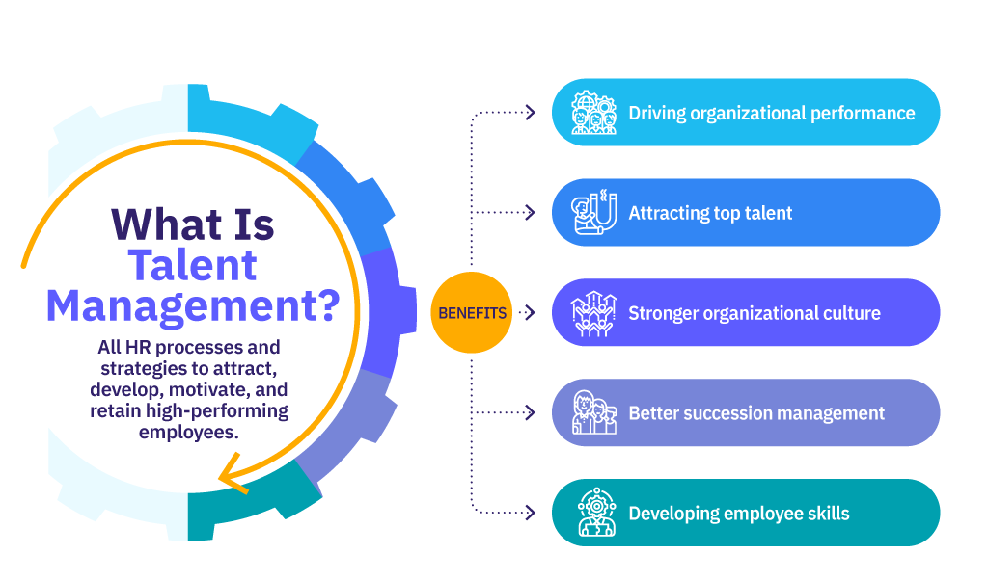
Recruitment creating a strong Employer Brand and using targeted methods to attract and hire the best external candidates. Onboarding Integrating new hires into the company culture and providing them with the necessary information and support to become productive quickly. Development and Engagement Learning and Development (L&D) Providing ongoing training, coaching, mentoring, and experiential learning opportunities to close skill gaps and build potential. Performance Management establishing clear expectations, providing regular feedback, and evaluating performance based on both results and potential. Employee Engagement: Implementing strategies to keep employees motivated, committed to the organization, and performing at their best. (Collings and Mellahi)

Fig 3.1: Framework of Talent Management (source: AHIR, 2018)
- AMO Framework
AMO model suggests that optimal performance is achieved when employees have the necessary skills and knowledge (Ability), the desire to perform (Motivation), and a supportive work environment (Opportunity).
Ability: Ability tends to the skills, knowledge and competencies to employees possess and perform the job effectively.
Motivation: Motivation reflects the internal drive and desire that individuals have to perform well in their roles. It involves factors that energize, direct, and sustain employees' behavior towards achieving organizational goals. Motivation can be influenced by various factors such as intrinsic and extrinsic rewards, recognition, career advancement opportunities, challenging work assignments, and a supportive work culture.
Opportunity: Opportunity refers to the enabling conditions and resources provided by the organization that allow employees to perform at their best. (LinkedIn, Mehul Manohar)
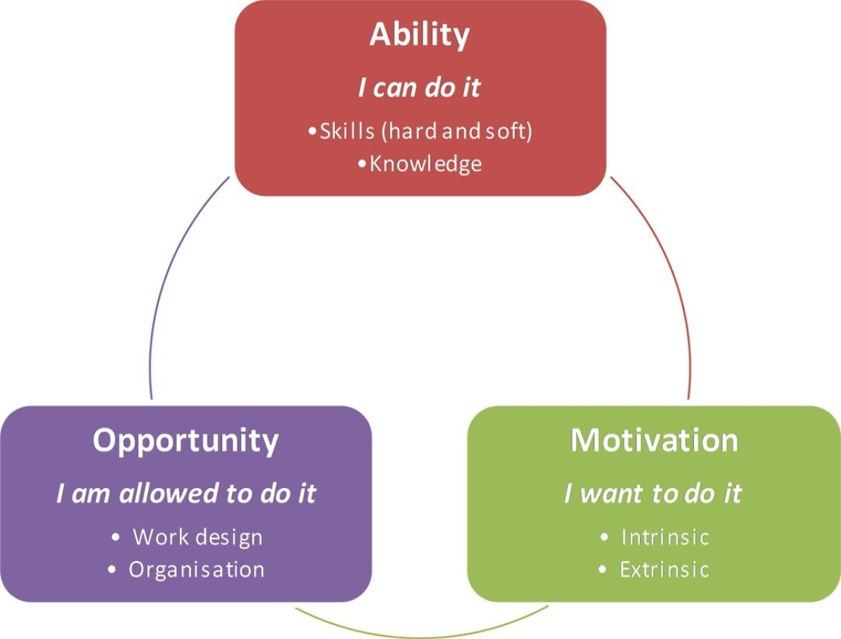
Fig 3.2: AMO Framework (Mehul Manohar linkedIn)

Reflective Report on preparedness of Labor Market

As we are aware that the technology is developing significantly, so it is very important to develop our skills and our personality and also applicable for the employees working within the organization should adopt the same skill with this dynamic environment.

Reflecting the report on my capabilities with my previous 3+ years’ experience in Customer Service and Purchase Officer I have accessed the Strength and Weakness of (Technology, Communication, Teamwork, Leadership, Self- Directed Learning) (Self Source)
Narration | Strength | Weakness
Technology | - Comfort with collaborative / remote tool  - Willingness to experiment  - Knowledge of the and new software like HRIS, CADD, ERP-1, ERP-2 | - Emerging Technology / AI  - Data Privacy / Cyber Crime
Communication | - Clear and structural  - Empathy and Active Listening | - Mistakes in Cross-Culture Communication  - Conflict / Hard Communication
Teamwork | - Reliability & Accountability  - Time Zone Coordination | - Resolving Conflict Soon  - Culture and Power Dynamics
Leadership | - Promote collaboration  - Adaptable / Flexible | - Motivating Remoting settings & Inspiring  - Influencing without Authority
Self-Directed Learning | - Increase in Micro-Learning  - Gaining Self knowledge | - Learning discipline  - Goal Setting

Table 4.1: Strength and Weakness (Self Source)

1. Technology
Plan to Leverage
- I will take targeted online micro-courses (e.g. in machine learning, APIs, data pipelines) during the next holiday break, applying them in mini personal projects.
- For systems integration, I will volunteer to lead “glue work” in collaborative tasks: setting up integration scripts, automations, or dashboards, thus forcing myself to learn.

2. Communication
Plan to Leverage
- I will read (and practice) cross-cultural communication frameworks (e.g. Hofstede, Hall’s high- vs low-context communication) and reflect, after each cross-cultural meeting, on whether I missed cues.
- To build confidence in difficult conversations, I will role-play challenging scenarios (e.g. negotiating deliverable changes) with peers, and ask feedback.

3. Teamwork
Plan to Leverage
- In the next group project, I plan to propose a shared leadership rotation (for example rotating the facilitator / coordinator role each week) so others take ownership and I practice letting go.
- I will introduce an explicit “check-in / retrospective” cadence (e.g. brief end-of-week reviews) to surface issues early and invite feedback.

4. Leadership
Plan to Leverage
- I will practice influence skills (e.g. persuasion, framing, reciprocity) in class teams—before asking someone to take a task, I’ll articulate the benefit to them (e.g. skill growth, recognition) rather than just the need.
- I will also learn that how to motivate the employees so they can increase the productivity.

Self-Directed Learning (SDL)
Plan to Leverage
- I will adopt a quarterly learning plan, selecting 1–2 “focus skills” (for example, a new programming library, data analytics tool, leadership framework) and scheduling micro-goals and checkpoints.
- I will enlist a learning buddy or peer group (perhaps classmates) so we share mini-projects, review each other’s work, and hold each other accountable.
In overall view, for me it is necessary to always work on my weakness first to avoid any kind of losses for the workplace and also essential to work on strength parallel to gain some extra knowledge apart from current. Addressing on my Strength and Area of Improvement I try to thrive in global, and changing environment.

Conclusion
National and International labour markets deeply shape both HRM and IHRM strategies. National labour market conditions determine what is possible and what is compulsory, while International labour markets impose competition, cross-border norms, and opportunities. Effective HRM / IHRM strategy lies in navigating this dual influence: extracting the benefits of global scale, shared practices, and mobility, while remaining sensitive to local culture, institutions, and labour market realities. Effective HRM and IHRM are therefore defined by their capacity to continuously scan, analyze, and strategically adapt to these complex, diverse, and constantly evolving labour market environments to secure and optimize the human capital essential for sustained competitive advantage.

References
- AIHR (2018). What is Talent Management? Fundamentals and Best Practices. [online] AIHR. Available at: https://www.aihr.com/blog/what-is-talent-management/.
- Chapo, A. (2025). How HR leaders can navigate geopolitical risks, protect employees, and future-proof their organisations.
- ss Darwish, T.K. and Fattaah, P.M.A. (2020). Human Resource Management in an Emerging South Asian Economy. International Human Resource Management. [online] doi:https://doi.org/10.4324/9780429030963.
- Mugisha, G.K. (2024). The Impact of Artificial Intelligence on Human Resource Management. The Impact of Artificial Intelligence on Human Resource Management, [online] 3(2), pp.14–18. Available at: https://www.researchgate.net/publication/383084162_The_Impact_of_Artificial_Intelligence_on_Human_Resource_Management.
- Shah, N. (2023). Leadership Strategies to Closing the Critical Skills Gap: A Review. International Journal Of Scientific Advances, [online] 4(5). doi:https://doi.org/10.51542/ijscia.v4i5.10.
- Steele, F. (2024). How can companies address the skills gap and ongoing talent shortage in their industry? - Workplace Insight. [online] Workplace Insight. Available at: https://workplaceinsight.net/how-can-companies-address-skills-gap-and-the-ongoing-talent-shortage-in-their-industry/.
- Takyar, A. (2023). AI in HR management: An overview. [online] LeewayHertz - AI Development Company. Available at: https://www.leewayhertz.com/ai-in-human-resource-management/.
- Talent (2024). Skill shortages are a growing concern across sectors and geographies. In an increasingly complex and technology-driven world, many industries are struggling to find workers with the skills needed to fill specialized roles. [online] Linkedin.com. Available at: https://www.linkedin.com/pulse/bridging-skills-gap-proven-hrm-strategies-address-g6rwf.
- Tmi.org. (2025). 5 Key Components of an Effective Talent Management Framework and Their Importance. [online] Available at: https://www.tmi.org/blogs/5-key-components-of-an-effective-talent-management-framework-and-their-importance
- Uwtsd.ac.uk. (2025). Available at: https://librarysearch.uwtsd.ac.uk/discovery/fulldisplay?docid=alma99100375897102421&context=L&vid=44WHELF_UWTSD:44WHELF_UWTSD_VU1&lang=en&search_scope=MyInst_and_CI&adaptor=Local%20Search%20Engine&tab=Everything&query=any
- Wahdaniah, Sucianti, R., Ambalele, E. and Tellu, A.H. (2023). Human Resource Management Transformation in the Digital Age: Recent Trends and Implications. [online] ResearchGate. Available at: https://www.researchgate.net/publication/376436926_Human_Resource_Management_Transformation_in_the_Digital_Age_Recent_Trends_and_Implications.
- World Economic Forum (2025). The Future of Jobs Report 2025. [online] World Economic Forum. Available at: https://www.weforum.org/publications/the-future-of-jobs-report-2025/in-full/1-drivers-of-labour-market-transformation/.
- ‌www.linkedin.com. (n.d.). Mehul Manohar on LinkedIn: #hr #development. [online] Available at: https://www.linkedin.com/posts/mehul-manohar-a05284228_hr-development-activity-7066763638451159042-wQ5i.
- Brown, S. T., Keegan, A., & Bondarouk, T. (2019). Algorithmic Management and the Digitalization of HR. Eman Research.

