
Applied Leadership and Management in the Workplace
Module Assignment Submission
Student Name: | Rosemarie Bennett
Student Number: | 2310781
Module No: | BMSK4015
Module Title: | Remote Management

Contents
Introduction 3
Managing Remotely 3
Literature What is Managing Remotely? 3
Remote Working 3
Managing virtual teams - advantages and disadvantages 3
Managing Global Teams 3
Managing Remotely 3
Skills for remote Managing 3
Advantages of Managing Remotely 4
Disadvantages of Managing Remotely 4
Lessons Learnt 4
Reflection 4
Conclusion 4
References 5
Appendices 6

Introduction
In recent years, ‘work’ has changed dramatically, with advancements in technology and society. One of the most notable shifts has been the rise of remote work, widely adopted during the global pandemic that made remote working the norm.
It became imperative for organizations to adapt their management practices to effectively lead remote teams. This report aims to explore remote management, by looking at the academic literature, practical examples, and by including personal reflections.

Managing Remotely

What is Managing Remotely?
Managing remotely involves working from home and different locations since covid 19, many companies have had no choice but to work out of their homes and away from the offices, to reduce the spread of the virus.
Common challenges of remote work start with managers needing to understand factors that can make remote work especially demanding, otherwise, high-performing employees may experience declines in job performance and engagement when they begin working remotely, especially in the absence of preparation and training. Challenges inherent in remote work include lack of face-to-face supervision: Both managers and their employees often express concerns about the lack of face-to-face interaction. Supervisors and managers worry that employees will also have anxiety issues which will reflect on their job performance and Perry (2021) identified a range of common challenges, which include:
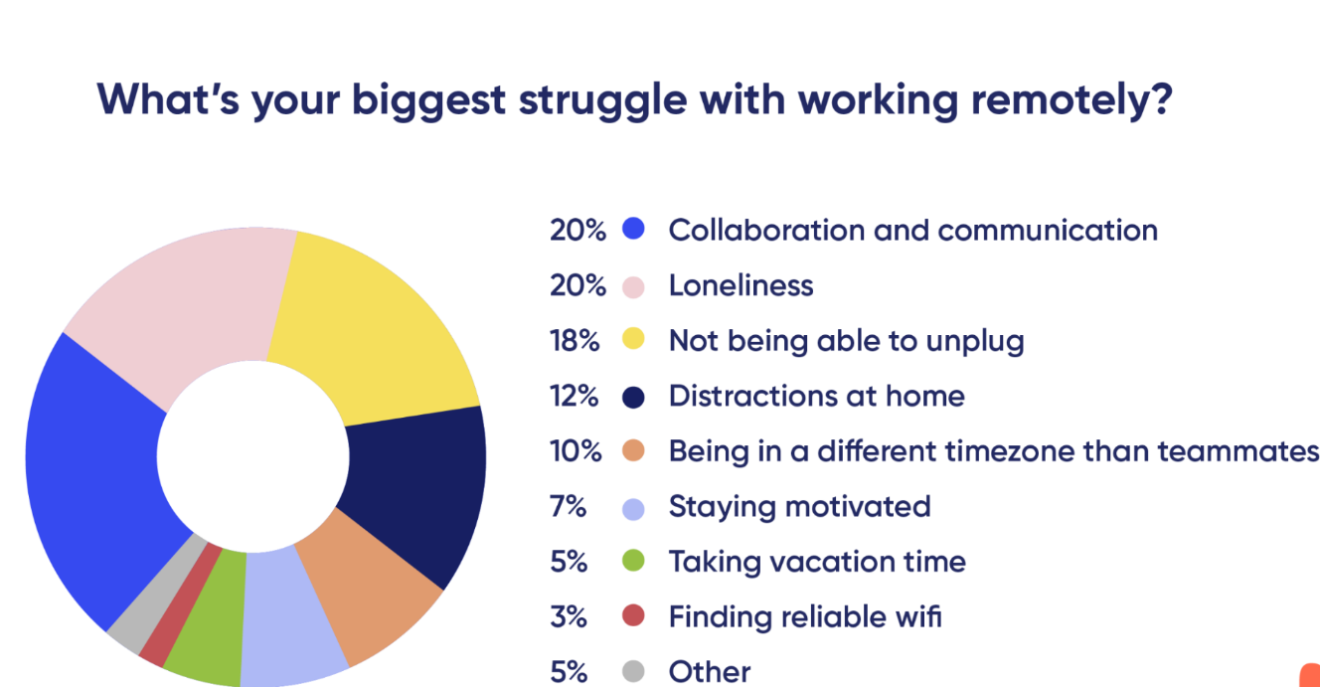
The chart above shows the challenging problems which have occurred during the covid 19 pandemic, also offering support for wellbeing is critical aspect of remote working in teams and individuals is very important.
Employees have had to adapt to new ways of working. According to Buffer’s 2021 State of Remote Work report (Cited Perry, 2021):
- 41% of new remote workers say the biggest change is how they collaborate and communicate with their colleagues.
- 22% say the biggest change is their location.
- 20% said their work hours are what has changed the most.
Helkvist et al (2021) reported that “Although our way of working is changing, we rely on the same techniques of managing and motivating employees, which is ultimately incompatible with remote work”, and this is reflected by the most common challenge being associated with collaboration and communication.
Managers need to communicate with their teams in multiple ways and through multiple mediums to keep expectations clear, to reinforce priorities, and to help understand and address barriers to maximizing their team's work while they are away from the office (Kluch, 2020) as this will help with the motivation and engagement of team members.

Remote Working
When we talk about remote work and remote teams today most of us are discussing the movement away from the traditional office (Burkis, 2021). Murphy (2023) defines Remote working as a type of working that enables individuals to work outside of the traditional working environment.
Neely (2020) reported that organisations had to prepare for this sudden transition very quickly, and some were better equipped to manage than others.
Remote working can lead to employees working longer than they would if they were in the office as Amico (2021) found that “employees who had previously developed strong work-life boundaries found them blurring during the pandemic transition”, and some employees worried that they had to be available 24/7 for their managers. This sometimes led to employee burnout and issues with wellbeing.
The difference between remote working from home and global remote working, remote working requires creating your own workspace, it also requires you to have the skills and the ability to have excellent time management, remote working also requires proactive communication and an almost hyperfocus on what's happening with team members since you don't have the regular face time with them. Remote working enables employees to have a break from the office it can also be affective because they can have their little office from home. Framework and structure would still be in place as if they were in the office, but regular check in emails would also be required to ensure you are actually working. (Aten, 2019)

Influence Of IT
Digital transformation is the fundamental rewiring of how an organization operates. The goal of a digital transformation, as outlined by McKinsey (2023), should be to build a competitive advantage by continuously deploying tech at scale to improve customer experience and lower costs. Digital transformations are different from regular business transformations, in both small and big ways. For one thing, business transformations usually end once a new behaviour has been achieved. Digital transformations, on the other hand, are long-term efforts to rewire how an organization continuously improves and changes (and that means long term; most executives will be on this journey for the rest of their careers). That’s because technology is not only becoming further integrated in business but also constantly evolving. (company, 2023) There was a need for rapid change during COVID as most employees were forced to work from home and technology had to advance to meet the demand. Online meeting tools were developed rapidly but are a long way away from the tolls that we are seeing today/
The ability to work from home increased as “technology advanced and computers shrank in size” (Burkis, 2021), and this ability was embraced during the pandemic, where all the previous arguments for not being able to work from home disappeared and it became the norm.
The development of technology has favoured an increase in the speed of information and communication, which made business fluid and new forms of flexible working relationships had spread, including the home office (da Rocha, 2020), however it has raised a question over the security and privacy of information.

Data Privacy vs. Data Security [definitions and comparisons]
- 10/01/2023
- in Blog, Data Privacy
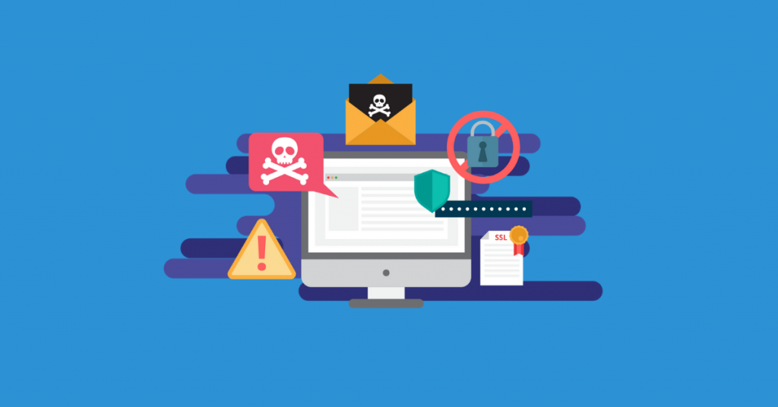
When it comes to data privacy vs data security, we frequently hear those terms used interchangeably. However, are these synonyms, or do they denote slightly different concepts?
We will try to untangle their distinctions, discover where they intersect, and make these critical concepts more understandable.
What is Data Privacy data privacy or Information privacy revolving Data security is focused on protecting personal data from unauthorized third-party access, malicious attacks, and exploitation. It is set up to protect personal data using different methods and techniques to ensure data privacy.
Data security ensures the integrity of the data, meaning data is accurate, reliable, and available to authorized parties.
Data Security methods, practices, and processes can include:
- Activity monitoring
- Network security.
- Access control
- Breach response
So, if you are using a Google Gmail account, your password would be a data security method, while the way Google uses your data to administer your account would be data privacy which is very important with security within the company.
- later, but not vice versa. Data security is a prerequisite for data privacy. Encryption The former can exist without the
- Multi-factor authentication

Similarities between Data Security and Data Privacy
around the proper handling, processing, storage, and usage of personal information. The most common concerns regarding data privacy are:
- Managing contracts or policies
- Applying governing regulation or law (like General Data Protection Regulation or GDPR)
- Third-party management

Similarities between Data Privacy Security and Data
In short, data privacy and data security are not the same terms. Data privacy is about the proper usage, collection, retention, deletion, and storage of data. Data security combines policies, methods, and means to secure personal data.
So, if you are using a Google Gmail account, your password would be a data security method, while the way Google uses your data to administer your account would be data privacy. This is very important between employers and companies.

The former can exist without the latter, but not vice versa. Data security is a prerequisite for data privacy.securit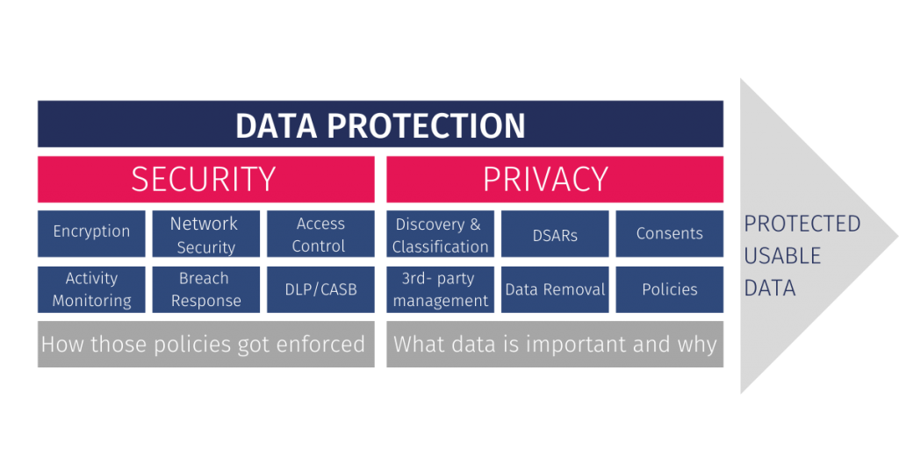

Influence of COVID
In the Spring of 2020, when the Covid-19 virus propagated throughout the world, millions of workers worldwide were obliged to work from home to mitigate the spread of the virus (Helkvist et al, 2021) The response to the threat of COVID19 pandemic brought the movement towards remote working to an all-out sprint, as moving people to work remotely was reactionary but seen as a temporary response, however for some the response has been for much longer than originally anticipated, and for some working remotely has now become the new norm. Employees saw the benefits of remote working and are not keen to return to the office (Burkus, 2021) because they have been able to build a better work/life balance and have reduced their commute time, which many seen as time wasted. Remote working has also benefitted organisations as they have been able to attract applicants from a wider catchment area, as people do not need to make the daily commute.
IBM conducted a report at the height of the Covid pandemic which indicated that more than half of employees wanted remote working to be their primary method of working and 75% said they would like the option of continuing to remote work at least some of the time (Burkis, 2021)
Perry (2021) found that 45% of remote workers were working from home because of the COVID outbreak and 46% reported that their organisation planned on making remote working permanent.
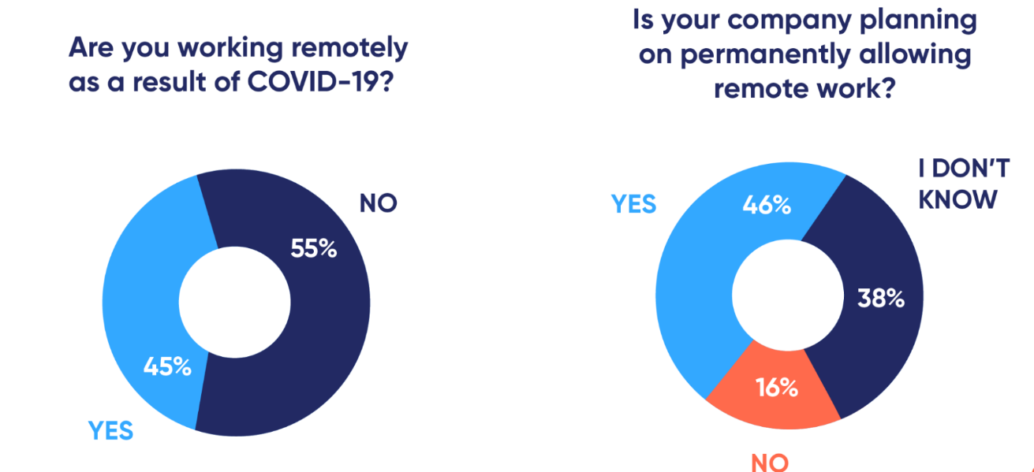
Fig 1 Remote working as a result of COVID, Perry, 2021

Whilst there are many reasons for not implementing remote working or not supporting remote working Perry (2021) found that 97% of the remote workforce would like to continue working remotely at least some of the time for the rest of their careers therefore there is a need for managers to continue to hone their skills in remote management.
Perry (2021) states that the benefits of remote work outweigh the drawbacks for employees, but this will only continue if the organisation also sees the benefits.

Managing Global Teams But understanding something can be very different from living it. My team has grown increasingly distributed across multiple time zones and regions of the world over the last couple of years, and we have Despite all our “understanding” of being a global team, we used to always privilege Grand Rapids (U.S. Eastern Time) in our meeting schedule and make our Asia team members stay up late learned, through experience and experimentation, a few ways to leverage the value of a global team while also minimizing the pain and disruption it can create for us as individuals. There is also a culture because of different and religion which include different languages which might result in having an interpreter.

This will also cause a problem for an employer due to meetings within the company managing global management. Managing a Team Across 5 Time Zones, Time separation on a global team presents one of the biggest physical, cognitive, and emotional challenges, between employers and management.
by
- Donna Flynn (June 17. 2014)
June 17, 2014
by
International Business
by
- Donna Flynn
June 17, 2014

Managing Remotely

Skills for remote Managing
Different skills for managers, remote working home based and remote workers global.
Communication - when e-mails and intranets are used appropriately, communication can facilitate shared understanding and help remote staff view their company as alive and exciting (Morgan, 2002) and are seen as a speedy ad cost effective way of communicating with employees, unfortunately managers send e-mails that may seem harsh and critical to employees and this has the opposite effect, especially when there are language barriers as well.

Advantages of Managing Remotely
- Reduced Costs
- remote work help keep employees happy, engaged, and fulfilled.
- working remotely can improve the health and wellness of employees by reducing stress.
- The ability for employers to trust their teams, even when they work out of the office.

Disadvantages of Managing Remotely
- Decline in productivity - One of the disadvantages of remote management is the lack of trust by managers who feel that employees may not be working as hard as they do in the office Amico (2021) found that “managers worry that employees still aren’t as productive at home as they are in the office”. However, Gleeson (2020) argued that managers need to understand factors that can make remote work especially demanding. Otherwise, high-performing employees may experience declines in job performance and engagement when they begin working remotely, especially in the absence of preparation and training.

Lessons Learnt

Reflection
Gibbs Reflective Cycle
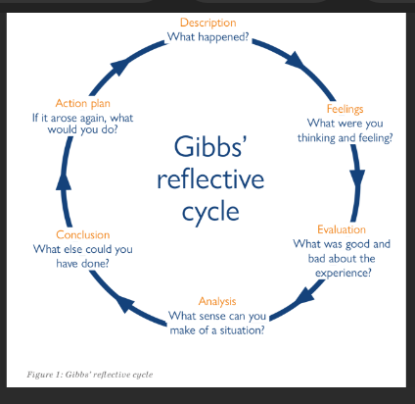

Description – researched remote working.
Feelings – what did you think about the findings, anything surprise you,
Evaluation – what was good about the assignment and what was bad (maybe finding the right papers/research to support what you were saying
Analysis – overall thoughts on what you have found about managing remotely,
Conclusion – could have spoken to people who had managed or been managed remotely during and after COVID
Action Plan – Better time management, start looking for research earlier and putting thoughts on paper. Being ore critical about what I have written and taken the time to get clear arguments about remote working.
- We are also prototyping a global “Social Hour” where we are all invited to bring coffee, lunch, on where you are and what time it is—and hang out together on videoconference. Every team needs to think about what may be best for them, but you’ll want more of these checkpoints than you would need for a fully co-located team.
- Use as many collaboration tools as you need to – and constantly search for better ones. The tools available to distributed teams today aren’t perfect. There is no one technology that does everything we need, so we use many of them for different purposes – including Google Drive, We have fully adopted Morally (a digital, highly visual sticky note canvas) as a team in the last year and it has dramatically improved our team’s collaboration. We are still searching for the best video conference platform; telepresence is limited since we always have some team members joining from home; Group Skype and Google Hangout are too unstable, to go to Meeting is more stable but only allows six video feeds and we frequently have ten people joining. We are now turning for a second time to a collaboration tool called Sonoco. We’ve found that it takes a lot of patience and flexibility to use these tools effectively, and adaptability in swapping out tools in the moment as needed – such as dropping an unstable video connection and switching to conference call because the bandwidth in Hong Kong is experiencing latency.
- Pay extra attention to your colleagues who are on the phone or on video. At Steelcase, we talk a lot about the concept of “presence disparity.” In meetings that bring people together via different communication channels, individual “presences” don’t necessarily have the same weight in the conversation. For example, people in the same room are more likely to talk to each other and forget about the person on the video screen and the person on the speaker phone. Likewise, it’s easier to enter the conversation as a distributed participant on video than from the phone because your visual presence makes it easier to get people’s attention. We are consistently looking for new ways to solve for this reality of modern communications at Steelcase – and yet too often our own teams succumb to its allure by privileging those who are physically present over those who are joining from afar. The most powerful tool for this is awareness - remember the value that your colleagues around the world bring to the table and honour them with consistent inclusion in the conversation. Practice eye contact with people on video, gently pause a passionate conversation in the room and ask the remote participants to chime in, or experiment with equalizing presence by having everyone call into the video conference or conference call individually.
Invest in bringing the team together on a regular rhythm to foster team cohesion. No tool can replace being together in the same room. I bring my globally dispersed team together twice a year for workshops, which have proven invaluable for renewing personal ties, building trust, and having unmediated and embodied experiences together. I have three rules for these workshops: We should build something together, we should learn something together, and we should have plenty of informal, social time. I also use these times for us to engage in team strategic discussions or decision-making, since it’s much more effective to reach alignment around complex issues when we are in the same room. (rebuilt something together). We spent an afternoon envisioning our team future through an experimental theatre exercise developed at Otto Scharmer’s Presenting Institute at MIT and another time). The travel costs for these two weeks. A smart travel budget is a necessary component for a high-performing, globally integrated team. International Business

Managing a Team Across 5 Time Zones
by Donna Flynn (June 17 2014)

All of these different approaches add up to increasing our team’s empathy for one another. This compassion fuels trust, engagement, and collaboration – and drives our business forward.

Areas to develop (also put in PDP)
  - Time Management
  - Effective Planning
  - Prioritising Tasks
  - Critical reading and thinking
Personal Development Plan
- What do I want to learn? | What do I have to do? | What support and resources will I need? | How will I measure success? | Target Date for Review
Computer literacy and skills | Attend a computer course. | My tutors support. keep using my laptop | Ability to use my laptop. | 2024
Time management  course | Good attendance for my course. | support. | Time scale | April 24
Cert HE Applied Leadership and Management in the workplace | Attend  Listen  Complete assignments | Tutor  Other learners | Assignment feedback | 2 months
Time management | Make time | Tutor | Assignment feed back | 2 months
Effective planning | Set times | Support from Tutor | Making my time more efficient | 2 months
Prioritising tasks | With my time | Always ask my tutor | Listening to feedback | 2months
Critical reading and thinking | Reading loads think more | Accessing information for assignments | By listening and thinking | 2months

Conclusion
My conclusion of this assignment is that I found it very informative, and I have learnt a lot about the different types of remote and global working. If I had to redo this assignment I would research more and conduct a interview based conversation with people that have had to turn to remote working since covid, this would give me more Insite information first hand as this is something I have never experienced.

References

Aten, J. (2019, October 09). 'Working From Home.' Here's the Difference and Why It Matters to Your
Amico L, 2021, The Realities of Remote Work, Harvard Business Review, 29th October
Burkus D, 2021, Leading from anywhere: The essential guide to managing remote teams, Houghton Mifflin Harcourt
company, m. &. (2023). What is digital transformation. What is digital transformation, 1-3.
da Rocha D G , Ribeiro F N, Borges J G, 2020, The Pros and Cons of Managing Remote Teams, International Journal of Arts and Social Science, Volume 3 Issue 5
Gleeson B, 2020, 13 Tips For Leading And Managing Remote Teams, 13 Tips For Leading And Managing Remote Teams (forbes.com), accessed 14/3/24
Hellkvist, M., Lundblad, M., & Soumi, J. (2021). Managing and Motivating Remotely (Dissertation). Retrieved from https://urn.kb.se/resolve?urn=urn:nbn:se:hj:diva-52860</div>
Kluch S, 2020, Leading Remotely: What Managers Need to Keep Teams Engaged, Inclusive-Leadership-During-Times-of-Crisis-Materials.pdf (mcca.com), 14/3/24
Morgan, S. J., & Symon, G. (2002). Computer-Mediated Communication and Remote Management: Integration or Isolation? Social Science Computer Review, 20(3), 302-311.
Murphy N, 2023, How to Effectively Manage Remote Employees, How to Effectively Manage Remote Employees | Positives & challenges (cpdonline.co.uk), accessed 14/3/24
Perry E, 2021, 12 challenges of working from home & how to overcome them, https://www.betterup.com/blog/challenges-of-working-from-home, accessed 14/3/24

Appendices

