 | APPENDIX GA28

MODERATION OF MARKED ASSESSMENT
This form is used to ensure that marked assessments have been through an internal and external review process. This form should be completed for each assessment for a particular module.

PARTNER (and taught location if relevant):
EXTERNAL EXAMINER NAME: | Ian Friend
ASSESSMENT AUTHOR :
MODULE TITLE: | Independent Project
MODULE CODE: | ACCA6020 |  |  | MODULE LEVEL: |  |  |  | 6
COMPONENT NO. (e.g. 1 of 2): |  |  |  | COMPONENT WEIGHTING  (e.g. 50% of the module): |  |  |  | 100%
ASSESSMENT PERIOD | Semester 1 | Semester 1 Re-sit |  |  | Semester 2 | Semester 2 Re-sit |  |  | Other, please state
TYPE OF ASSESSMENT: | Coursework |  | Examination |  |  |  | Practical
LANGUAGE OF ASSESSMENT: |  |  |  | TRANSLATION PROVIDED: |  |  |  | Yes/No
TURNITIN CHECK FOR UNFAIR PRACTICE: | Yes / No

Students listed in the sample below must be registered on a UWTSD award.
FOR COMPLETION BY INTERNAL MODERATOR
After moderation I am able to agree the marks of the sample as shown below.
Student Name or number | 1st Marker mark | Moderator/2nd Marker | Moderator/3rd Marker | Agreed Mark | Comment
All work was double marked so no moderation sheet required.

INTERNAL MODERATOR (or second marker) |  | Please |  | Comments
 |  | YES | NO | Comments
1 | Has agreement on the marks been reached?
2 | Does feedback identify opportunities for improved performance?
3 | Is feedback constructive?
4 | Is the feedback linked to the appropriate category/ classification of the assessment criteria?
5 | Is the feedback consistent across the sample?
6 | Is there mention of improvement to referencing and consideration of unfair practice, where relevant?
7 | Actions to complete  This box will expand as you type
8 | How was agreement between markers reached?  Double marking.  This box will expand as you type

EXTERNAL EXAMINER REVIEW ONLY FOR THOSE MODULES / ASSESSMENT COMPONENTS detailed in the annual GA15 External Examiner Agreement

EXTERNAL EXAMINER |  | Please |  | Comments
 |  | YES | NO | Comments
1 | Has appropriate internal moderation taken place? | X
2 | Does feedback identify opportunities for improved performance? | X
3 | Is feedback constructive? | X
4 | Is the feedback linked to the assessment criteria? | X
5 | Is the feedback consistent across the sample? | X
6 | Is there mention of improvement to referencing and consideration of unfair practice, where relevant? | X
7 | Actions to complete  This box will expand as you type

Signed (internal moderator):  Gaynor Thomas | Date: 11/6/21
Signed (Partnership Team Leader): | Date:
Signed (External Examiner):  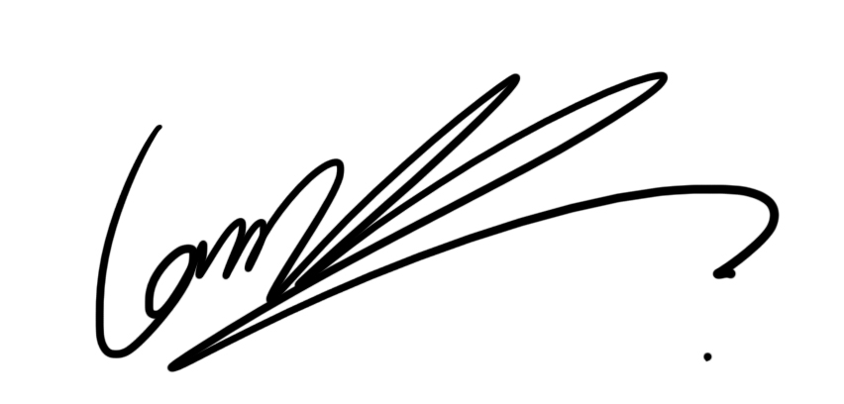 | Date: 11/06/21

UWTSD PROVISION: please submit the completed document to the appropriate Programme Director.
COLLABORATIVE PROVISION: please submit the completed document (or make available electronically) to the Partnership Team Leader. This must be in accord with specific arrangements for sharing electronic documents (e.g. via SharePoint or similar).

