Waheed Farid 2019666

Philippa Fitzgerald

International Meetings Management for the Hotel Industry (BMIH6007)

Feasability Plan for an International Meeting

https://uowtsd-my.sharepoint.com/:v:/g/personal/2019666_student_uwtsd_ac_uk/EXq8Onr3UE5Fga_e-DbNQTIBWCl9HGgyopkMf6m5tcMJ3A?referrer=Teams.TEAMS-ELECTRON&referrerScenario=MeetingChicletGetLink.view.view

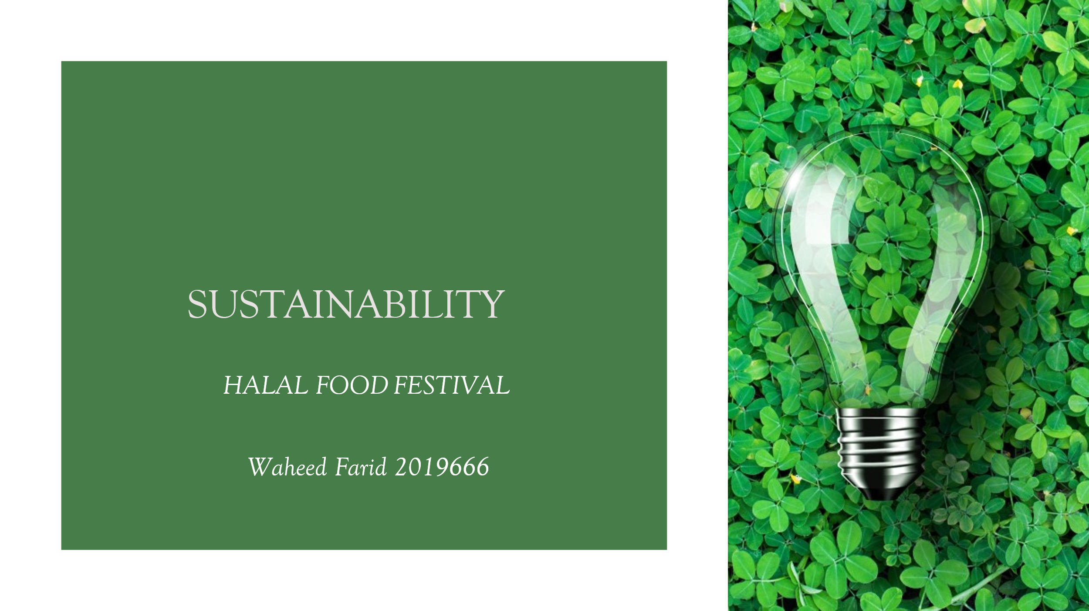
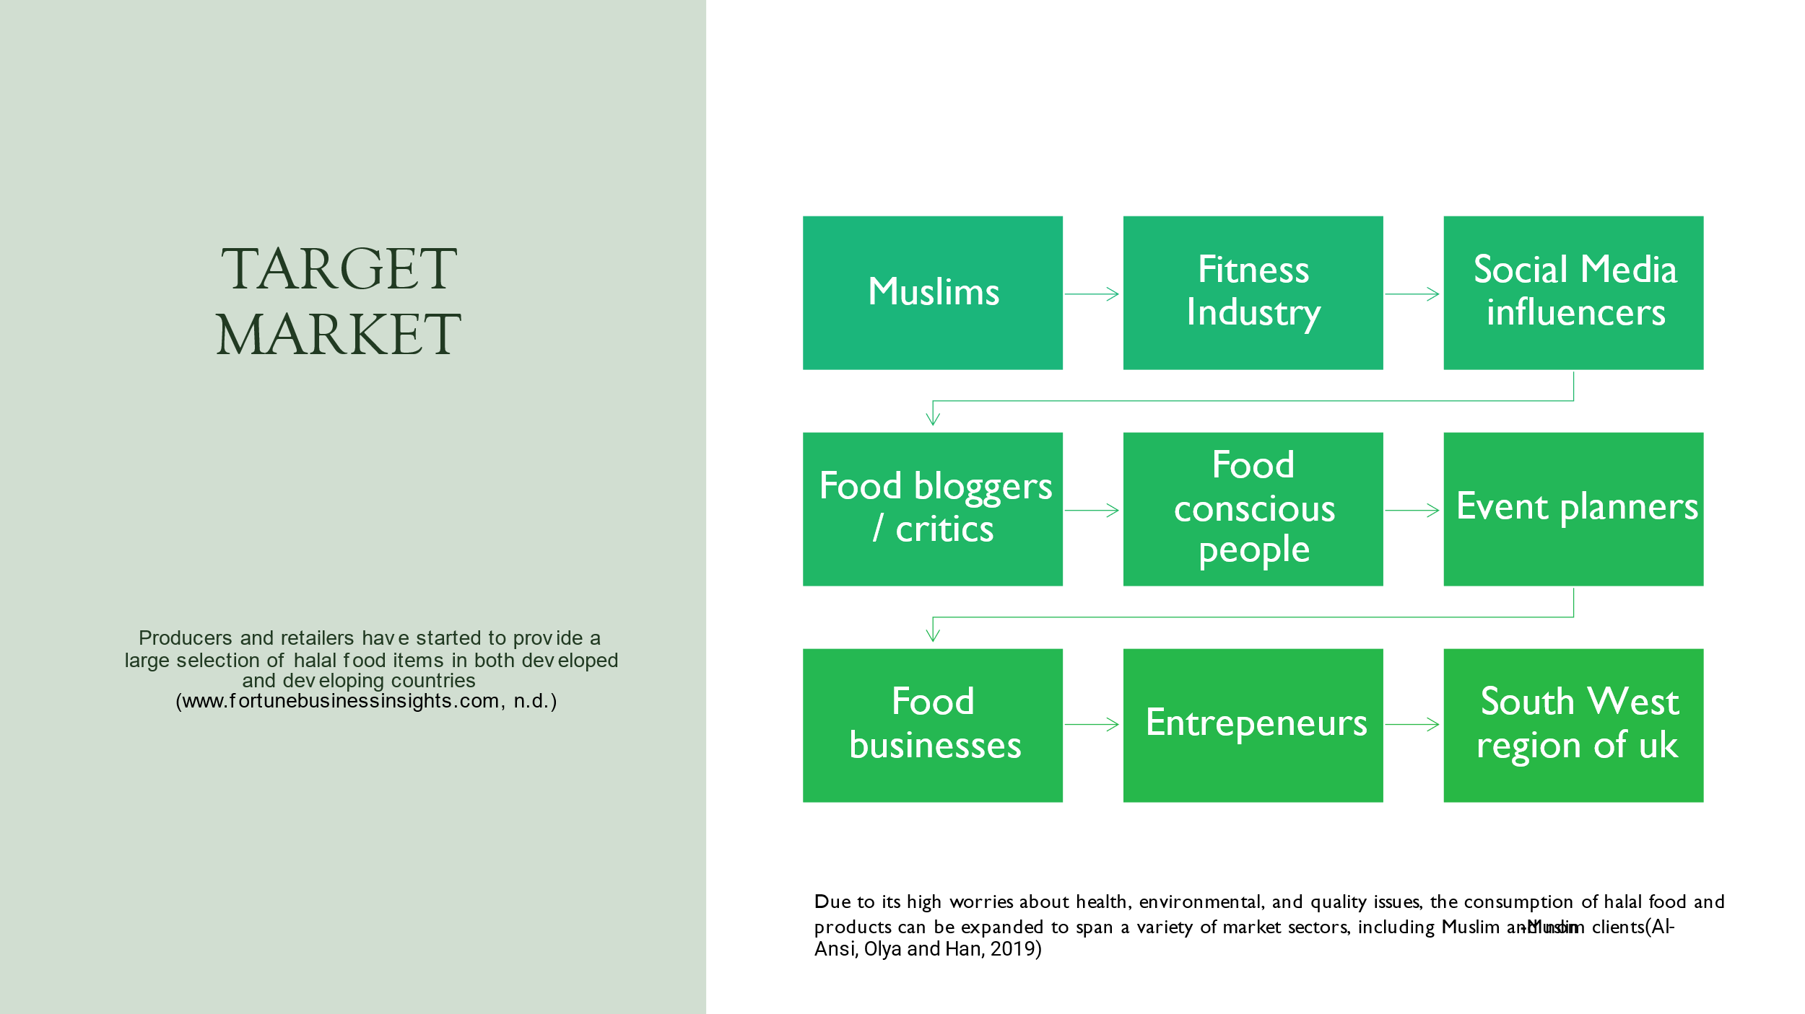

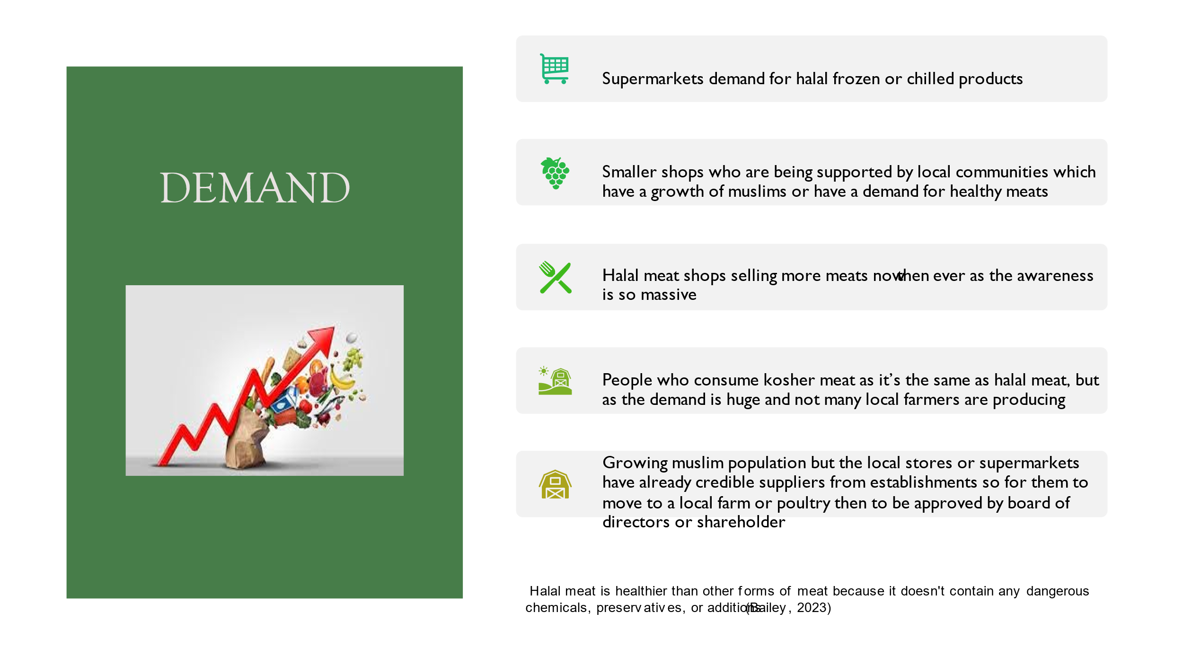
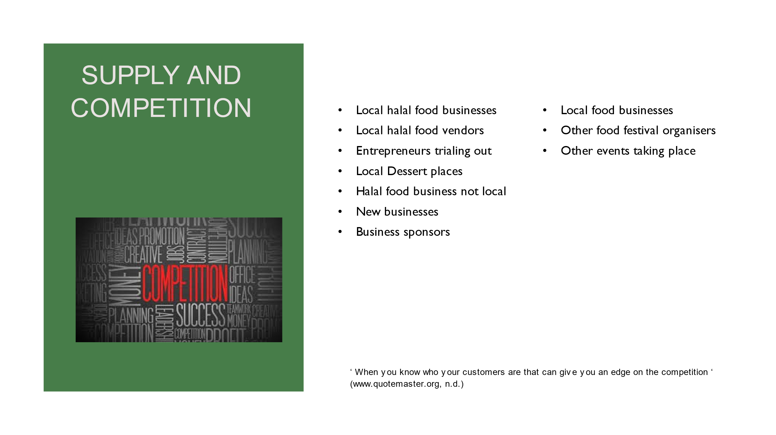
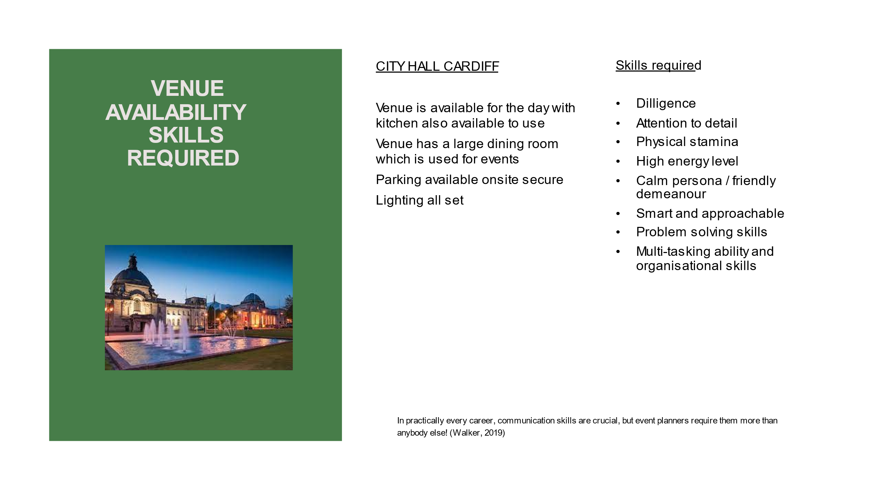
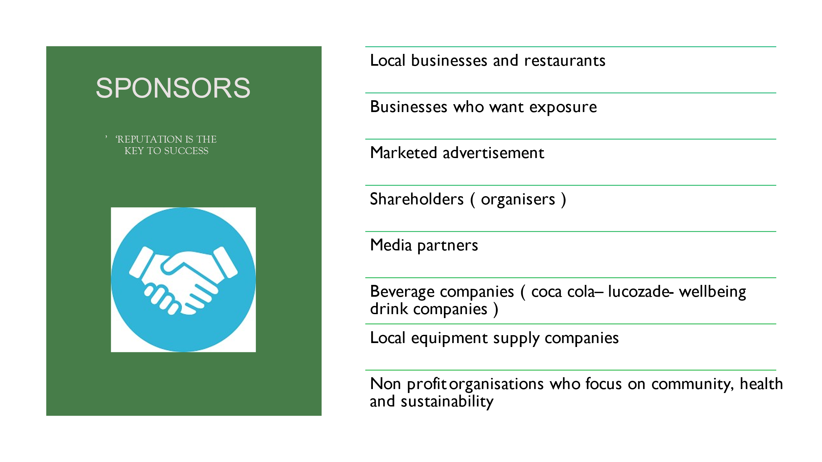
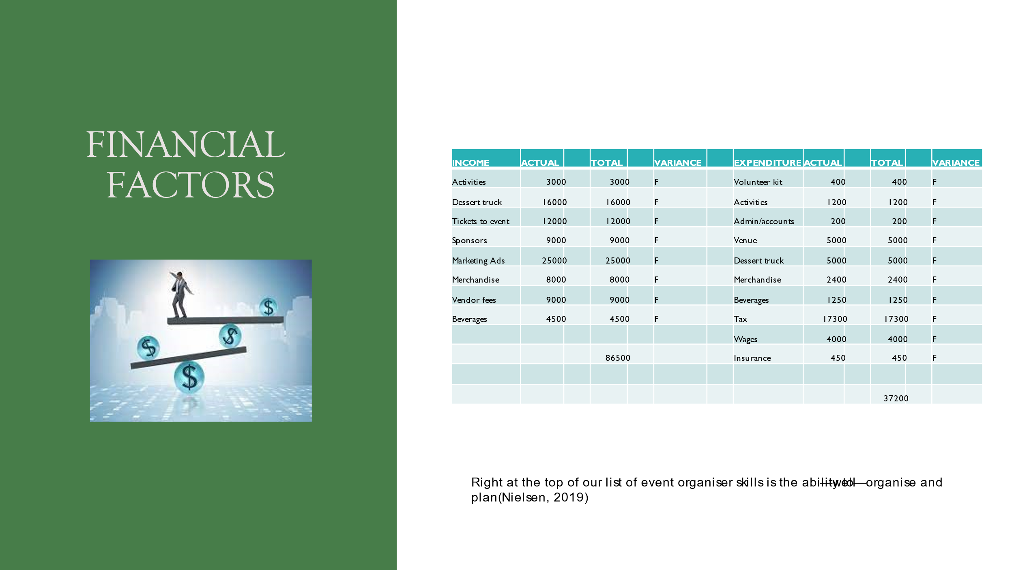
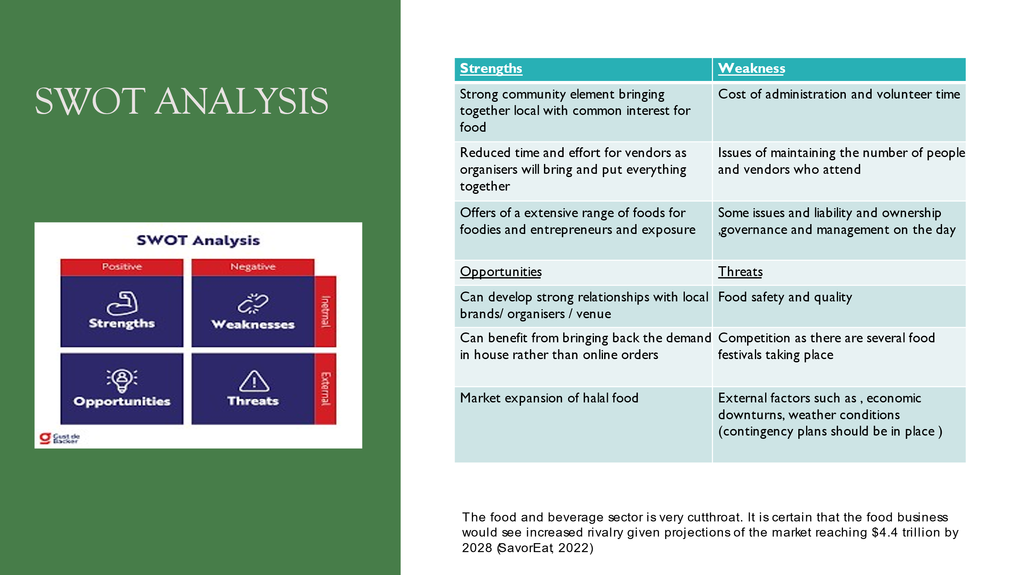
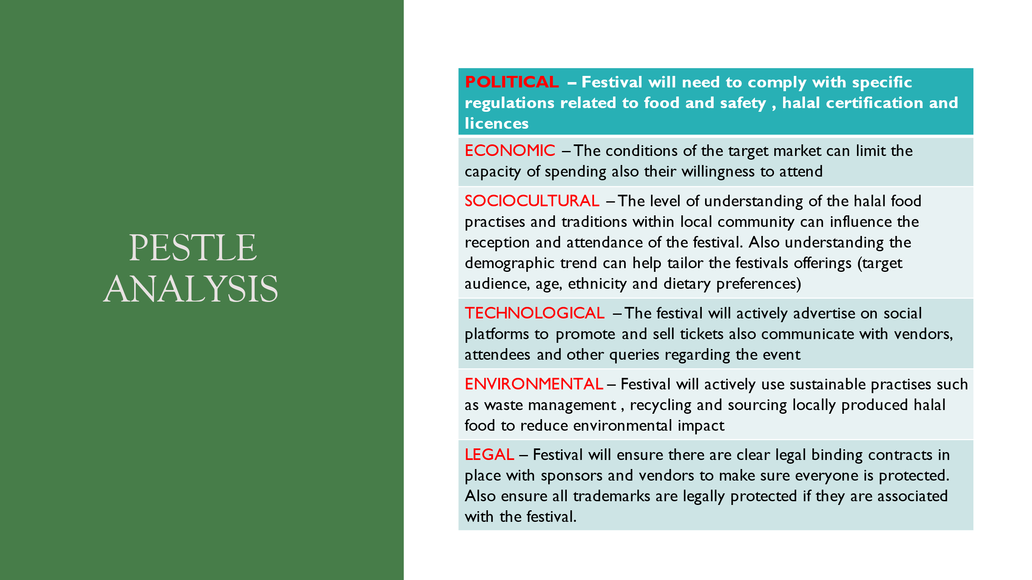
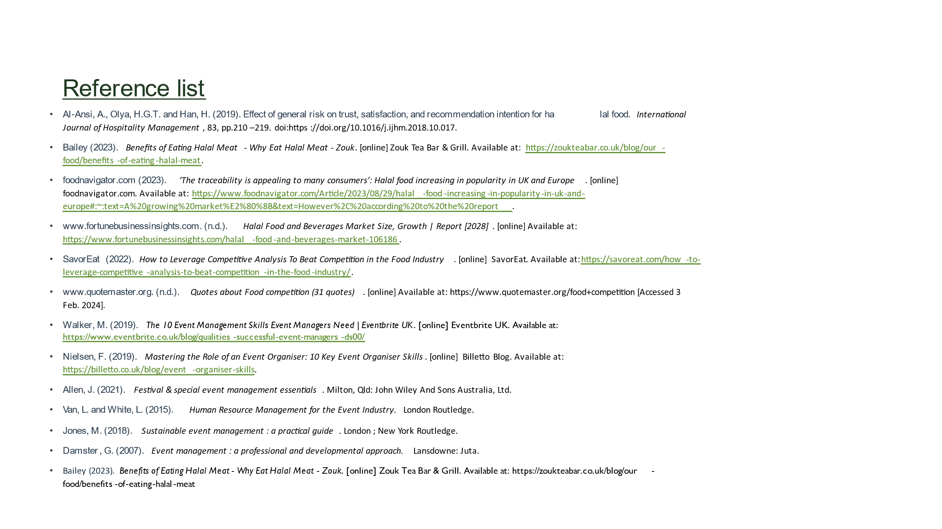

https://uowtsd-my.sharepoint.com/:v:/g/personal/2019666_student_uwtsd_ac_uk/EXq8Onr3UE5Fga_e-DbNQTIBWCl9HGgyopkMf6m5tcMJ3A?referrer=Teams.TEAMS-ELECTRON&referrerScenario=MeetingChicletGetLink.view.view

Reference list
Al-Ansi, A., Olya, H.G.T. and Han, H. (2019). Effect of general risk on trust, satisfaction, and recommendation intention for halal food. International Journal of Hospitality Management, 83, pp.210–219. doi:https://doi.org/10.1016/j.ijhm.2018.10.017.
Bailey (2023). Benefits of Eating Halal Meat - Why Eat Halal Meat - Zouk. [online] Zouk Tea Bar & Grill. Available at: https://zoukteabar.co.uk/blog/our-food/benefits-of-eating-halal-meat.
foodnavigator.com (2023). ‘The traceability is appealing to many consumers’: Halal food increasing in popularity in UK and Europe. [online] foodnavigator.com. Available at: https://www.foodnavigator.com/Article/2023/08/29/halal-food-increasing-in-popularity-in-uk-and-europe#:~:text=A%20growing%20market%E2%80%8B&text=However%2C%20according%20to%20the%20report.
www.fortunebusinessinsights.com. (n.d.). Halal Food and Beverages Market Size, Growth | Report [2028]. [online] Available at: https://www.fortunebusinessinsights.com/halal-food-and-beverages-market-106186.
SavorEat (2022). How to Leverage Competitive Analysis To Beat Competition in the Food Industry. [online] SavorEat. Available at: https://savoreat.com/how-to-leverage-competitive-analysis-to-beat-competition-in-the-food-industry/.
www.quotemaster.org. (n.d.). Quotes about Food competition (31 quotes). [online] Available at: https://www.quotemaster.org/food+competition [Accessed 3 Feb. 2024].
Walker, M. (2019). The 10 Event Management Skills Event Managers Need | Eventbrite UK. [online] Eventbrite UK. Available at: https://www.eventbrite.co.uk/blog/qualities-successful-event-managers-ds00/.
Nielsen, F. (2019). Mastering the Role of an Event Organiser: 10 Key Event Organiser Skills. [online] Billetto Blog. Available at: https://billetto.co.uk/blog/event-organiser-skills.
Allen, J. (2021). Festival & special event management essentials. Milton, Qld: John Wiley And Sons Australia, Ltd.
Van, L. and White, L. (2015). Human Resource Management for the Event Industry. London Routledge.
Jones, M. (2018). Sustainable event management : a practical guide. London ; New York Routledge.
Damster, G. (2007). Event management : a professional and developmental approach. Lansdowne: Juta.
Bailey (2023). Benefits of Eating Halal Meat - Why Eat Halal Meat - Zouk. [online] Zouk Tea Bar & Grill. Available at: https://zoukteabar.co.uk/blog/our-food/benefits-of-eating-halal-meat.

