

Programme Name: Master of Business Administration
Dissertation

Module code: LCMB7035
Supervisor Name: Dr Xavier Matieni
Student Name: Mitul Bharatbhai katrodiya
ID of the Student: 2423957
Word Count: 14432
Submission Date: 3rd Feb 2025
Dissertation Title:
Impact Of Social Commerce on Genz’s Buying Behaviour Master’s Degrees by Examination and Dissertation

Master’s Degrees by Examination and Dissertation
Declaration Form.

I, [Mitul Bharatbhai katrodiya], declare that this dissertation has been composed by myself, that the work contained herein is entirely my own except where explicitly stated otherwise in the text, and that this work has not been submitted for any other degree or qualification, in whole or in part, except as specified.

Signature: ………Mitul Katrodiya………………………............................

Date: ………03/02/2026………………………............................

Acknowledgement

I am grateful to my supervisor Dr Xavier Matieni, as He have assisted me with invaluable guidance, constructive feedback and sustained support throughout the dissertation process. His knowledge and support were a significant issue in determining the direction and quality of this study. The faculty members in this case are also thankful since they gave me the learning environment and academic resources that were essential in this study.
I want to sincerely thank my family and friends who will always be my driving force, be so patient, and understanding.
Lastly, I would like to credit all authors and researchers because their academic work is the basis and development of the given study.

Abstract
Chapter one presents the research about the role of social commerce in influencing the buying behaviour of Generation Z. It presents the research background, problem statement, aims and objectives and importance, and gives a brief of the methodology that is applied to analyse the platform's unique features of social commerce. The literature review concerning social commerce and the theme of Generation Z buying behaviour, in particular, its platform-related features, influencer marketing, trust and risk perception. The review appreciates the fact that evidence is fragmented and that a platform-based approach will play an important role in explaining Gen Z buying behaviour. This study has examined the effect of social commerce on the Generation Z purchasing behaviour that encompasses platform functions, peer and influencer marketing, and the element of trust and engagement. The findings based on the analysis of the quantitative data through SPSS indicate that the correlation between the social commerce variables and the result of purchasing is strong. The results of the regression indicate that trust and engagement are the most significant predictors of purchasing behaviour, yet platform features and social influence are also related. The study unveils the significance of trust-building activities in social commerce in shaping the consumer behaviour of Gen Z. This study explores how social commerce influences the Generation Z buying behaviour in terms of platform capabilities, social persuasion, credibility, and interactivity. Based on quantitative analysis, trust and engagement were found to be the most significant predictors of purchase behaviour, whereas their platform features and peer influence had indirect impact. The findings confirm the stimulus-organism-response model and point to significant strategic and ethical concerns with doing business with Gen Z customers.
Table of Contents
Chapter 1: Introduction 11
1.1 Background of the study 11
1.2 Problem Statement 12
1.3 Aim and Objectives 13
1.4 Research Questions 13
1.5 Research Rationale 14
1.6 Research Significance 15
1.7 Overview of the Methodology 15
1.8 Structure of the Dissertation 17
Chapter 2: Literature review 19
2.1 Introduction 19
2.2 Theoretical understanding 19
2.3 Review of existing work 20
2.3.1 Social Commerce Features and Gen Z Purchasing Decisions 20
2.3.2 Platform-Specific Features: TikTok Shop and Instagram Shop 22
2.3.3 Role of Peer Recommendations, Influencers, and User-Generated Content 23
2.3.4 Social Commerce Strategies for Engaging Generation Z 24
2.3.5 Trust and Risk Perception in Social Commerce among Generation Z 26
2.4 Conceptual framework 28
2.5 Literature gap 28
2.6 Summary 29
Chapter 3: Methodology 30
3.1 Introduction 30
3.2 Research Philosophy 30
3.3 Research Approach 30
3.4 Research Design 31
3.5 Data Collection Method 32
3.6 Population and Sampling 32
3.7 Data Analysis 34
3.8 Ethical Considerations 35
3.9 Summary and Limitations of the Methodology 36
Chapter 4: Results and Interpretation 37
4.1 Introduction 37
4.2 Variable overview 37
4.3 Quantitative data analysis 37
4.4 Key Interpretation 63
4.5 Summary 64
Chapter 5: Discussion of Results 66
5.1 Introduction 66
5.2 Social Commerce Features and Gen Z Purchasing Decisions 66
5.3 Platform-Specific Elements and Their Influence on Engagement and Impulse Buying 67
5.4 Peer Recommendations, Influencers, and User-Generated Content 69
5.5 Trust and Engagement as Primary Determinants of Purchasing Behaviour 70
5.6 Strategic Implications for Businesses Targeting Generation Z 71
5.7 Synthesis and Theoretical Contributions 72
5.8 Summary 72
Chapter 6: Conclusion and Recommendations 74
6.1 Introduction 74
6.2 Summary of Key Findings 74
6.3 Linking with objectives 76
6.4 Theoretical Contributions 77
6.5 Practical Implications and Recommendations for Business Practice 78
6.6 Limitations of the Research 79
6.7 Future work 80
References 81
Appendices 88
Appendix 1: Survey questions 88

List of figures
Figure 1.1: Overview of spending on social media for Gen Z and millennials 11
Figure 1.2: Structure of the report 17
Figure 2.1: Stimulus-Organism-Response (SOR) theory 19
Figure 2.2: Key Digital Marketing Tools Shaping Purchasing Behaviour 20
Figure 2.3: Key factors influencing purchase decision 22
Figure 2.4: Social media use for online purchase 23
Figure 2.5: Social media used by GenZ 25
Figure 2.6: Determinants of trust and purchase intention in social commerce 26
Figure 2.7: Conceptual framework 27
Figure 4.1: Age Distribution 36
Figure 4.2: Gender Distribution of Respondents 36
Figure 4.3: Most Frequently Used Social Commerce Platforms 37
Figure 4.4: Influence of Live Shopping Features on Purchase Interest 38
Figure 4.5: Impact of In-App Shopping Features on Purchase Convenience 39
Figure 4.6: Influence of Platform Algorithms on Purchase Decisions 40
Figure 4.7: Impact of Peer Recommendations on Purchase Likelihood 41
Figure 4.8: Influence of Influencer Endorsements on Consumer Confidence 42
Figure 4.9: Influence of User-Generated Content on Buying Decisions 43
Figure 4.10: Trust in Products Sold Through Social Commerce Platforms 44
Figure 4.11: Comfort with Direct Payments on Social Media Platforms 45
Figure 4.12: Effect of Interactive Features on Consumer Engagement 46
Figure 4.13: Impulse Purchasing Behaviour on Social Commerce Platforms 47
Figure 4.14: Influence of Social Commerce on Overspending Behaviour 48
Figure 4.15: Future Purchase Intention on Social Media Platforms 49
Figure 4.16: Descriptive statistics 50
Figure 4.17: Association Between Live Shopping Features and Future Purchase Intention 51
Figure 4.18: Relationship Between Platform Algorithms and Impulse Buying Behaviour 52
Figure 4.19: Association Between Influencer Endorsements and Trust in Social Commerce Products 53
Figure 4.20: Relationship Between Social Commerce Platforms and Interactive Engagement 54
Figure 4.21: Correlation analysis 55
Figure 4.22: Regression model summary 56
Figure 4.23: Regression coefficients 57
Figure 4.24: Collinearity Diagnostics of the Regression Model 58
Figure 4.25: Normal P–P Plot of Regression Standardized Residuals 59
Figure 4.26: Scatterplot of Standardized Residuals vs. Predicted Values 59

List of tables
Table 1.1: Methodology Overview 16

Chapter 1: Introduction

1.1 Background of the study
Social Commerce is a site of change in the digital retail space that combines both social interactions on social media with the feature of online shopping. As the social networking sites develop at a high rate, consumers are not restricted to other e-commerce pages but are increasingly shifting to carrying out their shopping affairs within the social networking sites. The TikTok Shop, Instagram Shops, and live shopping have transformed the experience of online shopping because users can now interact and receive personalised content in real-time and go through the process of shopping easily (Azhar et al. 2025). These mediums employ algorithms, user-created content, and Influencer Marketing to form extremely compelling and immersive shopping experiences.
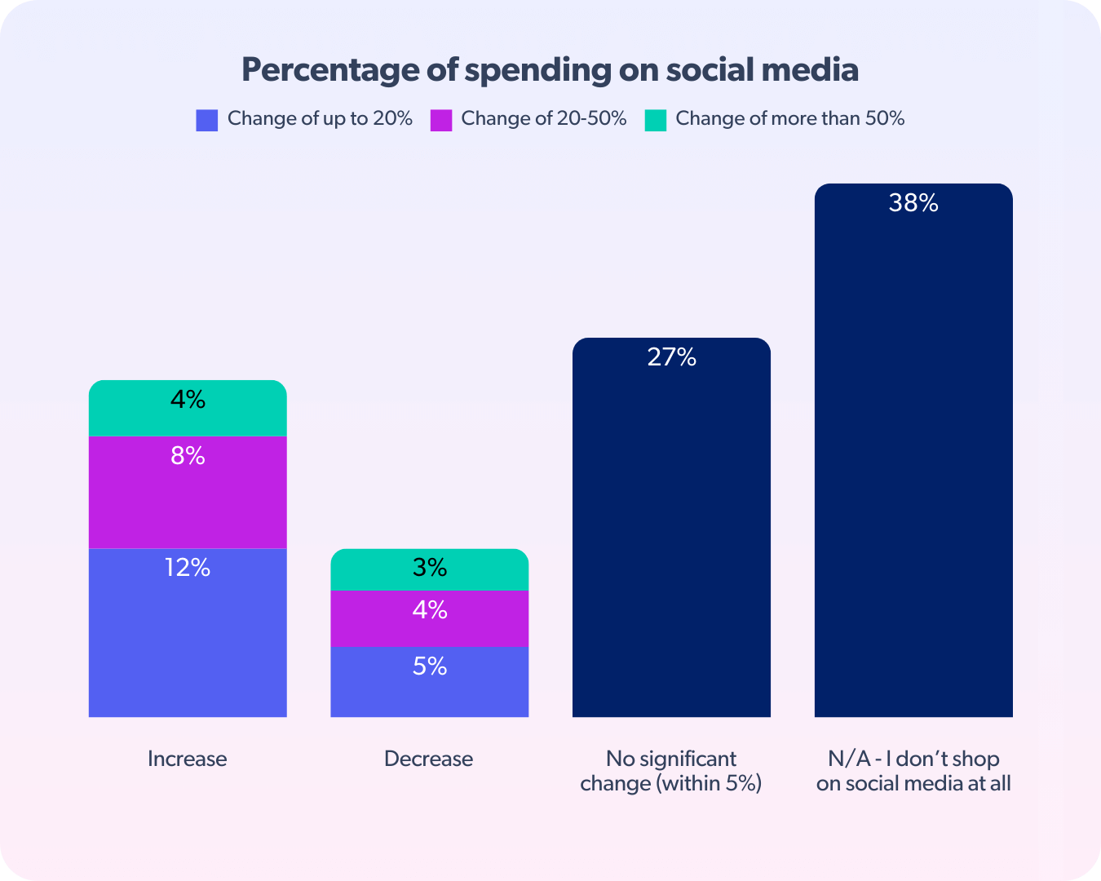

Figure 1.1: Overview of spending on social media for Gen Z and millennials
(Source: bazaarvoice.com, 2025)
Gen Z, which is generally considered to be people born during the middle of the 1990s, is a long-term consumer market that is highly interactive with social media apps. Gen Z consumers are dependent, unlike the older generations, on visual content, peer reviews, and the endorsement of influencers to make their purchasing decisions. The high level of their knowledge about technology and the tendency to use an authentic and interactive brand communication have predetermined them as one of the main target audiences to adopt a social commerce strategy (Huwaida et al. 2024). Such attributes as short-form video, live-streaming of product demonstrations, and even built-in payment systems are highly attractive to their need to be convenient and entertained.
The growing use of social buying has affected the Gen Z purchase behaviour, especially impulse buying, trust building and brand involvement greatly. Nevertheless, certain platform characteristics, including the relevance of the product discovery of TikTok based on an algorithm and the product tagging of Instagram, are not examined in scholarly literature. It is crucial that scholars and businesses treating Gen Z as a buying group find out how these factors influence their purchasing behaviour, as well as how to adjust to changing digital consumption trends to adopt a successful marketing strategy that relies on the specific platform.

1.2 Problem Statement
Although social commerce has developed so fast, with the impact becoming more pronounced on consumer buying behaviour, current studies have analysed social commerce as a broad concept and not the unique characteristics of each platform. Such platform-specific aspects as the algorithm-based product recommendation and the product tagging capabilities of Instagram Shops or the live shopping interactions have received limited academic consideration, especially concerning Generation Z users. This is one of the important areas of research that requires filling in, since Generation Z is a large and increasingly significant consumer group with very unique digital buying behaviour compared to those of the last several generations. Peer recommendations, influencer content, and interactive features of platforms have a significant impact on their purchasing choices, which is not fully covered in existing research (Hoang and Khoa, 2022). Businesses cannot design strong digital marketing strategies without a clear idea of the impacts of these platform-specific social commerce features on the trust, engagement, and purchase intentions of Gen Z. Thus, the paper aims to fill this void by exploring how social aspects of commerce can influence Gen Z purchasing behaviour.

1.3 Aim and Objectives
Aim
The main aim of the research is to evaluate how Gen Z's purchasing patterns are impacted by social commerce features on different websites, including live shopping, peer-driven recommendations, Instagram Shops, and TikTok Shops.
Objectives
- To examine the primary aspects of social commerce which influence Gen Z's purchasing decisions.
- To determine the manner in which specific platform elements promote involvement and impulse buys.
- To determine how peer recommendation and influencers contribute to developing confidence.
- To assess successful strategies that businesses have the potential that use online commerce to reach Generation Z.

1.4 Research Questions
Q1. What consequences do social commerce features impact on Gen Z's important platform purchase decisions?
Q2. Which TikTok Shop and Instagram Shop components are most important in influencing Gen Z's purchasing and engagement?
Q3. What effects do peers, influencers, and content uploaded by users have on the loyalty and spending intentions of Generation Z?
Q4. What tactics can companies use to effectively appeal to Generation Z using social media platforms?

1.5 Research Rationale
What is the issue
The main problem of the current study is the insufficient level of awareness regarding the impact on the purchasing behaviour of Generation Z of social commerce characteristics in dependence on platforms (Poh et al. 2024). Although social commerce is well accepted as significant in routes of digital marketing, available literature tends to adopt it as a generalised concept and does not explore the distinct features of platforms like TikTok Shop, Instagram Shops, and live shopping.
Why is it an issue
This is a problem since the social commerce among Generation Z consumers is not the same as it was with other generations. Algorithms, influence content, peer recommendation, and live engagement features highly influence their purchasing choices (Dilshani et al. 2022). In the absence of the analysis of these platform-specific factors, scholarly studies cannot reveal the real props of Gen Z purchase behaviour, which restricts the development of theoretical significance and applied implications.
What is the issue now
The problem is especially timely in these days of the active growth of social commerce and the increasing purchasing power of Generation Z because companies need evidence-driven knowledge to develop effective platform-driven strategies.

1.6 Research Significance
This study is notable because it has both theoretical and practical implications for social commerce and the buying behaviour of Generation Z. Academically, the research paper fills a literature gap by studying platform-specific features of social commerce instead of studying social commerce as a general concept. These features of the analysed product, including TikTok Shop algorithms, Instagram product tagging, live shopping, and peer-driven recommendation, enrich the theoretical understanding of how the functionality of digital platforms impacts trust, engagement, and purchase intentions of Gen Z consumers (Tseng et al. 2025). This platform-based but oriented method gives a better idea about contemporary consumer behaviour and will be useful in future studies about digital marketing and consumer psychology.
Practically, the conclusions of this research will be useful to businesses, marketers, and social commerce professionals who wish to understand how to effectively target Generation Z. Since Gen Z is the most digitally native and must not be overlooked as an influential consumer group over time, comprehending their tastes and decision-making mechanisms is a fundamental aspect of remaining competitive in the digital market (Leonga and Tatb, 2023). The insights provided due to this study can determine the formation of specific marketing strategies, content creation, and collaboration with influencers specific to this or that platform. Finally, this research can help companies to streamline their social business approaches to achieve better customer communication, develop trust and market to Generation Z shoppers.

1.7 Overview of the Methodology
The current study uses quantitative research methodology to understand how aspects of social commerce influence the Generation Z buying behaviour. Quantitative approach is assumed to be appropriate because it is possible to gather measurable data and define the patterns and relationships among important variables like platform features, trust, engagement and intent to purchase. This study uses an inductive method, as it allows us to make the conclusions based on the information to create a better explanation of the behavioural reaction of Gen Z towards social commerce.
Aspect | Description
Research Design | Quantitative
Approach | Inductive
Population | Gen Z (18–25 years)
Data Collection | Online survey
Sampling | Random sampling
Sample Size | ~66 respondents
Instrument | Structured questionnaire
Analysis Tool | SPSS
Techniques | Descriptive & inferential analysis

Table 1.1: Methodology Overview
(Source: Self-created)
An online structured questionnaire deliverable over social media will be used to gather primary data. The target audience is a group of Generation Z individuals whose age group is 18 to 25 years and actively uses social commerce platforms like TikTok Shop, Instagram Shops, and live shopping. The questionnaire will consist of closed-ended questions that will be measured using a Likert scale to ensure consistency and application to statistical analysis. Measurements that will be made include platform experience, influencer and peer influence, impulsive buying behaviour and trust (Goldberg and Kotze, 2022). The SPSS software will be used to analyse the data collected. The current study will involve descriptive statistics that summarise respondent characteristics, whereas inferential statistics will be used to explore the relationship between social commerce features and Gen Z purchasing behaviour using correlation and regression analysis.

1.8 Structure of the Dissertation

Figure 1.2: Structure of the report
(Source: Self-created)
- Chapter 1: Introduction
Presents the background of the research, problem statement, objectives and framework of the methods.
- Chapter 2: Literature Review
Examine literature on social commerce and Generation Z purchasing behaviour that is applicable.
- Chapter 3: Methodology
Outlines the research design, methods of data collection, sampling strategy and techniques of analysis.
- Chapter 4: Result and Interpretation
Presents the results and interpreted as per the objectives of the research.
- Chapter 5: Discussion of Result
Discusses the findings in relation to the research objectives and existing literature.
- Chapter 6: Conclusion and Recommendations
Concludes with main findings and practice, and further research recommendations.

Chapter 2: Literature review

2.1 Introduction
The chapter presents a literature review of the existing literature on the areas of social commerce and its influence on the purchasing behaviour of Generation Z. This chapter aims to create a strong theoretical and empirical language of the study based on the examination of relevant concepts, theories, and research results of the past. It covers the key social commerce features, platform details on the TikTok Shop and Instagram Shop, and the influence of peer-to-peer recommendation and influencers on their brands and the impact on Gen Z buying habits. Moreover, this chapter has mentioned the gaps in the available literature and a conceptual framework to show why this study is needed.

2.2 Theoretical understanding
Theory is important to explain the impact of social business on the Generation Z purchasing behaviour. Two theories are particularly applicable to this study: the Stimulus-Organism-Response (SOR) theory and the Flow Theory. The SOR theory is practical to explain consumer behaviour since it assumes that external elements (such as platform functionality, content posted by influencers, and interaction with peers) impact internal cognitions (trust, enjoyment, and engagement), which, in turn, lead to behavioural consequences (including purchase intention and impulse buying). The theory has most often been applied in digital and social commerce research as it represents the interpersonal and sensory nature of online shopping environments.
On the other hand, Flow Theory is about how a consumer finds themself thoroughly preoccupied and delighted and taking pleasure in the communication with digital platforms. Potential in-store features, such as live shopping or short-form videos, when using personalised recommendations, can create the same effect, encouraging existing and buying impulse continuation. Although the Flow Theory helps explain hedonic motivation, it holds an unimportant role in the context of the process of social influence and trust-building that prevail among Gen Z purchasing behaviour.
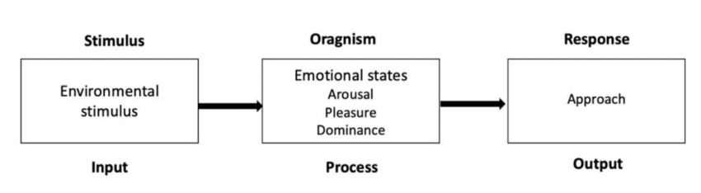

Figure 2.1: Stimulus-Organism-Response (SOR) theory
(Source: Wang, 2023)
Among them, the SOR theory is selected as the most appropriate theoretical foundation of the current study. This is because social trading apps like TikTok Shop and Instagram Shop are also deceptive, such that their tech features, socialization, and power of influencers act as message sources to change the thought and emotional process of Gen Z. These reactions, in their turn, influence the purchasing choices, loyalty intentions and expenditure intentions. Therefore, the SOR framework is an elastic, broad-headed prism for examining platform peculiarities of social commerce and its impact on Generation Z purchase behaviour.

2.3 Review of existing work

2.3.1 Social Commerce Features and Gen Z Purchasing Decisions
Based on the latest empirical studies, social commerce attributes are most of all attractive to the decision-making process of Generation Z because its members are highly engaged with the interactive and social-intensive online environment. An interactive study of the survey data relating to more than 300 Gen Z users conducted by Tseng et al. (2025) found that the social commerce-based information sharing activities positively influenced the social support and online trust, and the two variables explained a significant portion of purchase motivation. Specifically, the purchase intention was significantly (β> 0.40) affected by online trust, and perceived privacy risk showed a negative effect on the purchasing decisions. The study is methodologically sound, but it considers the generalised platform perspective and does not distinguish between platform-specific differences in features between platforms, such as TikTok shop or Instagram shops. Huwaida et al. (2024) discovered in their study of 204 GenZ Indonesian consumers who were consumers of SEM that information quality, subjective norms and hedonic expectations positively and significantly influenced the purchase intention. Interestingly, subjective norms also had some of the highest effects, a fact that explains why peer influence is relevant in social business.
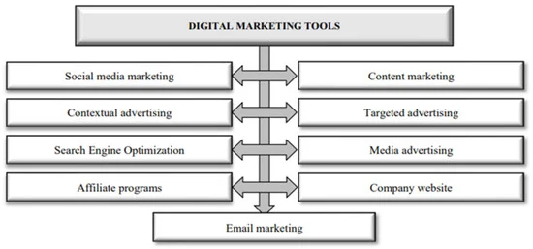

Figure 2.2: Key Digital Marketing Tools Shaping Purchasing Behaviour
(Source: Rosnerova et al. 2025)
However, the study is limited in use and practical senses due to local focus and the introduction of behavioural intention in contrast to actual purchasing behaviour. Ngo et. al. (2024) report more specific details regarding the feature-driven behaviour as they surveyed 438 Vietnamese users of the Shopee video platform in the Gen Z generation. According to their findings, visual stimuli and social influence established a significant effect of arousing emotional stimulation, which mediated the impulse buying behaviour and urgency cue. Despite the establishment of arousal and pleasure as the given psychological driving force, the paper is too focused and does not even listen to the long-term effects, such as trust and loyalty. Similarly, Andika et al. (2025) basing on the answers they received based on the feedback of 263 GenZ subjects, could make known the fact that when the presenter of the live stream was present, perceived usefulness and positive emotions of the subject matter rose and, therefore, fostered intentions to engage in impulse purchases.

2.3.2 Platform-Specific Features: TikTok Shop and Instagram Shop
The recent literature highlighted that TikTok Shop and Instagram Shop, peculiar to the platforms and combining technological abilities with social and emotional value, are critical contributors to the buying behaviour of Generation Z. Putri et al. (2024) provide one of the most detailed analyses of TikTok Shop, relying on 717 responses to the survey and 30 interviews. Their findings reveal that mental and emotional trust is determined to positively affect purchase intention immensely, but privacy concerns are identified to negatively affect buying behaviour. This study is planned in a mixed-method and trust-transfer perspective and can be regarded as one of its key advantages. Considering Instagram as a point of focus, Moghddam et al. (2024) assess how the integration of the so-called Shop buttons and perfect navigation enhances impulse buy through consumer motivation and brand awareness. Using a two-study mixed method, the authors prove that the desire to purchase is enhanced significantly by entertainment, convenient channels, and escapism in the United States.
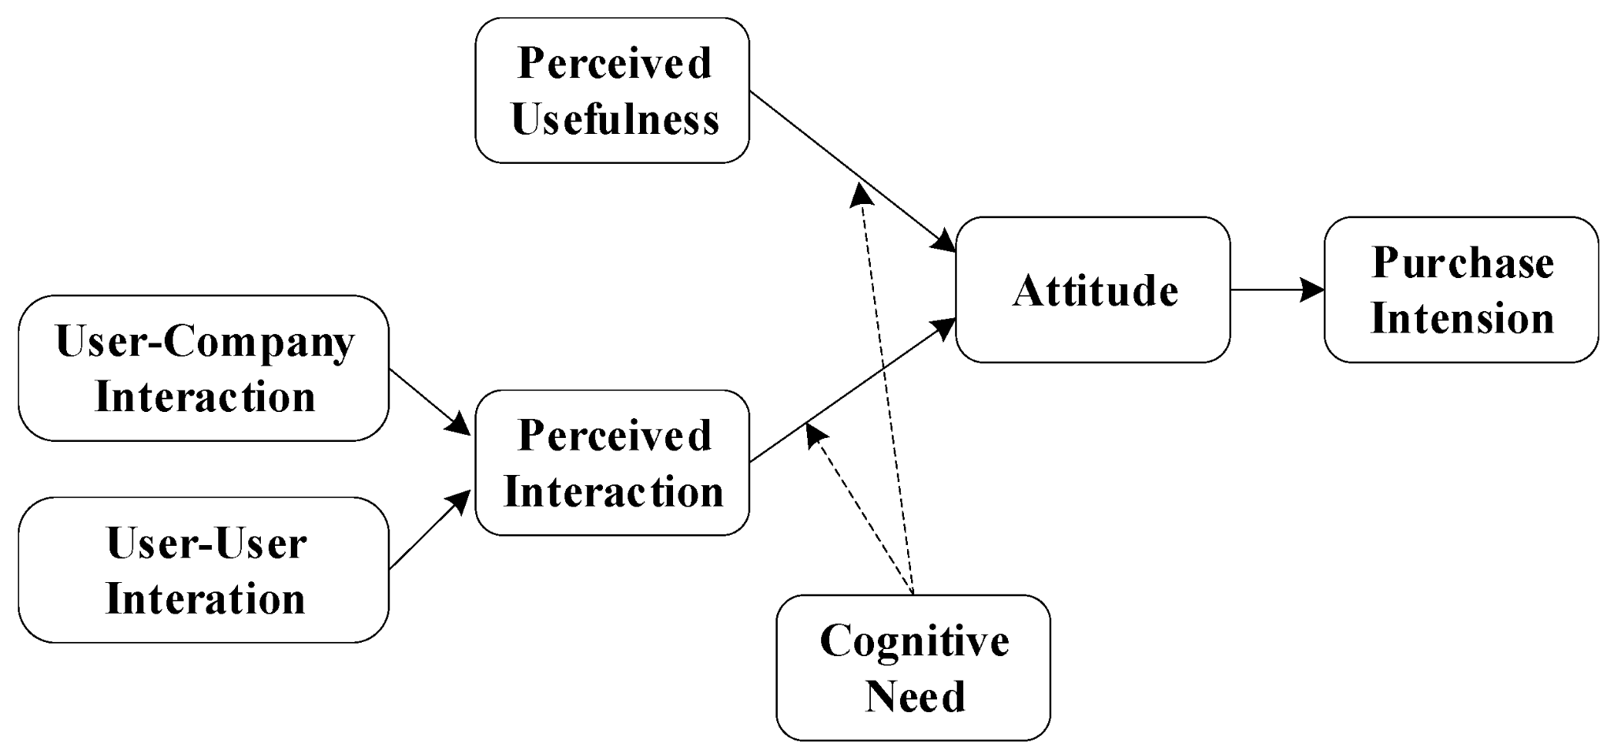

Figure 2.3: Key factors influencing purchase decision
(Source: Zhao and Zhu, 2023)
This study includes powerful theoretical explanations, but it pays more attention to the factor of psychological motivation than to the technological design aspects, which limits its ability to organize the development of the structural explanation of how specific Instagram commerce features precondition the acquisition behaviour. The perspective put forward by Broeder and Schouten (2022) is far more feature-centric because it examines product tagging on Instagram. The conclusion of their experimental studies on 225 individuals in two cultures is that the product tags can cause a significant feeling of trust and desire to buy the product. The research helps to demonstrate the way persuasive images and text may be applied to in-app shopping. However, it excessively focuses on female buyers and fails to offer dynamic shopping experiences, such as reels and live shopping, that are crucial to Gen Z. Ab Aziz and Poureisa (2025) offer the results of the 393 Instagram users who stored the information proving that the sociability, enjoyment, functionality, and task technology give a tremendous contribution to trust and purchase intention. In spite of the fact that this research offers a synthesis of theoretical methods, such a study is cross-sectional and therefore causation cannot be determined.

2.3.3 Role of Peer Recommendations, Influencers, and User-Generated Content
The literature agrees that peer recommendation, influencers, and user-generated content (UGC) are highly essential in shaping the online purchasing behaviour of Generation Z because they have the potential to impact trust, perception of the brand, and feelings. Leveraging the SOR model, Le and Ngoc (2024) provide the findings of a sample of 280 GenZ customers in Vietnam, according to which the consumption-related peer communication in social media produces a direct and indirect positive influence on the intention to make an online purchase. They discover that this relationship is mediated by the perceived brand quality and brand preference in a preceding manner, with subjective norms adding to the outcome. Even though there is a strong application of theory and methodology in this paper, the focus on peer communication is also lacking since it fails to cover the new concept of influencer-enhanced and algorithm-promoted content that is common on websites such as TikTok and Instagram. Tauseef et al. (2025) write about impulse buying and discuss it in the framework of social commerce with 150 Pakistani participants, and they give other ways where entertainment, brand intimacy, and escapism stimulate impulse buying. The study observes the importance of consumer-brand recognition in transforming social relationships into purchasing desires. However, its reliance on quite a small sample and the inability to provide the distinction between peer-created and influencer-created content limit its explanatory potential when it comes to global platforms controlled by Gen Z.
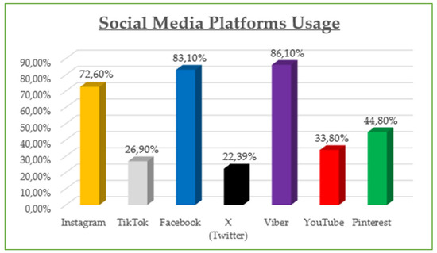

Figure 2.4: Social media use for online purchase
(Source: Migkos et al. 2025)
Guerra-Tamez et al. (2024) also discuss how technology-assisted UGC can be used and present the statistics of 224 Gen Z consumers to identify the effectiveness of the AI-modified content in building brand trust and making purchases. Their findings indicate that AI accuracy and flow experience constitute an imperative enhancement of confidence among the users that then translates to an urge to buy. Although the study adds to the existing knowledge of AI-mediated UGC, it reduces the social credibility aspect of social commerce that underpins social commerce. Along with these perceptions, Singh (2024) complements the Technology Acceptance Model with survey data of Gen Z consumers in India and demonstrates that the variables of trust, perceived risk, and perceived ease of use contribute significantly to the online purchase intentions. However, the research does not directly examine the social influence but rather examines it implicitly, limiting its use in the area of social commerce.

2.3.4 Social Commerce Strategies for Engaging Generation Z
In the recent literature, the interaction of GenZ should be based on the synthesis of the social commerce interaction, the construction of trust, as well as the content that is socially embedded. The findings of a research study carried out by Vuong et al. (2025) on 380 GenZ consumers in Vietnam indicate a huge volume of empirical data on influencer-led Livestream methods of TikTok that offer high customer loyalty in accordance with social relatedness and consumer satisfaction. According to the SOR framework, interactivity, visualisation and trust were the stimuli identified in the paper to cause emotional and relationship responses. Though the research offers valuable information that is platform-sensitive, its TikTok and specific cultural dependence lower the externalisability of the strategic implications. Moving beyond livestreaming, Deepika and Massand (2025) study 310 Gen Z participants and identify the social media marketing activities (SMMA) among the key aspects of engagement. Based on their findings, the three variables that are important in determining purchase intention are customisation, interaction, and targeted advertisements compared to electronic word-of-mouth. The study has provided a validated measurement scale of Gen Z, but the study operates temporarily, and the properties of social commerce are not considered without considering the real-time or community-based interaction processes that are gaining swiftness on applications like TikTok and Instagram.
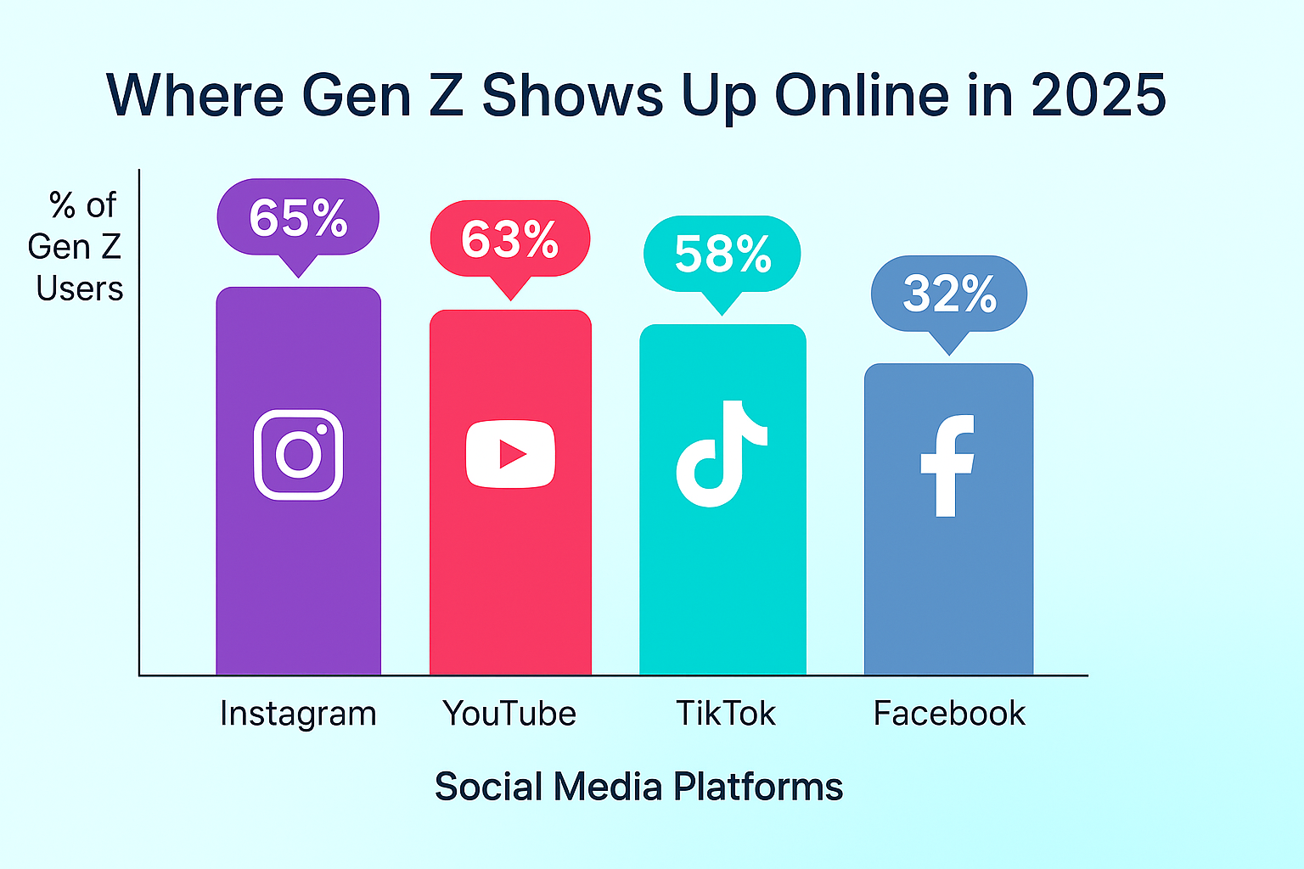

Figure 2.5: Social media used by GenZ
(Source: vivaldigroup.com, 2025)
In a broader theoretical perspective, Khoa (2025) integrates technology acceptance, trust signalling, and social contagion to determine the repurchase intention of the study sample (542 GenZ consumers). According to the research, functional performance, as a predictor of trust-forming signals such as lenient return policy and social validation mechanisms such as fear of missing out, acting together, induces sustained engagement. Though this integrative approach adds to the theoretical facts, it is focused primarily on the re-buy intention, yet it lacks deeper research on the initial involvement work, and the attraction in the earlier stage of consumer is still poorly studied. Additional business-specific concepts of Becdach et al. (2022) confirm the importance of a seamless purchase and creator rapport, and community communication in social commerce. However, these are non-empirical and lack the methodological transparency of these reports.

2.3.5 Trust and Risk Perception in Social Commerce among Generation Z
The trusted information and the perceived threat are always highlighted as the determining elements in Generation Z in terms of social trading portals. Utilizing 400 Gen Z consumers in Indonesia and PLS-SEM, Tjahjana et al. (2024) suggest that both security and privacy make a strong and statistically significant contribution to trust of the e-commerce environment. The study justifies this conclusion by the information that GenZ buyers are highly sensitive to transaction safety and data protection. Tseng et al. (2025) have applied social commerce theory to Generation Z by researching into the dual-wearing of trust and privacy risk empirically. Through PLS-SEM and CB-SEM, the authors prove that the information sharing activities have positive impacts on the social support and trust, and that the perceived privacy risk negatively impacts the purchasing decisions. Although the study makes great contributions to the theoretical and methodological sections, it also views social commerce platforms as not presenting sufficient information about platform-specific trust designs, such as live shopping or algorithmic recommendations.
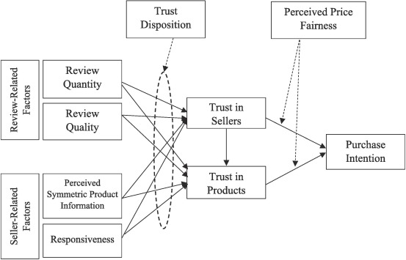

Figure 2.6: Determinants of trust and purchase intention in social commerce
(Source: Senali et al. 2024)
According to Ngah et al. (2021), the perceived risk and trust among Gen Z are subtly associated. The combination of the theoretical framework explains that the perceived risk does not inevitably reduce the perceived usefulness or ease of use but positively affects the trust, which is why GenZ may adopt risk awareness as informed decision-making. However, the study was conducted before the rapid development of the social commerce features and, therefore, is not representative of current threat concerns in the privacy of the information and referent power. To these findings, Lazacroiu et al. (2020) also stress that the relationship between perceived risk and intention to purchase does exist in the context of social commerce online trust. The study is underpinned, not Gen Z, and does not include the higher expectations of transparency and authenticity of digital natives.

2.4 Conceptual framework
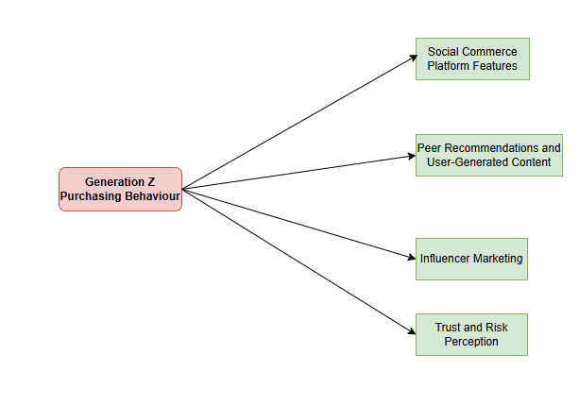

Figure 2.7: Conceptual framework
(Source: Self-created)

2.5 Literature gap
Even though extant literature has expanded on social commerce and Generation Z, the literature has several gaps, which are critical. Existing literature largely describes social commerce as a broad idea, typically devoted to a single particular part of trust, influencer marketing or impulse purchase, rather than offering a complete overview of different platform functions. Moreover, the bulk of the empirical results is contextual, focusing on country or platform-specific issues, and it is hard to generalize findings to other social commerce environments. Even though trust and perceived risk are widely studied, their interactive role with peer recommendations, characteristics of influencers' content and technological platforms has not been sufficiently explored within the same context of research. Furthermore, a little attention was paid to the TikTok Shop and Instagram Shop comparison, even though they are gaining more and more popularity among GenZ. Therefore, a platform-comparative research must be undertaken in a wholesome way in order to address these issues.

2.6 Summary
The chapter examined the literature on the subject of social commerce and Generation Z purchasing behaviour within the characteristics of the platform, peer recommendation, influencer marketing and the trust and risk perception. Gen Z purchases according to interactive technologies, social influence, and the trust-building mechanism to a great extent, as it is mentioned in the review. The study also discovered that the TikTok Shop and Instagram Shop exploit various attributes that facilitate interactions. However, this cumulative study that has been conducted by past researchers is fragmented and has a habit of researching a single aspect in isolated and limited environments. These gaps that require a concerted, platform-specific investigation to understand the synergistic impact of the properties of social commerce to guide the behaviour of the Generation Z in buying goods in a more effective manner.

Chapter 3: Methodology

3.1 Introduction
The chapter provides a detailed description of the research method used to examine the nature of social commerce aspects on Generation Z purchasing behaviour. The research design is created to support the research aim and objectives, which were set in Chapter 1, guaranteeing that the research results provide reliable and valid evidence that serves as an addition to the current body of knowledge. The chapter outlines the research philosophy, research approach, research design, data collection method, sampling strategy, data analysis techniques and ethical issues that support the study. Through a logical and strict methodology framework, the study aims at coming up with primary data collection using the survey for the analysis purpose.

3.2 Research Philosophy
The philosophical premise of the present research lies in the area of positivism that is associated with the use of scientific methods to social phenomena and the production of objective and measurable knowledge. Positivism is specifically suitable in the given research because it will allow studying the relationships between the features of social commerce and the purchasing behaviour of the Generation Z by the system of quantifiable data and the application of statistical analysis (Azhar et al., 2025). This philosophical position coincides with the quantitative aspect of the study and the aim to reveal the patterns, correlations, and causation between the essential variables, the features of the platform, the trust, the involvement, and the intention to purchase. The positivist approach makes sure that the study results are based on facts and not interpretation, which increases the validity of the results and their generalisability. Moreover, this philosophy advocates utilisation of structured data collection tools as well as application of standardised analytical protocols, which is crucial in preserving methodological rigour and replicating the study in other settings.

3.3 Research Approach
This paper will employ a quantitative explanatory research to investigate how social commerce characteristics can affect the purchasing behaviour of the Generation Z. The method is informed with the positivist assumptions, according to which the consumer behaviour is studied by objective measurement and statistical analysis of the data that may be observed. A quantitative method is especially suitable in this study because it allows the detection of patterns, ties as well as foretelling impacts involving social commerce platform features, social influence, trust, engagement, and purchasing conduct. Despite the fact that the study is grounded on the Stimulus–Organism–Response (SOR) framework, it is not aimed at experimenting strict hypotheses. Rather, the study adheres to an inductive analytical reasoning in a quantitative design, where patterns occurring in the data based on empirical evidence will be used to make larger inferences. This method can also be used in an exploratory study of the dynamic digital environment, including social commerce, where the behaviour of consumers and the features of platforms are constantly shifting (Huwaida et al., 2024). The inductive mode of analysis is flexible in determining the influences of platform-specific characteristics, including live shopping, algorithm-driven suggestion and in-app purchasing, on internal psychological conditions, such as trust and engagement that, in turn, affect purchasing behaviour. The analysis of the responses received with the help of the Generation Z users allows the study to find out recurring patterns in behaviours but does not attempt to impose some assumptions that are already formed in advance on the data. Such a method of research is effective especially with social commerce because the consumers of Generation Z possess dynamic and rapidly changing digital consumption patterns. The following combination of both the quantitative explanatory design and the inductive analytical reasoning makes sure that the findings are data-based, contextually-grounded and they will be able to add something new to the current literature on social commerce and the concept of consumer behaviour.

3.4 Research Design
A research design that has been chosen as the main methodological strategy in this study is quantitative. According to the quantitative research, its focus on the numerical information, statistical processing, and objective measurement of variables predetermines the superiority of this investigation in studying the correlation between social commerce characteristics and Generation Z purchase behaviour (Whitwam, 2025). The design also allows the researcher to gather standardised data from a sufficiently large sample of the respondents, thus raising the statistical power of the analysis and the possibility of generalising the findings to the situation of the immediate study. The quantitative methodology also helps to test certain hypotheses made based on the research objectives and offers a systematic structure to make comparisons of the effect of various social commerce characteristics across the platforms that include TikTok Shop and Instagram Shop. Furthermore, the quantitative research method is more structured, which guarantees the consistency of data gathering and lowers the possibility of the researcher's bias, enhancing the validity of the study results in general.

3.5 Data Collection Method
The use of primary quantitative method helped to gather the data needed in this study in the form of online structured questionnaire. This kind of approach is suitable when dealing with the consumer behaviour in question as it offers the chance of gathering measurable and standardized information and statistically examining the connections between variables. Darajat and Pribadi (2025) refer to a study claiming that surveys are productive to gather behavioural patterns and attitudes information during online data collection in online digital space, particularly, among the population groups that are active in technology usage. The survey was distributed via social media and to focus on the generation Z individuals aged between 18-25 years, and are heavy users of the social commerce sites featured such as the Tik Tok Shop, Instagram Shops and live shopping functionalities. The survey questions were in a closed-ended Likert scale, which determined consistency and reliability in the returns. The key variables measured include the platforms, influence, peer influence, influence, trust, engagement and influence behaviour and purchase behaviour. This type of strategy made it possible to gather data efficiently based on a reduced time frame and limited costs and geographical boundaries. Furthermore, the online structured format enhanced the accuracy and comparability of responses, implying that it is ideal in the case of quantitative research of the consumer behaviour related to the social commerce settings.

3.6 Population and Sampling
This research paper targets the Generation Z consumers, who are typically described as people born between the mid-1990s and early 2010s. In particular, the target audience is represented by the group of people aged between 18 and 25 years whose usefulness with social shopping platforms includes Tik Tok Shop as well as Instagram Shops, and live retail experiences. This group of the population is especially topical since it demonstrates high rates of digital skills, social media utilization, and incorporates new technology-oriented methods of shopping (Marsasi et al., 2024). Growing up in the environment where living digital enables and social networking is everywhere, Generation Z consumers also have different purchasing behaviour patterns with such characteristics as interactivity, social influence, and technology-mediated purchase decisions (Tseng et al., 2025). Consequently, this generation of the population should be the subject of specific scholarly studies in the framework of social trade. The present research utilizes non-probability voluntary response sampling method, which was aided by online delivery of a structured questionnaire due to the usage of the social media sites that were widely popular among Generation Z. The inclusion criteria was limited to one that presupposed that the respondents reached the age of 18 and had experience in using social commerce features. The chosen sampling method was because of the feasibility in the form of time constraint and accessibility to the target population. Although such an approach cannot be fully randomised, it is regarded as suitable in terms of exploratory quantitative studies that are related to digitally active communities in which it is challenging to apply more conventional probability sampling techniques. There were 66 valid responses that were obtained and analyzed. The sample size is quite modest, but it is still adequate in relation to performing the exploratory statistical analyses, such as descriptive statistics, correlation, and regression analysis via SPSS. In earlier social commerce literature that focus on studying the behaviour of the Generation Z, similar sample size has been used especially in situations when the research objective is to determine behavioural patterns but not to attain complete statistical generalisability. However, since such is a limited sample, the results should be interpreted with a great deal of caution as they only represent a hint of the overall population of Generation Z. The sample contained respondents having different usage rates in various social commerce platforms and this increases the variability of responses and internal consistency of findings. Nevertheless, there are weaknesses associated with self-selection bias and weaknesses in the generalisability. In spite of these limitations, the selected sampling approach suits the purposes of the research as it gives the valuable and useful information about the purchasing behaviour of Generation Z, in social commerce conditions. The results therefore provide meaningful exploratory information to the existing body of research on digital consumer behaviour besides pointing out prospects of future research using bigger and more representative samples.

3.7 Data Analysis
In analyzing the researches, statistical software called the Statistical Package of the Social Sciences (SPSS) was used to provide systematic, accurate, and repeatable quantitative analysis of the gathered data using the structured online questionnaire. The SPSS allowed managing the data rather effectively and provided the possibility of conducting a solid statistical analysis to minimize the likelihood of analytical inconsistencies and improve the trustworthiness of the results. The quantitative data analysis method was believed to be adequate because the research was supposed to determine patterns, relationships, and predictive impacts of the main variables in the context of social commerce and Generation Z purchasing behaviour (Poh et al., 2024). The process of analyzing took a clear and systematic procedure in accordance with the objectives of the research. First, the descriptive statistical analysis was conducted to describe the demographics of the respondents and the overall response trends. Categorical variables were described by frequencies and percentages whereas means and standard deviations were computed in relation to Likert-scale items assessing the features of social commerce platforms, peer and influencers impact, trust, engagement, and the purchase behaviour. The stage offered a general idea of distributions of data, central tendencies and variability and therefore has given a background information of what respondents feel and the general behavioural tendencies. To provide the quality of the measurement, internal consistency reliability of multi-items constructs was also measured by the Cronbach alpha and the results displayed all the constructs being within the accepted level of 0.70, which denoted satisfactory level of reliability. The previously validated scales in literature on social commerce and consumer behaviour were also used as measurement items which confirm the content validity. The construct validity was also enhanced by statistically significant and theoretically relevant correlation between variables. After descriptive analysis, there was use of inferential statistical methods to test the relationships between the independent and dependent variables. The strength of the associations between the social commerce characteristics, peer influence and influencer influence, trust and engagement, and the purchasing behaviour of Generation Z were identified with Pearson correlation analysis (Hong et al., 2025). This analysis aided in determining the considerable links and it was used in predictive modelling later. In order to determine the relativity of the effects of the independent variables on the purchasing behaviour, multiple regression analysis was performed. This method was applied to estimate the distinct contribution of all the predictors other variables in the model were controlled. Multicollinearity was measured using diagnostic tests, such as variance inflation factor (VIF) and tolerance values. Besides, residual plots and normal probability plots were used to assess the normality, linearity, and homoscedasticity, which indicated that the regression model was appropriate. In general, the chosen data analysis techniques are suitable in exploratory quantitative research and offer valid and evidence-based information regarding the role of social commerce on Generation Z purchasing behaviour. The interpretation of findings is done with a lot of caution though given the sample size and research design.

3.8 Ethical Considerations
This study completely relies on the primary data and due to this reason proper consent has been taken from the participants before the data collection. The study follows some of the core concepts of research ethics such as integrity, transparency as well and respect for intellectual property. The primary sources have been appropriately accepted and referred to in terms of the academic conventions so that the actual researchers should be credited with the contextual factors (Theocharis, 2025). The study is objective in reporting and interpreting the research results without selective reporting such that the evidence base is misrepresented or the inferences made by the studies reviewed in the study are compromised.
Ethical implications as to the research topic itself are also considered in the study as Generation Z consumers are especially susceptible to manipulative marketing tactics or privacy invasion in the context of social commerce. The findings of the research are provided with the consideration of possible use, the significance of ethical business practices in which consumer autonomy is considered and personal information is not endangered (Auliya et al., 2025). Moreover, the research takes into consideration the lack of clarity and evidence gaps in the evidence base of the research instead of exaggerating the findings, thus preserving science and offering a truthful presentation of contemporary information on the topics of social commerce and Generation Z behaviour.

3.9 Summary and Limitations of the Methodology
The chapter has outlined the research methodology that is quantitative in nature and is expected to be used to determine the impact of social commerce on exploring the purchasing behaviour of Generation Z. The questionnaire was online through the assistance of a structured questionnaire was useful in gathering standardised and measurable primary data, which could be analysed sequentially using the descriptive and inferential statistical tools using SPSS. This will also make the results valid and stable as the important variables, namely, platform features, trust, engagement and purchasing behaviour, can be objectively measured.
Despite these strengths, it is necessary to mention several methodological limitations. The study design adopted was cross-sectional, which was unable to establish the causal connections between variables since the data were amassed at a single point in time. The fact that they were able to administer an exploratory quantitative study with the relatively small sample of approximately 66 respondents could be an insufficient amount to generalize the research findings to the entire population of Generation Z. Besides, there would be bias in self-reporting of the survey since the perception and attitude of survey participants would not necessarily translate into behaviour. This is characteristic of a quantitative study with the use of surveys, as Ridwan et al. (2025) explain and needs to be considered when interpreting results. The adopted methodology, however, provides a robust foundation for researching the social commerce behaviour of the Generation Z consumers.

Chapter 4: Results and Interpretation

4.1 Introduction
The chapter describes the findings and discussion carried out by the quantitative analysis to examine the impact of social commerce on Generation Z buying behaviour. The focus of discussion is on the most significant elements of social commerce platform functionality, peer marketing and influencer marketing, and trust and engagement. Data analysis was conducted with the assistance of SPSS based on the frequency analysis, descriptive statistics, cross-tabulations, correlation and regression analysis on the data gathered with the aid of the structured questionnaire. These analytical tools were used to address the research objectives and communicate the relationships between the independent variables and the Gen Z buying behaviour. The chapter provides empirical data that has been employed to elaborate on the effects of social commerce on the consumers of Generation Z.

4.2 Variable overview
- Dependent Variable (DV): Gen Z Purchasing Behaviour
- Independent Variable (IV1): Social Commerce Platform Features
- Independent Variable (IV2): Peer Recommendations and Influencer Marketing
- Independent Variable (IV3): Trust and Engagement in Social Commerce

4.3 Quantitative data analysis
Frequency analysis
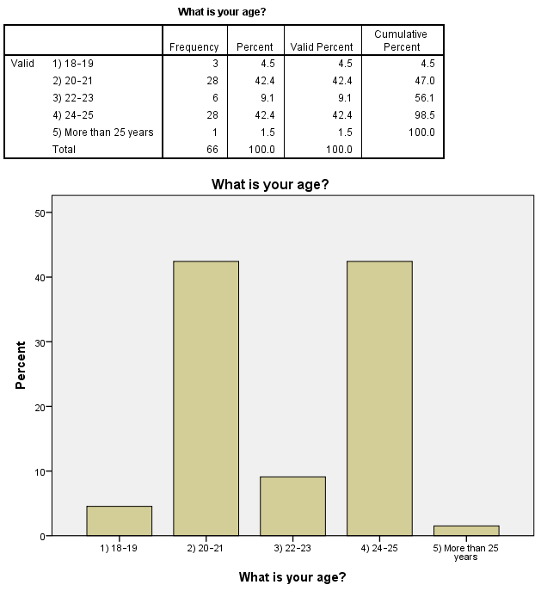

Figure 4.1: Age Distribution
(Source: SPSS)
The age range within which most of the respondents where is the 20-21 years (42.4%) and the 24-25 years (42.4%) brackets, which subject the respondents to most of the sample. It implies that the target consumers are properly represented and the results could be generalized to the knowledge of the social commerce buying behavior of target consumers.
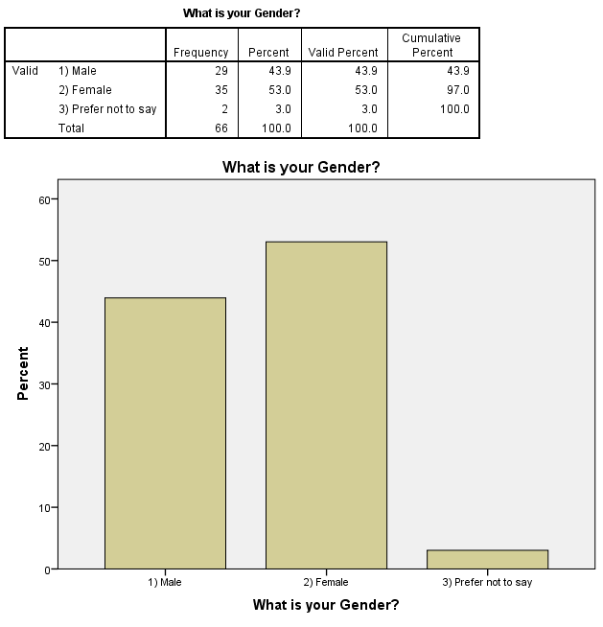

Figure 4.2: Gender Distribution of Respondents
(Source: SPSS)
Gender distribution of the respondents showed that 53.0% of the respondents were females and 43.9% of respondents were male and 3.0% chose not to state their gender. It is a comparative balance, which has contributed to the enhanced representativeness of the sample, and the analysis of Gen Z buying behavior in relation to the genders is pertinent.
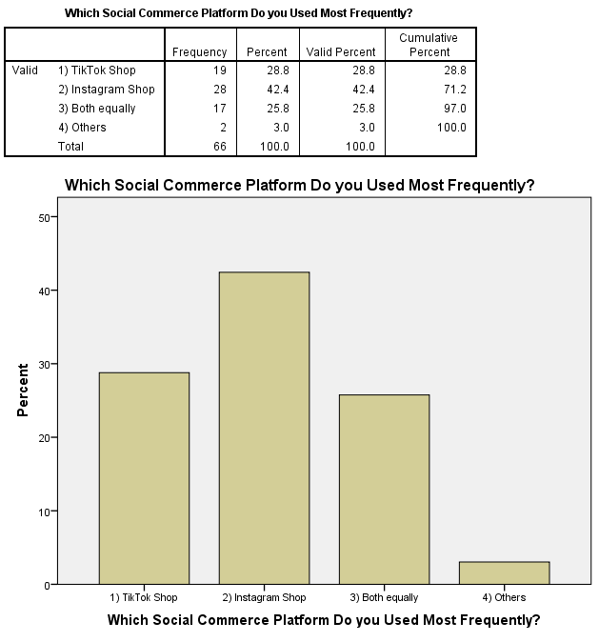

Figure 4.3: Most Frequently Used Social Commerce Platforms
(Source: SPSS)
Instagram Shop is the most popular according to the respondents (42.4%), then Tik Tok Shop (28.8%), and 25.8% of the respondents use both equally. It means that Gen Z clients are online shoppers on various social commerce sites, which presupposes that the priority should be given to cross-platform promotion.
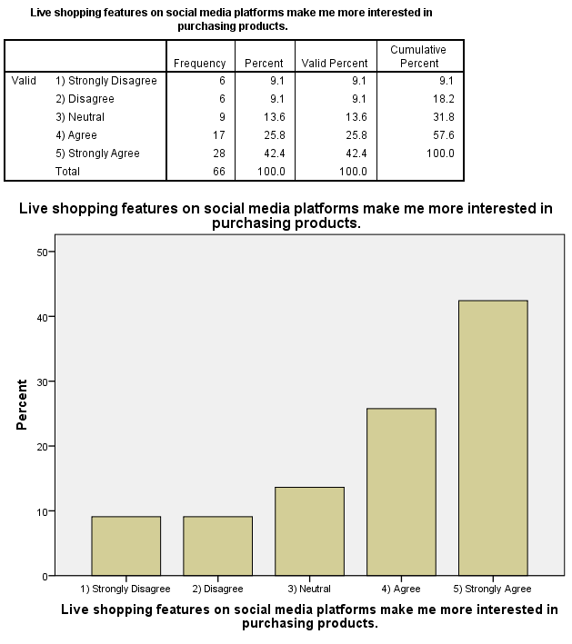

Figure 4.4: Influence of Live Shopping Features on Purchase Interest
(Source: SPSS)
According to the findings, most of the respondents (25.8%) are able to say that they are likely to say that they agree and a high number of them (42.4%) are likely to say that they strongly agree that live shopping features make them more interested in purchasing products. It also means that the interactive and real-time shopping experiences are very effective in reaching Gen Z consumers and fulfilling their desire to shop through social media.
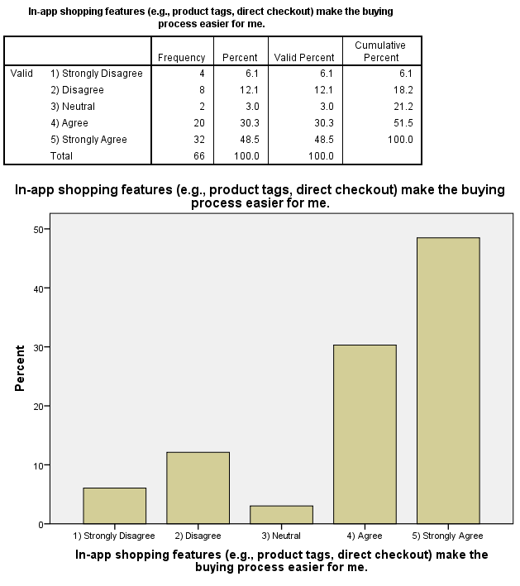

Figure 4.5: Impact of In-App Shopping Features on Purchase Convenience
(Source: SPSS)
The outcomes demonstrate that quite significant percentage of the participants agree (30.3%) and highly agree (48.5%) that in-app shopping functionality enables easier process of purchase. It means that the seamless solutions (product tags, direct checkout) are one of the factors that will allow people to feel more comfortable and willing to shop, and Gen Z will be ready to utilize social commerce platforms.
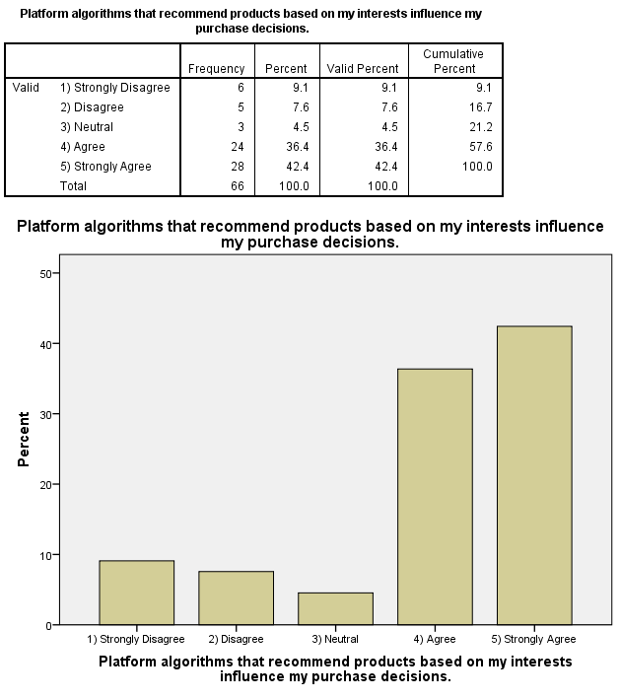

Figure 4.6: Influence of Platform Algorithms on Purchase Decisions
(Source: SPSS)
The findings indicate that 36.4% strongly agree and 42.4% agree that the platform algorithms influence their buying behaviors. This demonstrates that personal recommendations are a significant factor in shaping the buying behaviour of Gen Z because they will impact product discovery and interest in purchasing through social commerce websites.
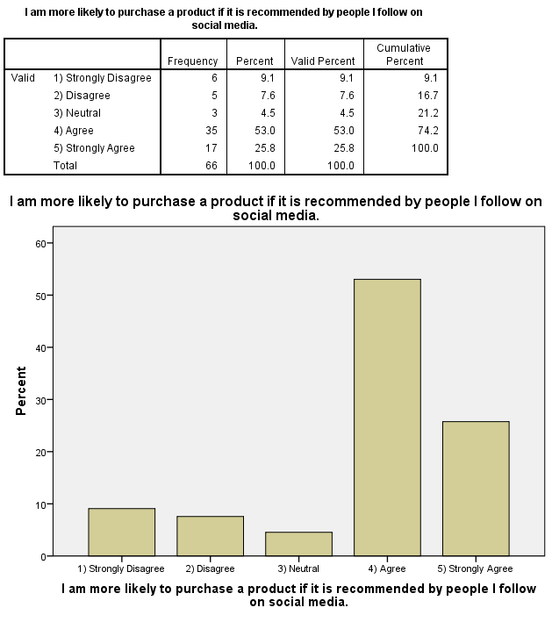

Figure 4.7: Impact of Peer Recommendations on Purchase Likelihood
(Source: SPSS)
According to the results, 53.0% of the respondents strongly agree, and 25.8% agree with the fact that they are likely to buy the products that people whom they follow on social media are recommending. This is where peer-to-peer recommendation can have a significant effect on the Gen Z consumer decision in a social commerce framework.
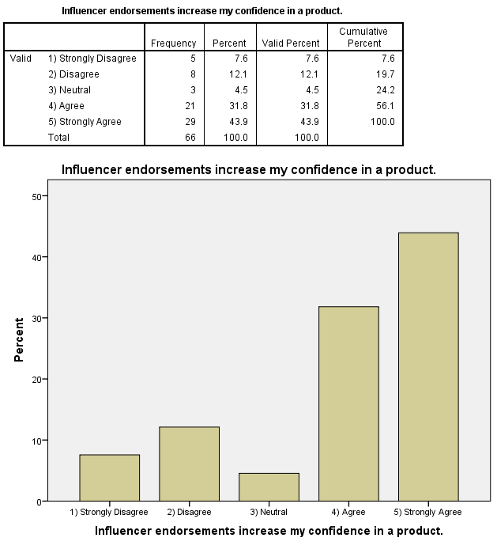

Figure 4.8: Influence of Influencer Endorsements on Consumer Confidence
(Source: SPSS)
The results show that 31.8% and 43.9% of the respondents, respectively, write their agreement and a strong degree of agreement that endorsement of influencers leads to them experiencing more confidence in a product. It implies that influencers are an essential part in the evolution of trust and perceived credibility, and thus render them an influential scheme of social commerce in influencing Gen Z buying behavior.
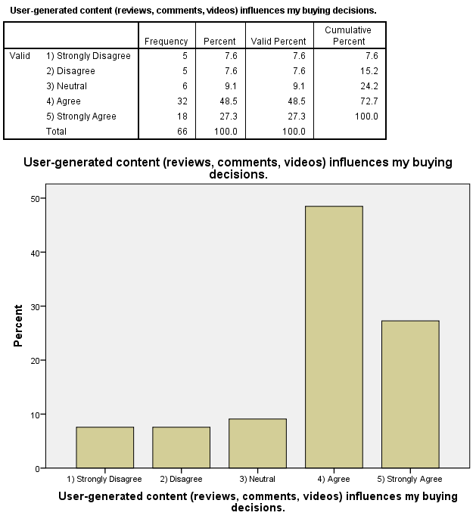

Figure 4.9: Influence of User-Generated Content on Buying Decisions
(Source: SPSS)
Based on the findings, 48.5% of the participants support, and 27.3% strongly support the fact that user-generated content influences their purchases. The role of reviews, comments and videos in building trust and reducing uncertainty is justified in this context, and user-created content is among the main drivers of Gen Z buying behaviour in social commerce.
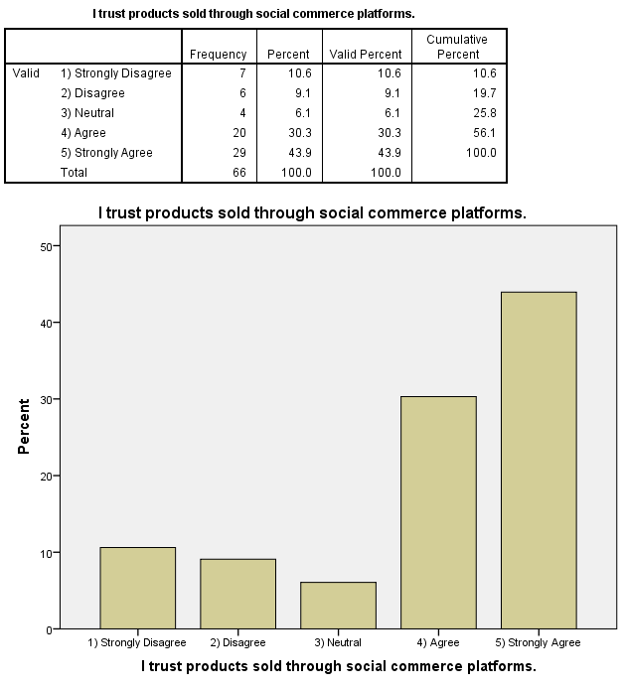

Figure 4.10: Trust in Products Sold Through Social Commerce Platforms
(Source: SPSS)
The findings demonstrate that 30.3% of the participants agree with it, and 43.9% strongly agree that they trust that they use the products sold by social commerce platforms. It mentions a high rate of trust among Gen Z consumers, which means that the social commerce activities are perceived to be credible and believable ways of making purchases online.
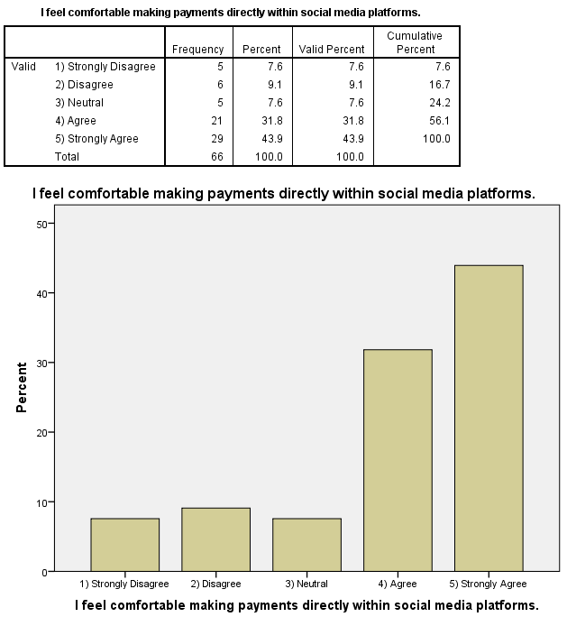

Figure 4.11: Comfort with Direct Payments on Social Media Platforms
(Source: SPSS)
These results indicate that 31.8% and 43.9% of the participants indicate that they feel comfortable with and strongly agree that they can easily afford to make payments on social media sites. This suggests that Gen Z customers are very confident in payment, which appears to be the same in social commerce environments since they have integrated and secure payment systems.
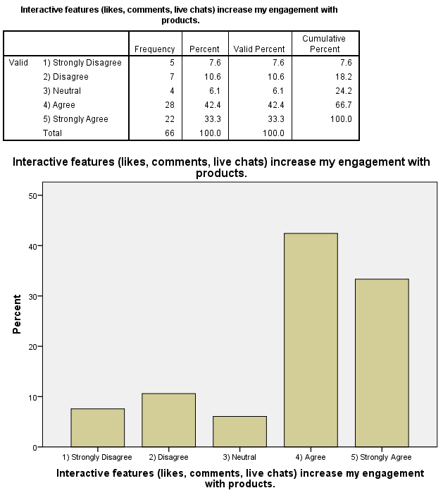

Figure 4.12: Effect of Interactive Features on Consumer Engagement
(Source: SPSS)
The result of the respondents is 42.4% of the respondents have responded in support of the fact that interactive features elevate their interest in the product, and 33.3% of the respondents responded strongly to the fact. This is a sign that likes, comments, and live chats are some of the crucial components that may attract Gen Z and encourage them to be active participants on the social commerce platforms.
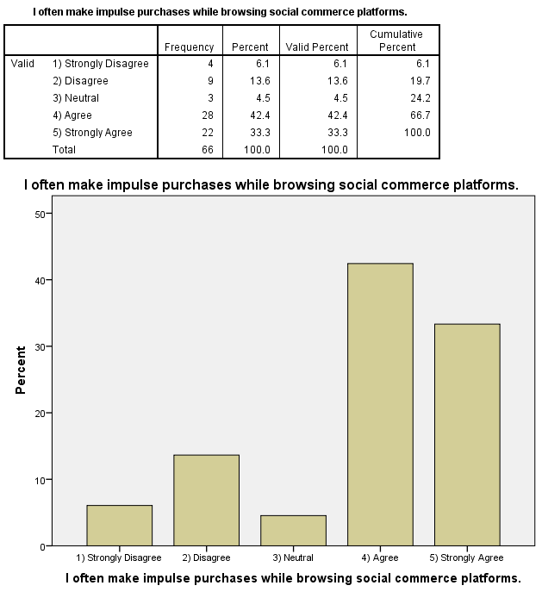

Figure 4.13: Impulse Purchasing Behaviour on Social Commerce Platforms
(Source: SPSS)
The outcome suggests that 42.4% of the participants mention that they are likely to make an impulsive purchase, and 33.3% of them strongly agree that they do so when they are browsing on the social commerce sites. This suggests that the social commerce conditions favour impulse buying behaviour in Gen Z, significantly based on their interactive ability and personalised content.
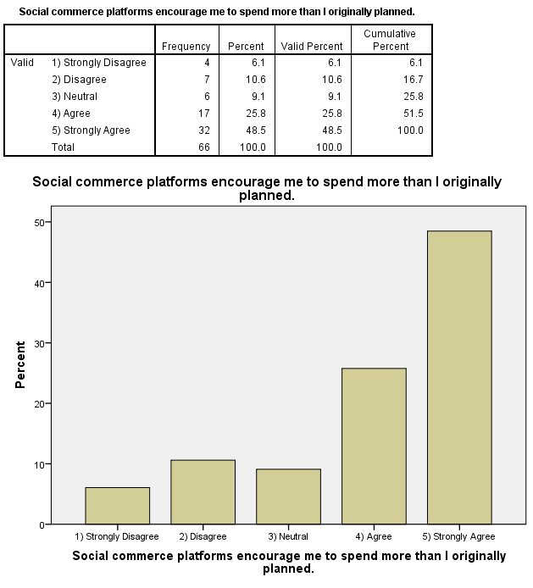

Figure 4.14: Influence of Social Commerce on Overspending Behaviour
(Source: SPSS)
The results indicate that 25.8% and 48.5% of the respondents agreed and strongly agreed that social commerce websites pressurize them to spend more than they had planned to spend. It is a sign that platform features of persuasion and content specialization go a long way in relation to convincing Gen Z consumers to overspend in the context of social commerce.
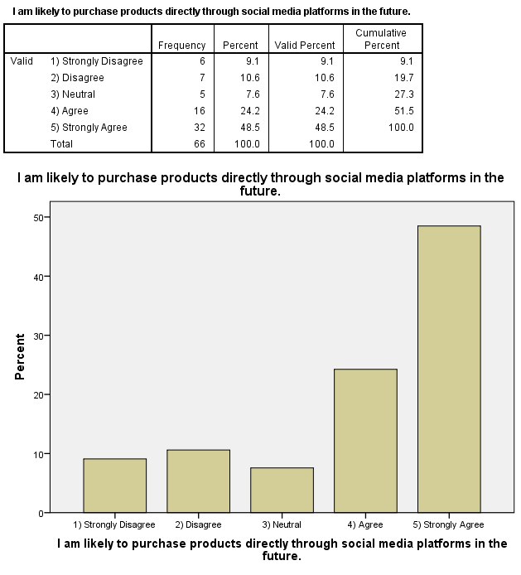

Figure 4.15: Future Purchase Intention on Social Media Platforms
(Source: SPSS)
The results show that 24.2% of the respondents’ state that they would likely purchase products through social media websites in the future. Moreover, 48.5% participants mention a strong level of agreement in this context. However, 10.6% responses have highlighted the disagreement with the opinion. It implies that Gen Z holds high future purchase intention, and hence, social commerce has a long-term growth potential as a shopping platform of desire.
Descriptive statistics
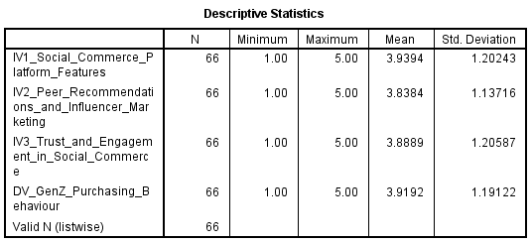

Figure 4.16: Descriptive statistics
(Source: SPSS)
The descriptive statistics show that the means of all the variables were extremely high, which implies that Gen Z respondents believe in social commerce positively. The level of agreement to the social commerce platform and the purchasing behavior is high (M = 3.94, SD = 1.20 and M = 3.92, SD = 1.19, respectively). Favorable attitudes are also expressed by trust and engagement (M = 3.89, SD = 1.21) and peer and influencer influence (M = 3.84, SD = 1.14), which means that both variables have a significant influence on the decision of Gen Z to purchase a specific product.
Cross-tabulation analysis
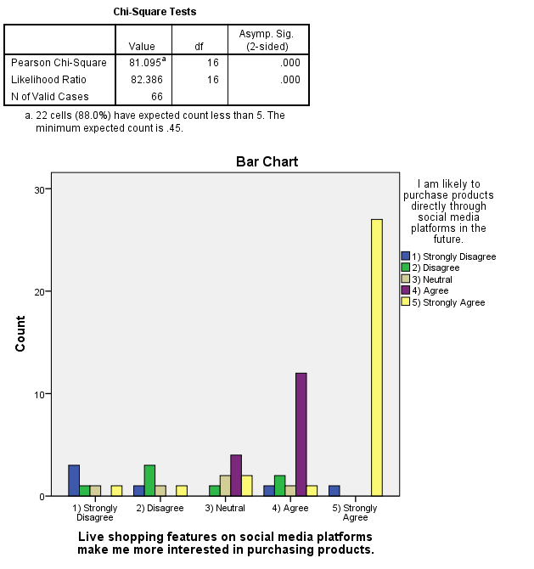

Figure 4.17: Association Between Live Shopping Features and Future Purchase Intention
(Source: SPSS)
The outcome of the chi-square test indicates that the relationship between live shopping features and future purchase intention is statistically significant (χ² = 81.095, p < 0.001). It means that those respondents who report more existent levels of agreement that live shopping increases their interest, as well as the respondents who show higher levels of liking, will buy on social media in the future. These results demonstrate that live shopping is an effective social commerce application that can effectively enhance the purchase intention among Gen Z consumers.
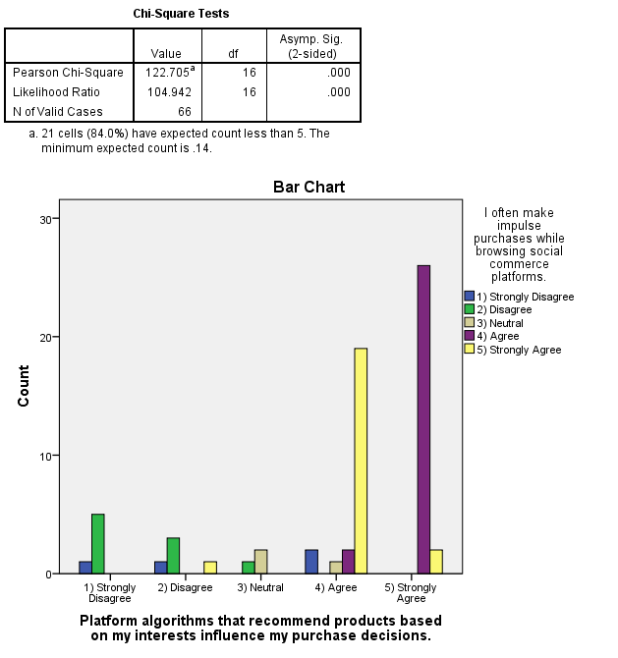

Figure 4.18: Relationship Between Platform Algorithms and Impulse Buying Behaviour
(Source: SPSS)
According to the findings of the chi-square test, there is a strong correlation between platform algorithm recommendation and impulse buying behaviour (χ² = 122.705, p < 0.001). The respondents who respond in the affirmative that algorithms modify their buying behaviour will most likely respond in the affirmative that they make impulse purchases as often as they browse the social commerce sites. It demonstrates that receiver interest-specific recommendations are strategic in stimulating the unplanned purchasing behaviour in Gen Z consumers.
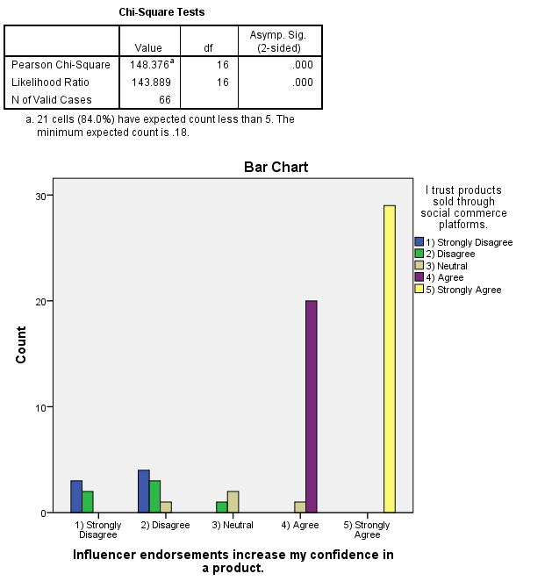

Figure 4.19: Association Between Influencer Endorsements and Trust in Social Commerce Products
(Source: SPSS)
The chi-square test indicates that the recommendation of an influencer and the faith in the social commerce items are closely and statistically significantly connected (χ² = 148.376, p < 0.001). The respondents who say yes or strongly agree that the influence of endorsements would make them more confident would be strongly prone to trust the products they are being sold on the social commerce sites. The fact highlights the significance of influencers in both the trust-building process and credibility among Gen Z consumers.
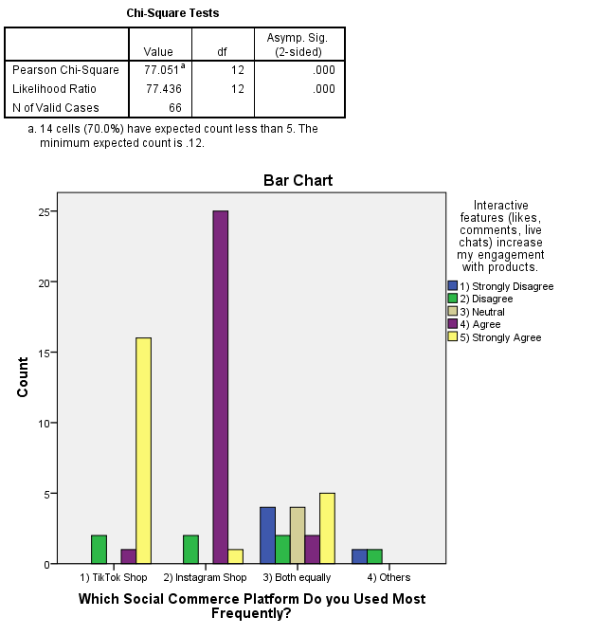

Figure 4.20: Relationship Between Social Commerce Platforms and Interactive Engagement
(Source: SPSS)
The results of the chi-square test identified that the most utilized social commerce platform was considerably connected with the perceived engagement of interactive attributes (χ² = 77.051, p < 0.001). The respondents of this Instagram Shop respond that it has enhanced features of interaction as compared to other social networks, making it more interactive. It means that the design and interactivity of the particular platforms play an important role in the level of Gen Z interaction in a social commerce environment.
Correlation analysis
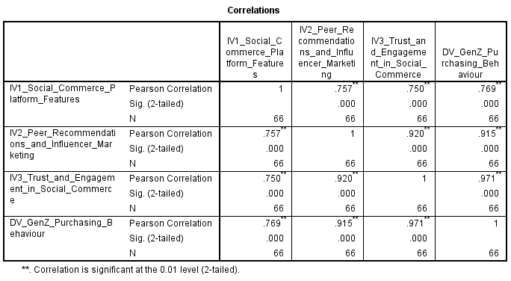

Figure 4.21: Correlation analysis
(Source: SPSS)
The correlation analysis shows that all the variables introduced in the study have a strong relationship that is statistically significant (p < 0.01). There is a strong correlation between the aspects of social commerce platforms and the buying behaviour of Gen Z (r = 0.769). The relationship between peer influence and influencer influence on buying behaviour (r = 0.915) and trust influence and engagement (r = 0.971) is represented as very strong, which indicates that social influence and trust have a critical role in Gen Z purchase behaviour in social commerce places.
Regression analysis
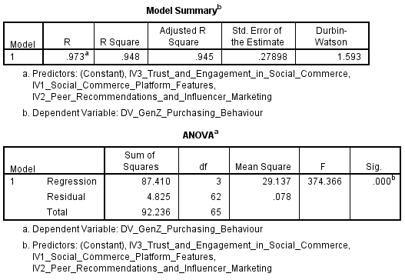

Figure 4.22: Regression model summary
(Source: SPSS)
The correlation coefficient (R = 0.973) also indicates that the regression model fits very well, and this also shows that the relationship between the independent factors and the Gen Z purchasing behaviour is very strong. The purchasing behaviour is presented with an excellent power of explanation, 94.8% (R²= 0.948), and the adjusted R²= 0.945. The ANOVA results reveal that the model is statistically significant (F=374.366, p<0.001), and this means that the composite value of the social commerce platform variables, peer and influencer recommendation, and trust and engagement have a statistically significant impact on the Gen Z purchase behaviour in social commerce environments.
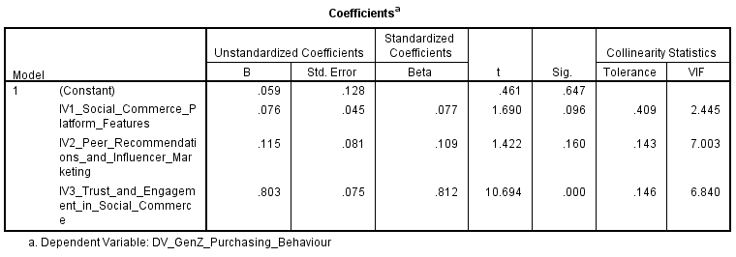

Figure 4.23: Regression coefficients
(Source: SPSS)
The regression coefficients reflect that trust and engagement in social commerce is best predictors of Gen Z buying behavior (β = 0.812, p < 0.001), and are statistically significant and strong in their positive impact. Social commerce platforms’ features (β = 0.077, p = 0.096), peer and influencer recommendations (β = 0.109, p = 0.160) are positively but not significantly affecting other factors with other variables held constant. This means that the purchasing behaviour may be influenced by features of the platform, such as social influence, but trust and engagement have more influence. The approaches taken in statistics of collinearity have made it possible to calculate tolerance and VIF levels that do not suggest serious instances of multicollinearity.
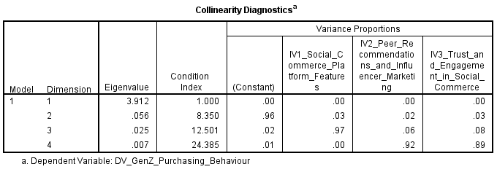

Figure 4.24: Collinearity Diagnostics of the Regression Model
(Source: SPSS)
The collinearity diagnostics show that the regression model has no excessive multicollinearity. The condition index is maximum and is low of 24.385 compared to the critical value of 30, which means that there is no severe problem of multicollinearity. The coefficients of variance reveal that there exists one variable that does not describe a high percentage of variance in a considerable number of independent variables. Although there is some overlap with peer and influencer marketing and trust and engagement at high dimensions, the latter do not attain critical levels. Overall, the results confirm that the independent variables are also different enough for the regression coefficients to predict Gen Z purchasing behaviour were stable, reliable, and interpretable.
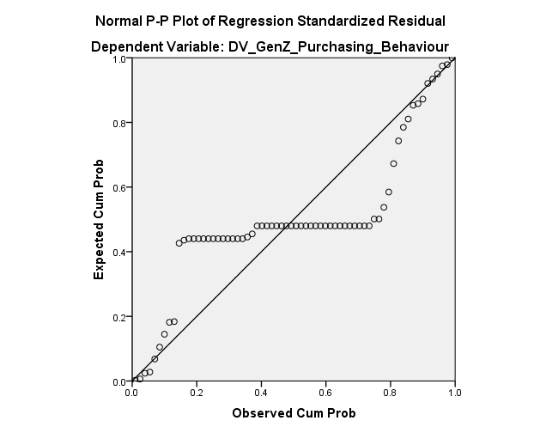

Figure 4.25: Normal P–P Plot of Regression Standardized Residuals
(Source: SPSS)
The Normal P-P plot shows that the large numbers of the standard residuals are close to the normal reference line that indicates that the residuals follow a normal distribution. It has some minor deviations on the upper and lower extremes, but they are acceptable. It means that the normality of linear regression is well satisfied and, thus, the validity of the regression estimate is suitable, and the model estimates and statistical inferences made after the analysis are valid.
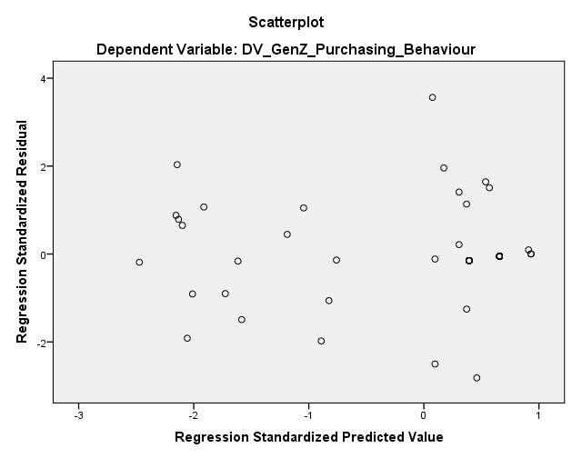

Figure 4.26: Scatterplot of Standardized Residuals vs. Predicted Values
(Source: SPSS)
The scatterplot of standardized residual values versus standardized predicted values shows that the scatter plots are more random and homogeneous along the zero line, and are not of a certain funnel shape or regulated structure. It implies that there is linearity and homoscedasticity. The absence of any visual trends could be attributed to the fact that the error distribution is comparable across the predicted values, and this is one of the indicators of the appropriateness and the power of the regression model to characterize the Gen Z buying behaviour.

4.4 Key Interpretation
The influence of social commerce on Gen Z buying behaviour has been discussed in this paper, and it has examined platform functionality, peer and influencer marketing, as well as trust engagement. These findings show that the attitude towards social commerce amongst Gen Z consumers is quite positive, particularly with respect to an interactive, convenient and socially-oriented shopping experience. The consistency of agreement between frequency and descriptive analyses is high, and this fact implies that the role of such features as live shopping, in-app purchasing, personalized recommendation, and the social interaction that influence the purchase-related attitudes and behaviors is definitely considerable. The inferential analysis also highlights more about these relationships. The Chi-square test showed that the main factors of social commerce and buying had statistically significant relationships. Future purchase intention was highly associated with the features of live shopping and closely correlated with impulse buying behaviour, with recommendations by an algorithm. Trusting social commerce goods that the endorsement of social commerce products relies on credibility and social validation, was also greatly connected to the endorsement of an influencer. The platform-specific interaction is a sign, as well, that design and functionality also influence levels of engagement among Gen Z.
The correlation analysis showed a positive correlation, which was significant across all independent variables and Gen Z purchasing behaviour, with trust and engagement showing the highest correlation. The regression analysis performed confirmed this observation, as trust and engagement were the strongest predictors of buying behaviour. Though the role of social commerce sites and peer and influencer marketing demonstrated a positive influence, this was not the same in the instance of a statistically significant relationship to trust and engagement within the model. The research findings reveal that trust and engagement play a determining role in influencing the Gen Z purchasing behaviour, but the characteristics of social commerce platforms and peer and influencer influence play a less direct role in influencing purchasing behaviour as they assist in building up trust and engagement, rather than having a direct effect.
The current research study aligns with the body of literature that recognizes the critical role of trust, interactivity and the perceived security in the determination of consumer behaviour on the social commerce platforms. In the earlier studies, Gen Z consumers are likely to engage in the buying processes on sites that include credible information, authentic payment systems, and interactivity, which additionally enhance user experience (Piarna et al. 2025). The strong effect of trust and involvement that was described in this study compares with the ones that describe that social validation, transparency, and platform trustworthiness are significant in the perception of risk reduction and purchase intention (Huwaida et al. 2024). Moreover, the findings are also aligned to the Stimulus-Organism-Response (SOR) model, which opines that external stimuli such as platform design, influence content, and social dynamics play into effect to stimulate interior psychological and trust and involvement upon which buying behaviour is eventually realized (Astuti and Suratman, 2025; Duffett and Mxunyelwa, 2025). Despite technological attributes and social effects attracting the Gen Z consumers in this research, the authors define that their utility is mainly founded on their ability to contribute to building trust and productive interaction. Thus, the findings validate the current scholarly arguments that trust-formation and interactive practices are the core of an efficient social commerce strategy that could be applied to access Generation Z.

4.5 Summary
This chapter involved the discussion of the quantitative findings in the field of social commerce and Gen Z purchasing behaviour. The results indicate that Gen Z consumers respond positively to securing interactive and personalized social commerce functionality when trust and engagement can be the most scale-influenced factors to define purchasing behaviour. Even though the platform functionalities, peer and influencer marketing have a role to play in consumer engagement, they have been observed to have an indirect effect on consumer engagement through trust-building channels. The statistical tests confirmed that the study variables were highly correlated and the regression models were of good quality. Overall, the outcomes contribute to a general understanding of the importance of factors of social commerce as the entire context that has contributed to the development of Gen Z buying behaviour as a foundation for the conclusion and recommendations chapter.
Chapter 5: Discussion of Results

5.1 Introduction
The chapter reveals findings of the research concerning the aims and objectives of the study and the existing literature concerning the topic of social commerce and the purchasing behaviour of the generation Z. The quantitative study offers solid information on the interplay of social commerce characteristics, social power, trust, and participation in forming the Gen Z purchase decision-making. This discussion provides a subtle explanation of the psychological and social processes beneath purchasing behaviour within the contexts of social commerce by combining the foundations of empirical research with the well-known theoretical frameworks, namely, the stimulus-organism-response (SOR) model. The chapter critically analyses the output of the study with previous studies by pointing out their theoretical contributions and implications on practice alongside their cognisance of the multifaceted nature of digitally mediated consumer behaviour.

5.2 Social Commerce Features and Gen Z Purchasing Decisions
The initial study aimed at exploring important social commerce attributes that affect Gen Z buying behaviour. These results reveal a significant positive relationship between the features of social commerce platforms and purchasing behaviour (r = 0.769), which proves that technological and functional features are significant in influencing the decision-making process in digital natives. The occurrence of high mean scores in platform-related variables is also an indication that the Gen Z consumers consider these features to be a part of their shopping experiences.
These findings correspond with the findings of Azhar et al. (25), who established that the combination of social and commercial functionalities will massively boost purchasing intention among Gen Z users. Likewise, Huwaida et al. (2024) found information quality, subjective norms, and hedonic expectations as the key factors of purchase intention. The current research extends this literature, however, by proving that the specifics of platforms have an indirect effect on purchasing behaviour due to trust and engagement as the main contributors and not as direct predictors.
The regression findings revealed that, when trust and engagement were added to it, the number of platform features had a positive, although non-significant, direct impact on purchasing behaviour. It implies that there is a mediating aspect in which the characteristics of platforms create the technological and social infrastructure that provides trust-building and engagement which, in turn, leads to purchase decision-making. Such an interpretation agrees with Khobibah et al. (2023) who reported that the platform's affordances facilitate social interaction instead of persuading consumers directly. Marsasi et al. (2024) also reported that knowledge-sharing and social capital accumulation are the factors that affect Gen Z purchase intentions in relation to platform functionality itself.
The analysis of the cross-tabulation revealed that certain features and behavioural outcomes had significantly strong correlations. Gen Z is fond of real-time, interactive and authentic experiences, which were significantly linked to the intention to purchase in the future because of live shopping. This, together with Fairistha et al. (2023) who discovered that live streaming augments purchase intention because it raises social presence and immediacy, supports. It seems that live shopping is synchronous and creates the urgency and credibility which is so powerful in Gen Z consumers.
Also, platform algorithms had a close relationship with the impulse buying behaviour. Recommendations are personalised and therefore not only do a better job of product discovery, but they also help more people to impulse buy. The given finding is a continuation of Singgih et al. (2025), who have found a close correlation between TikTok Shop experiences and the possibility of impulse buying in Gen Z. In the context of flow theory (Hoang and Khoa, 2022), algorithmic curation creates an immersive experience and makes people less likely to be cognitively resistant and more likely to make impulsive decisions.

5.3 Platform-Specific Elements and Their Influence on Engagement and Impulse Buying
The second research goal involved investigating the relationship between platform-specific features and engagement and impulse buying. The results show that in-app shopping options, including product tagging and in-app checkout, make shopping much easier, and about 78.8% of the participants define it as agree or strongly agree. Blending browsing and purchasing makes the consumer journey smooth, which makes both spontaneous and planned purchases easier.
Comparisons of fashioning through platforms emitted significant differences in the engagement patterns. Instagram Shop has been used most (42.4%), and chi-square analysis revealed that platform choice and perceived interactive engagement were significantly associated. This implies that the participation of users is determined by platform design and social architecture. These findings align with those expressed by Muhammad et al. (2024) who underlined the visual orientation of Instagram and the social validation processes as some of the factors that are especially attractive to Gen Z in collectivistic situations.
The interactive elements like likes, comments and live chats were felt to increase the interest of the product among 75.7% of the respondents. This supports the perception about social commerce as an active participation space where consumers are active participants instead of passive consumers. Mardhiana (2024) has highlighted the importance of parasocial interaction and emotional motivation in live-stream shopping, and the current paper is an addition to it by demonstrating that the interactive features can bring both informational and emotional value. Such exchanges work together to provide credibility in addition to reducing psychological obstacles to buying.
Impulse buying also became one of the defining behaviour trends to which 75.7% of the respondents replied that they often purchase something when they are surfing through the social commerce websites. This discovery is a strong argument in favour of flow theory (Hoang and Khoa, 2022), according to which immersive settings generateae state in which impulsive decision-making is possible. A service-dominant logic viewpoint, Kholida and Rini (2025) claimed that interaction with platforms turns the conventional purchasing behaviour into value co-creation. The current results show that platform design based on engagement can enhance the propensity to make impulse purchases.
One outcome was that 74.3% of the people interviewed confirmed that they spent beyond their plans because of their use of social commerce. This is in line with Purwaningdyah and Pratminingsih (2024) who associated stress and social media with impulsive purchasing among Gen Z customers. Ayyasy et al. (2025) also added that the effect of scarcity and the fear of missing out (FOMO) are actively integrated into the design of social commerce, which intensifies impulsive behaviour. These observations bring out the ethical conflicts of engagement-based commerce models.

5.4 Peer Recommendations, Influencers, and User-Generated Content
The third research focus involved how peer recommendations, influencers and user-generated content affect Gen Z loyalty and spending intentions. Study findings showed a remarkably high correlation between influencer and peer marketing variables and purchasing behaviour (r = 0.915), which highlights the central role of social validation in the purchasing behaviour of Gen Z.
A significant percentage of the respondents (78.8) indicated that they were highly likely to buy products that were suggested by profiles that they followed. This confirms Leong and Huam (2023), who discovered that such social factors as peer approval and community belonging have a revolutionary impact on Gen Z buying intentions. The current study builds upon this knowledge by demonstrating that the effect of peer recommendations has been influenced by social cues to legitimise and build the factual desirability of the products.
Influencer endorsements were also extremely impactful of 75.7% of respondents stating that they felt more confident with endorsed products. The chi-square testing found that there is a significant connection between influencer endorsements and trust and thus the influencers can be viewed as credibility intermediaries. The observation is connected to Dilshani et al. (2022), who showed that the credibility of influencers is relevant to the social commerce characteristics and purchase intention among Gen Z consumers.
The user-generated content (UGC) also played a significant role, as 75.8% of the respondents said it affected their buying behaviour. Negative feedback, reviews, testimonials and user-created videos were found to be more genuine and reliable than brand-created content. This echoes the case of Marsasi et al. (2024) concerning the democratisation of information within social commerce ecosystems where the consumers are the more active drivers of the formation of collective purchasing norms via sharing of experiences.
Although the correlations between peer and influencer marketing and the bivariate correlations are high, regression analysis indicated that the two marketing types did not significantly affect influencing variables when trust and engagement were entered. This implies that social influence has an indirect effect of generating trust and involvement, as opposed to making purchases. This observation is what Tseng et al. (2025) suggested to facilitate a mediation model where social support generates trust, and the trust subsequently determines the purchase intention. The current research is hence a contribution to a more detailed comprehension of social impact systems in social commerce.

5.5 Trust and Engagement as Primary Determinants of Purchasing Behaviour
The strongest predictors in Gen Z purchasing behaviour were trust and engagement as the standardised coefficient was 0.812. This is one of the main contributions of the research as it proves that features of the platform and social influence are also significant, but they should be effective to build trust and maintain attention.
The trust levels were high and 74.2 per cent of the respondents indicated that they were able to trust the goods offered by social commerce sites. The observation has been generalised to the work of Tseng et al. (2025), who discovered that social support and information-sharing also contribute to trust, whereas privacy concerns harm purchase intentions. According to the current paper, Gen Z buyers have acquired adaptive trust assessment systems that are adept in online contexts.
The confidence in the security of payments was also great as 75.7% of the respondents were confident that they would use direct in-app payment systems. This indicates how digital natives have normalised the use of integrated transactions and decreased one of the traditional barriers to online buying. Gen Z seems to have greater entry trust in digital payment systems compared to previous generations, which has made it easy to transition to a purchase opportunity straight out of engagement.
Interaction was also the key focus, and three-quarters of respondents stated that interactivity enhances product interest. Engagement is more of active participation and co-creation, and not passive exposure. This corresponds to the service-dominant logic approach and views of the consumers as value co-creators promoted by Kholida and Rini (2025). Involvement, therefore, enhances emotional attachment, confidence and buying intentions.
Using the SOR framework, the platform features and social influence are the stimuli, the organismic states are trust and engagement, and the behaviour is the purchasing. The prevalence of trust and involvement proves the relevance of the framework to the understanding of Gen Z behaviour in the context of social commerce and emphasises the superiority of the inner psychological processes.

5.6 Strategic Implications for Businesses Targeting Generation Z
The fourth study aim was to find the best business strategies of social commerce aiming at Gen Z. The results suggest that the marketing tactics must be used to build trust and interact instead of solely concentrating on platform functionalities or infrastructures of collaboration with influencers.
The intention to future purchase (72.7) is very high and indicates a good growth potential of social commerce among Gen Z consumers. Companies that manage to foster trust and interaction are likely to have long-lasting customer relations and repeat customers. The emphasis that should be put on social commerce should be as a long-term relationship-creating avenue and not as a short-term selling tool.
Findings on various platforms are platform-specific and underline the necessity of differentiated strategies. Although it is still predominantly used in Instagram Shop, TikTok Shop becomes more valuable by the second and both platforms demand specific content and interaction strategies. This can be supported by Singgih et al. (2025) who emphasised key distinctions in the process of discovery, content formats, and social conventions between platforms.
Peer recommendations and UGC are highly persuasive, which implies that companies need to enable genuine customer engagement instead of limiting themselves to branded or paid contents of influencers. Based on the results, Marsasi et al. (2024) stated that the idea of using social capital and sharing knowledge is more related to the values of Gen Z, which strengthens trust and engagement.
The overspending and impulse buying is however, common problem that brings moral concerns. The businesses are caught between profitability and responsibility with 74.3% of the respondents spending more than they planned and 75.7% making impulse purchases. Charles and Immanuel (2025) correlated the social commerce dealing with FOMO with post-purchase regrets especially in female customers. Such results imply that predatory practices can harm brand loyalty and consumer welfare in the long run.

5.7 Synthesis and Theoretical Contributions
This study is relevant to theory in a number of ways. To begin with, it confirms that the SOR framework is applicable to social commerce and also proves the internal psychological state to be more persuasive than potential external stimuli. Second, it explains the indirect route in which the features of the platforms and the impact of social influence on purchasing behaviour are mediated by the factors of trust and engagement.
Third, the platform-comparative technique is the response to the gap in the current literature, because social commerce was considered to be a heterogeneous phenomenon. Similar to the universality of trust and engagement, they are cultivated differently according to platform affordances and norms of the community.
Lastly, the research contributes to the existing knowledge on the digital consumer behaviour of Gen Z by emphasising that they are content with the use of built-in payment options, respond to user-generated content, and are more vulnerable to impulse purchases. These features imply that the marketing approaches that were used to appeal to the previous generations can be used with Gen Z customers only with pronounced modifications.

5.8 Summary
The findings have been discussed in this chapter against the research objectives and the literature available. Although social commerce features and peer and influencer marketing demonstrate a high level of correlation and purchasing behaviour, their impact is based on trust and engagement as opposed to the direct effect on the purchase decision-making. The results confirm the framework of stimulus-organism-response and focus on the primary importance of the psychological states in defining Gen Z purchasing behaviour. Platform-specific understanding illustrates different affordances and expectations of the user, whereas ethical implications emphasise that all people can benefit from responsible social trade practices. Overall, the analysis highlights the need to focus on the well-being of consumers when appealing to Generation Z towards commercial success.

Chapter 6: Conclusion and Recommendations

6.1 Introduction
This chapter entails the final considerations of the study inquiry of the effect of social commerce on the purchasing behaviour of Generation Z. The paper has fully analyzed the correlations between platform characteristics, social influence processes, trust, participation, and buying behaviors with the comprehensive quantitative studies. This last chapter is a synthesis of the main conclusions, presents the theoretical and practical advances of the investigation, mentions the limitations that were experienced in trying this investigation, and even gives recommendations to business practice and additional academic research. The accumulation of knowledge gained in the course of this research should give a clear insight to the stakeholders who need to know and appropriately interact with Generation Z consumers in social commerce settings.

6.2 Summary of Key Findings
This research study has yielded some significant conclusions that add to the awareness of how social commerce affects the buying behaviour of Generation Z consumers; nevertheless, the factors, by which this impact is created, are, mostly, those of psychology and not necessarily those of technology or marketing practices. In all the analyses, the most affecting factors in the purchasing behaviour in the social commerce platforms were trust and engagement. Correlation analysis showed a statistically significant and strong relationship between all the independent variables and Generation Z purchasing behaviour and the highest relationships were recorded among trust and engagement. This observation was further supported with the regression analysis that showed trust and engagement as the only variables that had statistically significant and significant direct effect on purchasing behaviour (β = 0.812). These findings demonstrate the utmost importance of internal psychological states in consumer decision-making and indicate that the likelihood of Gen-Z converting a purchasing intention increases when federal settings feel confident, emotionally engaged, and having a prolonged connection with social commerce platforms. In regards to social commerce platform attributes, the results show that the elements have an indirect but not direct effect on purchasing behaviour. Although platform features including live shopping, in-application purchase features, and product suggestions by algorithms had significant bivariate features correlations with purchasing behaviour, they did not have the same predictive ability when trust and engagement variables were added to the predictive model. This implies that the platform features serve to act as enabling mechanisms that give rise to trust and engagement that also result in purchasing decisions. The results of cross tabulation also contributed to this interpretation as it led to the statistically significant relationships between the features of live shopping and intention to purchase it in the future and between the features of algorithmic recommendations and the impulse buying behaviour. The correlations of the social influence factors, such as peer recommendation, influencer endorsement, and the user-generated content with purchasing behaviour were found to be very strong with a correlation coefficient of above 0.91. The results of the regression, however, showed that the independent effect of these variables could not be statistically significant when trust and engagement were also factored into consideration. The implication of this finding is that there is a mediated relationship where the social influence increases credibility by influencing the perceived risk, and increasing engagement thus indirectly influencing purchasing behaviour and not directly causing purchases. In comparison to the platform perspective, Instagram Shop is the most used social commerce platform among respondents and the second platform is identified as Tik Tok Shop, which is a platform that is growing rapidly. The findings showed significant variances in the engagement pattern and preference of the users platform to platform and the significance of platforms specific approach during engagement with consumer of Generation Zs. The study also determined strong behavioural patterns regarding the impulse buying and overspending, and a large proportion of the respondents indicated having bought more than they had planned to. This points out the influencing and engaging aspect of social commerce environments and poses good ethical questions of companies working with this channel. Summing up, the results are in direct response to the research questions of the current study. The characteristics of social commerce and social influence have a key impact on Generation Z purchasing behaviour due to this particular attribute of building trust and encouraging interactions with the audience (RQ1). The aspects of platforms, including live shopping and algorithmic suggestions, are also a major factor in developing engagement and impulse purchase predispositions (RQ2). Peer influence, the influence and user-created content trick the confidence and credibility, but do not serve as a direct buying stimulus (RQ3). Lastly, the findings highlight the importance of having businesses focus more on trust-building, interactivity, and responsible engagement strategies when appealing to Generation Z using the social commerce platforms (RQ4).

6.3 Linking with objectives
Linking with Objective 1
The findings are a direct response to the first objective as they hydrolyze trust and engagement as the most relevant characteristics of social commerce that can influence buying decisions of the Generation Z. The outcome of the correlational and regression analysis gives quantitative outcomes which reveal that platform features, social influence and purchasing behaviour are strongly and positively correlated with each other, trust and engagement are found to be the most predictable. This aligns with the reality that the buying behavior of the Gen Z population does not concern the features of the particular platform in the same way, but the offers of psychological comfort and communal experiences it brings to the social commerce environment.
Linking with Objective 2
The second objective is achieved through the research, which demonstrates that platform-certainty variables such as live shopping, in-app payment, and algorithm-driven recommendations influence the promotion of engagement and impulsive buying significantly. The descriptive and inferential analytics show that interactive attributes boost the interest in the product and the time of browsing the product, whereby this increases impulse acquisition behaviour. These findings prove that the elements of the immersive and real-time platform can be effective in provoking the impulsive purchasing habit of Generation Z consumers.
Linking with Objective 3
The influence of peer reviews and influencer recommendations on confidence and trust among Gen Z consumers, and content related to the user show the fulfilment of the third objective. The correlation values are large, and this implies that social validation enhances the perceived credibility of products and reduces purchase-related uncertainty. The results achieved through the use of regression, however, indicate that they have a high indirect effect, which works through the medium of trust and involvement, hence the influence of the social actors in the process of developing confidence rather than making a purchase directly.
Linking with Objective 4
The findings of the study are beneficial to the fourth objective, which outlines social commerce approaches that could be effective for companies that require the targeting of Generation Z. The results attribute the importance of trust-building behaviors, interactivity, platform-based content strategies, and authentic interaction with users. The more community building, convenient transactions, and ethical participation-oriented companies have, the better chance of achieving loyalty and long-term success in promoting among Generation Z through the social commerce networks.

6.4 Theoretical Contributions
The study has several theoretical implications that are relevant to the research of social commerce and online consumer behaviour. The study establishes that the stimulus organism response (SOR) paradigm can be applied to the social commerce environments since it empirically demonstrates that the psychological states mediate (Lestari and Hayu, 2025). The present study shows that the nature of the platform and social influence are stimuli and do not dictate direct influence on trust and engagement, along with buying behaviour that consequently has an effect on buying behaviour. This further explains that the established theoretical models explain the indirect way in which social commerce influences consumer decisions (Fathia and Halim, 2025). Moreover, the study can also enhance the generational consumer behaviour theory, as it will learn the peculiarities of the Generation Z consumer segment, including a high degree of digital trust, an ability to become a part of payment systems, high responsiveness to peer-created content, and high impulse purchasing. These peculiarities highlight the usefulness of theoretical frameworks that describe the concepts of digital nativity and socialisation on social media (Abdullah et al. 2025). Finally, among the major limitations of the literature, there is the gap related to the platform-comparative approach as it demonstrates that social commerce is not a singularly homogenous phenomenon. The differentiated theoretical interpretations are necessitated by affordances and mechanisms of platform-specific engagement.

6.5 Practical Implications and Recommendations for Business Practice
The real-life suggestions herein made are based on the empirical evidence of the research, specifically, the paramount importance of trust and engagement in the formation of the Generation Z buying behaviour in the social commerce settings. The most effective way of businesses to appeal to Generation Z, however, should be done through strategies that lead to the development of psychological confidence, prolonged contact, and ethical interaction instead of technological involvement.
Building Trust and Engagement
The results reveal that Generation Z consumers have trust and engagement as the strongest determinants of purchasing behaviour. Companies ought, therefore, to work on building interaction, relationship-based social commerce that is transparent and interactive. Open and sincere communication, a customer-driven customer service, genuine brand narration, and regular community activity play a crucial role in building a durable consumer relation and not a momentary transactional result (Anatasia et al., 2025). Interactive functions like live chat, live product demonstrations and comments should be actively used to increase consumer participation and emotional attachment. The practices facilitate building meaningful brand-consumer relationships, which are deeply valuable to digitally native generation Z consumers, who value authenticity and social connection so strongly.
Leveraging Peer Influence and Platform-Specific Strategies
The fact that peer recommendations and user-generated content (UGC) can have a powerful impact as observed in the study has recommended that the businesses ought to encourage and elevate the voices of real customers more than using paid or highly orchestrated influencer content. Social commerce strategies should include customer reviews, testimonials, user-created videos in order to raise the credibility and trust. Through sharing knowledge and social exchange, organisations will be in a position to turn satisfied customers to a brand advocate, thus enhancing the power of social capital and purchase intentions (Marsasi et al., 2024). Moreover, companies are advised to implement platform-based approaches in an effort to realise maximum efficacy. The use of Instagram Shop and TikTok Shop have different types of users and monitoring behaviors, and their content strategies should be different. More effective could be visual storytelling, edited product presentation, and interactive services on Instagram, short video, discovery on an algorithmic basis, and live shopping on Tik Tok (Kunjiapu et al., 2025). By fitting content forms to the platform affordances, a business is able to maximise the engagement and buying results.
Ethical Practices and Seamless Transactions
Interesting tendencies in the consumer buying tendencies of generation Z and overspending also feature in the study, making other intriguing ethical implications to businesses working within the social commerce framework. Businesses must strike a balance between their business interests and the welfare of consumers by encouraging elective marketing and refuting manipulative actions that capitalize on the activities of feeling left out or feigning scarcity. It has been demonstrated that ethical engagement strategies minimise the effects of post-purchase regret and boost the brand loyalty in the long run (Charles and Immanuel, 2025). Moreover, companies are advised to invest in in-app payment solutions that are both efficient and safe and provide improved convenience without compromising the security of data and privacy. Transparency in return, transaction and security assurances are essential in building credibility. Representing a more active advocacy of strong data protection and privacy practices as critically important to gain the confidence of Generation Z customers, which relates to a longer retention of customers on social trading platforms (Mathew et al. 2025).

6.6 Limitations of the Research
The study also has some shortcomings that must be put into consideration as the study explains the findings. The nature of secondary data analysis used in the first place curtailed the opportunity of developing data collection tools that are directly connected to the research objectives. The differences of measurement scales, activities of analysis, and theories applied in the reviewed articles could be compared to assess the inconsistency and comparability of the results. Moreover, the majority of those are cross-sectional, and, thus, it is impossible to establish causal associations between the attributes of social commerce and the purchase behaviour of Generation Z, as the results show the existing association between the two but not how the behaviour changes over time. Differences in samples and sampling methods, such as the most common use of convenience sampling, will reduce the statistical power and introduce the risk of selection bias, and therefore invalidate the representativeness of findings. In addition, the reviewed studies concentrate on active users of social commerce; hence, the findings cannot be generalised to the hindrances to adoption and non-user attitudes. These limitations suggest that future research should take the more potent, longitudinal and methodologically consistent research designs.

6.7 Future work
The constraints and discoveries of this study lead to some desirable avenues in which research can be conducted in future. It is proposed that the longitudinal studies should examine the long-term change in trust in Generation Z and their interest and usage of the platforms, and the impact of the first experience with social commerce to date on the purchasing behaviour and loyalty of Generation Z in the long-term. The comparative research would also help develop insight by examining the moderate influence of cultural values and communication patterns on the effect of the social characteristics of commerce, and in particular, trust and engagement, between the regional and online contexts. The qualitative research methodologies could also be employed in future research; it is possible to improve the comprehension of the decision-making process in the social trading environment by Gen Z through interviews or focus groups. Also, ethical considerations of social business, such as impulse buying, overspending, and the health of consumers, are to be paid special attention to, to investigate vulnerability and initiate responsible platform design. Finally, platform research should be promoted, which is platform-specific, to learn more about how future consumer experience of social commerce, trust formation, and consumer interaction can be adopted with new technologies in artificial intelligence, augmented reality, and virtual reality.

References
Ab Aziz, Y. and Poureisa, A., 2025. Social Commerce Dynamics in Online Retail: Examining Instagram's Design and Its Technology. International Journal of Technology and Human Interaction (IJTHI), 21(1), pp.1-31.
Abdullah, N., Mokhtar, N., Abdul Halim, T.F. and Shamsol, S.A.S., 2025. Digital influences on online shopping among Gen Z in Kedah: The role of social media interaction, online reviews, and price sensitivity. ESTEEM Journal of Social Sciences and Humanities, 9(1), pp.112-129.
Anatasia, V., Susilo, S.R., Robert, A., Hartono, R. and Christy, I., 2025, August. The Moderating Role of Big Data Attitudes in Gen Z TikTok Live Shopping Decisions. In 2025 4th International Conference on Creative Communication and Innovative Technology (ICCIT) (pp. 1-7). IEEE.
Andika, A., Najmudin, M., Nasution, A.A., Anisah, T.N., Luthfiana, D.N. and Nadia, N., 2025. Enhancing Impulse Buying Among Generation Z Through Social Presence in E-Commerce Live Streaming. TEM Journal, 14(1).
Andika, A., Najmudin, M., Nasution, A.A., Anisah, T.N., Luthfiana, D.N. and Nadia, N., 2025. Enhancing Impulse Buying Among Generation Z Through Social Presence in E-Commerce Live Streaming. TEM Journal, 14(1).
Astuti, B. and Suratman, A., 2025. Social Media Marketing and Actual Purchase Behavior Among Gen Z: The Mediating Role of Consumer Engagement and Purchase Intention with High Involvement Product Moderation. TEC EMPRESARIAL, 20(2), pp.935-952.
Ayyasy, M.Z., Belinda, K.I. and Dirgantara, I.M.B., 2025. FOMO Related Impulse Buying on Social Commerce: A Literature Review. Economic and Business Horizon, 4(2), pp.365-374.
Azhar, M., Akhtar, M.J., Rahman, M.N. and Khan, F.A., 2025. Measuring buying intention of generation Z on social networking sites: an application of social commerce adoption model. Journal of Economic and Administrative Sciences, 41(3), pp.979-1001.
Azhar, M., Akhtar, M.J., Rahman, M.N. and Khan, F.A., 2025. Measuring buying intention of Generation Z on social networking sites: an application of the social commerce adoption model. Journal of Economic and Administrative Sciences, 41(3), pp.979-1001.
bazaarvoice.com, 2025, How 80% of Gen Z and millennials are fueling social commerce growth, accessed from: https://www.bazaarvoice.com/blog/how-80-of-gen-z-and-millennials-are-fueling-social-commerce-growth/, on: 15.12.2025
Becdach, C., Brodherson, M., Gersovitz, D., Glaser, D., Kubetz, Z., Magni, M. and Nakajima, J., 2022. Social commerce: The future of how consumers interact with brands. McKinsey & Company.
Broeder, P. and Schouten, M., 2022. The Impact of Product Tagging on Trust and Purchase Intention: A cross-cultural perspective in visual e-commerce. Consumer Behavior Review, 6(1), pp.1-17.
Charles, C.E. and Immanuel, D.M., 2025. FOMO, materialism and the Gen Z shopping behaviour: The impact on online impulse buying and post-purchase regret (with a gender perspective). Jurnal aplikasi manajemen, 23(1).
Deepika, K.S. and Massand, A., 2025. A study on reflective factors of social media marketing activities and its influence on purchase intention of gen z. Acta Psychologica, 259, p.105459.
Dilshani, A.K.D.N., Praveeni, S.M.N. and Wanigasekara, W.D.M., 2022. Social Commerce Impact on Consumers' Purchase Intention among Generation-Z Consumers in Sri Lanka. International Journal of Research and Innovation in Social Science, 6(03).
Dilshani, A.K.D.N., Praveeni, S.M.N. and Wanigasekara, W.D.M., 2022. Social Commerce Impact on Consumers' Purchase Intention among Generation-Z Consumers in Sri Lanka. International Journal of Research and Innovation in Social Science, 6(03).
Duffett, R. and Mxunyelwa, A., 2025. Instagram Mega-Influencers’ Effect on Generation Z’s Intention to Purchase: A Technology Acceptance Model and Source Credibility Model Perspective. Journal of Theoretical and Applied Electronic Commerce Research, 20(2), p.94.
Fairistha, D., Bernessa, I., Cen, L.J. and Aryuni, M., 2023. The Effect of Live Streaming on Social Commerce Platforms on Generation Z’s Purchase Intention. In E3S Web of Conferences (Vol. 426, p. 01081). EDP Sciences.
Fathia, T. and Halim, R.E., 2025. The influence of trust, popularity, and social media influencer fit on impulse purchases of affordable luxury fashion brands among millennials and generation z. Linkage, 2(1), pp.1-16.
Goldberg, R. and Kotze, A., 2022. The influence of reference groups on millennials’ social commerce buying behaviour. Malaysian E Commerce Journal (Mecj), 6(1), pp.24-28.
Guerra-Tamez, C.R., Kraul Flores, K., Serna-Mendiburu, G.M., Chavelas Robles, D. and Ibarra Cortés, J., 2024. Decoding Gen Z: AI's influence on brand trust and purchasing behavior. Frontiers in artificial intelligence, 7, p.1323512.
Hidayanto, A.N. and Yaiprasert, C., 2024. Generation Z and Indonesian Social Commerce: Unraveling key drivers of their shopping decisions. Journal of Open Innovation: Technology, Market, and Complexity, 10(2), p.100256.
Hoang, C.C. and Khoa, B.T., 2022. Impulse buying behavior of generation Z customers in social commerce: Flow theory approach. Journal of Logistics, Informatics and Service Science, 9(4), pp.197-208.
Hoang, C.C. and Khoa, B.T., 2022. Impulse buying behaviour of generation Z customers in social commerce: Flow theory approach. Journal of Logistics, Informatics and Service Science, 9(4), pp.197-208.
Huwaida, L.A., Yusuf, A., Satria, A.N., Darmawan, M.A., Ammar, M.F., Yanuar, M.W., Hidayanto, A.N. and Yaiprasert, C., 2024. Generation Z and Indonesian Social Commerce: Unraveling key drivers of their shopping decisions. Journal of Open Innovation: Technology, Market, and Complexity, 10(2), p.100256.
Huwaida, L.A., Yusuf, A., Satria, A.N., Darmawan, M.A., Ammar, M.F., Yanuar, M.W., Hidayanto, A.N. and Yaiprasert, C., 2024. Generation Z and Indonesian Social Commerce: Unraveling key drivers of their shopping decisions. Journal of Open Innovation: Technology, Market, and Complexity, 10(2), p.100256.
Huwaida, L.A., Yusuf, A., Satria, A.N., Darmawan, M.A., Ammar, M.F., Yanuar, M.W., Hidayanto, A.N. and Yaiprasert, C., 2024. Generation Z and Indonesian Social Commerce: Unravelling key drivers of their shopping decisions. Journal of Open Innovation: Technology, Market, and Complexity, 10(2), p.100256.
Kamran, Z. and Karim, Y., 2026. The Influence of AI-Powered Chatbots on Customer Trust and Purchase Intention: A Case Study on Gen Z Online Shoppers in Lahore, Pakistan. Journal of Management & Social Science, 3(1), pp.49-65.
Khoa, B.T., 2025. The Triple Helix of Digital Engagement: Unifying Technology Acceptance, Trust Signaling, and Social Contagion in Generation Z’s Social Commerce Repurchase Decisions. Journal of Theoretical and Applied Electronic Commerce Research, 20(2), p.145.
Khobibah, N., Permadi, I., Setyawan, M.A.S., Nisa, F.K.N. and Kom, S.I., 2023. The phenomenon of social shopping in Generation Z. Medium, 11(2), pp.207-220.
Kholida, A. and Rini, G.P., 2025. Exploring Gen Z Consumers’ Impulse Buying Behaviour on E-commerce: An SDL Perspective. Economics and Business Solutions Journal, 9(1), pp.65-80.
Kunjiapu, S., Ali, S.F.S., Baki, N.U. and Quan, M.K., 2025. The Trust Pathway: Mediating Effects of Trust between Perceived Authenticity, Real-Time Interaction, and Generation Zâ€™ s Purchase Intentions. International Journal of Research and Innovation in Social Science, 9(4), pp.6252-6260.
Lăzăroiu, G., Neguriţă, O., Grecu, I., Grecu, G. and Mitran, P.C., 2020. Consumers’ decision-making process on social commerce platforms: Online trust, perceived risk, and purchase intentions. Frontiers in psychology, 11, p.890.
Le, T.M.H. and Ngoc, B.M., 2024. Consumption-related social media peer communication and online shopping intention among Gen Z consumers: A moderated-serial mediation model. Computers in Human Behavior, 153, p.108100.
Leong, T.K. and Huam, H.T., 2023. Do social and commercial desires influence the purchasing intentions of Generation Z in online social shopping?. Journal of Applied Structural Equation Modelling, 7(1), pp.27-113.
Leonga, T.K. and Tatb, H.H., 2023. DO SOCIAL AND COMMERCIAL DESIRES INFLUENCE THE PURCHASING INTENTIONS OF GENERATION Z IN ONLINE SOCIAL SHOPPING?. Journal of Applied Structural Equation Modelling, 7(1), pp.95-113.
Lestari, S.A. and Hayu, R.S., 2025. Product-Related Tiktok Content Stimuli And Emotional Mechanisms Driving Gen Z Impulse Buying. Kontigensi: Jurnal Ilmiah Manajemen, 13(2), pp.964-997.
Mardhiana, H.R., 2024. GEN Z’S IMPULSE BUYING BEHAVIOR OF SHOPPING THROUGH LIVE-STREAMING SOCIAL COMMERCE PLATFORMS: Investigating the Role of Parasocial Interaction and Social Commerce Emotional Motivation. Srawung: Journal of Social Sciences and Humanities, pp.29-50.
Marsasi, E.G., Barqiah, S. and Gusti, Y.K., 2024. Investigation of the Effects of Social Capital on Information/Knowledge-Sharing Behaviour that Drives Gen Z Purchase Intentions through Social Commerce. Media Ekonomi Dan Manajemen, 39(1), pp.42-60.
Migkos, S.P., Giannakopoulos, N.T. and Sakas, D.P., 2025. Impact of Influencer Marketing on Consumer Behavior and Online Shopping Preferences. Journal of Theoretical and Applied Electronic Commerce Research, 20(2), p.111.
Moghddam, H.A., Carlson, J., Wyllie, J. and Rahman, S.M., 2024. Scroll, Stop, Shop: Decoding impulsive buying in social commerce. Journal of Business Research, 182, p.114776.
Muhammad, A.S., Adeshola, I. and Isiaku, L., 2024. A mixed study on the “wow” of impulse purchase on Instagram: insights from Gen-Z in a collectivistic environment. Young Consumers, 25(1), pp.128-148.
Ngah, R., Azizan, N.A., Kadir, M.A.B.A., Thuraisamy, R., Mohamad, Z. and Danila, N., 2021. Exploring antecedents of online purchasing behavioral intention of generation z: An integrated model of four theories. Malaysian Journal of Consumer and Family Economics, 27(1), pp.1-24.
Ngo, T.T.A., Nguyen, H.L.T., Nguyen, H.P., Mai, H.T.A., Mai, T.H.T. and Hoang, P.L., 2024. A comprehensive study on factors influencing online impulse buying behavior: Evidence from Shopee video platform. Heliyon, 10(15).
Piarna, R., Vernanda, D. and Apandi, T.H., 2025. Building trust in social commerce: A sequential model of platform features, marketing content, and dual trust in shaping Generation Z engagement. JEMA: Jurnal Ilmiah Bidang Akuntansi dan Manajemen, 22(2), pp.263-298.
Poh, S., Hasan, D.G. and Sudiyono, K.A., 2024. The power of social commerce: TikTok's impact on Gen Z consumer purchasing behavior. Manajemen dan Bisnis, 23(2), pp.501-515.
Purwaningdyah, S.W.S. and Pratminingsih, S.A., 2024. Stressed and Shopping: Examining Social Media-Induced Stress and Online Impulsive Buying in Gen Z. JBTI: Jurnal Bisnis: Teori dan Implementasi, 15(3), pp.343-359.
Putri, N., Prasetya, Y., Handayani, P.W. and Fitriani, H., 2024. TikTok Shop: How trust and privacy influence generation Z’s purchasing behaviors. Cogent Social Sciences, 10(1), p.2292759.
Rosnerova, Z., Ponisciakova, O., Kicova, E. and Strenitzerova, M., 2025. The Impact of the Digital World on the Buying Behaviour of Generation Z. Administrative Sciences, 15(12), p.459.
Senali, M.G., Iranmanesh, M., Ghobakhloo, M., Foroughi, B., Asadi, S. and Rejeb, A., 2024. Determinants of trust and purchase intention in social commerce: Perceived price fairness and trust disposition as moderators. Electronic Commerce Research and Applications, 64, p.101370.
Singgih, A.A., Aslamah, A.N., Usman, O. and Parlyna, R., 2025. The Effect of Social Commerce and the TikTok Shop Marketplace Experience on Generation Z’s Impulse Buying, Moderated by Self-Control. Journal of Digital Business and Global Economy, 1(5).
Singh, P., 2024. What drives or decelerates Generation Z? An empirical study navigating consumer buying intentions in online shopping. SAGE Open, 14(3), p.21582440241263173.
Tauseef, M.H., Hameed, R.M., Ullah, I., Abbasi, H., Raja, A.R.M. and Bashir, F., 2025. SCROLL, STOP, SHOP: DECODING IMPULSIVE BUYING IN SOCIAL COMMERCE IN PAKISTAN. Journal of Media Horizons, 6(2), pp.403-417.
Tjahjana, D., Dwidienawati, D., Hakim, A., Rivera, A.L.F.R.E.D.O., Tandiono, N. and Ardika, Y., 2024. The Influence of Security and Privacy on Gen Z Trust in Indonesian E-Commerce. WSEAS Transactions on Business and Economics, 21, pp.775-7.
Tseng, H.T., Jia, S., Nisar, T.M., Hajli, N. and Shabbir, H., 2025. The study of social commerce in Generation Z context: the role of social support and privacy risk. Information Technology & People, 38(3), pp.1505-1525.
Tseng, H.T., Jia, S., Nisar, T.M., Hajli, N. and Shabbir, H., 2025. The study of social commerce inthe Generation Z context: the role of social support and privacy risk. Information Technology & People, 38(3), pp.1505-1525.
vivaldigroup.com, 2025. Gen Z Marketing Strategies: The Essentials. Available at: https://vivaldigroup.com/gen-z-marketing-strategies/ [accessed on: 23/12/2025]
Vuong, N.L., Pham, H.M., Tran, H.N., Nguyen, B.H., Dang, D.T. and Lai, T.T., 2025. Engaging Gen Z: how influencer livestreams on TikTok build customer loyalty through social ties. International Journal of Organizational Analysis.
Wang, Qingwei. 2023. The Impact of Expert Endorser in Electric Vehicle Advertising on Consumers' Purchase Intention. Advances in Economics, Management and Political Sciences. 41. 106-110.
Zhao, J. and Zhu, C., 2023. Modeling and quantifying the impact of personified communication on purchase behavior in social commerce. Behavioral Sciences, 13(8), p.627.

Appendices

Appendix 1: Survey questions
Section A: Demographic Information
Q1. What is your age?
- 18–19
- 20–21
- 22–23
- 24–25
- More than 25 years
Q2. What is your Gender?
- Male
- Female
- Prefer not to say
Q3. Which Social Commerce Platform Do You Used Most Frequently?
- TikTok Shop
- Instagram Shop
- Both equally
- Other
For Sections B–E, the options are the following Likert scale:
- Strongly Disagree
- Disagree
- Neutral
- Agree
- Strongly Agree
Section B: Social Commerce Platform Features
Q4. Live shopping features on social media platforms make me more interested in purchasing products.
Q5. In-app shopping features (e.g., product tags, direct checkout) make the buying process easier for me.
Q6. Platform algorithms that recommend products based on my interests influence my purchase decisions.
Section C: Peer Recommendations and Influencer Marketing
Q7. I am more likely to purchase a product if it is recommended by people I follow on social media.
Q8. Influencer endorsements increase my confidence in a product.
Q9. User-generated content (reviews, comments, videos) influences my buying decisions.
Section D: Trust and Engagement in Social Commerce
Q10. I trust products sold through social commerce platforms.
Q11. I feel comfortable making payments directly within social media platforms.
Q12. Interactive features (likes, comments, live chats) increase my engagement with products.
Section E: Gen Z Purchasing Behaviour
Q13. I often make impulse purchases while browsing social commerce platforms.
Q14. Social commerce platforms encourage me to spend more than I originally planned.
Q15. I am likely to purchase products directly through social media platforms in the future.

