
Programme: Master of Business Administration
Module: International Business Concepts
Module code: LCMB7034
Lecturer: Hoang Dang Nguyen
Name : Rishith Reddy Jammidi
Student ID:2429155
Word Count: 5384
Date of Submission: 15-12-2025
Table of Contents
1. Introduction 5
2. Benefits And Challenges Of International Operations 6
2.1 Tesla as an MNC/TNC 6
2.2 Nature of Tesla’s Global Operations and Value Chain 7
2.2.1 Research and Development (R&D) 7
2.2.2 Sourcing and Supply Chain 7
2.2.3 Production and Manufacturing 8
2.2.4 Financing and Partnerships 8
2.3 Entry Modes Used by Tesla 9
2.4 Benefits and Challenges of International Operations 10
2.4.1 Benefits 10
2.4.2 Challenges 11
3. OLI Analysis for Tesla Expanding into Vietnam 12
3.1 Ownership Advantages (O) 12
3.2 Location Advantages (L) of Vietnam 14
3.3 Internalisation Advantages (I) 15
4. Cultural Differences Between the U.S. And Vietnam 17
4.1 Presentation of Cultural Data 17
4.2 Implications for Tesla’s Entry Strategy 18
4.2.1 Hall’s High–Low Context Theory 20
4.3 Impacts on Tesla’s Success Potential in Vietnam 20
4.3.1 Marketing Challenges and Opportunities 20
4.3.2 HR and Management Implications 21
4.3.3 Consumer Adoption and Behaviour 21
4.3.4 Partnership and Stakeholder Management 21
5. Three Major SOP Adjustments 22
5.1 SOP Adjustment 1: Localised HR & Management System 22
5.2 SOP Adjustment 2: Market-Specific Sales, Pricing & Marketing SOP 23
5.3 SOP Adjustment 3: Local Manufacturing & Supply Chain SOP 24
6. Conclusion 27
7. References 28

List of Figures
Figure 1: Logo of the company 5
Figure 2: Tesla 6
Figure 3: Tesla's Shanghai Gigafactory 8
Figure 4: OLI Framework 12
Figure 5: Tesla Leads Public Fast and Ultra-Fast Charging in the US and Europe 13
Figure 6: Vietnam Electric Vehicle Market Analysis 14
Figure 7: VinFast 15
Figure 8: Cultural Comparison of the US and Vietnam 18
List of Tables
Table 1: Entry Modes Used by Tesla 10
Table 2: Benefits of International Operations 11
Table 3: Hofstede’s cultural dimensions of Tesla 20

1. Introduction
This report outlines an analysis of the global business of the company Tesla Inc. and an appraisal with a critical analysis of its future in the expansion into Vietnam. This analysis is formed following the required assessment criteria by examining the advantages and limitations of the global operations of Tesla, using the OLI (Ownership, Location, Internalisation) model to decide on the most suitable entry mode to be adopted in Vietnam, evaluating the differences in cultures between the United States and Vietnam, and providing crucial clarifications to the Tesla Standard Operating Procedures. Tesla is one of the leading electric-vehicle producers located in the United States but has a strong international presence in over 30 countries (Tesla, 2025). The country of Vietnam has been discovered to be a salient emerging market to expand because the GDP of the country has grown at the rate of about 71 percent in 2024, speeding urbanisation, rising vehicle ownership, and strong governmental support to electric vehicles which includes no registration tax until 2027 (Levinson, 2025).

Figure 1: Logo of the company
(Source: Tesla, 2025)

2. Benefits And Challenges Of International Operations

2.1 Tesla as an MNC/TNC
Tesla is generally known to be a multinational and transnational company due to its vast operations in different parts of the world and its internationally coordinated approach to doing business. The company enjoys an operation in over 30 countries in the main markets and through its operation includes the United States, China, Germany, Canada, Japan, Mexico, Australia and the United Kingdom (Katje, 2025). This extensive global presence fulfils the fundamental condition of qualifying as an MNC, that is presence in more than one country with a coordinated strategy across the borders. Tesla operates a network of connected activities worldwide, which include research and development time and manufacturing plants (Gigafactories), global sourcing, regional sales subsidiaries, and a global system of charging infrastructure (Tesla, 2025).
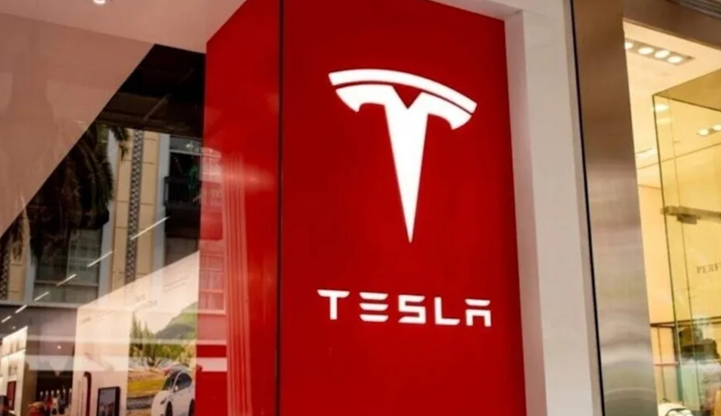
Figure 2: Tesla
(Source: Katje, 2025)
Tesla has a highly efficient global value chain with a high degree of localisation strategies in China and Europe to ensure that it complies with the local regulations and customer demands. Its financial layout is also a sign of global diversification, the amount of revenues increased to 96.8 billion dollars in 2023, and the margin of increase in sales is 0.9 in 2024 (Shvartsman, 2025). The transnational nature of the corporation, that is, the high global integration and selective responsiveness at the local level is demonstrated in the strategy that the company uses to establish a tight control of technology, data, and brand positioning.

2.2 Nature of Tesla’s Global Operations and Value Chain
The Tesla international business is designed with a very well-integrated global value chain that encompasses research and development, sourcing, production, distribution, and after-sales services. This system is consistent with the Value Chain and Global Value Chain (GVC) notions by Porter, which means that Tesla is a company that develops value and extracts it in more than one country.

2.2.1 Research and Development (R&D)
The fundamentals of Tesla R&D are still based in the U.S. mainly in Palo Alto and Austin (Reuters, 2021). The areas targeted by these centres include battery chemistry, autonomous driving algorithms, vehicle software, AI neural networks, and technological innovation overall. Other research and development work is spread in North America, particularly Canada where Autopilot and sophisticated AI functionality are being developed. Maintaining high-level R&D in the home country, Tesla retains control of ownership benefits and intellectual property protection, in addition to incorporating the experiences obtained during the international operations.

2.2.2 Sourcing and Supply Chain
The sourcing strategy of Tesla is very globalised. Lithium and nickel, which are the key raw materials are obtained in Australia, Indonesia, and Canada. The collaboration with Chinese battery producer CATL and Korean LG Energy provides the means of access to the large-scale battery supplies (Ani, 2025). However, between 2022 and 2024 Tesla experienced supply-chain difficulties because of the lack of semiconductors, soaring prices of raw materials, and extended shipping times. To reduce the risks, the company is progressively investing in vertical integration and multi-country supplier networks, in line with GVC risk-diversification strategies.

2.2.3 Production and Manufacturing
Tesla is a firm with a manufacturing strategy that is based on the Gigafactory. It has major plants in Nevada, Shanghai, Berlin and Texas, and has recently announced a new plant in Mexico. The Shanghai Gigafactory takes the biggest part as it made 947000 vehicles alone in 2023 (Xinhua, 2024). Movement towards localisation means lowering importation tariffs, shrinking the delivery schedule, and lowering logistics expenses. Economies of scale as well are supported by the Gigafactory model through process standardisation and application of voluminous and specialised machinery like Giga Press, which is a big boost in productivity.
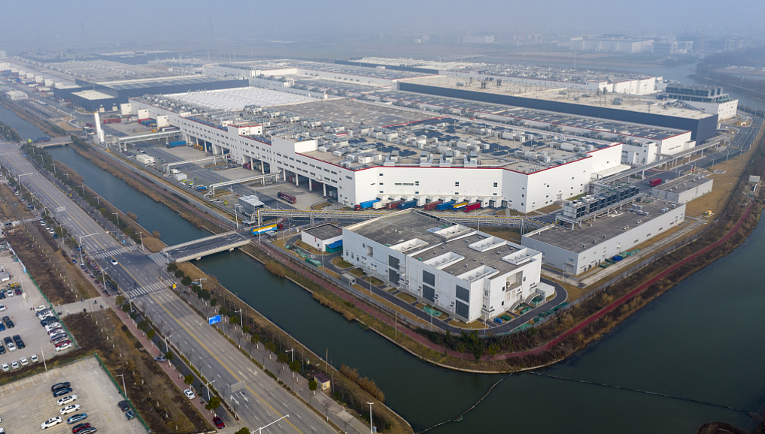
Figure 3: Tesla's Shanghai Gigafactory
(Source: Xinhua, 2024)

2.2.4 Financing and Partnerships
Tesla retains profits, government subsidies, and partnerships with battery manufacturers including Panasonic, LG and CATL as business prerequisites to its high capital expenditure model. These partnerships help Tesla to increase production and benefit from new technologies and cost-efficiencies. Generally speaking, the Tesla value chain in the global market is quite developed, with a highly integrated form of the value chain that combines the global coordination of Tesla with localisation (Ross, 2025).

2.3 Entry Modes Used by Tesla
The case of Tesla's expansion behaviour to other countries implies that it implements various entry methods and relies on its technology protection or brand control and quality consistency as a strategic option. Using the entry-mode theories (Root, Hill), Tesla shows a strong preference for full ownership designs and little dependence on shared-control designs.
Greenfield Foreign Direct Investment (FDI) | Greenfield foreign direct investment is also one of the most important means of entry into the Tesla firm, especially in the form of building its Gigafactories. The Shanghai Gigafactory is an example of such a strategy, which was constructed as an entirely-owned enterprise following the elimination of the joint-venture stipulation of foreign automakers in the electric-vehicle segment in China (Xinhua, 2025). This helped Tesla to gain full control of the production, processes, supply chain, quality standards and product technology. This plant has been a success which highlights how Tesla is most likely to jump-start operations when strategic resources and complete control are of utmost importance.
Wholly Owned Subsidiaries | Tesla also has wholly owned subsidiaries in many markets globally and these subsidiaries manage both sales, marketing, services and charging infrastructure (Tesla, 2025). This model is mostly common in Europe, Japan and Australia whereby Tesla incorporates separate legal structures to operate the business in the area. This group of subsidiaries services Tesla's direct-sale system and provides and maintains tight brand- and service-quality consistency.
Exporting | Before the creation of large-scale domestic production, Tesla mostly shipped cars out of its production centres located in the United States (Reuters, 2022). Most of the markets such as Canada, Japan, and early European operations were supplied through export. This market entry method has helped Tesla to test the market potential and reduce the risk of initial investment.
Licensing and Strategic Partnerships | Tesla does not normally enter licensing deals concerning its most basic vehicle and battery technologies to protect intellectual property. However, it is involved in selective partnerships in relation to charging infrastructure, software integration, and cell production of batteries to companies like CATL, LG Energy Solution, and local energy providers.
Table 1: Entry Modes Used by Tesla

2.4 Benefits and Challenges of International Operations
The global activities of Tesla bring significant strategic, economic and operational value, nevertheless, the companies also pose significant threats that have effects on the long-term competitiveness of the company. The dynamics may be analysed using the prism of the FDI motive theory which identifies the imperatives of market and efficiency and strategic assets (Khdir and Cieślik, 2025).

2.4.1 Benefits
Market Diversification | Internationalisation minimises the dependence of Tesla on the United States, offering access to large consumer markets in other countries. China has become the biggest market for Tesla with 93,680 vehicle deliveries in 2023 (He, 2023). This participation in various regions helps in the stabilisation of demand as well as against the economic fluctuations of the respective countries.
Efficiency Gains and Cost Reduction | Production of vehicles close to the major markets reduces significantly logistic costs as well as the tariffs of importing products. An example is the Shanghai Gigafactory, which saved about 20 percent in terms of cost in comparison to exporting the vehicles in the United States (Reuters, 2025). These economies of scale enhance the competitiveness of Tesla in Asia and Europe.
Scale and Network Effects | The global operations allow Tesla to expand its network of Superchargers and compile more data in order to optimise its autonomous driving system, which makes Tesla technologically leading.
Table 2: Benefits of International Operations

2.4.2 Challenges
Despite strong advantages, Tesla faces notable risks:
- Political Risk: U.S.-China tensions are increasing and they are threatening the stability of the supply chain and access to the market.
- Foreign Exchange Volatility: The revenues collected in foreign currencies will be vulnerable to changes in the U.S. dollar (Alsulami and Raza, 2025).
- Competitive Pressure: Tesla has to face strong competitors like BYD in China and VinFast in Vietnam who take market share and localisation abilities.

3. OLI Analysis for Tesla Expanding into Vietnam
The Eclectic Paradigm by Dunning provides a solid analysis of assessing the expansion that Tesla undertook in Vietnam by examining the three categories of advantages, namely, Ownership, Location and Internalisation.
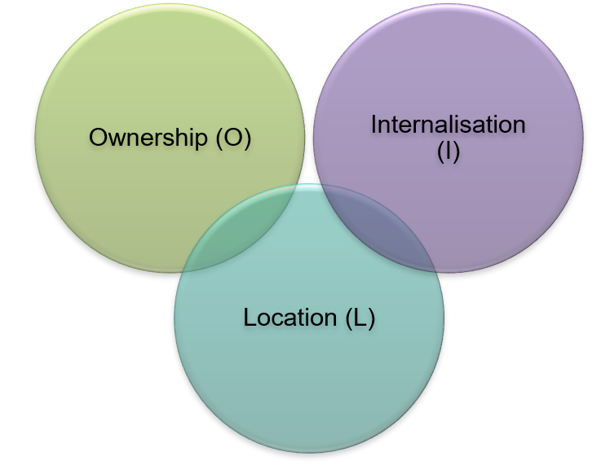
Figure 4: OLI Framework
(Source: By Author)

3.1 Ownership Advantages (O)
Tesla has a great asset of ownership that makes it stand out compared with conventional car manufacturers as well as upcoming EV makers (Renascence, 2024). These advantages can have a great impact on the nature of its entry mode that would be most appropriate to expand into Vietnam. A main strength of ownership includes the fact that Tesla has developed a state of art technology in the pertinent aspects of batteries, drive train, and software. A significant competitive advantage is attributed to the proprietary 4680 battery cell technology, efficient electric motors, and highly integrated battery management systems of the company (Miles, 2025).
Its dominance in autonomous driving software, specifically its Full Self-Driving (FSD) software, presents good differentiation and builds Tesla an image of being innovative. Such technologies need a lot of protection as they possess commercial value and the investment in R&D has been substantial. The next important ownership strength of Tesla is its strong global brand. The company is well-established as a quality and innovative and sustainable EV manufacturer (Carlier, 2025). Tesla also has its own network of Superchargers, which can be valued as a unique infrastructure resource, consolidating the loyalty of customers and increasing the comfort of its clients (EVBoosters, 2024).
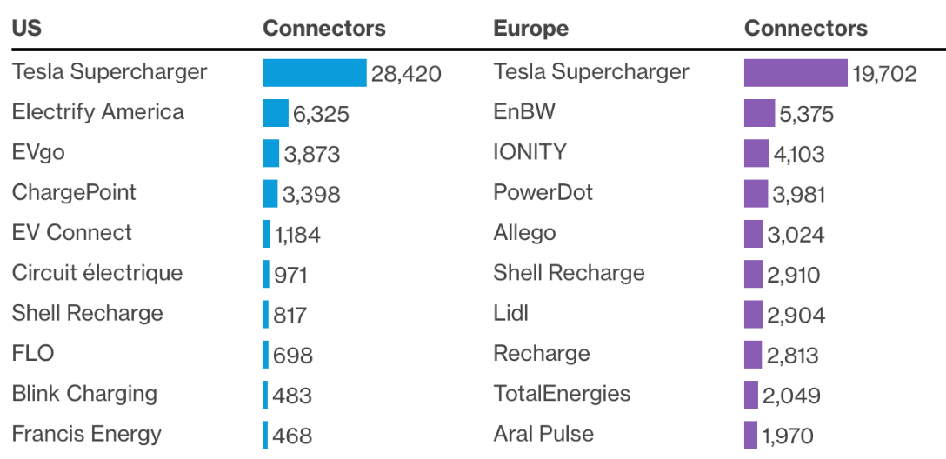
Figure 5: Tesla Leads Public Fast and Ultra-Fast Charging in the US and Europe
(Source: EVBoosters, 2024)
Ownership advantages are also supported by the financial strength of Tesla. Tesla has had consistent profitability since 2020, as well as increased global sales and R&D investment, which provide it with the resources necessary to implement large-scale market entries, like building gigafactories. These ownership benefits are quite strong towards a wholly owned subsidiary or the greenfield investment model of Vietnam. These forms give Tesla all the power to control its production process, the quality of the products, the systems, and proprietary technologies (Liu, et al., 2025). They are also consistent with the fact that Tesla is committed to direct sales and not sharing intellectual property with partners, especially when there are local competitors such as VinFast in the market that are evolving rapidly.

3.2 Location Advantages (L) of Vietnam
Vietnam has several appealing location threats that make the country a promising market for Tesla. These benefits are associated with the national features of the economy, industry-related incentives, infrastructural development, and the population factor. Economically, Vietnam has demonstrated a high and steady growth rate, whose GDP is projected to increase at 6.8 percent in 2025 (World Bank Organisation, 2025). Median age in the country is only 32, which means that there is a young and expanding consumer base that is more urbanised and technologically receptive. By 2030, Vietnam is expected to grow its middle class to USD 7.41 billion, and this means that the state will have a vast potential market of high-end electric cars (Mordor Intelligence, 2025).
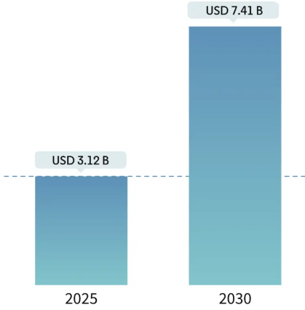
Figure 6: Vietnam Electric Vehicle Market Analysis
(Source: Mordor Intelligence, 2025)
The EV companies like Tesla have strong industry-related benefits. The Vietnamese government also has substantial bonuses related to the adoption of electric vehicles, such as the fact that the registration tax is 0 percent when it comes to EVs and that the tax is lowered on imported EV parts (Vietnam Plus, 2025). To support long-term policies, it has also laid ambitious targets, where the national government wants one million EVs on the road by 2040. However, the adoption of EVs in Vietnam does not exceed 3% of the population, which is why the idea that the market is still at its initial gathering and thus has huge potential in the future is justified (Tien, 2025). Vietnam has dynamic ports and logistics, especially in locations like Cai Mep Thi Vai which are utilised in imports and the manufacture of vehicles on a large scale.
Even in the light of such opportunities, there are some risks. VinFast is a national champion with government support, which might introduce a competition problem (Vin Group, 2024). Tesla may also be challenged by regulatory uncertainty and the elasticity of price among consumers.
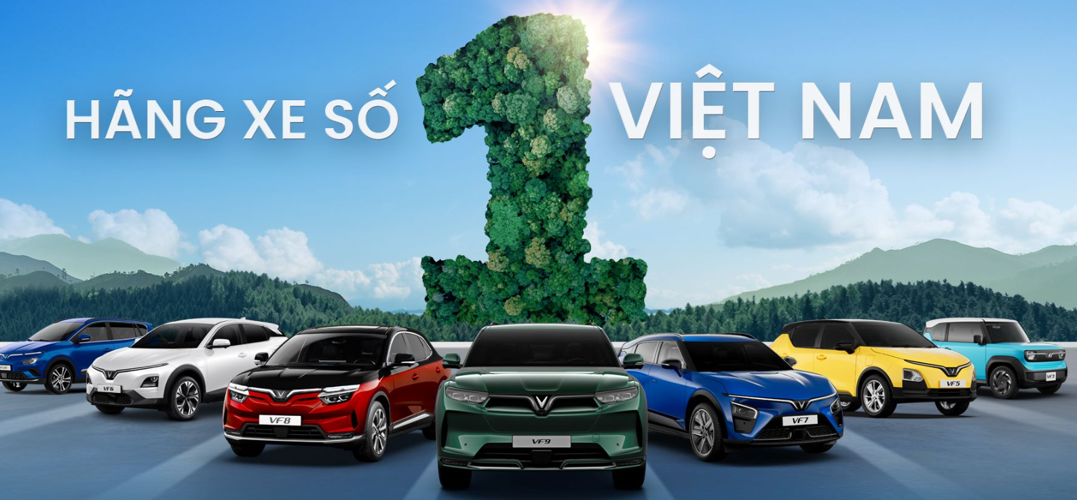
Figure 7: VinFast
(Source: Vin Group, 2024)
The emerging market nature of Vietnam makes the Greenfield assembly plant an alternative long-term solution (Hanh, 2025). Yet, as the EV adoption is still at its early stages, Tesla can also benefit from a gradual process, starting with imports, with the introduction of the charging infrastructure via partnerships and proceeding with local production.

3.3 Internalisation Advantages (I)
The benefit of internalisation in Tesla is attributed to the fact that the organisation must exercise absolute control over proprietary technology, quality of the products and customer experience. These benefits have far-reaching implications on the choice of entry mode that the company would prefer to use when entering a new market like Vietnam. The software programmes, battery chemistry, autonomous driving algorithms, and the specific charging standards are core technologies at Tesla that are highly sensitive and vital to the firm's competitive advantage in the long run (Ghonda, 2024). The intellectual property might also leak through licensing or sharing these technologies to local partners particularly in markets where there are strong local competitors like VinFast.
Another huge internalisation advantage is quality control. Tesla is known to have a vertically structured model of production with major parts being produced internally. The use of new technologies like Giga Press to cast vehicle bodies requires dedicated infrastructure and standards of manufacturing (Lehmhus, 2024). Having a wholly owned facility or subsidiary gives Tesla a chance to have uniform production quality, which is a critical success factor to customer satisfaction and brand reputation. The company does not use networks of dealerships to avoid discrepancies in its sales procedures and the level of customer service. Direct control helps Tesla to control communication, software updates, after-sales services and charging infrastructure without outside interference.
The benefits of internalisation are highly in favour of a wholly owned subsidiary to a Greenfield investment as compared to a joint venture. This strategy will retain all the control that Tesla has on its technology, data, operations and customer experience. However, a joint venture can also be beneficial to charging infrastructure, and network growth may be expedited through cooperation with local utilities, for example, EVN (Vietnam Electricity) or even with VinFast (Kim, et al., 2025).

4. Cultural Differences Between the U.S. And Vietnam
When creating an effective entry strategy it is imperative to understand the culture between the United States (the country where Tesla is founded) and Vietnam (the target market). The cultural dimensions as presented by Hofstede and the currently existing cross-cultural management theories, including the High-Low Context model by Hall and relationship orientations, offer a systematic way of determining how the cultural differences can specify how Tesla can achieve its operations in Vietnam.

4.1 Presentation of Cultural Data
The Vietnam-United States cultural comparison indicates that differences exist that Tesla should bear in its attempt to venture into the Vietnamese market. Vietnam is rated highly on Power Distance (70) which means that people are mostly comfortable with unequal distribution of power and accept their decision to be made hierarchically (The Culture Factor, 2025). However, the opposite is true in the U.S., which has significantly lower Power Distance, is egalitarian, and open with respect to communication. Vietnam is ranked low in Individualism (30) that is the representation of a collectivist culture based on the principles of community, devotion and intergroup harmony, whereas the U.S. is one of the most individualistic societies worldwide (Ziatdinov, et al., 2024). However, the Uncertainty Avoidance in Vietnam is also low (30) and this means the country is open to new ideas and flexible, with the U.S. standing at a moderate level. The countries are moderate in terms of Long-term Orientation. The score of Vietnam on the dimension of Indulgence (35) is much less as compared to that of the U.S, which means that Vietnamese consumers are more critical about their expenditure.
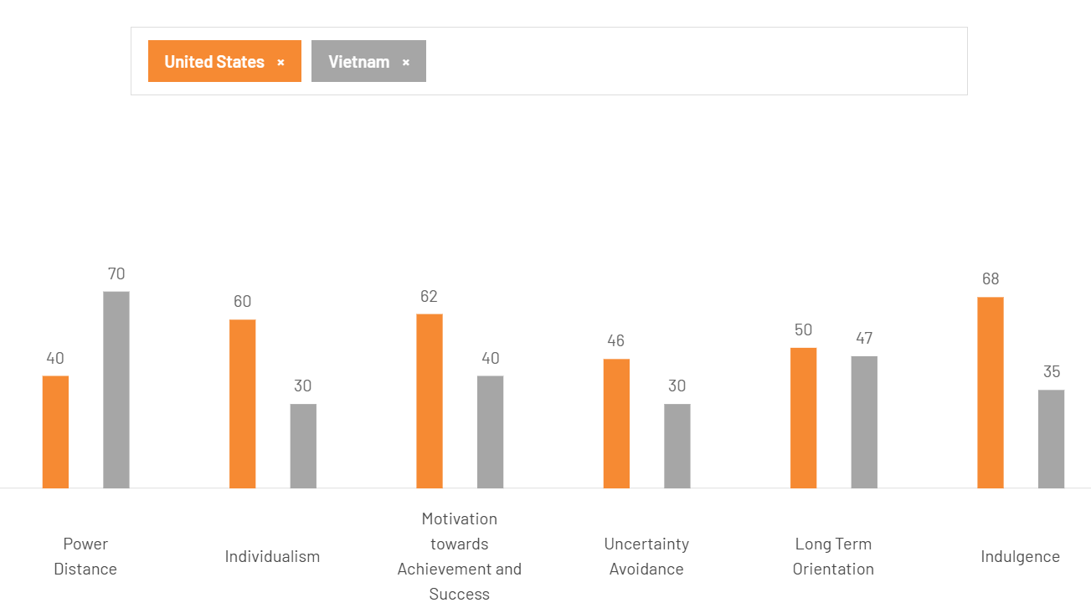
Figure 8: Cultural Comparison of the US and Vietnam
(Source: The Culture Factor, 2025)

4.2 Implications for Tesla’s Entry Strategy
Power Distance (PDI) | The fact that Vietnam scores highly on Power Distance implies that employees should demand hierarchy, respect senior leaders and an obligation to make sound decisions. Tesla on the other hand works in a comparatively lean organisational hierarchy, loose communication and short-term decision making. In case Tesla tries to directly transfer its U.S.-style low-hierarchy system to Vietnam, it will possibly confuse, provoke or alienate the native employees. In Vietnam, managers might require greater direction, directives and visible managerial powers (Hua, et al., 2025). Thus, Tesla will have to change by introducing more precise reporting relationships, protocols and executive behaviour that portray authority yet preserve the innovative culture of the company.
Individualism vs. Collectivism | The culture of Vietnam is collectivist whereby teamwork, group loyalty, and peaceful relationships are looked at. The employees will tend to insist on group decision-making and long-term organisational commitment. However, at Tesla, the very individualistic and performance-based culture has promoted personal performance, speed of innovation and direct communication (Tesla, 2022). Tesla might require introducing group incentive plans, team performance indices and team problem-solving strategies. Moreover, instead of only having individual KPIs, the management should seek to establish trust, relationships and strong teams because the ideas do not necessarily work well within the Vietnamese setting (Liao and Lu, 2025).
Uncertainty Avoidance | Vietnam scores low on Uncertainty Avoidance, which means that consumers along with employees are comparatively open to ambiguity, experimentation, and innovative concepts. This cultural characteristic benefits Tesla, because spreading electric cars requires receptiveness to technological change. Vietnamese consumers are also likely to research EVs if they are convinced about the brand and see its value in the long term (Liu, et al., 2025). However, since EVs are a significant financial investment, Tesla should also provide a wide range of customer education, straightforward, and reliable information and guarantees on charging infrastructure and maintenance costs.
Long-Term Orientation (LTO) | Vietnam and the United States have a medium-long-term orientation, which means that they share a common view of long-term planning and benefits built on the future. This is positive for Tesla, since the introduction of EVs is subject to forward-looking views of sustainability, fuel efficiency, and asset ownership gain. Incentives by the government favouring long-term planning also help Tesla to establish a position as an environmentally-conscious, forward-thinking brand in Vietnam.
Indulgence vs. Restraint | Vietnam has a low score in Indulgence, which implies that people are economical and do not favour impulse buying. Their focus lies in being practical, saving money, and ensuring security. This cultural aspect implies that Tesla needs to reconsider its pricing strategy, add domestic financing opportunities, and underline long-term economic efficiency in terms of minimised fuel costs, minimised service expenses, and long battery life of Tesla vehicles. Advertising messages need to promote usability, dependability, and family values instead of personal luxuriousness, or lifestyle perceived image that is commonly used in the U.S market (Barakati, et al., 2024).
Table 3: Hofstede’s cultural dimensions of Tesla

4.2.1 Hall’s High–Low Context Theory
Vietnam is a high-context culture, the communication in this context is grounded on employing non-verbal communication, relationship building, and other indirect communication methods. Conversely, the United States is a low-context society, which consists of a direct, explicit, task-oriented manner of communication. This variance influences the marketing, negotiation and customer care practices of Tesla. Tesla will have to use relationship-based marketing, advertising styles that are culturally sensitive, and emotion-driven communications in Vietnam that focus on trust, respect and emotional attachment (Dwivedi and McDonald, 2025). The local employees or business partners with adequate knowledge of the high-context communication norms will be very crucial in helping to bridge the gap in cultures.

4.3 Impacts on Tesla’s Success Potential in Vietnam

4.3.1 Marketing Challenges and Opportunities
The U.S. marketing strategy of Tesla is strongly based on the innovative audacious messages, uniqueness, technological dominance and ecological mission. Nevertheless, these strategies do not necessarily comply well with the Vietnamese cultural virtues. Within a collectivistic culture, market marketing focusing on group interests, family welfare, and societal peace works better (Cui, et al., 2022). Tesla will need to tailor the campaigns to reflect the nature of EVs in helping to achieve shared prosperity, cleaner cities, and lifetime savings by households. The importance of storytelling, emotional appeal and building trust will be emphasised over mere technical specifications.

4.3.2 HR and Management Implications
The internal culture of Tesla promotes independence, rapidity and informal communication that may not align with the Vietnamese values of orderly leadership and distinct authority. Local workers can expect managers to be very direct, their relationship to be formal, and the decision-making to be visible (Khalid Alrashedi, 2024). In the absence of modifying the management styles, confusion or a lack of employee motivation may occur. As an expat leadership training programme and empowering Vietnamese managers to feel the local culture should be considered as a part of cross-cultural training that Tesla should invest in. The performance management systems should include team-oriented goals and should recognise harmony and collaboration instead of putting emphasis on individual performance (Khatoon, et al., 2025).

4.3.3 Consumer Adoption and Behaviour
Even though Vietnam has a low Uncertainty Avoidance meaning that they are ready to adopt new technology, EVs are a luxury, and the price elasticity is high (Lanzini, et al., 2024). Tesla must build some trust by means of education and showrooms, clear financing opportunities, and a long-term warranty. It is possible that consumers need more personal contact and consultation before finalising the purchase, and this fact suggests that the direct-sales model utilised by Tesla should be supplemented by the local support personnel and tailored advice.

4.3.4 Partnership and Stakeholder Management
The Vietnamese business culture focuses on relationships and trust. Local stakeholders (the government agencies, partners, suppliers) anticipate long-term participation and respectful negotiations. Tesla needs to take time to develop partnerships and not just the transactional ones. Close consultations with government agencies as to charging networks, safety requirements and incentives will play a vital role in the long-term success (Ayoade and Longe, 2024).

5. Three Major SOP Adjustments
To expand successfully in Vietnam, Tesla must focus on the changes to its Standard Operating Procedures (SOP) to mirror the cultural aspects, geographical benefits, and internalisation focus area found in the previous analysis. Three of the SOP changes documented below concern the major areas of operation and include, but are not limited to, HR and management practice, sales and marketing system, and manufacturing and supply chain localisation.

5.1 SOP Adjustment 1: Localised HR & Management System
The Vietnam has a high-Power Distance, collectivism, and preference for formal power and states show that Tesla cannot directly accept its U.S.-based flat culture and implant it in this market. It will need a structured, hierarchical, and relationship-oriented HR system (Du, et al., 2024). The initial modification must thus be directed towards the creation of a localised HR/management SOP that can meet the expectations of the Vietnamese, without compromising on the innovative work style at Tesla.
Why is this adjustment required?
High Power Distance of Vietnam implies that employees desire to have visible chains of command, prominent leadership, and clear job descriptions. On the same note, collectivist orientations lay stress on teamwork, team loyalty, and group harmony, which also drives collaboration, motivation, and performance evaluation (Renner, et al., 2025). In the absence of adjusting to these expectations, Tesla can face the problem of miscommunication, poor employee engagement, and difficulty in retaining qualified talent. In addition, Tesla has an internalisation and protection of core technology policy that demands a workforce that is highly aligned and dependable and therefore, cultural adaptation is the key.
How this adjustment works:
The SOP needs to implement hierarchy in reporting, formalised titles, more decisive authority, and a clearer definition of tasks (Ahmad, et al., 2025). Tesla must also adopt team-related performance indicators which include team output, team projects and team problem-solving. This change directs the performance system outside of individual KPI and towards the group-based incentive that is in accordance with the local cultural standards.
Also, the SOP should involve cross-cultural leadership training of the U.S. expatriates and the top managers so that they gain knowledge on which communication norms, expectations in hierarchy, and establish relationships in Vietnam. The internal communication policies must be reinforced that allow embracing high-context communication styles whereby face-to-face meetings are encouraged, formal communication processes, and well-documented (Kabanda and Barrena-Martinez, 2025).
Impact on cost, risk and strategic positioning:
Though the implementation only needs investment in training and HR restructuring, in the long term, companies get better employee retention, increased productivity, and less conflict (Koman, et al., 2024). By matching its leadership and communication within the local expectations, Tesla would lower the risk of its operations along with its talent recruitment and retention capability. This change can also enable Tesla to establish a good employer brand in Vietnam, which will assist other long-term manufacturing and service goals.

5.2 SOP Adjustment 2: Market-Specific Sales, Pricing & Marketing SOP
The aspects of the Vietnamese culture, such as the low level of indulgence, high sensitivity to price, collectivism, and high-context communication do require dramatic changes in Tesla sales, prices, and marketing (Nugroho, et al., 2025). The second SOP change involves creating a market-oriented strategy of customer-facing operations to ensure Tesla effectively relates with the Vietnamese consumers.
Why is this adjustment required?
Vehicles by Tesla are rather costly, but Vietnamese buyers are rather cautious and prioritise savings on practical and long-term investing. This makes the U.S. individuality-driven or aspirational messaging less effective. At the same time, EV penetration will need intensive customer education and trust development, which is demanded in a high-context culture that makes use of relationships and verbal communication nuances. The inability to localise its sales and marketing SOPs to the local consumer behaviour would lead to misalignment and thus hinder market penetration.
How this adjustment works:
To begin with, Tesla ought to integrate localised pricing schemes like provision of an instalment plan, subscription-based software packages, and customised financing using local banks. This counteracts initial expenses. Second, marketing SOP at Tesla needs to focus on community and family-driven communications, with various benefits shared including decreased pollution, fuel, security, and value in the long term. The individuality aspect of promotions should be less accentuated and more group-oriented (Gutiérrez-Carmona, et al., 2021).
The SOP must also promote collaboration with the government agencies, universities and environmental organisations to promote EV education and public awareness (Zaino, et al., 2024). Tesla needs to modify the customer experience in showrooms, where the staff should be trained on high-context communications and employ more personalised and relational interactions instead of a direct or more technical approach.
Impact on cost, risk and strategic positioning:
These modifications can raise initial marketing and operating expenses but decrease the risk of market resistance in the long term and reinforce the brand of Tesla in a price-sensitive market. Personalisation of consumer experience enhances customer loyalty and makes Tesla one responsible and community-driven brand, which is a necessary edge when Tesla competes with VinFast and other new entrants in the EV market.

5.3 SOP Adjustment 3: Local Manufacturing & Supply Chain SOP
Tesla needs a long-term localisation strategy for their production and supply chain business in Vietnam to leverage the benefits of the localisation presented by the country, including its growing manufacturing base, labour pool, and EV package. The third SOP change is centred around the gradual localisation of production and alliances towards infrastructure formation, which allows Tesla to save on expenses, enhance local industrial activity, and enhance its positioning (Meegoda, et al., 2024).
Why is this adjustment required?
Due to favourable taxation, the country has the most powerful economic and industry-specific incentives to EV makers, tax reduction, the development of the logistics system is rapid, and the government helps to electrify Vietnam. Such benefits make local manufacturing a long-term workable strategy. Full first entry however, is riskier because of the developing EV environment in Vietnam and because of the presence of a competitor within the country, which is strong and has the brand, VinFast. A gradual strategy of localisation minimises risk as it prepares against future cost effectiveness (Aziz and Koo, 2025).
How this adjustment works:
The SOP must map a three-stage approach of localisation:
- Phase 1: Imports and Infrastructure Partnerships: Tesla will initially import cars to Vietnam with the partnership of either EVN (Vietnam Electricity) or other companies to increase the number of charging stations. This creates brand presence without a serious investment.
- Phase 2: Semi-Knocked Down (SKD) or Assembly Operations: Once the demand is stabilised, Tesla establishes a local assembly plant, which lowers import tariffs and enables testing of the Vietnam industrial ecosystem (Oo, et al., 2025).
- Phase 3: Full Localisation of Key Components: Tesla is diversified to greater levels of localisation of the articles that need to be assembled to battery packs, local suppliers of non-critical parts and finally, a less massive Gigafactory model should the volume of sales justify it.
Impact on cost, risk and strategic positioning:
The phased localisation minimises risks in terms of initial investments but Tesla can ensure cost savings in the long term. Taxes reduce the logistics and tariff costs, enhancing the price competitiveness (Boșcoianu, et al., 2025). Tesla's charging infrastructure partnerships help the company attract an edge in its ecosystem. This progressive move will place Tesla as one of the long-term industrial participants in Vietnam, contribute to the development of the goodwill and consumer confidence of the government.

6. Conclusion
The status of Tesla as a global multinational corporation is supported by the high level of integration of the value chain, innovative technologies, and strong global presence. Its diversification into other markets has made it have enormous economies of scale, increased innovations, and made its operations to be efficient. Vietnam is a promising new market for Tesla, owing to its stable economic development, high youth population, growing middle income and the government having high intention towards electric mobility. All these make the environment favourable to the long-term adoption of electric vehicles and justify the decision by Tesla to enter the market. According to the OLI framework, Tesla has strong ownership benefits namely its proprietary technology, brand strength, and vertically integrated model of production. The benefits are in favour of a wholly owned entry mode. The locational benefits of Vietnam are simultaneous to a scenario where localisation strategy progresses through imports and infrastructure alliances as a step to assembly and integration of further chained supply chain components. This is a cost-risk-competitiveness long-term strategy.
The cultural differences between the United States and Vietnam represent pertinent issues especially on the basis of leadership expectations, communication styles, and consumer behaviour. In a bid to succeed, Tesla should change its human-resource practices, marketing policies and customer-engagement processes in order to fit into the Vietnamese cultural values and business traditions. Vietnam has the potential to become a strategic manufacturing and sales location of Tesla in the ASEAN region with proper modifications to the standard operating procedures and culture-sensitive market strategy, which will help the company expand globally in the long term.

7. References
Ahmad, K., Marchesano, M.G., Popolo, V., Revetria, R. and Rozhok, A. (2025) Development of a European Sustainability Reporting Standards Compliant Sustainability Assessment Framework for Manufacturing Organisations Using Analytic Hierarchy Process. Sustainability, 17(11), p.4772.
Alsulami, F. and Raza, A. (2025) Financial markets effect on cryptocurrency volatility: pre-and post-future exchanges collapse period in USA and Japan. International Journal of Financial Studies, 13(1), p.24.
Ani. (2025) Tesla turning towards Samsung SDI for huge ESS battery deal. [Online]. Available at: https://economictimes.indiatimes.com/news/international/business/tesla-turning-towards-samsung-sdi-for-huge-ess-battery-deal/articleshow/125104817.cms?from=mdr [Accessed on: 26 November 2025].
Ayoade, I.A. and Longe, O.M. (2024) A comprehensive review on smart electromobility charging infrastructure. World electric vehicle journal, 15(7), p.286.
Aziz, T. and Koo, I. (2025) A Comprehensive Review of Indoor Localization Techniques and Applications in Various Sectors. Applied Sciences (2076-3417), 15(3).
Barakati, P., Bertini, F., Corsi, E., Gabbrielli, M. and Montesi, D. (2024) Luxury Car Data Analysis: A Literature Review. Data, 9(4), p.48.
Boșcoianu, M., Toth, Z. and Goga, A.S. (2025) Sustainable Strategies to Reduce Logistics Costs Based on Cross-Docking—The Case of Emerging European Markets. Sustainability, 17(14), p.6471.
Carlier, M. (2025) Tesla - statistics & facts. [Online]. Available at: https://www.statista.com/topics/2086/tesla/?srsltid=AfmBOoqdu9Gax7ttLHeGgIXwShB8l-5VshpsIAJS4dw6xGur008xcD_l [Accessed on: 26 November 2025].
Cui, G.Q., Zeng, J.Y. and Jin, C.H. (2022) The impact of vertical/horizontal individualism and collectivism on ethical consumption. Sustainability, 14(21), p.14254.
Du, S., Zhong, G., Wang, F., Pang, B., Zhang, H. and Jiao, Q. (2024) Safety risk modelling and assessment of civil unmanned aircraft system operations: A comprehensive review. Drones, 8(8), p.354.
Dwivedi, A. and McDonald, B. (2025) A model of brand price premiumness and its marketing outcomes. Journal of Marketing Theory and Practice, pp.1-22.
EVBoosters. (2024) Tesla dominates fast and ultra-fast EV Charging networks in the US and Europe. [Online]. Available at: https://evboosters.com/ev-charging-news/tesla-dominates-fast-and-ultra-fast-ev-charging-networks-in-the-us-and-europe/ [Accessed on: 26 November 2025].
Ghonda, M. (2024) Tesla’s Waves of Disruption and Innovations. [Online]. Available at: https://maevaghonda.medium.com/teslas-waves-of-disruption-and-innovations-99013152527a [Accessed on: 26 November 2025].
Gutiérrez-Carmona, A., Urzúa, A. and Rdz-Navarro, K. (2021) Ethnic identity and well-being of andean indigenous people: the effect of individualistic and collectivist value orientations. International Journal of Environmental Research and Public Health, 18(13), p.6811.
Hanh, V.N. (2025) Vietnam Manufacturing Tracker: As of November 2025. [Online]. Available at: https://www.vietnam-briefing.com/news/vietnam-manufacturing-tracker.html/ [Accessed on: 26 November 2025].
He, L. (2023) Tesla’s China deliveries account for more than half of global sales. [Online]. Available at: https://edition.cnn.com/2023/07/05/business/tesla-china-sales-surge-intl-hnk [Accessed on: 26 November 2025].
Hua, H.H., Le, T.T., Phuong, H.Y. and Pham, T.T. (2025) Sustainable leadership in higher education: a case study exploring the emergent strategies of four Vietnamese leaders’ strategies. Cogent Social Sciences, 11(1), p.2516076.
Kabanda, M.K. and Barrena-Martinez, J. (2025) Effective communication in management. In International managerial skills in higher education institutions (pp. 17-42). IGI Global Scientific Publishing.
Katje, C. (2025) Tesla Operates in Five Continents, A Sixth Could Be On The Way With This Country. [Online]. Available at: https://finance.yahoo.com/news/tesla-operates-five-continents-sixth-233116358.html [Accessed on: 26 November 2025].
Khalid Alrashedi, A. (2024) The key sustainable strategies criteria for effective human resource management practices. Sustainability, 16(12), p.5250.
Khatoon, U.T., Babgi, M., Hadi, N.T., Mir, R.N. and Velidandi, A. (2025) Technology-Driven Change in Human Resource Management: Reshaping Talent Management and Organizational Design. Administrative Sciences, 15(11), p.452.
Khdir, S. and Cieślik, A. (2025) Regional Concentration of FDI and Sustainable Economic Development. Sustainability, 17(16), p.7449.
Kim, H.J., Shrestha, S. and Pranawengkapti, K. (2025) Capacity and market potential for local production and distribution of electric two-wheelers in Southeast Asia, focused on Thailand, Indonesia and Vietnam. Sustainable Earth Reviews, 8(1), p.3.
Koman, G., Boršoš, P. and Kubina, M. (2024) Sustainable human resource management with a focus on corporate employee recruitment. Sustainability, 16(14), p.6059.
Lanzini, P., Nguyen, T.T. and Slanzi, D. (2024) The role of market insights in shaping sustainable mobility in fast developing countries: the case of Vietnam. Sustainability, 16(2), p.651.
Lehmhus, D. (2024) Advances in metal casting technology: A review of State of the art, challenges and trends—Part II: Technologies new and revived. Metals, 14(3), p.334.
Levinson, E. (2025) Vietnam – Asia’s Next Tiger Economy: VinaCapital’s Perspective. [Online]. Available at: https://hubbis.com/article/vietnam-asia-s-next-tiger-economy-vinacapital-s-perspective#:~:text=Vietnam's%20economic%20resilience%20is%20also%20a%20focal,ranging%20between%206.5%25%20and%207.1%25%20for%202025 [Accessed on: 26 November 2025].
Liao, T.S. and Lu, H.P. (2025) Enacting Sustainability Through Organizational Routines: A Grounded Theory of Capability–Institution Co-Structuring. Sustainability, 17(17), p.7841.
Liu, L., Wang, L. and Rong, D. (2025) Coupling Mechanisms in Digital Transformation Systems: A TOE-Based Multi-Level Study of MNE Subsidiary Performance. Systems, 13(9), p.763.
Liu, X., Kim, T.H. and Lee, M.J. (2025) The Impact of Green Perceived Value Through Green New Products on Purchase Intention: Brand Attitudes, Brand Trust, and Digital Customer Engagement. Sustainability, 17(9), p.4106.
Meegoda, J., Charbel, G. and Watts, D. (2024) Second life of used lithium-ion batteries from electric vehicles in the USA. Environments, 11(5), p.97.
Miles, S. (2025) How Tesla Uses Technology Innovations in Electric Vehicles. [Online]. Available at: https://techeve.co.uk/how-tesla-uses-technology-innovations-in-electric-vehicles/ [Accessed on: 26 November 2025].
Mordor intelligence. (2025) Vietnam Electric Vehicle Market Size & Share Analysis - Growth Trends and Forecast (2025 - 2030). [Online]. Available at: https://www.mordorintelligence.com/industry-reports/vietnam-electric-vehicle-market [Accessed on: 26 November 2025].
Nugroho, C.A., Wibowo, E.P., Perdana, J.P. and Utomo, J.D. (2025) The Effect of Cultural Differences on International Marketing Strategies. International Journal of Humanities, Social Sciences And Business (INJOSS), 4(2), pp.182-195.
Oo, N.Z., Wider, W., Jiang, L., Tanucan, J.C.M., Santos, J.M., Arokiasamy, A.R.A. and Deng, P. (2025) Driving the Future: Strategic Imperatives and Systemic Challenges in Myanmar’s Transition to Electric Mobility. World Electric Vehicle Journal, 16(7), p.348.
Renascence. (2024) How Tesla Enhances Customer Experience (CX) Through Innovation and Customer-Centricity. [Online]. Available at: https://www.renascence.io/journal/how-tesla-enhances-customer-experience-cx-through-innovation-and-customer-centricity [Accessed on: 26 November 2025].
Renner, R., Cvetković, V.M. and Lieftenegger, N. (2025) Dealing with High-Risk Police Activities and Enhancing Safety and Resilience: Qualitative Insights into Austrian Police Operations from a Risk and Group Dynamic Perspective. Safety, 11(3), p.68.
Reuters. (2021) Tesla to expand presence in Palo Alto despite HQ move to Texas. [Online]. Available at: https://realty.economictimes.indiatimes.com/news/commercial/tesla-to-expand-presence-in-palo-alto-despite-hq-move-to-texas-source/87012207 [Accessed on: 26 November 2025].
Reuters. (2022) Tesla has considered exporting EVs from Shanghai to U.S., Canada. [Online]. Available at: https://www.reuters.com/business/autos-transportation/exclusive-tesla-mulls-exporting-china-made-evs-united-states-sources-2022-11-11/ [Accessed on: 26 November 2025].
Reuters. (2025) Tesla plans Model Y costing at least 20% less to produce to defend China share. [Online]. Available at: https://www.reuters.com/business/autos-transportation/tesla-plans-model-y-costing-least-20-less-produce-defend-china-share-sources-say-2025-03-14/ [Accessed on: 26 November 2025].
Ross, L. (2025) Behind the Tesla Supply Chain. [Online]. Available at: https://www.thomasnet.com/insights/tesla-supply-chain-2/ [Accessed on: 26 November 2025].
Shvartsman, D. (2025) Tesla Growth and Production Statistics: How Many Vehicles Are Sold Across the Globe?. [Online]. Available at: https://www.investing.com/academy/statistics/tesla-facts/#:~:text=Tesla%20earned%20$97.7%20billion%20in%20sales%20revenue%20in%202024.,growth%20year-over-year [Accessed on: 26 November 2025].
Tesla. (2022) Tesla 2021 Impact Report. [Online]. Available at: https://www.tesla.com/ns_videos/2021-tesla-impact-report.pdf [Accessed on: 26 November 2025].
Tesla. (2025) About us. [Online]. Available at: https://www.tesla.com/about [Accessed on: 26 November 2025].
Tesla. (2025) Additional Resources. [Online]. Available at: https://www.tesla.com/en_in/legal/additional-resources [Accessed on: 26 November 2025].
Tesla. (2025) Manufacturing. [Online]. Available at: https://www.tesla.com/manufacturing
The Culture Factor. (2025) Country Comparison tool. [Online]. Available at: https://www.theculturefactor.com/country-comparison-tool?countries=united+states%2Cvietnam [Accessed on: 26 November 2025].
Tien, N.T. (2025) Vietnam Automotive Industry in 2025: Growth, Tariff Impacts and Future Outlook. [Online]. Available at: https://www.vietnam-briefing.com/news/vietnam-automotive-industry-in-2025-growth-tariff-impacts-and-future-outlook.html/ [Accessed on: 26 November 2025].
Vietnam Plus. (2025) EV buyers enjoy zero percent registration fee till 2027. [Online]. Available at: https://en.vietnamplus.vn/ev-buyers-enjoy-zero-percent-registration-fee-till-2027-post311130.vnp [Accessed on: 26 November 2025].
Vin Group. (2024) VinFast Secures Top Market Position In Vietnam. [Online]. Available at: https://vingroup.net/en/news/detail/3247/vinfast-secures-top-market-position-in-vietnam [Accessed on: 26 November 2025].
World Bank Organisation. (2025) Viet Nam’s Economy Forecast to Grow 6.8 Per cent In 2025. [Online]. Available at: https://www.worldbank.org/en/news/press-release/2025/03/12/viet-nam-s-economy-forecast-to-grow-6-8-percent-in-2025-wb [Accessed on: 26 November 2025].
Xinhua. (2024) Tesla's Shanghai plant delivered 947,000 vehicles in 2023. [Online]. Available at: https://www.chinadaily.com.cn/a/202401/04/WS65964e5da3105f21a507a908.html [Accessed on: 26 November 2025].
Xinhua. (2025) Tesla's China operations demonstrate potential of win-win cooperation. [Online]. Available at: https://www.chinadaily.com.cn/a/202501/05/WS6779d84ca310f1265a1d903a.html [Accessed on: 26 November 2025].
Zaino, R., Ahmed, V., Alhammadi, A.M. and Alghoush, M. (2024) Electric vehicle adoption: A comprehensive systematic review of technological, environmental, organizational and policy impacts. World electric vehicle journal, 15(8), p.375.
Ziatdinov, R., Atteraya, M.S. and Nabiyev, R. (2024) The fifth industrial revolution as a transformative step towards society 5.0. Societies, 14(2), p.19.

